

9B18M007

MOUNTJOY SPARKLING: CREATING A BUZZ IN THE CANNABIS-INFUSED beverage BUSINESS

Allen Kupetz wrote this case solely to provide material for class discussion. The author does not intend to illustrate either effective or ineffective handling of a managerial situation. The author may have disguised certain names and other identifying information to protect confidentiality.

This publication may not be transmitted, photocopied, digitized, or otherwise reproduced in any form or by any means without the permission of the copyright holder. Reproduction of this material is not covered under authorization by any reproduction rights organization. To order copies or request permission to reproduce materials, contact Ivey Publishing, Ivey Business School, Western University, London, Ontario, Canada, N6G 0N1; (t) 519.661.3208; (e) cases@ivey.ca; www.iveycases.com.

Copyright © 2018, Ivey Business School Foundation Version: 2018-01-18

In the summer of 2017, Alex Mountjoy, founder of Mountjoy Sparkling (Mountjoy), was getting ready for the biggest challenge of his young company’s life—developing a strategy to grow the availability of its cannabis-infused sparkling water. Made by hand on Alex’s farm in the famed wine country of California’s Sonoma County, the sparkling water had received nearly universally positive initial customer feedback. However, the product was available in just a handful of dispensaries in California and Alex knew he had to get ready for the future. California voters had approved Proposition 64, which meant in just a few months Californians over the age of 21 could buy and use up to an ounce of cannabis for recreational purposes, and individuals could grow as many as six plants. The measure would also allow retail sales of marijuana and impose a 15 per cent tax. Colorado had already approved the recreational use of cannabis, but the California market was 10 times larger.

The challenge for Alex was where to grow the business. California had 40 million people; that market alone could drive revenue. Why not go after other states that approved recreational use and even those where only medical marijuana was legal? Alex also thought the product would be popular in many international markets. Where to grow—instead of how to grow—was a good problem to have, but it was still a problem. Alex stated:

I developed Mountjoy Sparkling because I wanted to be more productive and to be a better person. I have a carefully curated cocktail database, but I never felt that alcohol made me a better person. My motivation now is to share with people a product I believe will help people live better, happier, and healthier.

FLOATING AN IDEA

In 2014, Alex bought a refrigerated unit to carbonate water and attached it to his well. He could get fresh sparkling water on demand for his family and friends. Then in 2016, Alex become interested in the cannabis business and started experimenting with different ways to infuse cannabis into the sparkling water. He went to a seminar in California focused on helping people get started in the industry and decided to launch Mountjoy.

As a result of the November 2016 elections in the United States, medical or recreational marijuana became legal in more than half of the 50 states. Alex saw this situation as market validation of the idea to devote his full attention to the company’s line of cannabis-infused sparkling waters. Alex saw sparkling water as a way to enter the cannabis market by overcoming what he saw as two shortcomings in current product offerings: smoking was bad for you, and the amount of sugar in marijuana edibles made them less attractive to many consumers. Alex decided to make and distribute three cannabis-infused sparkling waters, one with natural flavour and two with a hint of fruit flavour—orange and peach (see Exhibit 1). He decided to market the products in a distinct refrigerator unit similar to the approach other premium beverage companies used (see Exhibit 2).

Alex knew “the trend is your friend” and wanted to seize the opportunity. North American cannabis sales grew by an unprecedented 30 per cent in 2016 as the legal market expanded in the United States and Canada. Also, North American sales were projected to top US$20.2 billion[1] by 2021, including Canada as it moved toward implementing legal adult use of cannabis. To put these numbers in perspective, the industry growth was larger and faster than even the dot-com era.[2]

A LIFE OF CRIME?

While the U.S. Constitution granted sweeping powers to states, it also granted Congress powers under the Commerce Clause (Article 1, Section 8, Clause 3) “to regulate commerce with foreign nations, and among the several states, and with the Indian tribes.”[3]

Complicating Mountjoy’s—and the entire marijuana industry’s—growth was the *Controlled Substance Act* (CSA). In 2016 and 2017 the CSA listed marijuana next to heroin as a Schedule I controlled substance having “a high potential for abuse,” “no currently accepted medical use in treatment,” and “a lack of accepted safety for use.”[4] The CSA prohibited the manufacture, distribution, dispensation, and possession of marijuana. Pursuant to the U.S. Constitution’s Supremacy Clause, state laws conflicting with federal law were generally preempted and void.[5]

As states moved to formally and informally decriminalize some marijuana use, the federal government weighed in. In a memorandum dated August 29, 2013 (the “Cole Memorandum”), Deputy Attorney General James M. Cole wrote that while marijuana remained illegal under the CSA, the Department of Justice would focus resources on “most significant threats in the most effective, consistent, and rational way.”

Cole’s enforcement priorities (“the eight preventions”) were: distribution of marijuana to minors; marijuana sale revenue going to criminal enterprises, gangs, and cartels; diversion of marijuana from states where it was legal under state law in some form to other states; state-authorized marijuana activity from being used as a cover or pretext for trafficking of other illegal drugs or other illegal activity; violence and use of firearms in marijuana’s cultivation and distribution; drugged driving and exacerbation of other adverse public health consequences associated with marijuana use; growing of marijuana on public lands, and attendant public safety and environmental dangers posed by marijuana production on public lands; and marijuana possession or use on federal property.[6]

While comforting, Alex knew this memorandum was possibly not as long lasting as a formal piece of legislation passed by Congress and signed by the President. A new U.S. Attorney General could simply tear up the Cole Memorandum. Another problem was the banking industry, which was highly regulated at the federal level and tended to be highly risk averse. Because of the CSA, providing financial services to a cannabis-related business would result in compliance risk and costs that most banks would simply refuse despite the opportunity for a return. The Department of the Treasury’s Financial Crimes Enforcement Network Guidance compounded compliance costs by requiring that a bank providing financial services to a cannabis-related business file suspicious activity reports.[7]

The challenge of being in the cannabis business would not end for Alex, even with legalization at the federal level. Unlike with cigarettes and alcohol, all 50 states could and likely would implement their own standards for packaging. This decentralization was already present. Packaging requirements in Colorado, the nation’s largest adult-use market and second-biggest medical cannabis market, included that the product had to be placed in a child-resistant container or that the container had to be placed in a child-resistant exit package. Washington state required that prior to offering items for sale, all marijuana-infused products, labels, and packaging be approved by the agency charged with running its marijuana program—the Liquor Control Board. Nevada’s packaging regulations required that any container or packaging containing usable marijuana, edible marijuana products, or marijuana-infused products had to protect the contents from contamination, and not impart any toxic or deleterious substance to the usable marijuana or marijuana product.[8]

As if being in the cannabis business in California was not difficult enough with the myriad of state and local regulations, entering another state was challenging beyond the packaging requirements. Companies were subject to changing laws and regulations in their home states and in the states in which they did business. Since the legal cannabis industry was still in its infancy, Alex would have to try to anticipate new rules and how they might affect his business. Rapidly changing laws could create numerous expenses for a growing business and enable “fast followers” to gain a competitive advantage by learning from the early entrant’s mistakes. Increased regulatory compliance costs could result in lower gross margins or higher retail prices, or both, while competition from the black market loomed.

Furthermore, not all of those costs would be deductible as they would in other businesses. Except for “cost of goods sold,” Section 280E of the Internal Revenue Code prohibited a marijuana business from taking tax deductions for numerous ordinary and necessary business expenses. Also, insurance laws for marijuana-related risks were not well-developed, and common coverages might not be available to Mountjoy. As with any product manufacturer, Mountjoy was subject to the risk of product liability claims. The loss of any such claim in excess of insurance coverage could have a material adverse effect on Mountjoy’s business and financial condition.

BOTTLING A LIFESTYLE

Alex set out to develop the product category as much as the Mountjoy brand itself. He knew some investors and other people would equate consumption of marijuana in any form with the drug user begging for money on the corner. However, Alex compared his product to a glass of wine, offering more of a relaxed feeling than a high. He envisioned it being consumed around the pool with friends, with cheese and crackers before a dinner party, or after a long run or some other kind of exercise.

Alex believed that cannabis consumption was at a tipping point. Just as states had promoted marriage equality well ahead of federal rules and regulation, so too he thought was the case with cannabis. With legalization in the United States at over 50 per cent of the states in 2016, he thought there would soon be pressure on the federal government to regulate cannabis similar to how it regulated alcohol and cigarettes. States would not have to legalize cannabis, but the federal government would not prevent states that wanted to from doing so.

Alex’s optimism was based on two developments that were getting a great deal of news coverage all over the country: taxes and the opioid crisis. States, always under budgetary pressure, saw marijuana sales as a way to increase tax revenue. In Colorado, for example, “the state received nearly $200 million in marijuana tax revenue, whereas just a decade ago it was receiving zero.”[9] In 2017, “legal recreational marijuana sales in Nevada generated [$3 million in sales](https://lasvegassun.com/news/2017/jul/05/first-days-of-recreational-pot-sales-generate-3-mi/) revenue and roughly $500,000 in tax revenue in their first four days, according to the Nevada Dispensary Association. That puts the state on track to pull in sales of $30 million by the next six months.”[10] Moreover, Washington state “expects to rake in about $730 million from sales of legalized marijuana over the next two years.”[11]

More controversial was the reporting that marijuana could serve as an alternative to opioids for pain management. According to an article in *Scientific American,* “A handful of drug makers are taking their first steps toward developing marijuana-based painkillers, alternatives to opioids that have led to widespread abuse and caused the U.S. health regulator to ask for a withdrawal of a popular drug this month.”[12]

In 2017, Alex hired a social media consultant and public relations firm to promote awareness of the Mountjoy brand to consumers and would-be investors. The imagery used to do so was consistent with Alex’s belief that the brand should be seen as a healthy lifestyle choice. Most of the early pictures were taken near the ocean to reinforce that Mountjoy was, after all, a sparkling water. The mainstream press picked up on this theme, with a major health publication writing about it in its Healthy Eating—Healthy Drinks section:

Now that recreational weed is legal in some states, there are so many more ways to get your weed fix other than smoking a joint. Companies are infusing all kinds of things you’d never think to with cannabis. . . . One cannabis product that’s sure to appeal to all the La Croix-guzzling millennials out there: Mountjoy Sparkling’s cannabis-infused sparkling water. The zero-calorie drink comes in orange, peach, or natural, and is now sold in dispensaries in California and [online](https://www.mountjoysparkling.com/). . . . They’re also more fast-acting than edible options (which can take an hour to work), with a high that kicks in within 15 minutes of drinking and lasts three to four hours after drinking it. . . . Overall, the beverage is being marketed as a way to “mellow out” in daily life, without getting overly stoned.[13]

GROWTH ON THE HIGH SIDE

In June 2017, about seven months after Mountjoy’s soft launch, Alex hired two full-time sales people to get the product on the shelves of dispensaries. Mountjoy’s wholesale price allowed retailers to sell the product at high margin, even with a $5 suggested retail price. Given the product quality and the favourable reviews online and in the press, sales started to grow quickly. Customers contacted the company wanting to know where they could buy it in their area. This pull made it easier for Mountjoy to push more dispensaries to carry the sparkling water.

Like most fast-growing start-ups, costs were rising faster than sales. Alex had to buy bottles, flavourings, and, of course, cannabis. The cost to produce was roughly $1 per bottle, including the water, carbon dioxide, bottle, cap, cannabis, flavouring, label, and cardboard box. However, bottles and caps needed to be purchased in quantities of 10,000 pieces to achieve a price break. Similarly, the cannabis extract was manufactured in a volume of 10,000 doses. These volumes created a short-term cash flow issue that Alex felt was best addressed by selling a small equity stake in the company. While debt might normally have been the right approach given the high demand and quick inventory turn, it was not easily available for a cannabis product. The capital from investors could also be used to reduce the cost of goods sold. For example, Alex could buy 100,000 bottles at a time, which was significantly cheaper than what he was paying for his current run of 10,000 units.

Alex calculated he should raise $500,000 in growth capital to get Mountjoy to cash flow positive (allowing for a modest founder’s salary) more quickly (see Exhibit 3). The founder of a venture fund out of Florida who was focused on cannabis businesses had heard about the product, and he flew to California to sample it and tour the production facilities. Impressed with what he saw, he invested $125,000 without waiting for another fund to match, as was customary. The fund gave Mountjoy some sales goals to obtain and offered additional funding if those goals were achieved. Alex also tapped his friends and business contacts to raise money. All investors wanted and expected a return, of course; however, most just wanted to be in the cannabis space, given the prospect of dissipating federal control.

DRENCHED IN OPPORTUNITIES

Alex knew he was in the right place at the right time. His challenge was deciding how best to capitalize on this fast-growing market. He could focus solely on California and increase the availability of the product to the over 3,000 dispensaries licensed to sell medical marijuana and just wait for the recreational market to explode a year later. He could establish production facilities in other U.S. states that had legalized either medical or recreational marijuana. He could pursue international markets, including Canada and some countries in Europe and South America. He could create a premium line of beverages to complement what he felt was the entry-level pricing of the company’s original three products. He could focus his sales efforts on direct-to-consumer sales either through home delivery or at special events.

Alex gathered his team at his farm in California. With Mountjoy the beverage of choice, they sat together to discuss the different opportunities in additional markets and products. All of them agreed that the future offered tremendous rewards if they could develop the right strategy.

EXHIBIT 1: THREE FLAVORS OF MOUNTJOY SPARKLING WATER

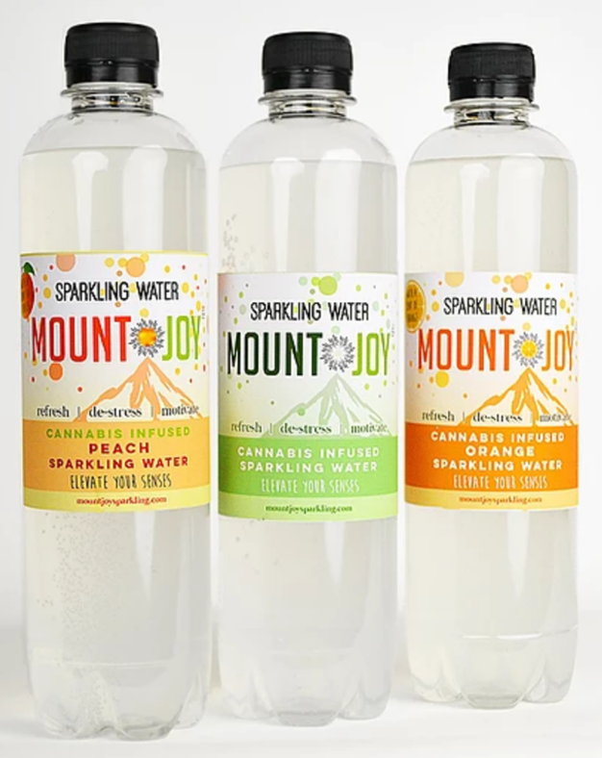

Source: Company documents.

EXHIBIT 2: DISPENSARY REFRIGERATORS

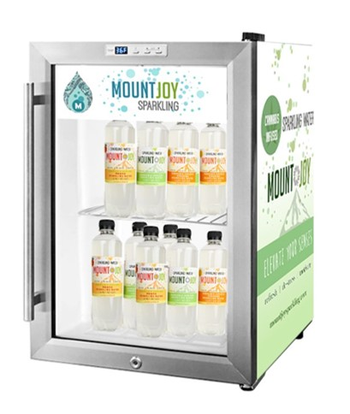

Source: Company documents.

EXHIBIT 3: REVENUE PROJECTIONS AS OF FALL 2017 (IN US$)

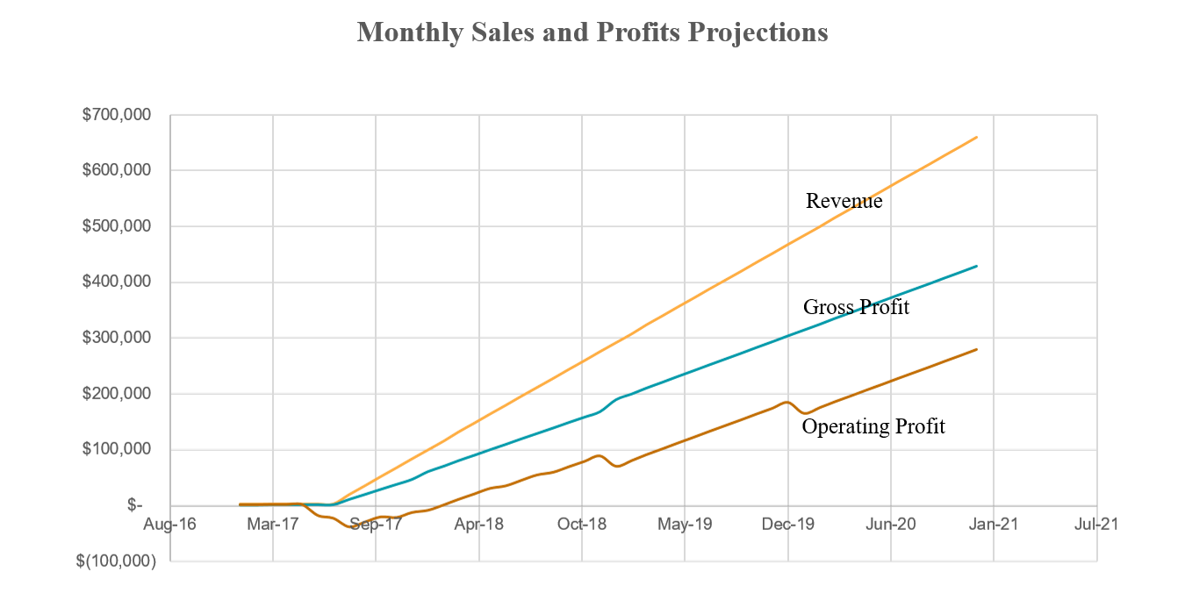

Source: Company documents.

1. All currency amounts are in U.S. dollars unless otherwise specified.
2. Debra Borchardt, “Marijuana Sales Totaled $6.7 Billion in 2016,” *Forbes*, January 3, 2017, accessed July 31, 2017, https://www.forbes.com/sites/debraborchardt/2017/01/03/marijuana-sales-totaled-6-7-billion-in-2016.
3. “Commerce Clause,” Legal Information Institute, accessed August 6, 2017, https://www.law.cornell.edu/wex/commerce_clause.
4. U.S. Department of Justice, Drug Enforcement Administration, Diversion Control Division, *Title 21 United States Code (USC) Controlled Substances Act,* Subchapter 1, Part B, §812(b)(1), accessed August 6, 2017, https://www.deadiversion.usdoj.gov/21cfr/21usc/812.htm.
5. “Supremacy Clause,” Legal Information Institute, accessed August 6, 2017, https://www.law.cornell.edu/wex/supremacy_clause.
6. U.S. Department of Justice, Office of the Deputy Attorney General, *Cole Memorandum,* August 29, 2013, accessed August 6, 2017, https://www.justice.gov/iso/opa/resources/3052013829132756857467.pdf.
7. Julie Weed, “Lawyer Offers Five Facts to Know Before Starting a Marijuana Business,” *Forbes*, March 12, 2016, accessed December 10, 2017, https://www.forbes.com/sites/julieweed/2016/03/12/lawyer-offers-five-things-to-know-before-starting-a-marijuana-business-2/#ca46126c1d52.
8. Steve Schain, “Canna Business 101: Packaging and Labeling Compliance,” *Legal Intelligencer,* June 29, 2016, accessed August 6, 2017, www.thelegalintelligencer.com/id=1202761339364/Canna-Business-101-Packaging-and-Labeling-Compliance.
9. Trey Williams, “Marijuana Tax Revenue Hit $200 Million in Colorado as Sales Pass $1 Billion,” MarketWatch, February 12, 2017, accessed August 6, 2017, www.marketwatch.com/story/marijuana-tax-revenue-hit-200-million-in-colorado-as-sales-pass-1-billion-2017-02-10.
10. Chris Morris, “Nevada on Pace for $30 Million in Marijuana Sales by End of Year,” *Fortune*, July 7, 2017, accessed August 6, 2017, http://fortune.com/2017/07/07/nevada-marijuana-legalization-sales/.
11. Melissa Santos, “Where Does Washington’s Legal Weed Money Go? A Breakdown,” *News Tribune*, updated June 29, 2017, accessed August 6, 2017, www.thenewstribune.com/news/local/marijuana/article130464479.html.
12. Natalie Grover, “High Hopes Ride on Marijuana amid Opioid Crisis,” *Scientific American*, June 23, 2017, accessed August 5, 2017, https://www.scientificamerican.com/article/high-hopes-ride-on-marijuana-amid-opioid-crisis/#.
13. Renee Cherry, “This Company Is Adding Weed to Sparkling Water,” *Shape,* August 3, 2017, accessed August 5, 2017, www.shape.com/healthy-eating/healthy-drinks/cannabis-infused-sparkling-water.