

9B18M008

For the Love of Laundry: comparing organizational forms TO SCALE A social enterprise

Kent Walker, Ian Stecher, Francine Schlosser, and Megain O’Neil-Renaud wrote this case solely to provide material for class discussion. The authors do not intend to illustrate either effective or ineffective handling of a managerial situation. The authors may have disguised certain names and other identifying information to protect confidentiality.

*This publication may not be transmitted, photocopied, digitized, or otherwise reproduced in any form or by any means without the permission of the copyright holder. Reproduction of this material is not covered under authorization by any reproduction rights organization. To order copies or request permission to reproduce materials, contact Ivey Publishing, Ivey Business School, Western University, London, Ontario, Canada, N6G 0N1; (t) 519.661.3208; (e)* [*cases@ivey.ca*](mailto:cases@ivey.ca)*;* [*www.iveycases.com*](http://www.iveycases.com)*.*

Copyright © 2018, Ivey Business School Foundation Version: 2018-01-19

In August 2014, Melissa Power founded her social enterprise, For the Love of Laundry (FTLOL), in London, Ontario. She planned to sell homemade, eco-friendly soaps through local retailers and online in order to fund free laundry events in her community.[1] She would use the profits from the sales to power her social mission—to run events where she would provide free laundry facilities and soap to families in need, so they could clean their clothes, which those on limited incomes often considered a luxury, and many others took for granted. From its inception, FTLOL had hosted 19 separate laundry events. Those events, all held in the London area, had assisted 819 people to wash 3,756 loads of laundry and had saved families roughly $15,000[2] in laundry costs.

In July 2017, Power received nearly $20,000 in entrepreneurship grants from a local university. These grants came with the opportunity to attend specialized business classes to learn how to grow her business and accelerate its life cycle as she saw fit. Power felt this growth was necessary because FTLOL had reached a tipping point. It was large enough that it dominated her time and had a significant social impact in London, yet its revenues were too small to afford her an appropriate, livable salary or to extend her social mission. She needed the business to grow in order to extend its social impact and sustainability. Power faced a complex problem: What was the best way for her to scale her efforts and continue to grow FTLOL, both financially and socially?

While the business was small, Power had been content to operate it as a sole proprietor; however, she was unsure how FTLOL could scale up within this model. Would a different business structure—perhaps a for-profit organization—aid Power’s goals of expanding beyond her local community, across Ontario, and ideally, across the country? Perhaps grants offered exclusively to non-profit organizations (NPOs) would give Power the necessary money to scale her operation. Another option was to become a registered charity, which would provide tax-exempt status and allow Power to emphasize her social mission and receive capital in the form of donations.[3] Or perhaps she could continue as a for-profit corporation, raising capital through investors and working hard to increase sales; this option would give her the freedom to make decisions independent of a governing body attached to grants or donations. There were many options for growth and change as a social enterprise, but Power needed to choose the option best suited to allowing the business and its social value to grow.

Background

In May 2014, Power had a simple, yet powerful vision: to build healthier communities by providing free, environmentally friendly laundry services to low-income families so that they would not face a choice between clean clothes and paid bills. As she had once been a single mother living on a limited income, Power understood the reality and burden of this decision. She had made her own laundry soap for years as a way to cut costs, and she had recently recognized that she could give back to her community by donating the excess soap.[4] With the help of Lore Wainwright, a director at the Pillar NonprofitNetwork, Power was encouraged to turn her small charitable effort into a social enterprise.

The idea of establishing a social enterprise—a commercial venture that used its profits to fund a socially beneficial mission—had not occurred to Power. The social entrepreneurship concept of a triple bottom line—addressing financial profit, social concerns, and environmental concerns, and creating and sustaining social value—seemed to be the perfect way for Power to focus on helping others while maintaining sustainability and independence through the sale of the FTLOL products.[5]

Power’s new venture quickly found traction in her community, and before long, she was expanding the product line to include not just soap but also stain removal sticks and dryer balls (an eco-friendly replacement for dryer sheets). By the end of the 2016 fiscal year, FTLOL had achieved $22,000 in sales and had begun running free laundry events every one to two months.

Financials and Growth

Fiscally, FTLOL was showing great promise as a social enterprise in London, Ontario, and the surrounding area (see Exhibit 1). Its products were being sold by eight small retailers in the community, at a weekly farmers’ market in the city, and online via the FTLOL website. These revenue sources had allowed FTLOLto achieve $22,000 in sales in 2016, and sales of $30,000 were projected for 2017.

FTLOL had the following expenses: (1) $125 per week as a minimal salary for Power, to cover her expenses; (2) $11.40 an hour for a part-time employee who operated the farmers’ market booth for eight hours each week; (3) $55 per week to rent the booth; and (4) $2,400 per year to run the laundry events ($300 for each event, held every one to two months).

FTLOL had minimal expenses for a number of reasons. First, because she had the support of her husband’s income, Power had been able to heavily invest her time in the business without needing much financial return. However, the lack of income for all the work was not sustainable. At some point, Power would need to draw a salary. Second, FTLOL had no utility, warehousing, or production expenses since Power hand-mixed the soaps and outsourced the production of the other products.

With minimal expenses, FTLOL had a favourable profit margin on all its products. Website sales provided a higher profit margin than retail sales, despite prices being constant, because FTLOL did not need to share profits with retail partners on sales made via the website. The soap packages Power made herself (see Exhibit 2) cost only $2.30 to make and earned $3.20 profit for every package sold through a retail outlet and $6.69 profit for every package sold online. The business had established an exclusive partnership with a source in London that produced its stain removal sticks (see Exhibit 3) for $1.80 each; these provided FTLOL with $0.95 profit on each retail sale and $3.20 profit on each website sale. Finally, Power had created her own dryer ball design (see Exhibit 4) and outsourced the production to an established partner in India. In the latest agreement, these products cost $7.00 each and earned FTLOL $11.00 profit for each retail sale and $18.00 profit for each website sale.

Because large retail stores were unwilling to carry FTLOL’s products, the company faced uncertain levels of demand and inconsistent sales. Small retailers placed orders only on an “as-needed” basis, and while Power could personally produce 40 packages of the laundry soap in 45 minutes, she often faced long stretches where she was not producing any, due to slower sales. The business experienced its most significant and steady sales from September 2016 to January 2017, which was attributed mainly to gift-giving and people’s desire to give back to their community during the holiday season.

Power was eager to see FTLOL expand into larger retail stores across Ontario. She was not interested in expanding the product line, as she felt the products covered all of the essential laundry needs; incorporating new products seemed unnecessary and could be potentially harmful to FTLOL’s pro-environmental image, so she saw retail partnerships as an opportunity for financial growth. With the possibility of increased sales, she hoped to hire more employees and rent out a small warehouse space to handle production and shipping. Additionally, she hoped to couple this business growth with the expansion of her social mission, including an FTLOL-branded laundromat in the London area.This first laundromat would serve as another sales location for FTLOL products and would be the regular location for free laundry events, making them more accessible and more frequent for those who required the service. Finally, Power hoped to use the financial growth to open more FTLOL laundromats across Ontario, drastically increasing FTLOL’s social impact.Of course, before any of these activities could happen, Power required capital, which, depending on FTLOL’s organizational structure, could come from more established and larger revenue streams, investors, grants, or donations.

Although simultaneously expanding revenue and the social mission might have seemed ambitious, it was seen as imperative to the core identity of FTLOL. Organizational identity was often an expression of the central and enduring characteristic of a company. It defined a company and what it sought to accomplish.[6] For Power, the identity of FTLOL was that of a social enterprise, and she was unwilling to focus solely on financial profit, even temporarily. That is, unlike a traditional for-profit company, FTLOL was primarily concerned with furthering its social value; thus, financial profit was viewed as a means and not an end. Social enterprises sought to use the power of market-based approaches to address real and pressing social issues in the world.[7] Based on this identity, Power was certain that the future of her company centred on social enterprise, regardless of how she decided to scale her business moving forward.Power knew she had a formidable product line that had both environmentally and socially competitive advantages, and she needed to balance revenue and capacity growth with the growth of her social mission.

Competitive Advantage

For the Love of Laundry had two main competitive advantages: environmentally friendly products and a positive social impact. Power understood the importance of these key advantages, and while some entrepreneurs might have viewed environmental and social bottom lines as distractions from the financial bottom line, she strongly believed that they would help her raise capital and gain access to big-brand stores for sales.

Environmental Consideration

An advantage that FTLOL held over many big-brand competitors in the laundry industry was its use of environmentally friendly ingredients in all of its products. Research by the University of Washington had found that conventional scented laundry detergents and scented dryer sheets were responsible for the release of “more than 25 volatile organic compounds, including seven hazardous air pollutants.”[8] This same research asserted that these chemicals could harm not only personal health but also environmental and public health.[9] The FTLOL soap—a secret formula of Power’s own creation—contained no harmful chemicals or additives and was a natural blend of cleaning powders.

Another major environmental concern posed by conventional detergents was their contribution to the eutrophication of water sources.[10] Eutrophication was a process whereby harmful phosphates entered water sources, stimulating the growth of algae and other plant organisms. This process in turn led to deoxygenation of the water, making it uninhabitable for fish and other organisms, which negatively affected fishing industries and even, in some instances, made water unusable for humans.[11] Many large brands of conventional laundry detergent added phosphates to improve the cleaning power.[12] FTLOL soaps did not rely on the use of harmful phosphates, yet received excellent product reviews from customers.

Soap was not the only FTLOL product with a large competitive advantage that the company could leverage to increase its product sales. FTLOL dryer balls were an environmentally friendly, economically responsible option for consumers. Made of 100 per cent sheep’s wool and functional for roughly 1,000 loads of laundry, dryer balls were an excellent alternative to dryer sheets. These dryer balls eliminated static in the same way the dryer sheets did, while also absorbing moisture to speed the drying process. While dryer sheets could reduce static in the same way, they were also proven to contain numerous harmful chemicals.[13] Studies had linked chemicals found in dryer sheets and their emissions to respiratory toxicity causing sensory irritation, pulmonary irritation, and inflammation.[14] Possibly more concerning was the link that had been found between dryer sheets and asthma[15] and the presence of carcinogenic chemicals in the sheets.[16]

By offering effective cleaning products free of dangerous chemicals, FTLOL was helping protect and maintain an environmentally healthy community—an impact Power hoped to expand through her business.

Social Impact

FTLOL’s second competitive advantage was that it enabled customers to give back to their community simply by purchasing the products. Neurological studies and research had shown that people often experienced pleasure and satisfaction when they were able to give back to others.[17] By hosting laundry events for people without the income or ability to clean their own clothes, FTLOL was able to offer that same sense of gratification to its customers while delivering a product they needed to have—something other businesses were not doing.

While social impact was notoriously difficult to measure or quantify, Power had been using a few techniques to measure FTLOL’s work. She had been quantifying FTLOL’s impact by tracking the numbers of events run, the number of people helped, the money saved, and the number of loads of laundry cleaned during the time the business had been running. The scale and influence of these events would increase as FTLOL expanded its operations, helping to address a real need throughout Canada.[18]

In 2010, Statistics Canada reported a median Canadian income of $28,400 for 99 per cent of the population.[19] Accordingly, alleviating laundry expenses could be a huge help to numerous people living in Canada. Statistics Canada also defined 14.2 per cent of the population, or 5 million people, as having low income after tax. Indeed, these people earned less than half of the median income in Canada.[20] Possibly most concerning was that one in six children, or 16.3 per cent, lived in low-income households, and 44.5 per cent of children living with single mothers lived in households classified as low income.[21] FTLOL could contribute to healthier people and communities across Canada by alleviating laundry expenses for low-income households.

Often taken for granted, clean clothes were important to the health of individuals and the community. Research found that the state of the clothes people wore could significantly affect their self-image[22] and the way others viewed them.[23] Studies found that employers were more likely to hire applicants who wore tidy clothes than those who wore dirty or damaged clothing.[24] People had also been found to display higher levels of concentration and competency at their jobs when they were suitably clothed in high-quality, well-maintained clothing.[25] Studies also found that people often adopted characteristics of the clothes they were wearing.[26] This finding meant that people in dirty, worn clothing often expressed lower self-confidence and felt worse about themselves than those who were cleanly dressed.All of this research demonstrated that, by helping people keep their clothes clean and in good shape, FTLOL was improving community and personal health. The business was helping improve the employability, productivity, well-being, and general confidence of those who could not afford to maintain their clothing.

FTLOL offered customers the opportunity to help a substantial number of Canadians who struggled financially to enjoy the benefits of clean clothes. By giving customers this feeling of satisfaction while fulfilling its social mission, FTLOL had been able to add value to the brand and product line. As FTLOL grew and sought to expand its social impact, the company hoped that the opportunity to give back to company-branded laundromats in specific communities would generate more interest and sales from the people within those communities.

Scaling Up and Identity

Looking forward to the future, Power realized that FTLOL had four structural options: it could operate as a for-profit business, an NPO, a registered charity, or a co-operative.

For-Profit Business

There were four potential benefits to continuing as a for-profit organization. First, a for-profit model came with a wealth of established growth practices based on the creation of a business plan. Second, for-profit social enterprises could pursue revenue, manage their assets, and utilize profits without legal restrictions, which allowed them to fully utilize growth tools such as debt without losing organizational control.[27] Third, a for-profit structure would attract traditional investors with the promise of financial return. Finally, for-profit social enterprises could also attract socially responsible investors. Impact investing, one of the main branches of socially responsible investing, was investment in companies, funds, or NPOs with the intention of generating beneficial social or environmental impact.[28] Investment research showed that impact investing was a growing phenomenon: US$25.9 billion of capital was invested into this area in 2017.[29]

There were four potential costs to continuing as a for-profit organization. First, no tax exemptions were available. Second, as a for-profit organization, FTLOL could not legally receive funding from charities or foundations.[30] Third, equity investors could interfere with the company’s social operations in an effort to pursue profit distribution,[31] which could damage the social effectiveness of the organization.[32] Finally, as a for-profit social enterprise, the company could not legally enforce its social mission on shareholders,[33] and thereby risked eroding FTLOL’s core identity,[34] which could in turn result in poor execution of the social mission and disillusionment of external stakeholders.[35]

Non-Profit Organization

There were five potential benefits to operating according to a non-profit model. First, NPOs were exempt from paying income tax and property tax. Second, NPOs could qualify for many government grants that could fuel growth.[36] Third, NPOs could receive capital from impact investors.[37] Although, as mentioned previously, some impact investors sought traditional financial returns, numerous impact funds had no financial fiduciary responsibility to their investors,[38] which granted them the freedom to invest based solely on social impact and to offer capital to NPOs. This type of impact investing was growing; the Global Impact Investing Network found that 71 of the 209 investors responsible for investing US$25.9 billion in social impact funds in 2017 offered funding to NPOs at below-market rates or for no return at all.[39] Fourth, NPOs were legally required to invest any profit into pursuing their social missions, thus protecting their social identities. Finally, NPOs were eligible to receive and offer funding to like-minded organizations or foundations, allowing for growth partnerships.[40]

There were potential costs to a non-profit model. To maintain their tax-exempt status, NPOs in Canada needed to comply with strict regulations and faced government oversight surrounding revenue generation, including demonstrating that any profits were reinvested in the social mission.Charitable donations to NPOs that were not registered charities were not tax-deductible, and NPOs could not attract traditional investors.[41] An NPO was required to have a board of directors, which signalled a loss of control for founders.

Registered Charity

There were four potential benefits to a registered charity structure: (1) charities were exempt from paying income tax and property tax; (2) they could issue tax receipts to individuals and businesses for contributions they made; (3) they were eligible to receive funding from other charities and foundations looking to support their social mission;[42] and (4) they were legally required to enforce the execution of their charitable goals, which meant that all of their profits had to be adequately distributed to objectives that furthered their positive social impact. Significantly, board members for charities were restricted from having financial stakes in the charities themselves, which avoided conflicts between revenue-generating activities and the charity’s social mission.[43]

A charitable structure posed three potential challenges. First, charities needed to satisfy a government-mandated disbursement quota and generate accountability reports for their operations and activities. Second, strict government regulations and oversight impaired the flexibility and adaptability of charities, which needed to prove all revenue-generating activities were closely tied to their social mission. Third, charities could not attract traditional investors, but instead relied on fundraising, grants, and donors for growth capital. Finally, charities were required to elect boards of directors, which meant that founders sacrificed any organizational control.[44]

Co-operative

Co-operatives were membership corporations controlled and owned by members and designed to function for the benefits of their members and the community. They operated according to three core principles: (1) all members had one vote each, regardless of their investment level; (2) there were hard limits on the amount of interest paid for debt financing and dividends, though they could be paid; and (3) co-operatives were required to operate on a cost-recovery model as much as possible, with any additional profits being reinvested into the social mission.[45]

There were five potential benefits of using a co-operative model. First, co-operatives were restricted to a fixed percentage of revenue to repay loans or pay dividends. This limitation protected them from identity erosion. Second, the fixed payout percentage allowed co-operatives to attract capital from traditional and socially responsible investors. Third, co-operatives could issue shares and loans to non-members in an effort to raise capital. Fourth, the one-vote-per-member rule ensured that no investor could gain excessive control over business operations, which prevented organizational goals from being shifted away from the social enterprise due to internal disagreement. Finally, while they were required to operate according to a cost-recovery model, co-operatives were unrestricted in terms of the methods they could use to make money; this latitude made them much more flexible in a business sense than NPOs or charities.[46]

One potential cost of using a co-operative model was that, despite the legal requirement to operate close to a cost-recovery basis and invest any profits into the social mission, co-operatives enjoyed no tax advantages or preferential tax treatment. While it would have been possible for FTLOL to operate as an NPO or charity to gain tax advantages, doing so would have meant taking on the added restrictions of those structures, and losing any flexibility or investment advantages of the pure co-operative model.

There were three other potential costs to using the co-operative model. First, since only a fixed percentage of revenue could be paid out to raise capital under the co-operative agreement, any returns initially promised to stakeholders would be exceedingly low, unless revenue grew quickly. Second, scaling up in this model required dedicated members who would be willing to invest into the business financially and participate heavily in the decision-making process. Third, co-operatives always operated on a one-vote-per-member basis, and founding members were treated no differently; this represented a large loss of organizational control for founders.[47]

Power’s Choice

As Power considered the future of her company, she couldn’t help but be proud of how far it had come: from a small dream to donate laundry supplies to a social enterprise generating thousands of dollars in revenue and helping hundreds of people. It was clear, however, that the next step in the company’s evolution would be critical. Selling products to stores across the country while helping more people than ever before would clearly not be possible with just one part-time employee and production in Power’s home. Scaling up was essential.

The concept of strategic balance was critical as Power moved forward with her social enterprise. She needed to balance her social goals with expanding beyond the local community, generating capital, growing revenue, and maintaining organizational control. She knew she was at the helm of a hybrid organization, and that it would be easy to lose organizational stability and identity during the scaling process. She needed to find a way to bring together two seemingly contradictory concepts—financial growth and social purpose—to allow FTLOL to achieve the growth it was capable of while ensuring that its social mission remained its fundamental identity marker.[48]

Exhibit 1: For the Love of Laundry’s Financial summary

|  |  |
| --- | --- |
| **Item** | **Expenses**  **(in CA$/year)** |
| Power’s Salary | 6,500.00 |
| Part-Time Employee | 4,742.40 |
| Market Booth | 2,860.00 |
| Laundry Events | 2,400.00 |
| Total Expenses | 16,502.40 |
| 2016 Sales Revenue | 22,000.00 |
| Expected 2017 Revenue | 30,000.00 |

|  |  |  |  |  |
| --- | --- | --- | --- | --- |
| **Product** | **Price/Unit** | **Cost/Unit** | **Retail Profit/Unit** | **Website Profit/Unit** |
| Soap Packages | $8.99 | $2.30 | $3.20 | $6.69 |
| Stain Removal Sticks | $5.00 | $1.80 | $0.95 | $3.20 |
| Dryer Balls | $25.00 | $7.00 | $11.00 | $18.00 |

Source: Created by authors using company documents.

Exhibit 2: For The Love Of Laundry Soap

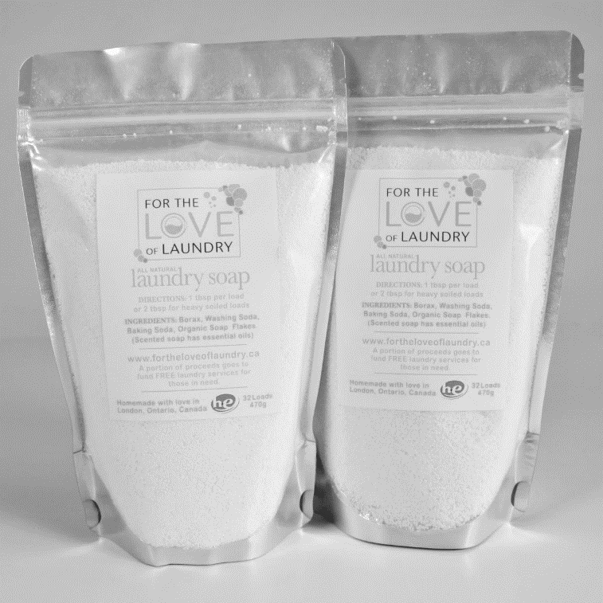

Source: Company documents.

Exhibit 3: For The Love Of Laundry Stain Removal Sticks

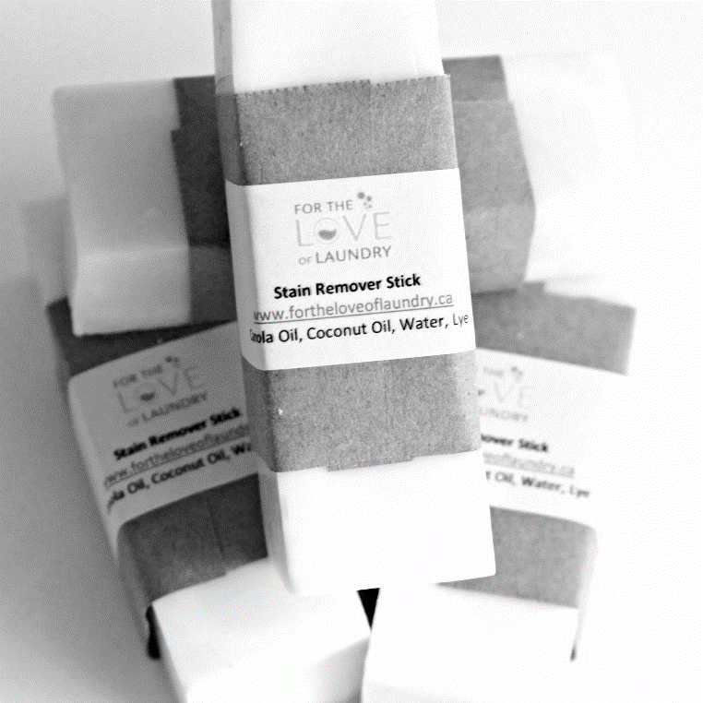

Source: Company documents.

Exhibit 4: For The Love Of Laundry Dryer Balls



Source: Company documents.

Endnotes

1. Jane Sims, “For the Love of Laundry,” *London Free Press*, May 31, 2015, accessed August 23, 2017, www.lfpress.com/2015/05/31/social-enterprise-founded-by-former-single-mom-allows-less-fortunate-individuals-to-do-their-laundry-for-free.
2. All currency amounts are in Canadian dollars unless otherwise specified.
3. Government of Canada, “About Registered Charities,” accessed August 22, 2017, https://www.canada.ca/en/revenue-agency/services/charities-giving/giving-charity-information-donors/about-registered-charities/what-difference-between-a-registered-charity-a-non-profit-organization.html.
4. Sims, op. cit.
5. Raymond Dart, “The Legitimacy of Social Enterprise,” *Nonprofit Management & Leadership* 14, no. 4 (Summer 2004): 411–424.
6. Stuart Albert and D.A. Whetten, “Organizational Identity,” *Research in Organizational Behaviour* 7 (1985): 263–295.
7. Fiona Wilson and James E. Post, “Business Models for People, Planet (& Profits): Exploring the Phenomena of Social Business, a Market-Based Approach to Social Value Creation,”*Small Business Economics* 40, no. 3 (April 2013): 715–737.
8. Hannah Hickey, “Scented Laundry Products Emit Hazardous Chemicals through Dryer Vents,” *UW News*, August 24, 2011, accessed January 10, 2018, www.washington.edu/news/2011/08/24/scented-laundry-products-emit-hazardous-chemicals-through-dryer-vents/.
9. Anne C. Steinman, Lisa G. Gallagher, Amy L. Davis, and Ian C. MacGregor, “Chemical Emissions from Residential Dryer Vents During Use of Fragranced Laundry Products,” *Air Quality, Atmosphere & Health* 6, (March 2013): 151–156.
10. Ana Carolina Kogawa, Beatriz Cernic, Leandro Domingos do Couto, and Herida Salgado, “Synthetic Detergents: 100 Years of History,” *Saudi Pharmaceutical Journal* 25, no. 6 (September 2017): 934–938.
11. Fred Lee, Walter Rust, and R. Anne Jones, “Eutrophication of Water Bodies: Insights for an Age-Old Problem,” *Environmental Science & Technology* 12, no. 8 (1978): 900–908.
12. Kogawa, Cernic, Domingos do Couto, and Salgado, op. cit.
13. Rebecca Sutton, “Don’t Get Slimed: Skip the Fabric Softener,” EWG, November 1, 2011, accessed August 23, 2016, www.ewg.org/enviroblog/2011/11/dont-get-slimed-skip-fabric-softener#.WZ4dUyiGM2w.
14. Rosalind C. Anderson and Julius H. Anderson, “Respiratory Toxicity of Fabric Softener Emissions,” *Journal of Toxicology and Environmental Health* 60, no. 2 (May 2000): 121–136.
15. Sutton, op. cit.
16. Carol Potera, “Indoor Air Quality: Scented Products Emit a Bouquet of VOCs,” *Environmental Health Perspectives* 119, no. 1 (January 2011): A16.
17. Lalin Anik, Lara B. Aknin, Michael I. Norton, and Elizabeth W. Dunn, “Feeling Good about Giving: The Benefits (and Costs) of Self-Interested Charitable Behaviour,” HBS Working Paper 10-012, Harvard Business School, Boston MA, August 2009, accessed August 24, 2017, www.hbs.edu/faculty/Publication%20Files/10-012.pdf.
18. Tavia Grant, “Nearly Five Million Canadians in Low-Income Status, 2012 Research Shows,” *Globe and Mail*, December 10, 2014, accessed August 24, 2017, https://www.theglobeandmail.com/report-on-business/economy/nearly-5-million-canadians-in-low-income-status-2012-research-shows/article22020841/.
19. Statistics Canada, “High-Income Trends among Canadian Taxfilers, 1982 to 2010,” January 28, 2013, accessed August 24, 2017, www.statcan.gc.ca/daily-quotidien/130128/dq130128a-eng.pdf.
20. Statistics Canada, “Canadian Income Survey, 2015,” May 26, 2017, accessed August 24, 2017, www.statcan.gc.ca/daily-quotidien/170526/dq170526a-eng.htm.
21. Grant, op. cit.
22. Jill Ferguson, “How Clothing Choices Affect and Reflect Your Self-Image,” *Huffpost* (blog), *Huffington Post*, February 5, 2017, accessed August 24, 2017, www.huffingtonpost.com/jill-l-ferguson/how-clothing-choices-affect-and-reflect-your-self-image_b_9163992.html.
23. Jacquelyn Smith, “Here’s How Clothing Affects Your Success,” *Business Insider*, August 19, 2014, accessed August 24, 2017, www.businessinsider.com/how-your-clothing-impacts-your-success-2014-8.
24. Sandra Forsythe, “Effect of Applicant’s Clothing on Interviewer’s Decision to Hire,” *Journal of Applied Social Psychology* 20, no. 19 (November 1990): 1579–1595.
25. Hajo Adam and Adam D. Galinsky, “Enclothed Cognition,” *Journal of Experimental Social Psychology* 48, no. 4 (July 2012): 918–925.
26. Karen J. Pine, *Mind What You Wear: The Psychology of Fashion* (Amazon Digital Services, May 13, 2014), Kindle edition.
27. Susan Manwaring and Andrew Valentine, “Social Enterprises in Canada: Structural Options,” MaRS White Paper, MaRS Discovery District, Toronto, December 2011, accessed September 7, 2017, https://www.marsdd.com/wp-content/uploads/2012/04/MaRSReport-Social-Enterprise_2012.pdf.
28. Global Impact Investing Network and Cambridge Associates, *Introducing the Impact Investing Benchmark*, 2015, accessed August 31, 2017, https://thegiin.org/assets/documents/pub/Introducing_the_Impact_Investing_Benchmark.pdf.
29. Abhilash Mudaliar, Hannah Schiff, Rachel Bass, and Hannah Dithrich, *Annual Impact Investor Survey* (New York: Global Impact Investing Network, 2017), accessed September 8, 2017, https://thegiin.org/assets/GIIN_AnnualImpactInvestorSurvey_2017_Web_Final.pdf.
30. Susan Manwaring and Andrew Valentine, “The State of Social Enterprise in Canada,” in *The 2012 Lexpert/American Lawyer Guide to the Leading 500 Lawyers in Canada* (Thomson Reuters Canada Limited, 2012), accessed August 24, 2017, www.millerthomson.com/assets/files/article_attachments2/S-Manwaring_A-Valentine_Social-Enterprise-in-Canada_Miller-Thomson.pdf.
31. Manwaring and Valentine, “Social Enterprises in Canada: Structural Options,” op. cit.
32. Brett Smith, Joshua Knapp, Terri Barr, Christopher Stevens, and Bendetto Cannatelli, “Social Enterprises and the Timing of Conception: Organizational Identity, Tension, Management, and Marketing,” *Journal of Nonprofit & Public Sector Marketing* 22, no. 2 (May 2010): 108–134.
33. Manwaring and Valentine, “Social Enterprises in Canada: Structural Options,” op. cit.
34. Francine Schlosser, Eva Balan-Vnuk, “Balancing Social and Entrepreneurial Foci in Born and Adapted Social Enterprises,” *Frontiers of Entrepreneurial Research* 32, no. 19 (2012): 9.
35. Smith, Knapp, Barr, Stevens, and Cannatelli, op. cit.
36. Ibid.
37. Global Impact Investing Network and Cambridge Associates, op. cit.
38. Paul Sullivan, “With Impact Investing, a Focus on More than Returns,” *New York Times*, April 23, 2010, accessed August 23, 2017, www.nytimes.com/2010/04/24/your-money/24wealth.html.
39. Mudaliar, Schiff, Bass, and Dithrich, op. cit.
40. Manwaring and Valentine, “Social Enterprises in Canada: Structural Options,” op. cit.
41. Ibid.
42. Sara Neely, “Non-Profits, Not-for-Profits, and Charities: What’s the Difference?,” *Scrivener* 12, no. 3 (October 2003): 11–12, accessed August 23, 2017, www.notaries.bc.ca/resources/scrivener/fall2003/12_3_5.pdf.
43. Manwaring and Valentine, “Social Enterprises in Canada: Structural Options,” op. cit.
44. Ibid.
45. Canada Business Network, “Why Start a Co-operative?,” March 20, 2014, accessed September 7, 2017, https://canadabusiness.ca/blog/why-start-a-co-operative-1/.
46. Manwaring and Valentine, “Social Enterprises in Canada: Structural Options,” op. cit.
47. Ibid.
48. Wilson and Post, op. cit.