

9B18M023

BARTOS STAINLESS LIMITED: FACING TURBULENCE

Sushant Kumar and Rohit Dwivedi wrote this case solely to provide material for class discussion. The authors do not intend to illustrate either effective or ineffective handling of a managerial situation. The authors may have disguised certain names and other identifying information to protect confidentiality.

*This publication may not be transmitted, photocopied, digitized, or otherwise reproduced in any form or by any means without the permission of the copyright holder. Reproduction of this material is not covered under authorization by any reproduction rights organization. To order copies or request permission to reproduce materials, contact Ivey Publishing, Ivey Business School, Western University, London, Ontario, Canada, N6G 0N1; (t) 519.661.3208; (e)* [*cases@ivey.ca*](mailto:cases@ivey.ca)*;* [*www.iveycases.com*](http://www.iveycases.com)*.*

Copyright © 2018, Ivey Business School Foundation Version: 2018-02-06

On September 16, 2015, Vijay Bartos, chair and managing director of Bartos Stainless Limited (Bartos) in Mumbai, India, sat in his office eagerly awaiting his next appointment. His childhood friend, Mohit Reddy, head of the consulting division of a U.S.-based firm, soon arrived for their first meeting in five years. They discussed the changing scenario of business dynamics, government initiatives, and investor confidence. Vijay raised his growing concern about Bartos’s profitability and employee retention. Employee satisfaction had decreased sharply, and human resource (HR) practices were no longer yielding results. Bartos had shown losses over the previous two years, and its shares were trading at an all-time low of around ₹30.[1] The company had also lost a few big orders from government companies (the orders went to a Chinese steel manufacturer), as the government would not allow a loss-making company to participate in its tendering process. In the past, such government orders had been a significant source of Bartos’s revenue.

Reddy was aware of similar scenarios around the world, especially in the steel industry, which was going through a rough phase. Not long before, Tata Steel Limited, one of the largest manufacturers of steel in India, had been contemplating selling off its U.K.-based unit Corus, which it had acquired in 2007. The severity was of such magnitude that the British Prime Minister had to step in. The global meltdown of metal prices and uncertainty in demand had sent the steel industry into turmoil.

In the three years from 2011 to 2014, Bartos changed its chief executive officer (CEO) three times, which propagated negative notions among investors, employees, and customers. Vijay expressed his concerns about these challenges the company was facing and sought advice from his friend. How was he going to manage the risks of his business while maintaining profits?

company background

Bartos, a pioneer in making stainless steel, was situated in an industrial area on the outskirts of Pune, Maharashtra (India). The founder, Ajay Bartos, had little formal education, but his willingness to learn and play with machines had led him to start his industrial career. In 1952, he started the journey with a bucket-manufacturing unit in Pune, moved to a pipe-manufacturing unit in 1964, and ultimately set up a steel-making company in 1969 in Pune. The company dedicated itself to producing a special grade of steel—stainless steel, with minimum 10.5 per cent chromium. Apart from chromium, other rare earth metals such as nickel, molybdenum, titanium, and copper were added into the mix to produce different grades of stainless steel with various mechanical properties. The company produced flat products, which included finished products in the form of coils, sheets, and plates of hot rolled and cold rolled steel in different finishes, sizes, and thicknesses. Bartos enjoyed a monopoly from its inception. The huge investment required in setting up a stainless steel plant, unavailability of skilled labour, complex manufacturing processes (see Exhibit 1), and volatility in the availability of raw materials (see Exhibit 2) created barriers to entry for other steel manufacturers, and thus provided immunity from competition.

After the sudden demise of Ajay in 2004 in an accident, the company legacy passed to Vijay, his eldest son. Vijay was well educated, ambitious, and fully geared to take his father’s vision to a new level. He devoted himself to taking the company to greater heights. By the time he became managing director, the company had emerged as a strong brand. The annual report for 2006 showed all-time high revenue of US$580 million[2] and net profit after tax of $26 million. All stakeholders were delighted with the company’s performance.

In 2007, to chase global competition and meet Bartos’s high ambitions, Vijay revised the company’s vision and mission (see Exhibit 3). He implemented the latest Systems Application and Products (SAP) enterprise resource planning (ERP) software to stay ahead of competitors through information technology and data management. He also created a research and development (R&D) department and paid particular attention to developing new grades of stainless steel. A new unit, called the Special Product Division, was formed. It was responsible for the manufacturing, sale, and marketing of specialized grade steel. Within a year, the R&D team was able to develop two new alloys (grades of stainless steel). These alloys were used for manufacturing razor blades and coins, thus enabling the company to target two profitable and cyclical markets. The 2008 annual report recorded a new revenue high of $950 million and net profit of $40 million.

Since its inception, Bartos had been a market leader with a 60 per cent market share in the stainless steel sector. Adding to the operating plant at Pune, the company established a mammoth facility with a high level of automation and modern engineering machines on the outskirts of Bokaro, Jharkhand, in 2009. The company’s balance sheet was skewed because of massive capital expenditure (more than $900 million) made in phases in establishing the new plant. The capacity of the new facility was three times that of the old one.

Although the Bokaro plant was operating at only 30 per cent capacity in 2009 because of a scarcity of raw material and shortage of skilled labour, the combined output of both the plants was more than what the Indian market could consume. This, coupled with the changing preferences of buyers for imported Chinese steel, put a lot of pressure on the company’s sales force because the Chinese companies were offering a comparable quality product at a lower price. Immense pressure from management left the sales professionals frustrated, and the retention rate decreased to an all-time low. The attrition rate was high in the operations department too, as professionals did not want to live in the tribal belt of Jharkhand where the new manufacturing facility was established.

In June 2015, for the first time the company appointed a combined director for sales, marketing, and finance to pay particular attention to these departments. To alleviate the company’s financial position, the director started pushing all three departments, especially sales, to improve their performance. This pressure increased the frustration among sales personnel, resulting in many resignations. However, there was no improvement in the company’s financial position (see Exhibit 4 and Exhibit 5). The pressure to maintain the bottom line translated into increased pressures on individual level targets, and the work climate deteriorated. The unfortunate and untimely death of a company employee left many people gossiping about the impact of such pressures.

Operations

Bartos offered stainless steel in flat products that included sheets, coils, and plates. Initially, it produced steel according to the American Society for Testing and Materials standards. In 1969, the company had neither access to world-class technology nor enough capital to spend on high-precision machines. However, Ajay was able to make efficient devices by using locally available materials. Many types of equipment were designed and built in-house. For example, the company purchased a big motor from an auction of an old ship castoff. The motor was further reworked in-house and used in rolling machines to generate high pressure to roll steel slabs of thickness ranging from 2.000 to 0.002 metres. Frequent breakdowns of machinery and operational losses were obstacles on the company’s glowing path.

Bartos worked on the make-to-order concept. On receiving an order from a customer, the company would start its process and supply the finished goods within four weeks. The Pune processing units (see Exhibit 1) could use only iron or steel scrap as input. The process flow of the Pune plant (see Exhibit 1) started with melting iron scrap, adding alloying elements, passing heat through the various processes of argon-oxygen decarburization, and finally casting into slabs of two metres. Slabs were further rolled into thin sheets, as specified in order details, and then supplied after the desired mechanical and chemical properties were achieved. The process of melting to slab casting took one hour. Up to the slab-casting stage, the process followed was “make to stock.” Beyond that, the process was “make to order.”

Since all the raw material used in steelmaking was imported from different countries, there was always a need for an efficient supply chain. Scrap, precious metals, and refractories were not easily available, and lead time for the supply fluctuated from 12 to 20 weeks (see Exhibit 2). The company maintained a surplus of raw materials to avoid any opportunity loss due to stock-out situations. Since all the metal prices were governed by the London Metal Exchange, the variability of inventory costs was high.

New Horizon

To explore new markets, Bartos hired a marketing expert who worked closely with the R&D team. Vijay started calling a monthly meeting with all the department heads to ensure that all departments were functioning in line with the company vision. He also attended a weekly meeting—called the sales, marketing, and operations meeting—with the sales, marketing, and operations head to pay particular attention to the company’s customers. He appointed a renowned scientist as the head of R&D to put more emphasis on innovation. The R&D team was able to patent new stainless steel grades. With support from the R&D team, the marketing team penetrated into new profitable segments.

In one of the monthly review meetings, Vijay observed that in the preceding six months customer complaints about late delivery had quadrupled. Such issues had been there in the past too, but the sales force had been able to manage such situations. Ramesh Kashyap, chief marketing officer, explained that the lead time for delivery of a generic stainless steel coil or sheet was four weeks, but the company was so overbooked that it could not cater to all customers within the agreed delivery time. Frequent breakdowns in the plant coupled with supply chain issues further aggravated the problem of not meeting delivery dates on a daily basis. According to Kashyap, the Pune plant capacity was 0.6 million tonnes per annum (MTPA; 1 tonne = 1,000 kilograms), but the current demand was more than 1.0 MTPA. The market was expected to reach 1.5 MTPA in the next five years. To meet the growing demand, Bartos needed a robust supply chain with minimum delivery lead time. Kashyap also explained that due to delivery failures, the sales force was having a hard time facing customers.

In April 2009, Vijay discussed his growing concern over customer dissatisfaction with Kashyap, and Ravi Verma, chief operating officer. Complaints about late delivery increased to an all-time high due to operational issues. The sales team was getting new commitment dates more frequently; in many cases, these new commitment dates could not be honoured. At the same time, small players were expanding their capacity to capture more market share. New retailers had developed and established connections with foreign countries such as China, the United Kingdom, and Malaysia. Import quantity was increasing month by month. China was the biggest supplier of stainless steel, offering the lowest rate with quality material. The cautious notion about Chinese products, in general, offered Bartos temporary relief.

In the next monthly meeting, looking at the demand forecast data, the current problem, and Bartos’s vision of becoming a global player, Vijay put forward the proposal to expand the capacity of the existing plant. The need for expansion was agreed to by everyone, but the department heads were not in favour of increasing the capacity of the current plant. It was decided that the new facility must be an integrated plant. The new facility should be located where it would have low labour and land costs. The idea behind an integrated plant was to ensure the smooth flow of material without any supply chain issues, and to minimize processing costs and offer low-cost stainless steel of the highest quality. A core team was set up to take the work ahead.

After a few months, the team put forward two proposals to set up a new plant either at Bokaro (Jharkhand) or at Karnataka. The government of Jharkhand assured Bartos that it would provide all necessary facilities required to set up the new facility, including the lease of iron ore mines, which was vital for an integrated plant. It would also declare the location a special economic zone (SEZ) for 10 years. The board of directors, along with Vijay, agreed to set up the plant in Jharkhand. Subsequently, a memorandum of understanding was signed with the government of Jharkhand for leasing mines and declaring the location a SEZ unit.

Strategy

A three-year plan was made ready for phase-wise development. It was expected to be completed by 2012. The new plant would have cutting-edge technology—a blast furnace (using iron ore as raw material to make steel) with capacity of 1.8 MTPA, three times the existing plant capacity. For investment, money was borrowed from different banks as a secured loan. This loan money propelled the plant establishment process on many parallel fronts.

In August 2010, the new government of Jharkhand identified a mining scam and put a long-term hold on all mine-leasing in the state. Bartos had by then already invested on many fronts, using iron ore as its raw material. The balance sheet for 2010 showed an investment of $1.21 billion. The state government’s decision to impose a long-term hold on the raw material had a multiplier effect on different fronts such as the partly-established processing units, the mission to offer low-cost products, competitive advantage, longer processing time, and loss of economies of scale.

The new government also reduced the SEZ unit benefits for five years. Delay in legal and operational aspects skewed the balance sheet further. The secured loan amount increased to $1.54 billion in 2012. In a board meeting, it was decided that the Bokaro manufacturing facility would replicate the processes of the Pune plant. The establishment of the blast furnace was put on hold. Whole processing units were redesigned to take iron or steel scrap as raw materials. During the same period, customers’ late delivery grievances increased, and the breakdown of old machinery reached an all-time high. Due to the delay in setting up the auxiliary and supporting units, the plant commissioning was extended for one more year. This extension further aggravated the cost. By the end of 2013, the plant finally started its operations.

The board of directors was getting excessively anxious over the growing debt. In December 2013, Dinesh Ghosh was appointed as Bartos’s new CEO to manage the new plant and find a way to relieve Bartos’s debt burden. After a few months, the board lost faith in Ghosh. In June 2014, Vivek Sinha, an expert in the steel industry, was appointed as the new CEO. Sinha started delving deep into all fronts, especially operations and sales. He initiated many customer-centric campaigns to boost customer and investor confidence. Sinha began participating in several steel and metals seminars across the world. He invited all of the company’s customers to visit the Bokaro plant and offered them an opportunity to understand the process. A large turnout of clients ensured the campaign’s success. As these promotional events started taking shape, sales improved and orders started flowing in. Sinha and Vijay were working together to capitalize available resources to reduce the company’s debt, improve its brand image, and increase the confidence of all stakeholders.

Human Resources

To manage the day-to-day operations of the Bokaro plant, Bartos hired a new operations head. The new location had many constraints, such as a lack of medical, housing, and recreational facilities for employees. Locational disadvantages led to an increasing attrition rate. The unavailability of skilled labour in the market coupled with the locational disadvantage was tough on the head of the HR department. To manage the daily operational work, the HR head prepared a list of employees from the Pune plant who would be transferred to Bokaro. These employees were assured they would be compensated well. Experienced people from the old plant were sent to the new location at regular intervals.

Initially, the new facility was running at only 15 per cent of its capacity. The existing operations team was not able to increase the productivity. In consultation with the CEO, the HR head prepared a list of 50 senior employees of the operations team who would be transferred to Bokaro on a permanent basis. The senior employees from the Pune plant perceived that workers in Bokaro were rebellious. A recent fatal accident involving a local worker near the company main gate heightened the concern over safety risks. Nikhil Desai, a senior manager who witnessed the accident, expressed his concern as follows:

I was there at the company main gate when a speeding car ran over a local worker [from a different company]. It was not our company vehicle, but it seemed that locals perceived that [a] Bartos company vehicle caused the accident. More than 500 workers and locals gathered at the company gate with many flags of different trade unions and started protesting. It was a dangerous situation, as I had never seen such a strong crowd backed up by strong trade unions. It took a full day to convince them that the company was not involved—that too with the help of local police and a local minister. The company has to pay a hefty compensation for the damage that it did not cause.

The presence of strong trade unions in the Bokaro region forced Bartos to contemplate whether it would be able to carry out all its functions smoothly. The concept of a labour union was new for Bartos. Senior employees above the manager level (see Exhibit 6) were aware of the locational disadvantages and were not ready to relocate. After the initial round of discussions with management, the employees were still not convinced about relocation. Further rounds of negotiations went on but achieved no useful results. Sinha assured the employees that they would get all the benefits and that their work would be rewarded appropriately.

Sinha put particular emphasis on setting up a culture of labour without trade unions and ensuring work satisfaction for all. He started the “Growth with People” campaign to boost employee confidence in the company. He incorporated the campaign as the heart of corporate ethos and HR policies. HR practices were revised to create a superior workplace. To ensure high performance in the workplace, the HR team started focusing on identifying employees who showed talent early on and giving them adequate grooming through leadership development programs.

The HR department took many new steps to measure and award performance and leadership. The institutionalization of new appraisal methods left a few employees puzzled, and after being offered appropriate time to adjust, they were given the notice to leave. Sinha directed Bartos to set a standard to become an “equal opportunity employer.” Employing and retaining key talent and providing them with career development opportunities had become integral to the company’s people processes. The company reviewed its resourcing policy so as to attract the right talent to fit the right role. It instituted competency-based recruitment that measured technical expertise, leadership skills, and cultural fit. It also established an employee referral scheme. The company’s core values were revised, and new guiding principles were formulated (see Exhibit 7).

As part of the talent management process, Bartos initiated an internal job posting policy to provide opportunities to its employees to discover internal career options, thereby assisting career growth and progress. Under Sinha’s guidance, new employee engagement practices started to take shape. The HR team launched B-Beat, a common communication platform for employees to share thoughts; form, voice, and propose ideas; and be heard.

GLOBAL BUSINESS ENVIRONMENT IN THE Stainless STEEL INDUSTRY

India’s stainless steel sector was facing a threat from the sudden and immense rise in imports from different countries, especially China. Stainless steel imports surged sharply from fiscal year (FY) 2012–2013 to FY2015–2016 (see Exhibit 8). The major competitors were Baosteel Group Corporation from China, Pohang Iron and Steel Company Ltd. from South Korea, and Nippon Steel and Sumitomo Metal Corporation and JFE Steel Corporation from Japan. Of these four companies, Baosteel Group Corporation offered the greatest competition to Bartos in terms of price. The import price of Korean and Japanese stainless steel was comparable to that of Bartos, as was the quality. Customers were importing stainless steel from other companies around the world including China, the European Union, the United States, South Africa, Taiwan, and Thailand, though they were not importing from these countries on a regular basis.

Cheap imports and an unfavourable import duty structure resulted in a reduction of approximately 40 per cent in domestic capacity use. India ranked third globally in steel and stainless steel production, but it was still far behind the top producer in the sector (see Exhibit 9). In the 2014 budget session, the government announced an increase in duties for five years on stainless steel imports from China, the European Union, and the United States. Imports from South Korea, South Africa, Taiwan, and Thailand would also be taxed. This was the first significant move ever by the government to protect and support high-value steel products.

The stainless steel industry produced only 3 to 4 per cent of India’s total steel production, whereas its contribution to government revenue stood at 10 to 12 per cent of the entire steel industry. However, industry experts were not satisfied with the government’s move to increase the import duty from 5 per cent to 7.5 per cent. The president of the Indian Stainless Steel Development Association said, “Countries such as China and Brazil impose around 14 per cent and 10 per cent import duty respectively, whereas India’s increased import duty is still lagging behind, and in turn, offering an unfair competition to the domestic manufacturer.” Bartos’s director of procurement expressed his dissatisfaction with government policies:

In India, 60 to 70 per cent of stainless steel is produced through recycling, and this leads to higher dependency on stainless steel scrap. Most of the scrap needs to be imported, as India is relatively new to stainless steel and scrap generation is still to come out. Request by industries to remove the import duty on SS [stainless steel] scrap is mostly unheard by the government.

Moreover, the volatility in raw material prices and fluctuation in exchange rates—coupled with the import duty of 2.5 per cent on pure nickel, ferronickel, mild steel, and other such raw materials—would severely affect profitability and operations.

Seema Agarwal, assistant general manager of costing at the Pune plant, said, “Import duties on important raw material and scrap are almost nil in China, which gives Chinese manufacturer an edge over Indian manufacturer in the international market. Indian policymakers must devise policies to curb import and help its stainless steel industry flourish.” Ratnagiri Saha, head of the operations department at Salem Steel Plant (a government-owned stainless steel producing unit), said, “India has the potential to cater to the projected demand of both cold rolled product and hot rolled product. With support from the government and proper policies, India can become a global leader in the stainless steel industry.”

turbulent phase

Bartos’s annual report for 2014 documented an increase in debt from $1.79 billion in FY2013 to $1.82 billion in FY2014. The interest amount to be paid by the company grew from $72.1 million in FY2010 to $205.6 million in FY2014. The company’s retained earnings decreased sharply from a profit of $63 million in FY2010 to a loss of $218 million in FY2014. The board of directors was unhappy with the financial results. Market sentiments were reflected in the plummeting prices of stock and volume traded (see Exhibit 10). Banks were constantly approaching Bartos for their interest and principal repayment, but they were not able to get any substantive repayment plan. To explore a way out, the chief financial officer had already looked into corporate debt restructuring. Bartos had not paid any dividend since 2010, and its earning per share was at an all-time low. Share prices were showing a decreasing trend from 2010 (see Exhibit 10).

The newly hired CEO, Sinha, was working on all fronts but could not help alleviate Bartos’s financial position. In the face of growing concerns to alleviate not only the company’s financial position but also the board of directors’ anxiety over delivering faster results, Sinha left the organization. The employees could not completely understand the reason behind his departure, and all the new initiatives Sinha had begun could not take shape. The sales force was perplexed, as in a short span of time the company had seen three CEOs. The new plant, operating at 30 per cent capacity, was facing a tremendous supply chain problem. Raw material procurement was taking more than the standard lead time. Bartos planned to increase the day’s payable period to boost its working capital, but suppliers were not ready. The suppliers started losing faith in the company.

Bartos reduced its day’s receivable and cut credit sales to only a few bulk buyers and long-term customers. These steps helped improve the working capital situation. Customers, who were already annoyed with an extended delivery period and commitment failure, were not ready to accept the change of payment terms. Frequent changes in company management, massive debt, and unavailability of working capital caused customer confidence to drop.

Since the new plant was not operating at optimal capacity, the earlier plan to supply low-cost stainless steel was no longer effective. Unaware of these internal company facts and problems, customers felt cheated by having to rely on false hopes. Many of them started looking for a different source. Competitors seized the opportunity and began serving Bartos’s clients. Many retailers began importing steel from Chinese companies, which offered a three-times-longer payable period than Bartos, comparable lead time delivery, and acceptable quality. Many high-end customers began testing Chinese material to check whether it suited their applications. These circumstances led to a decrease in order position for Bartos.

In the monthly meeting in April 2015, department heads were brainstorming ways to resolve the situation. As recommended by Reddy, Vijay suggested working on productivity improvement, employing new technology to reduce cost, or laying off employees. Sahil Kumar, general manager of the production unit, discarded productivity improvement as an alternative. He said:

We have taken all the measures to improve productivity. We have taken an innovative approach to cut the refractory bricks [used to protect the frame of the furnace from extreme heat] in half and then use it for inner furnace lining. This has helped us to improve the production capacity. We are exploring the different areas of operations but chances of improvement are minuscule.

Technology consultant Aita Sen said, “For our Bokaro unit, we have used the best available machines. Further changes in technology may be possible, but it will take a longer time to reap its benefits. Considering the financial situation, I would suggest that we might not borrow further debt for technological improvement whose benefits are longer to realize.” According to the HR director,

Laying off workers may give us some cost saving, but we must also consider the strong presence of trade unions in the Bokaro region. Company workers are not associated with any trade union, but in the case of a bulk layoff, union leaders would not miss a chance to include company workers on their side. We may lose our control over the workers, and subsequently, production will be hampered.

Vijay concluded the meeting by asking the team to delve deeper into the suggestions or propose new alternatives.

In June 2015, Vijay took over as CEO and appointed Harsh Sharma as director of HR, sales, marketing, and operations. Sharma, an expert in operations, started pushing operations for more productive work. For him, if a problem existed, so did a solution—and it had to be the duty of employees to resolve problems on their own. He initiated cost-cutting measures in all departments. As a cost-cutting initiative, all employees who were shifted to the new plant location for process improvement were made permanent. Many employees were not ready to relocate but went there on a commitment by the previous CEO. All the benefits offered to relocated employees were withdrawn.

People were in shock over such actions. However, Sharma was not ready to listen to the grievances of employees. According to him, the company was in bad shape and everyone should contribute the maximum possible. He used a policy of shift or leave. He also put on hold all the previous policies that were initiated for appraisal and engagement. The company announced that it would not offer any salary increment that year. For the past three years, the company had been offering half the increment of the industry average. Because of little growth, employees were frustrated, but they had faith in the organization.

Sharma was not happy with the targets the sales team was hitting. He started pushing the sales team to get more orders, and the monthly sales order target was increased by 20 per cent. The sales team, which was already disappointed with the delivery failure issues and raw material issues, was surprised by the increased target. The team did not understand why management was pushing for more orders by increasing the order booking target when it was consistently failing in its delivery commitments. This situation led to dissatisfaction among the workers. They believed that management was not ready to dig deeper into the problem and find a solution but only wanted to increase targets.

With this series of actions in the backdrop, employees started losing faith in Bartos. Many senior people from operations resigned, which led to a massive shortage of skilled labour. To their surprise, the company did not even ask them to stay and their resignations were readily accepted. In the face of such policies, many people across several levels left the organization. A raid by the Central Pollution Control Board at the Bokaro plant worsened the situation. Two crucial production lines were not complying with the rules and regulations, which led to the temporary closure of the manufacturing facility. The action jeopardized production, leading to a complete loss of trust by employees, customers, and all other stakeholders.

Weighing the options

In late September 2015, Vijay was sitting at home watching news about Bartos on television. He closed his eyes and started contemplating the options he had on hand to solve his problem. Looking at the current situation for Bartos and the market, Reddy had suggested rationalizing on three fronts: (1) productivity improvement to reduce cost, (2) laying off employees, and (3) technological advancement. Vijay switched off his television and went over the alternatives. He had partially explored these alternatives, but he needed to re-examine their applicability to the company’s situation and organize his thoughts before meeting with the board of directors.

Exhibit 1: PROCESS FLOW AT the Pune PLANT

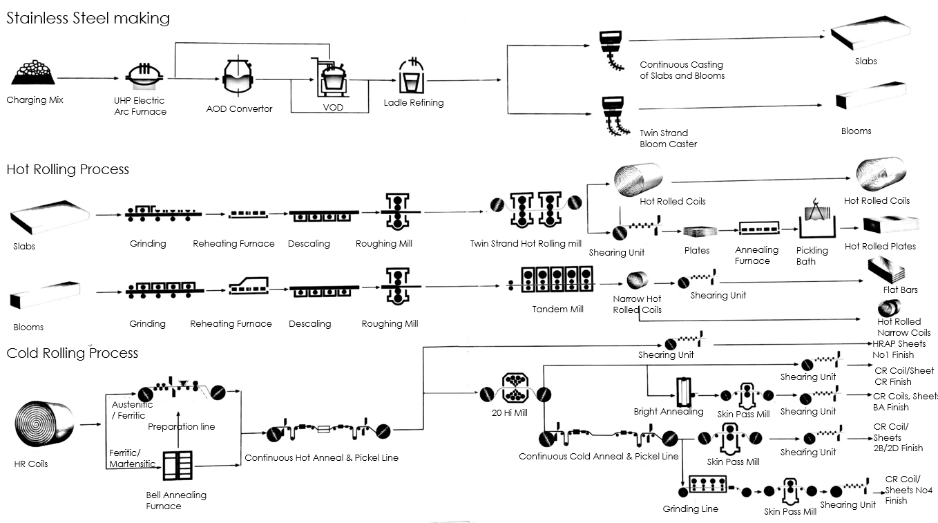

Source: Company documents.

Exhibit 2: OUTLINE OF PROCUREMENT PROCESS

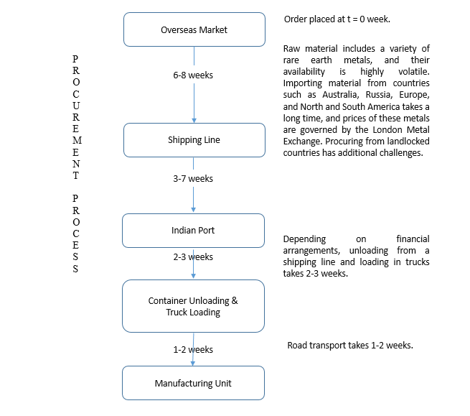

Source: Company documents.

Exhibit 3: BARTOS’s vision

|  |  |
| --- | --- |
| 1 | To be among the top 10 stainless steel producers in the world |
| 2 | To gain international recognition for cost leadership, product innovation, and customer satisfaction |
| 3 | To be admired as a socially responsible and sustained value creator for all of its stakeholders |

Source: Company documents.

Exhibit 4: bartos BALANCE SHEETS

|  |  |  |  |  |  |
| --- | --- | --- | --- | --- | --- |
| **Sources Of Funds** | **March 2010** | **March 2011** | **March 2012** | **March 2013** | **March 2014** |
| **12 Months** | **12 Months** | **12 Months** | **12 Months** | **12 Months** |
| Total Share Capital | 6.19 | 6.24 | 6.32 | 6.80 | 7.71 |
| Equity Share Capital | 6.19 | 6.24 | 6.32 | 6.80 | 7.18 |
| Share Application Money | 0.00 | 0.00 | 0.00 | 0.00 | 0.00 |
| Preference Share Capital | 0.00 | 0.00 | 0.00 | 0.00 | 0.53 |
| Reserves | 312.75 | 369.56 | 357.37 | 239.17 | 24.56 |
| Net Worth | 318.93 | 375.80 | 363.69 | 245.98 | 32.26 |
| Secured Loans | 1,214.34 | 1,426.63 | 1,534.18 | 1,792.46 | 1,813.82 |
| Unsecured Loans | 40.40 | 19.99 | 6.49 | 5.45 | 4.77 |
| Total Debt | 1,254.74 | 1,446.62 | 1,540.67 | 1,797.91 | 1,818.59 |
| Total Liabilities | 1,573.67 | 1,822.42 | 1,904.36 | 2,043.89 | 1,850.85 |

|  |  |  |  |  |  |
| --- | --- | --- | --- | --- | --- |
| **Application of Funds** | **March 2010** | **March 2011** | **March 2012** | **March 2013** | **March 2014** |
| Gross Block | 886.30 | 985.62 | 1,984.74 | 2,109.84 | 2,147.77 |
| Less: Revaluation Reserves | 0.00 | 0.00 | 0.00 | 0.00 | 0.00 |
| Less: Accumulated Depreciation | 235.77 | 291.89 | 358.84 | 475.32 | 574.83 |
| Net Block | 650.53 | 693.74 | 1,625.90 | 1,634.51 | 1,572.94 |
| Capital Work in Progress | 647.50 | 816.83 | 76.91 | 25.73 | 25.56 |
| Investments | 58.58 | 27.88 | 28.32 | 28.89 | 28.41 |
| Inventories | 272.14 | 351.45 | 450.46 | 546.07 | 550.81 |
| Sundry Debtors | 176.62 | 203.56 | 250.94 | 318.17 | 281.56 |
| Cash and Bank Balance | 62.35 | 51.31 | 27.37 | 14.63 | 8.11 |
| Total Current Assets | 511.12 | 606.32 | 728.77 | 878.87 | 840.48 |
| Loans and Advances | 177.17 | 205.13 | 217.47 | 186.39 | 148.05 |
| Fixed Deposits | 52.23 | 0.00 | 0.00 | 0.00 | 0.00 |
| Total Current Assets, Loans, and Advances | 740.52 | 811.44 | 946.24 | 1,065.26 | 988.53 |
| Deferred Credit | 0.00 | 0.00 | 0.00 | 0.00 | 0.00 |
| Current Liabilities | 478.24 | 463.22 | 708.65 | 708.44 | 762.78 |
| Provisions | 49.84 | 64.23 | 64.35 | 2.06 | 1.81 |
| Total Current Liabilities and Provisions | 528.08 | 527.46 | 773.00 | 710.50 | 764.59 |
| Net Current Assets | 212.44 | 283.99 | 173.23 | 354.76 | 223.94 |
| Miscellaneous Expenses | 4.63 | 0.00 | 0.00 | 0.00 | 0.00 |
| Total Assets | 1,573.67 | 1,822.42 | 1,904.36 | 2,043.89 | 1,850.85 |

Source: Company documents.

Exhibit 5: bartos INCOME STATEMENTS

|  |  |  |  |  |  |
| --- | --- | --- | --- | --- | --- |
| **Income** |  |  |  |  | **US$ Million** |
| **March 2010** | **March 2011** | **March 2012** | **March 2013** | **March 2014** |
|  | **12 Months** | **12 Months** | **12 Months** | **12 Months** | **12 Months** |
| Sales Turnover | 1,019.91 | 1,139.83 | 1,315.18 | 1,714.37 | 1,992.17 |
| Excise Duty | 63.05 | 0.00 | 0.00 | 0.00 | 0.00 |
| Net Sales | 956.86 | 1,139.83 | 1,315.18 | 1,714.37 | 1,992.17 |
| Other Income | 46.51 | 18.54 | –22.08 | –20.47 | –62.81 |
| Stock Adjustments | 6.95 | 40.15 | 72.56 | 60.64 | –19.94 |
| Total Income | 1,010.32 | 1,198.51 | 1,365.66 | 1,754.54 | 1,909.43 |
| **Expenditure** |  |  |  |  |  |
| Raw Materials | 629.09 | 818.99 | 1,020.77 | 1,303.27 | 1,433.67 |
| Power and Fuel Costs | 83.96 | 93.38 | 107.72 | 205.86 | 212.01 |
| Employee Cost | 20.24 | 25.30 | 28.31 | 41.06 | 39.89 |
| Other Manufacturing Expenses | 20.90 | 26.23 | 31.15 | 38.96 | 47.35 |
| Selling and Admin Expenses | 29.20 | 0.00 | 0.00 | 0.00 | 0.00 |
| Miscellaneous Expenses | 3.06 | 35.91 | 49.12 | 83.37 | 91.71 |
| Preoperative Expenses Capitalized | 0.00 | 0.00 | 0.00 | 0.00 | 0.00 |
| Total Expenses | 786.45 | 999.81 | 1,237.06 | 1,672.51 | 1,824.63 |
| Operating Profit | 177.36 | 180.17 | 150.68 | 102.50 | 147.61 |
| Profit before Depreciation, Interest, and Taxes | 223.87 | 198.71 | 128.60 | 82.02 | 84.80 |
| Interest | 72.27 | 64.79 | 86.13 | 165.05 | 205.78 |
| Profit before Depreciation and Taxes | 151.60 | 133.92 | 42.47 | –83.03 | –120.98 |
| Depreciation | 56.65 | 59.36 | 68.10 | 116.89 | 114.61 |
| Other Written Off | 0.53 | 0.00 | 0.00 | 0.00 | 0.00 |
| Profit before Tax | 94.42 | 74.56 | –25.64 | –199.91 | –235.59 |
| Extraordinary Items | 0.64 | 0.00 | 0.00 | 0.00 | 0.00 |
| Profit before Tax  (Post-Extraordinary Items) | 95.06 | 74.56 | –25.64 | –199.91 | –235.59 |
| Tax | 31.98 | 21.50 | –8.32 | –63.11 | -3.91 |
| Reported Net Profit | 63.08 | 53.06 | –17.32 | –136.80 | –231.68 |
| Total Value Addition | 157.36 | 180.81 | 216.29 | 369.25 | 390.95 |
| Preference Dividend | 0.00 | 0.00 | 0.00 | 0.00 | 0.00 |
| Equity Dividend | 0.00 | 0.00 | 0.00 | 0.00 | 0.00 |
| Corporate Dividend Tax | 0.00 | 0.00 | 0.00 | 0.00 | 0.00 |
| **Per Share Data (Annualized)** | | | | | |
| Shares in Issue (Millions) | 185.58 | 187.32 | 189.51 | 204.08 | 215.38 |
| Earnings per Share (US$) | 0.34 | 0.28 | –0.09 | –0.67 | –1.08 |
| Equity Dividend (%) | 0.00 | 0.00 | 0.00 | 0.00 | 0.00 |
| Book Value (US$) | 1.72 | 2.01 | 1.92 | 1.21 | 0.15 |

Source: Company documents.

Exhibit 6: bartos ORGANIZATIONal STRUCTURE

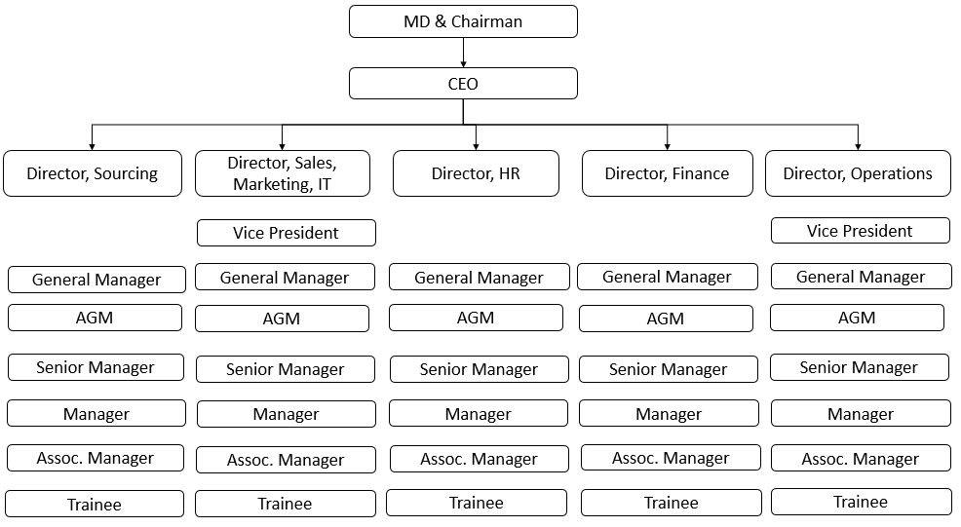

Note: MD = managing director; AGM = assistant general manager; Assoc. Manager = associate manager.

Source: Company documents.

EXHIBIT 7: BARTOS CORE VALUES AND GUIDING PRINCIPLES

Core Values

|  |  |  |  |
| --- | --- | --- | --- |
| 1 | Integrity | 4 | Dynamic Thinking |
| 2 | Respect for Individual | 5 | Creativity and Innovation |
| 3 | Meritocracy | 6 | Social Responsibility |

Guiding Principles

|  |  |
| --- | --- |
| 1 | **Value Creation**: Sustained value creation for all stakeholders: customer, employee, supplier, shareholder, society and nation. |
| 2 | **Transparency**: Conduct all business dealings along transparent lines. |
| 3 | **Personal** **Conduct**: Display high standards of personal and professional conduct. |
| 4 | **Learning** **and Development**: Foster an environment of learning and excellence. |
| 5 | **Creativity** **and Innovation**:Encourage creative experimentation and institutionalize continuous improvement in all aspects of business and performance. |
| 6 | **Environment, Safety, and Health**: Manage and protect the safety and health of our people, products, locations, and the environment. |
| 7 | **Responsible Corporate Citizen**: Enrich the quality of life of the communities we serve. |
| 8 | **Confidentiality**: Respect and ensure confidentiality of all business-related information. |

Source: Company documents.

Exhibit 8: Import data for Stainless Steel (in Metric Tonnes)

Note: 1 metric tonne = 1,000 kilograms

Source: Ministry of Steel, Government of India, *Annual Report 2012–13*, July 2013, accessed December 5, 2017, http://steel.gov.in/sites/default/files/Annual%20Report%20%282012-13%29.pdf; Ministry of Steel, Government of India, *Annual Report 2013 2014*, July 2014, accessed December 5, 2017, http://steel.gov.in/sites/default/files/Annual%20Report%20%28English%29%20%283%29.pdf; Ministry of Steel, Government of India, *Annual Report 2014–2015,* July 2015, accessed December 5, 2017, http://steel.gov.in/sites/default/files/Annual%20Report%20%28English%29%282014-2015%29.pdf; Ministry of Steel Government of India, *Annual Report 2015–2016,* July 2016, accessed December 5, 2017, http://steel.gov.in/sites/default/files/Annual%20Report%20%28English%29.pdf.

Exhibit 9: TOP four STEEL PRODUCERs IN the WORLD

|  |  |  |  |  |  |  |
| --- | --- | --- | --- | --- | --- | --- |
| **Crude Steel Production**  **(in million tonnes)** | **2010** | **2011** | **2012** | **2013** | **2014** | **2015** |
| China | 638.0 | 701.0 | 731.0 | 822.0 | 822.7 | 803.8 |
| Japan | 109.0 | 107.0 | 110.0 | 110.6 | 110.7 | 105.2 |
| India | 68.9 | 73.4 | 77.2 | 81.3 | 86.5 | 89.4 |
| United States | 80.4 | 86.4 | 88.7 | 86.9 | 88.2 | 78.8 |
| **World** | **1,433.0** | **1,538.0** | **1,560.0** | **1,650.0** | **1,670.0** | **1,622.0** |

Source: “50 Years of the World Steel Association,” World Steel Association, accessed December 5, 2017, <https://www.worldsteel.org/en/dam/jcr:80fe4bd6-4eff-4690-96e6-534500d35384/50+years+of+worldsteel_EN.pdf>.

|  |  |  |  |  |  |
| --- | --- | --- | --- | --- | --- |
| **Stainless Steel Production**  **(in million tonnes)** | **2010** | **2011** | **2012** | **2013** | **2014** |
| China | 11.2 | 14.0 | 16.0 | 18.9 | 21.6 |
| Japan | 3.4 | 3.2 | 3.1 | 3.1 | 3.3 |
| India | 2.0 | 2.1 | 2.8 | 2.8 | 2.8 |
| United States | 2.2 | 2.0 | 1.9 | 2.0 | 2.3 |
| **World** | **31.0** | **33.0** | **35.9** | **38.0** | **41.6** |

Source: “Stainless Steel in Figures 2017,” International Stainless Steel Forum, accessed December 5, 2017, www.worldstainless.org/statistics.

Exhibit 10: TREND IN STOCK SHARE PRICE (in ₹)

|  |  |  |  |  |  |
| --- | --- | --- | --- | --- | --- |
| **Year** | **Open Price** | **High Price** | **Low Price** | **Close Price** | **Number of Trades** |
| 2010 | 149.63 | 162.59 | 116.75 | 129.95 | 327,364 |
| 2011 | 131.93 | 135.65 | 79.25 | 87.11 | 110,111 |
| 2012 | 86.39 | 106.43 | 66.47 | 85.19 | 150,393 |
| 2013 | 86.45 | 95.27 | 42.12 | 45.00 | 284,489 |
| 2014 | 45.00 | 77.27 | 34.20 | 51.84 | 408,206 |

Source: “Stock Prices of Shares,” BSE India, accessed September 26, 2015, www.bseindia.com/.

1. ₹ = INR = Indian rupee; ₹1 = US$0.02 on March 31, 2015.
2. All currency amounts are in US$ unless otherwise specified.