

9B18M024

MAGIC MARKERS (A): Growing a Whiteboard Animation Company

Liliana Lopez Jimenez and Matthias Tietz wrote this case solely to provide material for class discussion. The authors do not intend to illustrate either effective or ineffective handling of a managerial situation. The authors may have disguised certain names and other identifying information to protect confidentiality.

*This publication may not be transmitted, photocopied, digitized, or otherwise reproduced in any form or by any means without the permission of the copyright holder. Reproduction of this material is not covered under authorization by any reproduction rights organization. To order copies or request permission to reproduce materials, contact Ivey Publishing, Ivey Business School, Western University, London, Ontario, Canada, N6G 0N1; (t) 519.661.3208; (e)* [*cases@ivey.ca*](mailto:cases@ivey.ca)*;* [*www.iveycases.com*](http://www.iveycases.com)*.*

Copyright © 2018, Ivey Business School Foundation Version: 2018-02-06

“Wow, that Mr. Ponton really sees potential in us.” It was late 2017, and Santiago Espinosa was debriefing Christian Delgado, his co-founder, on his meeting with Marcos Ponton, senior executive at Latam Ventures. Ponton had just left the offices of Magic Markers, Espinosa’s and Delgado’s Bogotá, Colombia-based whiteboard animation company, after proposing a 20 per cent investment and regional expansion plan.

Magic Markers, founded in 2013, specialized in the production of hand-drawn animated explainer videos. The founders, Espinosa and Delgado, were liberal art graduates who were passionate about visual sense-making but had no prior experience running a business. In 2014, after one of the company’s early videos had gone viral, demand for Magic Markers’ videos had grown at a pace that was as spectacular as it was unanticipated, and the company had needed to adjust quickly to take advantage of the opportunity. By mid-2017, Magic Markers had served over 70 corporate customers, had attracted over 100,000 followers on its YouTube channel, and its videos had exceeded 15 million views.

As excited as Espinosa and Delgado were about the business proposal, they wondered how much growth they could realistically expect and continue to deal with. They shared a learning-by-doing management style, which kept them tightly involved in every aspect of the operation, but they were unsure how to transfer their skills to enable regional growth. Would their style of doing business need to change? If they sold equity, what would be the consequences for the creative control of their business? So far they had remained true to their values in deciding which topics and customers to work with. They had put much effort into building the company from scratch and turning it into a successful, independent media producer, which had been valuable, motivating, and rewarding for both of them. They wanted to ensure that pursuing the business proposal would be the right move at the right time for their company.

**INDUSTRY OVERVIEW**

The relentless evolution of digital technologies and the growing digitization of personal habits fuelled the production of digital video content that was consumed through online streaming services. Digital videos could be easily uploaded, watched, and shared from a variety of Web-connected devices—including computers, tablets, and smartphones—via streaming platforms such as YouTube and Vimeo, and social media sites such as Facebook, Instagram, Snapchat, and Twitter. Facebook alone attracted a daily average of 1 billion video views in 2014,[1] which exploded to eight billion daily views in 2016.[2] In 2015, more than 65 per cent of worldwide mobile phone users were streaming video on their phones daily,[3] and in 2016 Snapchat users consumed 10 billion video streams per day.[4]

Since the launch of YouTube in 2005, content creators had been vital actors in the digital video sharing landscape. While virtually anybody with an Internet-enabled device could upload and share a video, some content creators had turned their video-making activities into real businesses. Market research distinguished two important types of video-content creators—vloggers (i.e., video bloggers) and new-media producers. Vloggers were independent individuals who regularly posted videos about their lives, experiences, and preferences; their success was underpinned by their ability to establish a human connection with their mostly teenage viewers.[5] New-media producers (mostly known as digital advertising or digital marketing agencies) operated in the business-to-business market space, developing digital content for companies. Most of these producers created not only videos but also various other types of digital content, such as websites, blogs, and social media posts.[6] Such content was produced to help corporate customers position their brands or products within a target segment. In addition to these new players, old-media producers, such as television, movie, or music video producers, had managed to adapt their products to the video streaming environment, thereby grabbing a piece of this growing market.

In late 2017, new records were still being broken on a monthly basis—the business of producing and streaming digital video content rushed from one all-time peak to the next. As measured by Emerging Markets Information Service, global traffic for digital video content accounted for 50 per cent of the total mobile traffic, and was expected to grow to 82 per cent by 2020, due to higher demand and better information technology infrastructure.[7] This trend in traffic for video content over the Internet was driving the growth of video production services offered by new-media producers.

While figures for the Colombian digital video market had not been produced as of 2017, Internet use in Colombia followed global trends. The penetration rate for mobile phones was 120.4 per cent in August 2016 (virtually equivalent to the 120.6 per cent found in developed markets), with smartphones having an increasing share of this market. Fifty-eight per cent of households had Internet connectivity, and over half of these connections were broadband. Ninety-six per cent of municipalities enjoyed fibre-optic Internet speed, and more than 60 per cent of small businesses were connected.[8]

The digital video market had its own performance metrics, which were carefully tracked by video-streaming companies, social media platforms, and content creators. Performance was defined primarily in terms of the popularity gained by content creators and the items they uploaded. The popularity of individual items was gauged by such metrics as the number of views, “likes,” and “shares,” and by aggregated measures of positive or negative opinions expressed by commentators using sentiment analysis tools. Content creators had specific sites (e.g., channels in YouTube, or pages in Facebook) to manage their digital content. Internet users could register on these sites (e.g., subscribe to a YouTube channel or follow someone’s Facebook page), which meant that the number of subscribers/followers was also an important metric for tracking content creators’ popularity. The importance of these metrics had spread to other areas, as indicated by *Billboard*’s inclusion of social media interactions in its calculations of music charts.[9] Videos were said to have gone “viral” when they reached a high number of views in a short period of time. In the early 2010s, digital content that reached more than one million views in a week was considered viral.[10] The virality of digital content mattered because it could channel information rapidly to a large volume of people, thereby affecting public opinion. Therefore, such content creators as governments, politicians, and activists saw virality as a means to make their programs and causes visible and meaningful to large audiences.

Animated Videos

By the early 2010s, content creators had started to tap into the learning potential afforded by the video format. A video could be a helpful vehicle for acquiring a variety of new skills, from knitting to playing the guitar, and could result in viewers engaging with interesting ideas in a much more fun way. In fact, recent company-sponsored research had suggested that animated videos fared better than other media in important cognitive and affective learning outcomes.[11] Whiteboard-animated videos were a special kind of learning video that, for the most part, sought to help viewers understand ideas in a visually appealing fashion. These videos featured a story being simultaneously narrated and hand-drawn on a whiteboard.

Since 2007, when United Parcel Service launched its whiteboard-animated video explaining its courier service, whiteboard-animated videos grew to the point of becoming a recognizable genre in the digital video arena. The U.K.-based company Cognitive Media Ltd. was recognized as a prominent actor in defining and developing the nascent genre, owing in no small part to its success with the video series it animated for the Royal Society for the Encouragement of Arts, Manufactures and Commerce (RSA). A dozen of these videos were watched more than a million times, with two videos reaching 14 million and 15 million views. This wide viewership had made the RSA channel the most popular non-profit YouTube channel in 2011.[12]

Other types of animated videos, such as those using computer-based animation, were not as labour-intensive as hand-drawn animation videos and hence were less expensive to produce. Explainer videos were becoming a popular and cost-effective marketing tool for entrepreneurs to showcase their products. Dropbox was among the first companies to make extensive use of these videos. Interested companies could have their explainer video professionally made by a new-media producer or, alternatively, could use software to produce their own video.

Overall, the market for making animation videos was fragmented and in its infancy. It included many old-media producers (who formerly specialized in the production of traditional videos) and a growing number of emergent digital marketing agencies that were capable of producing computer-animated videos. The Spanish-speaking market was served by companies such as Operary SL, based in Madrid; Explicamos SAS, headquartered in Bogotá and with sales representatives in three more Latin American countries; and Giraffe Colombia LTDA, with offices in Bogotá and in Florida in the United States. The industry’s growth was fuelled by the widespread use of animated videos for various purposes beyond business—Kindea Labs in New York, for example, specialized in making videos for universities worldwide that were interested in communicating their research, and VideoScribe, a software tool, was popular among teachers creating educational videos.

Yet, the market was already showing signs of competition, because high-quality products were available for free or at low prices. Traditional content creators were increasingly aware of the new channel and developed their own competencies quickly. The greenfield growth phase would not last forever.

**THE COMPANY**

Magic Markers was a new-media producer located in the Colombian capital of Bogotá, specializing in whiteboard-animated videos that aimed to “explain with clarity and communicate with grace.” Magic Markers produced both paid videos and self-funded videos. Paid videos were sold to government agencies, non-governmental organizations (NGOs), and corporations at an average price of US$1,700[13] per minute (see Exhibit 1). Typically, customers approached Magic Markers when faced with the challenge of communicating complex messages to their stakeholders. Customers were attracted by the popularity and explaining potential of the whiteboard animation genre.

Self-funded videos addressed topics of public interest. In selecting topics for self-funded videos, Magic Markers looked for topics that were relevant to Colombian audiences, and therefore had the potential to attract a large number of local viewers. In topics pertaining to politics, the team was generally guided by a liberal, progressive, and civic-minded agenda: they deliberately chose topics for which poor or inaccurate information seemed to prevail, resulting in misinformed citizens. In such cases, they believed a good explanation could help inform the public and shift public opinion from harmful ideology or plain misinformation.

To fund operations, Magic Markers developed what it wittily called a “Robin Hood” model, whereby it generated revenue from wealthy organizations that could afford their paid videos, and used part of that money to make self-funded videos that fulfilled its social purpose of better informing the public on a broad range of topics.

Starting Operations

Espinosa and Delgado founded Magic Markers in May 2013. Espinosa, who had a degree in literature and worked for a digital advertising agency, was an avid consumer of animated learning videos. He spent his spare time following the emergence of the whiteboard animation genre and dreamed about being involved in producing such videos. Initially, Espinosa had viewed animated videos as an outlet for producing creative content in collaboration with friends. However, he rapidly envisioned a business opportunity.

Customers needed to not only deliver clear information but also tell a complex story. Espinosa understood that, for this purpose, short videos were a much better medium than traditional advertising pieces. In 2013, local advertising companies had seemed to be slow to notice the benefits of short videos and were not developing video-making capabilities. He thus saw a relatively unexplored niche in which to start his own company. Espinosa had discussed his interest with several friends, in the hope of putting together a team with the right skills for producing whiteboard animation videos. The first to indicate interest was Delgado, a long-time friend, anthropologist, and bricoleur (i.e., someone skilled at various trades), who had a passion for and substantial work experience in the audiovisual arts. Espinosa and Delgado were confident that, together, they could produce good-quality whiteboard animation videos.

In September 2013, with a bit of luck and no portfolio to show, Espinosa landed their first customer, Fundación Karisma, an NGO in need of delivering an innovative explanation of Internet governance to a wide audience. The video was due in four weeks. Espinosa would write the script and do the voice-over, while Delgado would produce the video. Neither of them could draw, so they moved quickly to find an illustrator. A few years earlier, when teaching at a private school, Espinosa had met Alejandra Céspedes, another teacher, who had a bachelor’s degree in fine arts and illustration experience. When Espinosa asked if she wanted to give the work a try, she accepted. That day marked their first day in business.

Delgado built the team’s first production unit using a drawing board for Céspedes, a video camera to capture the drawing process on film, some lights to improve the quality of the video, and an eclectic selection of pieces for creating a dolly,[14] which would hold the camera steady from a ceiling-like structure. The pieces comprised, among other things, two sets of skateboard wheels, a few metal bars purchased at the local hardware store, and some nuts and bolts found in Delgado’s toolbox (some years later, they used production units similar to the first one described here; see Exhibit 2). With their production unit ready, the team set off to work—out of Delgado’s living room. Espinosa wrote the script, Delgado planned the visuals, Céspedes drew the visual plans, and the finished drawings went back to Delgado for final editing. Upon the successful completion of this first video, and with new prospects on the way, Espinosa and Delgado were happy about having invited Céspedes to join them as a partner, and she felt the same.

From then onward, they posted their videos on Facebook, and their friends would occasionally share them; in this way, some of their friends’ friends learned about Magic Markers and requested a quote. Requests were typically made over Facebook’s messaging system or by phone. Espinosa recalled, “Each customer seemed to bring us the next one, [and] these new customers were all people we were connected to in some way.” This small-scale but effective word-of-mouth effect slowly fed Magic Markers new customers for approximately a year. The work flow was stable—promising enough for the team to rent a small, inexpensive space for work, yet insufficient for Céspedes or Delgado to quit their day jobs. Espinosa had quit his job a couple of months prior to getting their first customer, out of a desire to commit full-time to the new venture. He wanted time to put up a website and bring in customers. He also felt the need to pinpoint a topic for a video that would captivate a large audience. The team had agreed to fund that video out of their own pockets, in the hope of truly getting their name out there.

The TransMilenio Breakthrough

While browsing the Internet, Espinosa and Delgado came across the topic they had been looking for. They found a relatively popular slide deck by Guillermo Ramirez, a university professor, which explained some of the major route design drawbacks of TransMilenio,Bogotá’s rapid bus transit system, and advanced suggestions for improvement to the system. Issues pertaining to TransMileniowere highly relevant to the majority of Bogotá’s eight million people,and the ideas in the slides were complex enough to justify an explanatory video. Espinosa emailed Ramirez and the two met a few days later. Ramirez agreed to have his work explained in a video, aiming to reach a wider audience and prompt a response from TransMilenio’s management. It took Magic Markers a couple of months to produce the video, as it was already difficult for Céspedes and Delgado to make time to work on paid videos, let alone a free one.

On September 7, 2014, Magic Markers launched a video on its YouTube channel titled “Why Doesn’t TransMilenio Work?”[15] The video attained its goals quickly: It reached 10,000 views a few hours after its launch, more than 100,000 views in a couple of days, and more than 500,000 views in a week. Major newspapers and magazines covered the story, helping with the video’s viralization. The day after the video was launched, TransMilenio published a tweet inviting Ramirez to meet with the operations team.[16]

The implications of the video’s popularity for the business were apparent immediately. Espinosa’s mobile phone, which was the number listed on the company’s website, did not stop ringing until the late hours of that first day. He recalled that for each call he was able to take, his phone reported about three missed calls that he could not take because he was already on the phone. The company’s email account was flooded with some 400 messages on just that first day, and more were to come in the following days.

As exciting as it was, the team was overwhelmed to be receiving so much attention. Magic Markers needed help with the sudden work overload. The team called in family and friends, who helped sort out emails and took phone calls, so as to retain actual business opportunities and act on them. After producing approximately 300 quotes and meeting with as many prospects as they could in the following weeks, their efforts paid off: by late October 2014, they had 10 videos to be delivered in the next four months (the team’s average production rate had been one video every six weeks). With that outlook, Céspedes and Delgado quit their day jobs. Assembling the right talent to deliver on the new demand was demanding in itself. Since a three-person team (one illustrator, one writer, and one producer) had proven successful, the founders decided to run a small recruitment campaign among friends and acquaintances. They hired a second team who, in Espinosa’s words, “would be a clone of the first team in terms of their skill set,” and two extra people for administration and sales. The new team started working in January 2015.

Trial-and-Error Learning

With no formal business training and no previous experience running a company, the founders faced a steep learning curve. Yet, they were eager to do their best and learn from their experiences. Trial and error had helped the company foster a culture of learning by experience, whereby the team was open to trying new things, observing the results, retaining what worked, and changing what did not.

Pricing decisions were difficult. The founders had set a very low price per minute in 2013, which they hoped would increase their possibilities of being hired. They were fully aware that this low price would not allow them to stay in business, as it was not enough to earn a decent income, let alone cover overhead costs. In the days following the viral TransMilenio video, they raised the price aggressively and continued to make moderate increases as they received more calls. They wanted to understand how price-sensitive their customers were and then set the price near its perceived ceiling. To accomplish this goal, they actively monitored reactions to the offered price, and were willing to increase it or reduce it accordingly. By the end of the month, they had offered different prices to different prospects. Unfortunately, they had not kept a written record of which prices were offered to each individual prospect, which led to communication blunders, annoyed prospects, and awkward conversations to correct the situation. From then onward, they stabilized the price, formalized some rules for price changes, and improved their communication practices.

Another area affected by trial-and-error learning was recruitment and team management. As new illustrators joined Magic Markers, Céspedes’s style fell out of favour. The partners tried to set in place roles to make Céspedes’s contribution valuable to the company, but their attempts resulted only in a strained relationship. After several unsuccessful attempts to resolve the situation, Céspedes left in 2016, selling her share equally to Delgado and Espinosa. Similarly, they tried to hire a new writer, but had to let him go shortly after hiring him because the old and new writers could not find a productive way to work together. A few months after the second trio had started, it became apparent that the notion of clone teams was neither ideal nor truly achievable (as individual talents were unique). Despite trying different team configurations, the partners failed to find a formula that would ensure a flow of creative collaboration within each team. In fact, the quality of Magic Markers’ videos suffered as a result of the growing conflict within one of the teams. They also noticed that production was better served by being centralized with only one person. These experiences laid the foundation for the functional organizational structure the company still had in 2017 (see Exhibit 3), which included two in-house writers, two in-house illustrators (supplemented, if needed, by freelance illustrators who billed $70 per day and drew, on average, 0.33 minutes of video per day), one in-house editor, and Delgado in charge of all production, plus freelance audio editing (at $23 per minute) and voice-over services (at $27 per minute) hired on demand.

One of the company’s operational challenges related to sequencing the illustrators’ work. After implementing the new functional structure, Espinosa and Delgado spotted two problems with the new set-up. Initially, Delgado had planned one block of work at a time; only when he was done planning the block would he could give work to only one of the illustrators. This approach meant losing precious illustrator time and jeopardizing delivery times. Second, planning the blocks sequentially put creative flexibility at risk: the team would start with a visual concept (e.g., a robot) and make the illustrations based on that idea. If along the way they came to realize that another visual concept was superior (e.g., a machine), they had to forgo it because redrawing would be inefficient and costly. To solve these problems, Delgado designed a “step outline,” which was a document that described in detail the visual narrative for the whole video while keeping the blocks of text as narrative units. With the step outline, a whole visual plan was designed before illustrators began their work. When the step outline was ready, Delgado discussed it with the illustrators, and then assigned tasks so that the two illustrators could work simultaneously on different parts of the same video. As the illustrators became familiar with this new way of working, they could make incremental improvements to use their time more effectively, such as sequencing scenes in order from the hardest to the easiest to draw, or taking advantage of the step outline to communicate details to the editor (a new role created in 2016).

Looking retrospectively at the evolution of the company’s work practices, Delgado commented, “The process we have today is the best we’ve created out of all the experiences we’ve had.” The operational process resulting from trial-and-error learning (see Exhibit 4) allowed them to respond to increasing volumes of work, contain costs, and handle change requests more effectively. Process improvements had even resulted in Magic Markers innovating within the whiteboard animation genre, by having two illustrators behind a single video, and developing video endings that differed from the poster-like style typical of RSA Animates.

PAVING THE WAY TO GROWTH

Over two years had passed since the great success of the TransMilenio video. Delgado and Espinosa were satisfied with their accomplishments: a few more of their videos had gone viral and they had reached over 100,000 subscribers to their YouTube channel. They had produced videos for salient customers, including national public agencies, prestigious newspapers, and high-profile NGOs; they had even completed a couple of successful offshore projects for U.S.-based multinational corporations. Additionally, by the end of 2017, Magic Markers had become a 16-person company and had been featured in the press as one of the most promising entrepreneurial companies in Colombia. Also, importantly, Espinosa and Delgado had managed to stay in control of the projects they accepted and the artistic direction of their work; creative control was not only personally rewarding but also key to ensuring motivation and productivity of the creative staff, who valued the chance to work on meaningful projects with a large degree of decisional latitude.

Despite their bright position, the two co-owners wondered about the company’s future. As exciting as the new-media industry was, they had begun to notice a routine side to doing one video after another, and they did not want to become, in Espinosa’s words, “a convenience store for explaining videos.” They further realized that few Colombian organizations could afford their videos, and they had already served many of them. Finally, a few members of their staff worried that hand-drawn videos were a fad and that the company would not continue to be in business when the fad was over. While Espinosa and Delgado viewed whiteboard-animated videos as an emerging genre rather than a fad, they acknowledged that they did not have a plan B if the fad hypothesis turned out to be true.

The business proposal

In September 2017, Marcos Ponton, a senior executive at Latam Ventures, contacted Espinosa. Latam Ventures regularly scanned the market in search of new business ventures that appeared interesting for its investors, and Magic Markers fit the profile. When Espinosa and Ponton met later that month, Ponton explained his two-fold business proposal: First, the investor would buy a 20 per cent share of Magic Markers in cash and ask the company to use the money to strengthen the business to prepare it for geographical expansion. Second, the investor would partner with Magic Markers to open a branch in Mexico City. He would provide the seed money and facilitate contacts with prospects for a year, while Magic Markers would close sales and take care of operations. Shares of the Mexican branch would be split 60 per cent for the investor and 40 per cent for Magic Markers. Ponton invited Espinosa to view the Mexican office as the first in a series of steps for regional expansion, which, if the relationship went well, could take place over the following five to seven years. He then asked Espinosa to consider the proposal and get back to him in the next couple of weeks with an answer.

Immediately after the meeting, Espinosa called Delgado and told him about the proposal. They both felt flattered by the attention and thrilled with the proposal. They agreed to meet the next day at the office to review the details, exchange opinions, and start crafting a response.

Exhibit 1: magic markers’ FINANCIAL DATA, 2015–2016 (in US$)

|  |  |  |
| --- | --- | --- |
|  | **2016** | **2015** |
| Revenue (videos sold) | 328,000 | 219,000 |
| Price per minute | 1,700 | 1,650 |
| **Overhead Costs** | | |
| Payroll | 16,150 | 15,380 |
| Office lease | 1,600 | 1,520 |
| Bookkeeping services | 1,000 | 950 |
| Taxes (other than income tax) | 1,000 | 950 |
| Utilities | 260 | 250 |
| Other (includes office supplies and software subscriptions) | 1,170 | 1,120 |
| Interest | 270 | 250 |
| **Other Monthly Payments** | | |
| Assets/emergency fund | 330 | 330 |
| Loans | 980 | 980 |

Source: Company documents.

Exhibit 2: magic markers Production Unit



Source: Company documents.

Exhibit 3: Magic Markers organizational chart

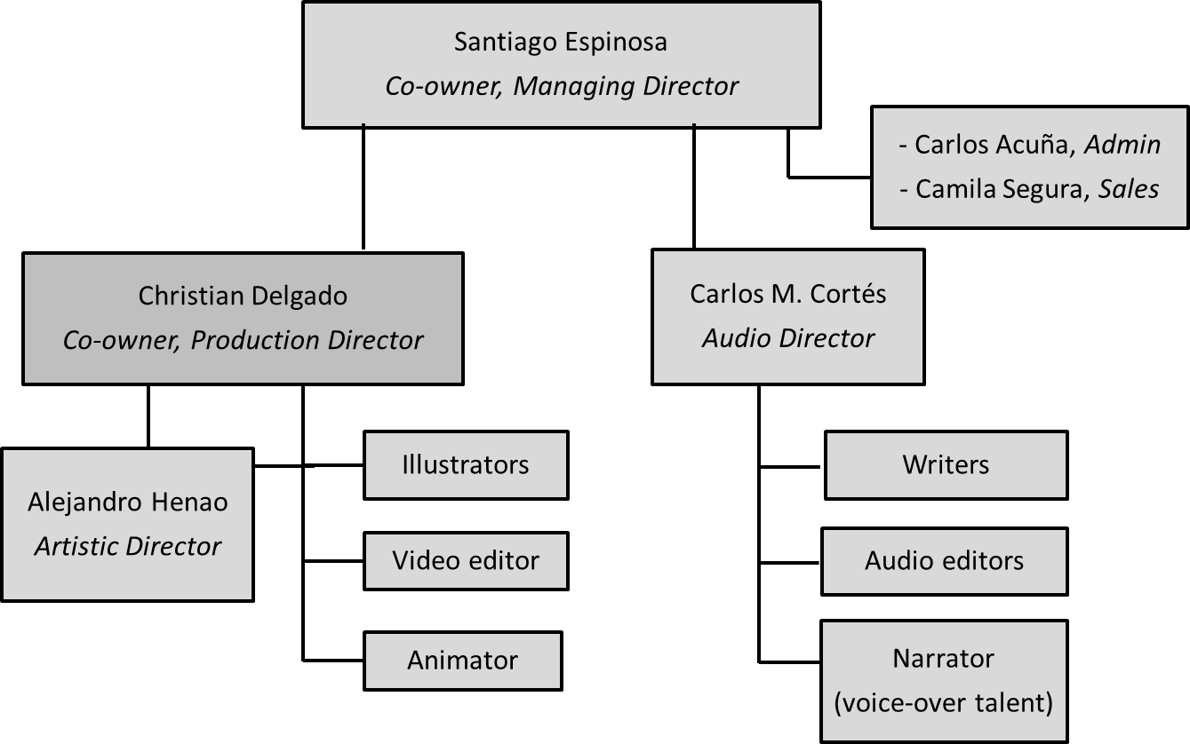

Source: Company documents.

Exhibit 4: magic markers operating process

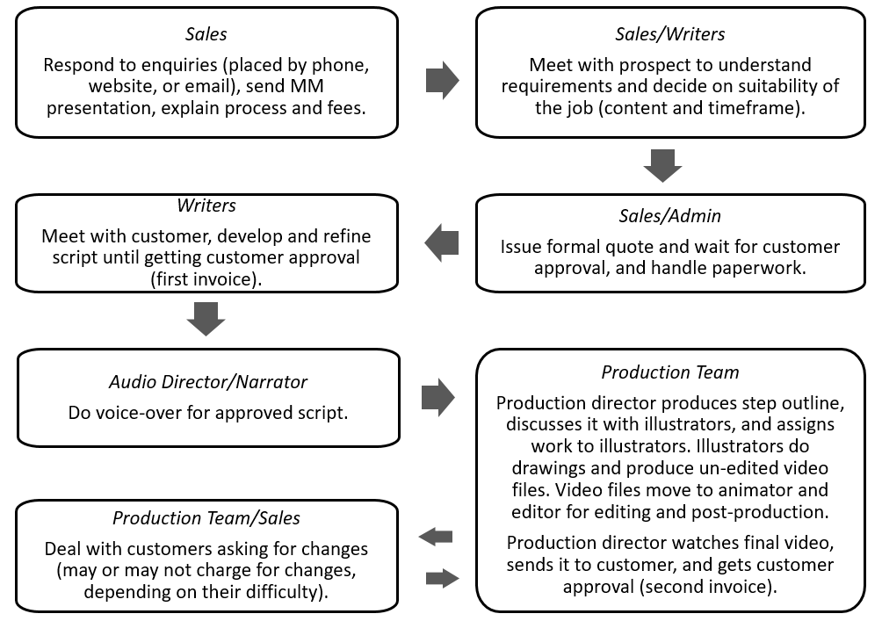

Note: MM = Magic Markers

Source: Company documents.

1. Infinity Research Ltd., “Global Digital Video Content Market 2016-2020,” technavio, September 2016, accessed March 15, 2017, www.technavio.com.
2. Jonathan Savage, “Top 5 Facebook Video Statistics for 2016 [Infographic],” Social Media Today, April 10, 2016, accessed August 17, 2017, www.socialmediatoday.com/marketing/top-5-facebook-video-statistics-2016-infographic.
3. Infinity Research Ltd., op. cit.
4. Sarah Frier, “Snapchat User ‘Stories’ Fuel 10 Billion Daily Video Views,” Bloomberg, April 28, 2016, accessed August 17, 2017, https://www.bloomberg.com/news/articles/2016-04-28/snapchat-user-content-fuels-jump-to-10-billion-daily-video-views.
5. Daphne Kasriel-Alexander, “Q&A: The Vlogging (Video Blogging) Landscape,” Euromonitor International, June 1, 2016, accessed March 16, 2017, https://blog.euromonitor.com/2015/12/qamillennials-marketing-to-a-global-generation.html.
6. Infinity Research Ltd., op. cit.
7. Ibid.
8. International Trade Administration, “Colombia—Information and Communication Technology (ICT),” export.gov, August 1, 2017, accessed October 21, 2017, https://www.export.gov/article?id=Colombia-Information-and-Communication-Technology-ICT.
9. *Billboard*, “FAQ,” accessed June 5, 2017, www.billboard.com/faq.
10. Megan O'Neill, “What Makes a Video ‘Viral’?,” Adweek, May 9, 2011, accessed July 10, 2017, www.adweek.com/digital/what-makes-a-video-viral/.
11. Richard Wiseman, “Drawing on Knowledge: An Experimental Comparison of a ‘Talking Head’ and Animation-Based Video,” Cognitive, accessed June 8 2017, https://www.wearecognitive.com/media/pdf/as-if-principle-report-richardwiseman.pdf; “How Whiteboard Video Technology Works in Education,” YouTube video, 3:30, posted by VideoScribe, May 23, 2014, accessed June 5, 2017,https://www.youtube.com/watch?v=kcft5B1c-JE.
12. Josh Halliday, “Internet Users Get Animated about RSA Short Film Series,” Guardian, October 21, 2011, accessed June 5, 2017, https://www.theguardian.com/artanddesign/2011/oct/21/internet-users-animated-rsa-films.
13. All currency amounts are in U.S. dollars.
14. In film production, a dolly was a platform used to hold the camera and move it while it filmed.
15. Magic Markers, “¿Por qué no funciona TransMilenio? [Why Doesn’t TransMilenio Work?],” YouTube video, 10:13, posted by Magic Markers, September 7, 2014, accessed June 3, 2017, https://www.youtube.com/watch?v=HfrBFM8L64Y.
16. Bogotá Editorial Office, “TransMilenio, interesado en modelo de rutas diseñado por profesor universitario [in Spanish],” *El Espectador*, September 9, 2014, accessed June 1, 2017, www.elespectador.com/noticias/bogota/transmilenio-interesado-modelo-de-rutas-disenado-profes-articulo-515622.