

9B18M029

Belle FLeur: Buying an Existing Business or Starting Fresh

Atul Teckchandani and Jana Hammoud wrote this case solely to provide material for class discussion. The author does not intend to illustrate either effective or ineffective handling of a managerial situation. The authors may have disguised certain names and other identifying information to protect confidentiality.

*This publication may not be transmitted, photocopied, digitized, or otherwise reproduced in any form or by any means without the permission of the copyright holder. Reproduction of this material is not covered under authorization by any reproduction rights organization. To order copies or request permission to reproduce materials, contact Ivey Publishing, Ivey Business School, Western University, London, Ontario, Canada, N6G 0N1; (t) 519.661.3208; (e)* [*cases@ivey.ca*](mailto:cases@ivey.ca)*;* [*www.iveycases.com*](http://www.iveycases.com)*.*

Copyright © 2018, Ivey Business School Foundation Version: 2018-03-08

In April 2017, Pamela Coquis, a college student in California, was only a month away from graduating with her bachelor’s degree in business administration with a minor in entrepreneurship. Like many of her peers, Coquis was contemplating life after graduation. However, while many of them were trying to figure out what life after graduation would look like, Coquis knew what she wanted to do: open up her own business. For the past six years, she had been working as a florist and was ready to start her own flower business.

The owners of the flower shop she was working at, Belle Fleur, had been trying to sell the shop for the past few years. Mr. and Mrs. Greenhill were in their mid-sixties and ready to retire. About a month ago, they offered to sell the shop to Coquis at a discount from their current asking price. The price they offered Coquis was US$145,000,[1] while other buyers were told that the asking price was $175,000. No offers had been made, but the number of prospective buyers was increasing so Coquis needed to make a decision soon.

Her years working as a florist had given her deep knowledge of the industry, and she was eager to bring a fresh perspective to an industry that seemed to be stagnating. On her own and through projects in her entrepreneurship classes, Coquis had been working on ways to reinvent the flower arrangement business. However, she was faced with a dilemma. Was purchasing Belle Fleur the right way to go, or should she open her own flower shop? What were the advantages and disadvantages of each option? Were Mr. and Mrs. Greenhill offering her a fair price?

THE BUSINESS

Belle Fleur was located in a shopping centre with heavy foot traffic in a high-income suburb of Southern California, about 50 miles from Los Angeles. In recent years, the flower business had been steady, and it seemed that it would remain that way.

There were three main ways for customers to order flowers from the shop. The first was by walking in and talking directly with a florist. There were catalogues with standard arrangements that customers could choose from. Alternatively, if a customer had a particular set of preferences, the customer could work with the florist to create an arrangement.

The second way was ordering by telephone. This method was similar to the in-store ordering process in that the customer could either order an arrangement found in the online version of the floral catalogue or work with the florist to create an arrangement.

The third way that customers ordered flowers was through Wireflora. Wireflora was an online flower shop that contracted with local flower shops across the United States to create and deliver the flower arrangements that customers ordered through their website. Belle Fleur was one of those flower shops. To assist local flower shops, Wireflora provided them with floral designs, advertising, a website, a point-of-sale (POS) terminal, and a wire service to allow communication between flower shops. In exchange for these services, flower shops paid a one-time charge of $10,000, and $500 each month. The flower shop received 80 per cent of the amount that the customer who ordered through Wireflora paid for the flower arrangement. For all other transactions at the shop—regardless of source—Wireflora charged a $0.20 fee. This fee was tracked through the POS system.

Partnering with Wireflora increased Belle Fleur’s revenue as it enabled orders to come in from anywhere in the world. For example, a customer in Singapore who wanted to send flowers to someone in Southern California could use Wireflora to do so. The order would then be sent to a Wireflora-affiliated flower shop that was located near the recipient. If the recipient was near Belle Fleur, it was likely that the order would be sent to them. The shop did not have to accept every order that came through Wireflora. If a flower shop did not have the flowers or items required to fulfill an order that came through Wireflora, the shop would reject the order and Wireflora would send it to another shop.

Once an order was placed through any of these three methods, it could be picked up in the store or delivered to a nearby address. Belle Fleur used an independent contractor to deliver the floral arrangements to recipients.

THE FINANCIALS

As part of her due diligence, Coquis asked the Greenhills for information on the financial health of Belle Fleur. The owners provided her with documents on the financial performance of the shop for the past three years (see Exhibits 1 to 4). The documents highlighted revenue segmented by source, the number of orders placed by time of day, and the number of orders that came through Wireflora. However, the Greenhills refused to share audited financial statements until Coquis made an official offer to purchase the shop.

Through conversations with Mr. Greenhill, Coquis was able to get a rough estimate of key expenses for the shop. The staff consisted of two full-time florists (Coquis and Mrs. Greenhill) and two part-time florists each working 10 hours per week. Mrs. Greenhill did not pay herself a salary. Combined salaries for the other three staff members were $3,000 a month. Rent was $4,000 a month. Utilities, including electricity, phone, and water, were typically $900 a month. The owners also paid about $200 per month in insurance and workers’ compensation.

Mr. Greenhill also told Coquis that the main stream of revenue came from online and telephone orders. Seldom did customers walk into the store to buy flowers. On average, an arrangement was sold for $65 and the cost of goods averaged $15. Given this financial picture, Mr. Greenhill told Coquis that the shop had a $5,000 monthly profit, on average.

COQUIS’S VISION

Working as a florist for six years, Coquis had gained deep knowledge of how the industry operated. As a result, she had developed her own vision of how she wanted her flower business to operate. Currently, almost all flower shops offered the same services and products. Customers chose an arrangement they liked (from a catalogue or photo book), and the florist would mimic the chosen arrangement using a “recipe book.” The problem with this system was that the images in the catalogue were deceiving. The images almost always showed the flower arrangement to be much fuller because all the flowers used to make the arrangement were placed near the front. If another picture were taken of the back side of the vase, it would show large gaps among the flowers and a lack of colour.

In addition, the industry had lost its uniqueness. Just about every florist had the same recipe book, resulting in no meaningful difference between one florist’s arrangement and another’s. Coquis saw herself as an artist, and the generic recipe books were inhibiting her creativity. She envisioned a flower business where the arrangements were unique. There would be no catalogue for customers or recipe book for the florist. Instead, a customer would describe a specific need (for instance, the occasion for which the flowers were needed, any allergies, the personality of the recipient, flower preferences, budget, and so on) to the florist, who would then visualize the arrangement and create it using his or her unique artistic talents. This method would result in a highly personalized arrangement uniquely tailored for each customer. No two arrangements would be the same. In addition, the shop would use a proprietary box for the flowers and arrange them in such a way that the arrangement was fuller looking from every angle (see Exhibit 5).

Coquis was not the only one who wanted to bring artistry back to floral arrangements. J’Adore Les Fleurs, a luxurious flower shop located about 60 miles away from Belle Fleur (near Los Angeles), also offered custom arrangements. Their high-quality flowers and excellent customer service kept their customers satisfied and loyal, as was evident from their 5-star rating on Yelp and highly followed Instagram page. However, J’Adore Les Fleurs charged much higher prices for their arrangements—$250 and up. Coquis did not believe that unique, customized flower arrangements needed to be so expensive and limited to wealthy clients.

WAS BUYING BELLE FLEUR THE WAY FORWARD?

Coquis was trying to figure out if buying Belle Fleur would help her achieve her goals more quickly. If she were to buy Belle Fleur, she would have a steady stream of revenue coming in each month. The business was already established, which would spare her the challenges and restless nights that came with starting a new business from the ground up.

However, Coquis would need to make a few changes to make the shop fit her vision. First, she would have to rebrand the shop by changing its name (she preferred the name Floral Filosophy), remodel the bland-looking shop, and redesign the website to complete the makeover.

Second, Coquis would likely discontinue Wireflora’s services. The products offered by Wireflora contradicted Coquis’s vision. However, once she revoked her affiliation with Wireflora, the firm would take back all the equipment it had given the shop, such as the POS terminal. Not only would Coquis need to replace the lost sales and equipment, but she would also need to take charge of her own advertising. She estimated her advertising costs would be about $700.00 per month.

Finally, current employees would need to undergo training to prepare them to work with customers and make flower arrangements that were consistent with Coquis’s vision. Coquis would also seek to delegate more responsibility and empower the staff in a way that the current owners of Belle Fleur did not. The Greenhills assumed almost all of the responsibility for managing and caring for the shop. Coquis had seen firsthand how stressful this method of management was and how demotivating it was to the staff due to the limited amount of autonomy they were given.

In summary, if she purchased Belle Fleur, Coquis would effectively have two different business models operating concurrently. She could not afford to lose the shop’s current customer base, which meant she would need to continue offering arrangements from a catalogue. Coquis was planning to present her unique arrangements as an option for these customers, while also seeking new customers who would value her new arrangements. Coquis hoped these new arrangements would appeal to men who would appreciate being able to specify some basic criteria and then have the floral designer create the perfect arrangement. She also hoped that the new business model would appeal to women, who would appreciate the greater autonomy they would have in specifying and choosing flower arrangements. Over time, Coquis hoped to transition the shop to only creating uniquely designed flower arrangements. In this way, she would make the shop fit her vision and alleviate the challenges of managing a shop with two different business models.

SHOULD Coquis START FRESH?

Coquis could also choose to launch her own shop. A new shop would be designed and operated to exactly fit her vision. Her degree in business, coursework in entrepreneurship and small business management, and experience working at Belle Fleur had taught Coquis how to run a flower shop efficiently.

During her research, Coquis learned that starting a flower shop from scratch would cost her about $45,000. To start, she would need equipment and furniture. Refrigerated cases and display cases to keep flowers fresh would cost $3,000. Office furniture, such as desks, tables, workbenches, shelves, and chairs could be bought at a used office furniture store for about $3,000. Other decorations like painting and flooring would cost approximately $3,000. A computer and POS terminal would cost about $2,000. Coquis’s friend agreed to build the website for $1,600. All the supplies Coquis needed to start creating floral arrangements could be purchased for $800, which included a modest inventory of flowers.

A big disadvantage with a new shop was that Coquis would have no existing customers. As such, she would have to spend heavily on advertising. She would advertise on the most popular social networking sites, such as Facebook, Instagram, and Yelp. She would also create professional flyers to send out to nearby wedding shops, funeral homes, hospitals, and other industries that used flowers extensively. Designing and printing the flyers would total around $800. A sign would also be needed to display outside the shop. A decent sign would cost about $1,000. After the shop opened, Coquis would need to spend about $1,000 per month on advertising.

Initially, Coquis would only hire one part-time helper who would work 20 hours a week or less. This hire would keep her salary expenses to a minimum. The helper, who would not be a florist, would be paid $10 per hour. Coquis would pay herself a $2,000 salary—just enough to cover her living expenses. She estimated her workers’ compensation and insurance would be around $100per month. Since her shop would be smaller than Belle Fleur, she expected that rent would be about $3,000 a month. Any other expenses, such as utilities and cost of goods sold, would be similar to Belle Fleur’s. Since immediate profitability was not guaranteed, Coquis wanted to keep enough funds on hand to pay for operating expenses for at least six months.

CHOOSING A PATH

With graduation only a month away, Coquis’s eagerness to graduate was coupled with the anxiety of facing her post-college future. She was facing the biggest decision of her life, and she didn’t know how to proceed. Should she buy Belle Fleur or start her own shop? For each path, what were her next steps?

EXHIBIT 1: BELLE FLEUR sales BY SOURCE, 2014–2016 (in Us$)

2016:

|  |  |  |  |  |  |  |  |  |
| --- | --- | --- | --- | --- | --- | --- | --- | --- |
| **Source** | **Count** | **Merchandise** | **Service/Delivery Fees** | **Discount** | **Net Sales** | **Tax** | **Total Sales** | **Average Net Sales** |
| Carry-Out | 1,502 | 67,243.19 | – | 314.98 | 66,928.21 | 5,312.62 | 72,240.83 | 44.56 |
| Delivery | 1,893 | 147,338.51 | 21,422.82 | 410.27 | 168,351.07 | 11,761.94 | 180,113.01 | 88.92 |
| Pick-Up | 223 | 14,848.51 | – | 72.65 | 14,775.86 | 1,179.22 | 15,955.08 | 66.19 |
| Wire-Out | 97 | 7,613.15 | 1,284.42 | – | 8,897.57 | 711.51 | 9,609.08 | 91.82 |
| Overall Totals | 3,715 | 237,043.36 | 22,707.24 | 797.90 | 258,952.71 | 18,965.29 | 277,918.00 | 69.70 |

2015:

|  |  |  |  |  |  |  |  |  |
| --- | --- | --- | --- | --- | --- | --- | --- | --- |
| **Source** | **Count** | **Merchandise** | **Service/Delivery Fees** | **Discount** | **Net Sales** | **Tax** | **Total Sales** | **Average Net Sales** |
| Carry-Out | 1,512 | 65,364.45 | – | 169.27 | 65,194.23 | 5,216.36 | 70,411.53 | 43.11 |
| Delivery | 2,062 | 151,161.02 | 23,067.66 | 240.70 | 173,987.98 | 11,877.32 | 185,865.30 | 84.40 |
| Pick-Up | 212 | 17,683.86 | – | 67.92 | 17,615.95 | 1,405.73 | 19,021.68 | 83.09 |
| Wire-Out | 108 | 8,428.59 | 1,407.86 | – | 9,836.45 | 784.88 | 10,621.33 | 91.08 |
| Overall Totals | 3,894 | 242,637.91 | 24,475.52 | 477.89 | 266,634.60 | 19,284.29 | 285,919.84 | 68.47 |

2014:

|  |  |  |  |  |  |  |  |  |
| --- | --- | --- | --- | --- | --- | --- | --- | --- |
| **Source** | **Count** | **Merchandise** | **Service/Delivery Fees** | **Discount** | **Net Sales** | **Tax** | **Total Sales** | **Average Net Sales** |
| Carry-Out | 1,536 | 68,954.95 | – | 178.45 | 68,776.50 | 5,334.35 | 74,110.86 | 44.77 |
| Delivery | 1,989 | 144,720.93 | 21,643.35 | 96.77 | 166,267.51 | 11,381.69 | 177,649.20 | 83.58 |
| Pick-Up | 195 | 12,921.61 | – | 7.03 | 12,914.58 | 1,032.56 | 13,947.14 | 66.31 |
| Wire-Out | 93 | 6,967.02 | 1,042.51 | – | 8,009.54 | 641.73 | 8,651.26 | 86.03 |
| Overall Totals | 3,813 | 233,564.51 | 22,685.86 | 282.25 | 255,968.12 | 18,390.34 | 274,358.46 | 67.13 |

Note: Carry-out sales are floral arrangements sold to walk-in customers. Delivery sales are floral arrangements sold to customers who placed orders by telephone or online, and requested that the floral arrangement(s) be delivered to a specific address. Pick-up sales are floral arrangements sold to customers who placed orders by telephone or online, and chose to pick them up at the shop. Wire-out sales are orders placed by customers who came into the shop or called by phone but were unable to be fulfilled by the shop. As such, they were sent to other flower shops to fulfill. A good example of such an order would be if the customer wanted the arrangement to be delivered to someone in a different part of the country; Average net sales = Total Sales / Count.

Source: Company documents.

EXHIBIT 2: NUMBER OF ORDERS FULFILLED, BY TIME OF DAY (2014–2016)

|  |  |  |  |
| --- | --- | --- | --- |
| **Time of Day** | **2016** | **2015** | **2014** |
| Before Hours | 9 | 9 | 8 |
| 8:00 a.m. | 147 | 159 | 193 |
| 9:00 a.m. | 375 | 412 | 268 |
| 10:00 a.m. | 461 | 502 | 456 |
| 11:00 a.m. | 488 | 470 | 423 |
| 12:00 p.m. | 442 | 440 | 457 |
| 1:00 p.m. | 405 | 433 | 418 |
| 2:00 p.m. | 361 | 429 | 402 |
| 3:00 p.m. | 310 | 375 | 395 |
| 4:00 p.m. | 320 | 335 | 357 |
| 5:00 p.m. | 321 | 270 | 328 |
| 6:00 p.m. | 68 | 52 | 78 |
| 7:00 p.m. | 6 | 6 | 20 |
| After Hours | 2 | 2 | 10 |
| Total | 3,715 | 3,894 | 3,813 |

Source: Company documents.

EXHIBIT 3: INCOMING AND OUTGOING WIRES, BY NUMBER (2014–2016)

|  |  |  |  |
| --- | --- | --- | --- |
|  | **2016** | **2015** | **2014** |
| Wires (incoming) | 257 | 318 | 321 |
| Wires (outgoing) | 97 | 114 | 98 |

Source: Company documents.

EXHIBIT 4: INCOMING AND OUTGOING WIRES, BY US$ AMOUNT (2014–2016)

|  |  |  |  |
| --- | --- | --- | --- |
|  | **2016** | **2015** | **2014** |
| Wires (incoming) | 20,485 | 25,061 | 23,254 |
| Wires (outgoing) | 9,610 | 10,622 | 8,652 |

Source: Company documents.

Exhibit 5: PHOTO OF one of COQUIS’S ARRANGEMENTs

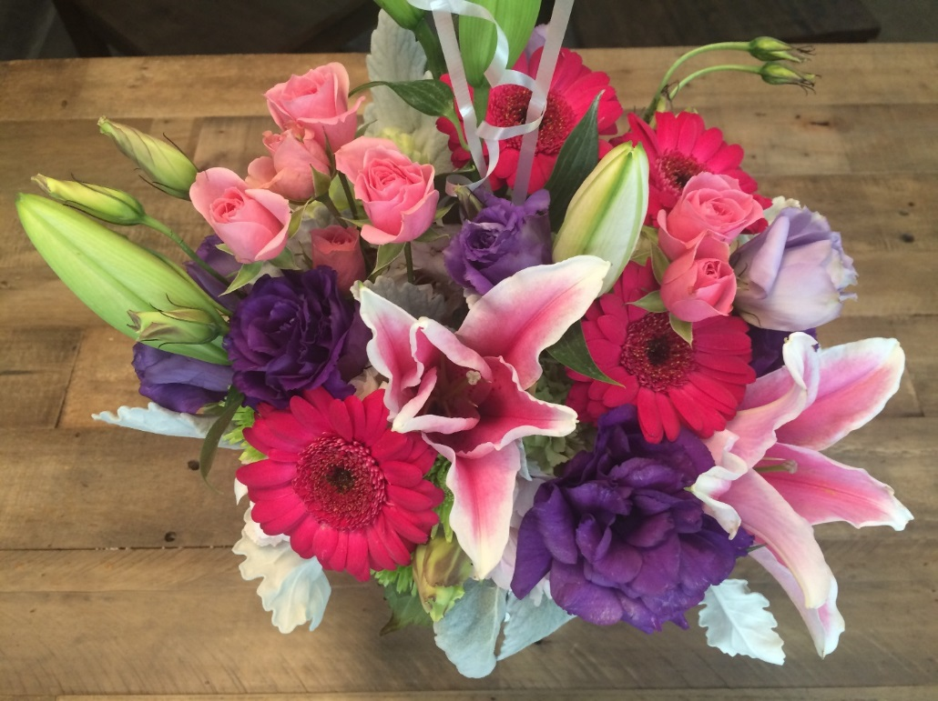

Source: Photo taken by case author.

1. All currency amounts are in U.S. dollars unless otherwise stated.