|  |  |
| --- | --- |
|  | **UC-hashayne-black** |

9B18M041

City of Calgary: financing infrastructure

Pernille Goodbrand, Darrin Ambrose, and Jyoti Gondek wrote this case solely to provide material for class discussion. The authors do not intend to illustrate either effective or ineffective handling of a managerial situation. The authors may have disguised certain names and other identifying information to protect confidentiality.

*This publication may not be transmitted, photocopied, digitized, or otherwise reproduced in any form or by any means without the permission of the copyright holder. Reproduction of this material is not covered under authorization by any reproduction rights organization. To order copies or request permission to reproduce materials, contact Ivey Publishing, Ivey Business School, Western University, London, Ontario, Canada, N6G 0N1; (t) 519.661.3208; (e)* [*cases@ivey.ca*](mailto:cases@ivey.ca)*;* [*www.iveycases.com*](http://www.iveycases.com)*.*

Copyright © 2018, Ivey Business School Foundation Version: 2018-03-23

When Dave Bronconnier took office as the mayor of Calgary, Alberta, Canada in the fall of 2001, he had a vision for the city: it would become a dense, vibrant, and sustainable urban powerhouse—a world-class city. Bronconnier knew that to achieve this goal, Calgary’s downtown core and the areas immediately adjacent would have to be rejuvenated and re-energized through redevelopment. The East Village area, in particular, was underutilized and often associated with urban blight. Located behind Bronconnier’s office in city hall, the East Village had plenty of development potential given its proximity to downtown and the beautiful Bow River. However, Bronconnier knew there were economic, social, and environmental issues that had to be addressed first—he could clearly see most of these from his office. While he believed it was possible to redevelop the area, he could not help but be concerned that the most difficult task would be to convince Calgary City Council that it was time to act; and he wondered, even if he did convince council members, how could they ensure success this time around?

In 2001, the East Village was little more than a zone of containment for homeless shelters, high-rise housing for low-income seniors, and a wasteland of crime-ridden surface parking lots. The East Village had not always looked like this, nor was its current state due to a lack of redevelopment efforts. Somehow, half a century of improvement attempts had all failed. In 2007, Bronconnier had the finances in place to revitalize the East Village. With failure in the past, how could he ensure that the attempt would be a success?

CALGARY

In 2017, Calgary, in the western Canadian province of Alberta, was a city of just over 1.2 million people. It was the third-largest municipality in Canada, and had the second-highest number of corporate head offices, largely due to its role as an administrative centre for the Canadian oil and gas industry. Although population growth had recently slowed due to an economic downturn, the city had been among the fastest growing cities in Canada in recent years. Since 1996, Calgary’s population had grown from 767,059 to 1,235,171—an average of just over 2.5 per cent per year.[1] Calgary’s economy was characterized by boom and bust cycles attributed to the volatility of oil prices, but recent booms had ensured that Calgary was generally prosperous. Households in Calgary had the highest median total income in Canada,[2] and close to 70 per cent of housing was owner-occupied. However, not all areas of the city had participated in the prosperity, and the East Village was a case in point.

the EAST VILLAGE

Calgary’s East Village covered 49 acres (19.83 hectares) on the eastern side of the city’s downtown (see Exhibit 1). The neighbourhood was established when the Canadian Pacific Railway built a station west of Fort Calgary in 1883. Maps of the East Village from the beginning of the 1900s show a mixed-use community with commercial, residential, and industrial uses; it was essentially a small town largely serving the working class and the railway. Apartment and tenement buildings were built for men seeking employment in the city. Despite an economic boom that attracted these newcomers, development began to slow down over the next decade, and in 1912, a “homeless men problem”[3] was mentioned for the first time.

By the 1920s, the automobile was competing with the streetcar,[4] and the demand for auto-related services increased. Mechanics’ garages, and motor and machine shops sprung up in the East Village, changing the physical environment toward being more industrial. After the Second World War, the growth of the oil industry raised the standard of living in Calgary, and suburban expansion away from the city’s core began. During this time, many more of the designated residential uses in the East Village were converted to garages and to auto body, auto parts, glass, and paint shops.

By the early 1960s, the East Village housed a variety of industrial and transportation uses, as well as the city abattoir and cattle pens. The few residential uses remaining were overwhelmingly apartments and rooming houses, as well as inexpensive single-room-occupancy hotels. In 1964, the area had the highest percentage of welfare caseloads in the city,[5] and several social agencies had by then increased their presence. The physical environment of the East Village had adapted to the evolving economy with more industrial sites, but had concurrently become a place where the down-and-out could secure cheap accommodation in an undesirable part of town.

Amendments to the *National Housing Act* in 1964 and to the *Alberta Housing Act* in 1965 culminated in an urban renewal scheme for the East Village. A 1966 report to Calgary City Council claimed that the renewal area comprised 20 per cent of the downtown core, yet yielded only 4 per cent of downtown property revenues and contained 54 per cent of condemned buildings.[6] Thus, a master plan was put in place to remove “urban ills” from the East Village, including what the City considered an undesirable population, made up of mostly single, unemployed men.[7] Underused areas were to be replaced with parcels for private developers and civic purpose buildings, many of which were later built on the western edge of the area. The unwanted population would be pushed out when their homes disappeared, but no one gave any thought to where they would go. While a significant number of buildings were torn down for redevelopment, they were not replaced by the time the urban renewal scheme was terminated in 1972.

In 1978, a new proposed Downtown Plan envisioned the East Village as a residential community within the downtown characterized by a high-quality pedestrian environment and integrated public spaces. This concept for the East Village was next incorporated into the 1981 Downtown Area Redevelopment Plan, which ultimately failed to be passed by the city council of the day and left the East Village underdeveloped once again. By 1985, the seemingly final blow to redevelopment of the area was the construction that year of the Calgary Municipal Building, which faced west and opened onto a plaza designed for the 1988 Winter Olympics. City hall had—literally—turned its back to the East Village. Compounding this insult (intended or not) was the construction of a safety fence to prevent people from crossing the Light Rail Transit tracks that ran behind the municipal building along the western edge of the East Village, leaving just a small passageway through which East Village residents could leave to enter the rest of downtown and return home.

Later, in 1990, another attempt at redevelopment surfaced through the proposed New Directions for the East Village plan, where only 15 per cent of the area included residential uses. The New Directions plan envisioned a low-, medium-, and high-density residential area with affordable rental and owned housing for up to 5,000 people. However, this proposed plan was doomed for failure based on assertions that Calgarians’ preference for living in the suburbs, combined with the shelters and dilapidated hotels of the East Village, would make it impossible to attract residents. The plan had no political backing and never came to fruition.

More than 10 years passed before another attempt at redevelopment was launched, in 2002. Known as the Canal Project, the plan envisioned a mixed-use, dense, and walkable community featuring a canal and pond.[8] The Canal Project, like its predecessors, did not present a concrete strategy for the infrastructure improvements needed to spur private investment in the East Village, nor did it involve any community engagement. It also blatantly ignored the social and environmental issues present in the area. Questionable land valuation processes further plagued the plan, which ultimately also went nowhere.

Each plan for revitalization had left the area stagnating and, therefore, worse off than it had been before. The result of 50 years of incomplete plans and unfinished, fragmented development had left the East Village severely lacking vision and cohesion. There was no immediate solution in sight, as the Canal Project had divided city council between those who felt that innovative municipal intervention was needed, and those who felt the market should take care of itself. Mayor Bronconnier represented the first camp, as he was well aware of the area’s complex history and recognized the need for environmental remediation. Bronconnier also knew that the lack of infrastructure made it unlikely that any private sector developer would take on the risk of a project of this scale and cost. The initiative would have to be led by the public sector, but Bronconnier had to be strategic about how to approach the matter.

POLITICAL WILL AND PLANNING CONTEXT

When Bronconnier initiated another effort to develop the East Village, in 2004, he received backlash for fighting what many believed was a losing battle. He brushed off the criticism and set himself to the task of creating a plan to finance the redevelopment effort. Bronconnier understood that investing in the East Village would not be popular with many of his colleagues or citizens, but he also knew that delivering the best value for the City of Calgary in the long term was a priority. He would need to effectively communicate to council his vision for another try at redevelopment, and convince the skeptics that his idea was not just another plan doomed to fail. It would be a long process, and the initial scope would have to extend beyond the East Village. Thus, Bronconnier embarked on creating a shared vision of a thriving downtown that would benefit all Calgarians, with investment in the East Village as a worthwhile commitment to reaching that goal.

The first step toward realizing this vision was the resuscitation of the East Village Area Redevelopment Plan (ARP), which dated back to 2001, and the ill-fated Canal Project. An ARP was a detailed planning document created by a municipality, and adopted by city council, to facilitate development and improvements in a specific area. The renewed version of the ARP for the East Village set out to “ensure that lands within the planning area be made ready and capable for redevelopment at the earliest opportunity.”[9] The ARP was situated within the context of imagineCALGARY, the city’s long-range urban sustainability plan, developed in 2006.[10] ImagineCALGARY was “a blueprint for a sustainable future . . . a community visioning and consultation process” involving input from 18,000 residents. In other words, imagineCalgary was a concrete plan for achieving the sustainable growth principles Bronconnier had been advocating for. After several revisions, the East Village ARP was approved in March of 2005 (resulting in Bylaw 24P2004). In January 2007, city council also adopted the Sustainability Principles for Land Use and Mobility as set out in imagineCALGARY.

Following the formalization of a strategy through the East Village ARP, spring 2007 saw the release of the Rivers District Community Revitalization Plan (RDCRP). This plan outlined: 1) a comprehensive redevelopment plan for the East Village and surrounding areas to the south; 2) the economic, social, and environmental barriers to development; and 3) concrete solutions to deal with these issues.[11] While the RDCRP would extend into two neighbouring areas, the Beltline and Stampede Park (see Exhibit 2), primary investment would occur in the East Village. The RDCRP involved a public infrastructure program that would “facilitate the reclamation, redevelopment and revitalization” of the area, and would involve an innovative method of funding through a community revitalization levy (CRL).[12]

**FINANCING THE RDCRP**

When Bronconnier and the City of Calgary’s Asset Management and Capital Works department were researching financing solutions used by cities that had taken on similar projects, they noticed that many successful examples had involved tax increment financing (TIF).[13] Dating back to 1952 in California, TIF involved determining a catchment area that would provide the needed tax uplift to finance infrastructure improvements in a redeveloping area. The existing tax base was determined, and scenarios were built to predict future tax revenue based on improvements through redevelopment. The assessed existing tax base became a baseline. Over time, as city investment occurred, any increments in taxes collected beyond the baseline were used to fund the investment in the area. TIFs were imposed for a set time frame (typically 20–25 years), with taxes reverting to the larger municipal pool when the TIF expired (see Exhibit 3).[14]

TIF schemes were long-term investments that could pay off in the appropriate circumstances. In a successful TIF setting, the selected area was generally underutilized, and it often required environmental remediation. In fact, TIFs worked best for downtown mixed-use areas that had been neglected, had seen limited (if any) private investment, and had vacant land.[15] The East Village met all the criteria. These criteria were also the reason why land developers had lost confidence over time that change could happen in the East Village and were unwilling to invest there. Bronconnier knew that if redevelopment was ever to happen, public intervention and funding was needed. In the summer of 2004, he managed to convince council to direct City administration to look at TIFs as a way to finance the East Village.[16] After careful research, review of evidence-based case studies, and the completion of financial analyses, Bronconnier was prepared to argue that TIF was a viable option for the East Village.

Bronconnier’s path toward council approval of this new financing tool, however, was not easy. In April 2005, council approved TIF as an urban revitalization tool and approved, in principle, the creation of a “special purpose vehicle” to implement it.[17] However, the scenario was hypothetical, and Bronconnier knew that to succeed with the redevelopment, they would need something concrete—and they had no Canadian examples to follow. Despite being used in almost all U.S. states, TIF was a foreign concept in Canada. For this reason, introduction of this type of financing tool required buy-in and facilitation from the provincial government, which oversaw municipal affairs through the *Municipal Government Act* (MGA). When Bronconnier initially approached then Premier Ralph Klein in 2005 about using the mechanism, Klein was open to exploring the idea. Having been a former mayor of Calgary, Klein recognized that the East Village required stable funding over an extended period to get it off the ground. However, Klein did not like the implications of the word “tax” and maintained that provincial legislation would need to be written and enacted to address this financing option to avoid potential misuse. For these reasons, two things happened at the provincial level to facilitate the East Village TIF: 1) the province agreed to forgo a portion of its property tax revenues in the RDCRP to enable the City to leverage funds for infrastructure redevelopment, and 2) the Alberta equivalent of a TIF would be named community revitalization levy (CRL).[18] Because the City needed CA$135 million just to begin initial infrastructure upgrades (see Exhibit 4), this was a significant signal of support from the province.

This new way of financing major infrastructure projects was possible through amendments to the MGA, which the province of Alberta initiated after Bronconnier met with Premier Klein. The actual tool for achieving this was the CRL, essentially a “technique for harnessing future revenues to pay for current expenditures.”[19] A successful CRL would need to be supported by its own future cash flows, meaning that predicted tax uplifts from redevelopment were critical to the City’s ability to pay back the upfront investment in infrastructure. Using an analysis of the external business environment—including economic trends in residential and commercial real estate, interest rates, and the strength of the Canadian dollar—the CRL was estimated to generate between CA$725 million (low scenario) and CA$1.166 billion (high scenario) over 20 years (see Exhibit 5). These calculations used for the CRL projected a viable working model, even with the most pessimistic forecasting.

Yet, Bronconnier still had to consider what would happen if the revitalization effort were unsuccessful and the CRL failed to be economically viable, a scenario that had not been uncommon south of the border. Bronconnier worried what would happen if this inaugural attempt at TIF through a CRL in Canada failed with Calgary’s East Village project. He knew that a CRL was not a sure win; what if the City had overestimated growth in land values or potential developer interest? The CRL hinged on private investment after the City of Calgary provided the necessary infrastructure for redevelopment. What would happen if there was not enough growth to support the CRL? Even worse, what if Alberta’s oil-and-gas-dependent economy faced a disruption and slid into a bust cycle?

Despite the careful calculations that had been considered to date, Bronconnier felt more assurance was needed. Part of his concern focused on how to determine the geographic area that the CRL should cover. When drawing maps for TIF areas in the United States, properties that had maximized their tax growth potential as well as institutional and government buildings were often excluded from modelling.[20] Instead, the focus was on the potential for development and the subsequent tax lift from the properties to be built. In the case of the East Village, very little property tax revenue was generated from the area itself, with it having just a few condominiums and small businesses. The rest of the East Village consisted of social housing, not-for-profit organizations’ premises, and municipal or provincial government uses, which yielded little or no taxes. It would therefore be critical to create a catchment area that would invite interest from the private sector to build properties that would generate the needed tax lift.

In this regard, the City received a lucky break. In 2006, Encana Corporation announced plans for the construction of a skyscraper—to be known as “The Bow”—to serve as its corporate headquarters, which would be located in the east end of downtown. It would be the tallest skyscraper in Western Canada and would produce millions of dollars in property taxes. While Bronconnier was aware that there were no guarantees in redevelopment scenarios, he determined that including The Bow in the East Village CRL zone would be the next best thing. After making the case to city administration and his council colleagues, The Bow development, which broke ground in 2007, was officially included in the CRL zone in the RDCRP (see Exhibit 2).

The ARP and RDCRP processes, combined with financial modelling and risk assessment, had produced a thorough analysis that supported the CRL. The financial groundwork had been laid, and political support for the project had been established at the provincial level. Implementation of the CRL required new legislation, policies, and bylaws, all of which were supported by public investment in the project. This signalled confidence that the East Village was worth the effort of redevelopment.

As he stood in his office and looked out on the East Village below, Bronconnier knew that he now had to educate his fellow city council members on the merits of the plan. In order to get their support, he needed them to see not only the financial viability, but also how the plan fit with the vision he had for a world-class city. Without their support, the plan would suffer the same fate as the redevelopment plans that came before it, and the residents of the East Village would be overlooked yet again. He knew this would be a defining moment for the City of Calgary.

With one amendment, the RDCRP was approved as part of Bylaw 27M2007 on April 16, 2007. The approval of the RDCRP was a victory for Bronconnier and a testament to his dedication. He understood the significance of the decision he and his fellow council members had just made. By approving Bylaw 27M2007, they had introduced the first (ever) CRL in an Alberta municipality since the enabling MGA amendment came into place in 2005. The final vote was 12 to three in favour of the CRL, with only one minor amendment to the motion. This meant he had strong support from council to revitalize a critical part of the city.

With the financing tool in place to create the infrastructure necessary for revitalizing the East Village, council’s next task was to determine how this infrastructure project should be managed. Skepticism was high, as previous redevelopment efforts for the East Village had failed for a variety of reasons, and it was strongly suggested that the City should not be responsible for implementing the RDCRP. With so much at stake, financially for the City and reputation-wise for Bronconnier, how could Bronconnier ensure that this attempt at redevelopment would be successful without the City’s direct involvement?

This case was made possible through the generous support of the Westman Centre for Real Estate Studies at the Haskayne School of Business at the University of Calgary.

**EXHIBIT 1: LOCATION OF THE EAST VILLAGE RELATIVE TO DOWNTOWN**

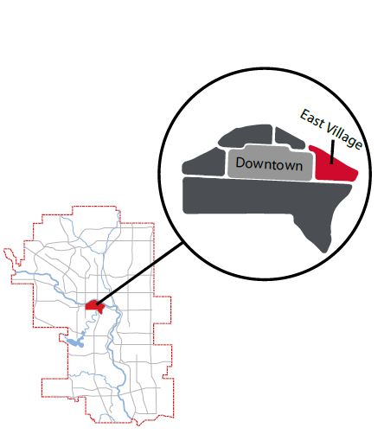

Source: City of Calgary, *East Village Area Redevelopment Plan*, 10, 2017, accessed July 5, 2017. www.calgary.ca/PDA/pd/Documents/arp-asp/arp/east-village-arp.pdf. Used with permission from the City of Calgary.

EXHIBIT 2: COVERAGE AREA OF RDCRP

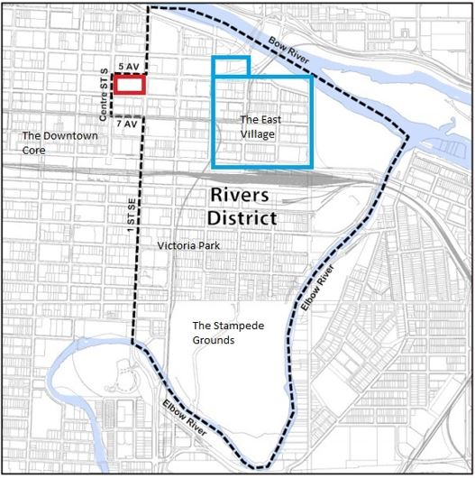

Note: RDCRP = Rivers District Community Revitalization Plan; the square in the upper left corner at the corner of Centre ST S and 5 AV represents The Bow development, which was included in the RDCRP zone.

Source: City of Calgary, *Rivers District Community Revitalization Plan 2007*, April 16, 2007, accessed July 5, 2017, <https://www.calgary.ca/CS/CPB/Documents/rivers/rivers_community_revitalization_plan.pdf?noredirect=1>. Used with permission from the City of Calgary.

EXHIBIT 3: COMMUNITY REVITALIZATION LEVY (IN CA$)

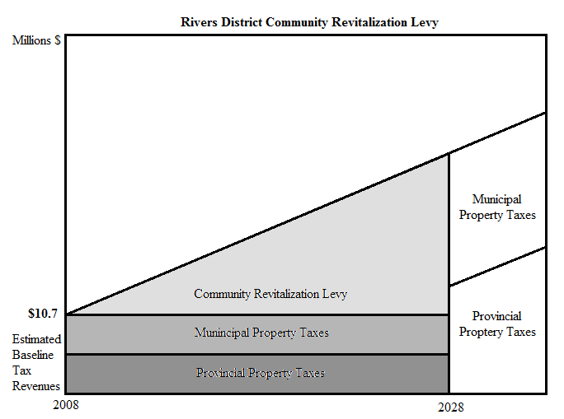

Municipal

Property Taxes

Source: Adapted from: City of Calgary, *Community Revitalization Plan: Presentation to City Council*, April 16, 2007, accessed July 5, 2017, [www.calgary.ca](http://www.calgary.ca) (enter item number C2007-14 in the search function, which downloads the pdf file). Used with permission from the City of Calgary.

EXHIBIT 4: INITIAL PROJECT COSTS (IN CA$)

|  |  |
| --- | --- |
| **Initial Projects** | **Estimated Costs** |
| East Village Infrastructure   * Underground utilities * Surface improvements * Sidewalks and streetscape * Parks and open space * Cost escalation contingency   **SUBTOTAL** | $ 14,000,000  $ 40,000,000  $ 24,000,000  $ 7,000,000  $ 28,000,000  **$113,000,000** |
| Riverwalk   * Consultant estimate * Cost escalation contingency   **SUBTOTAL** | $ 17,300,000  $ 4,700,000  **$ 22,000,000** |
| **Total Initial Project Costs** | **$135,000,000** |

Source: Adapted from City of Calgary, *Community Revitalization Plan: Presentation to City Council*, April 16, 2007, accessed July 5, 2017, [www.calgary.ca](http://www.calgary.ca) (enter item number C2007-14 in the search function, which downloads the pdf file). Used with permission from the City of Calgary.

EXHIBIT 5: PROJECTED ASSESSMENT GROWTH

|  |  |  |  |  |  |
| --- | --- | --- | --- | --- | --- |
| **Low Scenario Projected Assessment Growth (CA$ billions)** | | | | | |
|  | Years 1–5 | Years 6–10 | Years 11–15 | Years 16–20 | **Total** |
| Residential | $1.4 | $1.5 | $2.2 | $3.3 | **$8.4** |
| Non-Residential | $1.4 | $0.5 | $0.8 | $1.1 | **$3.8** |

|  |  |  |  |  |  |
| --- | --- | --- | --- | --- | --- |
| **High Scenario Projected Assessment Growth (CA$ billions)** | | | | | |
|  | Years 1–5 | Years 6–10 | Years 11–15 | Years 16–20 | **Total** |
| Residential | $1.8 | $2.2 | $3.0 | $4.5 | **$11.5** |
| Non-Residential | $2.3 | $0.9 | $1.5 | $2.0 | **$6.7** |

Source: Adapted from City of Calgary, *Community Revitalization Plan: Presentation to City Council*, April 16, 2007, accessed July 5, 2017, www.calgary.ca (enter item number C2007-14 in the search function, which downloads the pdf file). Used with permission from the City of Calgary.

ENDNOTES

1. City of Calgary, *2016 Civic Census Results*, April 1, 2016, accessed July 5, 2017, www.calgary.ca/CA/city-clerks/Documents/Election-and-information-services/Census2016/2016-Census-Results-Book.pdf.
2. Statistics Canada, “Median Total Income, by Family Type, by Census Metropolitan Area   
   (All Census Families),” July 14, 2016, accessed July 5, 2017, www.statcan.gc.ca/tables-tableaux/sum-som/l01/cst01/famil107a-eng.htm.
3. Pat Hooper, “Tales of Our Past: Historic East Village Calgary Gospel Mission,” EVAC View Newsletter (March 2012): 6.
4. Beverly Sandalack and Nicolai Andrei, *The Calgary Project: Urban Form/Urban Life* (Calgary, AB: University of Calgary Press, 2006).
5. Earle L. Snider, “Calgary Metropolitan Area Environmental and Transportation Study: Social Factors Report: Administrative Report,” The City of Calgary, Corporate Records, Archives. Planning and Building Department Fonds, Series I, Box 4466, Folder “Skid Row and Social Factors” (1966).
6. Unknown Author, “Memorandum to His Worship J.C. Leslie for Press Release: Re: The Underuse of East Downtown Calgary – 31 Blocks of Blighted Conditions January 26th,” The City of Calgary, Corporate Records, Archives. Planning and Building Department Fonds, Series I, Box 4468, Folder “6269.3 Public Information Program” (1966).
7. City of Calgary Planning Department, *Calgary Metropolitan Area Environmental and Transportation Study: Outline of the Final Downtown Master Plan* (Calgary, AB: City of Calgary, May 1965).
8. “East Village Urban Design,” Abugov Kaspar, accessed July 5, 2017, www.abugovkaspar.com/projects/urban-design/east-village.html.
9. City of Calgary, *East Village Area Redevelopment Plan*, 1, 2017, accessed July 5, 2017, www.calgary.ca/PDA/pd/Documents/arp-asp/arp/east-village-arp.pdf.
10. City of Calgary, *imagineCALGARY: Calgary’s Plan for Long Range Urban Sustainability*, revised March 12, 2013, accessed July 5, 2017, www.imaginecalgary.ca/sites/default/files/pdf/2013_iCPlan.pdf.
11. City of Calgary, *Rivers District Community Revitalization Plan April 2007*, April 16, 2007, accessed July 5, 2017, https://www.calgary.ca/CS/CPB/Documents/rivers/rivers_community_revitalization_plan.pdf?noredirect=1.
12. Ibid.
13. City of Calgary, *Asset Management & Capital Works Report to Council: Calgary Eastcore Revitalization C2004-50*, 2004, November 29, www.calgary.ca.
14. Rachel Weber and Laura Goddeeris, “Tax Increment Financing: Process and Planning Issues,” Lincoln Institute of Land Working Paper, 2007.
15. Ibid.
16. *Asset Management & Capital Works Report to Council: Calgary Eastcore Revitalization C2004-50*, op. cit.
17. City of Calgary, *Corporate Report to Council: Calgary Municipal Land Corporation Financing Arrangements: Previous Council Direction/Policy C2007-61: 1*, 2007, accessed July 13, 2017, www.calgary.ca.
18. *Rivers District Community Revitalization Plan*, op. cit.
19. Weber and Goddeeris, op. cit.
20. Ibid.