

9B18M044

# LEBANON MOUNTAIN TRAIL ASSOCIATION: AIMING FOR SUSTAINABILITY

Mira Thoumy and Omar Sakr wrote this case solely to provide material for class discussion. The authors do not intend to illustrate either effective or ineffective handling of a managerial situation. The authors may have disguised certain names and other identifying information to protect confidentiality.

*This publication may not be transmitted, photocopied, digitized, or otherwise reproduced in any form or by any means without the permission of the copyright holder. Reproduction of this material is not covered under authorization by any reproduction rights organization. To order copies or request permission to reproduce materials, contact Ivey Publishing, Ivey Business School, Western University, London, Ontario, Canada, N6G 0N1; (t) 519.661.3208; (e)* [*cases@ivey.ca*](mailto:cases@ivey.ca)*;* [*www.iveycases.com*](http://www.iveycases.com)*.*

Copyright © 2018, Ivey Business School Foundation Version: 2018-03-16

On December 5, 2016, Nadine Weber was getting ready for her final meeting as president of the Lebanon Mountain Trail Association (LMTA) before a new board was elected. In that meeting, the board of directors was going to vote on whether to hire an executive director—a first for the association. This proposition came from a need to formalize the LMTA’s structure and operations while ensuring the continuity of its mission. Weber was nervous about this meeting. Although there were benefits to hiring an executive director, the new situation could create a new financial hurdle for the association. Should the LMTA hire an executive director?

# HISTORY OF RURAL DEVELOPMENT IN LEBANON

Lebanon was located on the eastern Mediterranean coast. It covered a surface area of 10,452 square kilometres (km), with an average width of 48 km (30 miles) and an average length of 220 km (137 miles).[1]

According to the World Travel and Tourism Council, the direct contribution of travel and tourism to the Lebanese gross domestic product (GDP) reached its peak of 14.4 per cent in 2003 and then dropped to 7.6 per cent in 2014 due to the unstable political situation in Lebanon and the surrounding countries.[2] Unfortunately, there were no available data indicating the contribution of rural tourism to the Lebanese GDP. Not only did the unstable political situation affect the Lebanese GDP, but it also had a direct impact on employment, which dropped from 13.6 per cent in 2003 to 7.4 per cent in 2014. The same applied to the number of tourist arrivals, which according to the International Monetary Fund had dropped by more than a third since the beginning of the Syrian crisis.[3]

Despite the political situation and lack of security in Lebanon, domestic tourism—defined by the World Tourism Organization[4] as tourism comprising the activities of resident visitors within the country of reference—was less affected by the internal troubles. This fact was reported by many rural businesses and tour operators, which saw a higher increase in the number of local Lebanese visitors than the number of foreign visitors.[5]

Rural tourism, which was “experiencing the country” through diverse tourism activities, had a positive impact on the local community and environment provided that responsible tourism principles were properly respected. The diverse rural assets in Lebanon included world heritage sites, archaeological sites, mountains, nature reserves, *himas,[6]* biospheres, vineyards, agricultural fields, natural and artificial lakes, rivers, rural seaside and coastlines, villages, museums, monasteries, cultural trails, literary trails, food trails, religious trails, and hiking trails, along with guesthouses and other accommodation facilities.

This variety in rural assets allowed Lebanon to develop existing and new tourism products such as nature-based trips and ecotourism, hiking and trekking, paragliding, biking, kayaking and rafting, camping, bird watching, fishing, diving, craft making, sightseeing and visits to villages, wine and agrotourism, cultural and religious tourism, culinary and food trail tourism (including exploration of food specialties by region and by season), adventure and sports, local festivals, and visits to cultural heritage sites.

Walking and donkey riding, which predated the automobile age, had been the common ways to travel in Lebanon for the past few centuries. Rural communities had to create various footpaths to link their villages. Many of those trails were used by the army and still existed. They were used by hikers and scouts who continued to discover the rural areas of the country. Among those groups of hikers, Club des Vieux Sentiers and Le Liban à Petits Pas had been organizing weekly hikes since the 1950s and continued to do so. Starting in the 1990s, many local specialized tour operators organized hiking trips with additional cultural and nature-based activities across the country.

Since early the 1990s and right after the end of the Lebanese civil war, large numbers of people living in rural areas started to move to Beirut and other major cities, looking for jobs with better economic opportunities. However, because the distances between the cities and rural areas were relatively short, many kept visiting their families during the weekends or even spent their summer holidays with their relatives back in the rural areas. This emotional and familial links with their original villages remained strong. Many Lebanese people owned second homes in their villages, hoping that economic incentives might enable them to permanently stay in their hometowns.

Rural tourism generated economic benefits and employment opportunities for rural communities, especially if links were well established among the various stakeholders in the supply chain. For example, it created employment in guesthouses, camping sites, small restaurants, and typical rural *saj* bakeries. It also generated work for local food producers, guides, and craftspeople.

Rural tourism empowered local communities by integrating women and youth into the social and economic life of their communities. Moreover, it encouraged local communities to conserve the landscape and local heritage. Their incentive in conservation was to maintain the healthy environment in which they lived and attract tourists to come and spend money in the local economy. The idea behind the Lebanon Mountain Trail (LMT) was to enhance economic development through responsible tourism and conservation over 470 km (292 miles) and across 75 villages and towns.

**LEBANON MOUNTAIN TRAIL ASSOCIATION BACKGROUND**

In 2005, the U.S. Agency for International Development (USAID) issued a request for applications to promote economic growth in rural areas of Lebanon. Joseph Karam, an environmental activist and president of ECODIT—a consulting firm working on environmentally and socially responsible development programs—saw an opportunity for materializing his long-awaited dream of having a long-distance hiking trail across Lebanon’s mountains. His idea was inspired by childhood walks with his father in his hometown Baskinta, coupled with his amazement at the Appalachian Trail, which he discovered in the United States while studying at the Massachusetts Institute of Technology. Fast forward to 2002, when Karam went back to Lebanon for a summer break and the pieces of the puzzle came together: his childhood walks, the Appalachian Trail, the natural and cultural heritage of the Lebanese mountains, and his love for the ecotourism. The idea was hence born. He shared it with his colleague Karim El-Jisr, and together they developed the concept of the Lebanon Mountain Trail.

With a US$3.3 million[7] award from USAID, ECODIT started to implement the LMT over a two-year period. In November 2007, a three-month, no-cost extension was approved to complete many activities that could not be finished on time due to the summer war of 2006 that struck Lebanon. The LMTA, a non‑governmental organization, was established on October 31, 2007. Unlike most hiking trail associations around the world, where the main focus was on promoting hiking trails and conservation itself, the LMTA had much broader goals. Expanding on the development, maintenance, and conservation of the LMT, it moved to protect the natural, cultural, and architectural heritage and landmarks near the trail; promote socially responsible tourism; and create rural economic opportunities through community development activities. The association divided the first long-distance hiking trail of 470 km (292 miles) into 27 sections, each with a distance of 9.3 to 24.5 km (5.8 to 15.2 miles) and an elevation profile of 570 to 2,011 metres (1,870 to 6,600 feet) above sea level. The trail crossed 75 towns and villages, one world heritage site, two biosphere reserves, and three protected areas (see Exhibit 1).

In 2009, the LMTA organized its first Annual April Thru-Walk, where hikers walked the entire trail in one month. Other walkers hiked sections of the trail throughout the year. Another annual event, the Fall Trek, was organized starting in October 2013. The LMTA offered training to local guides and helped in the renovation of some guesthouses and in training their owners. The LMTA was also one of the key players in advocating for the formalization of a decree by the Ministry of Tourism of Lebanon to recognize and legalize guesthouses in Lebanon. The decree was issued in 2011.

The role of ECODIT was crucial in launching the LMT and the LMTA, and the USAID fund helped jumpstart the trail. However, one of the main impediments to the survival of such an association was financial support. Funding was an essential challenge for LMTA to safeguard its sustainability.

# FUNDING AND FUNDRAISING OVERVIEW

The $3.3 million fund provided by USAID served to launch the LMT. Since 2008, the LMTA’s main source of funding was based on grants for specific projects under the LMTA’s three main programs: the trail program, the community development program, and the education program (see Exhibit 2). When given a grant, the LMTA had to secure the remaining balance of the budgeted project through corporate donations, individual donations (see Exhibit 3), or contributions from municipalities. Volunteers invested substantial time and effort on writing proposals that did not always yield positive results; they kept relentlessly looking for complementary capital when a fund was granted.

Besides the grants, the LMTA had many partners in the private and public sector who were contributing regularly to the different association programs. Corporate donations were also secured from companies that considered help for the LMTA to fall under their corporate social responsibility program. The LMTA collected extra donations during its Annual Thru-Walk through crowdfunding campaigns started by private donors while walking on sections of the trail.

It was challenging for the LMTA to cover its operations expenses, which amounted to about $100,000 every year (see Exhibit 4). This was mainly because most of the grants were directly allocated to specific projects. Moreover, the association had not received any local governmental contributions in the past and did not charge walkers any fees for using the trail. The LMTA organized a yearly fundraising dinner to cover 60–80 per cent of its expenses. The rest of the expenses were covered by the grants, membership fees, sale of promotional items through the LMTA store, annual events, and some private donations, each contributing not more than 5 per cent of the total operations expenses.

The LMTA was continuously looking to diversify its sources of funding, especially when proper grant opportunities were available. Many ideas were still under development. One was offering to private or corporate sources the option of adopting a section of the trail. Another was to establish an advisory board that could advise the current board on many issues and help it build a network with the corporate sector.

# SIDE TRAILS

In the final stages of its USAID-funded project, ECODIT developed in 2007 the first side trail connected to the Baskinta section, called the Baskinta Literary Trail (BLT). The trail was given this name because it invited hikers to discover 22 literary landmarks in Baskinta and the surrounding villages. The landmarks related to numerous novelists and poets, including Mikhail Naimy, Amin Maalouf, Abdallah Ghanem, Suleiman Kettaneh, Rachid Ayoub, and Georges Ghanem. Another aim of creating side trails was to allow hikers to get more in touch with the local community and generate economic benefits to the area while expanding the corridor of conservation.

The 24 km (15 mile) BLT side trail was a novel idea with something for everyone. Hikers could start from any of the designated entry points, which were clearly shown on the map and marked on the trail with information panels. Tourists could spend two to three days in Baskinta and the nearby villages of Ain el Qabou, Kfar Aqab, Wadi el Karm, and Boqaatat Kenaan, discovering the BLT’s cultural heritage with help from well-trained local guides.

Later in 2013, the LMTA received a request from the municipality council of the village of Ehmej, in the Jbeil district, for assistance in designing a side trail that would link their village to the national trail. However, to guarantee sustainable management of the new side trail, the LMTA had to set some standards to be respected by the municipality council before the trail was created. The rules were positively received. With funds from USAID, the LMTA provided technical assistance by identifying alternative side trails that started and ended on the LMT and went through the village of Ehmej. This work was done with the help of knowledgeable local people, volunteers, and tour operators on test walks.

The LMTA also designed the trail map and set the marketing tools for communication purposes. Cleaning and blazing the trail was another fundamental task executed with the help of locals to make the trail safe and enjoyable. The municipality council of Ehmej was later put in charge of conserving and managing the side trail based on the standards previously set by the LMTA.

The local municipality of Douma followed Ehmej in signing an agreement with the LMTA to have a side trail. This side trail was inaugurated in August 2016. With three successful projects in Baskinta, Ehmej, and Douma, the LMTA received several requests from different regions of Lebanon for similar assistance in designing side trails that would link them to the LMT. The LMTA received a new fund from USAID in November 2015, to be invested in developing two new side trails: one in Jabal Moussa Biosphere (the Kesrouan District), and one in Bkassine village (the Jezzine District).

# ORGANIZATIONAL STRUCTURE AND CULTURE

In 2014, the LMTA developed a code of governance to document how it operated internally and externally. It included a clear distinction between the roles of top management and the board of directors. The board acted as the top management team and was involved in the daily operations, namely because of the lack of resources. In 2015, the board was made up of nine volunteer members: a president, vice-president, treasurer, secretary, accountant, and four other members. Two staff members were full-time employees, two other employees worked part-time, and some employees were added when grants were secured for specific projects (see Exhibit 5).

## President

The president of the LMTA, Nadine Weber, was elected in 2015 and was the fourth president since the association was created. Weber was involved in different committees (trail committee, development committee, and education committee) and some administrative work such as human resources, fundraising, and communication. Prior to her election as president, Weber served as a board member in 2011–2012. Her story with the LMT started during the Thru-Walk in April 2010, when she hiked for a weekend on the Niha-Jezzine-Aaitanit section and got hooked. Weber had been fond of nature since her childhood, when she developed a love for the environment and outdoor sports. Having German roots, she travelled a lot and lived for a while in Germany before deciding to go back and settle in Lebanon. This was when she realized that, to deserve living in such a beautiful country, people had to give back somehow.

Weber was a part-time math teacher and was always driven by a social rather than a corporate mission. She was general secretary for two years at the Spéléo Club du Liban in Lebanon, she volunteered in a diving school and in a biking association called Poly-Liban*,* and she was involved in the scout movement for 20 years. The LMTA was a natural extension of her culture. It was a place where she was able to channel her energy and drive into a cause that was dear to her heart.

## Board of Directors

The LMTA board of directors was elected in 2015 with a mandate of two years. Board members could not serve for more than two terms in a row, and only four members out of nine were serving for their second term. The board was predominantly made up of female volunteers working in diverse fields. Some members worked in related sectors such as development and tourism, which made their experience valuable to the association. However, most members worked in unrelated fields such as architecture, auditing, consultancy, and entrepreneurship, which made their contribution just as interesting, as they brought fresh perspectives to the issues the association was dealing with.

Being heavily involved in strategic and operational responsibilities, the board needed support in raising funds and networking. Different suggestions were raised, including the need to revise the structure and the fundraising strategy. The board considered putting in place a new body—an advisory board—composed of influencers to help with policies and fundraising. As of 2016, the role of the advisory board was clear, but no decision about creating such a body had been made.

## Staff

The LMTA employed two full-time staff members: a field coordinator and an executive assistant. The field coordinator was responsible for the field and coordination work, including trail maintenance and development. The executive assistant did all the administrative tasks and managed the day-to-day office operations. A finance officer worked for the LMTA on a part-time basis. He performed accounting and financial services in order to meet legislative requirements. A communications officer was also employed part-time. His job was to establish the communication strategy and coordinate the new LMTA identity. A program manager and/or officer were appointed on specific mandates when grants became available. The idea that was about to be voted on—of having an executive director—emerged from a need for dedicated staff to manage the association. Management activities drove the board of directors to be extensively engaged in the daily operations of the association and required a great deal of commitment from individuals who had other full-time jobs.

## Committees

The LMTA had three overreaching programs: the trail program, the community development program, and the education program (see Exhibits 6 and 7).

A committee of active members was formed for each of these programs and headed by a board member. The trail program committee had 10 members volunteering on projects such as conservation, maintenance and blazing, signage, mapping updates, and developing new side trails. Five active members were involved in the community development program committee. They worked on projects related to guesthouses, local guide training and heritage sites, and municipal involvement. The education program committee had three members. It targeted kids in public school through the Trail to Every Classroom project as well as kids living in different villages on the trail through the Environmental Championship Program.

In addition to these programs, the LMTA had three cross-cutting services: administration, outreach (public relations, communication, and networking with stakeholders), and policy platform (including International Mountain Day, protection legislation, training standards, and blazing standards). Three members handled fundraising events such as the annual fundraising dinner. The outreach program—including all communication tools such as the quarterly newsletter, the LMT guide, the website, and the annual magazine—was handled by the communication committee with the help of the part-time communications officer. The different committees also took over the recruitment of members and organization of different events such as seminars, lectures, and the two annual trail walks: the Thru-Walk in April and the Fall Trek in October.

**Members**

The LMTA relied on its active members to advance its different projects. According to its bylaws, the LMTA had three types of membership: regular, supportive, and Adrian or lifetime membership. Regular members had to be of Lebanese nationality. They paid an annual $40 fee, and were requested to be more active and give time to the association. They became regular members after being supportive members for a while and proving their support to the association. The board had to decide whether to accept applications for regular membership. The supportive members were members of all nationalities. They paid an annual fee of $100 and helped support the association and promote the trail.

The LMTA had seven official ambassadors, who reinforced the promotion of the LMT worldwide and specifically in Canada, Kuwait, England, Belgium, the Netherlands, the United Arab Emirates, and France. The Adrian-life members were supportive members who paid a life membership fee of $500 to $1,000. All members received a 10 per cent discount on all LMTA activities and store items. As of 2016, the LMTA had around 200 members. From those, only the regular members had voting privileges at the general assembly meetings.

The members were considered the backbone of the LMTA. Their contribution and volunteering were crucial to the association’s sustainability. Recruiting members required time, effort, and follow up. The lack of resources made it challenging to reach the target number wished for. Despite the success of the thru‑hikes and fall treks, most participants in these events did not necessarily become members.

# SUSTAINABILITY

LMTA sustainability depended on different factors. These factors related to securing funds, protecting and maintaining the physical trail in the regions, and securing and sustaining a solid team comprised of the board of directors and knowledgeable staff.

Most of the LMTA’s development projects were done in collaboration with local municipalities. However, in Lebanon, most municipalities lacked environmental and development policy awareness, and this didn’t help them embrace sound environmental practices. Moreover, the LMTA had to lobby all relevant ministries—namely, the Ministry of Tourism, Ministry of Environment, and Ministry of Agriculture—to promote the trail and its conservation.

The LMTA wanted to remain apolitical, securing independent and committed team members (staff and board) who embraced the cause of development and conservation. It was constantly seeking board members who had the time and energy to give to the association. This was a little bit challenging given the time available to board members.

Important concerns for the board were securing the association’s financial sustainability and attracting constant funding to cover operational expenses. Effort was also needed to recruit more members.

The most vital sustainability issue was the trail, since it was the reason behind creating the LMTA. Only 19 per cent of the trail was protected. Protection was an issue where the trail crossed a nature reserve or a protected area. The board wished to make 50 per cent of the trail protected by 2020 but had no strategy for getting there. The LMTA perceived its role more in terms of a protection body rather than a conservation body. It offered to help local communities, including local authorities and stakeholders, by properly investing in their local heritage, which would generate economic opportunities. Other than real estate speculations, there were many imminent threats to the trail, such as hunting, signage vandalism, illegal waste dumping, environmental pollution, water degradation, road construction, extinction of plants and other species, and poorly planned urban development and quarries. All of these threats constituted unremitting challenges to the trail’s sustainability.

# THE FUTURE

On her way to the meeting with the board, Nadine Weber was trying to picture the LMTA’s future. Many thoughts flashed through her mind: How could they raise awareness about the LMT? How could they develop more side trails? How could they maintain and conserve the trail? How should they involve the owners of the lands and the municipalities? What was the best way to promote socially responsible tourism through the LMTA? How could they create rural economic growth on the different sections of the trail? What strategy should they adopt for the next three years? Would hiring an executive director give all the benefits expected? Was the financial hurdle worth it? Was there a better way to deal with the challenges ahead?

“Hello, Nadine. You seem troubled,” said one of her fellow board members. “Is everything all right? Are you ready for the meeting?” Weber affirmed, “Yes, everything should be fine. Let’s get in the room and get this meeting started.”

**EXHIBIT 1: LEBANON MOUNTAIN TRAIL MAP**

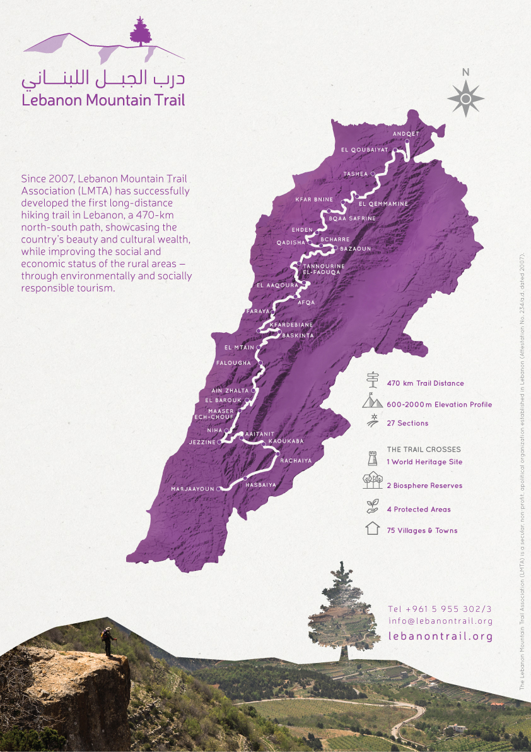

Source: Organization documents.

**Exhibit 2: LEBANON MOUNTAIN TRAIL ASSOCATION**

**GRANTS FOR SPECIFIC PROJECTS, 2015–2016**

Together with Italy’s Cooperazione per lo Sviluppo dei Paesi Emergenti (COSPE), the LMTA launched the Conservation and Development of Economic Opportunities on the Lebanon Mountain Trail project. The two-year pilot project was funded by the European Union through the Office of the Minister of State for Administrative Reform AFKAR III program. The project is being implemented in collaboration with the Italian Association for Responsible Tourism and local communities on four sections of the LMT in North Lebanon. It includes maintenance and development of the trail on the four sections, small community-based projects to promote destinations and conserve the LMT on these sections, and education programs at six local public schools.

**Total grant: €500,000**

With funds from the Swiss embassy in Lebanon, the LMTA began a project with the Fondation pour le développement durable des régions de montagne, entitled La montagne libanaise et ses enjeux : Malette pédagogique et ludique pour les enfants de 8 à 12 ans et leurs encadrants. The one-year project is being implemented in collaboration with the Ministry of Education and public schools. It includes the development of interactive educational tools and activities about the conservation of resources in the Lebanese mountains.

**Total grant: CHF150,000**

The LMTA received funds from USAID under the Lebanon Industry Value Chain Development project to implement a one-year project entitled Improving the Lebanon Mountain Trail as a Rural Tourism Destination. The project includes capacity building for local guides, the development of three side trails, and improving the LMTA website.

**Total grant: US$130,271**

Note: € = EUR = euro; $US1 = €0.9411 on December 1, 2015; CHF = Swiss franc; CHF1 = US$0.97 on December 1, 2015.

Source: Organization documents.

**EXHIBIT 3: LEBANON MOUNTAIN TRAIL ASSOCATION DONATIONS, 2015–2016 (IN US$)**

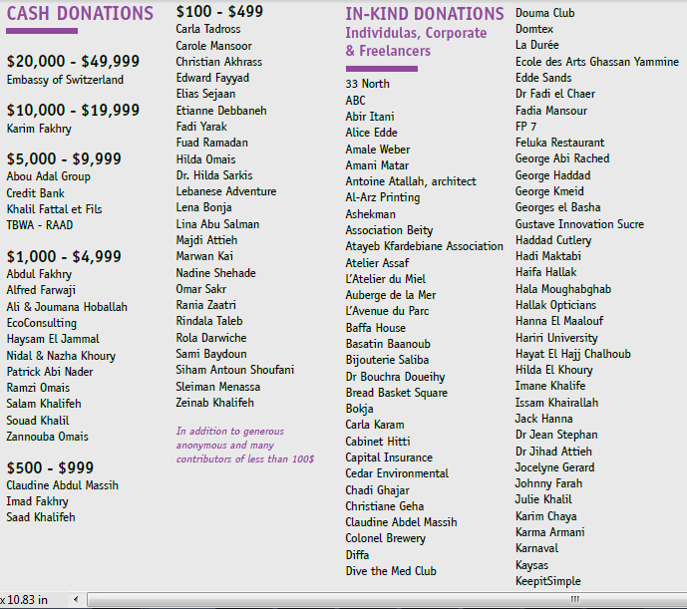

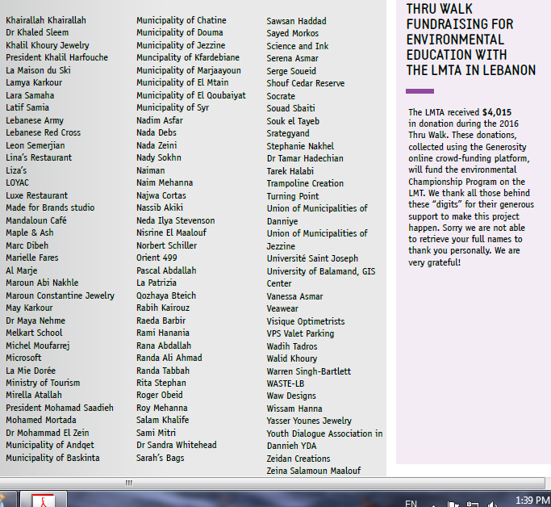

Source: Organization documents.

**EXHIBIT 4: LEBANON MOUNTAIN TRAIL ASSOCIATION 2015 INCOME STATEMENT**



Note: LBP = Lebanese pound; LBP1 = $US0.00066 on December 1, 2015.

Source: Organization documents.

# Exhibit 5: Lebanon Mountain Trail Association

# oRGANIZATIONAL CHART

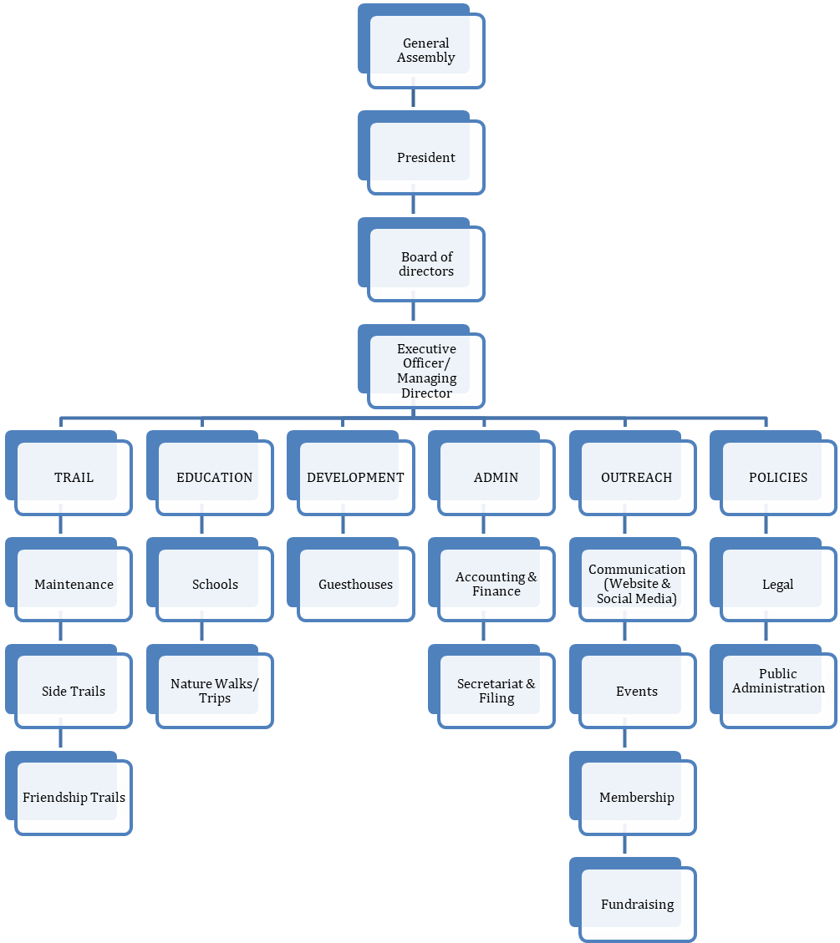

PROGRAMS/COMMITTEES

SUPPORT FUNCTION FOR PROGRAMS

Source: Organization documents.

**EXHIBIT 6: LEBANON MOUNTAIN TRAIL ASSOCIATION ACHIEVEMENTS, 2015–2016**

In 2015–2016, the LMTA achieved significant advances in all of its programs.

**Trail Program**

* The LMTA renewed signposts on the Baskinta Literary Trail side trail after small modifications were performed.
* 30 additional kilometres of the trail have been blazed.
* 60 hikers joined the Fall Trek in October 2015, while 180 joined the Thru-Walk in April 2016. Amounts of $25,000 and $65,000, respectively, were injected into local communities during these two months.
* A new side trail to Douma was launched in August, in collaboration with the municipality and the local communities.

**Community Development Program**

* The LMTA added 19 new places to stay, introduced seasonal menus promoting local specialties, and offered hosts expert training to ensure quality services were provided to guests.
* Three guesthouses were renovated in Ain Zhalta, Rashaiya, and Aaqoura. In addition, guesthouse owners were invited to help prepare the annual gala dinner.
* In Akkar el Atiqa, on section 1 of the LMT, a survey of the Church of Saints Sergius and Bakhous was carried out by the LMTA’s development team to evaluate its status and provide medium- and long-term recommendations for its preservation. In addition, a mapping of heritage sites was carried out for six sections of the LMT, including the preliminary localization and assessment of around 18 sites in these sections.
* The LMTA developed a calendar of events in collaboration with selected tour operators to promote food heritage on the LMT and increase the flow of visitors.

**Education Program**

* In partnership with the Ministry of Education and Higher Education, the LMTA’s education team organized two workshops for 65 health educators, school supervisors, coordinators, and teachers from 27 public schools to introduce them to the Water Awareness Teacher’s Guide. This guide was developed by the LMTA after studies carried out on the springs along the LMT.
* The LMTA launched the Trail To Every Classroom project in four public schools and one private school, selected from different villages along the LMT.
* 42 children aged between 10 and 12 took part in three editions of the Abtal Al Bi’a (Environmental Championship Program). As ambassadors for a better environment, the children were invited to launch environmental initiatives in their communities and recruit others to start making a difference.

Source: Organization documents.

# Exhibit 7: LEBANON MOUNTAIN TRAIL ASSOCIATION PLAN, 2016–2017

**Trail Program**

* Preparations will be made for the launch of two new side trails, Bkassine and Jabal Moussa, in collaboration with local municipalities and communities.
* The LMTA is updating LMT maps, taking into account segment loss, modification or addition over the last nine years, and adding the attractions that have been mapped along the trail since 2007.
* Individuals and associations may now adopt a section of the trail, taking responsibility for its maintenance and development, and providing direct or indirect financial sponsorship. The LMTA has already recruited 19 adopters and eight co-adopters, who are undergoing specific technical training.
* Upcoming events include the annual Fall Trek 2016, the Thru-Walk 2017, and a new initiative—running events along the LMT—which will allow local and international runners to experience the trail.
* Together with an arborist expert on the juniper tree and the Ministry of Agriculture, the LMTA is committed to cutting down all infected juniper trees along the LMT, to stem the disease rapidly spreading through the country.

**Community Development Program**

* The LMTA will continue mapping all archaeological and heritage sites along the LMT (an estimated 100+ sites), depending on the budget.
* At least two guesthouses will be refurbished, and eight owners will be given training.
* A modular training program is being designed to enhance the local guide services along the trail.
* The LMTA will be working closely with local communities and other stakeholders on sections 7 to 10, to develop their appeal as destinations and conserve the trail. This new project will take two years.

**Education Program**

* Forty-two more children will become champions this year. Abtal Al Bi’a camps are being supported both through corporate social responsibility actions and personal initiatives. The camps raise environmental awareness for children on and off the LMT.
* The Trail to Every Classroom initiative will be reaching out to six new public schools along the LMT this year, increasing the depth and scope of work with more time, outings, and activities allocated per school.
* The LMTA will develop a playful educational toolkit for children to raise their knowledge and awareness of our mountains as essential resources, of the challenges they face today, and how to change attitudes toward more sustainable development.

The LMTA team now has eight employees, in addition to seven ambassadors volunteering abroad, to assist in promoting the LMT through activities with hikers and associations.

Source: Organization documents.

1. Padeco Co. Ltd. and RECS International, Inc., *The Study on the Integrated Tourism Development Plan In the Republic of Lebanon* (Tokyo: Ministry of Tourism and Council for Development and Reconstruction, Republic of Lebanon and Japan International Cooperation Agency, 2004), accessed January 5, 2016, http://open_jicareport.jica.go.jp/pdf/11755048_01.pdf.
2. World Travel and Tourism Council, *Travel and Tourism: Economic Impact 2015 Lebanon,* accessed January 8, 2016, https://www.wttc.org/-/media/files/reports/economic%20impact%20research/countries%202015/lebanon2015.pdf.
3. Björn Rother, Gaëlle Pierre, Davide Lombardo, Risto Herrala, Priscilla Toffano, Erik Roos, Greg Auclair, and Karina Manasseh, *The Economic Impact of Conflicts and the Refugee Crisis in the Middle East and North Africa*, International Monetary Fund Staff Discussion Note (International Monetary Fund, 2016) accessed March 2, 2016, https://www.imf.org/external/pubs/ft/sdn/2016/sdn1608.pdf.
4. The World Tourism Organization (UNWTO) was a specialized agency of the United Nations.
5. Lebanon Ministry of Tourism, *Lebanon Rural Tourism Strategy*, 2015, accessed February 22, 2018, http://www.mot.gov.lb/Content/uploads/Publication/150225013030192~Rural%20Tourism%20Strategy_English.pdf.
6. *Hima* meant protected area in Arabic; it was a community-based approach used for the conservation of sites, species, habitats, and people in order to achieve the sustainable use of natural resources; Definition retrieved from Society for the Protection of Nature in Lebanon, accessed December 5, 2017, www.spnl.org/hima.
7. All currency amounts are in US$ unless otherwise specified.