

9B18M073

THE VIRTUAL MARKET: “MOM-AND-POP” SHOPS REBORN

Jasenko Ljubica and Miguel A. Montoya wrote this case solely to provide material for class discussion. The authors do not intend to illustrate either effective or ineffective handling of a managerial situation. The authors may have disguised certain names and other identifying information to protect confidentiality.

*This publication may not be transmitted, photocopied, digitized, or otherwise reproduced in any form or by any means without the permission of the copyright holder. Reproduction of this material is not covered under authorization by any reproduction rights organization. To order copies or request permission to reproduce materials, contact Ivey Publishing, Ivey Business School, Western University, London, Ontario, Canada, N6G 0N1; (t) 519.661.3208; (e)* [*cases@ivey.ca*](mailto:cases@ivey.ca)*;* [*www.iveycases.com*](http://www.iveycases.com)*.*

Copyright © 2018, Ivey Business School Foundation Version: 2018-05-01

It was out of indignation and with a sense of mission that, in August 2013, Cuevas Gonzales Cuevas and Espindola Espindola founded the Virtual Market in Mexico City. Cuevas and Espindola were Mexican and Spanish nationals, respectively, and lifelong friends who had spent their entire childhoods storming the “mom-and-pop” (i.e., family-owned) shops, or *tienditas* (i.e., small local stores), for some free candy.

Tienditas were an important element of the Mexican economy, producing approximately 15 per cent of the country’s true gross domestic product (GDP),[1] and represented a major contribution to retail sales in the Latin America and Caribbean (LAC) region. Cuevas and Espindola were indignant at witnessing the tienditas being overrun by big-box retailers—and they decided they had seen the last of it. The hypermarkets rushed to accommodate the new and sophisticated needs of the former customers of *tenderos* (i.e., the tiendita owners), who, thanks to increased economic growth and a rise in financial inclusion around the world (the LAC region included), had escaped the poverty of the base of the pyramid (BoP) and entered the middle of the pyramid (MoP) stratum.[2]

The MoP consumers expected more payment flexibility (e.g., the ability to use credit and debit cards), wider service and product selection, and, consequently, lower prices—an easy task for large retailers in possession of contemporary technology and state-of-the-art business knowledge, which enabled them to accommodate new consumer demands and expectations, and gradually ravish market share from the tienditas. For any tendero, this same task would be a difficult endeavour, given their typicallymodest business knowledge, skills, and resources; their tradition of basing their businesses on trust and social connections with their customers; their deeply socio-culturally-rooted aversion and distrust of modern intrusions that rendered them financially excluded; and their lack of any sort of tools to accommodate evolving customer needs.

Therefore, Cuevas and Espindola put themselves and their company on a mission to transform the traditional mom-and-pop shops into powerful market players and strong competitors to superstores. They set out to salvage not only the tenderos’ jobs and their families’ futures but also a tradition embedded deeply in the hearts and lives of the Mexican people, along with their significant contributions to the country’s economy. By 2017, the Virtual Market had successfully worked with 10,000 shops, but had still not attained break-even. How could they merge contemporary business tools and practices with traditional retailers while simultaneously tackling their high degree of informality, financial exclusion, low and unpredictable incomes, low margins, evolving customer needs, obsoleteness, and socio-cultural barriers, while also securing the scalability and profitability of their business?

THE RISE OF MOM-AND-POP STORES

The informal economy—defined by the International Labor Organization[3] as all economic activities of workers and economic units, in law or in practice, not covered or insufficiently covered by formal arrangements—was traditionally very profitable in the LAC region and represented 38 per cent of the region’s true GDP.[4] In retail, one of the most visible segments of this sector, the informal channel in the form of traditional, small family-owned stores, the so-called “mom-and-pop shops,” represented more than three-quarters of Latin American retail for fast-moving consumer goods in 2010.[5] This percentage grew immensely and reached a staggering 78 per cent of the region’s retail sales by 2016[6] with approximately 5 million[7] stores across the LAC region. The small-store segment was strong, as it served a large base of BoP and MoP consumers, while allowing good margins for manufacturers that applied higher prices to traditional retailers due to their small order volumes. In 2007, the market share of this traditional channel in Mexico was the largest in the LAC region, reaching approximately 48 per cent, which accounted for more than 1 million mom-and-pop stores producing approximately 15 per cent of the region’s GDP.[8] In 2016, despite a drop in their number, to 747,812 units, traditional shops remained important BoP and MoP retailers, producing 11 per cent of Mexicans’ overall grocery retailing sales and 36 per cent of traditional grocery retailers’ sales, with projected growth of 2 per cent by 2020.[9] However, due to the informality of the shops, these numbers may not have been completely accurate, and their exact number and contributions were impossible to determine precisely.

Both the owners and customers of the traditional mom-and-pop shops were largely those in the lower-income population. The overwhelming dominance of these shops grew over the years, due to several important factors. For example, the growth of this traditional, small-retailer format was driven by consumers’ limited earning power and the poor development in infrastructure across the LAC region, especially in rural areas. These traditional distribution channels meant that consumers could not only avoid costly travel to distant locations to purchase everyday necessities but also gain a sense of social connectedness and trust. Dual social, and commercial connections between the shop owners and their low- and middle-income customers represented the key reasons why the tienditaswere the key retail channel serving these segments.[10] Customers’ daily local purchases strengthened their personal relationships and trust with the tenderos. Thus, the culturally embedded behaviour of low- and middle-income consumers in the LAC region determined their basic needs for proximity, trusting relationships, the convenience of smaller size, and a social connection as driving their consumption in these regions and, consequently, the success of mom-and-pop stores over recent decades.

In addition, due to low overhead costs, none of the independent traditional retailers needed to serve a large consumer base on their own. They were located where modern retailers did not venture—rural areas and gaps around modern outlets in urban areas. BoP and MoP consumers made small and frequent purchases at these local commercial–social hubs because of their proximity and convenience. Sixty-seven per cent of the lower-income households in the region rarely ventured to locations different from those they usually frequented.[11] Due to social and cultural reasons, they were often willing to purchase a second-best product and pay a higher price rather than venture out of their communities or shop at new and unfamiliar locations.

The customers and tenderos at the BoP and MoP relied on each other. The tenderos provided products that customers needed, in quantities they needed, and allowed “trust-based credits,” enabling their customers to purchase products and pay when they had the funds, without requiring that customers have steady jobs, formal financial histories, or credit or debit cards. In exchange, customers would display trust in “their” tenderos, expressing their loyalty through everyday visits to their shops. For the tenderos’ fiercest competitors—the modern big-box hypermarkets such as Walmart and Superama—such services were practically impossible. Indeed, BoP and MoP members, both buyers and sellers alike, were unified in their opinion that large corporations largely ignored their lifestyle and needs, which further served to strengthen their relations.

**A THREAT EMERGING**

While mom-and-pop shops enjoyed a plethora of advantages, such as accessibility, convenience, and trust, which made them the driving force of the Mexican and LAC retail sector and a tradition deeply felt in the hearts of the people, they did have their deficiencies. The problems that had pushed the mom-and-pop shops to the verge of extinction were threefold—they included the tendero’s lack of contemporary business skills; the evolution of the shop’s BoP and MoP customers; and the emergence of the fierce competitors.

First, many shop owners and their employees had limited education and suffered from illiteracy. Not only basic illiteracy but also business illiteracy were significant weaknesses for many of the traditional retailers, with the latter, in particular, leading to challenges in terms of business finances, marketing, stock management and control, planning, and other business skills, which were all critical in the modern business world. In a World Bank survey of 2,022 Mexican tenderos, 47 per cent reported that they possessed either elementary education or no education at all, while only 15 per cent possessed some sort of tertiary education. In addition, more than 50 per cent of those surveyed revealed they had no sources of information in terms of business skills.[12] Congruently, only 30 per cent of those surveyed understood basic business terms such as “product diversification,” with only 41 per cent doing any kind of business planning; of those, only 34 per cent actually stuck to those plans. Traditional tenderos, similar to all BoP and MoP members in emerging markets in the LAC region, including customers, had low, erratic, unstable, and uneven incomes, which were rarely predictable.[13] As such, they lacked basic education, essential knowledge, and access to contemporary retail technologies and managerial skills. Lack of knowledge made them unaware of the benefits that such technology and skills could provide once mastered, and thereby fostered their fear of the same, which in turn deterred the use of these skills in mom-and-pop shops’ daily businesses.[14] Since shop customers were people who had the same or a similar level of literacy, both generally and in terms of their business sense, these incapacitations, at first, did not hurt tenderos and their businesses, as their convenience and trust were far more respected and appreciated by the customers.

However, when the customers themselves became more educated, a disparity grew between them and shop owners and employees, reflecting the second problem that shadowed the mom-and-pop shops—the evolution of the customer.

The seeds of the customer evolution were themselves threefold, entailing the upsurge in the regional economic growth; the congruent rise in financial inclusion; and the emergence of new technologies. Economic growth enabled a large portion of people to rise from the base of the pyramid to the upper middle of the pyramid. Across the LAC region, people at the BoP experienced an annualized income growth of 9 per cent between 2004 and 2012.[15] During this time, labour income growth was by far the biggest driver behind the strong reduction in poverty in the region, where median income rose from US$2 per day to $6 per day,[16] and steady growth was expected to continue.[17]

Mexico followed such trends with its own steady annual growth in GDP from 1.4 per cent (Mex$13,470.9 billion[18]) in 2013 to 3.5 per cent (Mex$15,155.1 billion) in 2017; this was expected to grow annually by 3.8 per cent (Mex$16,930.6 billion) until 2020.[19] Congruently, the gross national income of the country rose from $8.79 in 2010 to $9.04 in 2016.[20] The combined momentum ignited the rise of the MoP consumers, both in the region and throughout the country. The growth in Mexico’s middle class was among the greatest in the LAC region, reaching 12 per cent from 1990 to 2010, which translated into household consumption increasing by 10 per cent from 2012 to 2016.[21] Hence, new and larger middle-income segments in the LAC region and Mexico now had at their disposal higher and steadier (but still limited) income. Those higher earnings were accompanied by financial tools and services, such as credit cards, debit cards, cashless transactions, and monthly payments. However, the use of these contemporary financial services depended on the second issue propelling the evolution of the mom-and-pop shops’ customers—financial inclusion. LAC countries experienced a rapid rise in the financial inclusion of MoP customers. Latin American nations exerted effort and enjoyed success in bringing the new MoP members into the financial system, including 40 million adults who, until the end of 2012, started receiving payments to their bank accounts. The same year, 51 per cent of adults in the region had a bank account, up from 39 per cent in 2011. Until the end of 2014, 28 per cent of adults across the LAC region made payments directly from their account using a debit card, a credit card, or both.[22]

Between 2012 and 2015, users of any type of Mexican financial services grew, on average, by 5 per cent up to 33 per cent, depending on the financial service. For example, the percentage of bank account holders grew from 35 per cent to 41 per cent of the adult population, with 27 per cent of account holders having opened an account for the first time.[23] The percentage of loan and savings users also grew, from 48 per cent to 55 per cent of the adult population in the same interval. Debit card owners increased from 29 per cent to 37 per cent of the adult population, while credit card owners remained steady, at 24 per cent of the total number of adults.[24]

Lastly, the final force that wrapped up the customer evolution in the LAC region and in Mexico were new disruptive technologies, such as online and mobile platforms that, coupled with progressive public policies, offered cost-effective opportunities to the MoP customers. In the LAC region, starting from 2015, many nations had begun to implement previously adopted legislation and strategies, specifically designed to increase access to financial services by initiating the use of payment systems, electronic money, and credit facilities. These activities facilitated the adoption of such technologies by MoP customers. Accordingly, in Mexico between 2012 and 2015, adults using Internet banking services grew by 16.2 per cent, or approximately 25 million adult users; adults using mobile banking services grew by 9.5 per cent, or approximately 6.1 million adult users. E-commerce in the country boomed with 55 million Internet users, of which 22 million (40 per cent) were Internet shoppers.[25] Incomes and, congruently, access to affordable, diverse financial services had, evidently, expanded and deepened in the LAC region and Mexico.[26] These trends transformed buyers into more sophisticated and more demanding consumers, who asked for and expected flexibility and variety in payment methods, lower prices, and a wider range of products. Taken together, evolving customers’ needs, desires, and preferences; the appearance of new retail technologies; and the lack of mom-and-pop shops’ business literacy severely weakened the development potential of the tienditas, rendering them unable to comply with new customer expectations.

The third problem for the local shops was the emergence of fierce competitors in the form of large retail companies equipped with state-of-the-art business knowledge and technology that started conquering what had for many years been the mom-and-pop shops’ market. The new competitors provided consumers with a greater variety of products and services and lower prices, as they took full advantage of their economy-of-scale approach to purchasing and retailing. They also provided greater payment flexibility, allowing a variety of payments methods (e.g., monthly and weekly payments, consumer credit, and short-term loans), accommodating the customers’ use of credit cards and debit cards. The hypermarkets delivered additional conveniences, such as the ability to pay utility bills (e.g., phone, television, gas, and electricity) at their stores in cash or online by using a credit card. Congruently, Mexico’s big-box retailers in hypermarket and supermarket formats grew to become the largest retailer by sales value. By 2003, the supermarket sector accounted for roughly 30 per cent of retail food sales, and 45 per cent of all retail sales.[27] From 2008 to 2013, this channel captured a 48.3-per-cent share of the total retail market.[28]

In 2013, the supermarket sector represented retail revenues of Mex$1,060,858.6, which was estimated to increase to Mex$1,346,712.2 by 2018.[29] The business illiteracy and socially-embedded fear induced the inability of the mom-and-pop shops to offer contemporary retail services that represented “business as usual” for large retailers. Such inability had a devastating effect on the shops, which was reflected in the estimation that, for the opening of every new modern retailer, five to six traditional mom-and-pop stores experienced a loss in revenues of up to 40 per cent.[30] In a chain-reaction effect, those problems spilled over to not only the suppliers, who had low access to traditional stores, lack of visibility, and low productivity, but also to customers, who had a limited variety of products to select from and faced an even greater number of higher-priced goods. Although the traditional store formats employed many people, on a national level such informal, financially-excluded traditional store formats were almost impossible to supervise and, therefore, their real contribution to the national economy remained unknown. Also imposing a significant threat to the survival of traditional shops were the rise and popularity of the modern convenience stores (e.g., OXXO and 7-Eleven) and the superstores (e.g., Walmart, Soriana, and Superama). The tenderos’ retail business illiteracy and technological and financial exclusion, paired with strong new competition, led to a rapid loss of customers and declines in revenues and profits. Indeed, difficult times loomed for mom-and-pop-shops, and their ultimate survival was at risk.

THE VIRTUAL MARKET

**The Mission**

In 2013, after years of witnessing the struggle and the supervening extinction of mom-and-pop shops, Cuevas and Espindola founded VM in Mexico City. Driven by a desire to support traditional tenderos as essential players in Mexico’s economy and culture, they aimed to help the shop owners make their businesses more competitive with the large chains, and, most importantly, ensure their survival and improve the quality of life for their families. The pair articulated their desire into the company vision of becoming the largest network of affiliated stores in Mexico or, as they liked to say at the VM, the “Airbnb of mom-and-pop stores.” It was on these bases that the VM forged its mission—“to become the largest traditional store chain in the world by affiliating independent mom & pop stores, providing them with modern retail practices and technology and increasing their market-competitiveness to ensure their market survival and improvement of lives of shops owners and employees.”

**Mission Impossible**

Such a mission was a challenging one, indeed. To be able to help the tenderos face the threats casting a shadow over their future and to realize its own mission, the VM needed to face challenges of its own, reflecting on the myriad of problems inside and outside the shops.

Inside the shops, the VM needed to ignite the business and technological evolution, which was critical for the market battle with large chains, while breaking traditional merchants’ aversion toward such evolution, and simultaneously continuing to maintain their social cohesion with the BoP and MoP customers that large retailers lacked. Traditional tenderos’ decision making, which had been based on “a feeling or a “hunch,” needed to be replaced by modern tools that would enable them to execute various activities by applying business and market intelligence, which were “business as usual” in large retail chains. Such improvements were the only hope for mom-and-pop shops to accommodate the rapidly changing habits, needs, and preferences, and the still—in some ways—unsteady and sporadic payment abilities of their customers. As customers’ needs evolved over time, and in an effort to match the competitors, the VM needed to find a way to extend the range of services that shops offered to their customers, such as the payment of utility bills (e.g., phone, water, and electricity), while also enabling the purchase of additional necessities, thereby increasing their attractiveness to regular shoppers and potentially attracting new shoppers. In addition, the VM needed to address the burning needs of mom-and-pop shops to optimize and upgrade their “spatially limited” stock capacities and stock management capabilities. The VM aimed to equalize the shops’ portfolios of products with their sales history, by increasing productivity and eliminating shops’ tendencies to be out of certain products while being overstocked in other products, which rendered their offerings inadequate to customers and, consequently, hampered their sales.

To make such an evolution sustainable, the company needed to empower the tenderos with contemporary business knowledge, enabling them to handle modern retail tools on their own. Considering the notorious distrust and aversion of the traditional tenderos to such modern intrusions, the task for the VM was even more challenging. Because of the tenderos’ unwillingness to accept change, their financial inability to afford technological innovations, and the lack of knowledge that was necessary to tackle the threat of the large retailers, the VM’s task was to design a social approach and gain the trust of the tenderos so they would accept the VM’s model. Trust was necessary to transfer knowledge to these people on how to efficiently handle new technologies, which, of course, also needed to be socially adequate with respect to each merchant’s prior experience and educational background. The VM needed to develop its relationship with the tenderos gradually, not only by providing the tools and the knowledge but also by nurturing this relationship and supporting their clients.

From the supply side, due to shops’ inconsistent incomes and, consequently, inconsistent delivery payments, combined with suppliers’ reluctance to supply the stores with a second order before the first one had been paid for, a solution was needed to optimize communication and overall collaboration between the shops and suppliers. This task was important for preventing not only poor inventory management, but also the spill over of these supply problems to the customers, who would then have an even narrower range of products to choose from, which would make the shops even less competitive with the offerings of the large superstores. With strict spatial limitations, and consequently product volume limitations, another challenge the VM needed to remedy was the tienditas’ inability to achieve lower prices from their suppliers in order to compete with big-box stores. Suppliers were also displeased with the lack of feedback about their products, leaving them uninformed about the products’ display, promotion, and sales, and thereby posing another task for the VM.

The VM also needed to end the informality and financial exclusion of the shops, in order to transform them from one of the major factors of Mexico’s grey, or even dark economy to, concerning its size, a significant contributor if not the flagship and competitive advantage of the country’s economy. Such formalization was also important, as it had the potential to make mom-and-pop shops more reliable business partners for various entities. In terms of competitiveness and business security, financial inclusion would make the shops eligible to receive various financial aid and services such as access to working capital, should they require it.

Considering the magnitude of the VM’s mission, the company needed to design an innovative business model and value chain by including, addressing, and harmonizing the interests of various stakeholders, ranging from the tenderos, customers, suppliers, financial institutions, and the country itself, while at the same time securing scalability of its model and profitability of the company. Acknowledging the notoriously low income levels of the tenderos, which ranged from $4 to $12 per day[31] and the company’s social mission of helping and supporting but not taking over the tienditas, the business model could not presume ownership of a single store. The company could place (at most) a modest financial pressure on the tenderos. Hence, the financial backbone of the company’s business model needed to enable a harmonious combination of stakeholders’ interests and the company’s financial upswing, while not interfering with the social ideology of ministering the shop’s market competitiveness and improving the tenderos’ businesses and lives.

**Mission Accomplished. Or Is It?**

Finally, after several years of extensive research and development, in summer 2013, when the largest number of tienditas were operational due to tourist season, Cuevas and Espindola decided their business model was ready for market. They started to present and offer their solution to a few local tienditas in Mexico City, close to their newly-founded company’s central office. After a few initial visits and expected resilience from the tenderos, Cuevas and Espindola were persistent and eventually gained the trust of many tenderos. The VM could then start working with its first clients.

In the first step, the VM equipped the tienditas with the Integral Store Management Tool Kit (ISMK; see Exhibit 1) featuring a point-of-sale terminal, a card reader, a fingerprint reader (for security purposes), a receipt printer, and a wireless Internet connectivity router—all in a distinctive orange colour and accompanied by a promotional display for customers and a touch screen for owners or operators. The VM did not sell the kit—it was provided free of charge to shops, along with the Internet connection needed for the terminals. The $7.60 monthly membership fee was the tenderos’ only obligation to the VM. The ISMK delivered a variety of new opportunities for shops, such as an analysis of various market indicators, which facilitated performance evaluation and real-time response. It allowed both the shops and suppliers to analyze shoppers’ traffic and determine their optimal portfolio of products and services, according to customers’ purchases and payments, thereby improving revenues, incremental sales, and overall productivity.

The status of every store’s items was available in only one or two clicks, and the system displayed a warning to the operator when certain items were low in stock. Replenishment of the stock was also only a few clicks away, as the tenderos could use the terminal to submit an order directly to the supplier and pay for it. The ISMK also generated the suggested orders’ sell-outs (i.e., shops’ selling of the product to customers), sent them to suppliers, and forwarded the orders suggested by the supplier to the shops. Shops and suppliers could use the ISMK to communicate a promotion or discount based on the shop’s purchasing and payment histories, allowing tenderos to achieve lower costs, which they could transfer, as lower prices, to their customers to boost sales and customer loyalty. To use the ISMK, the shop, as a legal entity, it was required to have a bank account, which ensured they were operating in the formal sector, enabling tax collection and government oversight. With this financial inclusion, the VM also built partnerships with credit card and debit card issuers, connecting issuers with the ISMK interface and enabling BoP and MoP customers to pay for their purchases and more than 40 different utility bills at the shops using their cards, to be paid either all at once or in limited monthly installations. The ISMK also provided the stores with an eWallet, a service for financing additional products and services or for gaining working capital from microfinance institutions based on the shop’s credit history, its payment history, or both.

After two and a half years of operations, the company decided to rethink its model as a result of two factors: the number of mobile banking users rising by an incredible 123 per cent, from 1.4 million to 3.2 million, in both Mexican BoP and MoP from 2015 to 2016,[32] and the VM’s desire to cut additional costs to reach its break-even point faster. Thus, after a year of development, starting in July 2017, the VM introduced a mobile application (app), the VM Móvil (see Exhibit 2), which absorbed all functions of the ISMK but eliminated its hardware and its related costs (see Exhibit 3). The VM also offered an additional retail innovation called “growth challenges” (see Exhibit 4). Using the app, suppliers, based on both the analytics of their products’ status and traffic in the shops and their own strategic plans, could now send “growth challenges” to the tenderos to encourage sell-in (i.e., suppliers’ product being sold to the shop) and sell-out, or in-store execution of their products. If the tenderos successfully completed the “challenges,” they gained rewards in their eWallets (e.g., discounts). Once the contract had been signed and the maintenance of the app (e.g., upgrades and malfunctions) had been arranged (also free of charge), the VM arranged for the tenderos to receive a free download of the app, which was designed to require only a low-technology cellular phone to avoid large investments in smartphones.

In addition to the technological upgrades, the tenderos, and potentially their employees, received free on-site, classroom, or virtual training on operating the terminals and apps, and contemporary retail practices such as pricing, promotions, and exhibits, either by the VM alone or in collaboration with suppliers. The VM provided the shops with the Integral Activation Plan, which comprised biweekly promotional activities to generate sell-in and sell-out through the eWallet. Another service that tenderos received was the Awareness Plan, which included a biweekly advertising plan for the shops aimed at increasing both overall sales and the sales of products that had lower sale frequencies. The one-on-one communication was a further benefit of the VM’s model, as it enabled homogeneous communication between suppliers and shops regarding plans and commercial programs (e.g., value propositions, innovations, sales contests, and offers).

To attract the largest number of tenderos possible and to acknowledge socio-cultural barriers, the company devised a multi-stage process of attracting, training, and retaining shops—the so-called “stores affiliation model” or the Immersion, Attraction, Adoption, and Addiction (IAAA) model(see Exhibit 5). The immersion stage referred to gaining contacts through direct sales, commercial allies, and private contacts. The VM’s sales representatives, uniformed in distinctive orange shirts, each performed an average of 150 daily visits to the shops in their area and presented storeowners with the VM’s business model by explaining the advantages, benefits, and costs of implementing the VM’s business solution. Tenderos that showed interest and were proved to be viable (i.e., honest) business partners were invited to the engagement sessions to learn more about the VM business model and the nature of the proposed collaboration. In the week-long attraction stage, the VM deployed a series of training sessions at one of its training centres and assigned the ISMK kits (later, it installed apps). The adoption and addiction stages focused on in-store coaching and mentoring during real-life sales situations.

According to the VM’s sales representatives, the main challenge in this work was gaining the trust of the tenderos, as they were often reluctant to collaborate with unknown, high-tech companies, as the tenderos work principles tended to be relationship-based. However, once a trusting relationship was established, the VM sales representatives focused on nurturing shops as a critical part of the company’s value chain, and working further to acquire new shops through positive word-of-mouth. Every sales representative had their own area of responsibility as well as their own tenderos. Sales representatives received commission-based salaries, which varied depending on the number of new tenderos recruited. Every subsidiary of the VM had a supervisor, a tech-support officer, and sales representatives, who provided assistance by phone or on-site. Most problems were related to technological issues, although these issues decreased over time as store owners gained sufficient experience in handling the VM’s hardware and, later, its software.

Similar to its business model, the VM’s revenue model also had to be highly innovative. During the three years (2013–2016) of the “ISMK era,” advertising the VM’s ISMK (especially for suppliers to mom-and-pop shops) led to increased visibility for every tienditaunder the VM’s umbrella, and was responsible for 53 per cent of the VM’s revenues. For sales transactions that involved a bank or credit card company, the VM charged a fixed percentage of the sale to avoid transferring this burden to the stores or customers; such sales represented 33 per cent of all revenue. Membership fees constituted a mere 3 per cent of revenues, confirming the company’s commitment to helping and not exploiting the vulnerable traditional stores. Finally, the VM earned approximately 11 per cent of revenue from business intelligence and from service charges to the suppliers for the use of analytical lab tools. Once the VM Móvil became operational, the VM’s revenue structure changed slightly. Advertising income increased to 70 per cent of the VM’s total income, while 20 per cent came from transactional revenue services and 10 per cent from tenderos’ fees. The VM’s cost structure included the following: store owners’ training (28 per cent); hardware (21 per cent, eliminated after the introduction of the app, which decreased selling expenses by 50 per cent, from Mex$7,877,964 in 2016 to Mex$3,314,033 in 2017); Internet connectivity (17 per cent); hotspots and promotional screens (13 per cent); marketing and overhead (13 per cent); and innovation and technology (8 per cent).

By the end of 2016, the VM had 10,000 shops under its umbrella, generating approximately Mex$400,000 in monthly sales with an average bill of Mex$25. In November 2017, after the ISMK era and only five months after its introduction, the VM Móvil had an average of 6,000 active monthly users, 1,970 active daily users, and 138 new daily users. Due to heavy investments reaching $20 million in a three-year period (2013–2016), which were needed to develop and scale the model, the company had been operating with losses. However, the VM’s financial losses had a curvilinear trend, in that both gross profits (i.e., earnings before income and taxes) and net annual losses had been on a steady rise due to investments, but beginning in 2017 had started to fall (see Exhibits 3 and 6). The VM Móvil fostered the VM’s plans to absorb 200,000 traditional shops in Mexico in the long term and expand to foreign emerging markets, as a result of the VM’s innovative business model, brand name, and easier technology acceptance. Based on the up-to-date success of both its mission and its innovative business model, which were recognized and accepted by both the shops and the stakeholders, the VM planned to break even with all of its investments by April 2018.

However, although the VM was innovative and pioneering in the market, considering the company still needed to break even, was its business model truly economically sustainable in the long term? Could it function in other countries and cultures? Did the VM represent the saviour and the future of traditional retail, or was it just a “shot in the dark”—a random and ill-fated attempt to help the tenderos—that would ultimately be unsuccessful?

EXHIBIT 1: THE INTEGRAL STORE MANAGEMENT KIT

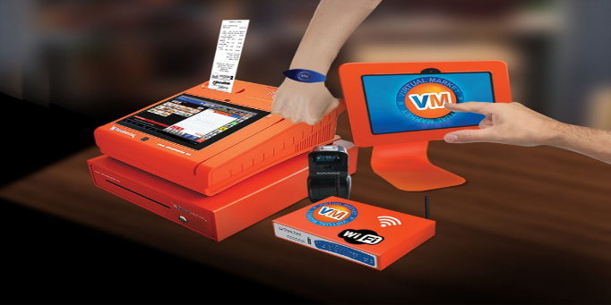

Source: Company documents.

EXHIBIT 2: The Virtual Market MÓvil App

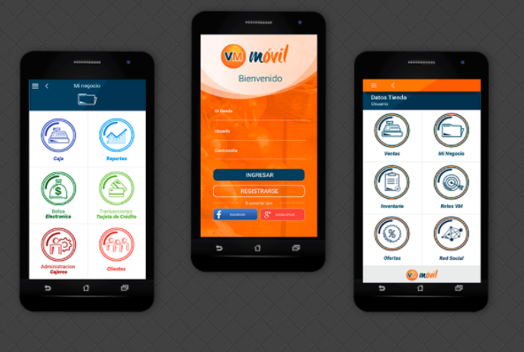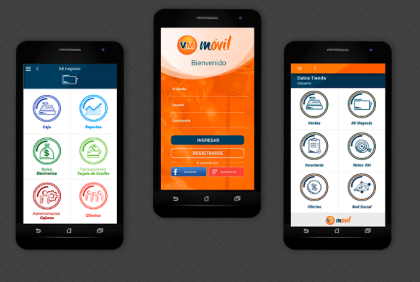

Source: Company documents.

Exhibit 3: The Virtual Market Income Statements, 2013–2017 (in MEX$ millionS)

|  |  |  |  |  |  |
| --- | --- | --- | --- | --- | --- |
|  | 2013 | 2014 | 2015 | 2016 | 2017 |
| Income | 221,216 | 15,461,342 | 86,961,583 | 147,015,950 | 114,680,669 |
| Costs | (205,731) | (15,210,160) | (84,156,357) | (134,432,426) | (106,756,076) |
| Profits | 15,485 | 251,182 | 2,805,226 | 12,583,524 | 7,924,594 |
| Direct Cost |  |  | (14,700,086) | (46,610,439) | (37,078,067) |
| Indirect Cost |  |  |  | (1,067,106) | (670,914) |
| Operational Cost | (343,661) | (9,774,411) | (15,118,189) | (26,651,728) | (11,167,630) |
| Gross Profit (EBIT) | (328,176) | (9,523,229) | (27,013,049) | (61,745,749) | (40,992,016) |
| Publicity and Promotion |  |  | 0 | (702,723) | 0 |
| Profits/Losses before Indirect Costs | (328,176) | (9,523,229) | (27,013,049) | (62,448,472) | (40,992,016) |
| Selling Expenses |  |  | (3,565,415) | (7,877,964) | (3,314,033) |
| Administration Expenses | (1,743,386) | (15,946,245) | (48,207,654) | (36,044,609) | (23,991,832) |
| Net Profits/Losses | (2,071,562) | (25,469,474) | (78,786,117) | (106,371,045) | (68,297,882) |
| Other Expenses | (142,857) | 153,281 | (6,972,447) | (26,332,592) | (4,927,178) |
| Net Profits/Losses for the Period | (2,214,419) | (25,316,193) | (85,758,564) | (132,703,638) | (73,225,060) |

Note: Mex$ = MXN = Mexican peso; Mex$1 = US$0.05 on March 31, 2017; EBIT = earnings before interest and taxes

Source: Company documents.

EXHIBIT 4: The Virtual Market MÓBil App showing Growth Challenges

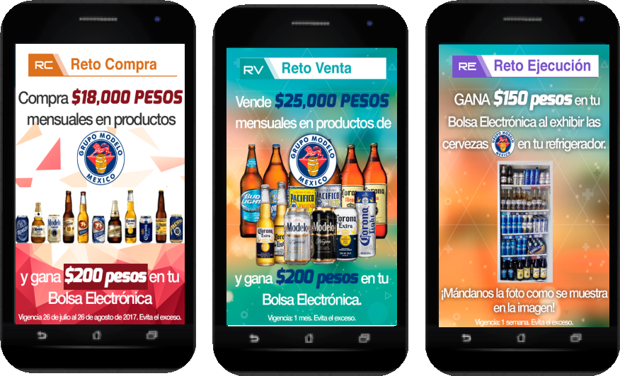

Note: From left to right, purchase challenge: buy Mex$18 of Grupo Modelo (brewery) products in one month and win Mex$200 in your eWallet; sales challenge: sell Mex$25 of Grupo Modelo (brewery) products in one month and win Mex$200 in your eWallet; execution challenge: win Mex$150 in your eWallet by exhibiting Grupo Modelo (brewery) products in your refrigerator (send us [the Supplier] a photo of the refrigerator)

Source: Company documents.

EXHIBIT 5: the Virtual Market’s IAAA MODEL

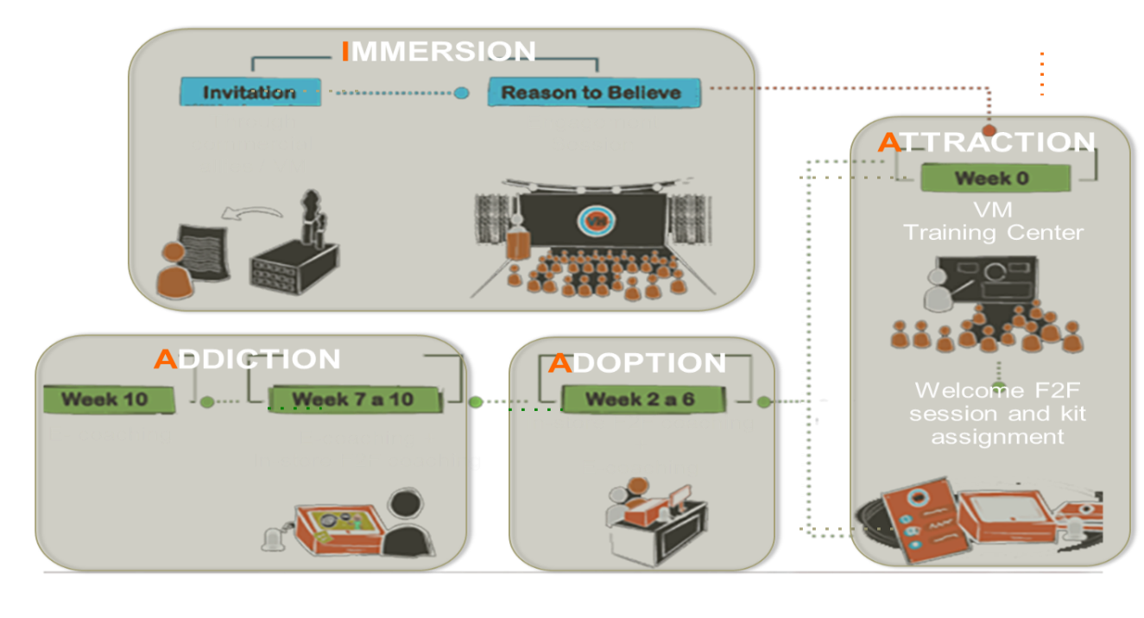Note: IAAA = immersion, attraction, adoption, addiction

Source: Company documents.

Exhibit 6: Virtual Market Balance sheets, 2013–2017 (in MEX$ millionS)

|  |  |  |  |  |  |
| --- | --- | --- | --- | --- | --- |
|  | **2013** | **2014** | **2015** | **2016** | **2017** |
| **Current Assets** | | | | | |
| Cash and Cash Equivalents | 1,062,792 | 5,984,892 | 34,583,172 | 34,412,394 | 19,537,690 |
| Clients |  | 77,903 | 101,282 | 4,045,335 | 2,616,661 |
| Various Debtors |  | 11,853,188 | 2,050,565 | 2,560,445 | 2,101,041 |
| Tangible Assets Inventory |  |  | 4,277,496 | 2,035,682 | 2,540,621 |
| Advances from Suppliers | 22,642 | 1,269,692 | 5,145,801 | 9,905,586 | 7,069,306 |
| Taxes in Favour | 495,903 | 5,497,401 | 21,996,873 | 38,404,262 | 45,770,073 |
| Total Current Assets | 1,581,337 | 24,683,075 | 68,155,189 | 91,363,704 | 79,635,392 |
| **Noncurrent Assets** | | | | | |
| Furniture, Office Equipment, and Other | 628,497 | 1,686,178 | 3,404,573 | 3,846,592 | 3,271,903 |
| Point-of-sale Equipment |  | 5,481,595 | 56,114,419 | 74,193,493 | 61,843,002 |
| Accumulated Depreciation | (29,824) | (1,033,470) | (4,893,956) | (22,598,444) | (41,707,057) |
| Guarantee Deposits and Other Deferred | 14,075 | 327,528 | 1,895,198 | 2,084,355 | 1,815,717 |
| Unearned Financial Interests |  |  | 3,624,929 | 5,165,771 | 13,113,738 |
| Intangible Assets | 1,048,719 | 1,044,182 | 20,975,769 | 20,993,863 | 20,993,863 |
| Total Noncurrent Assets | 1,661,466 | 7,506,013 | 81,120,932 | 83,685,630 | 59,331,166 |
| Total Assets | 3,242,804 | 32,189,088 | 149,276,121 | 175,049,334 | 138,966,557 |
| **Current (Short-term) Liabilities** | | | | | |
| Leases |  |  | 5,818,721 | 14,092,050 | 3,661,196 |
| Preferred Stock Interests |  |  | 12,876,637 | 610,323 | 974,323 |
| Suppliers | 47,331 | 41,559 | 5,261,078 | 2,076,771 | 4,876,659 |
| Various Creditors | 297,933 | 2,098,736 | 4,377,589 | 4,419,594 | 2,764,375 |
| Tax to Pay |  | 25,735 | 28,765 | 1,779,889 | 1,781,020 |
| Accumulated Reserves |  |  |  | 208,587 | 208,587 |
| Total Short-Term Liabilities | 345,263 | 2,166,030 | 28,362,789 | 23,187,214 | 14,266,160 |
| **Long-term Liabilities** | | | | | |
| Leases |  |  | 11,386,635 | 17,621,453 | 29,185,056 |
| Total Liabilities | 345,263 | 2,166,030 | 39,749,424 | 40,808,666 | 43,451,216 |
| **Stockholders’ Equity** | | | | | |
| Fixed Stockholder Equity | 70,922 | 67,376 | 67,376 | 67,376 | 67,376 |
| Variable Stockholder Equity | 1,984,710 | 53,480,756 | 72,502,283 | 374,521,049 | 409,020,783 |
| Preferred Stocks |  |  | 147,401,168 | 2,800,010 | 2,800,010 |
| Premium in Stocks | 3,056,328 | 4,005,540 | 4,005,560 | 4,005,560 | 4,005,560 |
| Profits/Losses of Earlier Years |  | (2,214,420) | (28,691,125) | (114,449,690) | (247,153,328) |
| Profits/Losses | (2,214,420) | (25,316,194) | (85,758,565) | (132,703,638) | (73,225,060) |
| Total Stockholder Equity | 2,897,540 | 30,023,058 | 109,526,697 | 134,240,667 | 95,515,341 |

Note: Mex$ = MXN = Mexican peso; Mex$1 = US$0.05 on March 31, 2017.

Source: Company documents.

Endnotes

1. Euromonitor International, *Grocery Retailers in Mexico*, December 2016, accessed October 27, 2017, www.euromonitor.com/grocery-retailers-in-mexico/report.
2. Schumpeter, “Mammon’s New Monarchs: The Emerging-World Consumer Is King,” *The Economist*, January 5, 2013, accessed November 5, 2017, www.economist.com/news/business/21569016-emerging-world-consumer-king-mammons-new-monarchs.
3. Ralf Hussmanns, International Labor Organization, *Statistical Definition of Informal Employment: Guidelines Endorsed by the Seventeenth International Conference of Labour Statisticians (2003)*, accessed November 5, 2016, Pg. 2 http://ilo.org/public/english/bureau/stat/download/papers/def.pdf.
4. Euromonitor International, *Grocery Retailers in Mexico*, December 2016, accessed October 27, 2017, www.euromonitor.com/grocery-retailers-in-mexico/report.
5. [Andres Cadena](https://www.mckinsey.com/our-people/andres-cadena), [Jaana Remes](https://www.mckinsey.com/our-people/jaana-remes), [James Manyika](https://www.mckinsey.com/our-people/james-manyika), [Richard Dobbs](https://www.mckinsey.com/our-people/richard-dobbs), Charles Roxburgh, Heinz-Peter Elstrodt, [Alberto Chaia](https://www.mckinsey.com/our-people/alberto-chaia), and Alejandra Restrepo, “Building Globally Competitive Cities: The Key to Latin American Growth”, McKinsey Global Institute, August 2011, accessed October 27, 2017, www.mckinsey.com/global-themes/urbanization/building-competitive-cities-key-to-latin-american-growth.
6. Euromonitor International, *2017 Retailing Top Trends in Latin America*, February 2017, accessed October 27, 2017, www.euromonitor.com/2017-retailing-top-trends-in-latin-america/report.
7. Viviane M. R. Azevedo, Alejandra Baigún, César Patricio Bouillón Buendia, Duncan Duke, and Maria Lourdes Galiardo Montoya, *A Rising US$750 Billion Market: Unlocking Opportunities at the Base of the Pyramid in Latin America and the Caribbean*, Inter-American Development Bank, March 2015, accessed November 5, 2017, https://publications.iadb.org/bitstream/handle/11319/6992/A_Rising_US$750_Billion_Market.pdf.
8. Allen L. Hammond, William J. Kramer, Robert S. Katz, and Jula T. Tran, *The Next 4 Billion: Market Size and Business Strategy for the Base of the Pyramid* (Washington, DC: World Resources Institute and International Finance Corporation, June 2007), accessed November 5, 2017, <http://pdf.usaid.gov/pdf_docs/Pnadl883.pdf>.
9. Euromonitor International, *2017 Retailing Top Trends in Latin America*, op. cit.
10. Coimbatore Prahalad and Stuart Hart, *The Fortune at the Bottom of the Pyramid* (Berkeley, CA: University of California Berkeley, 2004).
11. Azevedo, et al., op. cit.
12. Rekha Reddy, Miriam Bruhn, and Congyan Tan, “Financial Capability in Mexico: Results from a National Survey on Financial Behaviors, Attitudes, and Knowledge”, The World Bank, November 2013, accessed November 5, 2017, http://documents.worldbank.org/curated/en/653031468287158989/Financial-capability-in-Mexico-results-from-a-national-survey-on-financial-behaviors-attitudes-and-knowledge.
13. Euromonitor International, *2017 Retailing Top Trends in Latin America*, op. cit.
14. María José Roa, Gloria A. Alonso Másmela, Nidia García Bohórquez, and Diego Andrés Rodríguez Pinilla, *Financial Education and Inclusion in Latin American and the Caribbean Programs of Central Banks and Financial Superintendencies*, Center for Latin American Monetary Studies, Banco de la República, Colombia, 2014, accessed October 27, 2017, www.cemla.org/PDF/otros/2014-10-Financial-Education-Inclusion-LAC.pdf.
15. [Jamele Rigolini](https://www.google.ca/search?client=safari&rls=en&dcr=0&q=Jamele+Rigolini&stick=H4sIAAAAAAAAAOPgE-LVT9c3NEwqLyguziizUIJx08osTYwztGSyk630k_Lzs_XLizJLSlLz4svzi7KtEktLMvKLANca9BI-AAAA&sa=X&ved=0ahUKEwiGpeT5udXZAhVCWq0KHXXCBxwQmxMIoQEoATAQ), [Leonardo Lucchetti](https://www.google.ca/search?client=safari&rls=en&dcr=0&q=left+behind:+chronic+poverty+in+latin+america+and+the+caribbean+leonardo+lucchetti&stick=H4sIAAAAAAAAAOPgE-LVT9c3NEwqLyguziizUIJwkw0q8ioqjHO1ZLKTrfST8vOz9cuLMktKUvPiy_OLsq0SS0sy8osA74eTxD4AAAA&sa=X&ved=0ahUKEwiGpeT5udXZAhVCWq0KHXXCBxwQmxMIogEoAjAQ), and Renos Vakis, *Left Behind: Chronic Poverty in Latin America and the Caribbean*, The World Bank, 2015, accessed November 27, 2017, www.worldbank.org/content/dam/Worldbank/document/LAC/chronic_poverty_overview.pdf.
16. Schumpeter, *The Economist*, op. cit.; All currency amounts are in U.S. dollars unless otherwise specified.
17. National Council for Financial Inclusion, *National Policy for Financial Inclusion*, June 2016, accessed November 5, 2017, www.gob.mx/cms/uploads/attachment/file/199615/Mexico_s_National_Policy_Financial_Inclusion.pdf.
18. Mex$ = MXN = Mexican peso; Mex$1 = US$0.05 on March 31, 2017.
19. National Council for Financial Inclusion, op. cit.
20. Ibid.
21. Rigolini, Lucchetti, and Vakis, op. cit.
22. Asli Demirguc-Kunt and Leora Klapper, “Measuring Financial Inclusion: The Global Findex Database,” Policy Research Working Paper no. 6025, Washington, DC, The World Bank, accessed October 24, 2017, https://openknowledge.worldbank.org/handle/10986/6042.
23. Ibid.
24. Rigolini, Lucchetti, and Vakis, op. cit.
25. Valeria Jordán, Hernán Galparin, and Wilson Peres Núñez, *Broadband in Latin America: Beyond Connectivity*, Economic Commission for Latin America and the Caribbean April 2013, accessed October 24, 2017, http://repositorio.cepal.org//handle/11362/37524.
26. Demirguc-Kunt and Klapper, op. cit.
27. Tom Reardon, “The Rise of Supermarkets in Mexico”, *Chemonics International*, (March 30, 2004), Pg. 2, accessed November 3, 2017, http://pdf.usaid.gov/pdf_docs/Pnacx470.pdf.
28. PwC Mexico. *Retail Sector:**Global and Mexican highlights of the supermarket & hypermarket industry*. July 2016. Pg. 3. Accessed February 2017. https://www.pwc.com/mx/es/publicaciones/c2g/276_20150917-kc-supermarket.pdf.
29. Angela Bouzanis, “Economic Snapshot for Latin America,” FocusEconomics, November 8, 2017, accessed November 27, 2017, www.focus-economics.com/regions/latin-america.
30. Guillermo Vuletin Javier, “Measuring the Informal Economy in Latin America and the Caribbean,” working paper, April 2008, accessed October 24, 2017, www.imf.org/external/pubs/ft/wp/2008/wp08102.pdf.
31. Azevedo, Baigún, Buendia, Duke, and Gallardo Montoya, op. cit.
32. Jordán, Galparin, and Núñez, op. cit.