

9B18M074

B’nai brith camp, kenora: resource shortfall

Ethan Chochinov wrote this case under the supervision of Professor Julie Gosse solely to provide material for class discussion. The authors do not intend to illustrate either effective or ineffective handling of a managerial situation. The authors may have disguised certain names and other identifying information to protect confidentiality.

*This publication may not be transmitted, photocopied, digitized or otherwise reproduced in any form or by any means without the permission of the copyright holder. Reproduction of this material is not covered under authorization by any reproduction rights organization. To order copies or request permission to reproduce materials, contact Ivey Publishing, Ivey Business School, Western University, London, Ontario, Canada, N6G 0N1; (t) 519.661.3208; (e)* [*cases@ivey.ca*](mailto:cases@ivey.ca)*;* [*www.iveycases.com*](http://www.iveycases.com)*.*

Copyright © 2018, Ivey Business School Foundation Version: 2018-04-25

B’nai Brith Camp (BB), a Jewish summer camp for children in Kenora, Ontario that served the Winnipeg, Manitoba area, had experienced another successful yet challenging summer. In August 2016, Brenda Tessler-Donen, the camp’s executive director, had just left the quarterly board of directors’ meeting. The camp had been relying on alumni donations more heavily than usual, and the leadership wanted to reduce this dependency. The board of directors had demanded that Tessler-Donen and her staff increase camper revenue by at least 10 per cent in the upcoming year and expected an annual growth target of five per cent for the following two years. With increasing competition in the area and a changing demographic in Winnipeg, Tessler-Donen knew she had a difficult task ahead of her.

THE CAMP INDUSTRY[1]

The concept of sleep-over camps started in the late 1800s with the aim of taking young children away from the distractions of a bustling city and bringing them to a more pure and untouched environment.[2] With many of the same principles in mind, summer camps proved in time to develop campers’ social integration, environmental awareness, emotional intelligence, and more.[3] Children could begin attending these camps as early as age five and could return every summer—first as campers and then as staff—until their mid-twenties. Over this time, many campers developed a profound sense of loyalty and pride toward their summer camps and looked for ways to give back and remain connected.

Summer camps were considered a luxury purchase and were therefore affected by changes in the economy. North American overnight camps had grown alongside the economy at a rate of two per cent since the global economic downturn in 2008. With similar economic growth expected to continue, the outlook for this industry was positive.

B’NAI BRITH CAMP, KENORA

History

Several different BBs were located throughout North America. Each camp was independently operated and offered unique programming to its own geographical markets; however, all of the camps shared a common set of values under the BB name. BB, Kenora, started in the summer of 1954 as a non-profit Jewish co-educational summer wilderness camp. Since then BB had grown into a full-service sleepover camp with over 1,000 campers visiting each summer. Primarily focused on outdoor and wilderness activities, BB strived to provide campers and staff with an environment in which to develop wilderness, leadership, and social skills, while fostering an enduring sense of Jewish community. Operating on its own island on Lake of the Woods, BB bussed campers from Winnipeg to Kenora, Ontario, where they were picked up by camp boats and transported to Town Island to spend their subsequent weeks.[4]

Winnipeg, Manitoba

Winnipeg was the seventh largest city in Canada, with a growing population of over 700,000.[5] Largely due to the diverse nature of its economy, Winnipeg had experienced a lower than average unemployment rate and a strong real gross domestic product (GDP) growth rate of 6.5 per cent and 2.4 per cent, respectively.[6] Winnipeg’s population was culturally and ethnically diverse, with schools and cultural centres supporting a variety of communities from all over the world. Specifically, Winnipeg was home to a sizable Jewish community and had several Jewish faith schools close to neighbourhoods where the Jewish population was up to four times the national average.[7] This helped cultivate a tight-knit community supported by a Jewish Community Campus (JCC), where many cultural events were regularly held.

Kenora, Ontario

Kenora was a small city, located near the Manitoba border in Northwestern Ontario. Best known for its proximity to Lake of the Woods, Kenora was a prime summer tourist destination for families in the Winnipeg area and beyond. Kenora’s population of 15,000 more than doubled each summer; the city and its lake attracted more than two million visits each year.[8] Lake of the Woods had been described as one of the “natural wonders of North America” with over 65,000 miles of shoreline and upward of 14,500 islands. Renowned for its scenery, fishing, and natural resources, Lake of the Woods was a premier cottage destination and boasted some of the highest cottage prices in the region.

Operations

BB’s main source of revenue came from its resident camp during the months of July and August. As its financial statements and ratios indicate (see Exhibits 1 to 4), BB also relied heavily on its outdoor education program,[9] donations, and grants. BB’s business model was similar to that of many other summer camps in that participants, who had completed all their camper-years, were often hired as staff members. These former campers provided BB with experienced and competent staff committed to providing campers with a summer experience similar to their own. Staff members typically ranged in age from 17 to 25 years, with the exception of Tessler-Donen, who had just finished her 26th year with BB and 18th as executive director. Campers often attended camp from age seven and returned every subsequent year into their twenties. In fact, many senior staff had been attending BB for over 15 summers (see Exhibit 5).

On-Island Operations

The resident portion of the summer was split into two sessions: the first included campers aged seven to ten for two weeks, and the second included campers aged 11 to 13 for three weeks. On the island, campers and their cabin groups rotated through different activities during the day and enjoyed camp-wide programming at night. BB had a variety of activities for each cabin group, ranging from canoeing and arts and crafts to a fully operational ropes course and zip line course (see Exhibit 6). Special programming was coordinated every Friday night and Saturday for Shabbat.[10] Over the final days of each session, the entire camp was split into two teams that competed in an intensive event, involving massive relay races, sporting competitions, theatrical skits, and dancing, before a final winner was decided. All meals and snacks were provided in the dining hall with a fully equipped kosher kitchen.[11] Tessler-Donen knew that maintaining a strong Jewish identity at BB through elements such as Shabbat programming and a kosher kitchen was crucial to the camp’s ability to secure grants and donations from Jewish organizations.

In their last year as campers, 15- to 16-year-olds attended BB’s Leadership Training Program (LTP). This six-week program served as a transition year wherein senior campers (LTPs) were placed with various cabin groups and activities to learn the skills necessary to become a full staff member. LTP was often a major highlight of campers’ careers and pivotal to their transition in becoming staff. In recent years, due to a larger than average applicant list and insufficient building space, some LTP applicants had to be turned away.

The Overnight

As campers progressed through their years at BB, they were encouraged to spend their time on canoe trips, also known as “overnights” (see Exhibit 7). On overnights, participants had the opportunity to utilize wilderness skills learned at camp while they paddled to and stayed at various camp sites on Lake of the Woods. Starting with local sites on Town Island, the campers ventured progressively farther away each year and by age 13 would often have paddled up to 15 to 20 miles per day. Overnights provided campers a rare opportunity to escape from all forms of technology and experience nature at its purist. All electronics were left at camp, and counsellors used maps and compasses to navigate from site to site; even watches were left behind as an ode to the BB mantra: “Time is of no essence in the woods.”

Advanced Camp (AC), a four-week intensive canoe trip through the interior lakes of Northwestern Ontario, was considered the highlight of the BB experience. The 14- to 15-year-old campers attending AC were physically and mentally challenged as they travelled upward of 300 miles through 50 lakes. The camp tradition was to send off AC participants as “AC boys and girls” and welcome them back as “AC men and women.” The overnight, and AC specifically, were considered by many to be a key differentiator of BB from other camps and played a major role in the deep sense of loyalty alumni felt toward their camp. Campers often reminisced about the transformation AC made in their lives and in their personal development. Sometimes, teenagers who had never previously attended BB applied for AC due to its notoriety in the Winnipeg Jewish community. Tessler-Donen knew that there was high potential to retain these first-timers as LTPs the following year and ultimately as staff.

COMPETITION

Camp Massad

Camp Massad (Massad) was the only other Jewish summer camp servicing the Winnipeg area. Massad and BB targeted a similar demographic and used similar marketing strategies to attract new campers. Massad, located one hour from Winnipeg on Lake Winnipeg, had a variety of activities for campers and permitted younger campers to attend for the entire summer. However, Lake Winnipeg was not as amenable to canoe trips, nor was the surrounding area as scenic as Lake of the Woods. Instead, Massad specialized in programming and performing arts, with a heavier emphasis on Judaism and the Hebrew language.

Camp Stephens[12]

Camp Stephens (Stephens) was not associated with the Jewish community but was another wilderness-focused camp, located on a smaller island less than a mile away from BB. Stephens had four, two-week sessions each summer.[13] Campers had the option of choosing canoe trips or on-island activities. Stephens had a smaller repertoire of on-island activities and programming than BB but offered extended canoe trips ranging from two to six weeks. Stephens was funded by the YMCA and was therefore able to offer its services at a heavily discounted price compared to BB.[14]

Specialty Camps

The Winnipeg area had many other summer day camps. These camps allowed participants to choose specifically which activities they wished to specialize in (e.g., basketball, dance, computers) and were generally less of a time commitment. Many children who did not feel comfortable going away for extended periods preferred specialty day camps. However, campers often did not return for more than a few years as their interests grew and changed. Consequently, the level of enthusiasm among staff was affected because they might not have grown up with the camp and would therefore not feel the same sense of community or loyalty toward it.

CONSUMERS

Although BB did not have any restrictions on who could attend camp, the vast majority of campers came from a Jewish background. With that in mind, Tessler-Donen segmented BB’s campers into two categories: affiliated and unaffiliated Jewish families.

Members of affiliated families had deep roots in the Winnipeg Jewish Community and typically had children attending one of the Jewish day schools in Winnipeg. Due to the close-knit nature of the community, many people in this segment knew of other Jewish Community members’ children who attended BB and wanted their own children to attend to help them build a strong group of friends. In many instances, parents of these children had gone to BB themselves and wanted their own kids to have the same special experiences they had. Children in this segment simply looked for a fun place away from home where they could live more independently and have activity-filled days with their friends and counsellors. Although many campers were initially resistant to the overnight experience, as they matured and acclimated to camp, they also welcomed the opportunity to challenge themselves and cultivate their camping skills through canoe trips and other outdoor activities. This group came to know about BB by word of mouth, advertising in schools, and at the JCC. Additionally, these families would browse the BB camp website to find more information and pictures, and to register their child for camp.

Members of unaffiliated Jewish families consisted of new immigrants to Winnipeg and other Jewish families living outside the core population areas. These families did not yet have roots in the Winnipeg Jewish community but were often in search of affiliation for their children. This segment was not influenced as much through word of mouth and typically found out about the camp through their own research, which typically led them to BB’s website. Although a smaller portion of campers came from this segment, Tessler-Donen’s personal goal was to engage this population, knowing how valuable an experience at BB could be for them and how beneficial it would be to enrich the culture for current campers.

EXPANSION ALTERNATIVES

A New Customer

After further researching the Kenora market, Tessler-Donen was surprised to discover that no other organizations were presently offering day camp services. Recognizing that there was a limit to the growth potential of the resident camp market due to housing constraints, Tessler-Donen wanted to explore this idea further. She knew that BB had the facilities required to operate a successful day camp; however, she was unsure how many campers were needed to make the venture worthwhile. If pursued, Tessler-Donen estimated that $1,500 would be used on marketing toward the Kenora market.

Day campers would be dropped off at the Kenora boat docks every weekday at 8:30 a.m. where they would be picked up by boat drivers and later dropped off after camp at 4:00 p.m. Tessler-Donen estimated that three boat runs each day would be needed to service the campers.[15] Once at camp, campers would be greeted by staff and separated into their respective age categories.[16] Tessler-Donen estimated that in its initial year, BB would need to hire five first-year and five second-year day camp staff. These staff would accompany the participants throughout the day and would have complete responsibility for the campers. Additionally, one fourth-year staff member would need to be hired to supervise. Similar to the resident campers, day campers would rotate from activity to activity during the morning and have a shared camp-wide program in the afternoon. Lunch and one snack would be provided to each camper. Tessler-Donen was planning to offer six, five-day sessions for $184. After day campers finished their 5-day session, they would receive a complimentary BB T-shirt, at a cost to the camp of $10 each.

With the influx of families coming to Kenora for the summer, Tessler-Donen hoped for sufficient demand but wondered how her current stakeholders would feel about this new venture. Did day camp fit with BB’s strengths, or would it spread the camp too thin? Could she run the day camp the same way she ran the resident camp, or did other changes to operations need to be made? Several financial and logistical questions still needed to be answered in order for Tessler-Donen to move forward with this option.

A New Building

Tessler-Donen understood the importance of having competent staff and often commented on how the AC and LTP programs were vital to the camp; campers who attended these programs developed and refined the skills needed to become staff members. Additionally, because the LTP program was BB’s largest revenue generator, turning away campers and potential staff was extremely frustrating.

Currently, the one building for the LTP program, the LT Plex, was separate from the other cabins and large enough to house 24 campers. In the past several years, each LTP program had attracted significantly more participants than the building’s capacity. Therefore, workarounds such as sending LTPs on overnight trips at non-overlapping times or putting some of them in camper cabins were necessary. Although these measures often allowed the camp to service most of the LTPs, Tessler-Donen knew the makeshift arrangements detracted from their overall experience. Tessler-Donen and the board agreed that, if financially feasible, a new building—the LT Pad—could be constructed next to the current LT Plex.

The board grappled with the decision to construct the new building using in-house resources or contracting out to a professional builder. An architect on the board suggested that he and a group of volunteers could construct the building for a total cost of $45,000. Conversely, a company located in Kenora could complete the build for $150,000.[17] Tessler-Donen projected an average of three additional LTPs would sign up and be serviced each year if the building were built by volunteers, and four LTPs would sign up if it were built professionally. Tessler-Donen estimated that she could secure $50,000 in donations this year to complete the project, but anything above that would require a long-term bank loan.[18] Although confident in the board’s architect, Tessler-Donen was concerned about having volunteers take on such a large and time-consuming project. The building would be relatively simple, with two, six-bed bunkrooms for the campers and one common area, but would the volunteers be able to finish it in time? What other expenses might she have to incur to get it finished?

Lifecycle Events

Camp alumni typically had few opportunities to return to camp after their camper- and staff-years were complete. Tessler-Donen wanted to explore the possibility of having lifecycle events where alumni could return to camp and relive their glory days. She knew there were periods after the resident camp had finished when only staff members remained on Town Island. Tessler-Donen proposed the idea of using these times to host wedding ceremonies for those couples who may have gone to, or even met at, camp.

Tessler-Donen had little experience hosting events. Could she use the staff on the island as event employees or would the invitees expect a more professional atmosphere? Should she charge a flat fee or ask the participants to cover costs and make a donation to the camp afterward? Were there events other than weddings that should also be considered?

Status Quo

Since the camp had experienced such historical success, Tessler-Donen was also considering the option of maintaining the camp’s status quo. As a non-profit organization, BB focused more on the happiness of its campers, the camp’s impact on their lives, and the community than on financial returns. Tessler-Donen estimated that for next year, revenues from BB’s resident camp would increase by five per cent, while grants and donations would fall to $200,000. All other sources of revenue would stay at the same dollar amount, and all expenses were expected to remain at the same amounts or proportions of total revenue for the upcoming year.

Sell

Tessler-Donen felt that BB had been eminently successful in achieving its purpose, but she was unsure of BB’s future. Both 2014 and 2015 had shown significant losses. Tessler-Donen and the board were unsure about how BB would cope with a downturn in the economy or a significant decrease in grants and donations. After having recently purchased a portion of Town Island, BB had valuable assets on its balance sheet, and Tessler-Donen was confident the organization could yield a good price from the right buyer.[19] Could the money gained from selling the camp be used toward a cause that BB strived to support?

CONCLUSION

Tessler-Donen knew that whatever changes were decided had to be well thought out and implemented quickly in order to give her enough time to prepare for next summer. Although feeling uncertain, Tessler-Donen was excited to see how the future of her second home would unfold.

EXHIBIT 1: INCOME STATEMENTS AND FINANCIAL RATIOS

(for years ending August 31)

|  |  |  |  |  |  |  |
| --- | --- | --- | --- | --- | --- | --- |
|  | **2016** | | **2015** | | **2014** | |
| **Revenue** |  |  |  |  |  |  |
| Camper Fees | $ 688,037 |  | $ 672,975 |  | $ 601,047 |  |
| Grants and Donations(1) | 220,950 |  | 181,384 |  | 202,105 |  |
| Outdoor Education | 112,280 |  | 115,196 |  | 113,469 |  |
| Fundraising | $ 227,805 |  | $ 266,172 |  | $ 103,105 |  |
| **Total Revenue** | **$ 1,249,072** | 100% | **$ 1,235,727** | 100% | **$ 1,019,726** | 100% |
|  |  |  |  |  |  |  |
| **Expenses** |  |  |  |  |  |  |
| Salaries and Benefits | $ 252,600 | 20.2% | $ 285,963 | 23.1% | $ 267,583 | 26.2% |
| Professional Expenses | 103,126 | 8.3% | 98,189 | 7.9% | 131,790 | 12.9% |
| Gasoline Expense | 23,258 | 1.9% | 30,914 | 2.5% | 33,627 | 3.3% |
| Insurance | 48,194 | 3.9% | 41,137 | 3.3% | 38,130 | 3.7% |
| Maintenance | 99,560 | 8.0% | 77,883 | 6.3% | 89,423 | 8.8% |
| Utilities | 13,237 | 1.1% | 12,230 | 1.0% | 15,328 | 1.5% |
| Other Expenses | 19,077 | 1.5% | 12,319 | 1.0% | 28,148 | 2.8% |
| Administrative | 184,395 | 14.8% | 167,527 | 13.6% | 176,559 | 17.3% |
| Food(2) | 153,238 | 12.3% | 169,137 | 13.7% | 162,931 | 16.0% |
| Medical Supplies | 34,044 | 2.7% | 28,966 | 2.3% | 34,554 | 3.4% |
| Depreciation | 108,167 | 8.7% | 103,200 | 8.4% | 105,888 | 10.4% |
| Interest | 27,965 | 2.2% | 22,570 | 1.8% | 0 | 0.0% |
| Fundraising | $ 180,100 | 14.4% | $ 194,177 | 15.7% | $ 5,820 | 0.6% |
| **Total Expenses** | **$ 1,246,961** |  | **$ 1,244,212** |  | **$ 1,089,781** |  |
|  |  |  |  |  |  |  |
| Other Income |  |  |  |  | $ 25,562 | 2.5% |
|  |  |  |  |  |  |  |
| **Net Income** | **$ 2,111** | 0.2% | **$ (8,485)** | –0.7% | **$ (44,493)** | –4.4% |

Notes: (1) Donations came almost entirely from parents of current campers and from previous BB alumni. Grants were primarily obtained from Jewish foundations in the Winnipeg area. (2) Per camper, each meal cost BB an estimated $5.50 and each snack $0.75.

Source: Company files.

EXHIBIT 2: STATEMENTS OF RETAINED EARNINGS

(for years ending August 31)

|  |  |  |  |  |  |
| --- | --- | --- | --- | --- | --- |
|  | 2016 |  | 2015 |  | 2014 |
|  |  |  |  |  |  |
| Retained Earnings | $ 437,938 |  | $ 126,017 |  | $ 170,510 |
| Net Income (Loss) | 2,111 |  | (8,485) |  | (44,493) |
| Contributions | $ – |  | $ 320,406 |  | $ |
| Retained Earnings, End | **$ 440,049** |  | **$ 437,938** |  | **$ 126,017** |

Source: Company files.

**EXHIBIT 3: BALANCE SHEETS (for years ending August 31)**

|  |  |  |  |
| --- | --- | --- | --- |
|  | **2016** | **2015** | **2014** |
| **ASSETS** |  |  |  |
| **Current assets** |  |  |  |
| Cash | $ 0 | $ 60,218 | $ 0 |
| Accounts receivable | 246,067 | 163,097 | 307,272 |
| Short-term pledges | 347,429 | 191,000 | 532,000 |
| Prepaids | 15,214 | 30,703 | 148,239 |
| **Total current assets** | **608,710** | **455,018** | **987,511** |
|  |  |  |  |
| **Long-term assets** |  |  |  |
| Long-term pledges receivable | 783,313 | 679,823 | 0 |
| Land | 1,120,470 | 1,122,832 | 0 |
| Buildings | $ 1,030,771 | $ 937,849 | $ 816,374 |
| Boats and canoes | 215,385 | 208,456 | 208,456 |
| Equipment | 768,380 | 727,910 | 707,890 |
| Other fixed assets | 58,581 | 58,581 | 58,581 |
| Total long-term assets | 2,073,117 | 1,932,796 | 1,791,301 |
| Depreciation, all assets | (1,436,624) | (1,328,460) | (1,225,259) |
| Net fixed assets | 636,493 | 604,336 | 566,042 |
| **Total long-term assets** | **2,540,276** | **2,406,991** | **556,042** |
|  |  |  |  |
| **TOTAL ASSETS** | **$ 3,148,986** | **$ 2,852,009** | **$ 1,553,553** |
|  |  |  |  |
| **LIABILITIES** |  |  |  |
| **Current liabilities** |  |  |  |
| Line of credit (limit $120,000) | $ 18,441 | $ 0 | $ 102,851 |
| Accounts payable | 118,183 | 105,096 | 165,919 |
| Current portion long-term debt | 29,250 | 28,262 | 0 |
| **Total current liabilities** | **165,874** | **133,358** | **268,770** |
|  |  |  |  |
| **Long-term liabilities** |  |  |  |
| Capital | 658,678 | 628,140 | 626,766 |
| Capital campaign | 1,175,875 | 913,741 | 532,000 |
| Total deferred contributions(1) | 1,834,553 | 1,541,881 | 1,158,766 |
|  |  |  |  |
| Long-term debt(2) | 708,510 | 738,832 | 0 |
|  |  |  |  |
| **TOTAL LIABILITIES** | **$ 2,708,937** | **$ 2,414,071** | **$ 1,427,536** |
|  |  |  |  |
| **EQUITY** |  |  |  |
| Retained earnings | 440,049 | 437,938 | 126,017 |
|  |  |  |  |
| **TOTAL LIABILITIES AND EQUITY** | **$ 3,148,986** | **$ 2,852,009** | **$ 1,553,553** |

Notes: (1) Deferred contributions refer to future expenses BB will incur that will be paid by pledged capital. (2) In 2015, BB camp secured a long-term loan to purchase 30 acres of Town Island.

Source: Company files.

EXHIBIT 4: FINANCIAL RATIOS

|  |  |  |  |
| --- | --- | --- | --- |
|  | **2016** | **2015** | **2014** |
|  |  |  |  |
| **Profitability** |  |  |  |
| Return on Equity | 0.48% | N/A | N/A |
|  |  |  |  |
| **Liquidity** |  |  |  |
| Current Ratio | 3.67 : 1 | 3.34 : 1 | 3.67 : 1 |
| Acid Test | 3.58 : 1 | 3.11 : 1 | 3.12 : 1 |
|  |  |  |  |
| **Efficiency** |  |  |  |
| Age of Receivables | 71.9 Days | 48.2 Days | 110 Days |
|  |  |  |  |
| **Stability** |  |  |  |
| Net Worth to Total Assets | 14.0% | 15.4% | 8.1% |
| Interest Coverage | 1.08X | 0.62X | N/A |

|  |  |  |
| --- | --- | --- |
| **Growth** | **2016 – 2015** | **2015 – 2014** |
| Sales | 1.1% | 21.2% |
| Net income | N/A | N/A |
| Total assets | 10.4% | 83.6% |
| Equity | 0.5% | 247.5% |

Source: Company files.

EXHIBIT 5: STAFF WAGES

|  |  |
| --- | --- |
| 1st Year | $ 750 |
| 2nd Year | $ 1,150 |
| 3rd Year | $ 1,600 |
| 4th Year | $ 2,500 |
| 5th Year | $ 3,000 |
| 6th Year | $ 3,600 |

Note: All wages are listed on a per-summer basis.

Source: Company files.

**EXHIBIT 6: ROTATIONAL AREAS**

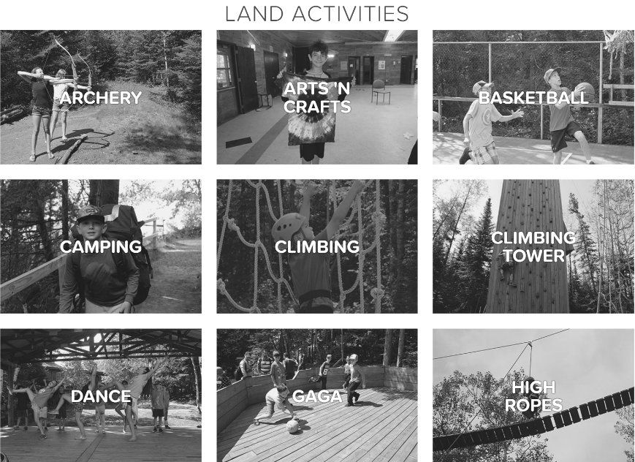

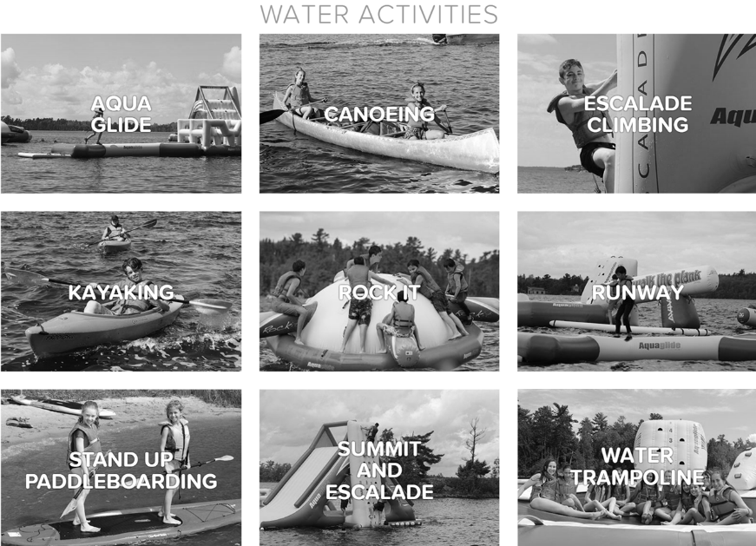

Source: Company files.

EXHIBIT 7: BREAKDOWN OF CAMPER PRICING PER SUMMER

|  |  |  |  |  |
| --- | --- | --- | --- | --- |
| **Session** | **Age** | **Total Time at Camp**  **(Days)** | **Length of Overnight**  **(Days)** | **Price** |
| 1st | 7–8 | 4 | 0 | $ 500 |
|  | 8–9 | 7 | 0 | $ 855 |
|  | 9–10 | 14 | 3 | $ 1,705 |
|  | 10–11 | 14 | 4 | $ 1,705 |
|  |  |  |  |  |
| 2nd | 11–12 | 21 | 6 | $ 2,600 |
|  | 12–13 | 21 | 8 | $ 2,600 |
|  | 13–14 | 21 | 12 | $ 2,600 |
|  |  |  |  |  |
| AC | 14–15 | 29 | 29 | $ 2,955 |
| LTP | 15–16 | 42 | 15 | $ 3,500 |

Note: BB’s costs were an estimated $75 per day to service a camper on-island, and $85 per day on the overnight.

Source: Company files.

1. Most of the information in this paragraph was obtained from an IBIS World industry report: “Summer Camps – US Market Research Report,” IBISWorld: Where Knowledge Is Power, February 2018, accessed June 12, 2017, https://www.ibisworld.com/industry-trends/specialized-market-research-reports/consumer-goods-services/sports-recreation/summer-camps.html.
2. Michael B. Smith, “'The Ego Ideal of the Good Camper' and the Nature of Summer Camp,” Environmental History 11, no. 1 (January 2006): 70–101, Oxford University Press, January 2006, accessed June 2, 2017, https://www.jstor.org/stable/pdf/3985739.pdf?refreqid=excelsior%3Ad1-cd62c0c6fe2ba0f5777e27e8a1b7e3.
3. Troy Glover, Amy Chapeskie, Steven Mock, Roger Mannel, and Hannah Feldberg, The Canadian Summer Camp Research Project: Examining the Outcomes of the Canadian Summer Camp Experience, University of Waterloo, 2011, accessed June 8, 2017, http://ccamping.org/wp-content/uploads/2012/11/CSCRP-Report-reduced.pdf.
4. Town Island was a 230-acre island, of which BB camp occupies 30 acres. The rest of the island consisted of forests and trails leading to BB’s seven campsites. BB camp owned its 30-acre portion, while the rest was owned by the Province of Ontario.
5. “Municipalities in Canada with the Largest and Fastest-growing Populations between 2011 and 2016,” Statistics Canada, February 8, 2017, accessed June 21, 2017, [www12.statcan.gc.ca/census-recensement/2016/as-sa/98-200-x/2016001/98-200-x2016001-eng.cfm](http://www12.statcan.gc.ca/census-recensement/2016/as-sa/98-200-x/2016001/98-200-x2016001-eng.cfm).
6. “Economic Indicators,” Economic Development Winnipeg, accessed June 8, 2017, www.economicdevelopmentwinnipeg.com/resources/research/economic-indicators/highlights.
7. 2006 Census Data—River Heights Community Area, Winnipeg, accessed June 15, 2017, <http://winnipeg.ca/census/2006/Community%20Area/River%20Heights%20Community%20Area/River%20Heights%20Community%20Area.pdf>.
8. Kenora Tourism Sector Profile: Invest in North America’s Premier Boating Destination, accessed June 8, 2017, <http://listview.kenora.ca/Files/LOWDC/Shared%20Documents/Reports%20and%20Plans%5CKenora%20Sector%20Profiles/2013%20Tourism%20Sector%20Profile.pdf>.
9. Outdoor Education was a one-month program where a variety of elementary- and middle-school children attended camp for a three-day period at the end of their school year.
10. Shabbat is a day of rest and celebration that begins on Friday at sunset and ends on the Saturday at nightfall.
11. Kosher kitchens prohibited certain foods and followed specific food preparation rules to satisfy the dietary restrictions of those who kept kosher.
12. Most of the information in this section was taken from material accessed from Camp Stephens’ website: Camp Stephens: Lake of the Woods, accessed June 10, 2016, www.ywinnipegcamps.com/campstephens/.
13. Campers at Stephens had the option of attending one or more sessions on-island, in the woods, or both.
14. A four-week canoe trip at Stephens, comparable to AC, cost only $1,900. All amounts are in CA$ unless otherwise specified.
15. Each boat run used 20 litres of gasoline (round trip). Current gasoline costs were $1.35/litre.
16. Age categories were split into Juniors, Intermediates, and Seniors (ages 3-5, 6-10, and 11-14, respectively).
17. The building had an estimated useful life of 15 years if built by volunteers and 25 years if built professionally.
18. BB could secure this loan with an annual interest rate of 3 per cent.
19. Due to government regulations, BB could sell only to a buyer intending on using the property as a camp.