

9B18M076

liyu ethiopia tours: GROWTH AND EXPANSION OPTIONS

Andrew Patton, Desmond Chan, and Joseph Hoekstra wrote this case under the supervision of Nicole Haggerty solely to provide material for class discussion. The authors do not intend to illustrate either effective or ineffective handling of a managerial situation. The authors may have disguised certain names and other identifying information to protect confidentiality.

*This publication may not be transmitted, photocopied, digitized or otherwise reproduced in any form or by any means without the permission of the copyright holder. Reproduction of this material is not covered under authorization by any reproduction rights organization. To order copies or request permission to reproduce materials, contact Ivey Publishing, Ivey Business School, Western University, London, Ontario, Canada, N6G 0N1; (t) 519.661.3208; (e)* [*cases@ivey.ca*](mailto:cases@ivey.ca)*;* [*www.iveycases.com*](http://www.iveycases.com)*.*

Copyright © 2018, Ivey Business School Foundation Version: 2018-07-12

In late May 2014, Yhun Ejigu sat down for a traditional meal at a local restaurant in Addis Ababa, Ethiopia. As the founder of Liyu Ethiopia Tours (Liyu), Ejigu had successfully established his company as a small but reputable tour operator in Ethiopia in a short time. However, to meet his goal of becoming the number one tour company in Ethiopia, Ejigu needed to develop a strategy to continue to grow the business. But he needed to decide whether to pursue expansion online, through domestic partnerships, or through international partnerships. He also needed to do so within the company’s limited budget.

ETHIOPIA AND ADDIS ABABA

With a population of 94 million people, Ethiopia was a landlocked country in Central-East Africa, bordered by Sudan, Somalia, Djibouti, Kenya, and Eritrea. Despite continuing unrest in its neighbouring countries, Ethiopia was named the world’s 15th-safest country to live in by a 2014 study.[1] The expansion in the agriculture and services sectors enabled Ethiopia to have one of the highest gross domestic products and fastest growing economies in Africa. Despite this growth, however, Ethiopia was still one of the poorest countries in the world with a per capita income of Br11,600[2] per year.[3] Poverty had decreased in the last decade, and the government was focused on continuous improvement in this area.

Addis Ababa, the capital city of Ethiopia, was often referred to as “the political capital of Africa” due to its historical and political significance for the continent.[4] The metropolitan city was well connected domestically and internationally by Ethiopian Airlines, which was consistently rated as one of Africa’s top airlines. Due to the city’s high altitude, Addis Ababa had a comfortable climate, with consistent highs of about 23 degrees Celsius throughout the year. This contrasted the lowlands of Ethiopia, which experienced a much hotter climate. Ethiopia had a rainy season that lasted from June until September.

TOURISM INDUSTRY IN ETHIOPIA

Ethiopia was a country rich in natural beauty, history, and culture. For nature enthusiasts, Ethiopia was a land of rugged mountains, broad savannahs, jungles, volcanoes, lakes, rivers, and an array of wildlife. One of the main attractions was the Simien Mountains National Park, one of the highest mountain ranges in Africa. Ethiopia was also rich in history and culture. Because the country was home to the discovery of “Lucy,” the world’s oldest known, almost complete hominid skeleton, it was often said that mankind originated in Ethiopia.[5] In addition, the remote southern Omo Valley region allowed tourists to see the lifestyle of the most unique tribal people in the world, who continued to live according to their ancient traditions.

The tourism industry had been growing rapidly in Ethiopia. From 2007 to 2012, the number of arrivals increased by over 10 per cent each year.[6] In 2014, Lonely Planet, the largest travel guidebook publisher in the world, named Ethiopia one of the best tourism destinations to visit.[7] However, tourism in Ethiopia was still underdeveloped, especially when compared to nearby countries. In 2012, Kenya and Tanzania had 1,822,900 and 1,043,000 arrivals, respectively, while Ethiopia had 596,000 arrivals.[8] Historically, the underperformance could be attributed to several factors. The first was a lack of international awareness of Ethiopia as a viable tourist destination. Many tourists visited Africa to experience exotic safaris in Kenya or climb Mount Kilimanjaro in Tanzania, but they were unaware of the unique attractions that Ethiopia had to offer. The lack of governmental support had also been a hindering factor. There had been a focus on growing infrastructure in Addis Ababa but not in major tourist areas. Unpaved roads and a lack of accommodations made it difficult to access tourist sites. For example, only three of the country’s 15 national parks had hotels on site.[9] Due to the lack of adequate road infrastructure, flying was often the only viable option to reach most of Ethiopia’s popular tourist destinations, which were outside Addis Ababa (see Exhibit 1).

Ethiopia had over 400 tour operators, mostly small businesses. However, some larger companies in the industry had a much wider reach. Ethiopia’s Ministry of Culture and Tourism was the formal regulatory body for tourism. This government institution controlled the marketing of Ethiopia both internationally and domestically, as well as the registration of tour companies. The ministry had historically struggled to find a consistent tourism development and promotional strategy for Ethiopia. To combat the issue, the ministry launched a new tourism development policy in 2010, which was expected to increase arrivals to one million by 2015.[10]

LIYU ETHIOPIA TOURS

Ejigu had always been a driven individual with a strong entrepreneurial spirit. His diverse background included experience as a shoe shiner, a bartender, and a disk jockey. He first became passionate about the tourism industry after hearing daily tourism programs on the radio. Ejigu started working for a tour company in 2009 while studying tourism at Addis Ababa University. His job initially involved creating guidebooks for attractions in Ethiopia, but it expanded to arranging bookings. He launched Liyu three years later, at age 24. The freedom of being an entrepreneur better enabled him to support himself and his young siblings. He initially arranged car rentals for tour guides, eventually expanding to providing guided tours and arranging bookings. Although his company did not yet meet all the government’s requirements for registration, he was issued a temporary licence so he could operate without restrictions.[11]

The company name, Liyu, means “unique” in Amharic, the official language in Ethiopia, which reflected the way Ejigu operated his small but rapidly growing company in the Ethiopian tourism industry. Ejigu differentiated his company by offering competitive prices on customizable and unique tour options. He placed a high priority on flexibility and complete customer service. While most tour companies in Ethiopia charged a mark-up of at least 20 per cent, Ejigu marked up his tours by only 10 per cent. Also, most customers negotiated prices, so margins were often thin. Ejigu offered 33 standard tour options, but customers normally customized their experience based on their preferences.

Ejigu’s finances were limited. There was no distinction between his personal and business finances. He took what he needed from the profits to support himself and his siblings and reinvested the remainder in promotional activities, which consisted mostly of printing and mailing brochures. Ejigu initially invested Br20,000 in the business, most of which was borrowed from a friend in the construction industry rather than from a bank. It would have been difficult for Ejigu, as new a young entrepreneur, to obtain a loan from a traditional institution without a suitable financial history.

Ejigu rented an office near the airport in Addis Ababa. He leveraged his connections in the car rental industry to gain access to drivers and vehicles for tours in and around Addis Ababa. He employed a full-time receptionist and several tour guides on a contract basis. Although Ejigu preferred to guide tours himself to keep costs down and control quality, he hired some freelance guides to assist during times of high demand and for distant tours. Due to the seasonality of the industry, hiring guides on a freelance basis was more effective than hiring full-time guides. Ejigu met with all guides before hiring them to ensure that they shared his high standard of customer service. Trustworthy guides were crucial to the business; unsatisfied customers tended to blame the company, rather than the specific guide, for their poor experience.

Much of Liyu’s business depended on word-of-mouth recommendations. To avoid limiting his potential customer base, Ejigu did not target a specific market segment. Most of his customer base consisted of foreigners who were already staying in Addis Ababa for business, and were looking to travel while they were there.

Ejigu’s most effective marketing strategy was striking a partnership with 10 hotels in Addis Ababa. He paid commission to the hotels for each referral to his company. Ejigu also advertised using brochures, which he distributed to major hotels throughout Addis Ababa (see Exhibit 2) and cost Br8 per copy to produce. Ejigu’s business had a limited online presence. His website, Facebook, Twitter, and LinkedIn profiles featured pictures and information about his tours. However, converting potential customers through this channel had been difficult and unsuccessful so far (see Exhibit 3).

**NEXT STEPS**

Ejigu was determined to continue to grow his business, but was unsure how to do so. He had brainstormed a few options he believed were viable. He wanted to reach as many people as possible but had not yet set aside any funding for business expansion.

Online Presence

Ejigu wanted to make his business more visible online. In Ethiopia, the most widely used search engine was Google, which offered Google AdWords to businesses as an advertising strategy. AdWords allowed businesses to bid in a cost-per-click auction to push their ads to the top of users’ search results on key search terms. Each bid represented the maximum amount that advertisers were willing to pay each time a viewer clicked on their advertisement to visit the company’s website. The advertiser was not charged for the display of the advertisement but was charged if a user clicked on the advertisement. Google offered advertisers the options of specific keywords, multiple advertisements, and specific location targets. Ejigu estimated that an annual expenditure of Br10,000 would be necessary for AdWords to be effective, but this amount was flexible and could be adjusted as needed.[12]

Ejigu also considered using TripAdvisor as an effective means of boosting his company’s online presence. TripAdvisor, one of the most popular international websites for travellers, allowed businesses to host their own pages. The free service relied on written user reviews to generate positive brand awareness. Ejigu was unsure how many additional customers he could reach through this channel, especially without any reviews to start the campaign. With online travel bookings growing 15 per cent year over year, he understood the importance of an online presence, but he did not know how to differentiate his company in this competitive market.[13]

Partnerships

Ejigu was considering expanding his successful hotel partnerships. He could increase his network of hotels within Addis Ababa, or he could expand to other hotels in popular tourist cities elsewhere in Ethiopia.

Ejigu was considering establishing cross-border partnerships with tour companies in neighbouring countries, including Kenya and Tanzania, to promote each another’s business. For example, if any of Ejigu’s customers were interested in travelling to Kenya, he would refer them to a partner company in that country. Both companies would earn a commission and increased business exposure.

International Trade Shows

Ejigu had always aspired to participate in a tourism trade show overseas. At these trade shows, tour companies would set up booths to promote their business to travel agencies, with the hope of entering into international partnerships. Most trade shows accommodated at least 200 booths from countries around the world. Most of Ejigu’s customers were from the United States and China, so he wanted to focus on trade shows hosted in one of these markets.

Americans who came to Ethiopia were primarily focused on eco-tourism; they were interested in activities such as hiking and travelling to natural landmarks. Ethiopia was home to plenty of outdoor excursions, and Ejigu had significant amounts of experience leading these types of tours. Although they tended to be more adventurous than average tourists, U.S. customers preferred structured itineraries and scheduled events. However, Ethiopia’s relaxed approach to time and schedules made it a challenge for Ejigu to cater to the needs of American customers.

Thanks to a significant Chinese investment in Ethiopia’s construction industry, Chinese customers were already an accessible market for Ejigu. Chinese travellers also typically had high expense budgets, primarily driven by a preference for visiting shopping malls. Unfortunately, as Ejigu was aware, the country lacked the infrastructure to compare to the shopping centres that Chinese consumers were accustomed to in their country.

Participating in a trade show in either region would require a significant investment. Ejigu would have to cover the entire cost of the trip, including the flight, booth, accommodations, and living expenses. He estimated the total cost of setting up a booth in one trade show at Br150,000.[14] The potential for exposure was unparalleled, but was the time right to invest in an overseas market?

CONCLUSION

Each of Ejigu’s options for business expansion had significant potential for success, but Ejigu was unsure where to begin. He wanted to grow his business as quickly as possible, but he had limited resources and many questions to resolve. Which of the various options available to him would most effectively reach his target audience? Which options were financially feasible? Were some options more suitable for a long-term plan? Which options would match his business goals? Was his current competitive advantage scalable?

Exhibit 1: TRAVEL TIMES TO POPULAR TOURIST DESTINATIONS OUTSIDE ADDIS ABABA

|  |  |  |  |
| --- | --- | --- | --- |
| **Location** | **Description** | **Travel Time (by Airline Flight)** | **Travel Time (by Tour Bus)** |
| Lalibela | A historical city full of ancient rock-hewn churches | 2 hours | 9 hours (660 km) |
| Simien Mountains | One of Africa’s largest mountain ranges, to experience the Ethiopian outdoors | 1 hour to Gondar  (plus a 2.5 hour drive) | 12 hours (876 km) |
| Bahir Dar | The beautiful Blue Nile Falls and Lake Tana, with its islands and monasteries | 1 hour | 7 hours (560 km) |
| Omo Valley | Home to some of the most unique traditional tribes in the world | 1 hour | 9 hours (594 km) |
| Aksum | Historical location with churches, cathedrals, and (supposedly) the Ark of the Covenant | 1.5 hours | 13 hours (954 km) |

Note: km = kilometre

Sources: Prepared by the authors based on information from online maps and “Ethiopia: Places to Go,” TripAdvisor, accessed on September 12, 2014, www.tripadvisor.com/Travel-g293790-c4125/Ethiopia:Places.To.Go.html.

Exhibit 2: LIYU ETHIOPIA TOURS BROCHURE

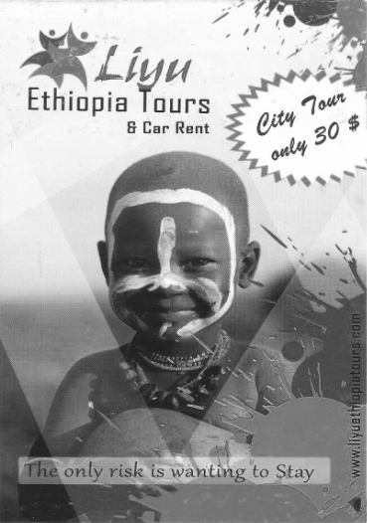

Source: Company documents.

Exhibit 3: LIYU ETHIOPIA TOURS WEBSITE

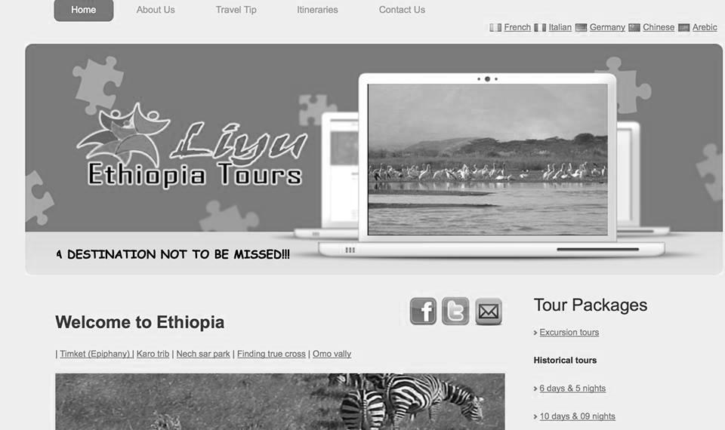

Source: Company documents.

1. Non-Aligned Movement News Network, “Ethiopia Ranks As 15th Safest Country In The World,” NAM News Network, April 27, 2017, accessed April 18, 2018, http://www.namnewsnetwork.org/v3/read.php?id=Mjc1OTcz
2. Br = ETB = Ethiopian birr; all currency amounts are in Br unless otherwise specified; Br19.67 = US$1 on August 2014.
3. “The World Bank in Ethiopia: Overview,” The World Bank: IBRD-IDA, accessed May 22, 2014, www.worldbank.org/en/country/ethiopia/overview.
4. “ECA Conference Center, Addis Ababa,” United Nations: Economic Commission for Africa, accessed May 22, 2014, www.uneca.org/uncc/.
5. Jamie Shreeve, “Oldest Human Fossil Found, Redrawing Family Tree,” *National Geographic*, March 5, 2015, accessed October 29, 2017, https://news.nationalgeographic.com/news/2015/03/150304-homo-habilis-evolution-fossil-jaw-ethiopia-olduvai-gorge.
6. “International Tourism, Number of Arrivals,” World Bank: Data, accessed May 22, 2014, https://data.worldbank.org/indicator/ST.INT.ARVL.
7. “Ethiopia,” Tourism Ethiopia, accessed May 22, 2014, http://ethiopianembassy.org.br/paginas/what_do_you_know_about_ethiopia.
8. “International Tourism,” op. cit.
9. James Jeffrey, “Ethiopia’s Big Plans to Boost Tourist Numbers,” BBC News: Business, May 1, 2014, accessed May 22, 2014, www.bbc.com/news/business-27112468.
10. Andualem Sisay, “Ethiopia Launches Revamp of Flagging Tourism Industry,” Africa Review, August 12, 2013, accessed May 22, 2014, www.africareview.com/Business---Finance/Ethiopia-launches-revamp-of-flagging-tourism/-/979184/1944824/-/n5xojkz/-/index.html.
11. Liyu met all requirements for registration except vehicle ownership.
12. “Choose How You Want to Reach Your Customers,” Google AdWords, accessed October 30, 2017, https://adwords.google.com/home/how-it-works/.
13. “Report: Online Travel Bookings Will Rake in $61B This Summer,” CMO by Adobe, May 26, 2014, accessed September 5, 2014, www.cmo.com/adobe-digital-insights/articles/2014/5/23/adi_online_travel.html#gs.=itYALc.
14. This cost would be higher for Chinese trade shows because a translator would be required.