** **

9B18M083

KNIGHTSBRIDGE CUSTOM HOMEBUILDERS LTd.:

COMMITMENT TO CORE VALUES

[Pernille Goodbrand](https://iveypubs.my.salesforce.com/003A000001xLo8O), [Jyoti Gondek](https://iveypubs.my.salesforce.com/003A0000021hbuI), and [Cheryl Brazell](https://iveypubs.my.salesforce.com/003A000001toeQS) wrote this case solely to provide material for class discussion. The authors do not intend to illustrate either effective or ineffective handling of a managerial situation. The authors may have disguised certain names and other identifying information to protect confidentiality.

This publication may not be transmitted, photocopied, digitized, or otherwise reproduced in any form or by any means without the permission of the copyright holder. Reproduction of this material is not covered under authorization by any reproduction rights organization. To order copies or request permission to reproduce materials, contact Ivey Publishing, Ivey Business School, Western University, London, Ontario, Canada, N6G 0N1; (t) 519.661.3208; (e) cases@ivey.ca; www.iveycases.com.

Copyright © 2018, Ivey Business School Foundation Version: 2018-05-08

It was 2014, and Joe Starkman, chief executive officer (CEO) of Knightsbridge Custom Homebuilders Limited (Knightsbridge), smiled and shook his head as he ended his phone call with his daughter. Did she really mean it when she said she did not want a car? Could she be right when she said no one her age was interested in owning cars? Starkman continued to think about his daughter’s comments as he looked down at the dirt of the site he had purchased for his next project in the rapidly gentrifying East Village neighbourhood of Calgary, Alberta. Buying the site was the culmination of years of success, which Starkman’s Calgary-based firm had achieved by prioritizing three core values: great locations, underserved markets, and niche products. Then, it hit him: the long, recent meetings focused on how to accommodate parking at the site may have been all in vain. Perhaps Knightsbridge did not need to determine how to accommodate parking; perhaps it simply needed to offer high-rise living without parking, which would be an entirely new concept in Calgary. But was developing a residential site without parking a viable plan in this growing city?

CONTEXT OF THE CALGARY HOUSING MARKET

Between 2006 and 2014, Calgary experienced unparalleled population growth rates—the highest of any metropolitan area in Canada. It became the country’s fourth-largest census metropolitan area (CMA) with 1.4 million people. This growth was largely due to a booming oil and gas industry, and supporting services that offered employment opportunities for interprovincial and international migrants. The unprecedented number of new arrivals resulted in vast changes to the physical layout of the city. No quadrant was immune to development, and surrounding counties inside and outside the CMA were also swept up in the building frenzy.

The health of Calgary’s economy rose and fell with fluctuations in oil prices. The periods of “booms” and impending “busts” were difficult to predict, but always left their mark on the built environment. Calgary had experienced the consequences of development during an economic upswing and was determined to manage its urban growth in a sustainable manner. In 2005, the city launched ImagineCALGARY, “a community visioning and consultation process.” Two years later, it released PlanIt Calgary. These initiatives laid out land use and mobility plans to guide policies and actions on growth into the future. Both ImagineCALGARY and PlanIt Calgary employed the “smart growth” principles that had informed the Municipal Development Plan adopted by the city council in 2009. It was the city’s goal to keep 50 per cent of population growth inside developed areas.[1] This target presented a major challenge for developers and home builders specializing in new communities; however, it also created an opportunity for developers who were able to adapt to a changing regulatory environment.

KNIGHTSBRIDGE: A HYBRID BEGINNING

Founded in 1990, Knightsbridge initially had a dual focus. One of its objectives was to build infill homes in three of Calgary’s inner-city communities—Sunnyside, Hillhurst, and Parkdale—where gentrification was occurring as a result of the market recognizing the amenity-based advantage of living in these established communities. With walkability to shops, restaurants, and pathways that encouraged people to reconnect with their communities, these areas of the city began to see buyers who were interested in combining location with a more contemporary home. With builders like Knightsbridge providing infill products that addressed these needs, established inner-city neighbourhoods in Calgary began to see changes in their physical and social landscapes.

Knightsbridge’s second focus was on designing and constructing estate homes in the upscale communities of Heritage Pointe, Springbank, and Elbow Valley, immediately outside Calgary’s city limits. Here, the company differentiated itself from most developers by taking a risk and presenting something new in a market that was already well established. Specifically, Knightsbridge began offering multifamily options in the form of high-end villas. In doing so, the firm exposed a new market opportunity within a location that typically contained only single-detached dwellings.

Both the infill and estate divisions were successful, and Knightsbridge’s revenues continued to increase; however, its construction costs also rose, negatively affecting its margins. As the company approached its 10th anniversary in 2000, Knightsbridge proudly offered products that reflected its core values, but these products were not scalable (see Exhibit 1). Starkman knew that to successfully scale the business, he needed to try something different while still adhering to the company’s values. He was convinced that he should take a more innovative approach and create something completely new, avoiding what he felt was the norm in the Calgary market.

BREAKING AWAY FROM THE norm

Starkman was aware that it would be a challenge to break away from the status quo. Still, he remained optimistic. He believed that his core values held the key to scaling Knightsbridge, and that successful growth could be obtained by sticking to them. Cities represented intersections of people and place, and Starkman knew the importance of talking to people and understanding their needs rather than focusing on designs and materials and expecting people to adapt. Staying informed provided Starkman with unique insight into underserved markets. In 2004, he saw an opportunity to shift Knightsbridge toward higher density development, starting with the 120-unit Villa D’Este in the Northwest Calgary community of Tuscany. In this way, one year later, when the city initiated ImagineCALGARY, Starkman was already ahead of the curve.

Villa D’Este was the first step on a path not yet taken by others in Calgary’s home-building industry. The development catered to people—especially older parents with children who had left home (also known as “empty nesters”)—who preferred the estate lifestyle, open floorplans, and high-end design that Knightsbridge had perfected, but presented in a “lock and go” package.[2] Villa D’Este offered a suburban environment with easy access to the Rocky Mountains and downtown Calgary, as well as to retail and health services in the vicinity, but without the maintenance often required in estate homes. Each unit had storage, a large master suite, and a titled parking spot in an underground parkade (a multistory parking garage). For most buyers, these units represented a “downsize,” but without sacrificing lifestyle. There was no equivalent to Villa D’Este in the market, which made marketing a challenge. However, Starkman maintained that Knightsbridge simply had to highlight the lifestyle advantages and amenities on offer, which would speak to an underserved market.

Starkman was right. Villa D’Este’s three phases sold out. The first two phases sold out within a year. The release of the third phase coincided with the 2008 global recession, which affected sales, but the phase still sold out in two and a half years.

Villa D’Este had been a success, but Starkman was still looking for a more desirable location for his next project. The City of Calgary had argued that “smart growth” policies were the key to better planning and design in the city. Starkman wanted to find a site to redevelop where he could exemplify these policies, which emphasized “compact, diversified urban districts, densifying along transportation corridors, promoting and requiring development within existing urban boundaries, as well as intensification, walkability, and reduced reliance on cars to accomplish most tasks.”[3] With these principles in mind, Starkman started exploring opportunities in communities that lent themselves well to this kind of development.

WHERE DO EMPTY NESTERS’ CHILDREN GO?

Calgary was often labelled as both sprawling and car centric, but with initiatives such as ImagineCALGARY, the city showed that it was starting to think differently about density. The city council’s desire to better utilize space within established neighbourhoods gave Starkman the confidence to seek a location closer to Calgary’s downtown core; however, land costs in such locations were prohibitive for Knightsbridge to manage on its own. Fortunately, in 2006, a Toronto-based developer and long-time friend of Starkman’s, Howard Sokolowski, CEO of Metropia Urban Landscapes (Metropia), reached out to Starkman to express his interest in expanding to Calgary.

Sokolowski had built Metropia on a vision of seeing beyond current trends to provide a variety of housing options at different price points. This vision meshed well with Knightsbridge’s core values of location, underserved markets, and niche products. Sokolowski was interested in a site in Calgary’s Brentwood community after Rio Can, Canada’s largest real estate investment trust, approached Metropia to form a partnership to redevelop the site to its “highest and best use,” which was defined as “the reasonable probable and legal use of vacant land or an improved property that is physically possible, appropriately supported, and financially feasible, and that results in the highest value.”[4]

Brentwood was an established neighbourhood in Northwest Calgary bordering the red line of the city’s light rail transit (LRT) and the University of Calgary’s main campus and research park. Most of the community consisted of single-family dwellings. The site that Metropia was interested in was home to the aging Brentwood Village shopping centre, which offered health services, fast-food restaurants, bars, home décor stores, pharmacies, and grocery stores surrounded by vast parking lots. The location was adjacent to public transit and had easy access to the university, as well as to employment hubs (downtown and nearby hospitals), which made it an ideal candidate for transit-oriented development (TOD). However, Metropia had little knowledge of the Calgary market and recognized that Knightsbridge could provide essential local expertise.

For Knightsbridge, the partnership would enable the company to take on a project of a much larger scale, while benefitting from working with a firm that had done similar developments in Toronto. Because of the land costs associated with the site, it was clear to Starkman that the development would need to accommodate significantly higher population density than the surrounding areas—an idea that displeased the local community. Further, Starkman knew that in order to appeal to the buyer segment most interested in this location (which market research had shown would likely be millennials and investors), Knightsbridge and Metropia would need to identify exactly what these groups wanted. Their marketing research showed that the key demand was affordability. In return for a lower entry point, prospective buyers were willing to sacrifice square footage, but not functionality. With this key point in mind, Knightsbridge and Metropia established their vision for the site and started planning.

The vision became “University City,” a 716-unit master planned condominium (condo) community on top of retail podiums that was introduced in two phases. Phase one consisted of two high-rise buildings (or “high-rises”), and phase two consisted of two mid-rises. Both types of buildings featured apartment-style condos varying from 343 square feet to 718 square feet in size. The development also included a townhouse complex, which was later named “Brentwood on the Park.” The variety of units (bachelor, one-, and two-bedroom condos; as well as one-, two-, and three-bedroom townhouses) ensured a diversification in the offerings, which was essential for a broad appeal. Bachelor units in phase one started at CA$159,900,[5] which Knightsbridge considered an “entry-level price.” On the other end of the spectrum, the largest townhouse in the “Brentwood on the Park” development started at $649,000. Because the project was a TOD, Knightsbridge and Metropia recognized that buyers would not necessarily require a car; therefore, buying a parking spot became an optional add-on at $11,900 each.

Not everyone was excited about the vision for the area. The 2008 Brentwood Station Area Development Plan (Brentwood SARP), which paved the way for development, was met with opposition from the Brentwood Community Association, as well as the nearby Varsity Community Association. In fact, 100 local residents attended a meeting at City Hall to oppose the Brentwood SARP. The increase in population density was cited as a concern for existing residents, who claimed that the development would have a major impact on their way of life.

Knightsbridge and Metropia managed to appease the community associations by addressing most of their concerns.[6] To minimize the impact of the development, the companies planned to create a height transition, situating the townhouses closest to the existing neighbourhood and gradually increasing the height of the new buildings (i.e., with the mid-rise buildings in the middle of the site, and finally, the high-rises closest to the LRT line). Knightsbridge and Metropia also addressed parking and landscaping concerns in great detail. The land use changes required for the master plan were approved in 2008, and the Brentwood SARP was approved in November 2009.

Unfortunately, other issues surfaced during this time. The global recession that had affected sales at Villa D’Este also affected University City, slowing the demand for housing as vacancy rates rose and property values declined. Moreover, the uncertainty of the market limited financing options. Most developers would usually attempt to finance at least 75 per cent of total project costs prior to construction,[7] but financing restrictions in the wake of the recession meant that in order to secure financing, Knightsbridge and Metropia needed 25 per cent equity upfront plus 80 per cent of units sold prior to construction.

With the economy still struggling, sales began in November 2010. The first tower in phase one (216 units) sold out on the first day, and the second tower within four days. To Starkman’s and his employees’ surprise, it was not only millennials, but also their parents and investors who were interested in the units. People of all ages working in the surrounding areas were interested — empty nesters represented 10 per cent of buyers. In the midst of an economic slump, the Calgary media was suddenly talking about “condo frenzy.”[8] With 100 per cent of the units in University City sold, Knightsbridge and Metropia secured financing and broke ground.

Construction on phase one commenced in November 2010. The recession was a concern, but the timing afforded Knightsbridge and Metropia some respite. They were able to secure ITC Construction Group (ITC), a Vancouver-based construction company specializing in residential high-rises and mixed-use developments, just as the firm finished projects for the Vancouver Olympics and was looking for another large-scale project. ITC had a solid track record of finishing projects on time, and its reliability and construction innovation ensured that delays were avoided. The company used unique concrete shoring systems and a technique called a “window-wall” system that allowed it to assemble walls from the inside rather than outside.

Despite making progress on the project, Knightsbridge’s troubles were not over. August 2011 saw an appeal from a few Brentwood citizens to revoke the development permit for University City due to traffic concerns, temporarily halting development.[9] Ultimately, city planners disagreed with the appeal, citing few concerns about vehicular traffic at the TOD site; still, the appeal meant months of delay, substantially increasing the soft costs of the project, which had to be recouped. Phase one was completed in November 2013—almost a year after it was slated for completion (December 2012). Phase two, which also sold out (albeit not as quickly), was launched in April 2013, and completed in January 2016.

A “NEW” OPPORTUNITY

In 2014, Knightsbridge and Metropia acquired a parcel of land in Calgary’s East Village neighbourhood (see Exhibits 2 and 3). East Village was located on the east side of Calgary’s downtown core, only a short walk to transit and the city centre. The area was in a flood zone and had flooded in 2013, but under the leadership of Calgary Municipal Land Corporation, it was undergoing almost complete redevelopment that would eventually see East Village transformed from an underused brownfield[10] dominated by surface parking lots into a thriving neighbourhood and shopping destination. The redevelopment strictly adhered to smart growth principles. The necessary infrastructure had been put in place, heritage buildings were renovated, and the first mixed-use developments were under construction. East Village offered prospective residents an opportunity for a new attitude, a new vision, and a new lifestyle.

As Starkman stood on the recently acquired piece of land in this area that did not cater to vehicles, he thought about what his daughter had just said. Eliminating parking would require a customized land use designation, which could prove complicated and time consuming (see Exhibit 3). However, doing so would also save significant construction time if rezoning was successful; Starkman estimated that Knightsbridge could save $75,000 to $85,000 per unit.

Considering Knightsbridge’s three core values, as well as the company’s experiences from previous projects, how should it approach the East Village site? Was developing a residential site without parking a viable plan? Current zoning did not allow for a structure with no parking. Should the firm proceed within the conventional building parameters or take another chance?

This case was made possible through the generous support of the Westman Centre for Real Estate Studies, Haskayne School of Business, University of Calgary.

EXHIBIT 1: MAP OF CALGARY SHOWING KNIGHTSBRIDGE PROJECTS (1990–2014)

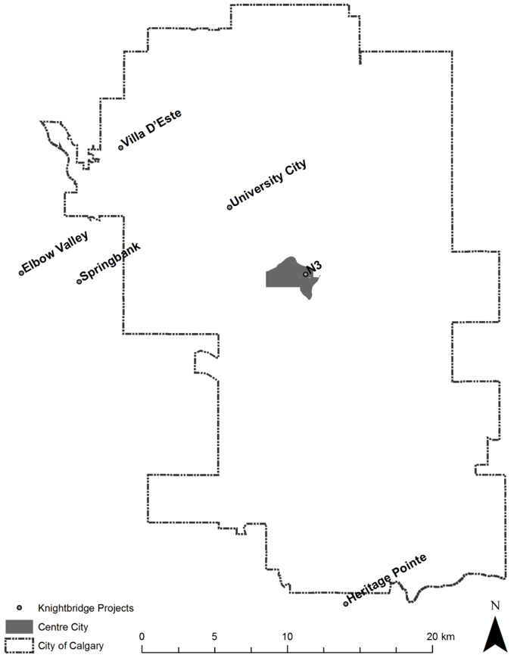

Source: Created by Kwangyul Choi based on “City Quadrants” City of Calgary website, November 13, 2017, accessed April 25, 2018, https://data.calgary.ca/Base-Maps/City-Quadrants/g8ma-sywr.

EXHIBIT 2: EAST VILLAGE SITE CONTEXT

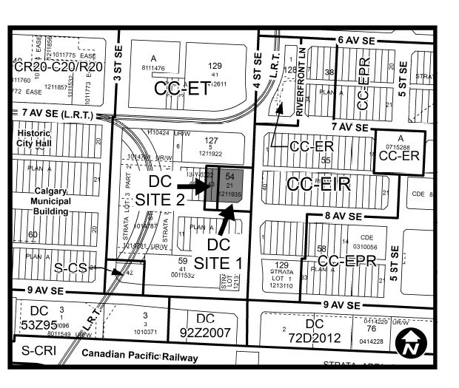

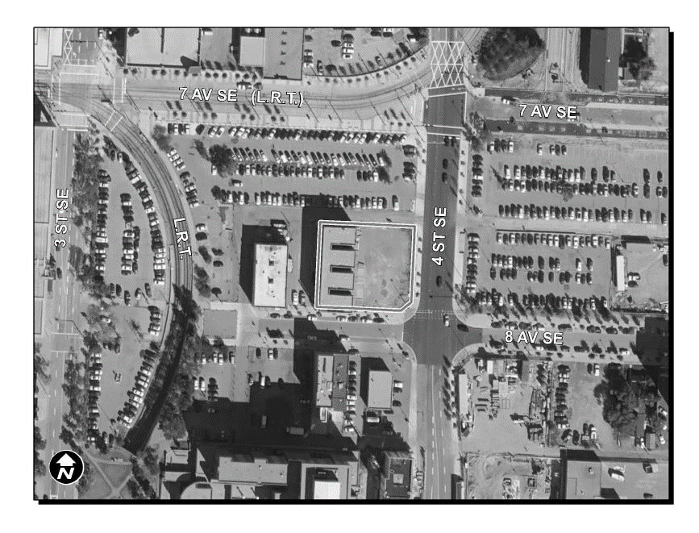

Source: City of Calgary, *Report to the Calgary Planning Commission*—*CPC2015-066*, 2015, accessed November 15, 2017, http://publicaccess.calgary.ca/searchCCProc/index.htm.

EXHIBIT 3: EAST VILLAGE LAND USE DISTRICTS/ZONES

**CC-EIR**

**Centre City East Village Integrated Residential District (CC-EIR)**

The CC-EIR designation is for intensive residential development integrated with a broad range of support commercial uses in the East Village area. Land Use Bylaw - CC-EIR

**CC-EMU**

**Centre City East Village Mixed Use District (CC-EMU)**

The CC-EMU designation is for a mix of commercial and residential uses in mid- and high-rise buildings in the East Village area. Land Use Bylaw - CC-EMU

**CC-EPR**

**Centre City East Village Primarily Residential District (CC-EPR)**

The CC-EPR designation is for intensive residential development with some support commercial uses in the East Village area. Land Use Bylaw - CC-EPR

**CC-ER**

**Centre City East Village Recreational District (CC-ER)**

The CC-ER designation is intended for public plazas next to the Bow River in the East Village area. Land Use Bylaw - CC-ER

**CC-ERR**

**Centre City East Village River Residential District (CC-ERR)**

The CC-ERR designation is for intensive residential development with ground floor commercial on sites strategically located with riverfront views in the East Village area. Land Use Bylaw - CC-ERR

**CC-ET**

**Centre City East Village Transition District (CC-ET)**

The CC-ET designation is for a mix of commercial, residential, and institutional uses that provide an appropriate transition between the higher density downtown core and the more residential East Village. Land Use Bylaw - CC-ET

**DC**

**Direct Control District, (DC)**

A Direct Control (DC) is a customized land use designation. It has a list of allowable uses and a set of rules specific to a particular property or development. Most DC designations include a cross-reference to the rules of one of the standard designations of the Land Use Bylaw (R-1, R-2, I-G, etc.). Land Use Bylaw - DC

Source: “Land Use Districts/Zones,” City of Calgary website, 2017, accessed November 15, 2017, www.calgary.ca/PDA/pd/Pages/Calgary-Land-Use-bylaw-1P2007/Land-Use-Bylaw-Land-Use-Districts.aspx.

1. City of Calgary, *Municipal Development Plan*, September 2009, Section 5.2, page 5-5, accessed November 15, 2017, www.calgary.ca/PDA/pd/Documents/planning_policy_information/mdp-municipal-development-plan.pdf.
2. A “lock and go” package referred to a housing option (often apartments, condominiums, or townhouses) where there was little or no maintenance associated with ownership, allowing people to simply lock the unit and leave when they wanted to go away without worrying about mowing grass, shoveling snow, and so on.
3. S. Michael Brooks, *Canadian Commercial Real Estate: Theory, Practice, Strategy* (Toronto, ON: RealPac, 2016), 156.
4. Appraisal Institute of Canada, “Chapter 12: Highest and Best Use Analysis,” *The Appraisal of Real Estate* (Vancouver, BC: UBC Real Estate Division, 2010), Section 12.1.
5. All currency amounts are in CA$ unless otherwise specified.
6. City of Calgary, *Report to the Calgary Planning Commission*—*DP no: DP2010-4889*, 2011, 15–16, accessed April 20, 2018, www.brentwoodcommunity.com/images/DP2010-4889_Report_to_Calg_Planning_Commission.pdf.
7. Brooks, op. cit., 278.
8. “Buyers Line up for Calgary Condo Project,” Belmor Mortgage News, 2010, accessed April 20, 2018, http://belmormortgage.com/buyers-line-up-for-calgary-condo-project/.
9. Jason Markusoff, “Protests Stall Condo Project at LRT Stop,” *Calgary Herald,* Aug. 10, 2011, accessed November 15, 2017, https://www.pressreader.com/canada/calgary-herald/20110810/292195216499967.
10. The Government of Canada defined brownfields as follows: “Brownfields are abandoned, idle or underutilized commercial or industrial properties where past actions have caused environmental contamination, but which still have potential for redevelopment or other economic opportunities. Brownfields are typically located in urban areas.” (“About Contaminated Sites,” Government of Canada website, October 3, 2016, accessed March 23, 2018, www.canada.ca/en/environment-climate-change/services/federal-contaminated-sites/about.html.