|  |  |
| --- | --- |
|  |  |

9B18M088

Kanaka bar indian band: towards self-sufficiency, vibrancy, and sustainability

Stefanie Beninger and Zain Nayani wrote this case solely to provide material for class discussion. The authors do not intend to illustrate either effective or ineffective handling of a managerial situation. The authors may have disguised certain names and other identifying information to protect confidentiality.

*This publication may not be transmitted, photocopied, digitized or otherwise reproduced in any form or by any means without the permission of the copyright holder. Reproduction of this material is not covered under authorization by any reproduction rights organization. To order copies or request permission to reproduce materials, contact Ivey Publishing, Ivey Business School, Western University, London, Ontario, Canada, N6G 0N1; (t) 519.661.3208; (e)* [*cases@ivey.ca*](mailto:cases@ivey.ca)*;* [*www.iveycases.com*](http://www.iveycases.com)*.*

Copyright © 2018, Ivey School of Business Foundation Version: 2018-06-01

It was the end of 2017, and the council and community members from the Kanaka Bar Indian Band (Kanaka Bar) were reflecting, in their regular monthly meeting, on the progress to date of a number of community initiatives. In recent decades, the community had created an impressive CA$200-million[1] run-of-river hydroelectric project on community lands and had invested in key governance measures, infrastructure assessments, and educational undertakings. These initiatives had assisted in the community’s process of recovering from dependence on other entities. Kanaka Bar was striving to attain self-sufficiency—that is, to no longer require any outside support for its continued survival—in the areas of food, energy, employment, and finance, and the band had enshrined this intention in a community vision in 2015. This led to the development in 2015 of a land use plan and an expansive five-year community economic development plan (CEDP) in 2016 that focused on implementing the community vision.

The five-person council, including Chief Patrick Michell, was responsible for social, cultural, and economic decisions in the community. Now, one and a half years after launching the CEDP, the council had some choices to make in order to meet its vision of self-sufficiency in a way that was sustainable over the long term and that would continue to infuse vibrancy into the community. The council and community asked what their available resources and their most pressing challenges were. How could the community’s unique resources be used to overcome its challenges? Did the community’s current planned initiatives—including developing renewable energy, acquiring land, providing educational and training resources, and introducing a community garden and bee hives—fit with its vision, resources, and challenges, or was another approach needed?

**KANAKA BAR**

Kanaka Bar is located in the interior of British Columbia, a province in what became known as Canada in 1867. It is approximately 250 kilometres (an average three-hour drive) from the major city of Vancouver. The region in and around Vancouver, called the Lower Mainland, comprises almost three million people, or 60 per cent of the province’s total population.[2] Kanaka Bar is situated south of the town of Lytton, along the Fraser River on the north end of the Fraser Canyon.

The Fraser River, the longest river in the province, originates in Fraser Pass in the British Columbia Rocky Mountains and emptied into the Pacific Ocean in Vancouver. The river is home to sturgeon, Pacific salmon, and steelhead trout. The climate in Kanaka Bar is characterized by very hot, dry summers with temperatures reaching up to 40 degrees Celsius, and mild, short winters with temperatures averaging from 0–5 degrees Celsius. The area receives high amounts of sunlight and moderate amounts of wind.[3]

**T’eqt’’aqtn: Prior to 1808**

Archaeological data and oral history reported that the Kanaka Bar traditional territory has been occupied for over 7,000 years.[4] Prior to colonization, Kanaka Bar was called *T’eqt’’aqtn* (“the crossing place”), home to “the crossing place people,” the *T’eqt’’aqtn’mux*. The community was self-sufficient, with established trade networks that respected the land and its resources by taking only what was needed. The community engaged in fishing, hunting, and gathering. It also harvested and produced medicines based on traditional knowledge and produced clothing, tools, baskets, and weapons. Knowledge about these activities was passed down through generations, with children participating in the community and learning from adults on a daily basis.

Kanaka Bar is part of the *Nlaka’pamux* Nation, which is made up of 15 distinct Indigenous communities. Historically, each community had regional autonomy over its traditional sites and surrounding areas, including the land and other resources. Each community was self-governing and had its own governance system of appointing *kokpe* (head men and women). Nations were self-sufficient and had intricate understandings with other nations in the region regarding resource sharing between families and communities.[5]

**European Contact and Colonization: 1808–1970**

Interaction with European settlers began with trade for Kanaka Bar’s sought-after dried salmon. Formal contact was established in June 1808, with the explorer Simon Fraser. Fraser named the people the *Couteau* (knife) tribe, and Fraser and those who followed him learned how to navigate and live in the area from theT’eqt’’aqtn’mux and other local communities*.*[6]

Contact with explorers and settlers presented the community with trade opportunities but also with unprecedented change. The changing trade flows affected the community’s way of life as the traditional barter economy became supplanted by a sales economy. This and other changes resulted in a situation where, in the words of Chief Michell, “The losses far outweighed any gains that may have been made” by the community.

For 50 years, trade between the groups continued in a relatively peaceful way, until a gold rush that started in 1857 brought thousands of miners into the region.[7] A commissioner, upon seeing gold miners from Hawaii in the area, labelled the people in this region “Kanaka Indians” and the community “Kanaka Bar,” (*kanaka* means “human being” in the Hawaiian Polynesian language). Chief Michell had this to say about these gold miners:

A new class of mixed people from around the world began arriving in the Fraser Canyon, bringing with them values and a world view hereto unknown and arguably incomprehensible to the Nlaka’pamux. Values like competition, intensive exploitation of land and resources for short-term gain, and an attitude of superiority were the new principles brought to the land. As miners moved up into the Fraser Canyon, there was no regard for Nlaka’pamux law, land, or people, and the miners simply took, took, and took.

This value clash and growing tensions over resources prompted a war between miners and the community. The war, called the Fraser Canyon War, ended with an informal truce. Colonial officials moved into the area, and in 1858, Lytton was named as a town while British Columbia was declared a colony of Britain.

In 1876, *The Indian Act*, which imposed huge legislated changes on the lives of the Nlaka’pamux, came into force. This act forcibly replaced the kokpe system with a new community leadership system composed of chief and council. Through *The Indian Act*, the government seized traditional territories, created reserve lands, criminalized traditional cultural elements such as potlatches and sun dances, and regulated and banned traditional economic activities such as hunting and fishing[8] and the trade of surplus goods, whether for barter or for legal tender. From 1884 to 1996, approximately 150,000 Indigenous children across Canada were removed from their homes and communities and placed in residential schools, where speaking their traditional languages was forbidden. They were not allowed to see their families and were disconnected from their traditional lands and homes, and many children suffered a range of physical, emotional, and sexual abuses.[9] The residential school in Lytton closed in 1979.[10]

Under this system, Kanaka Bar was allotted just under 700 acres (283 hectares) across six reserves; this land was considered by both the reporting federal agent and community members in 1878 to be of poor quality, and there were questions as to whether the land could support the needs of the community due to its sub-par topsoil, rocky conditions, and lack of flat lands.[11] The reserves allotted to Kanaka Bar, which were still in place as of 2017, were hilly, reaching up the steep slopes of the canyon on both sides of the Fraser River. Over 60 per cent of the land had slopes of greater than 25 per cent. As of 2017, the area was still covered in trees, shrubs, and berry bushes, and had an abundance of sand and gravel. It was crisscrossed by year-round creeks and fishing grounds, although by 2017, Chief Michell noted that climate change was depleting fishing opportunities.

During the 1950s, the community saw an outflow of members, partly due to a shortage of housing and jobs, and this outflow further depressed the local economy. By the 1970s, Chief Michell said, the status quo in the community was characterized by feelings of anger, despair, frustration, and dependency. A number of issues contributed to both disharmony within the community and a continued exodus; these included continued restrictions on traditional economic activities, challenges with alcohol and drug addictions, and attraction to the potential jobs and educational opportunities in mainstream society—that is, outside of the community.

Not only was the community losing people, it was also losing land, which was being seized for public purposes. Over the decades, the area had become a major transportation hub intersected by major routes, from trails (prior to the 1850s) and the Cariboo Wagon Road (in the mid-1860s), to the Canadian Pacific Railway (in the 1880s) and the competing Canadian National Railway (in the first two decades of the 1900s). By the 1950s, the building of the Trans-Canada Highway (Highway 1)[12]bisected the community’s lands even further. In addition to the highway, a number of government and private roads also ran through the community. These public transportation routes were forged without community permission, compensation, or provision of replacement lands, and their creation displaced community houses, gardens, and irrigation.[13] According to Chief Michell, by 1970, the federal government had allowed more than one-third of Kanaka’s original and best reserve land allotments to be used for public purposes.

**The Road to Self-Sufficiency: 1970–2011**

From the 1970s onwards, Kanaka Bar experienced a resurging desire to return to the “old ways,” and the community began a transition from despair and dependence towards self-sufficiency. A multitude of activities took place in the 1990s in particular; these included land purchases and strengthening of community infrastructure, for example, by building water treatment systems, houses, and access roads.

The community’s first business venture, Kwoiek Creek Resources Inc., was also created during the 1990s. The community seized an opportunity to start a hydroelectric power plant when BC Hydro, the provincial electric utility provider, opened the provincial electric grid in 1988 to independent power producers. The community kicked off this new venture by applying for a water licence to develop hydroelectric power generation on the Kwoiek Creek in the Whyeek Reserve, and this licence was accepted for review in 1990.[14] The application to develop a hydroelectric plant was led by then-Chief James Frank, who said that “the power of Kwoiek Creek has always been known to Kanaka. The clean energy industry represents an opportunity to exercise Nlaka’pamux rights and title in a modern way.”[15]

In 2001, the community collected baseline data and underwent a formal review, then looked for an appropriate partner to support the process. By 2005, Kanaka Bar had formed an equal partnership with Innergex Renewable Energy Inc., a Canadian developer and operator of sustainable North American energy facilities, who agreed to supply both expertise and equity financing. This partnership, called Kwoiek Creek Resources Limited Partnership (KCRLP), secured a 40-year power purchasing agreement with BC Hydro in 2006.[16]

The development of this project and the KCRLP partnership reflected Kanaka Bar’s intention to move away from a mindset of dependency to one of resilience. The community did not passively allow the partnership to decide the fate of the project. Instead, community members actively participated in discussions, with both its own leadership and the partners, about how the project would be developed. The passion to stay engaged with the project laid the foundation for the way the community wanted to govern itself and others living in community territory in the future. This project was a way to change the status quo of the past century and a half. Kanaka Bar fully understood that it would need good governance, transparency, and accountability within the community to sustain its goals of self-sufficiency, vibrancy, and sustainability.

In support of these aims, the KCRLP engaged in ongoing environmental assessments and community engagement. The project constantly solicited input—not only from the Kanaka Bar community, but also from the 15 other communities that composed the Nlaka’pamux Nation, many of whom would see energy transmission lines placed on their lands. Seven communities chose to become involved in reviewing the project, identifying its effects, and providing guidance. As Chief Michell recalled, to get all affected communities involved was simply “the right thing to do.” The Nation ultimately approved the project in 2010.[17]

The groundbreaking ceremony for the hydro project was held in 2011, and two years later, the project was completed. The hydroelectric plant generated energy by partially diverting the flow of the creek rather than damming or storing water; this diverted flow rotated turbines, and the collected energy then travelled more than 70 kilometres to a substation and was then delivered to BC Hydro.[18] Through this design and construction, the plant maintained the flow of the creek and ensured that the local aquatic life was protected through bypassing sections of the creek and the creation of habitat compensation channels.[19]

Average yearly energy production of the plant was over 200,000 megawatt hours—enough to power 20,000 homes[20]—and the income flowed back to the community. The successful hydroelectric plan had, in the words of Chief Michell, put “smiles on people’s faces and [brought about] the improvement in community pride, self-worth and self-confidence.”[21]

Building the project also allowed the community to improve local infrastructure such as roads and bridges, while providing employment. The project agreements stipulated that community members would be hired, and this led the plant to employ 50 per cent First Nation staff, including 24 band members. These employees benefited from additional training in diverse positions including operations, carpentry, and labouring. Chief Michell had this to say about the project:[22]

My own benefit analysis is that the 36 years taken to get the project into operation is reversing 150 years of colonization. Graduation levels are on the rise, addiction has declined, and suicide has been eliminated. How? Because the vision of leadership was to take control of the future by giving the present membership hope by the simple return to individual and community self-sufficiency.

**Furthering Economic and Social Development: 2012–2017**

Governance

The success of the hydroelectric power plant—a huge achievement for the community—was supported by a fundamental change in political governance. In 2012, the community introduced a new constitutional framework that laid out clear and precise rules pertaining to membership, elections, and wider governance. This governance structure separated the social and cultural arm of community leadership, which was responsible for education, training, social development, health, culture, and infrastructure, from the economic and business arm, which was focused on the community’s businesses and holdings. Both arms were ultimately responsible to the chief and council, who were now elected by community members (see Exhibit 1). The community also created a new chief executive officer position in 2013, which helped to separate both social and economic business from politics and kept decision making distinct from implementation. This system created a clear separation between business and politics, streamlined communication, and ultimately sought to reduce business risks and liabilities for the community.

The community’s economic development arm aided the economic development planning process; by the end of 2015, the community had established four new business entities. Kanaka Bar Land and Resources Limited Partnership was formed as the main holding company for other businesses and acted as the liaison between council and those businesses. Siwash Watershed Resources Inc. was created to develop another micro-hydroelectric project. Kanaka Land and Holdings Ltd. was established to own and manage all immovable assets on behalf of the community. Finally, Kanaka Bar Employment Services Ltd. was created to provide hands-on field work and training for community members.

The community also integrated processes that were designed to be fully transparent and accountable. More than 500 pages of laws, policies, and plans were written down, distributed, and posted online for everyone to read, and a formal financial administration law was introduced in 2014. Leadership also updated the website weekly. Since 2013, council meetings had been held regularly every first Monday and third Thursday of the month. The Thursday meetings were followed by community meetings, during which the leadership engaged with members about what had been done during the last 30 days and what would be done during the next 30 days. Additionally, the community created a summer and a winter plan each year. These plans, which were posted on the website, assessed the preceding six months, brought up challenges, shared how issues would be addressed during the next six months, and focused on new projects and programs.

Although this system and approach were still very new for the community, they were seen as catalysts of change. The new governance system also had its challenges, however; for example, over 500 pages of new documentation and processes created a situation where it was not always clear who was responsible for what and in what way. As such, this system was at times challenging to understand and to execute.

The Community Economic Development Plan

In 2014, the community began developing its first land use plan, which focused on identifying the lands and resources that the community could access and use. The land use plan also formalized the official vision of the community: “Kanaka Bar is committed to using its lands and resources to maintain a self-sufficient, sustainable, and vibrant community.” As of 2017, Kanaka Bar’s land was home to a host of wildlife, including mountain goats, deer, salmon, elk, Rocky Mountain bighorn sheep, and rattlesnakes,[23] and the community is flanked by government-protected wildlife habitat areas. The wider region had become increasingly well known for white-water rafting, fishing, and camping, with mountain ranges and forested areas providing mountain biking and hiking opportunities, all of which boosted tourism in the region.[24]

By mid-2015, building on the success of the hydroelectric project, Kanaka Bar began the process of identifying potential development initiatives that could improve the community’s social and economic situation. It conducted community meetings to hear ideas and to identify capacities, skills, and knowledge. Although community members recognized that there were limited reserve lands available for community development projects, they identified 17 opportunities, which were ultimately judged and ranked. The outcomes of that ranking became the basis for a five-year community economic development plan (CEDP).

The CEDP was launched in mid-2016, after two reviews by community members. At the core of this plan were the following general goals: to support the scaling up of projects; to create employment, capacity, and wealth for community members; to sustainably generate revenue for the band; and to work towards community self-sufficiency regarding finances, employment and community readiness, food and energy, and foundational infrastructure. The goals of the CEDP would ideally be realized through working with appropriate partners; striving to protect traditional values, practices, and land; and fostering and supporting community-owned endeavours.

The CEDP mapped out specific targets and objectives in support of these general goals. These objectives included increasing the number of community members engaged in traditional practices around food and medicine to 100 per cent; introducing 20 backyard gardens and creating two community gardens (from none in 2015), while providing educational resources (books, soil, and seedlings) to members who wished to tend home gardens; and introducing three beehives (from one in 2015). The community also planned to acquire strategic off-reserve lands of interest and properties within the territory; to strive towards producing 100 per cent of the energy needed for community use (from 0 per cent in 2015) through initiatives such as the Siwash Creek hydropower project and solar power pilot projects; to drop the unemployment rate by more than half; and to increase the community’s own-sourced revenue by 20 per cent. The community achieved these goals through pilot projects that ensured continual and sustainable capacity building and generated interest and benefits for the community. The CEDP summary outlined the projects that the community agreed to implement over the following five years (see Exhibit 2).

As the CEDP was laid down, the community also took a census of its members. As of 2017, there were 237 people in the Kanaka Bar community, but only 62 lived year-round on community lands,[25] largely because of a shortage of housing and employment opportunities. Many other members returned to the community lands throughout the year. The resident community members lived in 20 dwellings across the reserve lands,[26] and almost 90 per cent of these people had lived at the same address for at least five years.[27] The community was relatively young in 2017, with a median age of 28 years and over 37 per cent younger than 20 years.[28]

While facing an unemployment rate of 11 per cent in 2015, community members work primarily in agricultural, forestry, energy, and mining activities. Members maintain a myriad of traditional skills including catching, smoking, drying, canning, and cooking fish; hunting; beading and sewing; gardening; working in lumber and forestry; and practicing traditional medicine. Approximately 18 per cent of the community reported having knowledge of their traditional language,[29] and over 60 per cent of the adult community members hold high school diplomas or trade or apprenticeship certificates.[30]

The community noted a need for trained and skilled labour to run daily operations of the various projects; there were challenges around staff turnover, and there had been discussions about how to support education, training, mentorship, and social development. By late 2017, the community recognized that it needed to recruit an education officer, a social development worker, and project-level experts, such as a farming expert who could support plans regarding food self-sufficiency and at the same time mentor the local people. Human resources constraints were seen to reflect a challenge in understanding the relatively new governance system.

The community also faced continued challenges around infrastructure improvement and maintenance. Although the roads remained well maintained and although Kanaka Bar had acquired 100 more acres of non-reserve land since 2014, housing was still overcrowded and the energy efficiency of homes needed upgrading. Improvements to the water treatment plant, draining culverts, and septic drain fields were also needed. Without housing, it was difficult to persuade the more experienced and qualified community members to return to the community. Further, since the introduction of the CEDP, issues related to climate change had become more evident. In the spring of 2017, houses at Kanaka Bar flooded due to the spring freshet—something that had not happened before. There were also surprising irregularities in temperature, with flood and drought conditions at unusual times of the year, an increase in forest fires, unexpected die-offs of trees, and changes in precipitation levels. Further, there were shifts in the local flora and fauna: for example, deer were leaving the area, mushrooms were no longer growing, the number of berries was decreasing, and wild salmon stocks were shrinking.

The financial situation of the band was strong. As of March 2017, it had over $2 million in cash and very little in the way of liabilities; the band’s overall net financial assets stood at almost $4 million (see Exhibit 3). The band generated revenues through its own sources (e.g., taxation, revenue sharing, royalties, and businesses) and through various grants and contributions from external sources for delivery of specific programs and projects. In a typical year, the band generated 60 per cent of its revenue through its own sources and the rest through external sources. The year 2017 was an anomaly; revenue that year came primarily from Indigenous and Northern Affairs Canada (INAC). Most of this was grant-based and targeted for a new housing project. Meanwhile, the bulk of the expenses that year went to a variety of social and economic development programs (see Exhibit 4). The band had a comprehensive funding agreement with INAC that saw the band deliver various programs and services to its membership. While INAC contributed anywhere from 60 to 80 per cent towards the actual costs of delivery, depending on the type of program, the band had to fund the remaining costs through its own sources.

**LOOKING FORWARD**

By the end of 2017, the council reflected on past decades, took stock of its resources, and assessed its challenges, with the aim, in the community’s words, to “evolve and learn to focus energies on projects that play to the strengths of the community.” Council members asked themselves if the CEDP needed to evolve for the coming years to meet the overarching vision of making the community more self-sufficient, vibrant, and sustainable. Given the community’s multitude of resources, what resources could it use to achieve this vision? How could the community do this in a way that overcame its challenges but did not lose sight of its traditional community values? Which current or alternative projects would best meet the vision for the community, leverage its resources, and meet its challenges?

Exhibit 1: Kanaka Bar Indian Band’s Organization Chart, May 2016

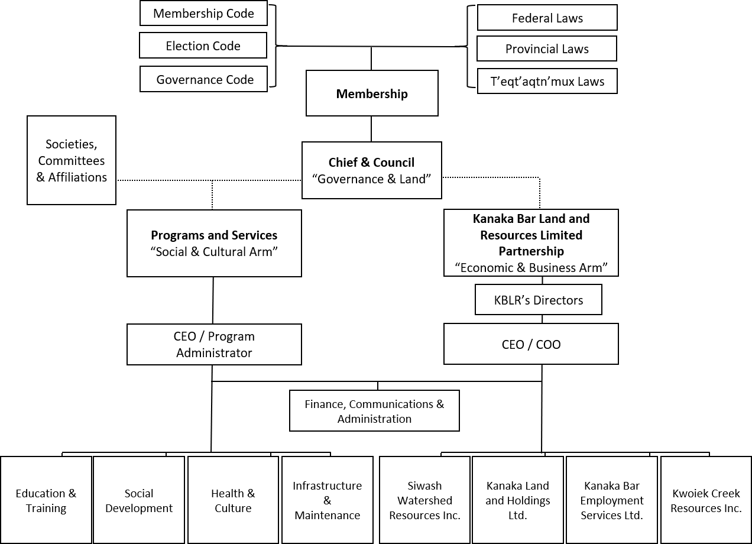

Note: CEO = chief executive officer; COO = chief operating officer

Source: Company documents.

Exhibit 2: Community Economic Development Plan (CEDP) Summary, 5-Year Implementation Plan



Source: Company documents.

Exhibit 3: Financial position as of March 31, 2017 (in ca$)

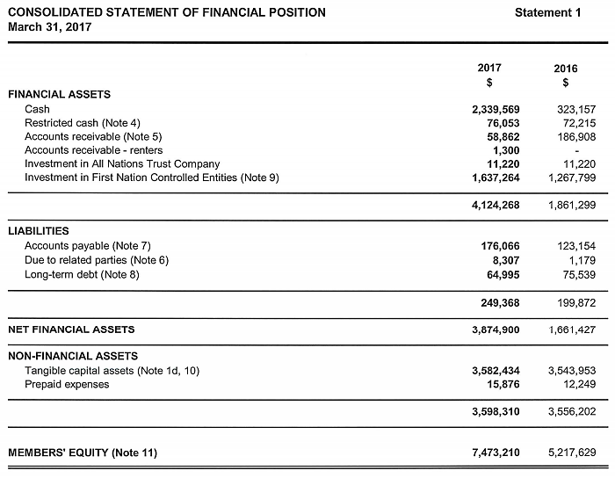

Source: Company documents.

Exhibit 4: Consolidated statement of operations as of march 31, 2017 (in ca$)

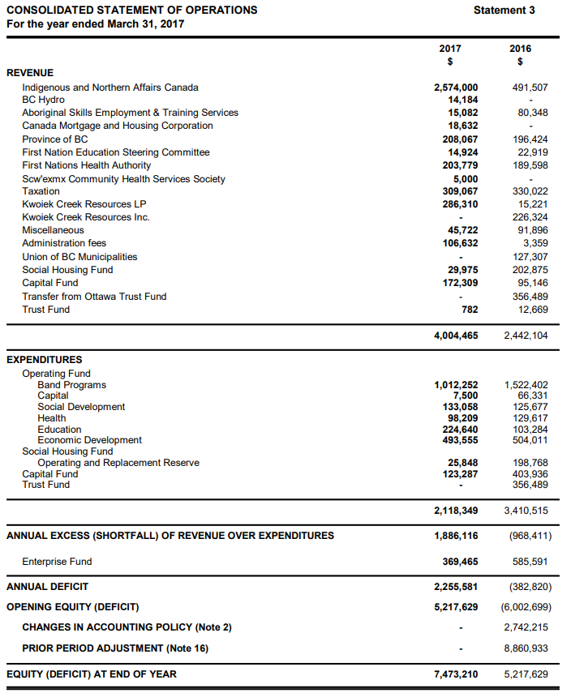

Note: BC = British Columbia

Source: Company documents.

ENDNOTES

1. All currency amounts are in Canadian dollars unless otherwise specified.
2. Statistics Canada, “Census Profile, 2016 Census: Lower Mainland—Southwest [Economic region], British Columbia and British Columbia [Province],” Statistics Canada, 2016, accessed December 13, 2017, http://www.12.statcan.gc.ca/census-recensement/2016/dp-pd/prof/details/Page.cfm?Lang=E&Geo1=ER&Code1=5920&Geo2=PR&Code2=59&Data=Count&

   SearchText= British%20Columbia&SearchType=Begins&SearchPR=01&B1=All&GeoLevel=PR&GeoCode=59.
3. Environment Canada, “Monthly Data Reports: Lytton, British Columbia,” Environment Canada, 2017, accessed March 15, 2017, http://climate.weather.gc.ca/climate_data/hourly_data_e.html?hlyRange=2013-08-20%7C2018-04-10&dlyRange=201

   3-08-22%7C2018-04-10&mlyRange=%7C&StationID=51598&Prov=BC&urlExtension=_e.html&searchType=stnProx&optLim

   it=yearRange&Month=4&Day=10&StartYear=1840&EndYear=2018&Year=2018&selRowPerPage=25&Line=1&txtRadius=2

   5&optProxType=custom&selCity=&selPark=&txtCentralLatDeg=50&txtCentralLatMin=07&txtCentralLatSec=00.7&txtCentralLongDeg=121&txtCentralLongMin=33&txtCentralLongSec=47.7&timeframe=1.
4. For more information on the history of Kanaka Bar and its people, please consult James A. Teit’s work on the Nlaka’pamux, as well as the following three sources: Andrea Lynne LaForet and Annie York, *Spuzzum: Fraser Canyon Histories, 1808–1939* (Vancouver, BC: University of British Columbia Press, 1999); Nancy J. Turner,‎ Laurence C. Thompson, M. Terry Thompson, and Annie Z. York, *Thompson Ethnobotany: Knowledge and Usage of Plants by the Thompson Indians of British Columbia,* Royal British Columbia Museum Memoir No. 3 (Victoria, BC: Royal British Columbia Museum, 1990); Darwin Hanna and Mamie Henry, eds. *Our Tellings: Interior Salish Stories of the Nlhaʼkapmx People* (Vancouver, BC: University of British Columbia Press, 1995).
5. Patrick Michell, *Memory, Loss and Sorrow. . .*, Kanaka Bar Band, 2010, accessed April 1, 2017, www.kanakabarband.ca/downloads/memory-loss-and-sorrow-2010.pdf.
6. Super Natural British Columbia, “Lytton: Culture & History,” Super Natural British Columbia, 2016, accessed March 27, 2018, https://www.hellobc.com/lytton/culture-history.aspx.
7. Ibid.
8. Michell, op. cit.
9. “Trudeau Apologies for ‘Deep Harm’ of Residential Schools,” BBC News, November 24, 2017, accessed January 23, 2018, www.bbc.com/news/world-us-canada-42101457.
10. General Synod Archives, “St. George’s School—Lytton, BC,” Anglican Church of Canada, accessed January 23, 2018, https://www.anglican.ca/tr/histories/st-georges-school-lytton/.
11. Michell, op. cit.
12. Super Natural British Columbia, op. cit.
13. Michell, op. cit.
14. Indigenous Business and Investment Council, “Kanaka Bar Indian Band and Innergex Renewable Energy Inc.,” Indigenous Business and Investment Council, 2014, accessed December 13, 2017, www.bcabic.ca/success-stories/kanaka-bar-indian-band-and-innergex-renewable-energy-inc.
15. Innergex, “By Doing Something Different,” Innergex, 2013, accessed April 4, 2017, www.innergex.com/en/in-review/edition-2013/agir-autrement/.
16. Indigenous Business and Investment Council, op. cit.
17. Ibid.
18. Ibid.
19. Innergex, op. cit.
20. Indigenous Business and Investment Council, op. cit.
21. Innergex, op. cit.
22. Indigenous Business and Investment Council, op. cit.
23. British Columbia, “Wildlife Viewing in the Thompson-Nicola Region,” British Columbia Government, 2016, accessed March 31, 2017, www.env.gov.bc.ca/fw/wildlife/viewing/docs/wildlife_viewing_thompson.pdf.
24. Village of Lytton, “About Lytton,” Village of Lytton, 2012, accessed December 15, 2017, www.lytton.ca/content/about-lytton.
25. Indigenous and Northern Affairs Canada, “Registered Population: Kanaka Bar,” Indigenous and Northern Affairs Canada, March 28, 2017, accessed December 1, 2017, http:// fnp-ppn.aadnc-aandc.gc.ca/FNP/Main/Search/FN RegPopulation.aspx

    ?BAND_NUMBER=704&lang=eng.
26. Indigenous and Northern Affairs Canada, “Household and Dwelling Characteristics: Kanaka Bar,” Indigenous and Northern Affairs Canada, March 28, 2017, accessed March 27, 2018, http:// fnp-ppn.aandc-aadnc.gc.ca/fnp/Main/Search/FNHousehol

    d.aspx?BAND_NUMBER=704&lang=eng.
27. Indigenous and Northern Affairs Canada, “Mobility Characteristics: Kanaka Bar,” Indigenous and Northern Affairs Canada, March 28, 2017 accessed March 27, 2018, http:// fnp-ppn.aandc-aadnc.gc.ca/fnp/Main/Search/FNMobility.aspx?BAND_NU

    MBER=704&lang=eng.
28. Indigenous and Northern Affairs Canada, “Population Characteristics: Kanaka Bar,” Indigenous and Northern Affairs Canada, March 28, 2017, accessed March 27, 2018, http://fnp-ppn.aandc-aadnc.gc.ca/fnp/Main/Search/FNPopulation.aspx?

    BAND_NUMBER=704&lang=eng.
29. Indigenous and Northern Affairs Canada, “Languages Characteristics: Kanaka Bar,” Indigenous and Northern Affairs Canada, March 28, 2017, accessed March 27, 2018, http://fnp-ppn.aandc-aadnc.gc.ca/fnp/Main/Search/FNLanguage.aspx?

    BAND_NUMBER=704&lang=eng.
30. Indigenous and Northern Affairs Canada, “Education Characteristics: Kanaka Bar,” Indigenous and Northern Affairs Canada, March 28, 2017, accessed March 27, 2018, http://fnp-ppn.aandc-aadnc.gc.ca/fnp/Main/Search/FNEducation.aspx?BAND_N

    UMBER=704&lang=eng.