

9B18M107

Asahi Kasei: Building an inclusive value chain in India

[Savita Shankar](https://iveypubs.my.salesforce.com/003A0000023pUdJ) and [Masahiro Okada](https://iveypubs.my.salesforce.com/003A0000023pVFh) wrote this case solely to provide material for class discussion. The authors do not intend to illustrate either effective or ineffective handling of a managerial situation. The authors may have disguised certain names and other identifying information to protect confidentiality.

*This publication may not be transmitted, photocopied, digitized, or otherwise reproduced in any form or by any means without the permission of the copyright holder. Reproduction of this material is not covered under authorization by any reproduction rights organization. To order copies or request permission to reproduce materials, contact Ivey Publishing, Ivey Business School, Western University, London, Ontario, Canada, N6G 0N1; (t) 519.661.3208; (e)* [*cases@ivey.ca*](mailto:cases@ivey.ca)*;* [*www.iveycases.com*](http://www.iveycases.com)*.*

Copyright © 2018, Ivey Business School Foundation Version: 2018-07-27

Takehiro Kamiyama gazed at the colourful koi fish in the pond at the entrance to Asahi Kasei Corporation (Asahi Kasei)’s Nobeoka plant on the island of Kyushu in Japan. The fish pond held a special significance for the company. The water in the pond was from the water treatment plant of the manufacturing facility and the healthy, colourful fish that swam in it served as visual reminders of Asahi Kasei’s corporate philosophy, which was based on corporate responsibility and the creation of shared value for all stakeholders. The plant had the distinction of being the only facility in the world to manufacture a type of cellulosic fibre called cupro. Cellulosic fibres were often used as a low-cost alternative to silk. Cupro yarn was a superior quality cellulosic fibre made using the cuprammonium process. Cupro’s unique properties distinguished it from the more common viscose rayon and made it a useful fibre for producing clothing garments, especially women’s traditional Indian garments (see Exhibit 1).

While Asahi Kasei had various product lines, cupro fibre had a special place among them. This was due not only to cupro fibre’s long history, dating back to 1931, and Asahi Kasei’s status as the world’s only producer of cupro fibre, but also to its unique value chain, which included several small and medium-sized enterprises in India. Kamiyama started his career in the cupro division in 1990. After a stint with another division in Taiwan, during which time he acquired an executive master of business administration degree, he was back as general manager of the cupro division handling the Indian market. In 2014, Asahi Kasei expanded the capacity of its cupro plant in view of the market potential in India. However, in 2015, the entry of finer variants of viscose rayon increased the competitive pressure in the market. During 2016, one of Kamiyama’s important goals was to address this challenge, but he would not stop there. He also had to help the company achieve its goal of building an even more inclusive value chain in India. He wondered if the two goals were indeed compatible.

Asahi Kasei

Asahi Kasei, a diversified company, was established in Japan in 1922 by Shitagau Noguchi. The manufacture of cupro yarn was one of its earliest lines of activity. Since then, the company continued to grow and diversify, and in 2015, it had a total turnover of US$17.2 billion[1] from operations in fibres and textiles, chemicals, electronics, home and construction materials, pharmaceuticals, and medical devices.

Asahi Kasei set up a corporate social responsibility (CSR) department in 2006, though it had been pursuing many CSR-like activities since 1976. The company was guided by its mission of “contributing to life and living for people around the world” and several CSR activities were embedded into the business practice. The four broad CSR areas were compliance, responsible care (including environmental protection and safety), corporate citizenship, and respect for employee individuality. Philanthropic activities were also undertaken by its international subsidiaries in Thailand, Korea, Taiwan, China, and India.

Cupro fibre was a product of Asahi Kasei’s fibres and textiles strategic business unit (SBU). The unit’s other products were non-woven fabric, spandex fibre, and nylon yarn for automotive applications. Of the SBU’s total sales of $1.3 billion in 2016, cupro accounted for approximately 20 per cent.

Cupro Fabric Production Value Chain

The technology to manufacture cupro fibre was originally developed in Germany in 1897 and was imported by Asahi Kasei in 1928. The fibre was used to manufacture unusually soft, moisture-absorbent textile that was comfortable to wear throughout the year.

The reason why Asahi Kasei was the only manufacturer of cupro in the world was because the manufacturing process resulted in waste water that contained copper. All of the other plants around the world had eventually discontinued operations due to their inability to meet environmental regulations. Asahi Kasei, however, had invested heavily in research and development and developed a process to reduce the copper content to only half of the level permitted by the stringent regulations in Japan. Thus, it could continue cupro production (see Exhibit 2). In fact, there was currently a research project in progress to further reduce the copper content of the waste water. Though the copper content was already at half of the permitted levels, Asahi Kasei continued to develop processing technologies to bring it down to one-tenth of the permitted level, with the ultimate goal of producing zero emissions.

The main raw material in the production of cupro was cotton linter, which was imported primarily from India, North America, and South America. Cotton linter was the short, soft fibre surrounding cotton seeds. The process of extracting linter, called “delinting,” involved thoroughly cleaning cotton seeds and then separating the fibre from the seed. The linter was processed chemically to produce yarn with properties distinct from those of cotton. Ninety per cent of the yarn produced was filament yarn and the balance was staple yarn. One-third of the yarn was sold domestically in Japan; another third was sold in the Indian market; and the rest was sold in Europe, China, and other countries. In some markets, the yarn was dyed and then woven; in other markets, the yarn was first woven and dyed later. After weaving and dyeing, the fabric was sold in wholesale markets or to large manufacturers of ready-made clothes. In some very small-volume businesses, a third method called “piece dyeing” was used, in which garments were sewn and then dyed.

Cupro partnerships in India

Asahi Kasei began selling cupro yarn in India in 1976, when the government of India allowed its import under the Open General License, even though a burden of 100-per-cent import tax existed at that time. Its first sale of cupro yarn, of 100 metric tons (MT), was made to a weaving unit in Surat, an important textile centre in the state of Gujarat. An engineer from Japan had to subsequently visit Surat to guide the weavers on handling the delicate yarn. Even in 2016, 98 per cent of the yarn exported to India was sold to weavers in Surat. These weavers sold the grey fabric to local fabric wholesalers and distributors, who in turn sent the fabric to dyeing factories (see Exhibit 3). The wholesalers then sold the dyed rolls of cloth made from cupro yarn to designers and apparel companies to make traditional Indian clothes for women such as *saris* and *dupattas* (a kind of scarf worn as part of the Punjabi *salwar kameez* outfit). In 2016, the president of the fibres and textiles SBU, Toshio Takanashi, used the phrase “40 years of miracles” to describe Asahi Kasei’s long relationship with weavers in Surat. The partnership had continued despite challenges such as the Indian foreign exchange crisis in 1991.

Asahi Kasei’s technical knowledge transfer to its Indian partners was an ongoing activity. Even in 2016, for instance, some dyers faced problems with dyeing quality. When Asahi Kasei explored the prospect of selling to another important textile centre, Varanasi in northern India, some weavers faced problems such as yarn breakage. Asahi Kasei decided to send its technicians from Japan to help resolve the issues faced by the weavers and dyers.

In 2012, the company’s partnerships in India were expanded to include a contract with a cotton ginning unit in Maharashtra for the regular supply of raw material—cotton linter. Previously, the unit had only processed cotton and extracted oil from cotton seeds. The supply of cotton linter resulted in additional revenue, which in 2015 accounted for 10 per cent of Asahi Kasei’s $18-million turnover. Asahi Kasei provided the unit with delinting machines worth $5 million in return for an exclusive bi-monthly supply of cotton linter. Initially, the quality of cotton linter supplied by the unit in Maharashtra was very poor and did not meet the requirements of the Japanese factory. Engineers from Japan worked closely with the unit so that it could progressively reduce the level of contamination in the cotton linter and deliver better quality.

Asahi Kasei officials regularly visited retailers to understand the latest fashion trends, which ultimately determined the demand for different types of yarn. Realizing the need to make fashion designers in India aware of cupro and its unique features, Asahi Kasei started collaborating with the National Institute of Design, Ahmedabad, and the National Institute of Fashion Technology, Mumbai. By conducting lectures and seminars, Asahi Kasei officials educated upcoming designers and apparel producers about how cupro fabric could add value to the garments they designed. The company also sponsored two students to visit Japan and intern at Asahi Kasei’s cupro plant.

As a yarn manufacturer, Asahi Kasei focused not only on the next stage in the value chain, namely weaving, but also on the entire value chain; it was aware that to build demand for cupro, it needed to develop awareness in the entire ecosystem. This strategy led to increased sales of cupro fibre in the Indian market, and increased India’s importance as a market relative to other countries (see Exhibits 4 and 5).

Inclusive Value Chain

While Asahi Kasei’s initial foray into India was motivated solely by market expansion considerations, over time, as India began to play an important role at both ends of the value chain, the company also started considering the development implications of its activities in the country, directly and indirectly. Besides contributing to child labour eradication efforts in India and ensuring that the cotton farmers were paid fair prices for corron linter. Asahi Kasei started focusing on making its value chain in India as inclusive as possible (see Exhibit 6). The company had already had some achievements in this regard. Since cotton linter was obtained from a part of the cotton plant that was previously thrown away, Asahi Kasei’s fair-price purchases of cotton linter provided a welcome boost to local farmers’ incomes. By 2015, approximately 270,000 farmers had benefited from this initiative, and it was estimated that by 2020, approximately 390,000 farmers would indirectly benefit. By bringing in experts in modern delinting, weaving, and dyeing technologies, the company helped train factory employees to use these technologies and techniques. Asahi Kasei also provided training and internships to students studying textiles and design, thus contributing to improving skill levels among the youth in India. By the end of 2015, it had partnered with 60 weaving and three dyeing factories, and achieved sales of 4,300 MT. By 2020, Asahi Kasei aimed to sell 6,000 MT to 80 weaving and 10 dyeing units.

In 2016, Asahi Kasei joined the “Business Call to Action,” a global initiative promoted by the United Nations Development Programme and various donor governments and development agencies. The initiative challenged companies to advance core business activities inclusive of poor populations and to contribute to the achievement of sustainable development goals.[2] Asahi Kasei committed to enhance the skills and productivity of 5,240 employees in the cupro fibre industry, to invest $40,000 in developing the capacity of 700 young people (75 per cent women) between 2016 and 2020, and to increase the production efficiency of 97 small- and medium-scale delinting, weaving, and dyeing units.

Outlook for cupro in India

In June 2014, Asahi Kasei invested approximately $29 million in a new cupro production facility, which increased its total capacity by 1,000 MT (to 16,000 MT). This capacity expansion was said to be the first new fibre production facility in 27 years in Japan. Further expansion of capacity to 18,000 MT by 2018 was in progress. These investments were made in view of the Indian market potential, as the domestic market was shrinking.

While sales of cupro to India had been growing since 2010, in 2015 the product started to face intense price competition from viscose rayon fibre, a fibre of a similar genre. In the past, viscose rayon manufactured in India had been much more coarse than cupro. Now however, it was available in finer variants, which competed with it more directly. Cupro fibre offered advantages in terms of the drape of the fabric and being more suitable for embroidery and other embellishments. The manufacture of cupro was also considered better than the manufacture of viscose fibre in terms of the safety of workers and the impact on the environment due to its use of ammonia rather than carbon disulphide. However, viscose rayon was 20 per cent cheaper, and in a highly price-conscious market like India, price was a significant factor. In addition, the retail customer who bought fabric made with cupro yarn often did not know that it contained cupro, because it was not always disclosed on the tag. Moreover, customers were usually unaware of the unique qualities and environmental advantages of cupro compared to viscose rayon.

Some segments of the ready-made market, such as the designer segment, were relatively price inelastic and were more likely to appreciate the superior nature of the cupro fabric. Asahi Kasei began discussions with leading Indian designers, working with labels such as Anita Dongre to supply them with cupro fabric. Some designers responded positively but others were concerned that parts of the fabric value chain, such as the dyeing units, were not producing consistent quality. This was because dyeing was done in small dyeing houses that lacked adequate quality control; also, these units found dyeing cupro fabric to be especially challenging compared to other kinds of fabric.

Next Steps

Kamiyama considered various courses of action that could be implemented to help address the quality issues arising in the fabric dyeing process. He also pondered how to increase awareness about cupro among retail customers. Only if awareness was created about cupro could the company tap into growing niche markets in India, such as segments that were highly quality-conscious or that were very concerned about the environment. But merely creating product awareness would not be sufficient; at retail outlets, customers wanting to buy the fabric should be able to easily identify it. As Kamiyama wandered away from the Koi pond, he thought about how to increase the sales of cupro in India.

Exhibit 1: Cupro fibre

* Cupro fibre was roughly three times more expensive than cotton yarn, as the cloth woven from it had several features that made it unique:
* Cupro fabric had a soft and smooth surface.
* Its moisture absorption was better than other synthetic fibres, even cotton.
* Various properties helped moderate the temperature inside the garment, making the fabric comfortable to wear year-round.
* The manufacture of cupro fibre offered some advantages from an environmental perspective:
* Cupro was made by processing cotton linter, a waste product obtained from cotton seeds before they were crushed for oil extraction.
* Production facilities were certified to meet both ISO 14001 and Oeko-Tex Standard 100 requirements. ISO 14001 referred to a general set of standards regarding environmental management. Oeko-Tex Standard 100 was an environmental standard specific to the textile industry.
* Fibre was biodegradable.
* Uses of cupro:
* Cupro fabric was used for a lining material by premium European brands such as Gucci and Canali, and for making innerwear by leading brands such as Uniqlo, Wacoal, and Gunze. It was also used to make socks, sportswear, and leggings.
* Cupro fabric was used selectively by leading brands such as Prada and Burberry for some garment designs. In India, it was used for making traditional garments such as saris and dupattas.
* In Japan, it was used to make fillings for cushions and futons. Staple yarn was used in the manufacture of quilts.

Source: Company documents.

Exhibit 2: Asahi Kasei Cupro Plant at Nobeoka, Japan

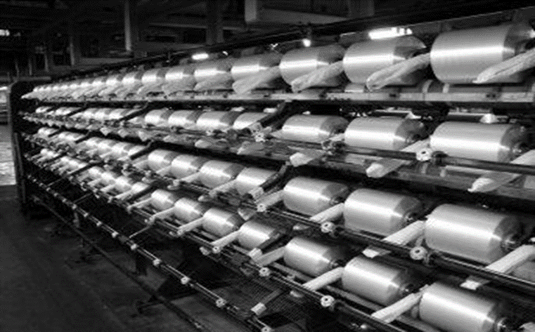

Source: Photo taken by the authors with company’s permission.

Exhibit 3: Weaving and Dyeing Units at Surat and Varanasi, India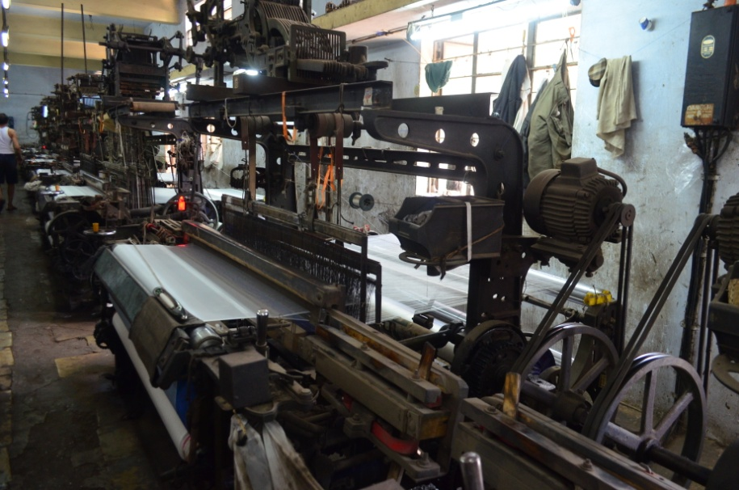

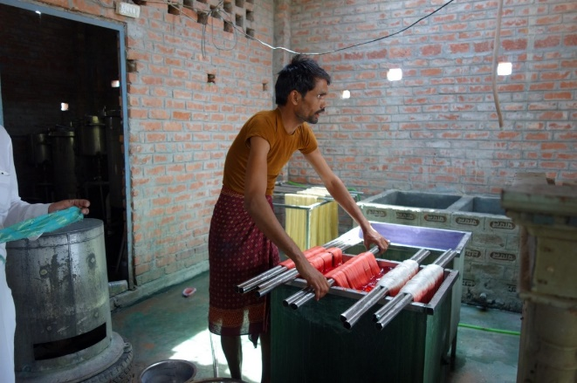

Source: Photos taken by the authors with company’s permission.

EXHIBIT 4: CuPRO NET SALES TO INDIA (IN metric TONnes)

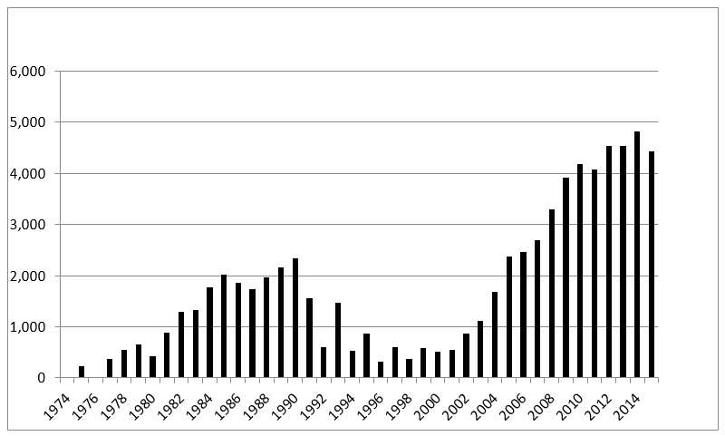

Source: Created by the authors based on company documents.

Exhibit 5: Sales Volume of cupro yarn, by country (in METRIC tonneS)

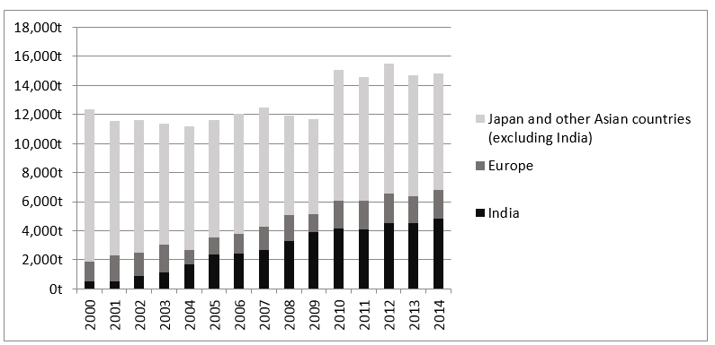

Source: Created by the authors based on company documents.

Exhibit 6: Asahi Kasei’s plans to build an inclusive cupro value chain in India

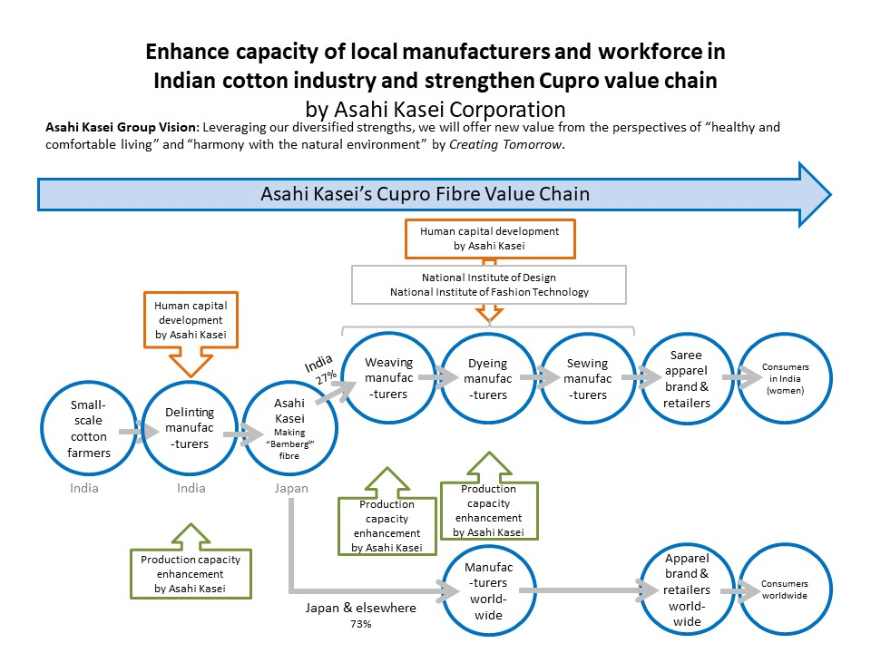

Source: Company documents.

1. All currency amounts are in US$ unless otherwise specified.
2. “About BCtA,” Business Call to Action, 2017, accessed April 20, 2018, https://www.businesscalltoaction.org/about-bcta.