

9B18M113

tvo: leading transformational change (c)

R. Chandrasekhar wrote this case under the supervision of Professors Gerard Seijts and Jean-Louis Schaan solely to provide material for class discussion. The authors do not intend to illustrate either effective or ineffective handling of a managerial situation. The authors may have disguised certain names and other identifying information to protect confidentiality.

*This publication may not be transmitted, photocopied, digitized or otherwise reproduced in any form or by any means without the permission of the copyright holder. Reproduction of this material is not covered under authorization by any reproduction rights organization. To order copies or request permission to reproduce materials, contact Ivey Publishing, Ivey Business School, Western University, London, Ontario, Canada, N6G 0N1; (t) 519.661.3208; (e)* [*cases@ivey.ca*](mailto:cases@ivey.ca)*;* [*www.iveycases.com*](http://www.iveycases.com)*.*

Copyright © 2018, Ivey Business School Foundation Version: 2018-11-21

In January 2014, Lisa de Wilde was examining ways of increasing TVOntario (TVO)’s revenue base. One of the options under consideration was to commercialize the existing educational products of the organization, which were being targeted at meeting the needs of post-secondary education (PSE).

PSE was a growth industry in Canada, where it consisted of 281 institutions comprising 92 public universities and university colleges, 30 private non-profit universities and university colleges, 131 public polytechnics and community colleges, and 28 private non-profit community colleges. Each was unique, pursuing a broad social objective of delivering public good at one level and competing fiercely for research funding, student mass, and faculty talent at the other. International education was one of the 22 priority sectors in which Canada had a strong competitive advantage, as identified by the federal government.[1]

PSE institutions were facing two limitations: the number of students was limited in Canada for reasons of geographical size; and the governments imposed limits on the tuition fee amount that could be charged to students. PSEs were overcoming these limitations by enrolling international students, since the fee limitation applied only to domestic students. International students could be charged up to five times the tuition fees that domestic students paid.

Therefore, de Wilde saw an opportunity for positioning TVO’s Independent Learning Centre (ILC), the largest distance learning provider in Ontario, as the first choice for international students seeking Canadian high school course credits, or a complete diploma, to facilitate acceptance into post-secondary education. Exporting TVO’s services to countries outside Canada seemed a better option than exporting the services to other Canadian provinces. The latter would not scale up, because Ontario was already the largest province. The ILC had developed a roadmap for the future in this regard (see Exhibit 1). It had also identified the courses with so-called future demand in which it could offer training to students and make them skills-ready (see Exhibit 2).

However, de Wilde identified several dilemmas she needed to resolve:

There are three dilemmas here. First, how do we ensure the integrity of each course credit? The person signing up for the course in a faraway location should indeed be the one getting the credit and the diploma and not somebody who might be standing-in. It is a big issue. Second, how do we align with the strategic partners we must choose in foreign markets? They need to have boots on the ground and give us scale. Third, how do we reinvent the back end of our operations? They should ensure that we provide the right services to our partners and the right offerings and service to international students.

Partnerships were one way of getting around the issue, as de Wilde saw it. TVO had begun talks with the London Language Institute, a Canadian organization involved in preparing overseas students for post-secondary studies in Canada. The London Language Institute was already present in countries like Brazil and China, and could therefore be involved in getting students aboard. Ramping up the program would be easier and faster with partnerships. TVO was also in talks with Stratagem Learning International, a Ghana-based organization specializing in providing Canadian high school education programs to Ghanaian students. TVO was in a position to provide scale to the operations of its educational partners, while enhancing its own revenues.

The Ivey Business School and the Ian O. Ihnatowycz Institute for Leadership gratefully acknowledges the generous support of Bill and Kathleen Troost in the development of this case.

Exhibit 1: INDEPENDENT LEARNING CENTrE

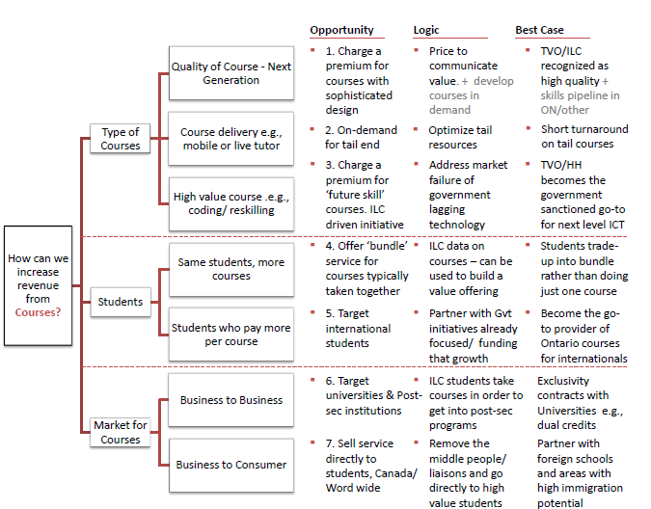

Note: ILC = Independent Learning Centre; ON = Ontario; HH = Homework Help; ICT = information and communications technology; Gvt = government; Post-sec = post-secondary institutions; Word wide = world-wide

Source: Company documents.

Exhibit 2: FUTURE DEMAND COURSES

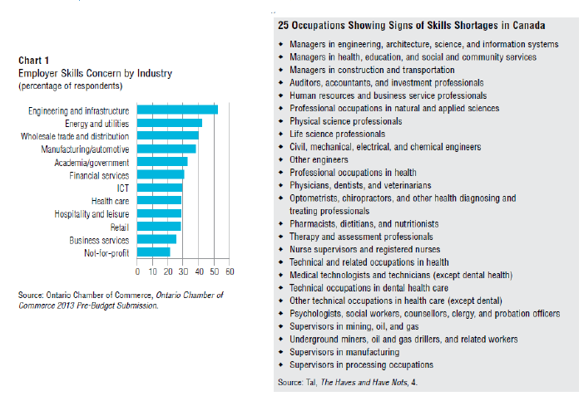

Note: ICT = information and communications technology

Source: Company documents.

1. Foreign Affairs, Trade and Development Canada, “Canada’s International Education Strategy: Harnessing our Knowledge Advantage to Drive Innovation and Prosperity,” Government of Canada, Global Affairs Canada, 2014, accessed March 12, 2017, http://international.gc.ca/global-markets-marches-mondiaux/education/strategy-strategie.aspx?lang=eng.