

9B18M119

Jaga: Managing creativity and open innovation (A)

[Wim Vanhaverbeke](https://iveypubs.my.salesforce.com/003A000001IGNFf) wrote this case solely to provide material for class discussion. The author does not intend to illustrate either effective or ineffective handling of a managerial situation. The author may have disguised certain names and other identifying information to protect confidentiality.

*This publication may not be transmitted, photocopied, digitized, or otherwise reproduced in any form or by any means without the permission of the copyright holder. Reproduction of this material is not covered under authorization by any reproduction rights organization. To order copies or request permission to reproduce materials, contact Ivey Publishing, Ivey Business School, Western University, London, Ontario, Canada, N6G 0N1; (t) 519.661.3208; (e)* [*cases@ivey.ca*](mailto:cases@ivey.ca)*;* [*www.iveycases.com*](http://www.iveycases.com)*.*

Copyright © 2018, Ivey Business School Foundation Version: 2018-08-23

Jan Kriekels, the owner and director of marketing and research and development (R & D) at Jaga, was at Malpensa Airport ready to return to Belgium after visiting the Salone Internazionale del Mobile in Milan, Italy. It was a sunny day in 2007. Reflecting on the many innovative projects Jaga, a central heating installation company, had launched between 2004 and 2007, Kriekels wondered about the success rate of those projects. What had worked and what had not? Why were some projects tremendous successes, while others failed? How could he further leverage these projects for the good of the company?

The next day he had a meeting about the Uchronia project, an online community and playground for creativity and product development that was not functioning as planned. Kriekels was the founder and main supporter of the project. The online community (which could be accessed at uchronians.org) was focused on the creative economy, an economy that was not based solely on materialism and consumption, but also contained creative, emotional, and spiritual elements. During the previous months, even he had started to doubt whether the community could become a success. Kriekels wondered about the future of the Uchronia project.

The history of Jaga

Kriekels’s father, Jan Sr., had founded Jaga in the middle of the 1962 economic boom with his brother Gaston. The brothers operated in the local construction market around Hasselt, Belgium as a modest family business. In the late 1960s, with the economy continuing to thrive, the two brothers experienced increasing delivery problems, so they established a local radiator company with one production line. During those years, Jaga manufactured just one product: an energy-efficient radiator with a guaranteed shorter delivery time. Most local installation companies became Jaga customers and the firm quickly expanded.

The first setback for Jaga was triggered by the global energy crisis. High oil prices in the 1970s had a dramatic effect on the construction market and, in its wake, on the radiator market. Jaga explored new energy saving products. Jaga designed and built three innovative concepts: a heat pump, an air dehumidifier, and a cool cell. These developments required significant R & D investments for what was then a modest family business. The new products proved successful, as the market for energy saving heating devices grew steadily. Less than five years later, however, energy prices dropped to one-third of their high and the idea of energy saving products ended rather abruptly.

Kriekels started working with his father at the beginning of the 1980s. Prior to joining Jaga, Kriekels had studied anthropology but was equally interested in psychology, engineering, philosophy, design, and economics. He was a passionate traveller who had lived with different indigenous tribes around the world. Kriekels’s personal experiences and his own philosophical view of the world would play a vital role in establishing his vision for Jaga’s future.

Over the years, he became familiar with nearly all Jaga departments, employees, and tasks, from blue-collar jobs on the production line to new product development projects in the R & D department. However, it soon became clear that product development was Kriekels’s true calling. By the end of the 1980s, he realized that Jaga’s products were not special enough for the company to differentiate itself from the competition.

The Jaga technology was excellent, but the design of the radiators was average, compared to competing products. Without a strategic change, Jaga would remain a local company facing increasing pressure on its margins. Father and son took a daring decision to customize products for specific customer groups, such as hospitals, leaving all other clients to make their own choices.[1] The company also expanded internationally by selling its product in Germany, Estonia, the former Republic of Czechoslovakia, and Russia. This allowed Jaga to access a market that was large enough to sustain its high-end products. Jaga used local partners to explore sales opportunities in Europe and to understand local customer preferences.

In the 1990s, Kriekels succeeded his father as chief executive officer and took over a company that needed a drastic strategy change to survive. Kriekels made significant changes by investing in creativity, design, and energy saving technologies. He introduced new marketing techniques and opted for experience branding. When customers chose Jaga, they were not simply buying a product, they were engaging in an experience (i.e., the Jaga experience). Jaga was not just another manufacturer. It was a company with a culture of creativity, technological savviness, passion, and adventure. When purchasing its products, customers could experience the typical Jaga sensation, which left an effect on every client.

The company introduced novel heating concepts into the market and won several innovation and design awards. Kriekels’s approach was also commercially successful. Revenues grew steadily through the 1990s and the first seven years of the new century, when exports excelled. In 2003, Jaga was awarded the Export Lion Award for outstanding success in expanding its export markets.[2]

By 2007, Jaga had grown into an international company with 600 employees and annual revenues of approximately €70 million.[3] Although its main production facility was still located in Diepenbeek, Belgium, it also established a factory in the Czech Republic.

Company structure and culture

In 2007, the company was restructured as a matrix organization. The creative part of the company (including the production and design departments) was divided among three product groups: energy savers, eye-catchers, and top performers. These groups catered to products with unique properties. Energy savers, for example, were products that emphasized the energy efficiency of a heating system. By contrast, eye-catchers were products that were a mixture of art and heating solutions. Top performer products were designed to deliver the best possible heating solution with a more compact radiator design. The experience department supported these three product groups by building facilities such as the Experience Lab and by representing Jaga at international product fairs.

At Jaga, each product group appointed a product specialist who was responsible for product development. Each product specialist had a technical background in product engineering and a long working history at Jaga. The role of the product specialist was created to establish a more effective link between the operational part of the firm and the specific product group market.

The innovation-centred company culture had been strengthened over the years and led to an exceptionally low employee turnover rate. Although most Belgian companies in labour-intensive industries were moving to Eastern Europe to reduce production costs, Kriekels was not considering leaving Belgium:

Over the years, we have established an innovative company with the help of the local community. Although no company should turn a blind eye to the changes that are happening in the world, one should never forget which forces inside the company are most important. Our processes demand a lot of specialist labour. In the long run, we could find this in other low wage countries too, but we would certainly miss out on creative opportunities. Right now, our design specialists can visit our production facility within five minutes to discuss a new idea, and this is of great value for the company. Jaga has a culture that encourages people to explore new ideas. This is more important for us than low labour costs.

Respect for employees and an open work environment were major reasons for the low employee turnover at Jaga. Another important trait of Jaga’s culture was the freedom of action. People were encouraged to be entrepreneurs for their own product or function within the company. Product developers were also urged to organize the marketing of their own products. Such an empowering working environment led to few structural limitations on the employees in the creative departments.

Jaga’s philosophy and its incorporation into jaga products

Kriekels initiated a major change in the 1990s by moving innovation and creativity to the heart of the company culture. As he explained, “When I took the company over from my father I realized we needed a different kind of company. My goal was to make the company more creative, but also to ensure that individuals would get more freedom inside it by becoming Jaga-entrepreneurs.”

Using his background in anthropology, Kriekels viewed business from an anthropological, as well as a philosophical, perspective. His view was based on five key values, each represented by an archetype with specific roles (see Exhibit 1). Kriekels believed that the five archetypes needed to be identifiable in each society, and that every company needed a constant interplay to innovate (and survive). The five key values that represented Kriekels’s view of business were as follows: respect nature, awake the artist, dream a future, create emotion, and build bridges.[4]

Respect nature

Jaga made durable products with a 30-year warranty and employed the cradle-to-cradle principle[5] to keep the impact of Jaga products on the environment to a minimum. Kriekels believed that managers had a duty to introduce the appropriate expertise to make energy-efficient, beautiful, and ecologically sound products.

Continuous technological innovations played an important role in attaining that goal. In the 1980s, Jaga started to develop a technology called Low H2O, which reduced the amount of water in radiators, making them light, compact, and efficient. Jaga worked with universities, research labs, and companies to find the most efficient ratio between water volume and surface area to be heated. The Low-H2O radiators maintained the same level of efficiency with reduced water amounts. The heart of a Low-H2O radiator was a fast, state-of-the-art heat exchanger made of fast-conducting materials. As Phil Marris, Jaga’s managing director, explained, “Our Low-H2O heat exchangers use 90 per cent less water than traditional steel panel radiators, and their low-mass construction helps keep thermal inertia to a minimum. This is why Low-H2O products are so fast to heat up and cool down.”

Energy savings were also realized by low-surface-temperature technology, which prevented the radiators from becoming excessively heated. The radiators were never warmer than 40 degrees Celsius, so that it was not the radiator being heated, but the air in the room. Another technology—the dynamic boost effect (DBE)—made Jaga radiators even more energy efficient and powerful, so that smaller radiators could heat up rooms nine times faster. DBE provided the quickest and most economical heating in the world.

Under the key value of respect nature, the corresponding archetype—the green engineer—played the important role of making products more sustainable, according to Kriekels. Despite these ideals, Kriekels observed that engineers were generally still technical problem solvers. Therefore, the next step was to help them think more holistically. Once they considered the life cycle of products, they would be able to attain efficiency in economic and ecological terms.

Awaken the artist

Improving the energy efficiency of radiators was a necessary achievement, but it was not sufficient. Very early in his career, Kriekels became convinced that if a product had a meaning to its owner, it would become more valuable. Jaga should evoke a personal meaning to each owner. “Jaga products should not only heat up your home but also your soul,” as Kriekels expressed it. “Products that have been given a soul are automatically more sustainable, [to become] products [that] consumers buy for a lifetime. The engineer needs the artist’s help to give a product that soul.” The aesthetic aspect of each radiator elevated it from an object to a work of art.

Kriekels had an aversion to the consumption-driven mentality of modern societies. “We buy finished products and when something breaks, we replace it with something new. Simply buying and consuming things doesn’t make anyone happy.” Therefore, he encouraged introducing art and creativity in companies and in their relationship with customers.

Creating things, making something with the available resources, is a process that helps people understand and develop themselves, explore the unknown, and ultimately innovate. This creative process brings satisfaction and happiness, which is of a higher order than the joy of buying a product in the shop. A creative person experiences a feeling that consumption can never bring about.

Kriekels wanted to reawaken the artist in every individual: “The path to our own creation is more valuable than the path to the shops.”

Creativity was a prerequisite for innovation and progress, according to Kriekels. Creativity, in turn, required flexibility, courage, and tolerance. Entrepreneurs who wanted to innovate had to provide opportunities for the “artists” and “dreamers” in their companies. Yet, these individuals were difficult to manage within a corporate context. The ability to innovate, therefore, relied on bringing together artists, engineers, and economists in a “free zone,” where they could give rise to new, functional, beautiful, and sustainable designs through a clash of ideas. Kriekels believed that this process, which he called “creative differentiation,” brought together different types of functions to allow the company to create new products and successfully differentiate its product portfolio from the competition. As he explained, “bringing together functionality (the engineer) and design (the artist) increases your chances of survival. It’s a kind of Darwinian design philosophy: if it is good, it will last.”

Since the 1990s, Jaga had developed a wide range of design radiators labelled eye-catchers. Examples included Iguana, Strada, Knockonwood, Heatwave, and Play (see Exhibit 2). The combination of functionality and design paid off and generated commercial success and many design awards for Jaga. The company received its first award in 1990—the European Design Award—for Linea Plus. Iguana won the Ish-Design Award in 1999 and the IF Top Ten Design Award in 2000. Three years later, Strada and Knockonwood won the IF Top Design Award. Heatwave was the winner of the innovation award at the International Furniture Fair Cologne 2006 and at the Red Dot Award in 2006. Jaga also received the Henri Van de Velde award for Best Design Company, and the Design Management Europe award in 2007. These awards increased Jaga’s international visibility and made the company a trusted voice in the international design world.

The internal design team played an important role in successfully awakening the artist’s spirit inside the company. It did so by continuously working alongside artists and external designers to absorb new trends, concepts, and designs. Co-creation with artists was the rule, rather than the exception. Heatwave was designed by the Dutch artist Joris Laarman and transformed into a radiator by Jaga (see Exhibit 2). It was an eye-catchingly baroque-style radiator made of concrete resin and reinforced aluminium fibreglass. It was comprised of four interconnecting shapes that could be arranged and extended to create unique designs. Retail prices could reach to US$2,750 for a small module (54 centimetres × 78 centimetres) and up to US$11,190 for a large module (104 centimetres × 209 centimetres).

Dream a future

The third key value in Kriekels’s view of business involved the contributions of visionaries:

In addition to engineers and artists, a company needs visionaries, people who design innovative products and have one foot in the next decade. Visionaries are important as people have the natural tendency to cling to products and solutions that have already proven their value. This tendency leads to increased effectiveness in daily problem solving through routine building, but it makes people lethargic when imagining answers to major problems such as climate change, population growth, resources depletion, etc. Routine is lethal to innovation! Genuine visionaries go beyond (mathematical) reasoning, and bring answers based on visionary imagination, conviction, and intuition. Yet, visionary ideas are powerful as they can truly change the future.

Visionary thinkers had always been welcome at Jaga. This had led to several revolutionary products, as well as more exploratory projects that did not directly add to the bottom line but enhanced Jaga’s reputation as an innovation leader. The visionary products were labelled top performers and included DBE radiators and Jaga Oxygen. In Jaga Oxygen, the system could transport fresh, but heated, air from outside the building into a room. It was an energy-efficient and fully programmable heating and ventilation solution, which created a healthy and comfortable indoor climate in buildings. It was particularly suited for rooms with high occupancy, such as classrooms, offices, and care homes. In schools, poor indoor air quality had long been an issue and had been proven to have a detrimental effect on educational performance. Similarly, in an office environment, a good indoor climate was essential to guaranteeing employee productivity. In care homes, the need was even more acute because poor air quality was a threat to healthy living and the comfort of occupants.

Having participated as a member of an art jury at the Hogeschool in Antwerp (Belgium), Kriekels was intrigued by a design developed by Steven Gosseye. The project was called Moby (or Modular Oxygen Bubble) and was created to give people a controlled environment. Moby was an airtight shelter in which air quality, temperature, and light intensity could be simultaneously controlled. In a way, it was an escape from daily life in a small but highly comfortable environment. Kriekels ultimately offered Gosseye a job as product designer at Jaga and an opportunity to further refine the design and eventually build Moby. Moby created its own energy using solar panels and was capable of heating and cooling, cleaning the air, and dehumidifying itself. In 2006, the first Moby prototype was built. The bubble gradually evolved into a comfortable wellness environment (see Exhibit 3).

In early 2007, Gosseye was asked to bring Moby into production. However, despite the availability of all necessary funds and a creative environment, producing Moby proved a difficult task. It required a complex air transportation system and extremely high production costs of well over US$20,000. The product never did become a commercial success.

Create emotion

The fourth key value in Kriekels’s view of business involved bringing ideas to life by connecting them to an experience:

Conceptualizing visionary ideas is one thing; bringing them to life is another. Dreams need collective support to become reality. The ecological designs of green engineers, [the] unique designs of the artists, and the dreams of visionaries can be as fantastic as you like, but if no one created the motivation to realize them, they will remain ideas.[6]

A visionary idea could only be realized when people became enthusiastic about it. That was the role of another archetype—the motivator:

Motivators get people moving because their enthusiasm inspires groups and puts them into action. They make co-operation possible through their ability to direct others and to bring together engineers, artists, and futurologists: in essence, they help shape a bigger and more ambitious project by joining individual quests.

According to Kriekels, companies could put the key value of creating emotions into practice by connecting their brand to an authentic experience, rather than just a purely commercial product. He was convinced that customers wanted to be associated with a good brand. “A company that strives to embrace environmental values, communicates openly and honestly, and meets expectations will be able to count on solid and lasting client relationships, and that is an undeniable value, in financial terms too.”[7] He was therefore convinced that producers should involve customers and other stakeholders in the development process.

Contributing to a cleaner world and enjoying the pleasure of design were the values that Jaga incorporated into its heating devices. Sharing emotions was also crucial—everyone was expected to embrace the Jaga culture. Therefore, Kriekels organized a number of initiatives to spur the collective creativity of Jaga’s stakeholders. Two of these initiatives were the Jaga Experience Lab and the Jaga Product Days.

The Experience Lab

The first step in the experience strategy was the launch of an experience department in 2002. This department was responsible for product events and Jaga marketing, as well as for communicating the Jaga philosophy to potential customers and stakeholders.

The experience department built the Experience Lab in 2005 to support engineers, but also to enable collaboration with technology partners, suppliers, and customers. Inside the lab, which was certified by European universities, Jaga analyzed the material and energy efficiency of various heating, cooling, and ventilation systems.

The tests were based on a race system: the temperature in two identical houses was controlled by two systems at the same time. In this way, engineers could simulate different weather conditions and calculate heating time and costs (with and without a Jaga radiator). The testing not only revealed issues in the design of the products, it also enabled engineers to make Jaga radiators more energy effective.

The Experience Lab also served as a dedicated collaboration area for employees, partners, suppliers, and customers by enabling them to exchange ideas on new designs and products. By opening to the scientific world, Jaga tried to connect the latest technological developments to stay ahead of the competition. In time, the Experience Lab proved to be an interesting innovation vehicle. For example, Jaga could test new technologies long before other organizations had even heard about them. Major potential customers could also test the effectiveness of Jaga’s systems against competing solutions on the market. The testing helped Jaga win contracts from some of the world’s leading building projects such as the new PricewaterhouseCoopers headquarters in London, the Mailbox in Birmingham, the Telefónica building in Madrid, and the Federation Tower in Moscow.[8]

In addition to the lab, the experience department also built a product showroom at the main facility in Diepenbeek. Professional and private customers could then visit a complete exhibition and receive professional advice from Jaga engineers. This advice mainly consisted of heating calculations for different radiator solutions, but it also included construction advice, upon request. The showroom was part of a strategy that explored how to more effectively reach out to clients, suppliers, and other actors along the value chain.

Product Exhibitions and Events

The second cluster of responsibilities of the experience department included product development, preparing for product exhibitions, and organizing Jaga events.

Jaga was known for building unique and eye-catching exhibition stands. For example, Kriekels introduced Jaga at the Milan Salone del Mobile in 2007 and left a lasting impression on the public and the press. The fair was considered the world’s leading interior design exhibition. Kriekels decided it was a perfect opportunity to present Jaga’s new product, Heatwave, at the popular Zone Totona, famous for its design focus. Jaga’s booth at the fair was an oversized white version of the Heatwave radiator; visitors found themselves walking within a Heatwave model (see Exhibit 4). The Heatwave radiator was shown to the public as if it was a piece of art. Jaga succeeded in creating an experience—an event that touched all senses, even taste. At the venue, every visitor received a micro-version of the Heatwave design made from the finest Belgian chocolate.

The international press was attracted by the novelty of the Jaga approach and the company made front-page news in newspapers and magazines in Italy, which anchored the Jaga brand to creative and art-like products.

The Jaga Product Days

Kriekels further stimulated the collective creativity in his company by launching the Jaga Product Days in June 2007. What started as a rather impulsive idea in mid-May 2007 gradually evolved into a five-day event about new product design.

All Jaga personnel were encouraged to come up with new ideas for future Jaga products. There were no a priori limitations indicating whether the design was expected to be a radiator or something else. Employees were given six weeks to create and present a product prototype, or product idea on a flyer, to a Jaga jury. The Product Days were organized as a contest, where professional and non-professional designers were divided into two groups, and product ideas were evaluated and rewarded accordingly. The contest gathered 137 ideas, 49 of which were developed by non-professional designers.

Multiple jury members were selected to evaluate the submissions. First, representatives from each export country graded the products based on the selling potential in their country. The R & D department then graded the products with a focus on design, technology, and inventiveness. Finally, management focused on the general selling potential of a product in the foreseeable future, as well as on the production requirements.

The presentation of ideas took place in the factory in Diepenbeek. During the first four days, the products were presented to the export country representatives who then graded the product ideas. Participants in the tournament had the opportunity to present and explain their ideas to the strolling audience. Guests were provided with a multi-sensory immersion experience, as Kriekels called it, to recognize what creativity, envisioning the future, and creating emotions entailed.

Ultimately, out of the 137 ideas, 10 were included in the Jaga catalogue. One of these projects was a child-friendly radiator called Play (see Exhibit 5), a novel idea for children’s bedroom radiators. The colourful and removable parts of the radiator could even be customized to match the interior of the bedroom. The Play radiator was designed with child safety in mind. The casing was made of medium-density fibreboard so that children could not burn themselves while playing in the room. The Play radiator also had no sharp corners. The edges of the casing were rounded, and the thermostatic valve was fully integrated into the design (see Exhibit 5). Play rapidly became one of Jaga’s most successful products.

Build bridges

The fifth key value in Kriekels’s philosophy involved creating mental bridges:

To develop a creative economy that goes beyond materialism and consumption, but also contains creative, emotional, and spiritual elements, it was necessary to create mental bridges of trust. Without trust in the future, mankind is helpless. Innovation is the temporary jump into darkness and it required courage to take that jump. Innovation is all about taking chances in life.

One of Kriekels’s favourite phrases was “We have to be daredevils instead of calculators.” Accordingly, he described the role of the archetype in this regard:

There is no proven path to set up these bridges of trust in the future: we have to build them together as a group—economists, engineers, artists, and visionaries. Building bridges to the future is the role of the last archetype, the navigator. He is open to new ideas and creative approaches, he has a trusting nature, and is not afraid of the future. A navigator inspires, motivates, brings people together, and shows them the way to a new, sustainable future. He dares to explore unexplored paths and to take people along with him.

Kriekels saw entrepreneurs as initiators or navigators. Entrepreneurs were the people who innovated and renewed the economy, he believed. “The basic requirement is a free spirit, having the perspective of a child with dreams for the future; and a fearless attitude. Entrepreneurs must show courage and renew themselves.”

According to Kriekels, a company had to either innovate or die. “The ability to transform a company is driven by innovations, and transformation equals survival.” He observed that most managers avoided real innovation. They held on to what they already had. They were afraid to let go, experiment in the unknown, and search for products and solutions that did not yet exist. He believed that “innovation is about following your passion and stimulating your imagination. Innovation is having the ability to dream and develop new products that people love.” Therefore, Jaga was determined to find its own path. It would never copy a competitor’s products, but create its own markets and develop and manufacture a unique offering. Jaga products were products that customers bought because of their meaning, because of their potential to change their lives, and because they simply loved them.

Kriekels was also critical about how the current economic system was killing creativity. He believed that most companies were a sterile environment for creativity. They killed individual creativity before it could develop. Companies asked customers to simply buy their products, but there was a lot to gain from co-creation with customers, architects, and installers. Companies that had the ambition to create and innovate had to bring together the creators and the economists. By matching the artist and engineer, designer and manager, a unique and creative corporate culture developed as a wellspring for new products and continuous change.

The launch of Uchronia

Jaga took the first step toward building bridges by creating the Uchronia community, a worldwide network of creative and innovative minds. The term “uchronia” referred to “non-time” (u was the Greek word for negation, not, or non; chronos meant time) and represented “a timeless zone, far away from our everyday profit-based logic,” according to Kriekels.

To officially mark the launch the Uchronia community, Kriekels decided to participate in the Burning Man festival, an annual event held in the Nevada desert. At the festival, more than 40,000 participants came together from all over the world to form a temporary community on an ancient lakebed, known as the “playa.” Participants had to survive with the resources they had brought in themselves, or else depend on others in the community. The Burning Man event was a creative cross-pollination of art, music, theatre, and barter economy. The atmosphere was friendly, open, chaotic, and boundless. Participants built creations that were burned at the end of the festival, as the name of the event implied.

It was this philosophy of the Burning Man festival that caught Kriekels’s attention:

The Burning Man has a philosophy that is very similar to the goals we have with Uchronia: building new, often beautiful art forms with a team of creative souls. In a way, Uchronia was a test to see whether creative people could work together towards one goal by creating excellence. The Burning Man has a community that shares resources, a very important ingredient for any creative group. It was also very important for me that Jaga personnel could experience this philosophy themselves.

Kriekels decided to participate in the Burning Man event in 2006 with a group of Jaga employees and friends. He wanted them to discover life again by creating an exceptional construction in the demanding environment of a desert. Based on the results of daredevil training in the Belgian Ardennes, he selected 43 people that had to complement each other—engineers, builders, artists, and philosophers. This was the only way to get the required diversity to generate a truly unique creation.

The 43 Belgians (mostly Jaga employees) worked for three weeks on a massive 15-metre high wooden structure called Uchronia, later known as the Belgian Waffle. It consisted of 150 kilometres of waste wood, with a floor spanning 60 × 30 metres (see Exhibit 6). The construction was erected after three weeks of toiling in scorching temperatures. Once finished, it became a unique dance temple and stage for music and theatre.

At the end of the festival the creation was set alight. The symbolism of the Burning Man perfectly fit Kriekels’s ideas about the creative economy: “Building up to demolish, demolishing to make room for creativity. Making room for creativity to be able to start again. Starting again to find happiness.” Jaga participated in the festival to give a statement to the world. The burning of the construction was meant as a source of inspiration for a new Uchronia project, while drawing massive press attention.

During the Burning Man festival, the Uchronia website was launched to provide live updates from the festival. Anyone could register online freely and become a Uchronian. The website had three major features: an interactive forum, where people could share ideas; a project page, where active projects were presented and continuously updated with new details about their progress; and an inspiration page, where recognized innovation leaders were interviewed. Ideas from the forum could also be promoted to active projects by request. By giving several company presentations each week and visiting cultural fairs, Jaga tried to spread the message of Uchronia.

During the first year, only 400 people registered on the website, most of them creative professionals. In 2007, there was growing discontent among Jaga management about the online community’s achievements. It had only attracted a few creative professionals and failed to keep them interested. The major reason was the lack of focus and spurious content on the website. There was also less support from Burning Man participants than expected. The culture of Burning Man was arguably not transplanted onto the Uchronia website. Moreover, although Jaga had taken a leading role by putting the Moby project on the website, there were no successful projects that continued the attention Moby had once received. Finally, although the forum generated active topics in the beginning, they gradually became inactive.

It was at this point that Katja Craeghs was hired to support the activities within Uchronia. Craeghs identified several problems:

The lack of content is our most visible problem, but there are more problems underneath the surface. We are discussing the community in a wide context: Do people want to share ideas in the current format? Can you work together on something like art? Is there enough trust in this community? Do we have the right people in this community? Which subjects should the community focus on? . . . The Burning Man festival was an inspiring launch, one that put us on the map internationally. But it was also an event that cost millions of euros. It is no surprise that the group of nonbelievers within Jaga has grown in the last year. You can sometimes see who went to the Burning Man festival and who didn’t. A part of the company didn’t experience this open and sharing environment and now has trouble understanding it. The few project requests that we received did not get any support within Jaga, and were doomed from the beginning. This lack of support is unavoidable when there aren’t any measurable targets and no clear vision [for] how the project should work. However, setting short-term targets on a long-term project such as Uchronia is also troublesome.

The decision

Kriekels was preparing for a meeting about the future of the Uchronia project. During the meeting, he would give an overview of the potential scenarios for the online Uchronia community. Kriekels leaned back in his chair and wondered why the people he met were still excited about the Burning Man project but would not participate in the online community. He questioned whether artists were willing to participate online in the first place. The community had not functioned as planned. It was time to take action.

EXHIBIT 1: The Kriekels’ View of Business

|  |  |  |
| --- | --- | --- |
| Key Value | Archetype | Archetype’s Role |
| Respect nature | Green engineer | Respects nature and the circle of life |
| Awake the artist | Artist | Awakens the artist within us |
| Dream a future | Visionary | Dreams about our future and builds a sustainable path to achieve it |
| Create emotion | Motivator | Creates emotion and inspires us to co-operate |
| Build bridges | Navigator | Builds bridges between our spirits |

Source: Jan Kriekels, *Innovate or Die* (Tielt, Belgium: Lannoo Campus, 2013), 21.

Exhibit 2: visual impression of Jaga’s Eye-catchers

**Iguana Strada Knockonwood**

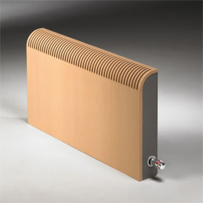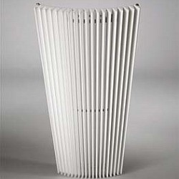

**Heatwave Play**

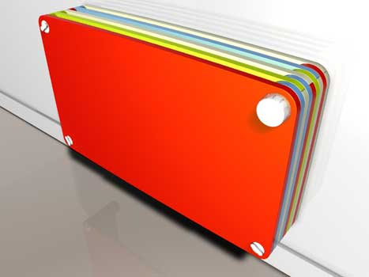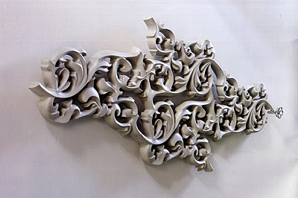

Source: Company documents.

Exhibit 3: artistic representation of the Modular Oxygen Bubble (Moby)

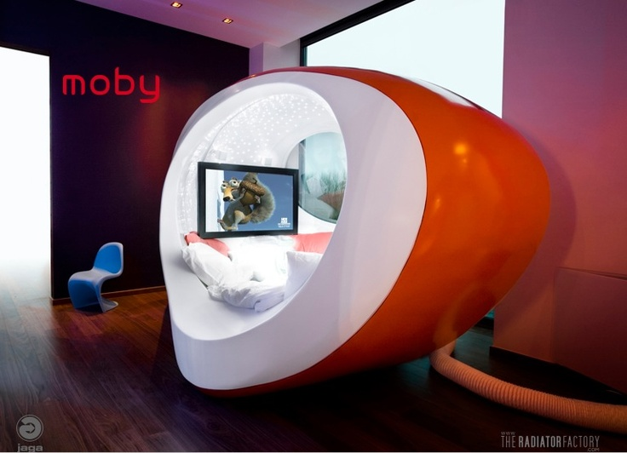

Source: Company documents.

ExHibit 4: The Jaga stand at Milan’s Salone del Mobile, 2007

A Section of Heatwave Chosen as Inspiration for the Stand

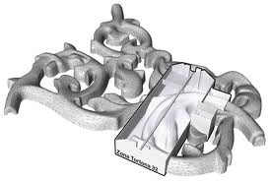

A View from the Outside: How It Was Constructed

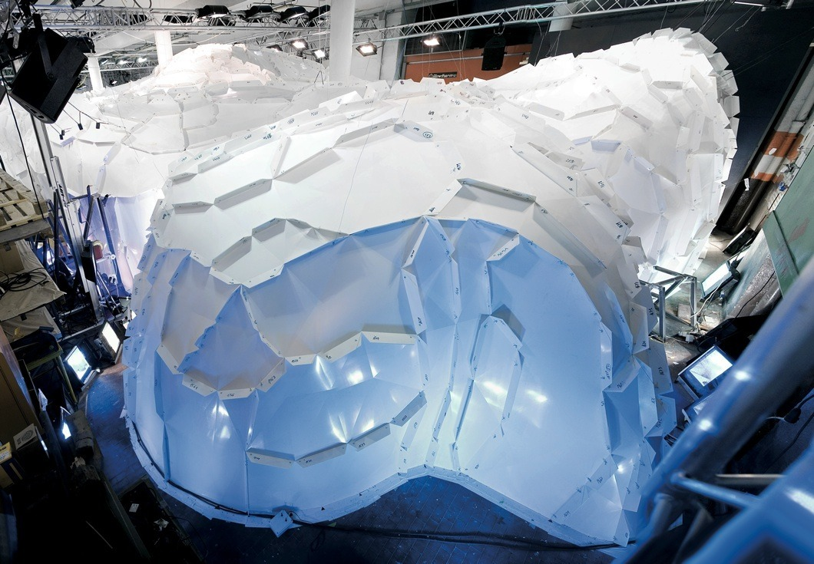

exhibit 4 (continued)

A Look from the Inside

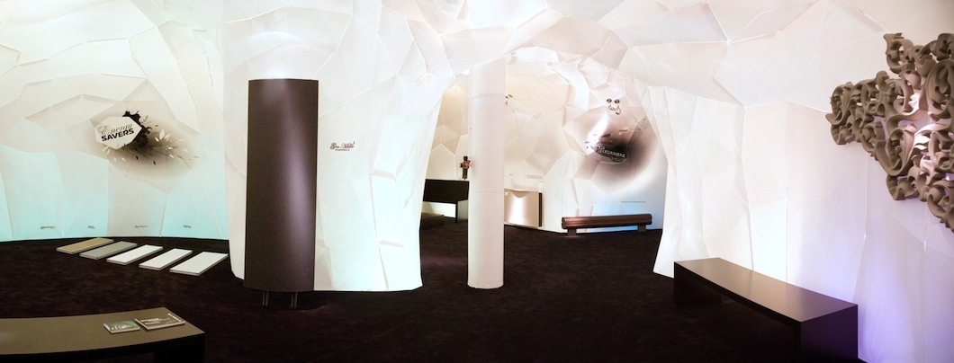

Source: Company documents.

Exhibit 5: The Play Radiator

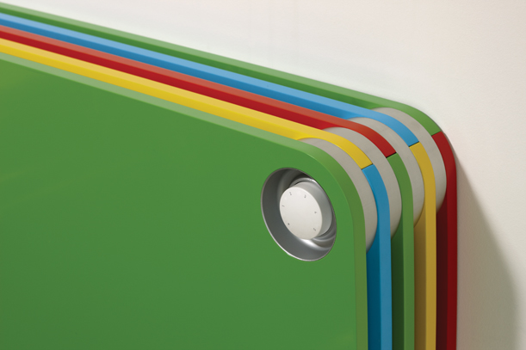

Source: Company documents.

Exhibit 6: Uchronia at the Burning Man Festival, 2006

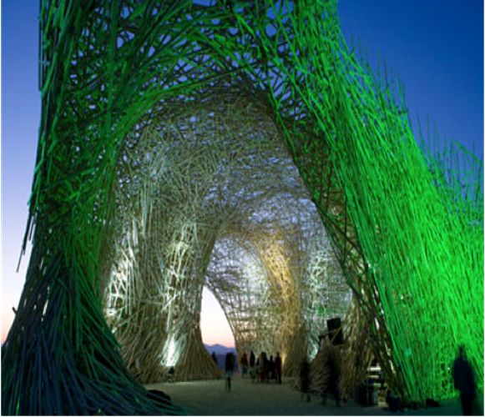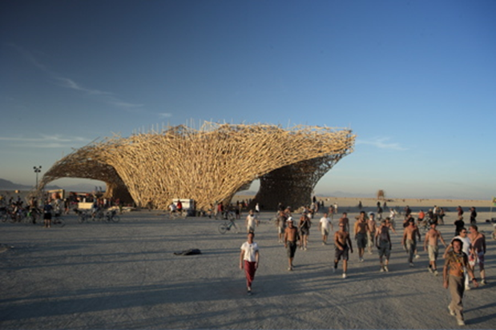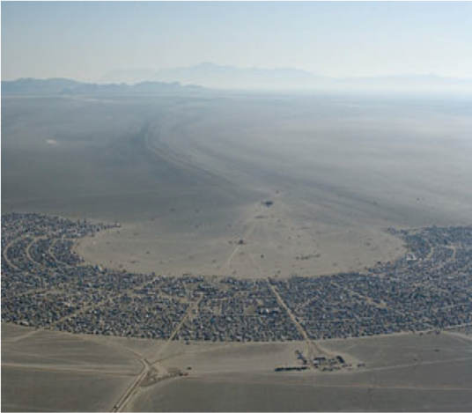

Source: Company documents.

1. Jan Kriekels, *Innovate or Die* (Tielt, Belgium: Lannoo Campus, 2013), 16.
2. The Export Lion Award was an annual prize awarded by Flanders Investment & Trade to Flemish companies.
3. € = EUR = euro; all currency amounts are in € unless otherwise specified; US$1 = €0.74 on July 1, 2007.
4. “Uchronians @ Burning Man: Philosophy,” YouTube video, 6:37, posted by “Jaga Experience Channel,” May 13, 2009, accessed January 20, 2018, www.youtube.com/watch?v=vU_usl-aH0w.
5. The term “cradle to cradle” was inspired by nature and referred to producing goods according to the principles of an ideal circular economy, where waste from one product became food for another; “Cradle to Cradle,” Environmental Protection Encouragement Agency, accessed July 11, 2018, https://www.epea.com/cradle-to-cradle.
6. Jan Kriekels, op. cit., 229.
7. Ibid., 197.
8. “The Experience Lab,” YouTube video, 3:01, posted by “Jaga Experience Channel,” May 6, 2009, accessed January 20, 2018, www.youtube.com/watch?v=IVSU9_7TaTM.