

9B18M124

WEstern regions gas pipeline company: the joint ventures

Xiuqin Wang and Professor Paul W. Beamish wrote this case solely to provide material for class discussion. The authors do not intend to illustrate either effective or ineffective handling of a managerial situation. The authors may have disguised certain names and other identifying information to protect confidentiality.

*This publication may not be transmitted, photocopied, digitized, or otherwise reproduced in any form or by any means without the permission of the copyright holder. Reproduction of this material is not covered under authorization by any reproduction rights organization. To order copies or request permission to reproduce materials, contact Ivey Publishing, Ivey Business School, Western University, London, Ontario, Canada, N6G 0N1; (t) 519.661.3208; (e)* [*cases@ivey.ca*](mailto:cases@ivey.ca)*;* [*www.iveycases.com*](http://www.iveycases.com)*.*

Copyright © 2018, Ivey Business School Foundation Version: 2018-08-31

In August 2015, Ma Haiyang, general manager of Western Regions Gas Pipeline Company (Western Regions Company), was gazing at a natural gas pipeline map in his Beijing office. The multinational natural gas pipeline (MNGP) shown on the map would deliver natural gas from the Republic of Timur (Timur) to China through the Republic of Frespirit (Frespirit). The construction of the pipeline was at the planning stage. To construct and operate the MNGP, Western Regions Company was legally required to set up a joint venture (JV) with a local company in each of the transit countries. However, the construction period for the MNGP was extremely short, and the relationships between the stakeholders were quite complicated. How to exercise control in the JVs to ensure the smooth construction and then operation of the MNGP had become a thorny issue for Haiyang.

**BACKGROUND**

As part of the trend of green and sustainable development, and specifically to move away from the use of coal and oil, China had been drastically increasing its natural gas consumption since the early 2000s. In 2015, China’s natural gas consumption reached 17.8 billion tonnes of oil equivalent. As a result, China had become the third-largest natural gas consumer in the world.[1] The huge gas demand certainly intensified China’s natural gas imports.

In April 2014, China New Group Corporation (CNGC)[2] signed an agreement, The Basic Principles of Establishing a Gas Pipeline from Timur to China (Basic Principles), with the Energy Department of Timur. The agreement stipulated that CNGC would take the lead in financing and building a land-based MNGP from Timur to China by the end of 2017 and that Timur would export 30 billion cubic metres of natural gas to China annually through the pipeline for 30 years, starting from 2017. However, China and Timur did not border each other, so the gas pipeline needed to go through a third country. Among a number of alternative routes, the route through Frespirit was the safest, though not the shortest. Taking into account the long-term operation of the pipeline, CNGC decided to build the gas pipeline from Timur to China through Frespirit.

**MULTINATIONAL NATURAL GAS PIPELINE**

The MNGP started from Timur and ran through Frespirit before entering China, with a total length of 2,000 kilometres (km) and a planned total investment of US$10 billion. In Timur, the pipeline was 500 km long and the investment was about US$3 billion. In Frespirit, the pipeline was 1,500 km long and the investment was about US$7 billion. The operating period of the MNGP was 30 years, starting at the end of 2017.

After the signing of the Basic Principles agreement in April 2014, the president of Timur resigned, which hindered the trade of natural gas between China and Timur. In July 2015, CNGC signed a gas sales and purchase agreement with the Energy Department of Timur. However, the deadline for completion was still the end of 2017, which meant that CNGC had only 28 months. (To put this in context, the construction period of the Maghreb–Europe Gas Pipeline, a pipeline of the same length, had been about six years.)

In August 2015, CNGC set up a wholly owned subsidiary in Beijing, namely, Western Regions Company, which was responsible for the construction and eventual operation of the MNGP. According to the laws of the transit countries, foreign companies had to set up JVs with local companies to construct and operate the pipelines. In these JVs, the proportion of foreign ownership could not exceed 50 per cent.

At the beginning of 2016, Western Regions Company established Western Timur Gas Pipeline Company (Western Timur Company) with Timur National Oil Holdings Group (TNG), and Western Frespirit Gas Pipeline Company (Western Frespirit Company) with Frespirit Gas Transmission Group (FTG). Western Timur Company was in charge of the construction and operation of the MNGP in the Timur section, and Western Frespirit Company was responsible for the part of the MNGP in Frespirit.

**CHINA NEW GROUP CORPORATION**

CNGC was a large-scale company in China that played a leading role in China’s petroleum industry. It was also among the world’s largest oil companies.

In the 1990s, CNGC successively opened up markets in Latin America, the Middle East, Frespirit, and other countries. The Sino–Frespirit crude oil pipeline of CNGC and FTG was built in 2011. By 2015, CNGC had also completed pipeline projects in China with a total length of more than 4,200 km and an investment of more than ¥140 billion.[3]

After signing the Basic Principles agreement in 2014, and in order to ensure the MNGP’s completion by the end of 2017, CNGC presided over the feasibility study, preliminary design, early procurement of pipe materials, and project financing of the MNGP. In August 2015, Western Regions Company, the wholly owned subsidiary of CNGC, was established in Beijing, and it took charge of the investment, construction, technology development, technical consulting, and operation management of the MNGP. CNEGC dispatched excellent project managers and technical personnel to join Western Regions Company; Haiyang was one of them. Haiyang had been engaged in overseas petroleum engineering construction since 1996 and had been responsible for CNGC’s oil and gas exploration projects in Venezuela and Sudan, which had provided him with rich experience in construction.

CNGC’s Western Regions Company was Western Timur Company’s parent company from China, while TNG was Western Timur Company’s parent company from Timur.

**TIMUR NATIONAL OIL HOLDINGS GROUP (TNG)**

TNG was a state-owned monopoly of oil and natural gas in Timur. In 2014, Timur’s gross domestic product (GDP) was US$171 billion, ranking 95th in the world. The pillar industries of the national economy were the “four golds”—gold, “white gold” (cotton), “black gold” (oil), and “blue gold” (natural gas). Timur had a single economic structure with developed agriculture, livestock husbandry, and mining industries; for more industrial products such as machinery and equipment, it relied on imports.

TNG controlled natural gas mining and transportation in Timur. As it was difficult for foreign petrochemical enterprises to set up wholly owned subsidiaries in Timur, Western Regions Company and TNG set up a JV there that was responsible for the MNGP’s construction and operation.

The experience of using natural gas for a long time and operating a domestic natural gas pipeline of over 10,000 km provided TNG with pipeline construction and operation capacity. However, as most of the pipelines in Timur had been constructed 50 years earlier and pipe diameters were small, TNG had no experience in building and operating a modern, high-pressure, long-distance natural gas pipeline.

Based on its own experience, TNG did not believe the pipeline could be completed within a period of only 28 months and thus did not pay any attention to the duration. In addition, TNG did not want to invest more equity money in the MNGP. However, TNG required that Timur’s construction company should take part in the construction of the MNGP. TNG hoped to negotiate with Western Regions Company to determine a high pipeline transportation fee.

**FRESPIRIT GAS TRANSMISSION GROUP (FTG)**

FTG was Western Frespirit Company’s parent company from Frespirit. The GDP of Frespirit in 2014 was US$810 billion, ranking 55th in the world. Its economy was dominated by oil, gas, mining, coal, agriculture, and animal husbandry, while its processing and light industries were relatively backward. Frespirit had implemented economic reforms, including the introduction of a market economy in stages and privatization. Owing to this, Frespirit’s economy had achieved rapid growth. Its average economic growth rate between 2008 and 2014 exceeded 9 per cent.

FTG was the major state-owned oil company in Frespirit. It had played a decisive role in the development of Frespirit’s oil and gas industry. In 2013, the company produced 9.4 million tons of liquid hydrocarbons, holding majority ownership in several large-scale projects. Approximately 35 million tons of oil were involved in mining, which was more than 50 per cent of Frespirit’s total oil production. The company accounted for almost 8 per cent of Frespirit’s GDP and 8 per cent of its national budgetary revenues. In addition, FTG owned more than 60 per cent of pipeline capacity and 30 per cent of oil processing capacity in Frespirit. The company had worked with CNGC to build and operate a crude oil pipeline in Central Asia. Western Regions Company and FTG had set up a JV in Frespirit that was responsible for the construction and operation of the Frespirit section of the MNGP.

FTG also did not believe the pipeline could be completed within a mere 28 months and did not want to invest more. Consequently, the group did not focus on the project deadline. Furthermore, it proposed that the project be constructed by its own engineering team. In addition, it asked CNGP to pay an additional transit fee. At the same time, FTG wanted to greatly limit the proportion of Chinese personnel and believed that it was necessary for it to have dominant control of the JV, which was troublesome for Haiyang and his team, as they also wanted to control the JVs.

**JV ISSUES**

Equity Ratio in JVs

To complete the MNGP within the stipulated time and exercise control over the decision-making power of the JVs during both project construction and project operation, CNGC had proposed to hold over 50 per cent of the equity interest in the JV company; TNG and FTG both opposed this proposal. As a result, both sides in each JV held 50 per cent of the equity.

Equity Capital of JVs

TNG and FTG were reluctant to invest too much capital in the JVs. Due to restrictions on shareholding, Western Regions Company could only invest the same amount of capital as domestic parties, which resulted in little capital available for the JV. In Western Timur Company, Western Regions Company and TNG each invested US$1.5 million. In Western Frespirit Company, both Western Regions Company and FTG invested US$5 million. The capital of the two JVs accounted for less than 1 per cent of the total investment—the proportion of the equity capital in comparable international projects was usually 20–30 per cent.

The lack of equity capital caused Haiyang distress. Traditional corporate financing could not solve the project’s huge financing need. Haiyang finally decided to adopt a project financing model[4] after several brainstorming sessions with his finance team. During the financing negotiation, the lending banks required a shareholders’ support agreement and a cross-default agreement between the two JVs in addition to the usual project financing credit support.[5]

**DECISION-MAKING MECHANISM**

The highest decision-making bodies of Western Timur Company and Western Frespirit Company were the shareholders. Shareholder groups were composed of the same number of people from each side.

In Western Timur Company, shareholders agreed that Xiao Yue Peng, who was from Western Regions Company, could serve as general manager of the JV and that someone from TNG could serve as the chief vice-general manager until the project loan was repaid. Also, the general manager in charge of construction, the general manager in charge of operations, and the vice-general manager in charge of business were from Western Regions Company, while the chief accountant and the vice-general manager in charge of administration were from TNG (see Exhibit 1).

In Western Frespirit Company, FTG insisted that the first general manager should be from FTG. It felt that this would allow FTG to more easily coordinate with other parties in Frespirit, such as the government and suppliers. It was also an issue of national pride. Haiyang agreed, but he proposed that a project management team (PMT)[6] should be set up in the organization. The PMT would be responsible for the construction of the project, and Chinese personnel would fill the roles of not only chief vice-general manager but also PMT leader. For the sake of reciprocity, besides the general manager and the vice-general manager, both Western Regions Company and FTG could choose one person to be the PMT vice-leader. Staff from Western Regions Company would serve as chief accountant and vice-general manager in charge of administration, and an FTG staff member would serve as vice-general manager of economy. Furthermore, Haiyang proposed that the PMT should include a technical department; control department; health, safety, and environment department; document control department; construction department; and procurement department (see Exhibit 2).

In Western Frespirit Company, besides guaranteeing the equal right of decision making in major incidents, both sides also agreed to implement a dual signature mechanism to ensure the safety of funds. Both the department manager and the deputy manager, or the general manager and the vice-general manager would need to follow it. Any payment documents would be accepted by the bank only with the signature of both the general manager and the chief accountant.

**STAFFING**

The JV needed to address the ratio of staff issue. Restrictions on foreign workers in both Timur and Frespirit were very strict, as reflected in the difficulty of obtaining visas and the proportion of employees in the JV; according to normal procedures, it was difficult for Chinese personnel to get visas and to enter Timur and Frespirit to carry out their work. Moreover, the domestic parties insisted that Chinese personnel should not exceed 10 per cent of the total number of staff of the JVs. Facing these two issues, Haiyang turned to China’s Ministry of Foreign Affairs, who helped Western Regions Company to negotiate with the foreign affairs ministries of the two countries. About the ratio of staff, after multiple rounds of negotiations with the domestic parties, an agreement was reached that more Chinese personnel could be appointed during the construction period, with the rate gradually reduced to 10 per cent by the time of operation. Western Timur Company employed 448 staff members, including 153 Chinese employees and 295 Timur employees. There were 42 employees in the construction-related departments: 13 from Western Regions Company and 29 from TNG. Western Frespirit Company employed 1,100 staff members, including 121 Chinese employees and 979 Timur employees. There were 135 staff members in construction-related departments: 30 from Western Regions Company and 105 from FTG.

Haiyang was also focused on key positions. In Western Timur Company, Western Regions Company controlled the construction and operation departments, which were headed by Chinese personnel as department managers. However, in Western Frespirit Company, in addition to providing the first deputy general manager and PMT leader in charge of the company’s project construction, the Chinese side in the project’s construction-related department supplied a high number of professional and technical personnel. Western Regions Company was able to staff such positions as the managers of the engineering and technology department, the document control department, and the purchasing department.

**PROBLEM TO BE SOLVED**

Haiyang and his team had struggled to define better JV structures with TNG and FTG. However, the present design of the JVs’ organizational structure was mainly for control of the JVs in the construction period. When it was time to operate the MNGP, would the control measures in the construction period also be effective during the operation stage? If not, what control methods should be adopted?

EXHIBIT 1: organizational structure of western timur company

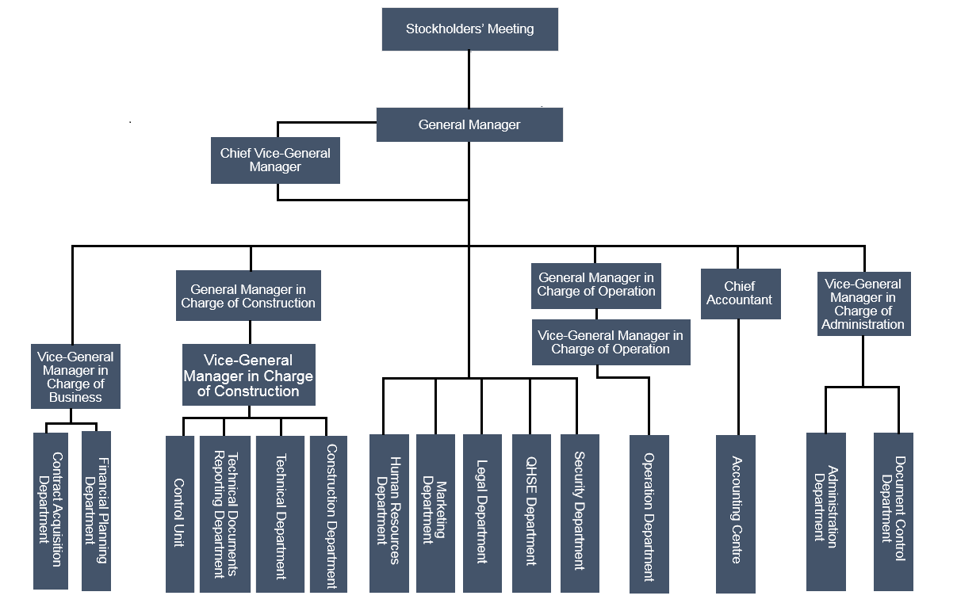

Note: QHSE = quality, health, safety, and environment.

Source: Company files.

EXHIBIT 2: organizational structure of western frespirit company

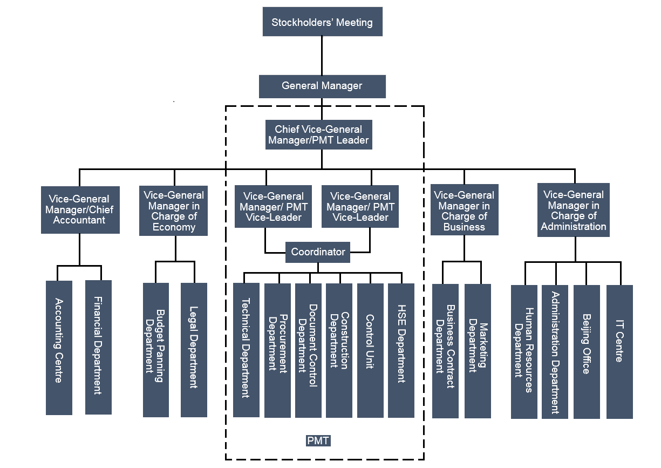

Note: PMT = project management team; HSE = health, safety, and environment; IT = information technology.

Source: Company files.

1. “Statistical Review of World Energy,” BP Global, accessed January 18, 2018, https://www.bp.com/en/global/corporate/energy-economics/statistical-review-of-world-energy.html.
2. CNGC was the parent company of Western Regions Company.
3. ¥ = CNY = Chinese yuan renminbi; US$1.00 = ¥6.3852 on August 31, 2015.
4. Project financing was the raising of funds on a limited-recourse or nonrecourse basis to finance an economically separable capital investment project, in which the providers of the funds looked primarily to the cash flow from the project as the source to service the loans; John D. Finnerty, *Project Financing: Asset-Based Financial Engineering*, 2nd ed., (Hoboken, NJ: John Wiley & Sons, Inc., 2007), 1.
5. Sufficient credit support for a project loan—such as the requirement of a construction-completion guarantee, a take-or-pay agreement, a cash-deficiency agreement, or a project’s assets as collateral—was a necessary precondition to successful project finance arrangements; John D. Finnerty, op. cit.
6. PMT (Project Management Team) was an owner-oriented organizational management method commonly used by owners of large-scale construction projects during the construction period.