** **

9B18M129

cMNGD (COMMONGOOD) linens: scaling a work-integration social enterprise

Professors Simon Parker and Houston Peschl wrote this case solely to provide material for class discussion. The authors do not intend to illustrate either effective or ineffective handling of a managerial situation. The authors may have disguised certain names and other identifying information to protect confidentiality.

*This publication may not be transmitted, photocopied, digitized, or otherwise reproduced in any form or by any means without the permission of the copyright holder. Reproduction of this material is not covered under authorization by any reproduction rights organization. To order copies or request permission to reproduce materials, contact Ivey Publishing, Ivey Business School, Western University, London, Ontario, Canada, N6G 0N1; (t) 519.661.3208; (e)* [*cases@ivey.ca*](mailto:cases@ivey.ca)*;* [*www.iveycases.com*](http://www.iveycases.com)*.*

Copyright © 2018, Ivey Business School Foundation Version: 2018-09-28

It was 8:00 a.m. on a fine day in June 2018 when Hannah Cree, co-founder of CMNGD (Commongood) Linens (CMNGD), was observing operations in the facility’s laundry room. CMNGD was a work-integration social enterprise based in Calgary, Alberta, whose purpose of “Doing Well by Doing Good” was fulfilled by equipping hard-to-employ workers (i.e., people facing employment barriers) with skills that could reintegrate the workers back into the regular labour force.

The new black uniforms spun round and round in the washing machine. Hannah watched Eric Smith, a new hire, empty the dryer and fold the black uniforms with gentle precision. She reflected on Smith’s journey with CMNGD. When Dave Cree, Hannah’s husband and co-founder of CMNGD, had first met him, Smith was living on the street and struggling to feed himself. His clothes were in tatters, and his few belongings were worn from weather and use. Smith’s morale was down, and he felt like he would never be able to become a productive member of society. Hannah and Dave, who had had their own experiences with poverty, empathized with Smith and gave him the opportunity to turn his life around by hiring him at CMNGD. After weeks of training, which accommodated Smith’s unique needs, the Crees had acquired a diligent and grateful worker.

As Hannah watched Smith, she realized that she wanted to give even more opportunities to people like him. She and Dave had discussed for some time whether, and how, they might scale their CMNGD business, which was already profitable. They knew that scaling a regular for-profit business was hard enough and wondered whether scaling was even possible for CMNGD. On the other hand, they risked restricting their social impact and financial returns if they never tried.

**FOUNDER MOTIVATION**

CMNGD was founded in Calgary in mid-2016 by husband-and-wife team Dave and Hannah Cree. The company’s mission—to provide individuals faced with the barriers of poverty and homelessness opportunities to become independent and self-sufficient—was derived from the founders’ personal experiences with poverty, homelessness, and social justice issues.

Dave had experienced a day of homelessness during a leadership course he had taken. For one assignment, he had been required to spend an entire day living in destitution: dressed in dirty clothes, he had walked the streets while begging for CA$15 from strangers. This had a significant impact on Dave; he witnessed the lack of empathy individuals had for him and other homeless citizens. People would bypass him without looking and would even cross the street to avoid him when they saw him heading in their direction. Dave shared, “The shame, desperation, and emotional and mental distress of the people I met that day forever changed the way I viewed homelessness and poverty. I knew we weren’t solving the root cause of the problem.” Dave realized how privileged he was to only endure this for a day and understood that others were not so fortunate. These experiences sparked Hannah and Dave’s passion to help those living in poverty.

In 2013, the Calgary flood changed Hannah’s life. With a backpack full of clothes and a cat in her purse, Hannah and her family trudged through knee-deep water, grasping what it felt like to be without a place to live. Hannah realized that she and Dave were very lucky to have had an outpouring of support from the community during the flood. At one point, they had over 15 strangers in their flooded home, dragging out waterlogged furniture and soggy memories. They were saved because of the immense financial and emotional support from family and friends. Hannah and Dave knew that not everyone had access to this kind of aid; in fact, every night in their city, over 3,000 people did not have a home or access to basic necessities.

After the flood and rebuild, Hannah and Dave recommitted to giving back to the community that had helped them. They began volunteering at the Calgary Drop-In & Rehab Centre (Drop-In Centre), a shelter and rehabilitation facility for people living in homelessness. The Crees detected a pattern in the stories they heard from people living at the shelter: despite upgrading their skills and creating a résumé, they still lived in a shelter without stable Internet access that was needed to find a job, and many lacked proper identification, a phone, and a bank account. No employers would take a chance on them. Without a job, they could not get their own home, and without a home, they were forced to live at the shelter. The barriers to returning to employment and living in their own home were not impossible to overcome, but they could not do it alone.

At a leadership course in 2017, Dave had met someone who was running a laundry service in Toronto, Ontario that a local homeless shelter was using to employ its residents. The laundry helped with rehabilitation and was imitable, but it was not profitable. Yet Dave knew the big service providers in the laundry industry were making profits, and he kept thinking about whether he could adapt the Toronto laundry approach to generate profits for social good.

One morning, while at their favourite brunch spot, Hannah and Dave observed a restaurant manager having a discussion with a chef regarding the expensive and inconvenient linen cleaning service that was currently being offered to the restaurant and the inflexibility of being tied into a long-term contract with their service provider. After this observation, Hannah and Dave began to investigate the restaurant industry for confirmation of this problem. They soon realized that a large and growing number of restaurants and hotels were frustrated with their laundry and linen cleaning services. After speaking to over 50 restaurant owners about their needs and gaps and discussing the model with the Drop-In Centre, the Crees decided to create a social enterprise that transitioned people facing homelessness from the Drop-In Centre to full-time employment by providing affordable and quality laundry services to restaurants and hotels.

Hannah and Dave spotted their entrepreneurial opportunity by noticing two gaps. One gap was in the labour market, where individuals living in homelessness experienced difficulties transitioning from positions of poverty to those of stability. The second gap was in the service market—namely, a lack of economical, reliable, and customer-friendly linen laundry services for small business owners in the restaurant and hospitality industry.

Hannah and Dave realized that there was room for a socially responsible provider of affordable, high-quality, and contract-free linen services to Calgary’s booming restaurant and hospitality industry, and whose social mission was to end poverty by providing employment to homeless Calgarians. With Dave’s background in sales and marketing and Hannah’s experience in community building, the pair was set to begin operations.

INDUSTRY SETTING

CMNGD operated within the Canadian industrial laundry and linen supply (ILLS) industry.[1] This industry sector supplied linen, uniforms, and dust-control items to food services, hospitality, and manufacturing operators. Nationally and regionally, the ILLS industry sector was dominated by a few large market players. The sector had undergone steady growth in the five years before CMNGD was founded: total revenue had increased at an annualized rate of 1.9 per cent over 2012–2017 to reach an expected CA$1.4 billion[2] in 2017. This growth could mainly be attributed to declining unemployment and rising demand from the health care, food services, and manufacturing sectors.

Over 2017–2022, industry revenue was expected to increase at an annualized rate of 1.4 per cent to reach $1.5 billion, attributed to general improvements in the Canadian economy. Yet the industry was in a mature stage of its overall life cycle within Canada—a situation that had already induced several companies to build market share by acquiring regional players. Ongoing entry accompanied rising industry concentration, which intensified competition in the industry.

The ILLS market within Calgary was dominated by three major firms: Canadian Linen and Uniform Service Co, K-Bro Linen Systems Inc. (K-Bro), and Fishman’s Personal Care Cleaners. As an example, K-Bro operated out of central Calgary and had been providing laundry services to its customers since 1954.[3] Given their dominant market shares, these players had imposed restrictive contracts on their clients and enjoyed price-setting power. Ever-rising prices were squeezing many restaurants’ margins, which presented CMNGD with a commercial opportunity.

CMNGD (COMMONGOOD) LINENS

CMNGD raised initial capital of $11,265 in June 2016 by crowdfunding their venture using the ATB Financial BoostR platform.[4] Once in operation, CMNGD offered affordable laundry services to trendy local three- and four-star restaurants that valued quality and were also interested in the social good and having more community impact. CMNGD supplied and washed kitchen uniforms and cleaning and polishing cloths (see Exhibit 1). CMNGD also strove to have a positive environmental impact by heating their water using biofuel and solar energy.

On average, CMNGD provided each location it served with eight uniforms and two orders of cloths for a price of $10 and $12 each, respectively, delivered twice a week. It also charged a low price of $12 per drop-off of linens to cover transportation costs. In terms of competitive positioning, CMNGD matched the prices of its competitors but provided a more attractive, customized service by eschewing restrictive long-term contracts with clients, providing bi-weekly deliveries, and fulfilling an important social mission. These factors differentiated CMNGD from other large market players.

The ILLS industry only had a 20 per cent profit margin as a whole, so CMNGD’s profits were much lower than those of competitors when taking account of the social good model. CMNGD needed to do about $250,000 of business per quarter to be profitable in Calgary and the surrounding area. On average, contracts for restaurants each brought in $600 per month, mainly through rentals and laundry, while the hotels each brought in about $1,400 through laundry only (since most hotels owned their own linens). CMNGD employed four full-time employees and served 60 locations in Calgary. It had achieved operating profit margins of approximately 81 per cent in 2016 and 2017, making approximately $10,000 in operating profit for each restaurant served (see Exhibit 2).

CMNGD provided a stable and safe work environment in which individuals transitioning out of homelessness could learn new skills and earn a living wage of $18 per hour in a real but supportive business setting. Hannah and Dave partnered with the Drop-In Centre to recruit homeless individuals who were actively seeking to improve their social situation. Recruiting requirements included sobriety for the past year, weekly attendance at Drop-In Centre counselling, improving mental health, and a positive, forward-thinking attitude. As a result of its social focus, CMNGD obtained a social license to operate,[5] received donations from several Calgary-based business leaders, and attracted interest from leading civic figures in Edmonton, Alberta and Vancouver, British Columbia who wanted to help citizens of their own cities who were struggling with poverty. CMNGD promoted its services through the BoostR pitch competition[6] (which CMNGD won in 2016), pop-up events, online videos, and word of mouth.

CMNGD’s social mission came at a price. Unlike the average employee in Canada who took approximately 40 hours to train, CMNGD’s employees were each provided with about 120 hours of individualized training and support. This 120 hours comprised 30 hours of laptop and smartphone training; 10 hours of customer service training; 40 hours of job-task training (e.g., cleaning and collecting laundry and linens); and 40 hours of personal development, such as setting up bank accounts, obtaining social insurance numbers, and getting drivers’ licenses. CMNGD also offered flexible work time and scheduling to its workers to accommodate their special needs, whenever possible. Unlike regular for-profit businesses, which aimed to retain their most productive employees, Hannah and Dave wanted to transition their employees out of CMNGD and into a better life within, at most, three years; they had already transitioned two such people in their first two years of operations. Hence CMNGD purposefully experienced ongoing turnover and recurrent training costs.

OPTIONS TO SCALE THE VENTURE

Hannah knew that the social impact of CMNGD was limited only by the size of the market it could serve. She had already given some thought to whether CMNGD could scale, and she had identified three possible options.

The first option was to consolidate and extend the venture’s footprint in Calgary. This had the advantage of exploiting an established customer base, where word-of-mouth marketing could be used, economizing on the marketing expenses involved in expanding to other cities. The Crees had already established reliable partnerships and long-term relationships in Calgary and were knowledgeable about the city. Hannah wondered if CMNGD should first address remaining issues with their business model in Calgary and possibly provide more products and services there. However, she was unsure what additional products and services CMNGD could develop without diluting their currently clear market positioning. There were also limits to scale: only so many restaurants could be serviced in Calgary, and deep penetration might induce an aggressive competitive response from CMNGD’s competitors. Focusing on Calgary also left profitable opportunities in other cities available for others to seize.

A second option was to expand CMNGD into other cities in Alberta, followed by cities in the rest of Canada. After all, there was no reason to think that Calgary was unusual in terms of its homelessness problem; CMNGD’s social mission was presumably applicable in plenty of other places. The potential for scale seemed enormous. For example, CMNGD could enter the Edmonton market in 2020, and the Vancouver market in 2022. Hannah estimated that CMNGD could capture 120 locations in Calgary and 60 locations in Edmonton during 2020, scaling up to 250 clients in Calgary, 230 in Edmonton, and 60 in Vancouver by 2022.

However, the Crees lacked detailed knowledge of other cities and did not yet have partnerships in any of them. Also, CMNGD’s business model might not easily transfer to other locations with different needs and competitive structures than Calgary. Specifically, Hannah was aware that if CMNGD expanded into different locations, additional expenses might arise (see Exhibit 3). Hannah wondered whether some franchising arrangement might be able to circumvent these issues, but neither she nor her husband had any direct experience with franchising, and she wondered, in any case, whether franchising of social enterprises might differ from franchising of conventional for-profit businesses.

The third option was to abandon the social mission and focus on being a low-cost provider of linen services. Removing the costly training and labour turnover features of a work-integration social enterprise could enable a strictly for-profit CMNGD to increase profits that could be reinvested to fuel faster growth through expansion both in and beyond Calgary. Later, perhaps, once CMNGD had attained scale, the social mission could be reintroduced. However, Hannah felt strongly about the value of the social mission and questioned whether CMNGD would have grown so fast in the first place were it not for that mission, which many clients claimed to value.

DECISION TIME

Hannah left the laundry, returned to her office, and pondered what to do. Could she scale CMNGD and so increase its beneficial impact? Or would doing so place so much strain on her fledgling company that its very viability would be thrown into question or its core values put at risk? Hannah knew that a lot was at stake, not only financially but also regarding the livelihoods of the vulnerable people she was committed to helping. What was the best course of action for her to take?

Exhibit 1: CMNGD CLOTHS AND UNIFORMS

 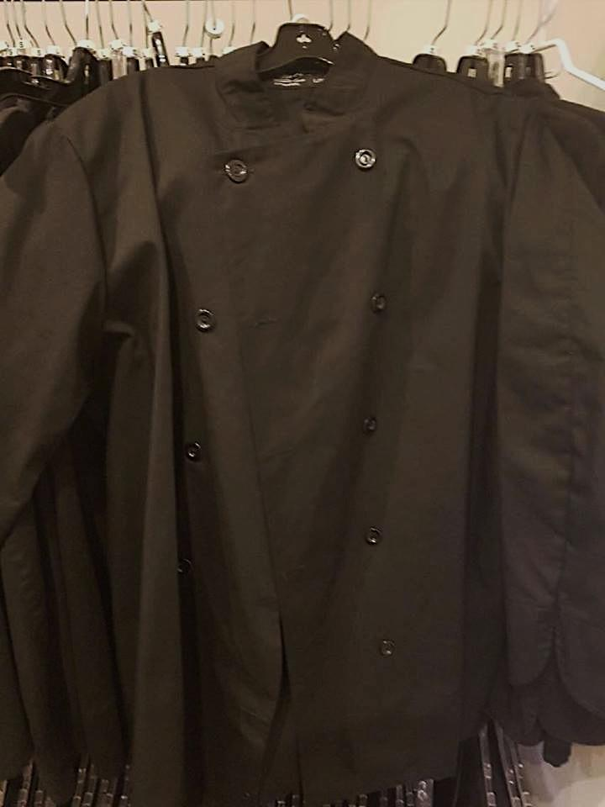

Cloths CMNGD provided to restaurants Uniforms CMNGD provided to restaurants

Source: Company promotional materials.

Exhibit 2: CMNGD FINANCIALS, 2016–2017 and Projections

|  |  |  |  |  |  |  |  |
| --- | --- | --- | --- | --- | --- | --- | --- |
|  | **2016** | **2017** | **2018** | **2019** | **2020** | **2021** | **2022** |
| Number of Locations Served | 15 | 35 | 60 | 120 | 180 | 280 | 400 |
| Gross Sales | 180,960.00 | 414,960.00 | 414,960.00 | 711,360.00 | 1,451,174.40 | 2,220,296.83 | 3,522,870.97 |
| Less: Sales Returns and Allowances | — | — | — | — | — | — | — |
| **Net Sales** | 180,960.00 | 414,960.00 | 414,960.00 | 711,360.00 | 1,451,174.40 | 2,220,296.83 | 3,522,870.97 |
| Items For Service |  |  |  |  |  |  |  |
| Uniforms | 49,920.00 | 116,480.00 | 199,680.00 | 399,360.00 | 599,040.00 | 931,840.00 | 1,331,200.00 |
| Cloths | 9,360.00 | 21,840.00 | 37,440.00 | 74,880.00 | 112,320.00 | 174,720.00 | 249,600.00 |
| **Total** | 59,280.00 | 138,320.00 | 237,120.00 | 474,240.00 | 711,360.00 | 1,106,560.00 | 1,580,800.00 |
| **Gross Profit (Loss)** | 121,680.00 | 276,640.00 | 177,840.00 | 237,120.00 | 739,814.40 | 1,113,736.83 | 1,942,070.97 |
| Administration and Supplies | 1,000.00 | 1,000.00 | 1,000.00 | 1,000.00 | 2,000.00 | 2,000.00 | 3,000.00 |
| Employee Training Costs | 1,440.00 | 1,440.00 | 4,320.00 | 7,608.00 | 9,619.20 | 13,478.40 | 17,664.00 |
| Equipment Depreciation | 3,000.00 | 3,000.00 | 4,800.00 | 9,600.00 | 14,400.00 | 19,200.00 | 28,800.00 |
| Insurance Expenses | 2,000.00 | 2,000.00 | 2,000.00 | 3,000.00 | 5,000.00 | 6,000.00 | 9,000.00 |
| Production Facility Lease | — | — | 50,000.00 | 50,000.00 | 90,000.00 | 90,000.00 | 150,000.00 |
| Salary and Wages | 107,440.00 | 144,880.00 | 219,760.00 | 387,892.80 | 573,026.40 | 862,770.96 | 1,269,856.65 |
| Transporation and Repair Costs | 11,000.00 | 25,850.00 | 44,000.00 | 89,760.00 | 13,733.28 | 218,290.49 | 317,910.33 |
| Utility Expenses | — | — | 2,400.00 | 4,800.00 | 7,200.00 | 11,200.00 | 16,000.00 |
| **Total Expenses** | 125,880.00 | 178,170.00 | 328,280.00 | 553,660.80 | 714,978.88 | 1,222,939.85 | 1,812,230.98 |
| **Net Operating Income** | (4,200) | 98,470 | (150,440) | (316,541) | 24,836 | (109,203) | 129,840 |

Note: All currency in CA$.

Source: Company records.

Exhibit 3: COSTS OF GROWING INTO NEW MARKETS

|  |
| --- |
| * Variable costs include the following: * 2.50 per uniform * 1.00 per unit of cloths (100 cloths in each unit) * Employee costs and details include the following: * Hannah and Dave’s salary to be 50,000 in 2016, 60,000 in 2017, and 70,000 in 2018 * Employee costs include 18 per hour (including training hours) * CMNGD purchased one truck in 2016 for 30,000, and five more trucks will be purchased for the same price, one in 2019, one in 2020, two in 2021, and one in 2022. Assume each truck has no salvage value and has an expected life of 10 years, using straight-line depreciation. * CMNGD purchased one washer-and-dryer set in 2018 at a cost of 18,000, and five more sets will be purchased for the same price, one in 2019, two in 2020, and two in 2022. Assume each washer-and-dryer set has no salvage value and has an expected life of 10 years, using straight-line depreciation. * CMNGD’s insurance expenses include 1,000 of business insurance for every city they operate in per year. There is a yearly charge of 1,000 for every operating vehicle. * Marketing resulted in a total cost of 5,000 in 2016, 10,000 in 2017, and projections of 15,000 per year from 2018–2019, 20,000 per year from 2020–2021, and a final cost of 25,000 in 2022. * Administration and supplies cost 1,000 per year for each city in operation. * Assume utilities cost 40 for each restaurant being serviced per year. * There is a 2% inflation rate that affects revenues, employee costs, and transportation costs each year following and including 2019. * Leasing operation space costs 50,000/year in Calgary, 40,000/year in Edmonton, and 60,000/year in Vancouver. |

Note: All currency in CA.

Source: Company records.

1. Olivia Ross, “Industrial Laundry & Linen Supply in Canada,” IBISWorld*,* May 2018, accessed May 1, 2018, http://clients1.ibisworld.ca/reports/ca/industry/default.aspx?entid=1731.
2. All dollar amounts are in Canadian dollars unless otherwise indicated.
3. K-Bro Linen Systems (website), accessed May 1, 2018, http://www.k-brolinen.com.
4. “ATB BoostR,” ATB Financial, accessed May 3, 2018, www.atb.com/business/experts/Pages/ATB-BoostR.aspx.
5. “Measuring the Social License,” Social License, accessed May 3, 2018, <https://socialicense.com/measure.html>.
6. ATB BoostR (website), accessed May 3, 2018, <https://atbboostr.ca/>.