|  |  |
| --- | --- |
|  | **logo_greyscale** |

**9B18M137**

FUJITSU: CO-CREATING DIGITAL BUSINESS

Sarah Lai-Yin Cheah and Foo Maw Der wrote this case solely to provide material for class discussion. The authors do not intend to illustrate either effective or ineffective handling of a managerial situation. The authors may have disguised certain names and other identifying information to protect confidentiality.

*This publication may not be transmitted, photocopied, digitized or otherwise reproduced in any form or by any means without the permission of the copyright holder. Reproduction of this material is not covered under authorization by any reproduction rights organization. To order copies or request permission to reproduce materials, contact Ivey Publishing, Ivey Business School, Western University, London, Ontario, Canada, N6G 0N1; (t) 519.661.3208; (e)* [*cases@ivey.ca*](mailto:cases@ivey.ca)*;* [*www.iveycases.com*](http://www.iveycases.com)*.*

Copyright © 2018, National University of Singapore and Ivey School of Business Foundation Version: 2018-09-13

On July 12, 2017, Heng Chew Wong stared at his computer screen in his office at One North, a Silicon Valley–inspired community of high-technology multinational companies (MNCs) and start-ups in Singapore. After seven years as president of the information and communications technology (ICT) firm Fujitsu Asia Pte. Ltd. in Singapore, a subsidiary of the Japanese conglomerate Fujitsu Limited (Fujitsu), Wong had witnessed how the company was able, in many situations, to continuously innovate as a powerful change agent and how it had developed invaluable competencies in the process.

In particular, Fujitsu had deployed engineering cloud computing to support the manufacturing industry in 2017, offering manufacturing companies cost-effective access to engineering support software such as computer-aided design (CAD) applications that users could access via their mobile devices. In its effort to rejuvenate Japan’s failing agricultural industry, Fujitsu had worked with industry stakeholders in 2012 to co-develop the Akisai platform, which used the Internet of things (IoT) and artificial intelligence (AI). Wong was certain that these competencies could potentially act as much-needed new engines of growth for Fujitsu Singapore in the next five to 10 years; they represented Fujitsu’s vision of connected services—a secure combination of key digital technologies, especially AI and the IoT, on a cloud-based computing platform, to connect customers and ecosystem partners to co-create value.

Studying the two project options presented on his computer screen, Wong compared the estimated costs, potential revenues, and strategic value of each project over the next five years. Having demonstrated its value to the manufacturing industry in Japan, the engineering cloud-computing platform seemed to be an ideal candidate to present as a cost-effective platform as a service (PaaS) and software as a service (SaaS) for small and medium enterprises (SMEs) in Singapore and the region. However, given the high costs of customizing and localizing the existing platform for local use, would the target SMEs generate sufficient demand to justify such a costly investment at this stage? The Akisai platform, using the IoT and AI, had attracted the interest of a European partner who had deployed the technology for vertical farming in Finland, a country that had similar demographics and constraints as Singapore. Was it the right time to introduce the platform in Singapore?

ABOUT FUJITSU

Headquartered in Tokyo, the Fujitsu parent company was a global provider of ICT products, solutions, and services in three key sectors: technology solutions, ubiquitous solutions, and device solutions (see Exhibit 1). With a staff strength of about 156,000 people in more than 100 countries, Fujitsu reported consolidated revenues of ¥4.5 trillion[[1]](#footnote-1) and operating profit of ¥128.8 billion in financial year (FY) 2016. Accounting for more than 60 per cent of Fujitsu’s revenue, technology solutions had been the company’s mainstay; these solutions included infrastructural platforms such as servers, storage, and networks and related services such as data centre outsourcing, cloud services, and network services. The ubiquitous solutions sector (personal computers, mobile phones, and mobile wear) made up another 23 per cent of the revenue, and the device solutions sector (large-scale integrated circuits and electronic components) made up 12 per cent (see Exhibit 2). For the past three years, revenue from technology solutions and device solutions had declined, while revenue from ubiquitous solutions, particularly the mobile wear area, had risen. In recent years, Fujitsu had identified four technology trends that it had adopted as core technology areas to grow its mainstay technology solutions sector: the IoT, AI, cybersecurity, and cloud computing. The company had embarked on initiatives to consolidate divisions related to these core technologies to form the new digital services unit, with the purpose of globally expanding a new growth area: digital innovation business.

TRENDS AND COMPETITION

The ICT industry was ever-evolving, and its trends were ever-changing. In response, Fujitsu constantly innovated with new products, services, and solutions offerings to keep up with the trends. One major trend in recent times included the IoT—the concept of connecting components and devices to the Internet. This connectivity revolutionized the way humans interacted with their tools and assets, as the human–Internet interface allowed central control by a designated administrator. Furthermore, network connectivity enabled the capture of more data about work processes, employees, and other relevant factors. The data collected about equipment, processes, and people could become useful information for companies to monitor their performance. According to a 2016 Gartner report,[[2]](#footnote-2) the IoT endpoints would reach an installed base of 20.4 billion units by 2020, at a compounded annual growth rate of 32.9 per cent from 2015. In the IoT platform space, the research firm International Data Corporation evaluated the existing players based on criteria such as breadth of product functionality and complementary portfolio offerings, device and edge support, and integration capabilities. It ranked International Business Machines Corporation (IBM), General Electric Digital, Microsoft Corporation (Microsoft), Amazon.com Inc. (Amazon), and PTC as leaders; Fujitsu was rated as a major player, in the same league as Oracle Corporation (Oracle).[[3]](#footnote-3) In response to this trend, Fujitsu had made the IoT a fundamental aspect of its business. In 2014, Fujitsu announced its Human Centric IoT initiative, and the following year, it launched its IoT platform. Fujitsu interpreted the IoT as “innovation that can provide users with new value through mutual connections of all kinds of objects, people and places.”[[4]](#footnote-4) Its solutions ranged from enterprise wearable devices and middleware applications to standardized business solutions for customer verticals. The data collected from the devices would be processed and analyzed to enhance staff productivity, optimize customers’ business models, and identify improvement areas such as workers’ safety and production efficiency.

The second core technology, AI, involved the ability of computers to perform certain tasks as well as or even better than humans. The consulting company Forrester predicted a greater than 300 per cent increase in AI in 2017 compared with 2016.[[5]](#footnote-5) In 2016, the number of AI-related start-up deals swelled to 658 from 160 in 2012, attracting US$5 billion in total investment, up about 60 per cent.[[6]](#footnote-6) One reason for the growing importance of AI was the rise of the IoT and the amount of data that could be harvested from it. Wong said, “Today, information can be collected through sensors and all that. AI needs to be there to give a sense of what this information is.” A 2017 study by Morgan Stanley revealed that the leading players in the AI marketplace were similar to those in the IoT: IBM, Microsoft, and Amazon.[[7]](#footnote-7) Each competitor’s AI platform had a market share of 20–30 per cent, and the popularity of these platforms was supported by the market perception that they had access to large existing datasets for mining and analysis. Recognizing the importance of AI, Fujitsu made extensive investments in Zinrai—the concept, brand name, and framework for its AI solutions—which it integrated into its MetaArc digital business solution. The company incorporated machine learning, deep learning, and visual recognition into its digital solutions and services. Fujitsu also conducted advanced research in fields such as neuroscience, social receptivity, and simulation with the view to complement human workflows rather than to replace humans.

Gartner projected that the global public cloud services market would grow at 18 per cent in 2017 to a total of US$246.8 billion.[[8]](#footnote-8) This market was driven primarily by cloud system infrastructure services⎯infrastructure as a service (IaaS)—and cloud application services⎯SaaS—which were growing at 36.8 per cent and 20.1 per cent, respectively. Amazon Web Services, the first to market cloud services in 2006, continued its position as a dominant leader, with revenue of US$14 billion and a whopping market share of 40 per cent in 2016. The other three players—Microsoft, Google LLC, and IBM—took 23 per cent of the public IaaS and PaaS market share.[[9]](#footnote-9) Other new players such as Alibaba Group Holding Limited and Oracle had also entered the fray. To meet the growing market demand, Fujitsu made cloud-computing technology the foundation of its main cloud service, K5, which included networking, IaaS, and PaaS. Fujitsu adapted these technologies to the situation or to customers’ needs—for example, by deploying an engineering cloud in response to the Miyagi earthquake and by creating the agricultural cloud Akisai. These end-to-end cloud services were created specifically to support the requirements of the target industries.

Because of the rapid digitization of consumer devices and enterprise records, the research firm Juniper Research predicted that the global cost of data breaches could reach US$2.1 trillion by 2019, as cybercrime continued to rise.[[10]](#footnote-10) *Forbes* forecast a US$170 billion cybersecurity market by 2020.[[11]](#footnote-11) Unlike cloud services, the cybersecurity market was fragmented, with no clear leader. For example, Cisco Systems, Inc. brought in over US$4 billion in revenue at only a small 5.3 per cent market share in 2016.[[12]](#footnote-12) Other players, such as IBM, were still trying to position themselves for growth, as connectivity and data exponentially increased. To capitalize on the burgeoning market, Fujitsu launched its Security Solution Global Managed Security Service in 2015 to enable its enterprise customers to implement damage assessments and counter-measures to cyberattacks, including malware infections. The company also set up an advanced artifact analysis laboratory in Tokyo and Yokohama to analyze up-to-date security information collected from sources worldwide.

It was apparent that competition in the ICT industry was stiff (see Exhibit 3), and agility in responding to technological, social, and economic changes was critical to a firm’s survival. In the ICT industry, players tried to differentiate themselves while building on their core competencies and existing customer bases. Fujitsu attempted to do this by providing a unique and compelling value proposition with the comprehensiveness of its service offerings. Besides leveraging its internal expertise to develop new product and service offerings, Fujitsu actively sought new ideas and knowledge from outside its organizational boundaries—from public research institutes, universities, users, and the larger community.

OPEN INNOVATION

Biomedical Research

In 2010, Fujitsu Asia Pte. Ltd. partnered with Singapore’s national research agency, Agency for Science, Technology and Research (A\*STAR) to establish its first biomedical research facility in Southeast Asia. At the research facility in Singapore, Fujitsu Laboratories Ltd. (Fujitsu Laboratories) worked with A\*STAR to develop aptamer technology[[13]](#footnote-13) to diagnose diseases that had traditionally been diagnosed with the use of antibodies. The benefits of using aptamers instead of antibodies included greater consistency, stability, and overall quality, leading to a more efficient and cost-effective diagnostic process. Individuals would enjoy earlier treatment and higher cure rates, while governments would enjoy lower healthcare costs.

Fujitsu was able to leverage its proprietary methodology for aptamer development based on almost 10 years of research and development (R&D) in nano-biotechnology (since 2010). Fujitsu also collaborated with A\*STAR’s drug discovery centre, Experimental Therapeutics Centre, the National University Hospital, the Cancer Science Institute, and the National University of Singapore to explore better methods of diagnosing diseases such as cardiovascular diseases, prostate and gastric cancers, and dengue. Kazuo Murano, the chairperson of Fujitsu Laboratories, explained:

One of the missions of Fujitsu Laboratories is to conduct strategic research that addresses important biomedical problems, through our novel technology methodology that presents major commercial potential. . . . The launch of Fujitsu Laboratories Singapore and our collaboration with A\*STAR symbolises our commitment to contribute to the Asia region by improving human life through innovative technologies.[[14]](#footnote-14)

By early 2013, Fujitsu had made significant progress in validating the effectiveness of its aptamer technology. With the support of its Singapore research partners, Fujitsu Laboratories developed a biomarker for prostate cancer and an aptamer for the West Nile virus. The company debated for some time whether it should continue to develop the biomarker in-house or spin off the technology.

Spinning off Apta Biosciences

In August 2013, Fujitsu partnered with Anglo Scientific Limited, a specialist in creating new public–private collaborative ventures in science, based in the United Kingdom, to set up a new company called Apta Biosciences Limited (ABS). Through its corporate venture capital fund, set up in 2010, Fujitsu invested in ABS, which then established a wholly owned subsidiary, Aptamer Solutions Limited, in Singapore to develop and manufacture aptamers. Aptamer Solutions Limited’s target customers were companies and research institutes creating diagnostic agents and therapeutic medicines. While the roles of chief executive officer and chief operating officer of the spin-off company were held by Anglo Scientific Limited staff members, the position of chief technology officer was filled by Shozo Fujita, the R&D director of Fujitsu Laboratories.

What had led Fujita to give up a secure and stable job in Fujitsu to join a start-up that was fraught with uncertainties? Having worked for Fujitsu Laboratories for 27 years, Fujita had seen many spin-offs from the company, including the robotics venture FANUC Corporation (FANUC), created in 1955, and the quantum dot laser technology firm QD Laser Inc., in 2006.[[15]](#footnote-15) FANUC had become one of the largest makers of industrial robots, with revenue of over US$6 billion in 2015, while QD Laser Inc. had achieved a cumulative shipment of more than 2.5 million units. Fujita started his research on protein detection in 2000, using deoxyribonucleic acid (DNA), as he was a protein chemist. After six years of R&D, his team found two protein detection technologies⎯aptamer technology and switchSENSE technology[[16]](#footnote-16)⎯that could be used to detect new target proteins such as cancer markers or food poisoning toxins. Excited by his discoveries, Fujita proposed to his management that these technologies should be commercialized. However, he found that “Fujitsu was not ready to commercialize and no business unit was capable of this commercialization . . . so this laboratory decided to spin out . . . because if [the company waited] for the business unit to be ready for commercialization, [its] key patents [would] expire before commercialization.”

With the blessing of his management, Fujita approached Japanese venture capitalists (VCs) in 2007, but they could not understand the potential of these technologies, and bundling the two key technologies as a package added more complexity to the equation. “It is very difficult for external people to understand because it is very complicated and involves different markets. So after first contact with the VCs, we decided to separate the technologies into separate businesses.” Leaving the switchSENSE technology to the German R&D partner, Technische Universität München, for commercialization, Fujita moved the aptamer technology to Singapore for further development with A\*STAR. In collaboration with the R&D partners in Singapore, under the auspices of Fujitsu Laboratories, Fujita continued to develop aptamers for specific applications, and he continued to seek external funding to finance the new venture: “Fujitsu and Fujitsu Laboratories have an internal venture incubation system [where staff create new ventures]; Fujitsu will support such activity. . . . So I visited venture capitalists in [the United States, United Kingdom,] and European countries . . . Silicon Valley, Boston, London, and Munich.” Of the 82 VCs Fujita had contacted by 2012, 15 showed initial interest, but only three remained engaged after further clarification. Reflecting on his journey, Fujita felt that Fujitsu Laboratories’ separation from Fujitsu prevented business pressures from affecting the direction of research and allowed researchers to spend more time focusing on their projects, without worrying too much about profitability. The autonomy granted to scientists at Fujitsu Laboratories to explore new ideas ranging from outer space to human biology was critical in generating innovative businesses for the future. Among Japanese high-technology companies, Fujitsu had been one of the most active in leveraging its intellectual property rights through sales or the spin-off of new companies to commercialize its technologies. In the case of Apta Biosciences, Fujitsu assigned key patents on aptamer technology to the new venture, besides making equity investments.

CONNECTED SERVICES

Fujitsu recognized a future market need for combinations of key digital technologies, especially AI and the IoT, and it made such connected services its company vision. The company provided access to such services on a cloud-based computing platform, connecting customers and ecosystem partners to co-create value. Connected services were new kinds of technology platforms that facilitated a number of endeavours: (1) joint research with research institutes, universities, and global technology partners; (2) contributions to government sustainable development projects in countries where the company operated; (3) support for core business; (4) co-creation with customers; (5) service delivery to customers; (6) alliances with leading global enterprises and ICT players; and (7) knowledge acquisition from experts in various fields (see Exhibit 4).

The Akisai Project: The Agricultural Cloud

One example of Fujitsu’s connected services was its agricultural cloud, Akisai. In recent years, Japan’s agricultural sector had been failing, as farmers abandoned arable land. The country had fewer farmers, and they were getting older and finding it more difficult to cope with the back-breaking labour of farming. To support the Japanese government’s effort to save the agricultural industry, Fujitsu worked with industry stakeholders in 2012 to co-develop and launch the Akisai platform, which used the IoT and AI. The project involved interviewing experienced farmers and agricultural advisors to capture their knowledge and expertise in farming under different conditions to build a knowledge base for AI. Fujitsu determined the needs and challenges of potential clients and sought support from device manufacturers to implement sensors, cameras, and mobile devices for integration with its IoT servers for back-end processing.

The Akisai platform aimed to support all aspects of agricultural businesses, from management through production to sales processes. In particular, the production process was supported by a production management system that captured, through sensors and cameras, daily data on air and soil temperatures, air and soil humidity levels, solar radiation levels, and other field conditions. Worker records, production history, and crop growth data were also collected daily via mobile devices. These harvesting data, together with inputs from farming advisors, data from agricultural experimental laboratories, and external data services such as Google Maps and weather forecasts, were then analyzed to support management functions such as planning and decision-making (see Exhibit 5).

New and inexperienced farming entrepreneurs could subscribe to the Akisai cloud services, which were offered as an SaaS, to optimize their work operations and increase both food production capacity and harvest per unit area. By 2014, the user base of Akisai had grown to 160 companies, including Aeon Agri Create Co. Ltd. (Aeon Agri Create), a subsidiary of Japan’s leading supermarket chain Aeon Group. With 12 farms and 3,000 contracted farmers, Aeon Agri Create used the Akisai cloud services for daily farm operations and monitoring. Workers used mobile devices such as tablets and smartphones to check on pesticide or fertilizer usage and track operational costs. The global positioning system function of the smart devices enabled collected data to be linked to the specific farm locations. Data collected from crops that suffered from insects or plant diseases added to the knowledge base in the cloud. Through the support of the Akisai cloud services, the farming subsidiary forecast an improvement in crop yield by up to 33 per cent.

The success of Akisai in Japan also attracted the interest of overseas partners. In Finland, Fujitsu established a joint venture with the horticultural company Robbe’s Little Garden. This collaboration combined the Akisai agricultural cloud solution with Finnish greenhouse automation technology and expertise in light-emitting diode (LED) lighting and environment control to automate multi-layer baby leaf salad production. The Akisai solution enabled wireless remote monitoring and control of greenhouse operations via mobile devices and could potentially be transposed to a larger facility. This collaboration aimed to increase the cost efficiency of growing salads and vegetables in challenging conditions.

The technology had clear production benefits in agricultural industries. Robert Jordas, founder of Robbe’s Little Garden, felt that big data would give farmers much more insight into the necessary growing conditions for various plants to maximize yield. He commented, “The nice thing about vertical growing is that when we know how to grow a certain plant in one place, we actually have the recipe to grow it anywhere in the world. This is really interesting and it is valuable information, valuable know-how, what we are able to find out with these tools.” Jordas emphasized that this data-driven cloud technology would be very important for industries such as agriculture, where venture capital interest had been limited.[[17]](#footnote-17) The adoption of technology such as Aksai would help to optimize growing conditions and maximize yields. Fujitsu had successfully combined the know-how of local greenhouse farmers with its connected services to produce smart agricultural solutions that could increase effectiveness and efficiency for the industry. Wong analyzed the growth of connected services as a source of revenue for the company: “I think it will be a mainstay . . . you project the next five to ten years, I think if it doesn’t hit more than 30 per cent, I will be surprised.”

What differentiated Fujitsu was not just its connected services. Having a long-standing tradition of focusing on customers’ needs, Fujitsu believed in developing deep relationships, taking the time to understand customers’ needs, and doing its best to tap into its network of partners to help solve customers’ problems. For Robbe’s Little Garden, the adoption of Akisai was more of a partnership than a mere implementation of the technology, as Fujitsu invested time and resources to learn about the needs and business of Robbe’s Little Garden. As Jordas observed, “Fujitsu works in quite an interesting way, they really want to get into this field of business. They really want to go really deep inside, and understand what it’s about. . . . That is maybe not the normal way for an IoT company to work, but Fujitsu does it this way and it is really an interesting way to do.”[[18]](#footnote-18) Such partnerships provided mutual benefits: the client gained the support of technical expertise, while Fujitsu gathered insights about the industry and the knowledge required to adapt and apply its solutions across the industry.

The Engineering Cloud

Since 2011, the concept of Industry 4.0 had begun to catch the attention of the manufacturing community. This concept encapsulated the notion of smart factories enabled by cyber-physical systems,[[19]](#footnote-19) the IoT, cloud computing, and cognitive computing. While large manufacturers had the financial and human resources to make the technological leap and business transformation to build smart factories, SMEs would have limited resources to follow suit. Traditionally, Fujitsu had served large multinational manufacturing companies, providing engineering support software applications such as CAD, computer-aided manufacturing (CAM), computer-aided engineering (CAE), digital mock-up, and product data management to support their product lifecycle management. However, as the manufacturing sector transitioned to Industry 4.0, Fujitsu found itself having to transform its own manufacturing processes.

Building on its business transformation experience and its capabilities as a manufacturer of hardware and software products, Fujitsu went on to develop and launch its engineering cloud concept as a next-generation manufacturing environment to support the manufacturing sector. By offering engineering software applications over the cloud using SaaS, Fujitsu gave customers with global or regional product development and manufacturing operations the ability to share data any time at any place. If customers wanted to customize manufacturing applications to their requirements, they could subscribe to a thin-client environment[[20]](#footnote-20) to support these applications from the engineering cloud using PaaS (see Exhibit 6).

In the past, because of the complexity and large file sizes of CAD, CAM, and CAE drawings and models, companies that produced these drawings and models needed expensive workstations with high processing power and resolution set up in proprietary development environments and powered by expensive servers and software licences. However, Fujitsu Laboratories had made advances in high-speed image compression technology that compressed these files to a fraction of their original sizes such that customers could transmit them efficiently over the Internet and process and display them with notebook computers or smartphones for convenient viewing and editing. By subscribing to the engineering cloud for manufacturing and engineering applications, the companies not only reduced their expenditures on servers, workstations, and related licenses—and hence, on manufacturing costs—but also improved product development time and their time to market.

Since focusing on connected services, Fujitsu had seen positive growth in its core business, particularly in the technology solutions sector. The growth of its core business, together with prior investment in business model transformation, had contributed to over 10 per cent in operating profit.

FUTURE OPPORTUNITIES

Looking at future growth opportunities for Singapore, Wong was upbeat about the potential of the two projects: the agricultural cloud and the engineering cloud. As he studied and compared the estimated costs, potential revenues, and strategic value of each project over the next five years, several thoughts ran through his mind.

How important would farming be to Singapore? Agriculture contributed less than 1 per cent of the country’s gross domestic product (GDP) and employed 1.3 per cent of its labour force in 2016. However, the estimated value added of the agricultural sector had increased from S$90.5 million in 2006 to S$126.6 million in 2014.[[21]](#footnote-21)This increase in value added could be attributed to the Singapore government’s recognition of the importance of farming to enhancing the resilience of the country’s food supply. The government agency overseeing agriculture, the Agri-Food and Veterinary Authority (AVA) of Singapore, had formulated a farm transformation map to transform the domestic farming industry through four key activities: (1) attracting and building modern farmers into agri-technologists; (2) overcoming physical space constraints; (3) seeking technological innovations to increase yield; and (4) building the ecosystem. An agricultural productivity fund of S$63 million had been launched in 2014 to co-fund local farmers’ investments in technology to facilitate the adoption of technology in the agricultural sector. By 2017, the AVA had a total land area of 1,465 hectares and six agro-technology parks comprising over 200 farms producing a diverse range of products from vegetables and fruits to livestock and flowers. In May 2017, for the first time in a decade, the government of the land-scarce country tendered 36 plots of agricultural land spanning 60 hectares on 20-year leases for food farming. The government hoped it would be a role model for the modern agricultural sector in urbanized societies.

Interestingly, in 2014, the consumer electronics company Panasonic Corporation started venturing into indoor agriculture in Singapore by growing leafy greens in a warehouse for sale to local restaurants and grocers. With an indoor farm of 248 square metres, Panasonic produced 3.6 tons annually. To attain higher yield in the limited space, the growing beds were stacked against the ceiling, with LED lights replacing sunlight.

With Fujitsu’s strengths in building ecosystems with its connected services and its experience in operating the agricultural cloud, it could certainly act as a technology partner for AVA and the aspiring modern farmers in Singapore. However, indoor or vertical farming would be quite different from the Akisai project, which had focused on outdoor farming in Japan. It became apparent that the insight from Fujitsu’s current joint venture in indoor farming with Robbe’s Little Garden in Finland would be valuable, although that project was still experimental in nature. Other issues, such as customization of the system for local operating conditions and languages, would also need to be considered. More innovative solutions to pursue water and energy efficiency would be needed as well, given the relatively higher cost of water for industrial use in Singapore than in other Asian countries and electricity tariffs that fluctuated in tandem with the cost of natural gas.

Turning his attention to the engineering cloud, Wong noted that manufacturing’s share of Singapore’s economy had declined from 28 per cent of GDP and 20.7 per cent of the workforce in 2005 to 18 per cent of GDP and 13.6 per cent of the workforce in 2016, as was the trend in many developed economies. The government was determined to sustain this sector, which was powered by close to 9,000 companies and employed over 384,000 people with total sales of S$259 billion and value added of S$70 billion in 2016. In its recent five-year budget, the government had set aside S$3.3 billion to develop the advanced manufacturing and engineering domain, focusing on technology areas—robotics and automation, digital manufacturing, additive manufacturing, and advanced materials—in preparation for Industry 4.0.

To help companies address gaps in adopting technologies for advanced remanufacturing processes, A\*STAR and the Nanyang Technological University formed the Advanced Remanufacturing and Technology Centre (ARTC) in 2012. The first test bed in Asia for developing manufacturing technologies, ARTC was a public–private collaboration that aimed to enable firms to build strong capabilities in the manufacturing sector.

Having seen Fujitsu demonstrate its value to the manufacturing sector in Japan with its engineering cloud platform, Wong was positive that the platform could offer PaaS and SaaS solutions for SMEs in Singapore to help them accelerate their transformation in the age of Industry 4.0. However, the costs of localizing the existing platform for these companies could be quite prohibitive, and it was unclear whether manufacturing SMEs would generate sufficient demand to cover the localization costs. In addition, the resources required to acquire new SME customers and support their operations would be quite different from those used to engage MNCs—which was what Fujitsu had been structured to do. Should Fujitsu engage the SMEs directly or collaborate with partners such as ARTC or chambers of commerce to access their networks of SMEs that were open to innovation and new technology adoption?

MOVING FORWARD

As Wong stared at the two project options displayed on his computer, he knew that he had limited time and resources and he needed to decide between them very soon. Should he leverage the Akisai project know-how and be the first mover in providing the agricultural cloud for vertical farming in a densely populated city? It could be Fujitsu’s future showcase for other Asian cities that faced similar farming constraints but placed a high value on food resilience. Or should the company focus on bringing the engineering cloud to Singapore’s manufacturing SMEs? Doing so could differentiate Fujitsu as a specialized cloud provider from its competitors that were commodity cloud providers.

EXHIBIT 1: FUJITSU’S ORGANIZATIONal STRUCTURE

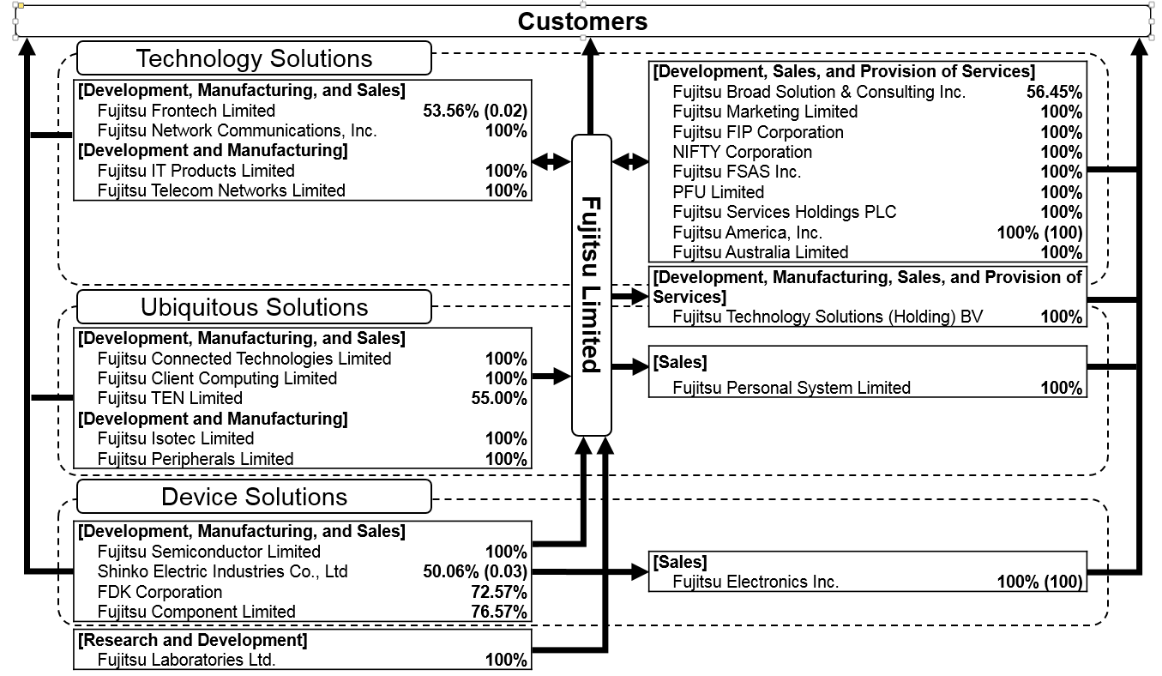

Notes: IT = information technology; (Equity-method affiliates): Fujitsu Limited, 44.25%; Fujitsu Leasing Co., Ltd., 20.00%; Socionext Inc., 40.00%; Percentages are percentages of voting rights, and figures in parentheses are indirect shareholdings, which are included in the percentages of voting rights; NIFTY Corporation changed its company name to Fujitsu Cloud Technologies Limited as of April 1, 2017.

Source: Company files.

EXHIBIT 2: FUJITSU’S REVENUE BY REGION AND SECTOR/CATEGORY

2014–2016 (in ¥ Billions)

|  |  |  |  |  |  |
| --- | --- | --- | --- | --- | --- |
| **Financial Year** | **Japan** | **EMEIA\*** | **Americas** | **Asia^** | **Oceania** |
| 2014 | 2,873.20 | 990.60 | 392.00 | 387.10 | 110.00 |
| 2015 | 2,845.00 | 952.00 | 420.40 | 421.00 | 100.60 |
| 2016 | 2,865.60 | 778.10 | 386.90 | 385.10 | 93.80 |

|  |  |  |  |  |  |  |
| --- | --- | --- | --- | --- | --- | --- |
| **Financial Year** | **Services** | **System Platform** | **PCs / Mobile Phones** | **Mobile Wear** | **Large-Scale Integrated Circuits (LSI)** | **Electronic Components** |
| Technology Solutions | | Ubiquitous Solutions | | Device Solutions | |
| 2014 | 2,706.20 | 596.50 | 709.30 | 353.50 | 313.70 | 283.40 |
| 2015 | 2,765.10 | 518.10 | 651.30 | 389.50 | 314.60 | 290.70 |
| 2016 | 2,624.20 | 502.30 | 611.60 | 414.10 | 269.40 | 276.00 |

Notes¥ = JPY = Japanese yen; ¥1 = US$0.0009 as of July 12, 2017; PCs = personal computers; \*EMEIA includes Europe, Middle East, India, and Africa; ^Asia excludes Japan.

Source: Company files.

EXHIBIT 3: information and communications technology COMPETITON BY TECHNOLOGY CORE AREA

|  |  |  |  |
| --- | --- | --- | --- |
| **Technology Core Areas** | **Competitors and Their Product Offerings** | | **Research Firms** |
| IoT | IBM’s Watson  GE Digital’s Predix  Microsoft’s Azure IoT Suite  AWS’s IoT  PTC’s ThingWorx | | IDC |
| AI | IBM’s Watson  Microsoft Machine Learning/Cortana Intelligence Suite Amazon Machine Learning | | Morgan Stanley |
| Cloud Computing | Amazon Web Services  Microsoft’s Azure  Google  IBM | Other upcoming:  Alibaba’s Aliyun  Oracle | Fortune |
| Cybersecurity  (Infrastructure Gateway Providers) | IBM Security  CISCO  Hitachi  Juniper Networks  Hewlett Packard Enterprise | | Gartner |

Note: IoT = Internet of Things; GE = General Electric; IDC = International Data Corporation; AI = artificial intelligence

Sources: Created by case authors based on data from Stacy Crook, Carrie MacGillivray, and Vernon Turner, *IDC MarketScape: Worldwide IoT Platforms (Software Vendors) 2017 Vendor Assessment*, IDC MarketScape, July 2017, accessed January 5, 2018, www.idc.com/getdoc.jsp?containerId=US42033517; Morgan Stanley, *Key Investor Debates Likely to Drive Stocks in the Coming Year*, January 19, 2018, accessed August 2, 2018, https://pwm.morganstanley.com/weilmangrasman/mediahandler/media/118821/GLOBAL

\_20180119\_0000.pdf; Barb Darrow, “Amazon Still Leads Cloud Rankings, But Competition Is Coming on Strong,” *Fortune*, June 15, 2017, accessed January 5, 2018, http://fortune.com/2017/06/15/gartner-cloud-rankings/; Gartner, “Address Cybersecurity Challenges Proactively to Ensure Success with Outsourced IoT Initiatives,” February 17, 2017, accessed January 5, 2018, www.gartner.com/doc/3613417/address-cybersecurity-challenges-proactively-ensure.

EXHIBIT 4: ECOSYSTEM FOR fujitSu’s CONNECTED SERVICES

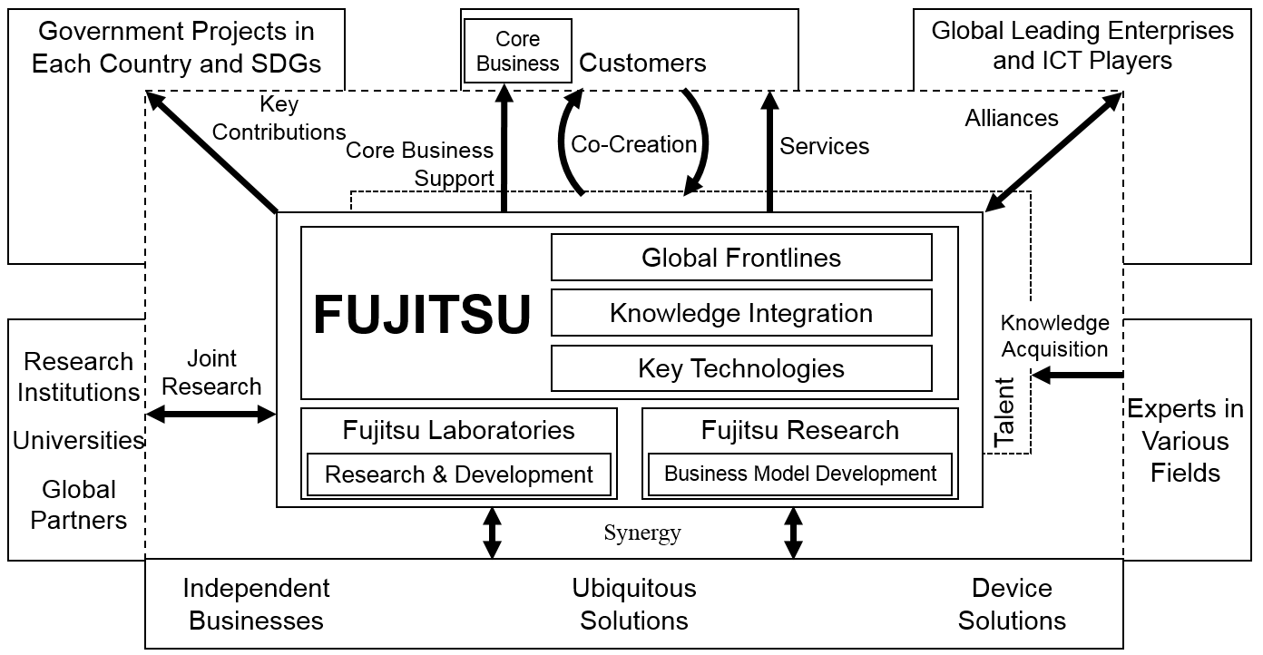

Note: SDGs = sustainable development goals; ICT = information and communications technology

Source: Company files.

EXHIBIT 5: fujitsu’s AKISAI AGRICULTURAL CLOUD

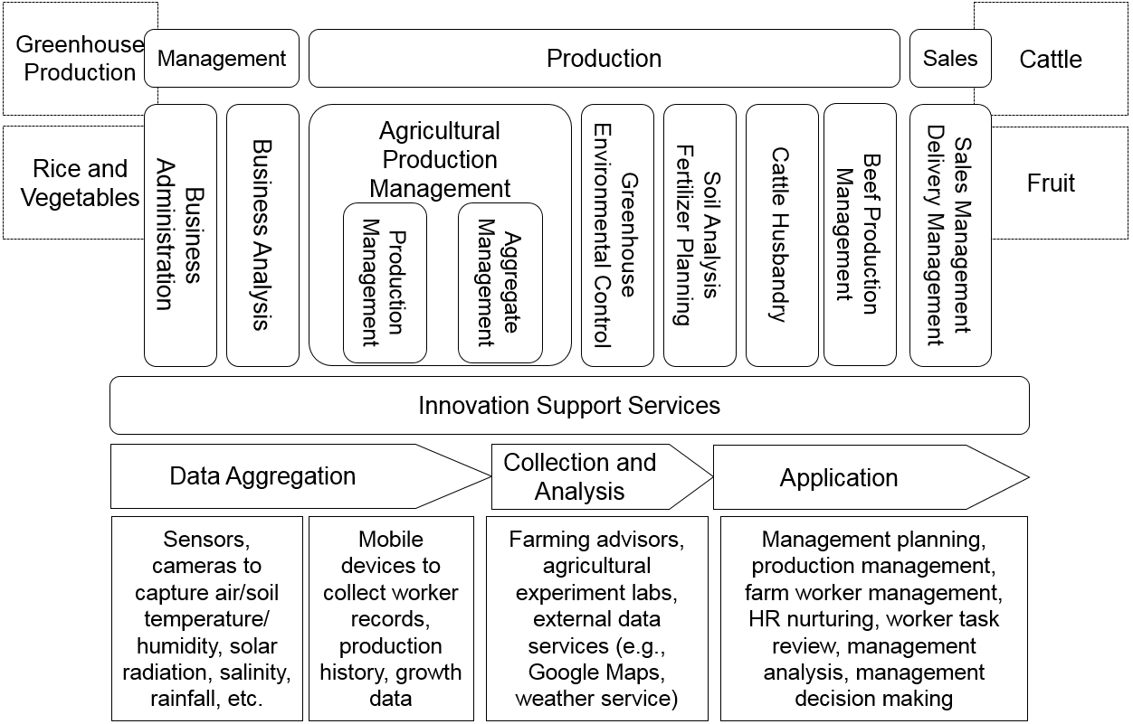

Note: HR = human resources

Source: Company files.

EXHIBIT 6: fujitsu’s ENGINEERING CLOUD

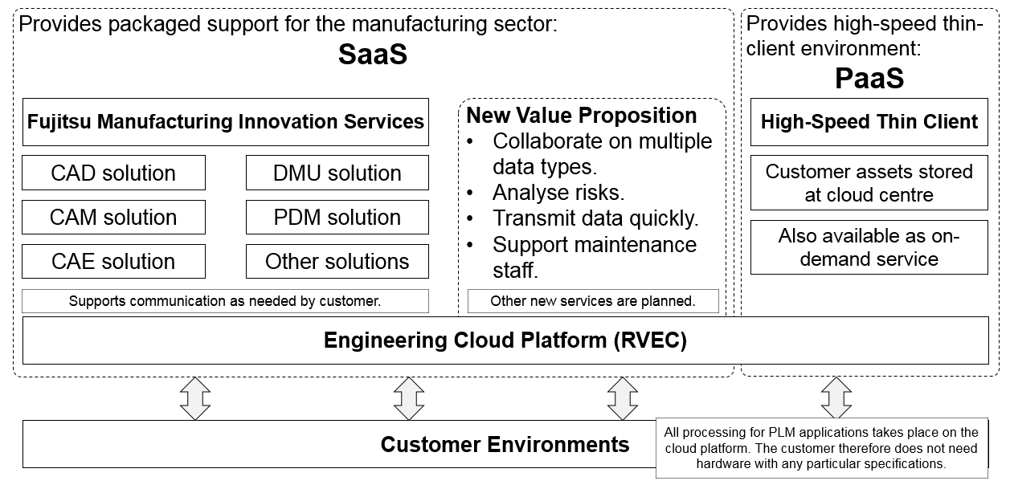

Note: SaaS = software as a service; PaaS = platform as a service; CAD = computer-aided design; CAM = computer-aided manufacturing; CAE = computer-aided engineering; DMU = digital mock-up; PDM = product data management; PLM = product lifecycle management.

Source: Adapted by case authors from company files.

1. ¥ = JPY = Japanese yen; ¥1 = US$0.0009 as of July 12, 2017. [↑](#footnote-ref-1)
2. Peter Middleton, *Forecast Alert: Internet of Things—Endpoints and Associated Services, Worldwide, 2016*, Gartner, January 6, 2017, accessed January 5, 2018, www.gartner.com/document/3558917. [↑](#footnote-ref-2)
3. Stacy Crook, Carrie MacGillivray, and Vernon Turner, *IDC MarketScape: Worldwide IoT Platforms (Software Vendors) 2017 Vendor Assessment*, IDC MarketScape, July 2017, accessed January 5, 2018, www.idc.com/getdoc.jsp?containerId=US42033517. [↑](#footnote-ref-3)
4. Takaaki Suga and Satoshi Okuyama, “Fujitsu’s Approach to IOT Business and Its Related Technologies,” *FUJITSU Scientific and Technical Journal* 52, no. 4 (October 2016): 8–16. [↑](#footnote-ref-4)
5. Gil Press, “Forrester Predicts Investment in Artificial Intelligence Will Grow 300% in 2017,” *Tech* (blog), *Forbes*, November 1, 2016, accessed July 4, 2018, www.forbes.com/sites/gilpress/2016/11/01/forrester-predicts-investment-in-artificial-intelligence-will-grow-300-in-2017/#7d4eb7ef5509. [↑](#footnote-ref-5)
6. CBInsights, “The 2016 AI Recap: Startups See Record High in Deals and Funding,” January 19, 2017, accessed July 4, 2018, www.cbinsights.com/research/artificial-intelligence-startup-funding/. [↑](#footnote-ref-6)
7. Michelle Jones, “Leaders in Artificial Intelligence in 2017: Microsoft, Amazon, IBM,” ValueWalk, December 14, 2016, www.valuewalk.com/2016/12/leaders-artificial-intelligence-2017-microsoft-amazon-ibm/. [↑](#footnote-ref-7)
8. Gartner, “Gartner Says Worldwide Public Cloud Services Market to Grow 18 Percent in 2017,” press release, Gartner Newsroom, February 22, 2017, accessed July 4, 2018, www.gartner.com/newsroom/id/3616417. [↑](#footnote-ref-8)
9. Barb Darrow, “Amazon Still Leads Cloud Rankings, But Competition Is Coming on Strong,” *Fortune*, June 15, 2017, accessed September 12, 2018, http://fortune.com/2017/06/15/gartner-cloud-rankings/. [↑](#footnote-ref-9)
10. Juniper Research, “Cybercrime Will Cost Businesses over $2 Trillion by 2019,” press release, May 12, 2017, accessed July 4, 2018, www.juniperresearch.com/press/press-releases/cybercrime-cost-businesses-over-2trillion. [↑](#footnote-ref-10)
11. Steve Morgan, “Worldwide Cybersecurity Spending Increasing to $170 Billion by 2020,” *Tech* (blog), *Forbes*, March 9, 2016, accessed July 4, 2018, www.forbes.com/sites/stevemorgan/2016/03/09/worldwide-cybersecurity-spending-increasing-to-170-billion-by-2020/#f935fc568323. [↑](#footnote-ref-11)
12. Zeus Kerravala, “Cisco Well Positioned to Dominate Cybersecurity Market,” Network World, August 22, 2016, accessed July 4, 2018, www.networkworld.com/article/3109562/security/cisco-well-positioned-to-dominate-cybersecurity-market.html. [↑](#footnote-ref-12)
13. Aptamers were artificial chemical substances made to resemble the characteristics of proteins such as antibodies. The aptamer technology was a platform technology developed by Fujitsu in collaboration with Nagoya University of Japan under a grant from the New Energy and Industrial Technology Development Organization in 2002–2005. [↑](#footnote-ref-13)
14. Agency for Science, Technology and Research (A\*STAR), “Fujitsu Establishes Its First Bio-Medical Research Laboratory in Singapore,” press release, May 19, 2010, accessed July 4, 2018, www.a-star.edu.sg/News-and-Events/News/Press-Releases/ID/1256/Fujitsu-Establishes-its-First-Bio-medical-Research-Laboratory-in-Singapore.aspx. [↑](#footnote-ref-14)
15. APTA Biosciences, “Dr Shozo Fujita,” accessed December 18, 2017, www.aptabiosciences.com/?lightbox=dataItem-itxenu15. [↑](#footnote-ref-15)
16. SwitchSENSE was a protein detection technology that used the artificially induced movement of DNA molecules as an indicator of protein presence. [↑](#footnote-ref-16)
17. Robert Jordas, interview with case authors, November 15, 2017. [↑](#footnote-ref-17)
18. Ibid. [↑](#footnote-ref-18)
19. Cyber-physical systems were mechanisms controlled by computer-based algorithms and tightly integrated with the Internet and its users. [↑](#footnote-ref-19)
20. A thin client environment referred to a client-server environment where low-cost computing devices (i.e., thin clients) were utilized to access network computer programs stored centrally in more powerful computers (servers). [↑](#footnote-ref-20)
21. Index Mundi, “Singapore – Agriculture,” accessed December 18, 2017, www.indexmundi.com/facts/singapore/agriculture. S$ = SGD = Singapore dollar; S$1.00 = US$0.75 as of January 4, 2018. [↑](#footnote-ref-21)