

9B18M146

CHAMPAGNE CATTIER: THE DIVERSIFICATION CHALLENGE

Nathalie Spielmann and Christopher Williams wrote this case solely to provide material for class discussion. The authors do not intend to illustrate either effective or ineffective handling of a managerial situation. The authors may have disguised certain names and other identifying information to protect confidentiality.

*This publication may not be transmitted, photocopied, digitized, or otherwise reproduced in any form or by any means without the permission of the copyright holder. Reproduction of this material is not covered under authorization by any reproduction rights organization. To order copies or request permission to reproduce materials, contact Ivey Publishing, Ivey Business School, Western University, London, Ontario, Canada, N6G 0N1; (t) 519.661.3208; (e)* [*cases@ivey.ca*](mailto:cases@ivey.ca)*;* [*www.iveycases.com*](http://www.iveycases.com)*.*

Copyright © 2018, Ivey Business School Foundation Version: 2018-09-27

The Cattier family had been active in the Champagne region of France for over 250 years. Starting out as growers of grapes, they moved into champagne production, initially for local consumption. By 2017, the Cattier company, which had reached 35 full-time employees, engaged in related diversification activities on multiple fronts and internationalized its market. Cattier was selling its champagne to markets such as the United States, Japan, and the United Kingdom. The company also created new product formats, developing signature branding and packaging. Cattier also partnered with fashion houses, bistros, and an international distributor owned by the American rap artist Jay-Z.

However, Cattier faced a multitude of challenges in 2017. There was fierce competition in the home market, while sparkling wine consumption was down in all key European markets. Rising protectionism and the possibility of raising trade barriers in key export markets also created new risks. These challenges were compounded by the fact that harvest conditions for producing vintage wines were unpredictable. Cattier was considering using further diversification to manage these threats. However, how would diversification address Cattier’s problems?

CHAMPAGNE CATTIER

The Cattier family had been actively involved in the vineyards of the Champagne region of France as growers and sellers of grapes in and around the village of Chigny-les-Roses since 1625. Chigny-les-Roses was a small village of approximately 520 inhabitants, located on the Montagne de Reims, between the two major hubs of the Champagne region: Reims and Epernay. In 1918, Jean Cattier decided to brand and market the champagne his family had been producing, rather than grow grapes to be sold to other firms and brands. Since then, the family business had been passed on from father to son. By 2017, the company employed 35 people. In 2011, brothers Jean-Louis and Jean-Jacques left the management of the family business to Jean-Jacques’s son, Alexandre (see Exhibit 1). Alexandre integrated the family business in 2003, following his oenological studies[1] and internships in Australia. He worked in all the technical departments of the company before becoming involved in the administrative area of the business.

For more than 15 years, two of Alexandre’s cousins had also been involved in the business: Agathe was vice-president, and Marie was the brand ambassador (see Exhibit 1). While no longer managing the business, Jean-Louis and Jean-Jacques formed the supervisory council for the Cattier family business. The Cattier family remained a pillar in Champagne, particularly thanks to Jean (Alexandre’s great-grandfather), who served two mandates as president of the general council of the Marne department and was also an instigator of the Syndicat Général des Vignerons de Champagne, the union that represented all growers in the Champagne region. The family heritage aspect of the brand was particularly appreciated in Japan and other foreign markets.

In 2017, the Cattier family owned or leased more than 33 hectares (ha) of vineyards—22 ha were owned and 11 ha were under contract. Of these vineyards, 87 per cent were designated as Premier Cru, whereas the remaining 13 per cent were without cru.[2] Most of the vineyards were spread across the villages of Chigny-les-Roses, Rilly la Montagne, Ludes, Villers-Allerand, and Taissy. The Cattier family also owned Clos du Moulin, one of the rare *clos*[3] in Champagne, which accounted for 2.2 ha. Plantations were 50 per cent pinot meunier, 25 per cent pinot noir, and 25 per cent chardonnay. The land where Cattier had planted vines was homogenous, considered appropriate for the pinot noir and meunier varieties, resulting in supple, nicely structured, and fruity wines that were easy to blend.

The Cattier family owned real estate in the adjacent village of Rilly la Montagne and in the town of Betheny, near Reims. The cellars of Cattier were located in Rilly la Montagne. The three levels of ageing cellars were among the deepest in the region (i.e., 30 metres underground), and each level was designed according to three different architectural styles: Renaissance, Roman, and Gothic. These cellars were more than 150 years old. Each was built in a different era and then acquired by the Cattier family in the 1950s. Tunnels were dug to connect the three cellars.

At the request of the family, the wines were made using reasoned agricultural techniques, meaning that the use of pesticides and other phytosanitary products was limited. Where possible, organic and non-invasive techniques were used. This approach allowed Cattier to obtain the Haute Valeur Environmentale (HVE) accreditation from the French Ministry of Agriculture for high environmental value. The HVE label certified that the agricultural firm in question used methods that were particularly respectful of the environment, including caring for the biodiversity in the vines and proper management of irrigation and fertilizers. Since May 2017, the firm was classified as a Sustainable Vineyard in Champagne. The classification was based on standards established by the wine growers and houses in the Champagne region and overseen by the Comité Interprofessionel du Vin de Champagne.

As a brand, Cattier was positioned as a house that valued excellence, creativity, the entrepreneurial spirit, and respect. The company was considered a small- to medium-size *négotiant manipulant* (NM)[4] brand. Its competitors in that class included Henriot, Lenoble, Ayala, Delamotte, and Philipponat. Cattier focused on growing the champagne brand without forgetting the family’s origins and the origins of the vines. The company liked to offer ample, opulent, fruity champagnes that were well made, but not so exclusive as to alienate potential new consumers.

The Cattier product line contained 14 different products, which varied in size, format, and price and represented approximately 600,000 bottles of champagne per year (see Exhibits 2 and 3). Champagne was sold in a variety of different formats.[5] The first Cattier product line—Tradition—was considered an introductory product line, accessible to all consumers. These wines did not come from a specific cru and were mostly available in bottle format, such as the Brut Icône, which was aged for 18 to 24 months. The Tradition line also included a sweet champagne selection—Dry—that was also offered as a rosé.

The second product line—Premier Cru—was targeted at more adept wine consumers. The Blanc de Blancs wines were particularly appreciated by the French market. The Brut Millésime was vintage champagne, coming out only during the best years. In 2017, the available vintages were 2008 and 2002. Future vintages would include 2009, 2012, 2013, and 2014.

The third product line—Clos du Moulin—consisted of only two wines: a white and a rosé sparkling wine. The specificity was that these two wines were produced from grapes (only pinot noir and chardonnay) originating exclusively from the Clos du Moulin, from the Premier Cru village of Chigny-les-Roses. This clos was a walled parcel that belonged exclusively to Cattier. These wines were blended over a three-year period to keep the signature taste constant. Approximately 15,000 numbered bottles of the Clos du Moulin Premier Cru and 3,000 numbered bottles of the Clos du Moulin Premier Cru Rosé were produced every year.

The fourth product line—Insolites—featured novelty products and emphasized the importance that Cattier placed on packaging. The objective was to tap into the gift-giving culture, as well as the younger-generation market in nightclubs and bars. However, Cattier continued to use its signature gold colour on most labels.

In addition to producing its own line of products, Cattier also established partnerships with fashion houses, restaurants, and food retailers. In the 1980s, Cattier produced champagne for the Courrèges fashion house. It innovated champagne packaging by offering a bottle with the first metallic sleeve, in a silver package. The metallic sleeve was heated and shrank onto the bottle, perfectly and seamlessly fitting around the bottle. From the mid-2000s to 2016, the Cattier family made champagne for Maxim’s, a famous bistro in Paris, highly evocative of the roaring twenties. For Maxim’s, Cattier produced several different varieties including half-bottle, bottle, magnum, vintage, and rosé champagnes, of which approximately 20,000 to 25,000 bottles were sold. From September 2014 to 2017, the Cattier family partnered with the Eiffel family of restaurateurs to produce a branded champagne.

The Cattier family also diversified its offerings by creating a luxury champagne brand—Armand de Brignac—with an American partner. In the United States, the champagne was nicknamed the “Ace of Spades,” based on its logo resembling the iconic playing card. The Armand de Brignac venture started as a partnership with the American company Sovereign Brands Wine & Spirits Company (Sovereign). The champagne entered the market in spring 2006. Cattier was responsible for the champagne’s production. Sovereign was responsible for the commercialization and marketing of the product. The champagne was presented in a metallic gold bottle (see Exhibit 4). After an appearance in a music video by the famous rap artist Jay-Z, the Armand de Brignac brand exploded in popularity in the US market and subsequently worldwide. In November 2014, Jay-Z purchased the rights from Sovereign to commercialize and market Armand de Brignac. Jay-Z’s holding company and Cattier maintained their partnership, and Cattier remained responsible for the production of the champagne. Jay-Z’s company handled the orders and marketing for the brand around the world. The number of Armand de Brignac bottles produced each year was kept secret.

Armand de Brignac was available in several varieties including brut, rosé, blanc de blancs, blanc de noirs, and demi-sec (see Exhibit 2). To maintain the signature style of the champagne, three vintages were blended. The grapes used for Armand de Brignac wines were sourced only from Premier Cru and Grand Cru villages, including Avize, Cramant, and Oger.

To promote its products, Cattier relied on the social media platforms Twitter, Instagram, LinkedIn, and Facebook, actively posting on these platforms since 2015. The company also focused on developing and creating partnerships by sponsoring special events in restaurants, fashion shows, and entertainment events. Cattier distributed the biannual newsletter *L’écho du Moulin* via its website, which communicated news about the company’s participation in events, new product initiatives, and technical information about the winery such as vineyard conditions. Cattier also used the website to announce special events occurring in the vineyards, environmental accreditations, harvest conditions, and product launches. In November 2016, Cattier launched an online boutique with a special offer to deliver its chilled champagne anywhere in Paris within an hour of an order being placed.

The Cattier family did not offer regular cellar tours and did not have an oenotouristic offer. However, visitors who passed by the Cattier headquarters could taste the wines during opening hours (e.g., weekdays from 9 a.m. to 12 p.m. and from 2 p.m. to 6 p.m.). Most of the sales in France (80 per cent) occurred via specialty wine retailers, known as *cavistes*, as well as restaurants and business clients. Cattier champagne was not available in supermarkets. The remaining 20 per cent of French sales were direct purchases by consumers who were on the company’s mailing list or visited the Cattier property. Export sales represented 55 per cent of all sales and occurred in over 45 countries worldwide. The most successful markets for Cattier’s champagne were Japan, the United Kingdom, Australia, Portugal, and Germany. For the Armand de Brignac brand, the biggest market was the United States, followed by the United Kingdom, the Middle East (Persian Gulf states), and France.

GLOBAL SPARKLING WINES INDUSTRY

The category of sparkling wines includes a large diversity of types, such as champagne, prosecco, cava, and sekt, all of which had their own methods of production and regulations. Primarily though, most types were of European origin. As a category, sparkling wines represented 7 per cent of all wine production, a steady increase since 2000, when it represented only 4 per cent of the world’s wine production. Close to 18 million hectolitres (hl) of sparkling wines were produced in 2015. Four countries were responsible for the production of 62 per cent of all sparkling wines: France (23 per cent), Germany (15 per cent), Italy (15 per cent), and Spain (9 per cent). In the previous decade, however, countries such as Australia, the United States, Argentina, and Brazil emerged as important minority producers. Other opportunities existed, especially in China, where numerous sparkling wine companies and champagne houses planted vineyards, although production quantities remained small.[6]

Since 2000, the amount of sparkling wine exports had grown from 3.1 million hl to reach 8.7 million hl in 2013, representing an average annual growth of 9 per cent. In contrast, the value of sparkling wine exports over the same period remained stable, registering an average annual growth of 5 per cent. Sparkling wines from the Champagne region represented only 15 per cent of the world’s production but 55 per cent of the value of sparkling wine exports worldwide.[7] Effervescent sparkling wines from Spain and Italy had become attractive alternatives to the more expensive champagne, especially in the US and UK markets. In general, non-champagne sparkling wines outperformed champagne. Therefore, to increase the volume of sales, champagne producers and retailers had been forced to cut prices.[8]

Since 2005, the consumption of sparkling wines had grown at a rate of 4.1 per cent, versus 1.3 per cent for still wines. During the same period, the value of the sparkling wine category (which represented 6 per cent of all wines consumed) increased by 30 per cent. Of the 15.4 million hl of sparkling wine consumed in 2013, fine champagne accounted for 25,291 hl, representing 0.1 per cent in growth since 2012, or approximately 4 per cent over the previous five years.[9] Champagne consumption was expected to continue to grow, although mostly for markets outside France. In 2016, export sales of champagne reached €4.71 billion[10] for the 306.1 million bottles exported. Projected key markets for champagne over the following years were China, the United States, Australia, the United Kingdom, Japan, Nigeria, Brazil, Russia, Poland, and Belgium. However, exports to these markets were often dependent on the economic situation of the country. In all of these markets, champagne consumption was expected to grow by at least 0.3 per cent in volume and at least 2.3 per cent in value.[11] Unlike other sparkling wines, however, champagne was considered highly sensitive to structural and macroeconomic fluctuations; when the economy was on a downturn, so were sales of champagne. The French economy had experienced extremely slow growth. The weak French economy had direct implications on its major industries, such as limiting their development potential. Furthermore, exports had been decreasing. French exporters reduced their profit margins to remain competitive. Many exporters tended to focus on nearby European countries, having easier foreign trade policies as members of the European Union. As such, the many financially appealing, but geographically distant, markets had received less interest from French exporters.[12] Historically, most champagne was consumed in Europe, with about 70 per cent of the Western European consumption occurring in France (see Exhibit 5).

WINE CONSUMERS IN FRANCE

There had been a steady decline in wine consumption in France. In 2014, the per capita consumption of wine was 42.1 litres, down from 54.8 litres in 2003. That amount included 4.7 bottles (750 millilitres) of sparkling wine.[13] The average price paid for a bottle of wine was €2.44, or €3.26 per litre.[14] The penetration rate[15] of wine was estimated at less than 67.2 per cent in 2015. Occasional and casual drinkers, as market segments, had been steadily increasing from 41.8 per cent in 2000 to 50.8 per cent in 2015. The share of non-drinkers, specifically men, had jumped from one-fifth of the population to one-quarter between 2005 and 2015. In contrast, women remained a stable market segment, with 60.5 per cent as wine consumers, buoyed by a certain preference for rosé wines and wine-based flavoured drinks.[16]

In 2015, overall sales of wine in France decreased by 8 per cent in volume but increased by 1 per cent in value over 2014. Red wine was by far the most sold in France (54 per cent), followed by rosé wine (25 per cent), and then white wine (20 per cent). Rosé wine remained the fastest-growing category of wines in France, with an increase of 41 per cent in volume and 145 per cent in value in between 2005 and 2015. Sparkling wines represented 10 per cent of all wines consumed. Every year, an average of 3.7 bottles of sparkling wines were consumed per person in France.[17] The average price that consumers of a bottle of champagne in France were willing to pay was €20 for their personal consumption and €24 for a champagne to give as a gift.[18]

The general preference was to consume wine off-trade.[19] On-trade consumption of wine in France was diminished by several factors, including strict alcohol consumption legislation, extreme markups on wines in restaurants (four to five times the price of wines directly purchased from the producer), a trend of staying at home rather than engaging in activities outside the home (referred to as “cocooning”), home entertainment, and mobility trends. French consumers could buy wines in grocery stores, cavistes, and virtually any food retail outlet. Helping off-trade sales remain fairly constant was the gift-giving culture in France. A common tradition was to bring the host a bottle of wine or champagne when invited to dinner or a party.

In 2016, the estimated population of France was 66.99 million. The median age was 41.2 years old. In 2015, the average per capita monthly income (after taxes) was €1,538. Disposable income had decreased in France from 2.4 per cent of revenue in 2010 to 1.8 per cent in 2016.[20] Accordingly, the demand for low-cost goods, including private labels and discount products, increased significantly. Nonetheless, as consumers grew older, their income increased significantly. Therefore, a class of wealthy consumers over age 65 had emerged in France. Although this age group represented only 18.2 per cent of the population, 22.2 per cent of the group earned more than €140,000 per year. This trend was expected to continue. By 2030, this age group was expected to represent 23.1 per cent of the population, and 34.8 per cent of the group would be earning more than €140,000.[21]

Changes in the luxury market—in particular, the emergence of accessible luxury—created a “new normal” trend of consuming luxury products as an everyday occurrence, often motivated by advertising messages and sales promotions with appealing price-to-quality ratios. Accordingly, champagne producers faced stiff competition from non-champagne sparkling wines such as cava, prosecco, and sparkling wines from the United States, Australia, and New Zealand. This trend had been exacerbated by the promotional strategies of competitive products and producers who used extreme discounting to eat away at the champagne category. There was also an increase in the purchase of various other French regional sparkling wines: crémant from the Burgundy, Alsace, and Jura regions; la Clairette de Die and Blanquette de Limoux from the South of France, and Vouvray and Montlouis Pétillant from the Loire region. All these products created a cannibalizing effect on the champagne category. Non-champagne sparkling wines accounted for almost 65 per cent of all sparkling wines consumed in France. While the average price paid for a bottle of champagne hovered around €20, the average price paid for a bottle of non-champagne sparkling wine was only €6.[22]

FRENCH WINE INDUSTRY AND CHAMPAGNE

The agriculture and agro-food industries were very important in France, much more than in other European countries. Wine was one of the main agricultural products in France, with 700,000 ha of land dedicated to wine production. In 2016, France was one of the largest producers of wine in the world, harvesting the equivalent of 45.6 million hl of wine. The largest wine-producing regions were Languedoc-Roussillon, Bordeaux, and the Rhône Valley. Champagne was the seventh-largest wine region in France in terms of area. Like Bordeaux and Burgundy, Champagne was considered a mature wine-producing region, where the value of the wines was considered relatively stable.[23]

Located northeast of Paris, the Champagne region benefited from a continental climate: low temperatures in the winter and hot summers, with an adequate amount of precipitation. There was enough sunshine in the spring and summer to promote vine growth and a warm enough fall to allow for the occasional late harvest (in early October). The subsoil was made up largely of chalk. The Champagne region was located in the heart of the Parisian Basin, which was once covered by the ocean. The chalk in the soil allowed the vine roots to stay humid during the hot summers, giving champagne its unique taste profile. Another key geographical feature of the Champagne region was its topography. Numerous hills and valleys allowed for sloped exposition to the sun and excellent drainage of the soil. There were 280,000 parcels of vines on 33,504 ha in Champagne, spread across five departments,[24] with 20 sub-regions, in 320 villages (or crus). Some of these villages—the 42 Premier Cru and the 17 top-tier Grand Cru villages—were classified as having a superior quality (see Exhibit 6).The Comité Interprofessionel du Vin de Champagne was responsible for regulating the champagne industry in France (see Exhibit 7).

Although it was highly structured, the champagne industry was also highly fragmented. The top five champagne companies, LVMH, Lanson, Vranken-Pommery, Pernod-Ricard, and Nicolas Feuillate, accounted for 40 per cent of the world’s volume of sales, whereas private labels accounted for 7 per cent. The rest was divided among all other producers of champagne. Companies operating in the Champagne region fell under one of the three categories: grower, co-operator, or house. There were approximately 15,800 growers in the region, who owned approximately 90 per cent of the land. In addition, there were more than 300 houses and about 140 co-operatives. Each producer of champagne took on different trade names depending on how they handled grapes and wines (see Exhibit 8). The wine sold in France and exported to most countries was mainly from houses, with lower percentages provided by growers and co-operators (see Exhibit 9).

In general, a grower had several choices for selling the wine: it could make and sell its own wine, sell it to a house, incorporate it into a co-operative movement, or do all three activities. Growers had the most control over the supply of grapes; yet, of the 15,000 champagne growers in the region, only 4,625 growers exported their champagne under their own brand. Growers marketed the notion of *terroir[25]* and a personal regional signature, which meant that they focused on champagne as “the place” and “the people.” Over the previous 20 years, there had been a growing trend toward favouring boutique growers of champagne, allowing numerous outstanding individual producers to make significant profits, even when selling small quantities.

Houses tended to own very little land; they purchased grapes from co-operatives and growers. However, houses had the most financial and marketing resources available, as well as wider distribution networks. Most houses belonged to larger conglomerates. For example, the LVMH group owned Moët & Chandon, Veuve Clicquot, Krug, Dom Pérignon, and Ruinart. All houses took the status of NM, purchasing grapes from anyone who was willing to sell. The average cost per kilogram of grapes in the Champagne region was €6. An NM could also sign contracts with wine growers for a short period (four to five years). The basis of NM champagne was selling a brand, including the vinification[26] technique, the house style, and the blend. Houses sold champagne—the product—and almost all houses exported their champagne.

Finally, co-operatives were the fruit of the collaboration between individual growers, sometimes in just one village or from a wide area of the appellation. Co-operatives pressed grapes from approximately 50 per cent of the land. A co-operative worked on the basis of membership. Contracts were signed with members for a minimum of 10 years (14 years, on average), with the producer member agreeing to sell a certain quantity of grapes to the co-operative for a set fee, according to the specifications outlined by the co-operative. Co-operatives could only buy grapes from members. The co-operative made technical support and investments available to the growers in the vines at the vinification stage and also supplied the growers with sales and marketing structures (e.g., marketing advice, promotional campaigns, and advertising budgets). If the brand that resulted from the wine grower’s contribution made a profit, the member wine grower would receive dividends. Jacquart and Nicolas Feuillate were examples of large co-operative brands. Of the 140 co-operatives, only 43 exported their wines.

CHALLENGES fACING CHAMPAGNE CATTIER

Cattier was facing challenges on multiple fronts. In France—the home market—there was fierce competition from cheaper local sparkling wines (e.g., Crémant de Bourgogne) and European sparkling wines (e.g., sekt from Germany, prosecco from Italy, and cava from Spain). The economy had suffered over several years and unemployment remained high. Overall, consumption of champagne was in decline. The largest export markets were the United Kingdom and the United States.

In June 2016, a UK referendum resulted in a decision to leave the European Union by March 2019. The value of the UK pound sterling against the euro plummeted, making French exports to the United Kingdom more expensive. In addition, there was great uncertainty surrounding the trading terms of the UK departure from the European Union. It was not known what trade tariffs would arise, when they would come into effect, and at what level they would apply. In contrast, while the United Kingdom had been a member of the European Union, there had been no trade barriers in place.

In November 2016, businessman and reality television personality Donald Trump won the US presidential election, largely on a platform of protectionism and “putting America first.” It was unclear what this might mean for exports of champagne to the United States. However, champagne producers were concerned, especially because the United States was the highest wine consumption country by volume, expected to grow a further 4.9 per cent by 2020. The US market also had a consumer trend toward higher-priced options.[27]

In an era of rising nationalism and protectionism, it was unclear what effect this would have on future demand for champagne in these two countries. In addition, champagne was highly dependent on vintage and harvest conditions. Being an agricultural product, it was difficult to ensure exact quantities. For example, the 2017 harvest was very complicated at the Clos du Moulin, and the firm was considering not issuing any Clos du Moulin wines for that vintage.

Nonetheless, Cattier was an established family business and its strategy to diversify into five product lines and use innovative packaging had proved successful in the past. However, the desire to engage in alliances in the home country and abroad, while often successful, were very short-lived. As well, the macro environment had become more turbulent, while competitive threats were intensifying. Cattier had to decide if further diversification would be helpful to deal with all these threats. If so, how would diversification be applied to resolve the issue?

Exhibit 1: Alexandre Cattier, Agathe Charles, Marie Cattier, and Jean-Jacques Cattier

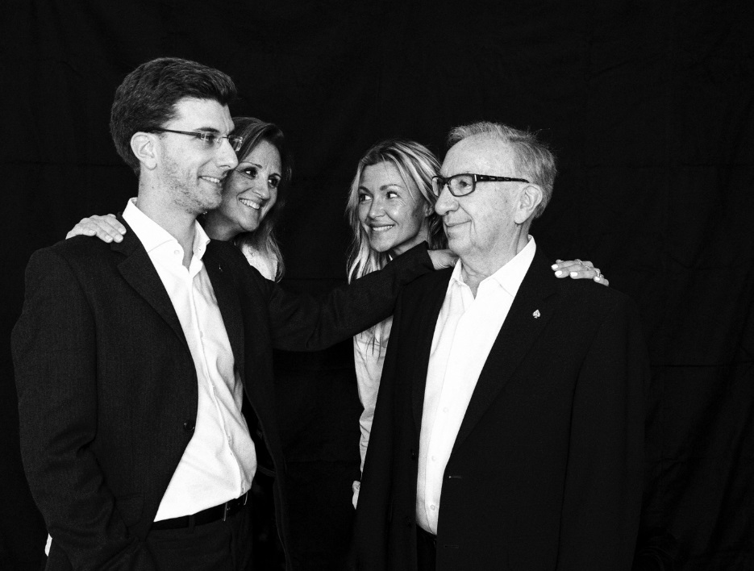

Source: Company documents.

**Exhibit 2: CATTIER PRODUCT RANGES, VARIETIES, AND PRICES FOR FRANCE**

**(September 2017)**

|  |  |  |  |  |  |  |  |  |
| --- | --- | --- | --- | --- | --- | --- | --- | --- |
| **Product Line** | **Name** | **Blend (%)** | | | | **Dosage (g/l)** | **Format  (ml)** | **Price  (€)** |
|  |  | **Meunier** | | **Pinot Noir** | **Chardonnay** |  |  |  |
| **Tradition** | Brut Icône | | 50 | 30 | 20 | 10 | 375 | 15 |
|  | |  |  |  |  | 750 | 26 |
|  | |  |  |  |  | 1,500 | 61 |
|  | |  |  |  |  | 3,000 | 170 |
|  | |  |  |  |  | 6,000 | 370 |
| Dry | | 50 | 30 | 20 | 25 | 750 | 27 |
| Dry Rosé | | 40 | 50 | 10 | 25 | 750 | 30 |
| **Premier Cru** | Brut Premier Cru | | 40 | 35 | 25 | 8 | 750 | 29 |
|  | |  |  |  |  | 1,500 | 64 |
| Brut Blanc de Blancs Premier Cru | | 0 | 0 | 100 | 8 | 750 | 35 |
|  | |  |  |  |  | 1,500 | 80 |
| Brut Rosé Premier Cru | | 40 | 50 | 10 | 8 | 375 | 19 |
|  | |  |  |  |  | 750 | 35 |
|  | |  |  |  |  | 1,500 | 78 |
| Brut Millésime Premier Cru 2008 | | 33 | 33 | 33 | 6 | 750 | 45 |
| Brut Millésime Premier Cru 2002 | | 33 | 33 | 33 | 6 | 1,500 | 160 |
| **Clos du Moulin** | Clos du Moulin Brut Premier Cru | | 0 | 50 | 50 | 6 | 750 | 85 |
|  | |  |  |  |  | 1,500 | 170 |
| Clos du Moulin Brut Rosé Premier Cru | | 0 | 55 | 45 | 6 | 750 | 95 |
| **Insolites** | Brut Blanc de Noirs | | 30 | 70 | 0 | 8 | 750 | 39 |
| Absolu Nature | | 35 | 30 | 35 | 0 | 750 | 39 |
| Brut Saphir | | 50 | 30 | 20 | 8 | 750 | 50 |
| Dry Rosé Red Kiss | | 60 | 30 | 10 | 25 | 750 | 55 |
| **Armand de Brignac** | Brut Gold | | 20 | 40 | 40 | 8 | 750 | 272 |
|  | |  |  |  |  | 1,500 | 646 |
|  | |  |  |  |  | 3,000 | 2,550 |
| Demi Sec | | 20 | 40 | 40 | 33 | 750 | 323 |
| Brut Rosé | | 40 | 50 | 10 | 8 | 750 | 493 |
|  | |  |  |  |  | 1,500 | 986 |
|  | |  |  |  |  | 3,000 | 3,740 |
| Brut Blanc de Blancs | | 0 | 0 | 100 | 8 | 750 | 731 |
|  | |  |  |  |  | 1,500 | 1,445 |
| Brut Blanc de Noirs | | 0 | 100 | 0 | 5 | 750 | 867 |

Note: g/l = grams per litre; ml = millilitre; € = euro; €1 = US$1.05 on January 1, 2017

Source: Company documents.

Exhibit 3: Examples from the cattier Product line

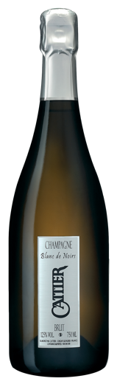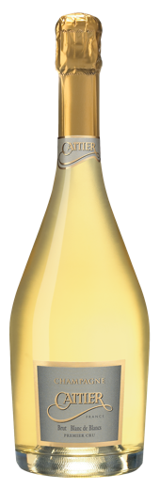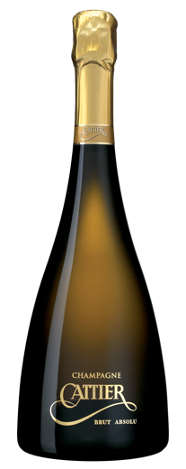

Absolu nature Brut Blanc de Blancs Brut Blanc de Noirs

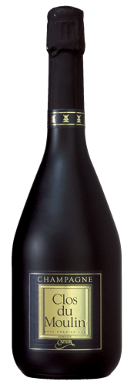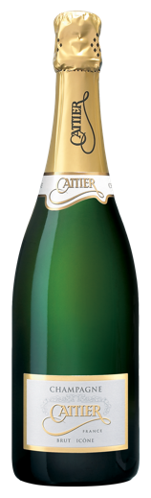

Brut Icône Brut Clos du Moulin

Source: Company documents.

**Exhibit 4: Armand de Brignac Product line (Left to right: Brut, Rosé, Demi-Sec, Blanc de Blanc, Blanc de Noir)**

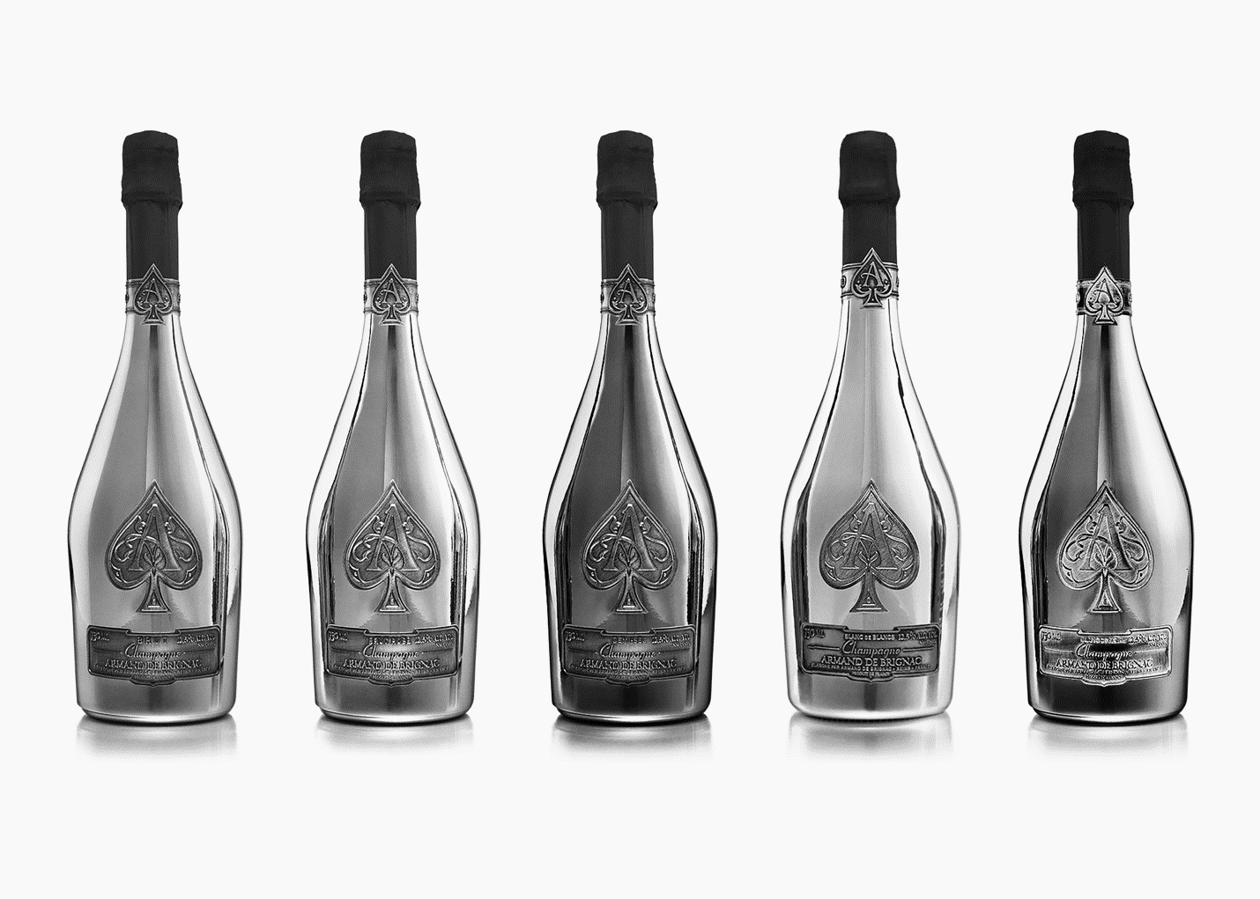

Source: Company documents.

Exhibit 5: Sparkling Wine Consumption IN KEY Markets

|  |  |  |  |  |
| --- | --- | --- | --- | --- |
|  | **Per Capita Consumption of Sparkling Wine in Litres (2015)** | **Wine Consumption per Capita in Litres (2015)** | **Population in Millions (2016)** | **Gross Domestic Product Growth in % (2016)** |
| **United Kingdom** | 1.7 | 19.7 | 65.6 | 2.0 |
| **United States** | 0.5 | 9.6 | 324 | 1.6 |
| **Germany** | 5.0 | 24.8 | 82.6 | 1.7 |
| **Japan** | 0.3 | 2.7 | 126.8 | 0.9 |
| **Belgium** | 3.9 | 21.2 | 11.3 | 1.4 |
| **Australia** | 1.9 | 22.2 | 24.4 | 2.9 |
| **Italy** | 2.1 | 33.5 | 61.2 | 0.9 |
| **Switzerland** | 2.2 | 37.2 | 8.3 | 1.0 |
| **Spain** | 1.5 | 21.6 | 46.4 | 3.2 |
| **Sweden** | 1.3 | 25.9 | 10.0 | 3.6 |

Source: “L'économie du Champagne: Les chiffres clés,” Comité Champagne, accessed June 21, 2018, www.champagne.fr/fr/economie/chiffres-clef.

EXHIBIT 6: THE CHAMPAGNE PRODUCTION PROCESS

Champagne was a region of blends: parcels, grape varieties, colours, vintages, and new with old wines. In 2016, 286 million bottles of champagne were produced. All grapes were harvested manually, whole-cluster pressed, and the extracted juice highly controlled in terms of quality and quantity. The juice, or “must,” was then left to ferment; yeasts then convert the sugars in the grape juice into alcohol. Another fermentation—malolactic fermentation—usually takes place to reduce the acidic bite and develop the aromas and texture of the wine. At this stage, wines from different parcels, vintages, and villages could be blended to create what could become non-vintage champagne. Blended or not, the wines could then be bottled (using a process called the *tirage*) as of January 1 of the following year with tirage liquor (wine mixed with cane sugar and yeasts) to enable fermentation in the bottle. This created the notorious effervescence of champagne. The wines were then cellared at 12 degrees Celsius and matured on lees, yeast deposits that resulted from fermentation, for a minimum of 12 months for non-vintage champagnes and three years for vintage champagnes. This amount of time was much longer, compared to European wine regulations that stipulated only a minimum of 90 days for all sparkling and effervescent wines in general. In the cellars of Champagne, there were 1,445 million bottles in reserve. At the end of the maturation period, wines were disgorged to remove the yeast deposits, and expedition dosage (this time, only wine with sugar) is added, topping off the champagne and giving it its style. More information is provided below on champagne styles and associated dosage (see Exhibit 10) and on the cost breakdown of champagne (see Exhibit 11).

Champagne was produced using the following grape varieties: pinot noir (38 per cent of the production), meunier (32 per cent), and chardonnay (30 per cent). Other authorized grape varieties included arbane, petit meslier, pinot blanc, and pinot gris. These only accounted for 0.3 per cent of the entire vineyard. Champagne could be a white sparkling wine or a rosé (pink) sparkling wine. When champagne was white but made only using the two black grape varieties (pinot noir and meunier), it was called a Blanc de Noirs. When champagne was made only using the white grapes, usually Chardonnay, it was called a Blanc de Blancs. Pink champagne was made using two techniques. The *saignée* technique consisted of pressing black grape varieties and leaving the skins in the tanks to macerate and tint the juice for a period of 24 to 72 hours. Alternatively, blending still red wine from champagne with the pressed juice from either black or white grapes also resulted in a pink champagne, called a “rosé d’assemblage.” Champagne was the only appellation d'origine contrôlée (or AOC) in France that allowed a blend of red and white wines to make rosé.

Note: * Lees were yeast deposits that resulted from fermentation;

Source: “L'économie du Champagne: Les chiffres clés,” Comité Champagne, accessed June 21, 2018, www.champagne.fr/fr/economie/chiffres-clef.

**EXHIBIT 7: THE COMITÉ INTERPROFESSIONEL DU VIN DE CHAMPAGNE**

The Comité Interprofessionel du Vin de Champagne (CIVC) was established in 1941 by representatives of the growers, houses, and co-operatives in Champagne to present a unified front to the Nazi occupation and manage the trade of champagne during the Second World War. By 2017, the CIVC continued to protect the interests of Champagne “the place” as well as champagne “the product,” and representatives from the three branches of champagne producers were responsible for its existence and operations.

The CIVC’s first mandate was to ensure that the Champagne appellation d’origine controllée (AOC), which was established in 1927, was respected. AOC regulation specified the scope of the appellation upon which champagne could be made, as well as the grape varieties, production processes, and ageing periods. As such, the CIVC provided technical support to winemakers. The CIVC declared the start of the harvest every year, as well as the size of the harvest and the quotas to be respected in function of the world supply and demand for champagne. Until 1990, the CIVC was also responsible for setting the price of grapes per kilogram.

The second mandate of the CIVC was to actively promote and protect the champagne territorial brand. The CIVC had become a well-respected and very powerful territorial brand manager. Champagne had become a trademark of the region and a name that could not be used for products made outside of the Champagne appellation. For example, fashion brand Yves Saint-Laurent was forced to rename its “Champagne” perfume to “Yvresse” in 1993, after the CIVC put in a complaint to the French courts for usurpation of the regional name. Since 1960, the CIVC had uncovered all non-Champagne uses of the term “champagne” and had successfully battled firms in England, Japan, Germany, Switzerland, and Sweden.

The CIVC had offices all over the world, including in Russia and in Japan, and had ensured that counterfeit bottles of champagne were tracked down and destroyed. The CIVC was also responsible for initiating bilateral agreements with other nations to prohibit the use of the word “champagne” for products not originating from the Champagne region. Although many nations had agreed, it was only in January 2014 that Canada finally agreed to stop labelling non-Champagne products as “champagne.” The United States continued to label some of its sparkling wines as “champagne” in 2016, albeit signing an agreement with the European Union in 2006 that would no longer allow new sparkling wine producers in the United States to use the word “champagne” on their labels. The United States had a grandfather provision, which stated, “Any person or their successor of interest may continue to use a semi-generic name on a label of wine not originating in the EU provided the semi-generic name appeared on a Certificate of Label Approval (COLA) that was issued prior to March 10, 2006.”

Source: Stephen Charters and Nathalie Spielmann, “The Characteristics of Strong Territorial Brands: The Case of Champagne,” *Journal of Business Research* 67, no. 7 (2014): 1461–1467; “TTB Response to Recent News Articles on Champagne Labeling,” Alcohol and Tobacco Tax and Trade Bureau, April 9, 2012, accessed June 21, 2018, www.ttb.gov/wine/champagne-labeling.shtml.

Exhibit 8: Trade Nomenclature in Champagne

**Négociant manipulant (NM):**

Persons or legal entities that bought grapes, grape must, or wine to make champagne on their own premises and market it under their own label. All major champagne houses belonged to this category.

**Récoltant manipulant (RM):**

Growers who made and marketed champagne under their own label, from grapes exclusively sourced from their own vineyards and processed on their own premises.

**Récoltant co-opérateur (RC):**

Co-operative growers who marketed co-op-produced champagne under their own label.

**Co-opérative de manipulation (CM):**

Wine co-operatives that marketed champagne made from members’ grapes.

**Société de Récoltants (SR):**

Family firms of growers that made and marketed champagne under their own label, using grapes sourced from family vineyards.

**Négociant distributeur (ND):**

Distributors who bought champagne in finished bottles for labelling on their own premises.

**Marque auxiliaire (MA):**

“Own brand” wine labels produced exclusively for specific clients (e.g., a supermarket, a celebrity, or other client).

Source: “Champagne Growers and Houses,” Comité Champagne, accessed June 21, 2018, www.champagne.fr/en/comite-champagne/champagne-growers-and-houses/champagne-growers-and-houses.

Exhibit 9: Champagne Sales (Percentage of sales per type of producer)

|  |  |  |  |  |  |  |
| --- | --- | --- | --- | --- | --- | --- |
| Country | Houses | | Growers | | Co-operatives | |
|  | 2007 | 2016 | 2007 | 2016 | 2007 | 2016 |
| France | 52.8 | 56.8 | 37.9 | 33.3 | 9.3 | 9.9 |
| United Kingdom | 80.8 | 87.3 | 2.0 | 1.4 | 17.1 | 11.3 |
| United States | 92.7 | 88.5 | 2.9 | 4.9 | 4.3 | 5.8 |
| Germany | 90.9 | 90.5 | 2.9 | 3.3 | 6.2 | 6.2 |
| Japan | 91.6 | 88.9 | 5.4 | 6.0 | 2.7 | 3.4 |
| Belgium | 81.2 | 82.0 | 8.5 | 7.6 | 10.3 | 10.4 |
| Australia | 96.6 | 96.4 | 1.5 | 1.7 | 1.7 | 1.7 |
| Italy | 91.1 | 84.5 | 6.4 | 11.7 | 2.5 | 3.8 |
| Switzerland | 88.1 | 86.8 | 5.1 | 4.9 | 5.8 | 5.9 |
| Spain | 96.2 | 92.6 | 1.3 | 3.4 | 2.5 | 4.0 |
| Sweden | 85.7 | 71.2 | 6.8 | 8.1 | 7.5 | 20.8 |

Source: “L'économie du Champagne: Les chiffres clés,” Comité Champagne, accessed June 21, 2018, www.champagne.fr/fr/economie/chiffres-clef.

Exhibit 10: Champagne Styles and Associated Dosage

|  |  |
| --- | --- |
| Style Name | Amount of Sugar per Litre of Wine |
| Doux | +50 grams |
| Demi-sec | 32–50 grams |
| Sec | 17–31 grams |
| Extra dry | 12–16 grams |
| Brut | Less than 12 grams |
| Extra brut | Less than 6 grams |
| Brut nature  Pas dose  Dosage zéro | Less than 3 grams,  No dosage liqueur added  No dosage liqueur added |

Source: “From Vine to Wine: Wine-Making: Disgorgement Dosage, or ‘liqueur d'expédition,’” Comité Champagne, accessed June 21, 2018, www.champagne.fr/en/from-vine-to-wine/wine-making/dosage.

Exhibit 11: Average Cost of Production and Overheads for Champagne

|  |  |
| --- | --- |
| Factor | Percentage of Overall Cost (Average) |
| Cost of grapes in the bottle | 36.5 |
| Vinification | 3.0 |
| Tirage | 8.1 |
| Champagnization/storage/commercialization | 24.3 |
| Social security | 8.0 |
| Financial cost | 4.3 |
| Administrative costs | 15.8 |

Source: F. Cobb, “The Cost of Champagne,” *Fine Wine Magazine*, December 31, 2010, accessed June 21, 2018, https://finewinemagazine.com/2010/12/the-cost-of-champagne.

1. Oenology was the science of wine and winemaking.
2. Crus were classifications meant to outline the quality of grapes produced in certain areas, usually villages. Grapes originating from Grand Cru villages were usually higher priced than those coming from Premier Cru villages or villages with no cru classification.
3. A *clos* was an enclosed vineyard, delineated by a short stone wall.
4. The term *négotiant manipulant* referred to persons or legal entities that bought grapes, grape must, or wine to make champagne on their own premises and market it under their own label. All the major champagne houses belonged to this category. A glossary including this and other trade terms related to the champagne industry is provided (see Exhibit 8).
5. In addition to the traditional 750 millilitre (ml) bottle, the formats had specific names: magnum (1,500 ml = 2 bottles); jéroboam (3,000 ml = 4 bottles); réhoboam (4,500 ml = 6 bottles); mathusalem (6,000 ml = 8 bottles); and nebuchadnezzar (15,000 ml = 20 bottles).
6. FranceAgriMer, *Rapport d’activité 2016,* accessed June 21, 2018, www.franceagrimer.fr/content/download/52935/510617/

   file/FranceAgriMer-Rapport-activité_Annuel_2016-BD.pdf.
7. Ibid.
8. Euromonitor International, *Champagne: Less than Bubbly*, January 2015, accessed June 21, 2018, www.euromonitor.com/champagne-less-than-bubbly/report.
9. FranceAgriMer, op. cit.
10. € = euro; all currency amounts are in € unless otherwise specified; US$1 = €0.95 on January 1, 2017.
11. Comité Interprofessionnel du Vin de Champagne, *Les expéditions de vins de champagne en 2017*, accessed June 21, 2018, www.champagne.fr/assets/files/economie/bulletin_expeditions2017.pdf.
12. Euromonitor International, op cit.
13. “The Economy of Champagne: Key Market Statistics,” Comité Interprofessionel du Vin de Champagne, 2017, accessed June 21, 2018, www.champagne.fr/en/champagne-economy/key-market-statistics; “Annual Wine Consumption per Capita in France from 2003 to 2016 (in Liters),” Statista, accessed June 21, 2018, www.statista.com/statistics/434726/wine-consumption-in-france-per-person;
14. FranceAgriMer, op. cit.
15. The penetration rate was calculated as a percentage of the population that purchased the product or brand at least once.
16. An example of a wine-based flavoured drink was the *rosé-pamplemousse*—rosé wine mixed with grapefruit juice.
17. FranceAgriMer, op. cit.
18. Raphael, “Comment consommé-t-on le champagne en France?” *Journal du luxe*, September 8, 2016, accessed June 21, 2018, https://journalduluxe.fr/marche-champagne-vignerons.
19. On-trade consumption referred to consumption that occurred on the premises of restaurants and bars, whereas off-trade consumption referred to purchases made in grocery stores and speciality stores, intended for consumption off premises, such as at home.
20. “Revenu disponible brut et pouvoir d’achat en 2017: Données annuelles de 1960 à 2017,” Institut national de la statistique et des études économique (INSEE), accessed June 21, 2018, www.insee.fr/fr/statistiques/2830244www.insee.fr/fr/statistiques/2830244
21. Euromonitor International, op. cit.
22. FranceAgriMer, op. cit.
23. “Chiffres 2016 de la production de vin en France,” douane.gouvr.fr, accessed June 21, 2018, www.douane.gouv.fr/articles/a13274-chiffres-2016-de-la-production-de-vin-en-france.
24. A department was equivalent to a state or a province. The Marne, Aisne, Aube, Haute-Marne, and Seine-et-Marne were the five departments that comprised the Champagne appellation.
25. *Terroir* was a uniquely French word that took on different definitions, depending on the region and the user of the word. Research demonstrated, however, that the general definition of the term could be summed up as “issued from a geographical region with a specific climate and created based on knowledge of the qualities of said place.” Nathalie Spielmann and Claire Gélinas-Chebat, “Terroir? That’s Not How I Would Describe It,” *International Journal of Wine Business Research* 24, no. 4 (2012): 254–270.
26. Vinification was the process of making wine, including the selection of which grapes were used to make the wine, assembling different wines together, and knowing how long to age the wines and when to put them in bottles.
27. Ellie Douglas, “Latest Wine Consumption Trends: US Still Rising,” *Decanter*, March 2, 2017, accessed June 21, 2018, www.decanter.com/wine-news/latest-wine-consumption-trends-356443-356443.