

9B18M153

MEG Energy: Surviving in a low-oil-price Environment

Adam Fremeth wrote this case solely to provide material for class discussion. The author does not intend to illustrate either effective or ineffective handling of a managerial situation. The author may have disguised certain names and other identifying information to protect confidentiality.

*This publication may not be transmitted, photocopied, digitized or otherwise reproduced in any form or by any means without the permission of the copyright holder. Reproduction of this material is not covered under authorization by any reproduction rights organization. To order copies or request permission to reproduce materials, contact Ivey Publishing, Ivey Business School, Western University, London, Ontario, Canada, N6G 0N1; (t) 519.661.3208; (e)* [*cases@ivey.ca*](mailto:cases@ivey.ca)*;* [*www.iveycases.com*](http://www.iveycases.com)*.*

Copyright © 2018, Ivey Business School Foundation Version: 2020-11-12

Bill McCaffrey, founder and chief executive officer of MEG Energy (MEG), was arriving for a meeting with the board of directors to discuss how the company should respond to a rapidly changing oil-price environment. It was the second week of December 2014, and the price per barrel (bbl) of oil for West Texas Intermediate (WTI) had fallen to US$60. Just a week earlier, his oil sands firm had announced a reduction in its 2014 capital expenditure to CA$1.2 billion[1] (from an original budget of $1.8 billion) and a planned capital expenditure program of $1.2 billion for 2015.[2] But in a matter of days, this guidance for 2015, which had focused on a further 15 per cent growth in oil production, seemed to be out of reach. Cash flow for 2015 was now expected to be a fraction of its earlier estimates, meaning the company would need to consider how to fund its capital-expenditure program, if at all—while financial analysts clamoured for answers. McCaffrey knew his investor relations team had been handling a barrage of angry calls, as investors were concerned with the choice to fund further growth in production while the stock price was getting pounded.

The drop in the price of oil represented a 45 per cent decline from just six months earlier when oil had been trading consistently between US$95 and US$105 per bbl—a range it had maintained for close to three years (see Exhibit 1). The price drop had resulted from a substantial increase in U.S. production of oil in North Dakota’s Bakken formation and the effort by the Organization of the Petroleum Exporting Countries (OPEC) to drive others out of business by pushing down prices. For McCaffrey’s 15-year-old upstream oil sands firm, this price drop translated into a 180 per cent decline in its share price (see Exhibit 2). Firms across Alberta were considering what the uncertain future had in store and whether they had a future at all. Analysts had begun to express real concern over whether smaller producers, such as MEG, had the necessary balance sheets to sustain a long-term depressed price and how much consolidation might happen as a result.

The rapid decline in prices had shaken much of the global oil-and-gas sector but had left Alberta’s oil sands firms particularly hard hit. Compared with extracting and refining liquid oil, the resource found in the oil sands required a costlier process for extraction and refinement, which could leave some firm’s operations ‘out of the money’ when global oil prices declined. In the oil sector, the measure of profitability per barrel produced was referred to as a netback,[3] and MEG’s 2013 netback was $35.87 (see Exhibit 3) and had risen significantly through the first three quarters of 2014 to $48.70 by the third quarter of the year. The firm’s netback and cash flow would certainly decline, however, if revenues dropped precipitously from US$60 per bbl. This pressure would be coupled with an already challenging operational environment from domestic and international concerns, as a result of the ecological impact of developing the oil sands resource and related constraints in terms of moving the product to foreign markets due to limited pipeline capacity.

MEG’s board of directors, chaired by McCaffrey himself, would need to identify the path forward in this low-price environment. McCaffrey had always prided himself in having grown the company from the ground up, as opposed to building a company only to package it and sell it at an opportune time. His vision had been to build a pure-play in situ company that identified and captured value across the entire value chain. This strategy was intended to ultimately position MEG alongside the sector’s premier resource developers and led MEG to rank among Canada’s 50 largest oil-and-gas firms (see Exhibit 4). MEG had leveraged the know-how of its management team with technological advancements to build what one Canadian Imperial Bank of Commerce (CIBC) analyst had called a great way for investors to gain exposure to the oil sands.[4] The past year had been focused on “adding more” by increasing reserves, enhancing oil production, and seizing greater value when getting product to market.

While MEG had been successful in adding more barrels of oil to production and finding more ways to market, it was unclear what it would need to do to survive—let alone maintain this trajectory. Angry calls from institutional investors were piling in as the stock took a nosedive. McCaffrey knew that whatever decision was made in a revision to the firm’s 2015 capital expenditure guidance would represent a big signal to the market for how MEG planned to navigate through this turmoil.

**THE CANADIAN OIL SANDS**

Canada and Alberta in particular were endowed with significant crude-oil resources that ranked Canada third in the world’s proven reserves at 171 billion barrels. Ninety-five per cent of these reserves were located in Alberta’s oil sands to the north of the city of Edmonton. These reserves were first surveyed in 1875 but would take nearly a century to reach commercial production, primarily because they were some of the world’s most challenging deposits to develop and required innovative research and production technologies to move them from resources to proven reserves. Yet the sheer magnitude of the resource, its location in a democratic country, and its ability to produce for decades rather than years has made it particularly attractive for development.

At the core of the challenge was that oil sands were a mixture of bitumen, sand, water, and clay. Unlike conventional crude oil that was liquid petroleum and could be easily pumped out of the ground, processed, and transported, bitumen was an unconventional oil that was too heavy or thick to flow or be pumped without first being diluted or heated. At 10 degrees Celsius, bitumen was hard as a hockey puck but could be heated to the viscosity of thick, cold molasses. Therefore, while the resource was abundant, its commercial viability would require significant technological development.

**Surface Mining**

The first of such developments that allowed for commercial production dated back to 1925, when the Alberta Research Council patented the process that allowed the separation of the bitumen from the sands using hot water and sodium hydroxide. This process would, in theory, allow for the oil sands to be mined in an open pit and then processed to enable the bitumen to be recovered. This basic technology would later be advanced by the Great Canadian Oils Sands Company, which, in conjunction with Sun Oil (later named Suncor), would, in 1967, open the first commercial oil sands mine in an effort to apply this process.

Extracting oil sands in an open pit was very similar to coal-mining operations, where large shovels scooped the oil sand into trucks, which then transported it to crushers that broke down the large clumps of earth. This mixture was then thinned out with water and processed and upgraded to create synthetic oil. However, this mining process applied only to deposits that were less than 75 metres below the surface, which was 3 per cent of the total oil sands surface area, representing 20 per cent of recoverable oil reserves. In 2014, approximately 47 per cent of oil sands production used this process at five mining projects. The continued growth of surface mining was limited, as most remaining oils sands deposits were too deep for its use.

The surface mining approach also garnered significant negative attention for the sheer scale of its operation and the impact on the environment and local communities. Oil sands mines were among the largest in the world, with the Syncrude project covering 140,000 square (sq) kilometres (km), making it the largest mine in the world by surface area. As a result, land disruption was significant and contentious, as the deposits were located within the boreal forest ecosystem, which would be permanently changed, inflicting a substantial impact on First Nations communities that had inhabited and depended on the land for centuries, the area’s roaming wildlife (such as buffalo and caribou), and recreational activities (including hunting and fishing). A significant by-product of mining operations was the large tailings ponds (some as long as 5 km), which were filled with toxic material. By 2040, these tailings ponds were expected to occupy 310 sq km, although successful efforts were underway to reclaim the tailings ponds. Finally, water use was significant, as approximately 14 barrels of water were required to mine and process a single barrel of oil. Much of this water was extracted from the Athabasca River, although efforts were underway to rely more heavily on recycled or brackish water.

The greenhouse gas (GHG) impact of oil sands mining was significant, and about 9 per cent more carbon-intensive per barrel on a “wells to wheels”[5] basis than oil produced in the Middle East.[6] The GHG emissions in mining operations came from the energy required to transport the sands, break it down into smaller pieces, and heat the water used both to separate the oil from the sand and produce the hydrogen needed to upgrade heavy crude. Many efforts were underway to reduce the carbon intensity. However, the absolute growth in carbon emissions from mining would continue to increase as production grew over the lifetime of the mines.

**In Situ Extraction**

While surface mining had garnered much of the early attention and criticism, the future of the oil sands lay in the 80 per cent of the deposits that were not as easily accessible. In the 1970s, development of the oil sands began to slow as firms encountered challenges in using the available technology to access the deeper resource. In response, the provincial government founded the Alberta Oil Sands Technology and Research Authority (AOSTRA) and charged it with developing technology to catalyze production. AOSTRA, under the direction of Dr. Roger Butler, helped to develop and test steam-assisted gravity drainage (SAGD, pronounced “Sag-D”), an extraction technology that would prove to be a game changer for its ability to access deeper oil sands deposits. By 2014, SAGD had been applied commercially to 24 projects.

SAGD would become the dominant technology for in situ extraction and was, in some ways, similar to traditional oil extraction since it involved digging wells and imposed a less significant footprint on the surface.[7] The technology utilized two parallel horizontal wells, known as a well pair. The wells were separated by approximately 5 metres when drilled into the land formation. The top well was used to inject steam in an effort to heat the underground chamber, build pressure, and melt the bitumen. The bottom well was then used to collect bitumen (and water) from the underground chamber. The ramp-up period prior to production could take up to two years, but production was then continuous once the process reached a steady state. It was common for a SAGD project in a good-quality reserve to operate at a constant rate for 30 years if capital was consistently expended both below ground, to sustain production with new wells, and above ground, to maintain the production plant. Without such expenditures, natural decline would occur, and performance would gradually deteriorate. MEG’s management realized a decline rate in its production at approximately 9 per cent, with the requisite investment. This finding was in contrast, however, to deterioration in other heavy oil plays, such as the Bakken region, where decline rates could be three times greater, and wells reached their end of life more rapidly.

The technology appealed to producers because of its lower costs and its ability to allow for staged growth, both of which allowed smaller producers to enter the sector. Unlike a mining operation, SAGD required only well pads, a processing plant, and access corridors that together accounted for less than 15 per cent of the leased land area. However, the SAGD process was still relatively new, and technical uncertainties could present obstacles in its implementation. Most importantly, the differences between reservoirs and geological formations could lead to the process being more or less effective. As a result, some firms struggled with production and needed greater amounts of steam to produce oil using the SAGD process.

Steam drove both the economics of a SAGD project and its carbon footprint. Unsurprisingly, the most closely scrutinized metric in SAGD production was the steam-to-oil ratio (SOR) that captured the amount of water and energy needed to generate the steam necessary to produce a barrel of oil. The steam was generally produced using natural gas. As a result, a lower SOR represented a win–win since the process was more efficient, less costly, and had a lower carbon intensity. Exhibit 5 illustrates how the SORs in 2014 varied across oil sands projects, with the leaders requiring just over two barrels of steam to produce a barrel of oil.

While SAGD projects were considerably more environmentally sustainable—due to their far smaller disruption to the land surface, absence of tailings ponds, and reliance on recycled, non-potable water—their need for energy to produce steam meant that their carbon footprint could be more substantial than mining operations. Gasoline that was produced from bitumen sourced from a SAGD project would have a carbon intensity 15 per cent greater than gasoline produced in the Middle East and 7 per cent greater than that produced by an oil sands mining project. This finding had led many firms to seek out new in situ technologies or enhancements to the SAGD process that would drive down the SORs.

**Marketing**

In addition to the technical challenges in producing oil from the oil sands resource, the sector had faced obstacles in getting the product to market. The location of the oil sands in Northern Alberta and the slurry nature of bitumen introduced logistical challenges. Thus, oil sands producers would need to take on additional costs and face price differentials based on where their product could be marketed.

First, in many situations, the extracted product would need to be diluted to ease its transport. Bitumen was combined with a diluent substance, such as natural gas condensate, to produce a new mixture called dilbit that could be transported by pipeline or another form of transport.

The next challenge was identifying the means of transport to move the product out of Northern Alberta and to the markets that would pay the highest price per barrel. Pipelines were the safest and most efficient mode of transport, yet pipeline capacity had been unable to keep pace with oil sands production. Pipeline projects such as Keystone XL, Energy East, and Trans Mountain had proposed new connections to domestic and foreign markets, but had been stalled in the regulatory process. Thus, oil sands producers were left relying on rail and even barge to move their product to the hubs that would offer the best price. The ability for firms to access the higher heavy oil pricing at the U.S. Gulf Coast was key to improving their revenues on a per barrel basis, or what is known as “bitumen realization.” Should a producer choose to forgo exporting bitumen but instead sell it in Alberta, it would realize the Western Canadian Select (WCS) price, which, in 2014, traded at a 21 per cent discount to the WTI price.

**THE GROWTH OF MEG ENERGY**

MEG was founded by Bill McCaffrey along with Steve Turner and Dave Wizinsky during the economic downturn of 1999, when oil prices had bottomed out at US$10/bbl. In March of that year, he began securing land leases from the Alberta Government[8] in the McMurray formation in the southern Athabasca region of the province. McCaffrey had been looking to secure quality resources that would lay the foundation for the sustained growth of his new company for decades. He was well aware of the great potential for in situ technology after his 17 years at Amoco Canada, where he had led the initiation and development of the Primrose oil sands project. Primrose was a 25,000 barrels per day (bbl/d) project that was one of the first commercial in situ operations that had used horizontal wells and thermal technologies. This familiarity led him to focus on plots adjacent to Cenovus’s already successful Christina Lake project.

Between 1999 and 2014, MEG had secured more than 2,300 sq kmof oil sands leases that held proven and probable reserves of 3 billion barrels of oil and an additional 3.8 billion barrels in contingent resources.[9] To put this opportunity in perspective, MEG’s reserves were about on par, if not greater than, all the oil reserves available in the Bakken formation in North Dakota. These leases included the Christina Lake Project, with a projected 210,000 bbl/d, and the Surmont Project, with an estimated 120,000 bbl/d. MEG also held growth properties to the west that had yet to begin the regulatory approval process (see Exhibit 6). The firm’s growth strategy was developed to follow a phased approach that would begin with the development and production of the Christina Lake Project. Commercial production had begun at Phase 1 of Christina Lake in 2008, and by 2014 MEG had reached 71,000 bbl/d in production across Phase 1, 2, and 2b.

A central element of MEG’s Christina Lake project and its overall strategy of capturing value across the value chain was its 50 per cent ownership of the Access Pipeline. The pipeline was a 343 km dual pipe: one pipe provided diluent north to Christina Lake to dilute the bitumen, and another pipe ran south to move its bitumen blend to MEG’s terminal near Edmonton. Interestingly, it had been completed even before Phase 1 of Christina Lake had reached commercial production and was financed by the first U.S.-denominated term loan for an oil sands project. No other oil sands producer had owned its own pipeline infrastructure, yet it was seen by MEG’s management as a means to improve profitability by offering greater flexibility in the purchasing of diluent and in the sale of bitumen.

Along with the growth in oil production was growth to the organization at its Calgary headquarters and at its projects in northern Alberta. The handful of employees in 1999 grew to a dozen in 2004, to 300 by the time MEG went public on the Toronto Stock Exchange in 2010, and stood at 1,200 in 2014. The early growth had been financed, similar to most start-ups, with equity financing from friends and family. But then, in 2003 and 2004, opportunities arose to dramatically increase MEG’s lease holdings in the Christina Lake area, and private equity firms entered to support the investment. By 2009, MEG had raised $3.2 billion in private equity, with the bulk of the investment from U.S.-based Warburg Pincus and the China National Offshore Oil Corporation (CNOOC). The magnitude of this private equity funding was a record not only in Canada but also globally, across all industries. These investors recognized the long-term nature of MEG’s operations and had stuck with its holdings in the firm after its $700 million initial public offering in 2010. This growth to employees and capital had worked well with the firm’s tempered growth strategy to the development of its wholly owned oil sands resource.

**OPTIMIZING ASSETS WITH TECHNOLOGY AT CHRISTINA LAKE**

The in situ extraction process deployed in the oil sands relied heavily on relatively new technologies and offered significant scope for further refinement in an effort to improve production and lower costs. From its founding, MEG had focused on creative technological solutions to improve its production processes. One of the employees that McCaffrey had brought on board shortly after acquiring the first leases was Chi-Tak Yee. Chi-Tak was named the vice-president (VP) of Reservoirs and Production, which would leverage his prolific track record in the oil sands. In fact, he had worked alongside Dr. Roger Butler in the early development of in situ processes, and the two would later operate a consulting company together for many years.

Chi-Tak’s experience had given him and MEG the perspective that succeeding in the oil sands was not just about getting barrels out of the ground but also about realizing value from those barrels. This perspective fed into how the Christina Lake operation was initially designed and later how further refinements and process improvements would be introduced into the production process. A key early decision for any SAGD project was the determination of the projected SOR for efficient production and the means for producing the steam. Yet determining what this SOR would be was not an exact science, and many SAGD projects were designed and constructed without the required steam, necessitating subsequent and costly capital outlays. However, should a project operate below the designed SOR, then further refinements could be made, known as debottlenecking, which could improve bitumen production and further increase returns. For Christina Lake, the projected SOR was 2.8, and the facility would be built using cogeneration technology. This technology ensured the reliability and efficiency of the operation by using natural gas on site to simultaneously create both the steam and electricity required. Surplus power from what would otherwise be waste heat was then sold back to the Alberta electrical grid as an additional revenue source. This approach had the added benefit of lowering the GHG per barrel.

By the time MEG went public in 2010, its early production results were extremely promising. Phase 1 and Phase 2 had an SOR of 2.4, with bitumen production beyond the forecasted levels. Management had attributed the performance to both the quality of the reservoir and the company’s effectiveness in executing and operating the project. However, Chi-Tak was well aware that further gains could be found should they consider committing to research and development. With oil prices hovering between US$90 and US$100/bbl in 2011–12, much activity and capital in the oil patch focused on improving production while reducing the GHG per barrel. Some projects sought entirely different in situ processes, such as Petrobank’s Toe to Heal Air Injection (THAI) or Laracina’s electromagnetic heating process, while others were relying on injecting solvents into the well to reduce the amount of steam required. While these processes had varying degrees of success, they were too costly for a firm of MEG’s size to consider.

With limited resources available, Chi-Tak drew on his research from the 1980s on how to improve performance and reduce the costs of a SAGD operation. His insight was that the efficiency of the SAGD process diminished over time as the steam condensed back to a liquid state and the pressure of the well declined, yet the bitumen remained quite hot. Chi-Tak approached McCaffrey with the idea of injecting a condensate, such as methane, in year three of a well’s life in place of steam, in an effort to maintain the pressure of the well while also drilling an additional well, known as an infill well, which would collect additional bitumen. These ideas were not novel, but the systematic approach of harnessing the heat of the SAGD chamber while accelerating incremental production through the gas push into the infill wells earlier in the well’s life had not been previously attempted. Chi-Tak had told McCaffrey that “the worst that could happen was that I screw up and you put the steam back in if it doesn’t work.” This process is depicted in Exhibit 7.

Steam did not need to be put back as the process was successful and would be coined enhanced modified steam and gas push (eMSAGP). It was rolled out through 2012 and 2013 at Phase 1 and 2 of Christina Lake, and the results were impressive. First, the SOR for these wells had been reduced to 2.0, meaning the carbon intensity had been decreased significantly. Exhibit 8 depicts the impact of eMSAGP on MEG’s SOR. Second, the excess steam now available would be redeployed to new wells that led to further production increases, which, combined with some debottlenecking, had allowed production to increase to 40,000 bbl/d by 2014. Such production was 60 per cent above the initial design of the plant. Next, the oil recovery factors from these wells had increased from 58 per cent prior to adoption to 62 per cent, as a result of the earlier use of the new infill wells. This increased oil recovery was seen as a prolific production rate, and the infill wells were contributing almost double the production of what other firms had realized from their application. Together, eMSAGP enabled MEG to enjoy production at the higher end of the range among all in situ projects in the oil sands.[10] Even more promising was that internal projections, informed by consulting engineers, had recovery factors increasing to more than 70 per cent. Such high recovery factors would further extend the life of the wells and increase production. Finally, the non-energy operating costs would be spread over more barrels and, as a result, decreased on a per barrel basis by 15 per cent from 2011 to 2013. These benefits all came with few additional upfront costs and no significant change to current operations.

Chi-Tak had considered the adoption of eMSAGP as a means to avoid the higher-risk innovations that were being tested in the oil sands, while improving the value of the barrels that MEG produced. He saw this as a “balanced approach to technology” that was consistent with the firm’s strategy of staged growth. With the early success of eMSAGP and the lessons that it had brought, Chi-Tak had begun to consider another technological development that he had once worked on with Dr. Butler. This technology was a further development on the eMSAGP process, in that it relied on the same additional infill well, but involved injecting solvents (e.g., propane) into the wells. This solvent would dissolve into the oil, reducing its viscosity and enhancing production. An added benefit was being able to reduce the amount of heat and steam needed, leading to potentially even lower SORs. Unlike competitors that had been experimenting with solvents, Chi-Tak had learned from eMSAGP the point in a well’s life to inject the solvent and the ability to recover a significant amount of the solvent at recovery rather than losing the costly material to the reservoir. This proprietary process was named enhanced modified vapour extraction (eMVAPEX), and, if successful, its benefits would be transformational in terms of its ability to reduce water use and increase efficiency, thereby lowering both costs and GHG emissions.

**REACTING TO A COLLAPSE IN OIL PRICES**

MEG’s strategy of staged growth had served the company well over its first 15 years. The firm had the flexibility and control to make the choices necessary to take advantage of opportunities when they were presented. For example, MEG raised capital when needed, applied technology where necessary, and increased production on its own schedule with greenfield expansion. In these ways, MEG operated in contrast to many other oil sands firms that were chasing greenfield growth in new projects and undertaking less certain technologies, all while under the pressure of an investment community that was seeking growth to take advantage of an extended cycle of record-high oil prices. This pretense of control, however, would come into question as the price of oil tumbled in December 2014.

Executives at MEG began to wonder how their company would survive in a completely different environment where it no longer had a cash flow cushion to rely on. Suddenly, the firm had gone from generating $1 billion in cash flow to less than $100 million. John Rogers, the VP of Investor Relations and External Communications, had summed up the first reactions as “everything we understood is not relevant anymore and now how do we adapt.” The company had ridden the wave of increasing oil prices from its founding and would need to determine what the path forward would entail. Important capital allocation and organizational decisions would need to be made, and McCaffrey knew that, to be successful, these decisions would require significant buy-in from the board and the large institutional shareholders. The pressure from investors was intense, and many had real concerns as to how to fund any future maintenance of MEG’s resources, let alone growth.

Most pressing was ensuring that despite a lower-priced barrel of oil, the firm would be able to meet its operational and financing commitments. The firm had budgeted $1.8 billion in 2014 for capital expenditure in an effort to continue growing production, although significant savings were realized, and within the year, non-energy costs (i.e., fixed costs that were now spread over more produced barrels) would allow MEG to break even at a WTI price of approximately $45/bbl. This situation had allowed MEG to announce in the first week of December that the final amount for capital expenditure in 2014 would be only $1.2 billion (see Exhibit 9). Analysts had forecasted the firm’s cash flow in 2015 to be at that same $1.2 billion mark at an $80/bbl WTI price. However, uncertainty would persist if the oil price collapsed further or stayed around $60/bbl for a sustained period.

While it appeared that MEG should have no problem maintaining its current levels of production in a low-price environment, the firm’s financing commitments loomed large. MEG had always relied on external capital to fuel its growth in production, and over the past two years, it had increased its debt financing by US$2.1 billion to fund its ambitious investment activities. Debt was relatively inexpensive, and high-yield markets were advertising their funds as practically “free money.” This view was supported by the firm’s institutional shareholders, who favoured driving further production growth without diluting their equity positions. The additional leverage brought total debt in 2014 to US$3.5 billion, which was denominated entirely in U.S. dollars. However, the debt had no financial maintenance covenants[11] that would encumber the firm, and the maturities were pushed out to 2020 and beyond. Nevertheless, this situation presented a significant leverage risk that had begun to worry capital markets—a concern that was broadly held by many oil sands producers that could be cash-strapped. MEG’s debt-to–cash flow ratio had dropped significantly from 11.1 in 2013 to 3.6 in October 2014, but by December 2014 was creeping up above 4.0, which was still considered respectable among its peers (see Exhibit 10). The concerns that were trouncing their stock, however, were whether this ratio would bounce back up with decreasing oil prices and whether the firm would be able to refinance its debt that it would so badly require in a sustained low-oil-price environment.

McCaffrey and MEG’s board of directors would need to weigh their options to ensure that the firm remained on its upward path. Most pressing would be how they might respond to the concerns of the financial community and how aggressively they would move forward with their growth plans. Maintenance of current operational levels of about 70,000 bbl/d could be achieved with annual capital expenditure of only $250 million.[12] The capital-expenditure plan for 2015 had not yet been set, but there had been clear intentions to again try to break production records. While some firms may have been preparing themselves to be snatched up in the midst of industry consolidation, McCaffrey had been weighing several options that would position his firm for further growth and ensure survival. These choices were not necessarily mutually exclusive.

**Scaling Down the Size of the Organization**

The first option that could be considered would include scaling down the size of the organization. MEG had grown substantially in 15 years to more than 1,200 employees, which included employees at the Calgary headquarters who had just moved into a newly built office tower and those on site who were working the projects, drilling the wells to sustain production, and performing maintenance on the production plant. Many of these on-site employees had been recruited from engineering, procurement, and construction (EPC) contractors as MEG required more of their time.

The firm’s organizational culture had embraced its entrepreneurial roots and had worked hard to make MEG an employer of choice. For instance, Christina Lake had some of the best accommodations, with top-quality rooms, first-rate gym facilities, and its own hockey rink. These amenities were important because recruiting and retaining talent was especially challenging when oil prices were above $80/bbl and producers were scrambling to scale up.

Any reduction to headcount would be hard felt and would offer only a one-time saving. The impact of a smaller staff, however, would have a ripple effect, as it could limit the growth opportunities that MEG could seize. The firm had significant untapped proven reserves and contingent resources at both the Christina Lake and Surmont properties. Further cuts to personnel could constrain undertaking the necessary greenfield investments to develop these properties in the future. It was also unclear how long oil prices would remain depressed and whether laying off employees would be premature.

**Lowering Debt**

A second option that could improve MEG’s financial position but could also impact operations was selling its share in the Access Pipeline. MEG owned a 50 per cent share of this pipeline that was estimated to have a market value of approximately $300 million. These funds would then be used for deleveraging the firm’s balance sheet by paying down outstanding debt. In fact, securities analysts often asked why MEG was the only oil sands operator that needed to own its own pipeline.

The pipeline had been the key starting point for the firm’s hub and spoke marketing strategy that was designed to move its diluted bitumen to the most attractive markets in Canada and the United States. The pipeline directly tied the Christina Lake project (and the nearby Surmont Project) to the Edmonton hub and MEG’s 900,000-bbl storage facility. This pipeline also offered the firm flexibility in terms of where and when it would sell its oil, as the firm could maintain inventory and sell when prices were most attractive. Given the nature of the pipeline, any sale would likely be a sale and lease arrangement, whereby MEG would lease back capacity on the Access Pipeline, which would result in MEG paying a toll to move its bitumen to the Edmonton hub and storage facility.

An alternative to deleveraging the firm without selling off the pipeline would be to simply divert all cash earned to paying down debt. Doing so would mean putting off investing in future growth, pulling back on research and development, and postponing maintenance until sometime in the future. Some investors saw this option as a preferable approach, yet the material impact to MEG’s balance sheet was unclear.

**Reducing Capital and Research & Development Expenditures**

A third option was to take advantage of the firm’s position as a low-cost oil sands producer and find ways to modestly enhance production while lowering costs in an effort to increase cash flow. The capital-expenditure budget could be slashed, and rather than relying on further external sources of capital, MEG could rely on internal cash flow to maintain operations. Internally funding the firm would be a very different tack than it had taken in past. This defensive position would mean that fewer wells would be drilled, and maintenance on the plant would be delayed. Deferring these expenditures would let the reservoir to temporarily enter natural decline. However, this option could allow MEG to organically grow into its debt over years, instead of lowering it within months, but would rely heavily on the firm’s robust projects and confidence in the underlying technology.

This approach would mean maintaining the current strategy of staged growth but moving forward with smaller projects and fewer initiatives. For example, MEG would need to shelve costly efforts, such as pursuing the development of the proven reserves at Phase 3 of Christina Lake or the Surmont project. The application of eMSAGP to Phase 2B of Christina Lake to enhance production and lower costs would be scaled back in favour of identifying process improvements and operational efficiencies, and the pursuit of more advanced technologies, such as eMVAPEX, would need to be delayed altogether.

This option would challenge the organization to find new ways to further reduce its already low-cost structure. While some minor operational advances might be quickly identified, more time-consuming brownfield additions to current infrastructure would help maximize MEG’s existing assets. These improvements would take 18–24 months and would be modestly focused on improving the processing capabilities of MEG’s water-treatment and steam-generation plants. If successful, the end result would be greater production capacity at a lower per barrel cost. However, the gains might not be realized for some time, and the price of oil could rebound before these upgrades were completed. It would also require further patience on behalf of investors and the financial community, who would see no changes to MEG’s leverage position for some time and far lower capital-expenditure announcements than what they had become accustomed to in the past.

**RECOMMENDATION TO THE BOARD**

McCaffrey’s recommendation to the board would need to lay out the preferred path forward to navigate a US$60 barrel of oil and consider further price volatility. The original $1.2 billion capital-expenditure program for 2015 had been overly ambitious. Investors clamoured for answers as to what the firm would do, while financial analysts questioned how the original capital-expenditure plan would be funded in a low-oil-price environment. McCaffrey knew that the board had maintained an internal leverage target of three times the debt–to–cash flow ratio and that the long-term survival of the firm would necessitate them being able to roll over the debt. At the same time, however, the maturities were more than five years out, and large institutional owners had been patient with their investments. Moreover, the firm still had a US$2.5 billion line of credit that had not yet been drawn on and could potentially be used to fund both further growth and applying the technological advancements that Chi-Tak had planned. While many oil sands operators were facing liquidity concerns and opting for a defensive tact, MEG had the external capital resources to go on the offensive and realize further growth in the low-price environment.

Updates to MEG’s 2015 capital-expenditure guidance would be an important indicator for not only the financial markets but also the leadership and broader workforce that had steadily built the firm into one of the premier in situ operators in the oil sands. However, significantly modifying the guidance that MEG had provided a week earlier would raise some concerns. Yet, doing so would, McCaffrey hoped, slow down the angry calls from investors. McCaffrey knew that the choices made after the dramatic decline in oil prices would determine whether MEG’s robust business would sustain itself in a very different environment.

**EXHIBIT 1: HISTORICAL WEST TEXAS INTERMEDIATE OIL PRICES, 2010–2014**

**(IN US$ PER BARREL)**

Note: WTI = West Texas Intermediate, bbl = price per barrel

Source: Created by the case author from data available on S&P Capital IQ.

**EXHIBIT 2: MEG ENERGY’S SHARE PRICE, 2010–2014 (IN CA$)**



Source: Created by the case author from data available on S&P Capital IQ.

EXHIBIT 3: MEG ENERGY’S FINANCIAL STATEMENTS, 2012–2013 (in CA$, 000s)

**Cash Operating Netback**

|  |  |  |  |  |
| --- | --- | --- | --- | --- |
|  | 2013 | | 2012 | |
|  | $000 | $ per bbl | $000 | $ per bbl |
| Bitumen Realization | 606,458 | 49.28 | 495,425 | 46.93 |
| Transportation | (3,172) | (0.26) | (3,231) | (0.31) |
| Royalties | (38,642) | (3.14) | (25,959) | (2.46) |
| **Net Bitumen Revenue** | **564,644** | **45.88** | **466,235** | **44.16** |
|  |  |  |  |  |
| Operating Costs: Non-energy | (110,742) | (9.00) | (102,481) | (9.71) |
| Operating Costs: Energy | (56,844) | (4.62) | (36,538) | (3.46) |
| Power Sales | 44,455 | 3.61 | 33,634 | 3.19 |
| **Net Operating Costs** | **(123,131)** | **(10.01)** | **(105,385)** | **(9.98)** |
| **Cash Operating Netback** | **441,513** | **35.87** | **360,850** | **34.18** |

Note: bbl = price per barrel

**Income Statement**

|  |  |  |
| --- | --- | --- |
|  | 2013 | 2012 |
| **Revenue:** |  |  |
| Petroleum Revenue, Net Royalties | $1,270,757 | $1,003,838 |
| Other Revenue | 63,740 | 46,666 |
|  |  |  |
| **Expenses:** |  |  |
| Diluent and Transportation | 623,648 | 512,814 |
| Purchased Product and Storage | 104,115 | 39,584 |
| Operating Expenses | 167,586 | 139,019 |
| Depletion and Depreciation | 189,147 | 144,950 |
| General and Administrative | 92,828 | 70,597 |
| Stock-Based Compensation | 38,792 | 25,246 |
| Research and Development | 5,588 | 5,157 |
|  |  |  |
| Revenue Less Expenses | 112,793 | 113,137 |
|  |  |  |
| **Other Income (Expense):** |  |  |
| Interest and Other Income | 22,250 | 19,896 |
| Gain on Disposition of Assets | 1,410 | 3,075 |
| Foreign Exchange Gain (Loss), Net | (180,278) | 36,618 |
| Net Finance Expense | (100,533) | (110,354) |
|  |  |  |
| Income (Loss) before Income Taxes | (144,358) | 62,372 |
| Deferred Income Tax Expense | 22,347 | 9,803 |
| Net Income (Loss) | (166,405) | 52,569 |

**EXHIBIT 3 (continued)**

**Balance Sheet**

|  |  |  |
| --- | --- | --- |
|  | 2013 | 2012 |
| **Assets** |  |  |
| Current Assets |  |  |
| Cash and Cash Equivalents | $1,179,072 | $1,474,843 |
| Short-Term Investments | – | 532,998 |
| Trade Receivables and Other | 186,183 | 110,823 |
| Inventories | 129,943 | 17,536 |
|  |  |  |
| Non-current Assets |  |  |
| Property, Plant and Equipment | 7,295,951 | 5,267,885 |
| Exploration and Evaluation Assets | 579,497 | 554,349 |
| Other Intangible Assets | 63,205 | 46,033 |
| Other Assets | 54,890 | 14,212 |
| **Total Assets** | **$9,488,741** | **$8,018,679** |
|  |  |  |
| **Liabilities** |  |  |
| Current Liabilities |  |  |
| Accounts Payable and Accrued Liabilities | $416,288 | 463,077 |
| Current Portion of Long-Term Debt | 13,827 | 9,949 |
| Current Portion of Provisions and Other Liabilities | 19,477 | 7,259 |
|  |  |  |
| Non-current Liabilities |  |  |
| Long-Term Debt | 3,990,748 | 2,478,378 |
| Provisions and Other Liabilities | 125,177 | 117,756 |
| Deferred Income Tax Liability | 93,794 | 71,444 |
| Total Liabilities | 4,659,311 | 3,147,863 |
|  |  |  |
| Total Shareholders’ Equity | $4,788,430 | $4,870,534 |
| **Total Liabilities and Shareholders’ Equity** | **$9,447,741** | **$8,018,679** |

Source: Created by the case author based on annual reports.

**EXHIBIT 4: PRODUCTION AND CAPITAL EXPENDITURE FOR CANADA’S 50 LARGEST OIL-AND-GAS FIRMS, 2013, BY OIL PRODUCTION (BARRELS PER DAY) AND CAPITAL EXPENDITURE (CA$ MILLIONS)**



Note: bbl/d = barrels per day

Source: Created by the case author from data available from Alberta Oil Magazine.

**EXHIBIT 5: STEAM-TO-OIL RATIOS IN CANADA’S OIL SANDS PROJECTS, 2014**

|  |  |  |  |  |
| --- | --- | --- | --- | --- |
| **Company** | **Project** | **Region** | **Steam-to-Oil Ratio (Monthly Average)** | **Bitumen Production (bbl/d)** |
| Cenovus FCCL Ltd. | Christina Lake | Athabasca | 1.74 | 138,099 |
| ConocoPhillips Canada Resources | Surmont | Athabasca | 2.36 | 27,233 |
| **MEG Energy Corp.** | **Christina Lake** | **Athabasca** | **2.48** | **71,116** |
| Pengrowth Energy Corporation | Lindbergh Pilot | Cold Lake | 2.59 | 1,686 |
| Cenovus FCCL Ltd. | Foster Creek | Athabasca | 2.59 | 118,268 |
| Devon Canada Corporation | Jackfish | Athabasca | 2.67 | 65,800 |
| Suncor Energy Inc. | Firebag | Athabasca | 2.76 | 172,807 |
| Suncor Energy Inc. | Mackay River | Athabasca | 2.87 | 26,641 |
| Osum Production Corp. | Orion | Cold Lake | 3.14 | 7,297 |
| Canadian Natural Resources Limited | Kirby | Athabasca | 3.38 | 15,141 |
| Statoil Canada Ltd. | Leismer | Athabasca | 3.39 | 13,256 |
| Canadian Natural Resources Limited | Primrose & Wolf Lake | Cold Lake | 3.48 | 91,426 |
| Imperial Oil Resources Limited | Cold Lake | Cold Lake | 3.70 | 145,898 |
| Connacher Oil and Gas Limited | Great Divide | Athabasca | 3.83 | 14,139 |
| Nexen Energy ULC | Long Lake | Athabasca | 4.53 | 42,912 |
| Japan Canada Oil Sands Limited | Hangingstone | Athabasca | 4.83 | 5,734 |
| Southern Pacific Resource Corp. | STP McKay | Athabasca | 5.33 | 2,011 |
| Shell Canada Limited | Peace River/Carmon Creek | Peace River | 5.82 | 4,288 |
| Husky Oil Operations Limited | Tucker Lake | Cold Lake | 6.46 | 10,830 |

Note: bbl/d = barrels per day

Source: Created by the case authors using data from Alberta Energy Regulator, *ST-53 2014 Alberta In Situ Oil Sands Summary*, accessed August 14, 2018, www.aer.ca/providing-information/data-and-reports/statistical-reports/st5.

**EXHIBIT 6: MAP OF MEG ENERGY’S PROPERTIES IN ALBERTA**

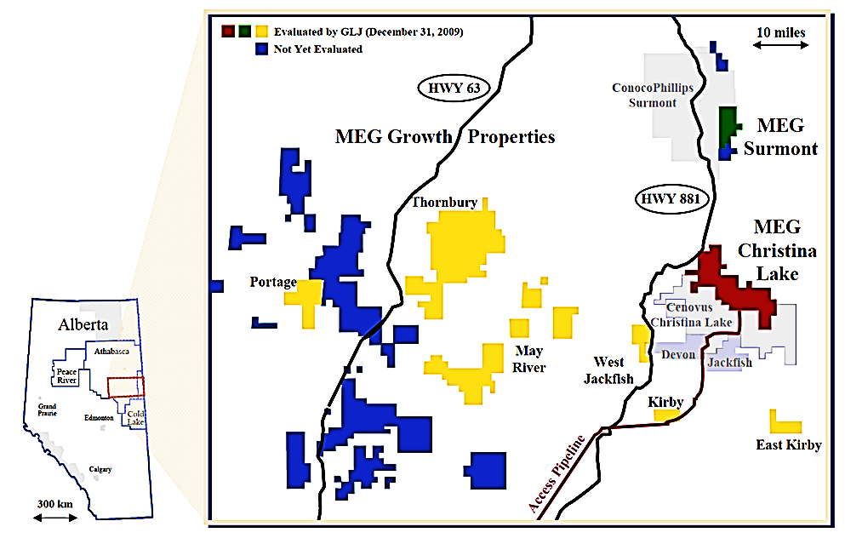

Source: Company files.

**EXHIBIT 7: DIAGRAM OF ENHANCED MODIFIED STEAM AND GAS PUSH (eMSAGP)**

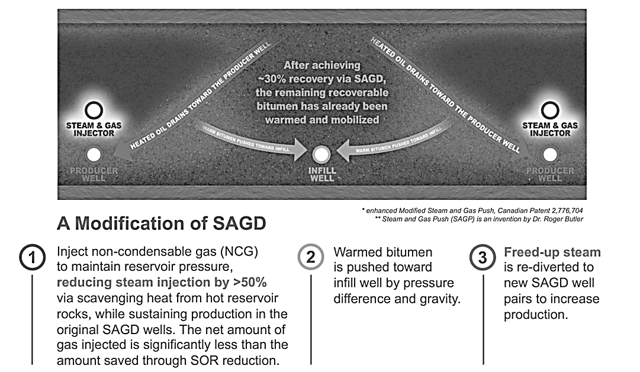

Note: SAGD = steam-assisted gravity drainage

Source: Company files.

**EXHIBIT 8: IMPACT OF ENHANCED MODIFIED STEAM AND GAS PUSH TO MEG ENERGY’S STEAM-TO-OIL RATIO, JUNE 2008–DECEMBER 2014**

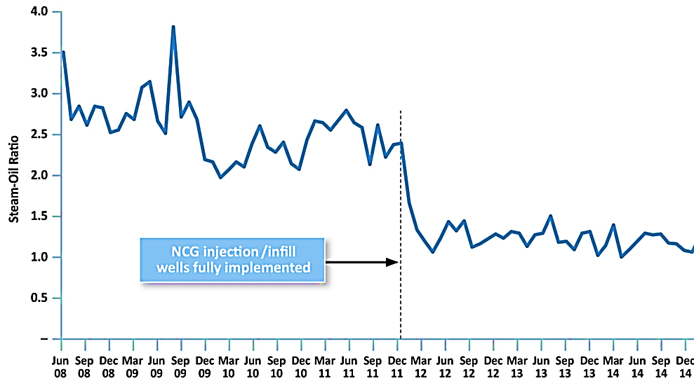

Note: NCG = non-condensable gas

Source: Company files.

**EXHIBIT 9: MEG ENERGY’S HISTORICAL CAPITAL EXPENDITURES (IN CA$ MILLIONS) AND OIL PRODUCTION (IN BARRELS PER DAY), 2007–2014**



Note: bbl/d = barrel per day

Source: Company files.

**EXHIBIT 10: COMPARABLE LEVERAGE, DEBT-TO–CASH FLOW RATIOS OF MEG ENERGY AND ITS PEERS**



Source: Created by the case authors using data from Thomson ONE.

1. All currency amounts shown are in Canadian dollars unless otherwise specified.
2. The initial investment program included $235 million in sustaining-and-maintenance capital directed toward maintaining current production levels and $965 million of growth capital that would support the company’s medium-term average growth of 10 per cent to 15 per cent per year.
3. A netback was the price received against the costs incurred to produce and transport a barrel of oil. This measure allowed investors to compare the profitability of the operations of various oil companies over a specific time period. Netbacks varied significantly across firms operating within the Canadian oil sands based on the nature of the extraction processes and the geological formation (or plays) within which they operated.
4. Paul Wells, “The Companies That Dominate the Oilsands Are Staying and Figuring out How to Get Bigger,” JWN, February 21, 2017, accessed August 14, 2018, www.jwnenergy.com/article/2017/2/companies-dominate-oilsands-are-staying-figuring-out-how-get-bigger/.
5. The wells-to-wheels approach to life-cycle analysis was one method for calculating the GHG emissions of automotive fuels that combined fuel production with vehicle use. The benefit of this approach was that it offered a technology- and policy-neutral approach to comparing different energy types, including fossil fuels and renewables.
6. Suncor Energy and Jacobs Consultancy, *A Greenhouse Gas Reduction Roadmap for Oil Sands*, 2010, accessed August 8, 2017, http://eralberta.ca/wp-content/uploads/2017/05/GHG-Reduction-Roadmap-Final-Report-Alberta-Oil-Sands-Energy-Efficiency-and-GHG-Mitigation-Roadmap.pdf.
7. Other in situ technologies had been developed and commercialized in the oil sands. The most successful was cyclic steam stimulation (CSS), which was developed by Imperial Oil and had been applied commercially to seven projects.
8. Development of the oil sands required permits and/or leases from the Alberta government that administered the Crown-owned mineral rights for the benefit of the citizens of Alberta. This process recognized the importance that both the people of Alberta and producers realize an acceptable return from the development of these resources. Producers were obligated to pay royalties to the province, based on the quantities produced and the prices received.
9. Oil, similar to other minerals, was classified based on its certainty of eventually being taken out of the ground using current extraction technologies. The highest-valued category of reserves was “proven” reserves, which had a “reasonable certainty” of being recovered, which meant a high degree of confidence that the volumes would be recovered. Next were “probable” reserves, which were volumes defined as less likely to be recovered than proven reserves but could become proven as a result of greater extraction and exploration. Finally, “contingent” resources were less certain than probable reserves but were potentially recoverable but not yet considered sufficiently mature for commercial development due to technological or business hurdles. For MEG, the bulk of its contingent resources were at the undeveloped growth properties.
10. The recovery of oil from a well or resource using any extraction method was never able to extract all the available oil. Instead, a share of oil would remain in the ground, and recovery factors indicated how much oil could be extracted. Average recovery factors from SAGD developments were between 40 per cent and 60 per cent, which rivalled the recovery factors in the world’s best conventional reservoirs.
11. Such covenants generally required the borrower to maintain an agreed level of financial health and the maintenance of particular leverage or liquidity ratios.
12. A unique feature of oil sands in situ projects was that production could be maintained with capital expenditure of approximately 20 per cent of cash flow, with the remaining 80 per cent going toward growth projects. This 20 per cent was known as *sustaining-and-maintenance capital*, which was used to keep production going with new wells and to ensure the proper running of the production plant.