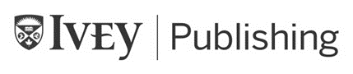

9B18M159

innogy consulting gmbh: COMPETING AWAY FROM HOME

Jonathan Chen, Son Tran Tuan, and Christopher Williams wrote this case solely to provide material for class discussion. The authors do not intend to illustrate either effective or ineffective handling of a managerial situation. The authors may have disguised certain names and other identifying information to protect confidentiality.

This publication may not be transmitted, photocopied, digitized, or otherwise reproduced in any form or by any means without the permission of the copyright holder. Reproduction of this material is not covered under authorization by any reproduction rights organization. To order copies or request permission to reproduce materials, contact Ivey Publishing, Ivey Business School, Western University, London, Ontario, Canada, N6G 0N1; (t) 519.661.3208; (e) cases@ivey.ca; www.iveycases.com.

Copyright © 2018, Ivey Business School Foundation Version: 2019-01-24

In September 2016, Dr. Klaus Grellmann, managing director of innogy Consulting GmbH (iCon), had many reasons to be delighted. iCon had risen to second place in an annual ranking of internal consultancies and had successfully expanded into four different countries.[1] Sitting in his office overlooking a leafy district of Essen in Germany’s otherwise-industrial skyline, he pondered new challenges and directions he might take iCon.

Grellmann originally took the helm of RWE Consulting—the predecessor to iCon—in 2007. As an internal consulting department within the RWE Group (RWE) in Germany, iCon mainly conducted information technology (IT) implementation and project management on behalf of entities within RWE. While the newly formed iCon could rely on this safe home for internal projects, Grellmann was well aware of the tough competition in the external management-consultancy market. How could iCon take steps to compete away from home?

RWE Group

RWE was founded in Essen, Germany, in 1898 as *Rheinisch-Westfälisches Elektrizitätswerk Aktiengesellschaft* (“Rhine-Westphalian Power Station Stock Company”). The company had won a contract from the city of Essen to build its first power plant, which was operational by 1900. By the early 2010s, the company had grown to be one of the world’s largest energy giants, spanning Europe with a business focused on the generation, distribution, trading, and retail of power. In 2015, the company had an earnings before interest, tax, depreciation, and amortization (EBITDA) of €7 billion[2] from a revenue of €48.6 billion and with a total workforce of 60,000 employees.[3]

RWE was firmly positioned in the “old world” of energy generation—32 per cent of electricity-generation capacity was based on gas, 23 per cent on lignite (mined by the company), 22 per cent on hard coal, 8 per cent on nuclear, and only 9 per cent on renewables.[4] The distribution business was in a dominant position in Germany and Eastern Europe, with over 570,000 kilometres of grid network and approximately 3,000 electricity- and 800 gas-network licences.[5] Long-term contracts provided a stable cash flow with high predictability. Barriers to entry in this sector were high, owing to the complex tendering process for each subsection of the grid and the presence of long-standing incumbents. By the time the decision was made in 2016 to separate the renewables, grid, and retail segments from RWE (i.e., to create innogy), the “grid” segment was expected to provide almost two-thirds of innogy’s EBITDA.[6]

In 2015, RWE’s customer-facing business (“retail”) grew to 16 million electricity customers and seven million gas customers across 11 European countries.[7] The company ranked first or second in market position in Germany, the Netherlands, and the Czech Republic. Nevertheless, continuous deregulation posed a challenge, and RWE had to deal with increased competition, thinning margins, and IT-related issues in its United Kingdom subsidiary that were causing high customer turnover.

Apart from the three core segments (generation, grid, and retail), RWE also ran its own energy-trading activities in the global commodity markets. Additionally, since 2013, RWE had seen a rapid expansion into the renewables-generation sector. Focusing primarily on wind power, RWE became the third-largest offshore wind farm operator in the world. The push behind entry into this relatively nascent field was Germany’s *Energiewende* (“energy transition”).

GERMANY’s Energiewende[8]

At the turn of the 21st century, the German government embarked on a new Energiewende, which culminated in 2010 with legislation that aimed to reduce greenhouse gas emissions by 80–95 per cent and meet a renewable energy target of 60 per cent by 2050. In response to fears surrounding climate change, this policy shifted Germany’s generation profile toward renewable energy. In 2000, feed-in tariffs had already been introduced.[9] These tariffs paid guaranteed above-the-market rates for 20-year periods to suppliers of solar and wind power; yet, it was the 2010 legislative bill that truly led to a boom in the capacity of installed renewables within the country. By 2016, renewables accounted for 32 per cent of overall electricity generation—up from 14.3 per cent just nine years earlier.[10]

Energiewende called for a phase-out of nuclear power, and efforts to denuclearize reached a peak in 2011, following the 9.0-magnitude earthquake that occurred off the coast of Japan and caused the Fukushima Daiichi nuclear disaster. Fifty minutes after the initial quake, a 13-metre-high tsunami reached the power plant and overwhelmed the seawall defences, disabling the primary emergency diesel generators, and causing coolant water in the plant to stop circulating. A day later, the battery-powered secondary emergency generators ran out of energy, causing the reactor to begin overheating and to eventually melt down. In Germany, reaction to this strengthened anti-nuclear feeling, and Chancellor Angela Merkel announced the immediate shutdown of the country’s oldest nuclear reactors and a total cessation of nuclear power by the year 2022.[11] German energy companies were to be responsible for funding the cleanup of the nuclear plants, which was estimated to cost up to €70 billion for the entire industry, with RWE’s share more than €10 billion.[12]

innogy’s carving out and its initial public offering

These events put significant pressure on RWE’s business model. Over 90 per cent of RWE’s generation capacity was in forms that the government was actively moving the country away from. The glut in electricity added by renewables had destroyed margins in the company’s relatively high-cost plants, and the company’s share price had dropped drastically from a high of €100 per share in December 2007 to around €9 per share by September 2015.[13] The company realized that it needed to act strategically in changing markets and to fund long-term liabilities such as nuclear decommissioning and pensions. In reaction to a similar announcement by RWE’s main domestic competitor, E.ON, the company decided to spin off a new entity to deal with the nuclear liabilities. Unlike E.ON, RWE decided to place its profitable power grid, renewable-energy generation, and retail operations into innogy SE, a new corporate entity that would be offered to the market in an initial public offering (IPO). RWE would retain a 76.8 per cent stake of the new company but act as a financial investor while retaining the old generation facilities. As a result, the IPO in October 2016 issued 129 million shares and generated proceeds of €4.6 billion. innogy SE was injected with €2 billion, and the remainder was left to RWE. It was the largest IPO in Germany in the new millennium.[14]

**INNOGY CONSULTING gmbh (ICON)**

The roots of iCon were established in 1981, when RWE bundled its internal-consulting department with shared services such as accounting, IT, and process support into a subsidiary called RWE Systems Consulting. Small teams within the consulting arm were tasked with ad hoc projects referred to as “body leasing.”[15] In the early 2000s, the unit became an independent legal entity under the name RWE Systems Consulting. Its work pipeline relied heavily on the implementation of IT projects within RWE.

Reaching a staff of 50 by 2005, RWE Systems Consulting opened up its first satellite office in Berlin to seek external clients for the first time. The company believed there were external clients that faced implementation challenges similar to those faced by RWE. Dropping “Systems” from its name in the same year, RWE Consulting became heavily reliant on freelancers.

In 2016, RWE Consulting was rebranded as innogy Consulting (iCon) and placed under innogy, the newly formed publicly traded company. iCon maintained strong relations with its clients within the former RWE Group in spite of the consultancy’s frequent name and structural changes (see Exhibit 1).

iCon grew to be one of Germany’s largest in-house management consultancies. It advised innogy and the RWE Group in strategic and operational areas linked to project implementation and process improvement. By 2016, iCon had offices in Germany, the Netherlands, the United Kingdom, the Czech Republic, and the United Arab Emirates. iCon consisted of 140 consultants who offered various advisory services and projects that spanned the entire value chain of the energy market: from energy generation to electricity and gas retail.

With growing numbers of projects within the parent company, as well as some initial external clients, iCon recruited a new wave of consultants from different backgrounds but with a unified passion for energy. iCon successfully delivered over 100 projects yearly, spanning across its various practices. The firm’s general management practice accounted for the largest share of revenue, while newer practices such as “change” and “operations” also made important revenue contributions (see Exhibit 2).

**IN-HOUSE CONSULTANCIES IN THE german consulting industry**

In Germany, the presence of in-house consultancy units (ICUs) at large corporations was more common. Two-thirds of the 30 DAX companies had an ICU in 2015.[16] These units were similar to external consultants in that they were used by the organization to solve a wide range of challenging problems. ICUs also were more active in implementing solutions—something that external consultancies did not always do. A benefit to the parent organization was that it was cheaper to perform a project with internal consultants rather than use an external firm. Additionally, knowledge was retained in-house, which aided future problem solving and guarded know-how from competitors. Internal consultants also had a better understanding of the underlying business model and were typically able to ramp up quickly on a project due to the familiarity with the business and stakeholders. They were also ideally suited to advise on softer aspects of change, such as the company culture and internal dynamics. However, there were also disadvantages, such as being seen as less impartial—and conflicts of interest occasionally arose.

Since 2010, the German consulting landscape had undergone a series of changes. Until then, only the top-tier external management-consulting companies were involved in high-profile strategic engagements. In 2007, the German government removed the strict separation of consultants and auditors.[17] Consequently, the top auditing companies decided to acquire a number of advisory boutiques to build up their management-consulting capabilities. A driving factor behind the rise of auditing firms was their focus on operations consulting compared with the focus on strategy presented by traditional management-consulting companies. This trend coincided with a shift in client expectation toward measurable indicators for the success of strategy implementation and also contributed to the rise of in-house consultancies; their inherent closeness to management and involvement in implementation made ICUs uniquely suited to fulfill the need for operational consulting and monitoring of strategy implementation.

ICUs entered the mainstream in the mid-1990s. Siemens Management Consulting (Siemens) and Porsche Consulting pioneered the model. These consultancies were expected not only to realize complex strategic and operative transformation processes but also to serve as a talent pool and train future managers for the company. Since 2010, these internal units had become the fourth pillar of consulting in Germany. The country’s advisory industry consisted of traditional management consultancies, which were often subsidiaries of overseas firms (e.g., McKinsey & Company, Boston Consulting Group, Bain & Company, and A.T. Kearney), the “Big Four” auditing companies (i.e., PwC, KPMG, Deloitte, and Ernst & Young), smaller boutique consulting firms, and the ICUs. According to a study by German magazine *WirtschaftsWoche*, 43 per cent of consulting mandates from DAX 30 companies were given to their own internal consultants by 2014.[18]

ICUs acquired projects in three different ways: (1) they could be delegated an assignment directly from management, (2) they could compete for projects with external consultancies, or (3) they could proactively identify current issues and initialize a project. Traditional project profiles for ICUs included strategy development, end-to-end process management, customer-journey analysis, and change management. DAX 30 companies had also been hiring many different large external consulting firms. These companies often worked on projects in collaboration with ICUs, taking advantage of company-specific knowledge. This model was common in Germany; an internal consultant’s specialist knowledge was integrated with new ideas and insights from external consultants to great effect.

Due to the fact that the DAX 30 companies increasingly conducted their business abroad, ICUs had to adapt to their global client base and set up offices in key foreign locations. Siemens, for instance, operated regional offices in Beijing and Mumbai, alongside its Munich headquarters.

GRELLMANN’s NEW strategy

Based on his experience from PwC and later at RWE, Grellmann recognized the need to professionalize the organization. Changes were made to turn the company into a competitive management consultancy that charged daily rates comparable to those of the top external consultancies.

One of the longest-serving partners in the company described the changes as follows:

The new vision wanted to put us on an eye-level with top external strategy consultancies in the industry. We suddenly wanted to move away from the previous business model of long-term operational assistance and body leasing. We now wanted to participate every year in top-10 projects with high strategic importance and visibility to the RWE board. We, however, did not have the people to deliver such services, as [the] core of RWE Consulting staff, including parts of leadership, consisted of long-timers with a mindset fitting usual corporate functions, rather than management consulting. As we already had 100 staff in 2008, it became apparent we had to accept a high turnover of personnel to get the right people on board.

Following an initial assessment, Grellmann focused on the RWE Group and cut all external project work. Freelancers were cut, and job titles were changed to match industry standards. Roles became more clearly defined. The hiring process became more rigorous, job requirements were aligned with those in other consulting companies, and assessment centres were set up to include case interviews during the recruiting process. Senior managers were hired from, among others, companies such as McKinsey & Company, the Boston Consulting Group, and Accenture. Grellmann introduced policies aimed at capability building through formal training and encouraging co-operation within teams. He also changed the culture by establishing continuous feedback and coaching as the centrepiece of people development.

Grellmann also initiated a significant shift from seniority-based promotions and compensation to a performance-based system. Regular performance evaluations and feedback after every project enabled employees to clearly see where they stood. This approach made the promotion process transparent and tied to individuals’ development. Partners started working toward overarching financial goals rather than focusing on their individual targets. As one partner noted, RWE Consulting started transitioning from a “single-fighter” mentality to an environment where a “team result is of paramount importance.”

Back-office activities such as IT support were outsourced to increase efficiency and achieve a better service level. RWE Consulting also became a separate legal entity with its own profit and loss. Even though it was still a fully owned subsidiary of RWE, RWE Consulting was able to operate independently of the mother company and make strategic decisions without requiring prior consultation with RWE.

This strategic change resulted in a major makeover of RWE Consulting staff. Within one and a half years of Grellmann’s arrival, approximately 80 per cent of the leadership team had been replaced, and within four years, approximately 80 per cent of RWE Consulting’s employees had been hired under his leadership, replacing a large number of staff that did not want to, or were unable to, make the transition. One year after Grellmann’s arrival, in 2008, RWE Consulting won its first high-profile project working directly for RWE’s new chief strategy officer. With this project, the transformed consultancy unit was now seen as a trusted advisor on both strategic and tactical questions within RWE.

INTERNATIONAL EXPANSION

The other pivotal change that Grellmann led was RWE Consulting/iCon’s international expansion. As the parent company, RWE pursued an aggressive international expansion strategy throughout the 2000s; consulting opportunities within the group started appearing all over Europe—and eventually beyond.

RWE Consulting’s first venture outside of Germany was in the United Kingdom, where it established the London office in 2007. Primarily serving npower—RWE’s retail arm, acquired in 2002—the U.K. branch also supported RWE Generation with its eight power plants in the United Kingdom. npower had been among the United Kingdom’s six-largest utilities, with more than five million electricity and gas customers. A similar situation happened in the Netherlands, where RWE acquired the country’s largest energy supplier, Essent, in 2009. Absorbing Essent’s consulting department as a result, RWE Consulting added a branch in Den Bosch that mostly focused on Essent’s core retail business that served electricity and gas customers. Moreover, RWE Generation’s gas-fired power plants presented further project opportunities. The Prague office was founded in 2010. Originally designed to serve RWE’s business in Eastern Europe, the Prague office grew to advise the group’s retail and grid businesses in the Czech Republic, Slovakia, Poland, and the Balkans, with a focus on the gas business.

All three offices (in the United Kingdom, Netherlands, and the Czech Republic) operated a hybrid model, officially reporting to the consulting head while being hosted by local retail branches. In practice, this meant that consultants outside of Germany were officially employees of npower (United Kingdom), Essent (Netherlands), and RWE CZ (Czech Republic), respectively.

Another important strategic decision for RWE Consulting was its expansion into external consulting in 2014 through the establishment of its Dubai office. While RWE had previously attempted to launch operations in the Middle East, it was ultimately unsuccessful. Grellmann decided to seize the chance, seeing the need for energy transformation in the Gulf region. He successfully transformed an ongoing technical co-operation with a local partner into a springboard for the launch of iCon’s management-consulting services. A new office in Dubai was established, winning high-profile strategy projects within the first two years. This success was partly due to forming a joint venture with the Dubai Electricity and Water Authority. The Dubai office pioneered RWE Consulting’s renewed venture into external consulting, competing with top-tier consultancies in the region.

PROJECTS AND GOVERNANCE AT THE NEWLY FORMED ICON

With RWE Consulting being recast as iCon, the firm needed to continue building on its capabilities and international presence (see Exhibit 3). iCon’s strengths included energy expertise, organizational-design skills, capability building, and strategy development. The firm had delivered a number of highly successful projects within RWE/innogy throughout the 2010s, including grid strategy development, renewables market analysis, creating customer journeys in retail, and setting up innogy’s Innovation Hub. iCon tended to do well on projects that required heavy client interaction, as its consultants were seen as highly collaborative and serving the group’s interests. As a result, the project teams had unprecedented access to data and information that clients would have been hesitant to share with external consultants. iCon also managed change projects, coaching RWE/innogy managers to help them handle the disruptive transformation of their business due to the Energiewende (see Exhibit 4). In 2016, iCon was the sole management consultancy to manage innogy’s IPO from idea to execution. This project lasted nine months and gave iCon unprecedented access and exposure to the top management of RWE/innogy.

On the other hand, iCon lacked external client experience, which made it difficult to compete in certain areas. For instance, the firm faced challenges in projects that required organizational health[19] analysis, non-energy industry knowledge, or external benchmarking.[20] iCon was also not considered completely impartial in projects that were more sensitive in nature. Concerns regarding a lack of impartiality would lead to a client preferring to work with other external consultancies on certain projects.

iCon’s culture was different from the culture at larger management-consulting firms in a number of ways. Most within innogy saw iCon as part of their own company. While communication and analytical skills were essential traits of every consultant, iCon consultants differed through focus and shared passion for the energy industry—something not found in consulting companies that dealt with a wide range of industries. The firm put a strong emphasis on interpersonal skills during the recruiting process, underlining iCon’s core value of co-creation through collaborative partnership with clients. Consultants were expected to build their own client network, cementing iCon’s trusted advisor role (see Exhibit 5).

Consultants regularly worked with colleagues from within innogy, accessing an expert network of more than 40,000 employees. Socializing and developing one’s personal network within the client company was common and encouraged. Additionally, iCon’s culture and governance relied on all consulting staff contributing to its internal development. The consultants also often cited an emphasis on work–life balance that was offered by the firm as a reason for joining. This focus on work–life balance was, in part, attributed to the vast majority of iCon’s projects being conducted in the Essen area, where most professional staff were based. Recent internationalization of the firm also increased importance of biannual “Consulting Days”: company-wide, all-hands meetings that offered opportunities to meet colleagues from other offices.

There had been some changes in the culture over time that encouraged new approaches, and led to more independent operations, which enabled consultants to take a more critical viewpoint on client problems. Independence also had practical implications, allowing iCon to operate outside of the usual German works council[21] framework that was common at large corporates. In practice, this approach allowed the firm to mimic external consultancies in areas such as compensation, promotion policy, working hours, and travel policy. This way, iCon also managed to steadily increase its revenues (see Exhibit 6).

GRELLMANN’s CHALLENGES GOING FORWARD

Revenue Growth

The leadership team set a revenue-growth target of 45 per cent within five years. The company contemplated entering industries such as telecommunications, transportation, or manufacturing. Additionally, further countries beyond the existing network were also debated. With an expectation to showcase iCon’s experience of dealing with the Energiewende, potential energy markets needed to be ripe for innovation and at the right stage of maturity to benefit from iCon’s expertise.

New Capabilities for New Niches

An altered client base required iCon to reconsider its offering. Digitization had become the word on the street, with competing consultancies moving toward engagements that were not fixed term, were not traditional consulting, and involved a continuous, data-driven approach. Being able to drive innovation for the client also turned out to be a service in high demand. Another new trend was pushing consultancies towards a more specific, tangible service offering, such as focusing on cross-selling retail products to end consumers. iCon would have to find new niches without spreading its capabilities too thin.

Managing People

Longer-tenured employees saw a distinct iCon culture emerge. However, this culture was now at risk due to employee turnover. While many new employees had joined, the overall number of consulting staff had remained at between 120 and 140 personnel for the past few years. One consultant commented as follows:

Back in 2013, we would add four or five new faces every quarter. Now we had that number of new employees joining every month. We all used to know each other very well, which made teams more close-knit and created [a] better environment for mentorship. As we grow, we need to make sure we do not forget about our culture.

Rapid international growth also put a strain on the firm’s internal administration and support services. As the company was poised to grow, its human resources, financial, and IT also needed to expand. The hybrid model at the international offices made this growth potentially more complicated. Another consultant observed:

It is rather difficult to get staffed on projects of choice and receive appropriate support, as that requires spending more time in the HQ [headquarters]. This is of course tricky for those of us based out of satellite offices.

Grellmann pondered these three challenges as he sat in his office in Essen in September 2016. The external management consultancy market was extremely competitive and most of iCon’s strong ties were within its internal market. But iCon did have a platform on which to expand? The key question was: How could iCon take further steps to compete away from home?

**Exhibit 1: HISTORY OF INNOGY CONSULTING, 1981–2016**

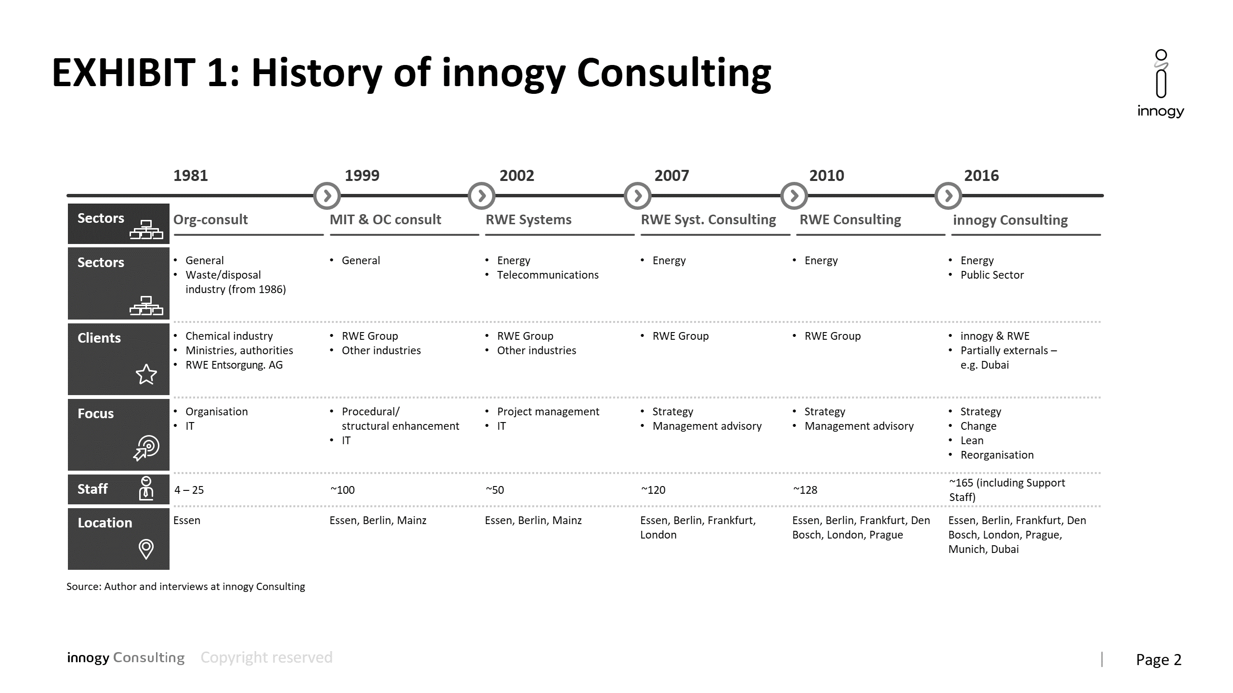

Note: IT = information technology

Source: Company documents.

Exhibit 2: CONSULTING SERVICES OFFERED AT Innogy CONsulting IN 2016

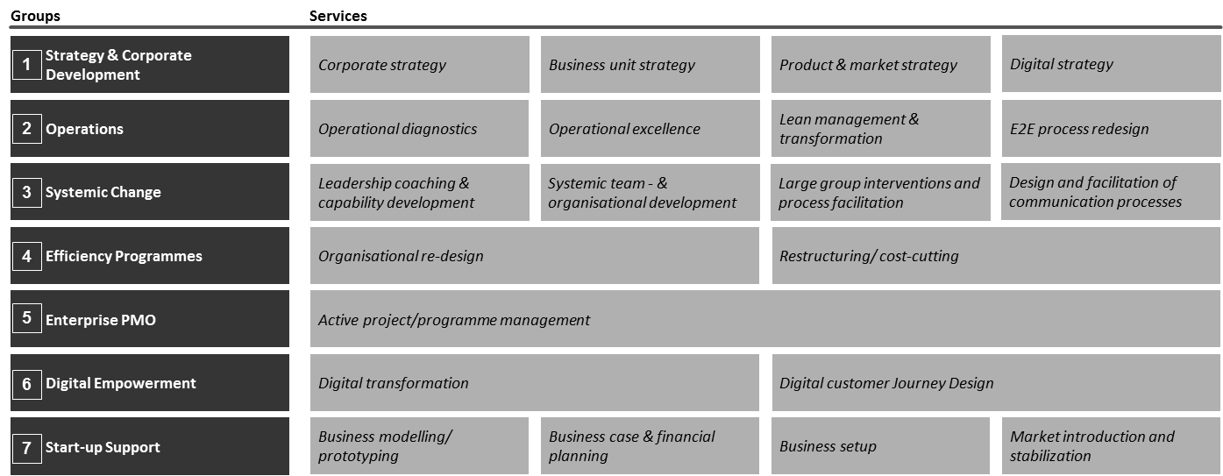

Note: E2E = end-to-end; PMO = project management office

Source: Company documents.

**Exhibit 3: innogy CONSULTING’S INTERNATIONAL OFFICES AND HEADCOUNTS IN 2016** 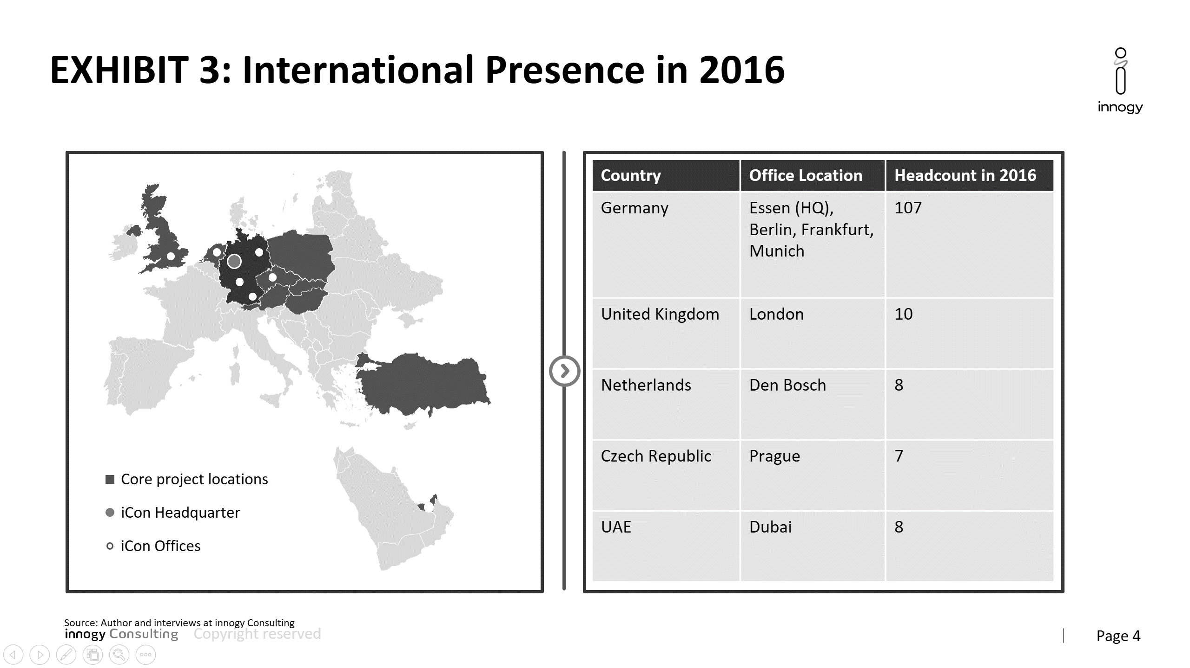

Note: iCon = innogy Consulting; HQ = headquarters; UAE = United Arab Emirates

Source: Company documents.

**Exhibit 4: innogy consulting’s REPRESENTATIVE SAMPLE OF PROJECTS IN 2015/16**

|  |  |
| --- | --- |
| **Project Location** | **Sample Project Description** |
| **Germany** | **Project Lux**: Development of innogy‘s steering model for grid, renewables, retail, and support functions |
| **B2C TOM**: Set-up of a target operating model for innogy’s B2C segment |
| **United Kingdom** | **NWoW@Pembroke**: Diagnostics phase of process-transformation project in gas power station aimed at enhancing effectiveness and performance |
| **Future of Functions**: Definition of organizational design and set-up of support functions for innogy’s retail arm |
| **Netherlands** | **NWoW@Eemshaven**: Diagnostic phase of a process-transformation project for a coal-powered plant |
| **Czech Republic** | **R&D@RWE ČR**: Technology-based scenario analysis, including strategic implications for the future development of the Czech energy sector |
| **Slovakia** | **Set-up RWE Slovensko**: Set-up of a new governance structure for RWE’s operations in Slovakia |
| **Poland** | **IT assessment@RWE**: IT assessment of processes and organizational set-up at RWE Polska and RWE IT Poland |
| **Belgium** | **Project Silver:** Creation of an external spend reduction target |
| **United Arab Emirates (UAE)** | **Mobile Workforce:** Development of a mobile workforce-management system for UAE’s key utilities |

Notes: B2C = business to consumer; TOM = target operating model; NWoW = new way of working; R&D = research and development; IT = Information technology

Source: Company documents.

**Exhibit 5: innogy consulting’s EMPLOYEE STRUCTURE IN 2016**

|  |  |
| --- | --- |
| **innogy Consulting—Consulting & Support Staff** | |
| Managing Director and Partners | 13 |
| Principals | 23 |
| Project Leads | 26 |
| Senior Consultants | 36 |
| Consultants | 42 |
| Support Staff | 25 |

Source: Company documents.

**Exhibit 6: innogy consulting revenues, 2011–2016 (in € Million)**

|  |  |
| --- | --- |
| **Year** | **Revenue** |
| 2011 | 23.0 |
| 2012 | 24.5 |
| 2013 | 29.3 |
| 2014 | 29.0 |
| 2015 | 28.5 |
| 2016 | 32.8 |

Note: US$1 = €0.83 on January 1, 2015; 2016 = Forecast for 2016 from Q3/2016

Source: Company documents.

1. “innogy Consulting (in German),” squeaker.net, 2016, accessed April 19, 2018, www.squeaker.net/de/Inhouse-Consulting-Ranking/p/15/t/Platz-2.
2. All currency amounts are in euros unless otherwise stated; US$1 = €0.83 on January 1, 2015.
3. RWE, *Annual Report 2015*, March 8, 2016, www.rwe.com/web/cms/mediablob/en/2974774/data/2705502/7/rwe/investor-relations/reports/2015/RWE-Annual-Report-2015.pdf.
4. Ibid.
5. innogy, “Further Steps towards the Planned IPO,” September 12, 2016, accessed April 19, 2018, https://iam.innogy.com/-/media/innogy/documents/ueber-innogy/Investor-Relations/ipo/ipo-2016-09-12-en.pdf.
6. RWE operated major distribution grids in Germany, Poland, the Czech Republic, Hungary, and Slovakia.
7. RWE, op. cit.
8. German for “energy transition”—the pivotal shift in German politics away from fossil fuels and toward renewable energy generation.
9. Feed-in tariffs were a regulatory mechanism that provided compensation above retail or wholesale electricity prices to operators of generation facilities, intended to increase investments in renewable energy.
10. Frauenhofer Institute for Solar Energy Systems ISE, “Power Generation in Germany—Assessment of 2016,“ February 7, 2017, accessed April 19, 2018, www.ise.fraunhofer.de/content/dam/ise/en/documents/publications/studies/power-generation-from-renewable-energies-2016.pdf.
11. Rebecca Staudenmaier, “Germany's Nuclear Phase-Out Explained,” Deutsche Welle, June 15, 2017, accessed April 19, 2018, www.dw.com/en/germanys-nuclear-phase-out-explained/a-39171204.
12. Christian von Hirschhausen, Clemens Gerbaulet, Claudia Kemfert, Felix Reitz, and Cornelia Ziehm, ”German Nuclear Phase-Out Enters the Next Stage: Electricity Supply Remains Secure—Major Challenges and High Costs for Dismantling and Final Waste Disposal,” *DIW Economic Bulletin* no. 22/23 (2015): 293–301, www.diw.de/documents/publikationen/73/diw_01.c.506840.de/diw_econ_bull_2015-22-1.pdf.
13. RWE, “RWE Share Price Information,” 2016, accessed April 27, 2018, www.rwe.com/web/cms/en/109536/rwe/investor-relations/shares/share-prices/.
14. innogy, “Annual Report 2016,” March 13, 2017, accessed April 27, 2018, https://iam.innogy.com/-/media/innogy/documents/ueber-innogy/Investor-Relations/q4-2016/annual-report-2016.pdf.
15. Individual consultants were leased by RWE to work on-site for a set amount of time—generally, a couple of months. These consultants would usually perform ordinary business functions rather than advise clients.
16. The DAX was a blue-chip stock market index that consisted of the 30 major German companies trading on the Frankfurt Stock Exchange. Horst J. Kayser, *Inhouse Consulting* (Frankfurt: Frankfurter Allgemeine Buch, 2015), 16.
17. Ibid.
18. Ibid., 23.
19. Organizational health was a quality that signified an organization’s ability to grasp strategic priorities and follow through with their execution. The concept included intangible measures such as culture, innovation, and leadership.
20. External benchmarking was a tool used to compare the client’s statistical data with other organizations within the industry. It helped companies assess their relative performance compared with the market average.
21. Germany’s *Works Council Constitution Act* formulated the way in which employers interacted with their employees. The council’s “co-determination” rights empowered elected employees to be involved in any decisions pertaining to areas such as rules of operation, wages, working hours and holidays, or workforce development.