

9B18M162

White Rock SKimboarding: fighting the changing tides

David A. Brooks wrote this case under the supervision of Julie Gosse solely to provide material for class discussion. The authors do not intend to illustrate either effective or ineffective handling of a managerial situation. The authors may have disguised certain names and other identifying information to protect confidentiality.

*This publication may not be transmitted, photocopied, digitized, or otherwise reproduced in any form or by any means without the permission of the copyright holder. Reproduction of this material is not covered under authorization by any reproduction rights organization. To order copies or request permission to reproduce materials, contact Ivey Publishing, Ivey Business School, Western University, London, Ontario, Canada, N6G 0N1; (t) 519.661.3208; (e)* [*cases@ivey.ca*](mailto:cases@ivey.ca)*;* [*www.iveycases.com*](http://www.iveycases.com)*.*

Copyright © 2018, Ivey Business School Foundation Version: 2019-06-14

It was August 2017, and White Rock Skimboarding (WRS) owner and Ivey Business School graduate Alex Dobbie was wrapping up another successful season of skimboarding and preparing to head to Toronto, Ontario, to begin working in the consulting industry. Dobbie was excited to begin this next stage in his career, but he continued to formulate plans, hoping to guarantee that the company he had founded would have many successful summers in its future.

**SKIMBOARDING**

Similar to surfing, skimboarding involved using a board, which could be made of a variety of materials, to glide across the water’s surface. Skimboards differed slightly in design from surfboards, as they were more rounded in shape and did not have underside fins. Despite the smaller design of the boards, skimboarders could still perform impressive tricks such as spins, flips, and jumps.

Skimboarding had begun in the 1920s in Laguna Beach, California, when lifeguards skimmed over the seashore on planks of wood. The sport grew in popularity throughout the 1960s and 1970s, when professional competitions began emerging. Skimboarding gained further media exposure in the 1980s and 1990s, including being on the cover of *Sports Illustrated*,the development of *Skim Magazine*, and early websites such as SkimOnline.[1]

Skimboarding was divided into two main categories: ocean skimboarding and flatland skimboarding.[2] Flatland skimboarding was developed after ocean skimboarding had been well established. Rather than skimming on the open ocean, flatland skimboarding focused on skimming across pools of shallow water, often created by receding tides, such as those found in White Rock, British Columbia (BC). WRS primarily focused on flatland skimboarding; however, as the tides came in, ocean skimboarding could also occasionally be performed.[3]

Skimboarding’s popularity remained consistent within coastal communities. Competitions and championships were held around the world and were often sponsored by global and local skimboard manufacturers.[4]

**WHITE ROCK SKIMBOARDING**

**White Rock, British Columbia**

The city of White Rock was located in Surrey, BC, and was part of the the greater metropolitan Vancouver area. It was named after the distinctive white boulder that was located on the famous White Rock Beach. The rock, which appeared white in colour due to the amount of bird excretions dropped onto it, was so recognizable that it was originally used as a beacon by nineteenth-century sailors. It remained white through monthly applications of white paint by municipal workers and was still the most prominent landmark on the beach.[5] Many local businesses, including WRS, still used it as a reference point when providing directions to visitors.

White Rock boasted a population of 19,952 and was especially busy in the summer, when it was a popular destination for both out-of-province tourists and BC locals.[6] The median age of the population was 53.8 years, older in comparison to the median age of the rest of the province at 41.9.[7] Dobbie observed how the city’s demographics changed in the summer months, as younger family members of the more mature population flooded in for extended visits. White Rock hosted several arts and cultural events throughout the summer and was known as a common shooting location for films.

**Company History**

An avid skimboarder for much of his life and a White Rock local, Dobbie launched White Rock Skimboarding in 2014, when he was just 18 years old (see Exhibit 1). Dobbie had noticed that whenever he and his friends went skimboarding at White Rock Beach, multiple children would continually crowd around with interest and attentively watch the skilled skimboarders skim and practice tricks. With the intent of converting this captivated audience into paying customers, Dobbie attained the necessary permits and licences to open a business, and by the summer of 2014, WRS was enjoying its first season of operations.

While attending Western University, Dobbie returned to White Rock each summer to ensure the smooth operations of his company. This steadfastness resulted in considerable growth for the company. The business’s popularity was such that day camp sessions regularly sold out, and campers returned over the course of several weeks and seasons. Even as he entered Ivey Business School and began adding to his business experience by working in several industries, Dobbie always ensured that he made time to return to White Rock for most of the skimboarding season.

To efficiently run WRS’s growing operations, Dobbie employed a large number of seasonal staff, who were well trained in all aspects of the business. Dobbie used WRS as an opportunity to provide fulfilling employment to some of his close friends and family members, as well as members of the BC skimboarding community. Staff members were both local to White Rock and from countries around the world, and many had competed in international skimboarding competitions. All staff members were personally trained by Dobbie. Trainees shadowed him until Dobbie felt confident enough in their abilities and expertise to assign them to day camp sessions or lessons, or to allow them to instruct customers on their own.

**OPERATIONS**

**Day Camps**

The core of WRS’s operations were the day camps that ran for two months out of the four-month operating season (May to August). These camps were designed for children aged seven to 14 and were run out of a WRS kiosk on White Rock Beach. An average session had room for 30 campers, but within each session, campers were assigned to small groups of five to nine and paired with a WRS instructor for the duration of the camp. Due to the fact that a high tide made it impossible to flatland skimboard, WRS camps were at the mercy of the ocean tides and had to compensate with different tasks and instruction when skimboarding could not be performed. This included alternative programming such as beach games, observing local wildlife, and occasionally cancelling camps on certain days due to extreme or unforeseen circumstances.

Camps were held in July and August of each year. In 2017, 13 sessions of camp were offered with five-, four-, and three-day camps being held over various weeks (see Exhibit 2). Regardless of how many days a camp ran, each day consisted of three hours at tide-dependent times.

Dobbie felt that the pricing was affordable for parents seeking a quality experience for their kids. Campers were required to bring their own skimboard, though WRS did make rentals available for campers who did not own their own boards.

**Private Lessons**

In addition to camps, WRS also offered private lessons for smaller groups of one to three people. Unlike in group camps, board rentals were included in the fee for private lessons, and lessons were offered from May through August—two months longer than standard camps. Private lessons were priced at $110[8] per hour for a group of three, $80 per hour for two individuals, and $45 per hour for one person. Lessons accounted for 7 per cent of WRS’s revenue in 2017. While private lessons were not a main source of income, they provided healthy margins and supplemented revenue, especially in the slower months of operations. Dobbie also noticed a pattern of less confident and shyer children taking private lessons prior to enrolling in WRS day camps.

**Skimboard Rentals**

All WRS campers were required to either own or rent a skimboard to participate in any camp. Those who elected to rent boards for their camp sessions were charged an additional $5 per day above camp costs (e.g., a skimboard rental for a five-day camp would be an additional $25). This was far below the typical rental price, as Dobbie felt strongly that not owning a skimboard should not be a barrier for children to participate in WRS camps. While most campers came with their own boards, Dobbie observed that if campers used the rental option for their first session, they would often have purchased a skimboard by the next session they attended.

WRS also offered skimboard rentals and sales to the public. Dobbie charged $7 per hour for skimboard rentals and only offered rentals to the public when WRS employees were already present on the beach running camps and giving lessons. Dobbie did not think it made financial sense to offer rentals outside camp operating hours. Board rentals were 1.4 per cent of WRS’s revenue in 2017 and had not seen any growth in recent years. Dobbie wondered if this service should be expanded to stimulate growth or instead discontinued as part of WRS’s offerings.

**Merchandise Sales**

WRS began selling skimboards in 2015—once Dobbie realized the company had been missing a significant opportunity to make further revenue from its existing customers. Board sales were a small but growing segment of the business, and Dobbie liked the idea of WRS campers using boards sold by his business. Dobbie did significant research to determine the best-value and highest-performance skimboards from various brands and decided that his target market would be best served by stocking the basic Channel One skimboard. Dobbie discovered that the best sourcing for the boards was to buy in bulk from WRS’s main competitor, Kayotics Skimboards (Kayotics), who was the main seller of the same boards. He was aware of the downsides associated with buying from his direct competitor, but he felt it was the best option for his current situation, as no other supplier could compare to the prices he was able to procure from Kayotics. WRS charged $60 per board (the same as Kayotics), incurring a $40 variable cost on each board. Recently, Dobbie had noticed that Kayotics had raised its consumer prices to $70 per Channel Oneboard, and he questioned if he should do the same.[9] He did not expect this increase would affect the price he paid to Kayotics for the boards.

In addition to skimboards, Dobbie also sold WRS-logoed T-shirts. Dobbie first began offering them in order to sell off extra unneeded staff uniforms but quickly realized that kids and parents alike would often purchase shirts as a souvenir of both skimboarding with WRS and the city of White Rock. While the shirts were not a major source of revenue, Dobbie enjoyed the exposure they gave WRS and saw no disadvantages to continuing to sell them along with boards.

**MARKETING**

WRS relied extensively on word-of-mouth advertising and was established as a reputable brand in the community. It enjoyed significant free media coverage and was featured in several local and national outlets such as *The Peace Arch News*,[10] Shaw TV,[11]andKid Approved BC.[12]WRS also maintained active Facebook and Instagram pages, which allowed for further engagement with customers and the community.

In 2017, WRS also established a partnership with the White Rock Sea Festival, an annual celebration established in 1949 and held on the first weekend in August on White Rock Beach.[13] WRS offered skimboarding prizes and ran free events for festival attendees over the course of the festival. This partnership provided additional exposure of WRS to people who may never have previously heard of the company or the sport.

**CONSUMERS**

**Children**

While WRS camps currently catered to children aged seven to 14, private lessons, rentals, and sales were open to all age groups. Still, the vast majority of WRS’s non-camp consumers fell within this age range. It was common for a single WRS consumer to be a client in multiple WRS revenue streams. Dobbie was hesitant to change the age range for camps, as he felt seven was the minimum age a child could be physically and mentally mature enough to gain value from the experience, while children generally outgrew summer day camps by age 15.

Dobbie felt customers were most influenced by seeing skimboarding in action, and found that a large portion of campers stumbled upon WRS while spending time on the beach. The openness and public nature of the beach occasionally resulted in onlookers attempting to join in and participate in camp activities, often not realizing these were for paying customers. These situations were typically resolved by a WRS staff member speaking to parents and explaining that a private camp was in progress. Dobbie wondered if there was a way to capitalize on the piqued interest of these potential campers.

**Parents and Guardians**

In addition to the campers themselves, Dobbie believed that parents and guardians were also their own consumer segment, as they paid the fees for WRS activities on behalf of their children. Dobbie knew that he needed to represent WRS as a professional, safe, and fun environment in order to convince parents and guardians that such a camp was suitable for their children. Dobbie felt that WRS did a good job at this portrayal, considering its past successes and the company’s professional website and secure payment system. However, he still wondered if there was anything further he should be doing or anything he could be doing differently to maximize the appeal to this consumer group.

**THE COMPETITION**

**Kayotics**

WRS’s most direct competitor was Kayotics Skimboards, a Vancouver-based skimboarding company founded in 2001. Kayotics was established by local skimboarders and branded itself as a “skimboarding lifestyle” company. In addition to the Channel Oneboards Dobbie bought from Kayotics, the company also sold its own Kayotics-branded boards. These boards were of higher quality than the Channel Oneboards and retailed for $100 to $200. Kayotics promoted these boards as a step up from beginner boards and used them to sponsor several skimboarding athletes in global competitions.[14]

Additionally, Kayotics operated competing skimboarding camps and private lessons in White Rock, Centennial Park (Tsawwassen), and Spanish Banks (Vancouver). Kayotics camps were slightly more expensive than WRS camps, offering a five-day camp for $150.[15] Dobbie did not feel that Kayotics White Rock Beach camps were preventing WRS’s success, as Dobbie’s business had no problem filling all camps it offered each year. Kayotics also did not offer rental boards for its camps and instead maintained the policy that all campers needed to bring their own board to camp.

**Summer Camps**

WRS also competed with various other summer and day camps locally and in the Greater Vancouver Area.[16] With over 200 camps to choose from,[17] it sometimes proved difficult for WRS to convince potential campers and parents of why WRS’s was the best available. Dobbie questioned the advantages and disadvantages of his three-hour camp style and wondered how the company could best move forward in the competitive landscape.

**Other Competitors**

Finally, the city of White Rock and surrounding area was full of various activities that children and families could choose to fill their summer days with.[18] Sports leagues, summer school programs, and vacation destinations were just some of the non-camp alternatives that could be chosen by potential campers and their families.[19]

**POTENTIAL ALTERNATIVES**

While Dobbie knew that demand for WRS would continue to be stable the following summer, he thought about several options for WRS’s continued future growth.

**Status Quo**

Dobbie was content with WRS’s performance and was happy to continue operations without any major changes. He remarked from his past financials that the company had consistently earned profitable financial results, especially given the limited four-month season (see Exhibits 3, 4, 5, and 6). Dobbie was, nonetheless, concerned about the logistics of maintaining operations, given that he would be starting a new career in Toronto beginning in September and was not sure if he could effectively run the company remotely.

Dobbie believed that if he decided to continue WRS as it was, revenue proportions would continue to shift. While he planned to offer the same level and varieties of camps as the previous year, Dobbie expected fewer campers to return for 2018 due to several factors, such as his future absence from the business and heightened competition. As a result, he predicted camp revenue to decline to $9,000. Private lessons, on the other hand, had grown tremendously, and Dobbie expected private-lesson sales to grow by at least 20 per cent the following year.

For the merchandise side of his business, Dobbie expected a modest growth in board rentals, with growth of one five-day camp board rental for an additional camper and additional three-day camp rentals for two campers. In 2017, public board rentals totalled 18 hours for the summer. It was anticipated that this would grow by 50 per cent for the upcoming year. Dobbie expected T-shirt sales to decline to $300 in 2018 but expected to sell seven additional skimboards above what was sold in 2017.

Dobbie expected business-licence expenses to remain at the same dollar value and staff wages to increase to their 2016 sales percentage. All other expenses were expected to remain at the same dollar value or the same percentage of sales.

**Expand into New Territory**

Dobbie thought about how WRS could grow if he decided to maintain the company. He felt the size and skimboarding culture in White Rock had been sufficiently established and the market sufficiently saturated. As a result, he began thinking about expanding the camp business model to other beaches and communities in the area. He cited White Rock as an example of a city supporting multiple skimboarding camps and wondered if this would hold true in other areas. Locations that he considered included Centennial Park (Tsawwassen) and Spanish Banks (Vancouver)—the two other locations where Kayotics ran its camps[20]—as well as Dundarave Beach (West Vancouver) and Crescent Beach (Surrey). Logistically, he believed he could only expand to one additional location for the upcoming season but could use the success or failure as an indication of whether further expansion would be warranted.

Regardless of which location he chose, Dobbie felt that the upfront investment and costs would be almost identical. He expected to purchase a new ramp for $160, a table for $100, new signage for $130, and another beach kiosk for $600. Additionally, Dobbie believed that he would incur another $400 in legal fees associated with the expansion, as well as initial recruiting costs of $220 in order to properly hire the necessary staff needed for the expansion. Dobbie did not believe that WRS was ready for a bank loan at this time, and he was prepared to use his own personal savings to fund the expansion.

Dobbie felt that WRS did not have the resources to offer all services currently offered in White Rock at a potential second location; instead, WRS would initially focus on day camps and private lessons. Dobbie planned to offer three five-day camps and two each of four-day and three-day camps. He expected that this would attract an average of 12 campers to each session. Additionally, he believed $670 in private lessons could be generated at a new location.

Unlike at White Rock Beach, WRS would have to pay rent at a new location totalling $500 per month for the summer operating season. To properly establish a brand, advertising would be necessary, which was budgeted for $400 per year. A new location would also require new staff working in proper uniforms, which was expected to total $1,350 in new wage costs and 90 per cent of 2017’s uniform costs. WRS’s insurance and licence costs would rise to $900 for the year if this option was pursued, but no additional website costs were expected. All other cash expenses were expected to remain at the same percentage as the White Rock Beach location.

Dobbie was also concerned about managing such a major undertaking remotely and questioned whether he would need to take an extended vacation or leave his new job in order for this to be successful.

**Order and Sell Custom Skimboards**

Dobbie was also looking into the costs of manufacturing a line of White Rock Skimboarding-branded custom skimboards. He had enjoyed success selling skimboards and other branded merchandise (such as T-shirts) to campers, and thought that branded custom skimboards could serve as a logical progression to increase revenue and further legitimize WRS as a strong skimboarding brand. He was considering several design ideas for a medium-sized skimboard (see Exhibit 7). This decision would come with a higher price, as a custom WRS skimboard would now retail for $90. Dobbie knew that this project would need to be outsourced and had already found a firm interested in completing an initial order of 100 skimboards. The company, Yuan Sports, was based in China and did not have an established reputation like other North American board manufacturers. It did, however, send a sample board to Dobbie, who personally tested it and was very pleased with its quality and performance. Yuan Sports offered to fill the order at a cost of $60 per board, with another $400 in shipping costs. Dobbie was not sure of the number of boards that would actually sell in the first season, and he thought about the amount of boards that would have to be ordered to merit the venture.

Dobbie also believed that to effectively promote WRS boards, advertising would be necessary. He felt that print pamphlets would be most effective, as he could personally target his own campers and easily distribute them across White Rock. To print 1,000 pamphlets per year would cost $0.35 per pamphlet, with an additional yearly $50 distribution cost. Dobbie believed this alternative would have significant brand value but was unsure whether it would be financially viable, especially if the boards did not sell as well as he hoped.

**Sell or Pass On the Business**

Dobbie also considered whether it was time to end his chapter with WRS and focus on a career in business. He felt there was significant value in the company but was not sure how to assess it. Dobbie had identified several potential buyers including his friends; existing WRS employees; and his sister, Adriana, who had been helping with WRS’s administration for several years. Alternately, he also could look to external buyers who might see value in WRS. Dobbie knew that whomever he agreed to sell the business to would have a major impact on the price. He was not interested in charging his friends or sister anything significant, and preferred to pass the business on to someone with a similar vision and passion. Dobbie also thought about what would happen if no potential buyer was interested and how he could best economically wind down the business.

**DECISION**

As Dobbie started packing up his skimboards and other equipment to put into storage, the many options circled in his head. He was optimistic for the future of WRS but knew that any decisions he made would deeply affect him, his employees, and the campers who returned every year.

**EXHIBIT 1: WHITE ROCK SKIMBOARDING LOGO**

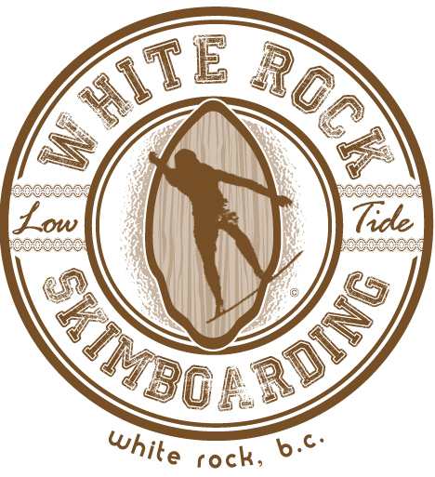

Source: Company website.

**exhibit 2: 2017 Camp Season**

|  |  |  |
| --- | --- | --- |
| **Number of Sessions** | **Number of Days per Session** | **Cost (CA$)** |
| 4 | 5 | $135 |
| 5 | 4 | $115 |
| 4 | 3 | $90 |

Source: Company files.

EXHIBIT 3: INCOME STATEMENTS AND FINANCIAL RATIOS

For years ending August 31

|  |  |  |  |  |  |  |
| --- | --- | --- | --- | --- | --- | --- |
|  | **2017** | | **2016** | | **2015** | |
| **Revenue** |  |  |  |  |  |  |
| Summer camps | $ 9,660 |  | $ 14,595 |  | $ 13,290 |  |
| Private lessons | 820 |  | 130 |  | 520 |  |
| Board rentals* | 201 |  | 189 |  | 154 |  |
| Board sales | 660 |  | 540 |  | 360 |  |
| T-shirt sales | 411 |  | 349 |  | 45 |  |
| Total Revenue | $ 11,752 | 100% | $ 15,803 | 100% | $ 14,369 | 100% |
|  |  |  |  |  |  |  |
| **COGS** |  |  |  |  |  |  |
| Transaction fees | $ 353 | 3% | $ 474 | 3% | 431 | 3% |
| Skimboards | 440 |  | 360 |  | 240 |  |
| T-shirts** | 206 |  | 175 |  | 23 |  |
| Total COGS | $ 998 | 8.5% | $ 1,009 | 6.4% | $ 694 | 4.8% |
|  |  |  |  |  |  |  |
| **Gross Margin** | $ 10,754 | 91.5% | $ 14,794 | 93.6% | $ 13,675 | 95.2% |
|  |  |  |  |  |  |  |
| **Operating Expenses** |  |  |  |  |  |  |
| Business licence and insurance | $ 635 | 5.4% | $ 650 | 4.1% | $ 635 | 4.4% |
| Depreciation | 349 | 3.0% | 331 | 2.1% | 294 | 2.0% |
| Supplies | 55 | 0.5% | 38 | 0.2% | 0 | 0.0% |
| Printing | 110 | 0.9% | 123 | 0.8% | 0 | 0.0% |
| Website maintenance | 488 | 4.2% | 252 | 1.6% | 1,050 | 7.3% |
| Staff uniforms | 258 | 2.2% | 620 | 3.9% | 620 | 4.3% |
| Wages | 1,902 | 16.2% | 4,644 | 29.4% | 2,090 | 14.5% |
| Total Expenses | $ 3,797 | 32.3% | $ 6,659 | 42.1% | $ 4,689 | 32.6% |
|  |  |  |  |  |  |  |
|  |  |  |  |  |  |  |
| **Net Income** | **$ 6,957** | 59.2% | **$ 8,136** | 51.5% | **$ 8,986** | 62.5% |

Note: All dollar amounts are in Canadian dollars; COGS = cost of goods sold; *board rentals for summer camps currently totalled $75; **White Rock Skimboarding took a 50-per-cent margin on T-shirts.

Source: Company files.

EXHIBIT 4: STATEMENTS OF CAPITAL For years ending August 31 (CA$)

|  |  |  |  |
| --- | --- | --- | --- |
|  | **2017** | **2016** | **2015** |
|  |  |  |  |
| **Starting capital** | $ 2,439 | $ 1,803 | $ (183) |
| Net Income (loss) | 6,957 | 8,136 | 8,986 |
| Less: Drawings | 7,500 | 7,500 | 7,000 |
| **Ending capital** | **$ 1,895** | **$ 2,439** | **$ 1,803** |

Source: Company files.

EXHIBIT 5: BALANCE SHEETS As at August 31 (CA$)

|  |  |  |  |
| --- | --- | --- | --- |
|  | **2017** | **2016** | **2015** |
| **ASSETS** |  |  |  |
| Current assets |  |  |  |
| Cash | $ 266 | $ 538 | $ 138 |
| Inventory: Skimboards | 960 | 840 | 720 |
| Inventory: T-shirts | 341 | 357 | 316 |
| Total current assets | $ 1,567 | $ 1,735 | $ 1,174 |
|  |  |  |  |
| Fixed assets |  |  |  |
| Ramp | $ 308 | $ 308 | $ 154 |
| Table | 178 | 124 | 124 |
| Signage | 267 | 232 | 200 |
| Awning | 561 | 561 | 561 |
| Other fixed assets | 432 | 432 | 432 |
| Total fixed assets | 1,746 | 1,657 | 1,471 |
| Less: Depreciation, all assets | (1,165) | (816) | (484) |
| Net fixed assets | 581 | $ 841 | $ 987 |
| **TOTAL ASSETS** | **$ 2,148** | **$ 2,577** | **$ 2,161** |
|  |  |  |  |
| **LIABILITIES** |  |  |  |
| Current liabilities |  |  |  |
| Accounts payable | $ 106 | $ 59 | $ 245 |
| Credit card payable | 147 | 79 | 113 |
|  |  |  |  |
| **Total Liabilities** | $ 253 | $ 138 | $ 358 |
|  |  |  |  |
| **EQUITY** |  |  |  |
| Capital | $ 1,895 | $ 2,439 | $ 1,803 |
|  |  |  |  |
| **TOTAL LIABILITIES & EQUITY** | **$ 2,148** | **$ 2,577** | **$ 2,161** |

Source: Company files.

EXHIBIT 6: FINANCIAL RATIOS

|  |  |  |  |
| --- | --- | --- | --- |
|  | **2017** | **2016** | **2015** |
| **Profitability** |  |  |  |
| Return on Equity | 367% | 334% | 498% |
|  |  |  |  |
| **Liquidity** |  |  |  |
| Current Ratio | 6.19 : 1 | 12.57 : 1 | 3.28 : 1 |
| Acid Test | 1.05 : 1 | 3.90 : 1 | 0.39 : 1 |
|  |  |  |  |
| **Stability** |  |  |  |
| Debt to Equity | 13% | 6% | 20% |

|  |  |  |
| --- | --- | --- |
| **Growth** | **2016 – 2017** | **2015 – 2016** |
| Sales | -26% | 10% |
| Net Income | -14% | -9% |
| Total Assets | -22% | 35% |
| Equity | -17% | 19% |

Source: Company files.

EXHIBIT 7: PROPOSED BOARD SCHEMATICS AND DESIGN short list

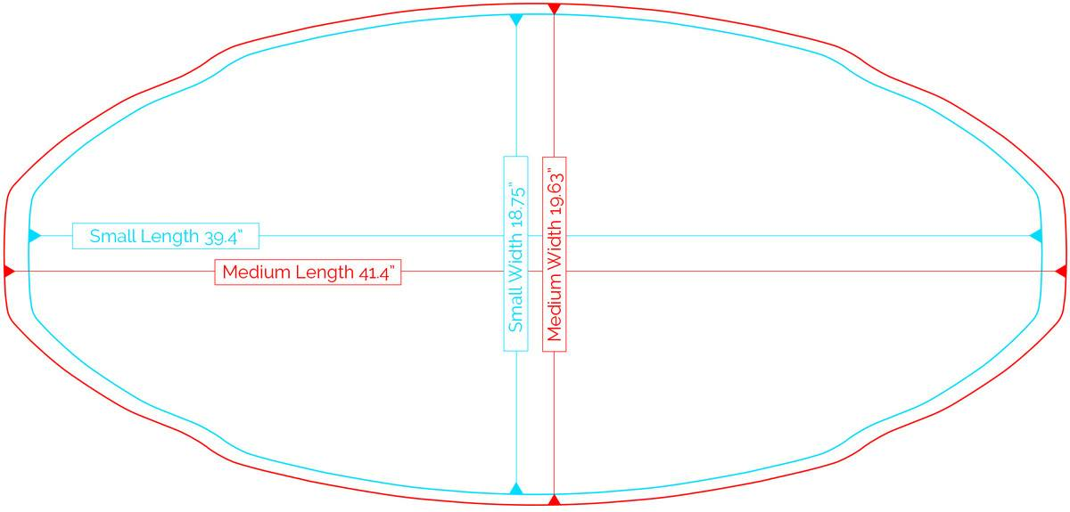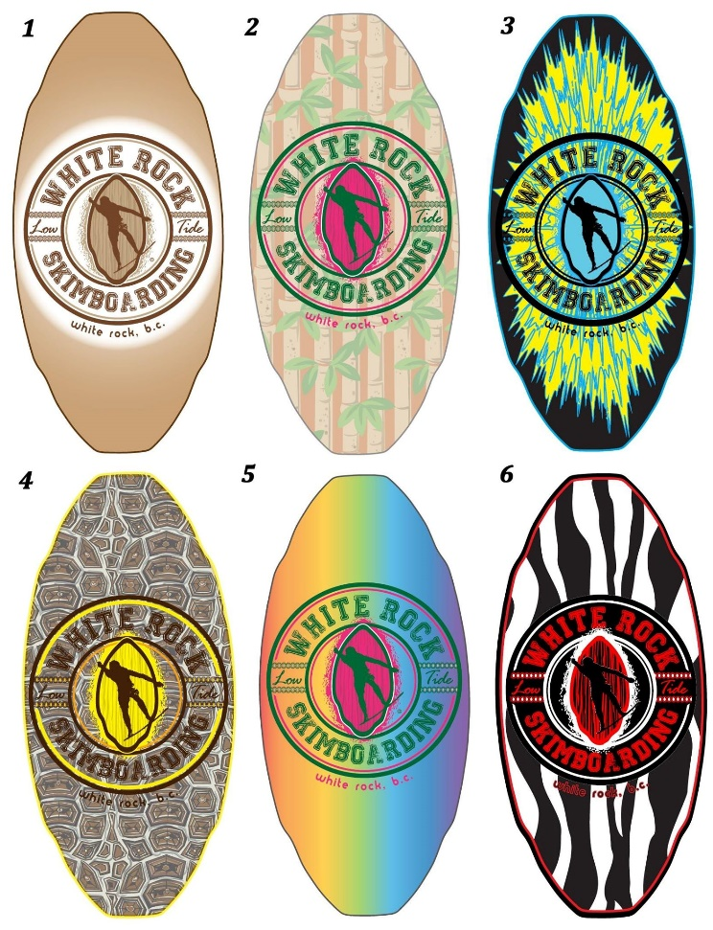

Source: Company files.

1. “History of Skimboarding,” UCLA, accessed June 10, 2018, http://shawnmor.bol.ucla.edu/Histroy.htm.
2. “The History of Flatland Skimboarding,” DB Skimboards, accessed June 8, 2018, https://dbskimboards.com/history-of-skimboarding.
3. “History of Skimboarding,” op. cit.
4. “History of Skimboarding,” SkimOnline.com, accessed June 8, 2018, skimonline.com/basics/history-of-skimboarding/.
5. Aliya Hussein, “The History Behind White Rock (And the Actual Rock),” 604 Now, Feburary 22, 2014, accessed September 18, 2018, https://604now.com/history-behind-white-rock/.
6. “Demographics & Statistics,” City of White Rock, accessed June 4, 2018, www.whiterockcity.ca/338/Demographics-Statistics.
7. “Census Subdivision of Prince George, CY (British Columbia),” Statistics Canada, Government of Canada, September 21, 2016, accessed June 4, 2018, www12.statcan.gc.ca/census-recensement/2011/as-sa/fogs-spg/Facts-csd-eng.cfm?LANG=E ng&GK=CSD&GC=5915007.
8. All dollar amounts are in Canadian dollars.
9. “Channel One Skimboard,” Kayotics.com, accessed May 11, 2018, www.kayotics.com/skimboards/channel-one-skimboard-red-silver.
10. “Skim Camps Return to White Rock Beach,” *Peace Arch News*, June 10, 2016, accessed May 7, 2018, www.peacearchnews.com/business/skim-camps-return-to-white-rock-beach/.
11. “White Rock Skim Boarding on Shaw TV,” YouTube video, 3:13, posted by “go! on Shaw TV Vancouver,” July 22, 2013, accessed May 7, 2018, www.youtube.com/watch?v=jvsE9MAhc84.
12. “Spotlight on White Rock Skimboarding,” Kid Approved BC, June 8, 2017, accessed May 8, 2018, https://kidapprovedbc.com/white-rock-skimboarding/.
13. “White Rock Sea Festival,” City of White Rock, August 1, 2017, accessed May 20, 2018, www.whiterockcity.ca/366/White-Rock-Sea-Festival.
14. “About Us,” Kayotics.com, accessed May 18, 2018, www.kayotics.com/about/.
15. Kayotics Skimboards Camps (website), accessed May 18, 2018, www.skimboardingcamps.com/.
16. “Kids & Teens Summer Camps,” White Rock Recreation and Culture, City of White Rock, accessed June 18, 2018, www.whiterockcity.ca/397/Recreation-Guide.
17. Lindsay Follett, “Summer Camps in Metro Vancouver,” Family Fun Vancouver, May 15, 2018, accessed June 25, 2018, www.familyfuncanada.com/vancouver/summer-camps-metro-vancouver/.
18. “White Rock Events,” City of White Rock, accessed June 19, 2018, www.whiterockcity.ca/Calendar.aspx.
19. “Things To Do—Attractions,” Explore White Rock, accessed June 1, 2018, explorewhiterock.com/things-to-do/.
20. “Locations,” Kayotics Skimboards Camps, accessed September 11, 2018, www.skimboardingcamps.com/contact/.