

9B18M168

phenicoptere: taking glov global

Aleksandra Wąsowska wrote this case solely to provide material for class discussion. The author does not intend to illustrate either effective or ineffective handling of a managerial situation. The author may have disguised certain names and other identifying information to protect confidentiality.

This publication may not be transmitted, photocopied, digitized, or otherwise reproduced in any form or by any means without the permission of the copyright holder. Reproduction of this material is not covered under authorization by any reproduction rights organization. To order copies or request permission to reproduce materials, contact Ivey Publishing, Ivey Business School, Western University, London, Ontario, Canada, N6G 0N1; (t) 519.661.3208; (e) cases@ivey.ca; www.iveycases.com.

Copyright © 2018, Ivey Business School Foundation Version: 2018-11-06

Ewa Dudzic and Monika Żochowska fastened their seat belts. They were heading home to Poland after a meeting held on September 15, 2014 at the headquarters of Armelle S.A. (Armelle) in Marseille, France, to sell their innovative product, a makeup-removal glove called GLOV, in Armelle’s global retail chain.

“Isn’t it exciting?” asked Żochowska, the chief executive officer of Phenicoptere Ltd. (Phenicoptere). “How often does such a small firm get a chance to talk to the buyers of a global retail chain?” Dudzic, the vice-president of the company, was not so enthusiastic. “It’s great we could talk to them,” she said. “But I’m not sure if this partnership is such a good idea. And I don’t only mean the exclusivity terms. There is also something else. We can’t afford to wait another year to start selling internationally.” Żochowska agreed, replying, “I can see your point. I’m worried too. Let’s try to rest a bit and we’ll talk later, okay?”

Before falling asleep, Żochowska washed off her makeup using GLOV and a bit of mineral water. Dudzic noticed curious looks from two French girls sitting next to them. She turned her gaze out the window and began to wonder whether partnering with Armelle was the best way to take Phenicoptere global.

Żochowska and dudzic

Żochowska and Dudzic were born in the 1980s in Communist Poland. For their generation, early exposure to foreign markets was limited to Barbie dolls and tiny packages of Lego bricks occasionally sent by relatives from abroad, or bought in Pewex (a chain of hard-currency shops) by those who were lucky enough to have the money to do so. As kids, Żochowska and Dudzic had lived in small cities and never gone abroad. During the post-communist transition, foreign travel became possible, though it was still expensive.

In 2004, Poland joined the European Union. That year, Żochowska and Dudzic moved to Warsaw, started their studies, and soon became best friends. In 2006, they participated in the Work and Travel Program in the United States. The following year, they applied for an Erasmus scholarship, which offered students an opportunity to spend a semester or two in a foreign European country. Dudzic went to France and Żochowska to Spain. During that time, both travelled extensively across Europe, making friends in the United Kingdom, Italy, Germany, Belgium, Netherlands, and Luxembourg. Żochowska and Dudzic sometimes chatted with each other on Skype, sharing their thoughts about how different young people in Western Europe were from young people in Poland. They had the impression that their friends from the “Old Europe” continued to complain but lacked the motivation to change the things they complained about. It was as if they had become too comfortable and a little bit lazy—feeling like they would never achieve as much as their parents had, and so concluding, why try? Żochowska, Dudzic, and their Polish friends had much less opportunity than the French and the Italians had, but it was still much more than their parents had had back in the 1980s.

Żochowska had always wanted to work in the cosmetics industry, but cosmetics firms continued to reject her applications. Upon her return to Poland, Żochowska undertook an internship with a large brewing company (at that time owned by SABMiller plc), wrote her master’s thesis on guerrilla marketing, and then went to Australia to work in a plastic surgery clinic. She then moved to Antwerp, Belgium, and worked as a diamond expert. Dudzic, unlike many of her friends, had never wanted to work for a large corporation; she was determined to start a business on her own. In her last year of university, while working on a master’s thesis on international business strategies, she founded a company offering sushi catering in Cracow. She soon developed into a full-fledged entrepreneur.

The idea

Żochowska was a big fan of makeup, but was fed up with the daily routine of cleansing. One day in 2010, she came home from work and realized that she had run out of cotton pads. This was when the idea of using microfibres for quick and easy makeup removal popped into her head. She had just learned from the doctor at the plastic surgery clinic where she had worked in Australia that microfibres were increasingly being used in the beauty industry, and that they could be useful for skin cleansing.

A few days later, she called Dudzic and told her about the idea of creating a makeup-removing product using microfibres. Dudzic intuitively sensed the potential of the product, since for her, too, makeup removal had always been a problem. They agreed that they needed a quick, simple, and natural product that would make the cleansing routine pleasant. They decided to give the idea a shot. After all, even if nobody liked it, they would still have a solution for their own use.

The two friends started to explore the technical side of the idea. They learned that microfibres were synthetic fibres approximately 100 times finer than human hair and were used in the apparel industry. The fibres were also used in accessories, cloths and mops, textiles for cleaning, and even basketballs. Realizing that they knew very little about the chemical processes behind microfibre production, Żochowska and Dudzic decided to seek out external expertise.

the product

The microfibres used to produce GLOV were made of polyamide (which absorbed water) and polyester (which absorbed sebum, the oily substance produced by the sebaceous glands in the skin). These microfibres “captured” daily dirt and excess sebum on the skin, instead of spreading it over the face, as traditional cotton pads did (see Exhibit 2). Using GLOV required no chemical products, just water. Żochowska and Dudzic often said that the product washed chemicals with physics, and compared their innovation to replacing sticks with forks. They coined the term “hydro-demaquillage” for the new makeup-removal process. The product was manufactured in Poland in an external factory on a long-term contractual basis. GLOV came in different sizes and colours. It had to be washed after each use with water and soap, and replaced every three months.

The start-up

In 2011, Dudzic learned of a competition organized by AIP Seed Capital, linked to Academic Business Incubators. It was dedicated to entrepreneurs at the very early stage of product development. Żochowska and Dudzic decided to enter the competition and take their chances, and ended up winning. That was a crucial moment in the making of their entrepreneurial venture. They thought that if these people believed in them, then they must seize the opportunity. In March 2012, Żochowska and Dudzic registered a firm called Phenicoptere, meaning “flamingo” in old French. AIP Seed Capital invested zł100,000[1] in exchange for 15 per cent of the firm’s capital.

It then took the duo nearly a year to develop and test their product. They approached manufacturers to produce a microfibre that could be used in cosmetics. To reduce development costs, they asked a friend from the department of chemistry at the University of Warsaw to test it in a laboratory there. They then tested it on their own skin, and finally sent it for final tests to a professional dermatology laboratory, which approved the product as 100-per-cent safe—even for allergic skin—and efficient in removing makeup. In March 2013, Żochowska and Dudzic filed a patent application with the European Patent Office.

In 2013, AIP Seed Capital sent Żochowska and Dudzic to Silicon Valley for entrepreneurial training. The women believed the training would give them an opportunity to network with important people. However, they were often trapped in traffic jams, and most of their conversations with people were by Skype or telephone. They learned that personal contact was not necessary to exchange ideas globally.

Żochowska and Dudzic called the product GLOV, which they thought would be an easy term to pronounce for people all over the world. They had a clear idea: they wanted GLOV to be the “top-of-mind” makeup-removal product for women all over the world. One of the thorny issues, however, was product size—Żochowska preferred larger gloves, because she used stronger makeup, while Dudzic wanted the product to be smaller and more comfortable for everyday use. Therefore, they decided to develop two product versions. They developed packaging and set up an online store. They then discovered that they had run out of money.

This was the first crisis Żochowska and Dudzic faced. Their chance of getting a bank loan was very low, and the seed money and all of their personal savings were already gone. For the previous two years, they had worked without a salary while developing GLOV, still living off their savings from previous job salaries. Żochowska and Dudzic desperately needed to start selling, and they knew they had to do it on a global scale. Some people said the women were “biting off more than they could chew” (an expression implying that they were working beyond their ability). The beauty market was difficult, saturated, and dominated by large firms. For them, however, remaining domestic in an industry dominated by global brands was not an option.

They applied to the Passport to Export program, which was offered by the Polish Agency for Enterprise Development under the Operational Programme Innovative Economy and was co-funded by the European Union. They received zł170,000 but had to find another zł170,000 because the program worked on a co-funding basis that required 50 per cent of the entrepreneur’s own funds. The women borrowed most of this amount from their parents. Another stream of money came from the cosmetics industry promotion program sponsored by the Polish Ministry of Economy. (When Żochowska and Dudzic completed the application for the program, they felt a bit ashamed to write “zero” under “last year’s income.”) Thanks to this support, in 2014, Żochowska and Dudzic participated in trade missions to Hong Kong and Russia, and then in their first trade show, in Bologna, Italy. The cost of participation in such an event amounted to at least zł50,000.

Żochowska and Dudzic were constantly scanning the environment in search of opportunities. Żochowska participated in a trade show in Warsaw, where she saw a stand with young entrepreneurs promoting *macarons*, French-style cookies that were considered a very fancy (and expensive) treat in Poland. Żochowska approached the entrepreneurs and proposed an exchange of macarons for promotional help. The two parties agreed on a trade: Żochowska and Dudzic would mention the macaron producers in every interview they gave; in exchange, the producers would provide free macarons, which would be included as a gift with press releases sent to media outlets. One of the macaron entrepreneurs happened to work in a large cosmetics company, and arranged a meeting for Żochowska and Dudzic with its management board. The cosmetics company invited Żochowska and Dudzic to a trade show in Duba, which was a great opportunity. Participation in this kind of event would normally cost about zł100,000.

the industry

The global beauty and personal care industry was one of the most innovative sectors in the global economy (see Exhibit 1). For example, the French giant L’Oréal S.A. spent €850 million[2] on research and development and registered over 400 patents annually.[3] Traditionally, women had been told that they needed a great deal of cosmetics to give the appearance of beautiful skin. Over time, however, a more natural approach to skin care had emerged as a new industry trend, with more and more customers convinced that “less was more.”

Makeup removal had been a neglected niche in the cosmetics industry. For decades, to remove makeup, women had used cotton pads dipped in makeup removing gels, lotions, and oils. However, these products were often unhealthy for the skin and needed to be further washed off the face, making the whole ritual long, uncomfortable, and perceived as an unpleasant task. The industry paradigm was to wash one type of chemical with another type of chemical.

Since the early 1990s, Poland, with its large domestic market and cheap labour costs, had been an attractive host country for multinational corporations. The Polish factories of L’Oréal S.A. and Avon Products Inc. were the largest in Europe. The presence of multinational enterprises in the Polish market had forced local firms to improve the quality of their products and invest in research and development. In 2016, local Polish brands accounted for 50 per cent of the Polish body and face care cosmetics market. Many of these companies were also increasingly active in foreign markets, especially in Asia, where they were positioned as European brands. Exports of cosmetics from Poland amounted to almost €2.7 billion, and constituted one of the most important categories of Polish foreign trade.[4]

Dilemma

Armelle was among the leading beauty specialist retailers in France. It also had a powerful presence in many other countries, offering over 250 brands in several categories, including colour cosmetics, fragrances, skin care, hair care, and men’s grooming. It also offered a wide range of private label products, positioned in the mid-to-premium price range.

In early 2014, Żochowska and Dudzic introduced their product in 15 Armelle stores in Poland on a trial basis. GLOV sold surprisingly well. After four months, the product was accepted for distribution in the entire Polish chain (about 100 stores). Eventually, the Polish subsidiary of Armelle decided to introduce GLOV to its headquarters. Żochowska and Dudzic were offered global distribution of the smaller version of their product (called GLOV “On-The-Go”), which was to be placed in the stands of Armelle stores. Armelle wanted to be the exclusive distributor of the brand in each country where it was present. GLOV was supposed to be available in Armelle stores as of September 2015.

In March 2014, during the trade show in Bologna, Żochowska and Dudzic met with managers of Monoprix S.A. (Monoprix), a large French retail chain, who also offered them distribution of GLOV in its 330 stores in France. However, the product could be introduced earlier, as soon as early 2015.

Monoprix and Armelle both offered Phenicoptere a similar profitability rate. The retail price of GLOV would be €10 for the small “On-The-Go” version, €15 for the standard version, and €20 for a travel set. These prices included value-added tax (22 per cent) and retail mark-up (approximately 100 per cent of the retail sell-in price). Manufacturing costs were below 20 per cent, and transportation (within Europe) was below 3 per cent of the retail price.

MOVING FORWARD

After the meeting with Armelle, Żochowska and Dudzic faced a serious dilemma. They were tempted to partner with a large, global player. They knew that Armelle had a history of finding innovative products in the market and transforming them into global “super products.” However, they were running out of money and struggling with liquidity problems. If they partnered with Armelle, they would have to agree to the exclusivity terms and wait another year to start selling. Monoprix was a sure thing—what some people referred to as “a bird in the hand”[5]—and it did not demand exclusivity. A big decision was ahead of them.

Exhibit 1: Global beauty and personal care market (in US$ billion)

Source: Created by the author based on Euromonitor International, *Channel Review in Beauty and Personal Care*, August 2017, accessed March 10, 2018, www.euromonitor.com/channel-review-in-beauty-and-personal-care/report.

Exhibit 2: Microfibre versus cotton

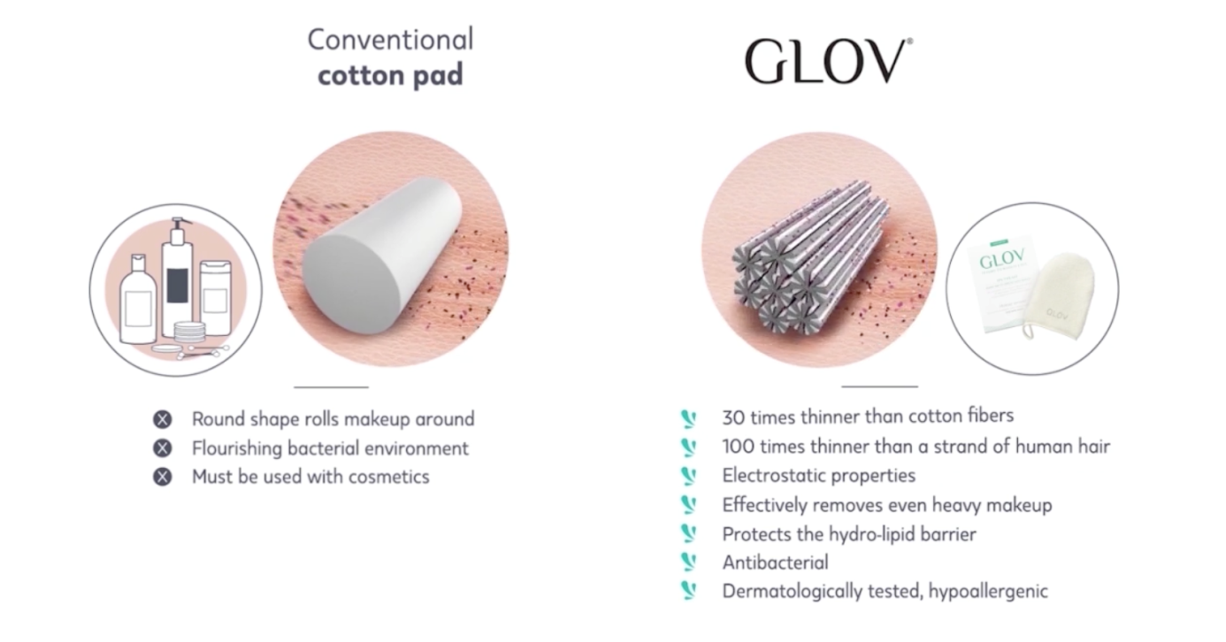

Source: Company documents.

1. zł = PLN = Polish złoty; all currency amounts are in zł unless otherwise specified; US$1 = zł3.24 on September 15, 2014.
2. € = EUR = euro; US$1 = €0.77 on September 15, 2014.
3. “Research and Innovation in Key Figures,” L’Oréal, accessed March 22, 2018, www.loreal.com/research-and-innovation/our-innovation-model/research-and-innovation-in-key-figures.
4. Krzysztof Bień, “The Best Polish Export Goods,” Central European Financial Observer, October 25, 2017, accessed January 10, 2018, https://financialobserver.eu/poland/the-best-polish-exports-goods/.
5. The old English proverb, “A bird in the hand is worth two in the bush” suggests that it is better to keep what one has, instead of risking it by going after more.