

9B18M172

PHENICOPTERE: CHANNEL STRATEGY FOR INTERNATIONAL EXPANSION

Aleksandra Wasowska wrote this case solely to provide material for class discussion. The author does not intend to illustrate either effective or ineffective handling of a managerial situation. The author may have disguised certain names and other identifying information to protect confidentiality.

This publication may not be transmitted, photocopied, digitized, or otherwise reproduced in any form or by any means without the permission of the copyright holder. Reproduction of this material is not covered under authorization by any reproduction rights organization. To order copies or request permission to reproduce materials, contact Ivey Publishing, Ivey Business School, Western University, London, Ontario, Canada, N6G 0N1; (t) 519.661.3208; (e) cases@ivey.ca; www.iveycases.com.

Copyright © 2018, Ivey Business School Foundation Version: 2018-11-09

On December 12, 2017, Monika Żochowska, the chief executive officer of Phenicoptere Ltd. (Phenicoptere), and Ewa Dudzic, the firm’s vice-president, were sitting in their two-level office, a few minutes’ walk from the park-and-palace complex Łazienki Królewskie, one of the central tourist spots in Warsaw, Poland. Their firm, founded five years earlier, was selling an innovative makeup-removing glove called GLOV. In 2017, Phenicoptere employed 20 people, its annual revenue amounted to PLN 10 million,[1] and its value exceeded PLN 20 million. GLOV was available in 40 countries all over the word. Żochowska and Dudzic were regularly receiving awards for their start-up and its product, including an award for innovation at the Salón Look Madrid awards in 2015, and a Special Citation Award at the 2016 EY (Ernst & Young) Entrepreneur of the Year Awards.

“German? I didn’t know you spoke German!” said Żochowska, pointing at the screen of her partner’s computer. “I don’t. I’m using Google Translate,” laughed Dudzic. “Amazon [Amazon.com Inc.] wants us to respond to every message from a customer within 24 hours. And by the way, don’t you think we should start treating e-commerce more seriously?” The partners both knew they had to reconsider their channel strategy; had the time come for Phenicoptere to focus on e-commerce?

Looking back

When Zochowska was a recent graduate of the Faculty of Management at the University of Warsaw in 2010, she came up with the idea of creating a makeup-removing product using microfibers while she was at an internship at a plastic surgery clinic in Australia. She soon shared the idea with Dudzic, her best friend from university, who at that time was running a sushi catering firm in Cracow, Poland. Though they knew very little about chemical processes, the women started to explore the technical side of the idea. In 2011, they won a competition dedicated to entrepreneurs at the very early stage of product development, organized by AIP Seed Capital and linked to Academic Business Incubators. In March 2012, Żochowska and Dudzic registered a firm called “Phenicoptere,” meaning “flamingo” in Old French. AIP Seed Capital invested PLN 100,000 in exchange for 15 per cent of the firm’s capital. Thereafter, it took Żochowska and Dudzic nearly a year to develop and test their product. They approached manufacturers to produce a microfibre that could be used in cosmetics. To reduce development costs, they asked a friend from the Department of Chemistry to test the microfibre in a laboratory at the University of Warsaw. Following this, they tested it on their own skin and eventually sent it for final testing at a professional dermatology laboratory, which approved the product as 100 per cent safe, even for allergy-prone skin, and as efficient in removing makeup. In March 2013, Żochowska and Dudzic filed a patent application with the European Patent Office.

Makeup removal was a neglected niche in the cosmetics industry. To remove makeup, women had used cotton pads for decades, dipped in makeup-removing gels, lotions, and oils. However, these were often unhealthy for the skin and needed to be further washed off the face, making the whole ritual long, uncomfortable, and perceived as an unpleasant duty. GLOV required no chemical products, just water, and because it was made of microfibres, it “captured” the daily dirt on the skin instead of spreading it over the face. Żochowska and Dudzic often said that GLOV washed chemicals with physics, and they compared their innovation to replacing forks with sticks. The product was manufactured in Poland in an external factory on a long-term contractual basis. The retail price was €10[2] for the small “On-The-Go” version of GLOV, €15 for the standard version, and €20 for a travel set. It had to be washed after each use with water and soap and replaced every three months.

Going global

From the very beginning, Żochowska and Dudzic had tried to sell their product globally. In early 2014, they introduced GLOV to Sephora stores in Poland. In the same year, they received support from the cosmetics-industry-promotion program sponsored by the Polish Ministry of Economy, which allowed them to participate in trade missions to Hong Kong and Russia and their first trade show in Bologna, Italy. During this trade show, Żochowska and Dudzic met with managers of Monoprix S.A., a large French retail chain, who offered them the distribution of GLOV in its 330 stores in France.[3] During another trade show, in Dubai, they met a Canadian producer of natural cosmetics for children. They sometimes watched over his stand at the show so that he could take a break. He later recommended them to his European agent, who, in 2015, introduced GLOV to the Marionnaud Lafayette SA (Marionnaud) chain of perfumeries in Switzerland. At another cosmetics trade show, Żochowska started to chat with a man working in one of the other stands. By then, Żochowska had already developed a habit of starting every conversation with two questions: “Where are you from?” and “Do you know GLOV?” She established that this man was German and that his parents distributed Italian nail products to beauty salons. He did not know about GLOV, but the idea of using microfibres for makeup removal caught his attention. Soon afterwards, his parents’ firm started to distribute GLOV to beauty salons in Germany, and he himself offered to help build GLOV’s presence in German retail chains. Thanks to his experience and network in the cosmetics industry, he introduced the product to dm-drogerie markt GmbH, one of the largest retailers in Germany, with 1,800 stores throughout the country. Phenicoptere soon expanded to other European markets, including the Czech Republic; Slovakia and Lithuania; Austria; Italy, where GLOV became available in Perfumery Douglas and other stores; and Spain, where it was distributed mostly by beauty salons and Marionnaud.

During one of the trade shows, Żochowska and Dudzic met the managers of one of the largest Polish exporters of cosmetics. In 2014, the Polish cosmetics company recommended GLOV to its South Korean distributor, who was looking in Europe for innovative cosmetics products. In September 2015, after a year of planning, tests, and additional certifications required by the Korean market, GLOV became available on CJmall (owned by CJ Corporation), one of the most important home shopping channels in the country. Television home shopping was much more popular in Korea than it was in Western countries, with Korea being one of the largest home shopping markets in the world.[4]

Since 2015, GLOV had been available in the Middle East and China. These markets were served through local distributors, who were responsible for finding the best distribution channels based on their knowledge of the market. For example, in Kuwait, the United Arab Emirates, and the Kingdom of Saudi Arabia, the product was available in international retail chains (e.g., Debenhams Plc; Vavavoom Beauty; and Boots, run by Boots Company Plc); Kuwait’s largest supermarket chain Saveco; and local co-op stores—that is, department stores put up by the government—which accounted for 55 per cent of retail trade in the Kuwait.[5] Phenicoptere’s rapid expansion was facilitated by the fact that GLOV was an accessory and did not require a lengthy certification process. Producers of cosmetics typically needed about a year of preparation to introduce their products to China, but GLOV was ready to enter China within a week.

Navigating local differences

As soon as Żochowska and Dudzic started to sell GLOV across borders, they discovered that people in different countries used their product in different ways, had different expectations of it, purchased it in different places, and had different understandings of the meaning of beauty. Żochowska and Dudzic needed to reconsider the concept of “global beauty.”

The beauty industry, which had started with homemade creams and secret recipes sold by local pharmacies, had been greatly exposed to the forces of globalization. In 2010, more than half of the industry’s sales were generated by the 10 largest firms, with L’Oréal SA and Procter & Gamble Co. alone accounting for more than 20 per cent of the world’s sales.[6] Yet, despite the dominance of global brands, the industry had some persistent local characteristics. First, customer propensity to spend money on beauty products varied, with annual per capita spending amounting to US$343 in Japan,[7] $252 in France, $216 in Germany, $193 in the United States, $191 in Brazil, and $6 in India.[8] Second, the types of beauty products that were purchased varied in different countries. For example, Americans spent proportionally much more on colour cosmetics than the Europeans or the Chinese, who spent much more on skin care. Third, beauty products were offered in different versions, reflecting local tastes for specific scents, colours, and textures.

Żochowska and Dudzic soon understood that to navigate local differences in the beauty industry, they needed to listen carefully to their local partners and adapt the product concept accordingly. Therefore, while the “content” of GLOV was the same in every market, the product’s packaging and communication strategies began to differ (see Exhibits 1 and 2). For example, in Arabic countries, emphasis was put on the product’s efficient makeup removal, while in European markets, the emphasis was on natural skin care. In France, where local brands were strongly preferred, the product’s Polish origin was downplayed, while in Asia, GLOV was positioned as a European product, and its origin was accentuated. To choose a model for advertising GLOV internationally, Żochowska and Dudzic sent some sample photos of models to distributors in different markets, asking for their opinions. It turned out that a blond model originally chosen by Żochowska and Dudzic was perceived as “ultimately Slavic” by their foreign partners, so the women decided to find a more “neutral” beauty type. From their distributors, they learned whether a photo chosen for Arabic markets would be deemed “too relaxed” in those markets and whether the skin of the models presented in Asia was shiny enough to attract customers.

Over time, Żochowska and Dudzic had discovered that relying on the local knowledge of distributors could be tricky, even for a simple language adaptation. Their distributor in the Middle East sent them translated text to be put on the packaging of GLOV. However, as their Polish graphic designer did not have an Arabic keyboard, she was not able to input the text into her program. Also, the layout was messy, and the text was full of typos. Żochowska and Dudzic decided to post a job advertisement; they had to hire an Arabic-speaking person with Adobe Photoshop skills.

Note on distribution channels in the beauty and personal care industry

In the beauty and personal care industry, store-based retailing accounted for 82 per cent of global sales in 2017. Store-based retailing included grocery retailers (e.g., hypermarkets, supermarkets, discounters, small grocery retailers), beauty specialist retailers (e.g., Marionnaud), chemists/pharmacies (selling prescription medicines as their core activity), and drugstores/parapharmacies (offering beauty and personal care, consumer health care, home care, and food and drinks). One per cent of global sales were generated by non-retail sales in hair and beauty salons.[9]

The remainder of global sales in the beauty and personal care industry was generated by non-store retailing, which included direct selling (9 per cent of global sales), Internet retailing (7 per cent), home shopping (1 per cent), and vending (less than 0.1 per cent).[10] Direct selling (used, for example, by Avon, Amway, and Herbalife) typically took place at homes or in workplaces and occurred on a one-to-one or party-plan basis. Internet retailing involved sales of personal goods to the general public via the Internet. Customers placed online orders for goods promoted in the web medium and paid for them through a web platform. Over the last few years, Internet retailing had been the fastest-growing retail channel, especially for skin care. Customers’ desire to test products before purchasing had previously been a significant barrier for online retailing in the beauty industry. Recently, however, the industry had developed a number of initiatives aimed at making its products suitable for e-commerce. These included virtual try-on applications, colour matching, and skin analysis with customized product recommendations.[11] The growth of Internet retail had been driven by third party marketplaces—specialized e-commerce platforms that offered independent sellers (often small and medium-sized companies) “a shop in their store.”[12] Top Internet retailers were Amazon, Alibaba Group Holding Limited (Alibaba), JD.com Inc., eBay Inc. and Rakuten Inc.

Customers’ propensity to make purchases online differed according to many factors, including the industry, the customer’s country of residence, and the seller’s location. In the European Union, 50 per cent of customers made purchases online, and 15 per cent made purchases online across borders.[13]

The challenge of e-commerce

Ever since they put GLOV on the market, Żochowska and Dudzic had used social media (Facebook Inc., LinkedIn Corporation, Instagram) to connect with customers and partners. In 2017, they invited two popular fashion and beauty bloggers to a makeup training event in Dubai, gathering over 500 influencers from around the globe. During the event, makeup artist Mario Devidanovic used GLOV on Kim Kardashian’s face. While Żochowska and Dudzic extensively used the Internet for communication purposes, for sales they relied on offline channels. Recently, GLOV had become available in Chinese e-commerce marketplaces (e.g., Taobao, run by Alibaba), with online transactions and customer communication managed by the Chinese distributor. Market growth in Chinese online sales was impressive.

Żochowska and Dudzic knew of many beauty businesses that had grown using the potential of e-commerce. In fact, some of these had been born online, selling directly to customers with no help from intermediaries and without even introducing their products to offline channels. One of the hottest brands in the beauty industry was Glossier Inc. (Glossier), a US-based direct-to-customer start-up. Glossier was founded in 2014 by Emily Weiss, a former style assistant at *Vogue*, four years after she started her blog “Into the Gloss.” In October 2017, Glossier began to ship to Canada and set up an office in Montréal, Québec. Ironically, Glossier did not ship to Québec at first, as for that it needed a French website and for all of its marketing to be translated into French. In late 2017, native French speakers recruited by the Montréal subsidiary started to work on the language adaptation of the brand. Żochowska and Dudzic had read Weiss’s blog and remembered that she had once declared: “Ever since Day 1, we’ve dreamt of making Glossier a global beauty movement that celebrates real girls in real life.”[14] And yet it had taken the company almost four years to start selling abroad—and to only the English-speaking part of Canada, and, a while later, the United Kingdom.

Żochowska and Dudzic felt they could no longer ignore the potential of e-commerce. In 2017, they introduced GLOV to Amazon stores in Europe, but they were not entirely sure what further expansion e-commerce channels would take. On the one hand, they knew that the margins in e-commerce were much higher than in their current offline distribution model (see Exhibit 3), in which they had to share their profits with partners and distributors. On the other hand, they knew that focusing on e-commerce would be challenging. How would they manage logistics across borders? How would they handle communication with foreign customers? The partners had to think seriously about their e-commerce strategy.

Exhibit 1: GLOV packaging

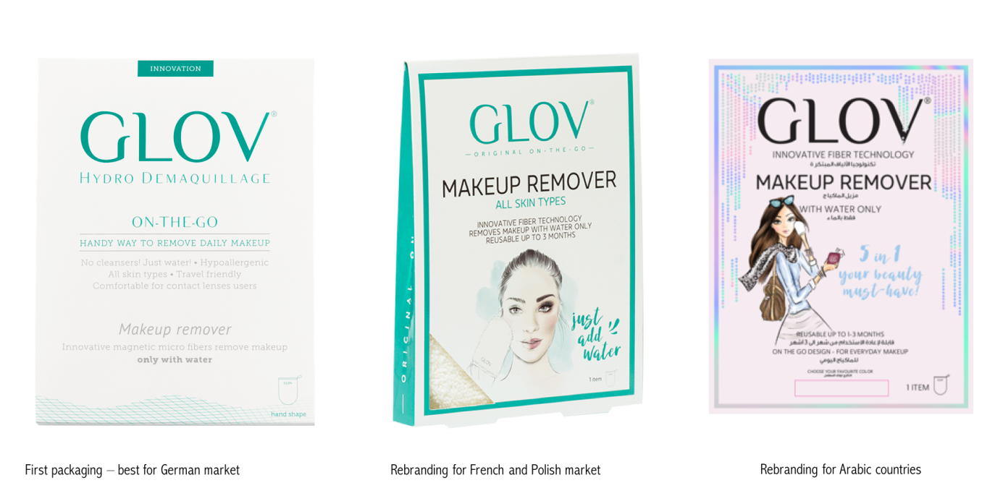

Source: Company documents.

Exhibit 2: GLOV advertising

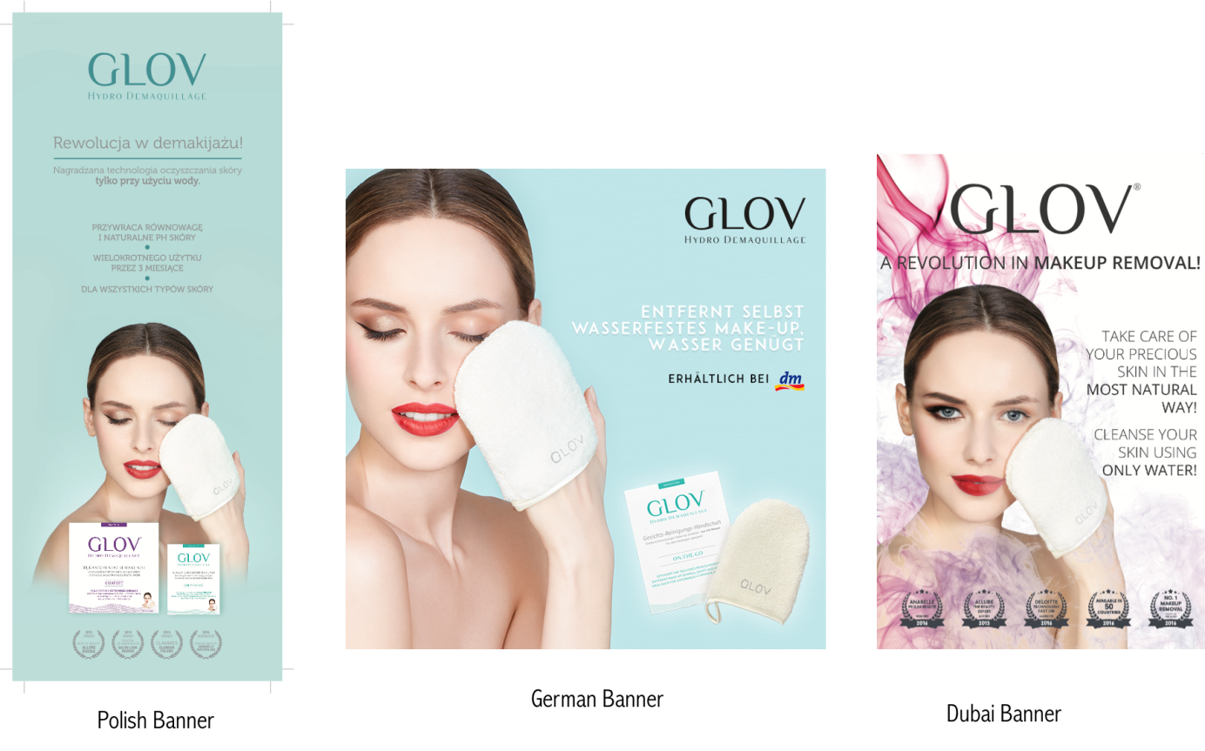

Source: Company documents.

Exhibit 3: Offline versus Amazon sales prices structure

|  |  |  |  |  |  |  |  |  |
| --- | --- | --- | --- | --- | --- | --- | --- | --- |
| **Offline sales price structure** | | | | | | | | |
| Product | Recommended retail price (RRP), including value-added tax (VAT) (22 per cent) | RRP excluding VAT | Retail markup (100 per cent) | Retail sell-in price | Distribution markup (45 per cent) | Landed  price | Transport/custom fee (10 per cent) | Distributor sell-in price |
| GLOV “On-The-Go” | €10.00 | €8.20 | €4.10 | €4.10 | €1.27 | €2.83 | €0.26 | €2.57 |
| GLOV Comfort | €15.00 | €12.30 | €6.15 | €6.15 | €1.91 | €4.24 | €0.39 | €3.86 |
| GLOV Set | €20.00 | €16.40 | €8.20 | €8.20 | €2.54 | €5.65 | €0.51 | €5.14 |
|  |  |  |  |  |  |  |  |  |
| **Amazon price structure** | | | | | | | |  |
| Product | RRP including VAT (22 per cent) | RRP excluding VAT | Amazon fee (15 per cent of RRP including VAT) | Fulfillment by Amazon fee (approximately 15 per cent of RRP including VAT) | Inbound logistic (1 per cent) | Performance marketing fee (20 per cent) | Amazon sell-in price |  |
| GLOV “On-The-Go” | €10.00 | €8.20 | €1.50 | €1.50 | €0.10 | €2.00 | €3.10 |  |
| GLOV Comfort | €15.00 | €12.30 | €2.25 | €2.25 | €0.15 | €3.00 | €4.65 |  |
| GLOV Set | €20.00 | €16.39 | €3.00 | €3.00 | €0.20 | €4.00 | €6.19 |  |

Note: Amazon = Amazon.com Inc.; € = EUR = euro; US$ = €0.85200 on December 12, 2017.

Source: Company documents.

1. PLN = Polish zloty; US$1 = PLN 3.5862 on December 12, 2017; Radosław Omachel, “Magiczna rękawiczka do demakijażu Glov,” [Magic Make-up Removal Glove ‘Glov’], *Newsweek*, December 12, 2016, accessed January 10, 2018, www.newsweek.pl/biznes/magiczna-rekawiczka-do-demakijazu-glov-start-up,artykuly,401893,1.html.
2. € = EUR = euro; US1$ = €0.85200 on December 12, 2017.
3. Marcin Gazda, “Polki rewolucjonizują świat kosmetyków. Dzięki pieniądzom z Unii,” [Poles Revolutionizing the World of Cosmetics. Thanks to European Union Funds], Fundusze Europejskie dla Ciebie, February 18, 2015, accessed June 24, 2018, http://funduszeue.wp.pl/informacje/polski-rewolucjonizuja-swiat-kosmetykow-dzieki-pieniadzom-z-unii_a77/2.
4. “Industry Insight: Korea’s Home-Shopping Industry Seeking to Become Global No 1” video, 3:26, posted by “Arirang News,” February 9, 2015, accessed January 10, 2018, www.youtube.com/watch?v=gJcV-4DHkyg.
5. “High Spending Power in Kuwait Drives Steady Expansion in Retail Sector,” in The Report: Kuwait 2017, Oxford Business Group, accessed January 12, 2018, https://oxfordbusinessgroup.com/overview/healthy-prospects-high-spending-power-and-increasing-demand-certain-segments-support-steady.
6. Geoffrey Jones, *Beauty Imagined: a History of the Global Beauty Industry* (New York, NY: Oxford University Press, 2010).
7. All dollar amounts are in US dollars unless otherwise specified.
8. Geoffrey Jones, op. cit.
9. Euromonitor International, *Channel Review in Beauty and Personal Care*, August 2017, accessed March 10, 2018, www.euromonitor.com/channel-review-in-beauty-and-personal-care/report.
10. Euromonitor International, “Retailing” database, accessed January 13, 2018.
11. Euromonitor International, *Channel Review in Beauty and Personal Care*, op. cit.
12. Jennifer Rankin, “Third-Party Sellers and Amazon—A Double-Edged Sword in E-commerce,” *The Guardian*, June 23, 2015, accessed March 22, 2018, www.theguardian.com/technology/2015/jun/23/amazon-marketplace-third-party-seller-faustian-pact.
13. European Commission, *Digital Agenda Targets Progress Report*, 2015, accessed January 23, 2018, https://ec.europa.eu/digital-single-market/en/download-scoreboard-reports.
14. Emily Weiss, “Glossier Goes International,” Into the Gloss (blog), 2017, accessed March, 22, 2018, <https://intothegloss.com/2017/07/where-can-i-buy-glossier-canada-uk-france/>.