

9B18M177

whizz: challenges for A first mover

Sushant Kumar, Pradip H Sadarangani, and Rohit Dwivedi wrote this case solely to provide material for class discussion. The authors do not intend to illustrate either effective or ineffective handling of a managerial situation. The authors may have disguised certain names and other identifying information to protect confidentiality.

This publication may not be transmitted, photocopied, digitized, or otherwise reproduced in any form or by any means without the permission of the copyright holder. Reproduction of this material is not covered under authorization by any reproduction rights organization. To order copies or request permission to reproduce materials, contact Ivey Publishing, Ivey Business School, Western University, London, Ontario, Canada, N6G 0N1; (t) 519.661.3208; (e) cases@ivey.ca; www.iveycases.com.

Copyright © 2018, Ivey Business School Foundation Version: 2018-11-15

It was May 29, 2016, and Ramesh Tyagi was lost in thought. Tyagi was the chief executive officer of Whizz, India’s first car rental company, established in Delhi in 2013. Tyagi was troubled by several issues: the recent exit of his co-founder Sumit Mittal, the company’s inability to realize the available growth potential, intense competition from registered and unregistered car rental companies, and the need for additional funding. A pat on the back from an old school friend, Charles Sink, brought Tyagi back from his thoughts. Sink worked for an American multinational corporation as a consultant for start-up businesses, so he was well acquainted with the various issues start-ups faced.

Tyagi was eager to express his concerns to Sink. Mittal, Tyagi’s friend and the co-founder of Whizz, had decided to leave the company for personal reasons. Mittal, who had been instrumental in securing initial funding for the start-up, had been heading the marketing and business development division of the company before he left. Although Whizz was the first mover in the Indian market, it had not generated a profit since its inception. However, rapid growth in the car rental industry and a sharp rise in the disposable income of the millennial generation offered an opportunity for expansion to India’s Tier 2 and Tier 3 cities. A fresh round of funding was desperately needed to realize this opportunity, but Mittal’s absence was deeply felt during a recent meeting with a potential investor to raise fresh capital for expansion. Tyagi was aware that organized competitors had similar ambitious expansion plans, and that an extensive marketing and business development plan was needed to expand Whizz to other cities. However, left suddenly without a head of marketing and business development, Tyagi had no idea how to proceed.

Tyagi’s friend Sink suggested that he focus on three areas: interaction with new investors, human resource management, and operations management. After Sink left, Tyagi began to prepare for the next investors’ meeting to attract fresh funding. Carefully considering his friend’s advice, he made a plan to meet new angel investors, hire experienced people for the company’s marketing and business development division, and reduce operational expenditure.

Whizz Car Rental service

Whizz was the first company to bring to the Indian market the concept of a customer-driven (as opposed to chauffeur-driven) car rental service that allowed customers to use their smart phones to reserve cars, make payments, and even unlock the reserved cars (see Exhibit 1). Customers could pick up their reserved cars from multiple locations within the city or choose doorstep delivery service for an additional fee (see Exhibit 2). Founded by Mittal and Tyagi, Whizz commenced operations on April 14, 2013. It started with a seven-car fleet, consisting of Ford Figo and Mahindra Scorpio models, and a team of 12 people that included call centre operators and executives. Within three years, Whizz’s fleet of available cars had grown to 2,200, with cars from various manufacturers such as Mahindra and Mahindra Ltd., Maruti Suzuki India Ltd., Ford India, and Tata Motors Ltd.. Whizz captured approximately 60–70 per cent of the Indian self-drive car rental market. Eventually, it grew to a team of 600 employees.

Car Rental Industry

Globally, the car rental industry had seen a major shift over the past five years. Tight competition and demanding economic growth had transformed the industry so that car rental companies had to significantly update their business models to remain competitive. Technology drastically changed the way car rental services were offered, with customers increasingly using the Internet for information, comparing services, evaluating, and selecting the final product. Online access offered convenience for both customers and operators. Global companies were increasingly using joint ventures and mergers and acquisitions to expand their territory, realize emerging market opportunities, and gain profits. However, challenges such as stringent vehicle emission rules and volatile crude oil prices had affected growth worldwide.

The global car rental industry was forecasted to develop at a compound annual growth rate of 5.6 per cent from 2016 to 2021. The significant development factors for this market were a rising global tourism industry, the expanding globalization of corporate tasks, and expanding pay levels across the globe. The key aspects of the car rental market included rental area (e.g., within or near an airport terminal), customer type, vehicle type, and method of booking (e.g., online or traditional store). Of these factors, rental area and method of booking were expected to be the most significant growth indicators during the 2016–2021 period, with airport and near-airport locations expected to be the biggest market segment. Increased air travel and household tourism were expected to expand the client base for airport terminal car rentals, which would, in turn, stimulate development in this segment. [1]

Geographically, the Asia-Pacific market was projected as the most significant because of its high urbanization rate and because of increased consumption expenditures by local visitors to the region. However, North America and other global markets were also likely to witness critical development thanks to rapidly developing economies, increasing numbers of local and global travellers, and high-quality infrastructure.

Although car rental companies normally offered a wide range of cars including luxury cars, executive cars, multi-utility vehicles, sports utility vehicles (SUVs), and economy cars, customers usually preferred economy cars for frequent and short-duration inter-city trips. Economy cars offered better mileage for a lower cost, which explained the growth in this segment.

India’s car rental market was in a stage of great opportunity and growth compared to the mature European and US markets. Over 70 per cent of India’s car rental market was dominated by unorganized competitors. Most users consisted of millennial residents of metropolitan Tier 1 and Tier 2 cities. Indian car rental companies were able to reach their target customers by leveraging the ubiquity of the Internet and various distribution channels. Of India’s 409 million urban consumers (in 2013), the middle cohort consisted of about 27 million people, who were the typical customers of car rental services.[2] This group of urban dwellers were mainly college students or working professionals in the age range of 16–33 and with an annual income of ₹200,000–500,000.[3]

Business travellers, tourists, and short-term vacationers made up a significant portion of the age 25–35 cohort, whose personal and behavioural characteristics included a nomadic lifestyle, love for mobility, networking, a liberal attitude toward social and cultural issues, and early adoption of new technologies. For this group, partaking in car rental services was a popular activity. Indian millennials were the first generation of digital natives. Their love for technology shaped their shopping and consumption habits. They believed in access rather than ownership, which inspired them toward a new set of services that provided access to products without the burden of ownership. Becoming increasingly aware of these characteristics of their target customers, car rental companies offered enhanced facilities related to safety measures, in-car Wi-Fi facilities, and route and travel assistance.[4]

Market Offering

Whizz promised its customers a hassle-free experience and a range of services:

* *Self-drive Car Rental Service*: Consumers could save the cost of owning a car and still have the convenience, mobility, and independence of driving a car themselves (rather than hailing a taxi or taking transit, for example). Based on their specific needs, customers could choose from a variety of cars—hatchbacks, sedans, SUVs, and luxury models that included features such as a global positioning system, keyless entry, and remote diagnostics.
* *Whizz on the Go*: Customers could reserve a car by the hour, day, week, or month by using their smart phones.
* *Whizz Associate Program (WAP)*: Customers could purchase a vehicle (or more than one) from Whizz, lease the vehicle back to the company, and then earn a share in the revenue (see Exhibit 3) as part of the WAP arrangement. WAP associates could list their existing (registered) or new cars in any of 15 major Indian cities. Whizz assumed all vehicle liability when the car was being driven by a Whizz customer. The owners received almost 75 per cent of the revenue earned from each rental, which varied in amount based on the type of car and the number of days the car was listed in the WAP system. For example, a hatchback had the potential to generate net earnings of ₹10,000–₹15,000 per month if it was listed in the WAP system for 15 days, which reduced the owner’s monthly payments by about 70 per cent, for a total of up to ₹3,500,000 in savings over the 30-month tenure of the agreement.
* *Pandora*: This service used Bluetooth technology and fourth generation (4G) connectivity to monitor information on driver behaviour, fuel levels, clutch position, harsh braking, inconsistent acceleration, seat belt usage, engine health, and other factors.
* *Cycle*: This service was India’s first private cycle-sharing system, which allowed Whizz to add elements of last-mile convenience and fitness into its offering, attempting to redefine urban mobility with more than just cars.
* *Get*: This service was targeted to a wide range of customers who needed a point-to-point, one-way, inter-city, self-drive service.

Target Customers

Whizz’s target customer group was comprised of educated, technology-savvy urban dwellers, especially those located in Tier 1, 2, and 3 cities. These customers usually did not wish to own a car but enjoyed the freedom and flexibility of having on-demand mobility (see Exhibit 4). This group consisted mainly of millennials in the age range of 18–35. Boasting the largest population of this demographic, the Indian market attracted car rental companies from across the world.

In a February 2014 monthly meeting, Tyagi expressed his plans and ambitions for the company as follows:

It is high time now that we grow. If we don’t gear up and expand, there are others ready to eat our share of the pie. We all have to work together to reduce costs, to strengthen the brand, and to make sure that we make a profit by the end of this financial year. Let the Whizzers go on a ride. It is our job to ensure that whenever someone thinks of renting a car, the first name that comes to his or her mind is Whizz.

Competition

In 2016, there were about 25 self-drive car rental start-ups in India. The notable indirect competitors for Whizz in India were Drivezy, Revv Self Drive Cars (Revv), Avis India, and, directly, MylesCars.

Drivezy started operations in April 2015 as a cab-sharing aggregator. After two years, the company shifted to the marketplace model and began offering motorcycle rentals. Drivezy connected existing vendors to the end customers through a local service network. Customers could rent vehicles through the company’s website or mobile application to be delivered to their doorstep. Drivezy did not ask for any security deposit while booking the vehicle. Among the products and services offered by Drivezy were car-sharing, two-wheeler rental, smart vehicle technology (SVT), and rental coins. SVT was in-house technology designed and built for the purpose of scaling the car-sharing business. The system kept track of tire pressure, fuel consumption, vehicle location, and scheduled maintenance. Rental coin was a cryptocurrency initiated by Drivezy in 2016 to allow investment in shared vehicles.[5]

Revv was set up in 2015 and offered the convenience of doorstep delivery of the rented vehicle. The delivery and pickup locations had to be the same. Later, however, Revv launched a model in which the customer could order a car to start the trip in one place and end in a different place. Revv was consistently increasing its presence in many Tier 2 and Tier 3 cities.[6]

Founded in 2013, MylesCar was present in 250 cities across India. MylesCar worked on an asset light model, where cars were sourced through collaboration with fleet operators, car dealers, and manufacturers. Recently, Myles had moved toward an optional limited security deposit when reserving a car. The customer could choose to purchase the loss damage waiver in exchange for paying the security deposit. The loss damage waiver included accidental damage, roadside assistance, accidental vehicle documents loss, and third-party damage implications. The company later lowered the minimum age for renting a car and the maximum speed limit for driving the rented vehicle.[7]

Avis Budget Group Inc. was an American car rental company originally started in 1946. It was the leading car rental company across the world, and had entered the Indian market in 2000. Avis India started as a joint venture between The Oberoi Group and Avis Budget Group Inc. Initially, Avis India was offering chauffeur-driven car service, but began offering self-drive car rental service in 2013. It offered customized solutions to corporations and individuals for long-term rentals.[8]

Whizz’s Journey

In 2013, Tyagi and Mittal, two friends who had met while studying at Delhi University, started Whizz with initial capital provided by their mentor, Shyam Bansal. Mittal soon started sourcing other funding from potential angel investors while Tyagi focused on developing the business. Later that year, Mittal was successful in raising funding both from individual angel investors (from India and the United States) and from group angel investors (from India). For fiscal year (FY) 2013, Whizz recorded total revenue of US$330,000 and operational expenses of US$1.07 million, which resulted in a loss of US$700,000.

The two Whizz founders kept meeting with potential new investors to raise subsequent series of investments, and they received enough funding to branch out to different cities, including Bangalore. The expansion helped the business grow rapidly and sparked the interest of venture capitalists from India, the United States, and the United Kingdom. In 2014, with new investments in several series, the company quickly expanded to Pune, followed by Mumbai, Chennai, and Hyderabad. Whizz also upgraded its fleet of cars, including additional economy cars and SUVs. Whizz also promoted its WAP arrangement to add associates to the program, which was well received and profitable for both Whizz and its associates. The total revenue in FY 2014 was US$2.45 million. However, operational expenses again exceeded revenue, at US$5.86 million, resulting in a loss of US$3.37 million.

Despite reporting losses for two consecutive years, Whizz was a growing company and investors were very optimistic about its potential. In 2015, Whizz managed to generate several additional rounds of funding (see Exhibit 5). Angel investors from the United Arab Emirates and corporate venture capitalist from the United States invested fresh capital in the company. Whizz also borrowed debt to support its expansion plan, and expanded to several other Tier 2 cities that same year, with plans to expand to Tier 3 cities (see Exhibit 6). In FY 2015, Whizz reported revenue of US$12.83 million, while operating expenses grew to US$27.42 million. That year, the company’s reported net loss grew to US$14.49 million, while competitors launched aggressive marketing campaigns to attract customers (see Exhibit 7). Organized competitors had also started expanding to other cities with competitive market offerings.

Expansion and Funding Plan

Whizz’s rapid expansion in the domestic market was followed by equally quick expanded operations in Bengaluru, followed by Mumbai, Chennai, and Hyderabad. Its various rounds of funding came from investors including Sequoia Capital and Nokia Growth Partners, who invested approximately US$11 million in 2015. According to Tyagi, Whizz was earning monthly revenues of approximately US$1 million by that time, with a fleet of 1,300 cars.

Whizz planned to continue increasing its rapid growth to more than 25,000 cars across 25 cities by 2018, with a launch of operations in Tier 2 and Tier 3 cities in the following 12 months. However, Tyagi expressed concern in achieving this goal.

Without his partner Mittal, Tyagi was running the business development of the company, pursuing investors for funding, and designing a strong marketing campaign to strengthen the brand. During his last meeting with the heads of departments on May 31, 2016, Tyagi asked Rashmi Batra, the human resources manager, to hire experienced people for the company’s marketing and business development division. He also asked Ramesh Siddhi, the head of operations, to reduce expenditures and promote judicial use of resources. However, Batra explained his dilemma to Tyagi, saying, “It is very difficult to get someone who is as knowledgeable and experienced as Mittal. Even if we find the right person, it will take some time for him or her to inculcate the organizational values. However, I will make sure not to disappoint you.”

Siddhi, in turn, offered an initial suggestion to Tyagi from an operations viewpoint: “We are trying our best to reduce the costs and extra expenditure of resources. We have made significant progress in the past and we will continue doing so. I will put in extra efforts to make this company profitable.”

After hearing these remarks, Tyagi concluded the meeting by asking the managers to delve deeper into the given suggestions. For additional funding, Tyagi decided to work closely with the initial set of investors rather than reaching out to new venture capitalists. He was preparing his presentation to deliver at the next investors’ meeting, where he hoped to attract fresh funding. He did all this while carefully considering the advice he had received from his friend Sink.

Exhibit 1: Steps for Booking a Car via the Whizz Mobile Application or Website

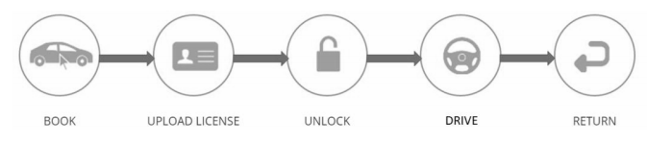

**Book:** The customer books a car on Whizz’s user-friendly website or mobile application (app). Customers can select the car model, duration, and location, among other details.

**Upload Licence:** The customer uploads his or her driver’s license and pays the security deposit of ₹5,000. The security deposit can be waived for regular users with a good track record.

**Unlock:** Whizz sends a text message with the car’s registration number 20 minutes before the booked time. The car can be unlocked using the Whizz app or by following the instructions given in the text message.

**Drive:** The customer completes a checklist of details on the app or by calling customer care. The keys can be retrieved from the car’s glove box to start the drive.

**Return:** The car can be returned to a predefined location. The customer completes a vehicle return checklist to end the booking.

Note: ₹ = INR = Indian rupee; ₹1 = US$0.0150 on July 31, 2016.

Source: Company documents.

Exhibit 2: Process Flow for Whizz Car Rentals

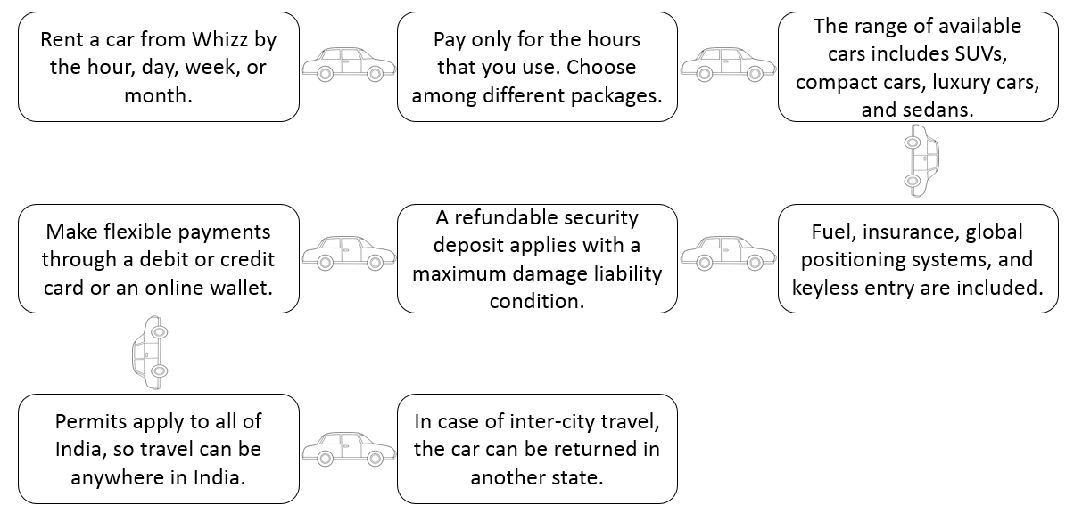

Source: Company documents.

Exhibit 3: Whizz Associate Program Business Model

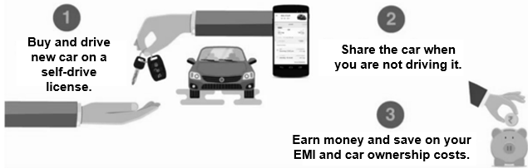

Source: Company documents.

Exhibit 4: Customer Decision Journey

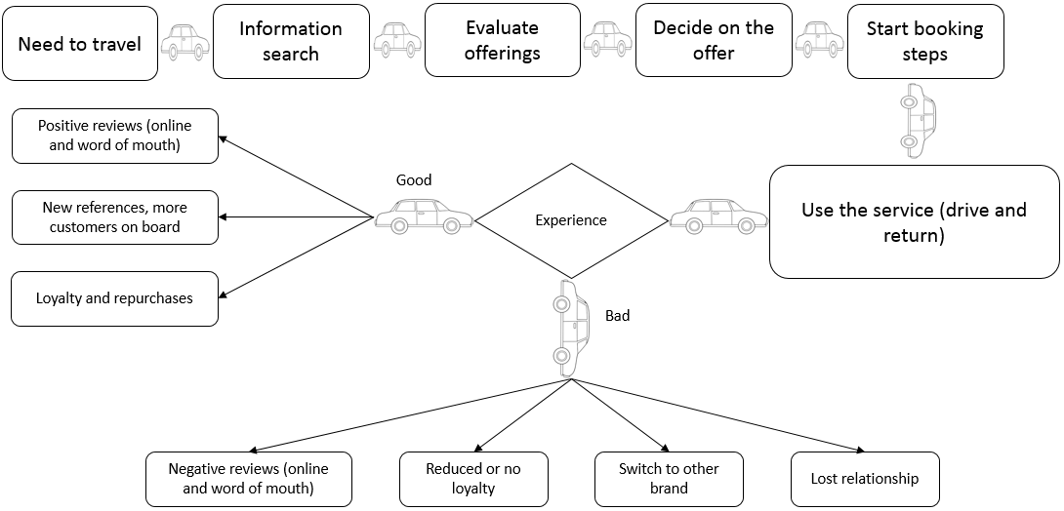

Source: Company documents.

Exhibit 5: Timeline of Funding for Whizz (US$)

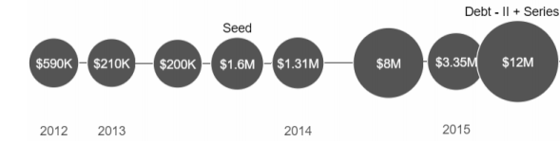

Note: K = thousand; M = million.

Source: Prepared by the case authors with information from “Research,” CB Insights, research portal, accessed May 5, 2017, www.cbinsights.com.

Exhibit 6: List of whizz Investors

|  |  |  |  |  |  |
| --- | --- | --- | --- | --- | --- |
| **First Funding** | **Last Funding** | **Type** | **Location** | **Rounds** | **Details** |
| April 1, 2013 | August 24, 2016 | Angel Investor (Group) | India | 7 | Angel (2013); Seed (2013); Angel-III (2014); Series A (2014); Series A-II (2015); Series B (2015); Series B-II (2016) |
| October 31, 2014 | August 24, 2016 | Venture Capital | India | 4 | Series A (2014); Series A-II (2015); Series B (2015); Series B-II (2016) |
| August 24, 2016 | August 24, 2016 | Corporate Venture | USA | 1 | Series B-II (2016) |
| May 28, 2015 | August 24, 2016 | Corporate Venture | USA | 2 | Series B (2015); Series B-II (2016) |
| August 24, 2016 | August 24, 2016 | Angel Investor | India | 1 | Series B-II (2016) |
| October 31, 2014 | May 28, 2015 | Angel Investor (Group) | UAE | 4 | Series A (2014); Series A-II (2015); Debt-II (2015); Series B (2015) |
| May 28, 2015 | May 28, 2015 | Debt & Speciality Finance | India | 1 | Debt-II (2015) |
| October 31, 2014 | May 28, 2015 | Angel Investor (Individual) | India | 2 | Series A (2014); Series B (2015) |
| October 31, 2014 | October 31, 2014 | Angel Investor (Individual) | India | 1 | Series A (2014) |
| October 2, 2013 | October 31, 2014 | Venture Capital | USA | 2 | Seed (2013); Series A (2014) |
| October 31, 2014 | October 31, 2014 | Venture Capital | UK | 1 | Series A (2014) |
| October 2, 2013 | October 31, 2014 | Venture Capital | USA | 2 | Seed (2013); Series A (2014) |
| July 12, 2013 | October 2, 2013 | Angel Investor (Individual) | India | 2 | Angel-II (2013); Seed (2013) |
| April 1, 2013 | October 2, 2013 | Angel Investor (Individual) | USA | 2 | Angel-II (2013); Seed (2013) |

Note: USA = United States; UK = United Kingdom.

Source: Prepared by the case authors with information from “Research,” CB Insights, research portal, accessed May 5, 2017, www.cbinsights.com.

Exhibit 7: Summary of Financial Results for Whizz (US$ MillionS)

|  |  |  |  |
| --- | --- | --- | --- |
|  | **Fiscal Year 2013** | **Fiscal Year 2014** | **Fiscal Year 2015** |
| Total Revenue | 0.33 | 2.45 | 12.83 |
| Operational and Overhead Expenses | 1.07 | 5.86 | 27.43 |
| Profit or Loss, Including Miscellaneous Expenses | –0.70 | –3.37 | –14.49 |

Source: Company documents.

1. “The Global Car Rental Industry 2016–2021: Trends, Forecast, and Opportunity Analysis,” Reportlinker, June 1, 2016, www.reportlinker.com/p03659252/The-Global-Car-Rental-Industry-Trends-Forecast-and-Opportunity-Analysis.html#backAction=1.
2. The World Bank, “Urban Population,” accessed October 30, 2018, https://data.worldbank.org/indicator/SP.URB.TOTL?locations=IN.
3. ₹ = INR = Indian rupee; ₹1 = US$0.0150 on July 31, 2016; all currency amounts are in ₹ unless otherwise specified; PTI, “Economic Survey 2014: India’s Working-age Population to Rise to 64% by 2021,” *The Economic Times*, July 9, 2014, accessed October 30, 2018, https://economictimes.indiatimes.com/news/economy/indicators/economic-survey-2014-indias-working-age-population-to-rise-to-64-by-2021/articleshow/38086479.cms; Statista, “Distribution of Average Monthly Income in Households Across Urban India in 2015 (in Indian Rupees),” 2018, accessed October 30, 2018, www.statista.com/statistics/653924/average-monthly-urban-household-income-india/.
4. Statista, “Car Rentals: India, Users by Age,” Statista Global Consumer Survey, July 2018, accessed October 30, 2018, www.statista.com/outlook/270/119/car-rentals/india#market-age.
5. “About Us”, Drivezy, accessed on October 12, 2018, https://drivezy.com/about.
6. “About Us”, Revv: Self Drive Cars, accessed on October 12, 2018, https://in.linkedin.com/company/revv-self-drive-car.
7. “What is Myles”, MylesCar, accessed on October 12, 2018, www.mylescars.com/self-drive-car-rental/what-is-myles.
8. “About Us”, Avis India, accessed on October 12, 2018, www.avis.co.in/about-us.