

9B18M179

DATRI: Solving donors’ Dilemma for saving lives

Abhishek Srivastava, Gopalakrishnan Narayanamurthy, Reddy Sai Shiva Jayanth, Raghu Rajagopal, and Krishnan Ranganathan wrote this case solely to provide material for class discussion. The authors do not intend to illustrate either effective or ineffective handling of a managerial situation. The authors may have disguised certain names and other identifying information to protect confidentiality.

This publication may not be transmitted, photocopied, digitized, or otherwise reproduced in any form or by any means without the permission of the copyright holder. Reproduction of this material is not covered under authorization by any reproduction rights organization. To order copies or request permission to reproduce materials, contact Ivey Publishing, Ivey Business School, Western University, London, Ontario, Canada, N6G 0N1; (t) 519.661.3208; (e) cases@ivey.ca; www.iveycases.com.

Copyright © 2018, Ivey Business School Foundation Version: 2018-11-22

Datri Blood Stem Cell Donors Registry (DATRI), a not-for-profit social venture established in 2009 with a registered donor base of 3,000, was India’s largest blood stem cell donor registry. Named for the Sanskrit word *Datri* (“donor”), its mission was to save the lives of people suffering from life-threatening blood disorders such as blood cancer, thalassemia, and aplastic anemia. Since its inception, DATRI had grown exponentially. By 2017, it had a donor base of more than 281,730 registered voluntary donors and had received more than 300 successful blood stem cell donations, including 35 donations for international patients. DATRI served patients from 59 transplant centres across the world. Its vision was to help every patient in need of life-saving blood stem cells by providing them with an opportunity to find a genetically matched, willing donor. DATRI worked with a societal welfare objective and relied heavily on volunteers, who contributed both human and financial resources. People who considered social welfare above the benefits to themselves volunteered to work with DATRI and to participate in the donation process in order to serve society.

However, DATRI had lately been experiencing problems that related to the voluntary nature of its working model. Donors who voluntarily enrolled in the registry were backing out when contacted for transplants. There were reports of cases where a match was found and the donor backed out after a complete health checkup. Donors who withdrew from the process failed to understand the impact their stem cell donations could have on the lives of patients and the well-being of their families. This could also affect DATRI’s credibility and create trust issues between DATRI and patients’ families. The organization had also been facing difficulties raising funding through corporate social responsibility (CSR) and fund donation camps.

Raghu Rajagopal, DATRI’s co-founder and chief executive officer (CEO), felt that not addressing these issues promptly would defeat the purpose of starting the organization. He was concerned about several issues: (1) the frequency with which donors backed out between the registration process and the donation process (after location of a match); (2) people’s misunderstandings about donation procedures; (3) the difficulty of communicating with donors due to changes in the contact information they provided during registration; and (4) key issues related to fundraising to keep the organization functioning. With his team at DATRI, he had been brainstorming to find solutions to these issues for the past three months. A meeting was scheduled for May 5, 2017, to finalize the future plan of action.

Blood Stem Cells: Mother of Cells

Blood cells in the human body started out as young (immature) cells called hematopoietic stem cells. They were responsible for making three types of blood cells: red blood cells, white blood cells, and platelets. Humans required active functioning of all three types of blood cells to be alive. Once blood cells matured, they left the bone marrow and entered the bloodstream. Through this process, a small number of stem cells also entered the blood stream, where they were called peripheral blood stem cells (PBSC).

Stem cell transplants were used to infuse new stem cells when a patient’s bone marrow had been destroyed by a disease, chemotherapy, or radiation. People suffering from life-threatening diseases like leukemia and lymphoma could be cured through stem cell transplants. Depending on where the stem cells came from, this procedure might be called a bone marrow transplant, a PBSC transplant, or a cord blood transplant. For a successful transplant of PBSCs, the patient’s genetic typing had to closely match that of the donor (the person donating the blood stem cells). Research showed that there was only a 25-per-cent probability of finding a match within a patient’s family. Donors for all other patients had to be sought outside the family, and the chances of finding highly compatible donors (i.e., at a resolution of 10/10) remained quite low. Rajagopal started DATRI with the intention of improving this chance of finding a donor.

About DATRI

In 2009, Rajagopal, a graduate of Birla Institute of Technology and Science, Pilani, set up DATRI with Dr. Nezih Cereb and Dr. Soo Young Yang, the founders of HistoGenetics India Pvt. Ltd., a global leader in high-resolution human leukocyte antigen (HLA) typing. DATRI was established with the objective of creating a wide and diverse database of potential blood stem cell donors that could be accessed by patients who needed to undergo blood stem cell transplants anywhere in the world. The organization had 30 regular employees and 40 volunteer workers, mostly retired, who were willing to help people. It was a social venture inspired by an online database registry that existed in the United States. DATRI was a registered member of the World Marrow Donor Association, and it strictly followed the association’s guidelines and processes. It was also a registered member of Bone Marrow Donors Worldwide (BMDW). DATRI had been instrumental in giving hope to a large number of patients in need, who found matched donors through the registry.

DATRI’s vision was to create a global society in which every patient in need of life-saving blood stem cells would be provided with an opportunity to find a genetically matched, willing donor (see Exhibit 1). DATRI aspired to achieve this in a responsible and ethical manner by increasing awareness, fostering a deeper understanding of unrelated blood stem cell donation, and enabling informed decision making. DATRI strove to do this through the collaborative efforts of representatives from all facets of blood stem cell transplantation: donors, recipients and their families, corporations, community resources, apheresis centres, transplant centres (see Exhibits 2 and 3), and other co-operative donor registries.

Global Status of Stem Cell Registries

BMDW had approximately 76 member donor registries in 54 countries and more than 18 million registered donors. Haemopoietic stem cell transplantation registries established worldwide had over 24.6 million adult volunteer donors and over 500,000 umbilical cord blood (UCB) units listed, including those registered with BMDW. In the United States, the National Marrow Donor Program, established in 1986, had grown to be the largest single registry in the world, with over 11.2 million adult volunteer donors and over 250,000 UCB units. Most Western countries had large numbers of registered donors, but India continued to lag behind in the area of donor registries. However, the number of registered donors had increased exponentially, from less than 500,000 in 1989 to approximately 30 million in 2017, due to the existence of online registries and donation awareness programs.

Why India needed DATRI

Firstly, India, with its very large population, had the potential to serve as a huge donor base for patients across the world. However, the percentage of Indian donors in more than 50 donor registries and among over 18.5 million registered donors across the globe continued to be minimal. As ethnicity played an important part in finding a match, this reduced the chances for patients of Indian origin to find potential matches. Thus, there was a need for a functional registry in India with donors belonging to diverse ethnic backgrounds.

Secondly, transplant costs were much cheaper in India. This increased the affordability of availing transplant facilities for patients across the world, including Indian patients. The majority of patients in India belonged to low- and middle-income households, and most of the time, they were unable to receive bone marrow transplants due to the unaffordability of the treatment. Allogenic transplants (transplants of stem cells from a matching donor who was either a sibling or an unrelated donor) cost around ₹1.0 million–₹1.2 million,[1] and autologous transplants (transplants of stem cells collected from the patient’s own body) cost around ₹0.8 million–₹1.0 million in the majority of the hospitals in India. In Western countries, the cost was 10 to 20 times higher than in India. DATRI developed its donor base registry to facilitate transplants of blood stem cells, which offered the only hope of a cure for patients suffering from fatal blood disorders, in order to utilize these opportunities and fill the gaps in India.

DATRI’s Model

Donor Identification

DATRI organized awareness programs in colleges and on corporate campuses and encouraged interested donors to register. Awareness programs were organized with an objective of dispelling myths and clarifying doubts in the minds of potential donors in order to help them make informed decisions about becoming donors. The DATRI team spread awareness about the blood stem cell donation mechanism through its campaigns. Interested donors could register both online and in person. In 2016, the majority of DATRI’s donor registrations were from the states of Kerala, Gujarat, and Tamil Nadu (see Exhibit 4).

Donor Registration and Human Leukocyte Antigen (HLA) Typing

The database of registered donors was stored in DATRI’s registry. Once a donor was registered, the DATRI team collected cell samples (through a process called a buccal swab) from the inside of the donor’s cheek, and sent these for HLA typing in the laboratory. Eligible donation candidates had to be between 18 and 50 years of age. HLA typing delivered a kind of genetic code. Just as it was necessary to know a donor’s blood group or blood type for matching with recipients’ blood groups before regular blood donations, it was a prerequisite to know one’s HLA type and match it with that of a patient before donating blood stem cells. People could only donate their blood stem cells if the HLA type of the potential donors matched closely with those of individual patients in need of stem cells.

Results of HLA typing, along with donors’ details, were stored safely in DATRI’s database and were used to match patients and donors when requests were received. Meanwhile, DATRI kept its registered donors informed and involved by sending regular newsletters and emails.

Patient–Donor Matching

If a patient required a donor, DATRI initiated a standard step-by-step procedure (see Exhibit 5). DATRI would enquire in its database for a donor whose HLA typing matched with that of the patient. After finding a donor with matching HLA typing, a DATRI specialist team contacted the donor to provide the required counselling. Once the donor agreed, the blood stem cell transplantation procedure began. The time between donor registration and being shortlisted for donation could vary from months to several years.

Donation Process

After confirmation of the HLA typing match, the donor would undergo a master health checkup to ensure the donor was fit, healthy, and free from any infectious disease. A donor had to choose one out of the two options listed below for donating blood stem cells.

Peripheral Blood Stem Cell Donation (PBSC)

PBSC donation, a largely adopted practice, functioned much like the donation process for blood platelets. Apheresis, the procedure followed for extracting PBSC, was an outpatient procedure that took about two to four hours. Five days before starting the donation process, the donor received a daily injection of a granulocyte-colony stimulating factor (G-CSF) called filgrastim (Neupogen), a growth-factor drug that caused the bone marrow to create and release stem cells into the blood. Injections would be given to the donor at their place of choice (e.g., at a workplace or at home) to avoid the schedule disruption of needing to travel to hospital for the injections. After five days of injections, the blood was taken through a catheter and cycled through a machine that separated the stem cells from other blood cells (red and white blood cells and platelets), which were returned to the donor’s body.

Bone Marrow Harvest/Donation

In bone marrow donation, bone marrow was extracted from the donor’s iliac crest (hip bone) under general anesthesia; this required a one-day hospital stay. The amount taken depended on the donor’s weight. Often, about 10 per cent of the donor’s marrow, or about two pints (0.946 litres) were collected. The body would replace these cells within four to six weeks.

DATRI’s Funding

DATRI relied on the generous financial support of individuals and organizations to support the costs of operations such as finding matches for patients through HLA typing, testing blood samples, and sending experts to visit donors. The cost of recruiting a donor to the registry was ₹2,500, which included HLA typing. DATRI’s HLA Typing lab used high-resolution (10/10) matching to avoid any risks related to HLA typing error. Costs after a stem cell match was found were managed by the patient.

DATRI used the funding it raised for initiatives such as the adoption of the latest technology; the improvement of donor clinics across the country; enhancement programs to recruit and retain blood stem cell donors; and investments in research, to stay up to date with global practices. DATRI’s main fundraising sources were CSR funding, online donations, and corporate sponsorship.

Issues Faced by DATRI

The issue of matched donors backing out when they were called to donate their blood stem cells was a significant concern for DATRI. Donors backed out primarily during two stages of the donation process. Some backed out when they were first contacted (after a match for donation was found). Others backed out after the complete health checkup, i.e., just before the donation (see Exhibit 6). Donors backing out during this second stage had an adverse effect on DATRI’s integrity as well as on patients and their families. Donors gave several common reasons for backing out of the process:

* Their families had concerns or did not permit the donation: The family and social structure in India meant that there were many influencers in a donor’s life (e.g., parents, spouse, siblings, fiancé, in-laws, etc.). Often, DATRI counsellors had to counsel not only the donor but also friends and family who influenced the donor’s decision.
* They had registered due to peer pressure: People who had been found to register with DATRI due to peer pressure were unwilling to donate when matched. These donors failed to understand the seriousness of registration and the significance of their donation for the patient.
* They were hesitant about sparing time for the donation.
* They had impending questions and doubts.
* Their contact information had changed: The contact information of some donors changed with time, and the DATRI team was therefore not able to reach them after finding that they were matches for patients.

Despite these challenges, the counsellors at DATRI tried their best to counsel the donors and those who influenced them to gift a life. Often, previous donors were helpful in addressing the concerns of potential donors.

Another challenge DATRI faced was raising consistent funding. Like most not-for-profit organizations that were not government funded, DATRI faced difficulties in raising funds through CSR and fund donation camps. Blood stem cell donor registries in most developed countries were supported by governments. For example, Canadian Blood Services, a quasi-non-governmental organization, was completely funded by provincial and territorial ministries of health, and its functions were federally regulated by Health Canada.[2] However, DATRI had not received support from either the state or the central government of India.

the Way Forward

As co-founder and CEO of DATRI, Rajagopal was concerned about these issues and had been brainstorming with his team at DATRI for the past three months to find solutions. He felt that these issues, if not addressed soon, would defeat the purpose of starting such an organization. For the meeting scheduled May 5, 2017, Rajagopal and his team needed to develop a future plan of action.

Please visit [www.datri.org](http://www.datri.org) to register as a voluntary blood stem cell donor. Your choice to become a donor can gift life to a patient in need.

Exhibit 1: Value System of DATRI

|  |  |
| --- | --- |
| Value | **Description** |
| Donor Safety | To ensure that donor safety is not compromised, irrespective of the urgency of the patient need |
| Excellence | To be driven by a spirit of excellence and to attain and maintain the highest level of quality in all endeavours |
| Integrity | To ensure the highest level of honesty and integrity in all our interactions |
| Compassion | To approach all our activities with a deep awareness of the situation of those who are in need of life-saving transplants and promote sensitivity to the dignity of each individual |
| Commitment | To be fully and passionately committed to our mission of saving lives through enabling of volunteer enrolment for stem cell donation |
| Transparency | To create openness and transparency in all our interactions and processes |

Source: Company documents.

Exhibit 2: International Transplant Centres

|  |  |
| --- | --- |
| Transplant Centre Name | Location |
| ACIBADEM University Hospital | Istanbul, Turkey |
| Acibadem Adana Hospital | Seyhan/Adana, Turkey |
| Baylor University Medical Center | Dallas, United States |
| Birmingham Children’s Hospital | Birmingham, United Kingdom |
| City of Hope | Los Angeles, United States |
| Direttore UOC Oncoematologia Pediatrica | Verona, Italy |
| Duke University Medical Center | Duke, United States |
| Hammersmith Hospital | London, United Kingdom |
| Hematology Oncology and SCT Research Center | Tehran, Iran |
| Royal Brisbane and Women’s Hospital | Brisbane, Australia |
| Medical City Dallas Hospital | Dallas, United States |
| Medipol University | Istanbul, Turkey |
| Queen Elizabeth Hospital | Birmingham, United Kingdom |
| Roswell Park Comprehensive Cancer Center | Buffalo, United States |
| King’s College Hospital | London, United Kingdom |
| Mayo Clinic | Rochester, United States |
| Royal Manchester Children’s Hospital | Manchester, United Kingdom |
| The Children’s Hospital | Boston, United States |
| University of California, San Francisco (UCSF) Medical Center | San Francisco, United States |
| Medical University of Vienna | Vienna, Austria |

Source: Company documents.

Exhibit 3: Indian Transplant Centres

|  |  |  |
| --- | --- | --- |
| Transplant Centre Name | Region | Location |
| Christian Medical College (CMC) | North | Ludhiana |
| Artemis Hospital | North | Gurgaon |
| Apollo Specialty Hospital | South | Chennai |
| Narayana Health | South | Bangalore |
| BGS Global | South | Bangalore |
| Amrita Institute of Medical Sciences (AIMS) | South | Kochi |
| Manipal Hospitals | South | Bangalore |
| Madras Institute of Orthopaedics and Traumatology (MIOT) | South | Chennai |
| Sri Ramachandra Deemed Medical University and Medical Centre (SRMC) | South | Chennai |
| HCG – Health Care Global | South | Bangalore |
| Christian Medical College (CMC) | South | Vellore |
| Basavatarakam Indo American Cancer Hospital | South | Hyderabad |
| Medanta – The Medicity | Central | New Delhi |
| BL Kapoor Memorial Hospital | Central | New Delhi |
| Rajiv Gandhi Cancer Institute | Central | Delhi |
| Apollo Hospital | Central | Delhi |
| Apollo Hospital, Ahmedabad | West | Ahmedabad |
| Gujarat Cancer & Research Institute (GCRI) | West | Ahmedabad |
| Sterling Hospital | West | Ahmedabad |
| Apollo Gleneagles Hospital | West | Kolkata |
| Tata Medical Center | West | Kolkata |
| Deenanath Mangeshkar Hospital | West | Pune |
| Parmanand Deepchand (PD) Hinduja Hospital | West | Mumbai |
| Tata Medical Center | West | Mumbai |

Source: Company documents.

Exhibit 4: Donor Registrations with DATRI in 2016, by State

|  |  |
| --- | --- |
| State | Number of Donors Registered |
| Kerala | 9,555 |
| Gujarat | 7,152 |
| Tamil Nadu | 6,308 |
| Karnataka | 2,946 |
| Maharashtra | 1,403 |
| Delhi | 633 |
| West Bengal | 568 |
| Andhra Pradesh | 512 |

Source: Company documents.

Exhibit 5: Donation Process

Peripheral Blood Stem Cell Donation (90% of Donations)

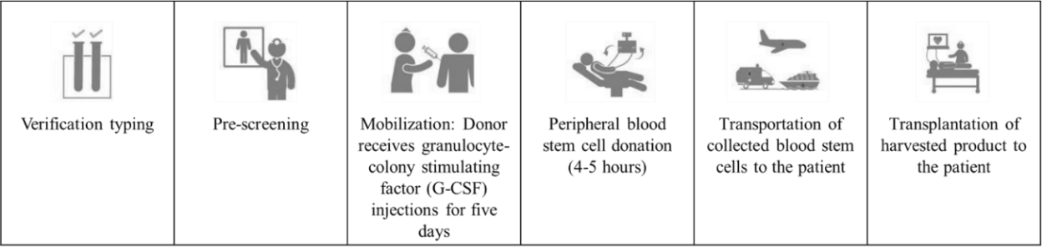

Bone Marrow Harvest

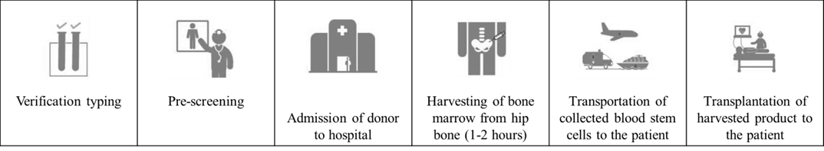

Overall Process Description

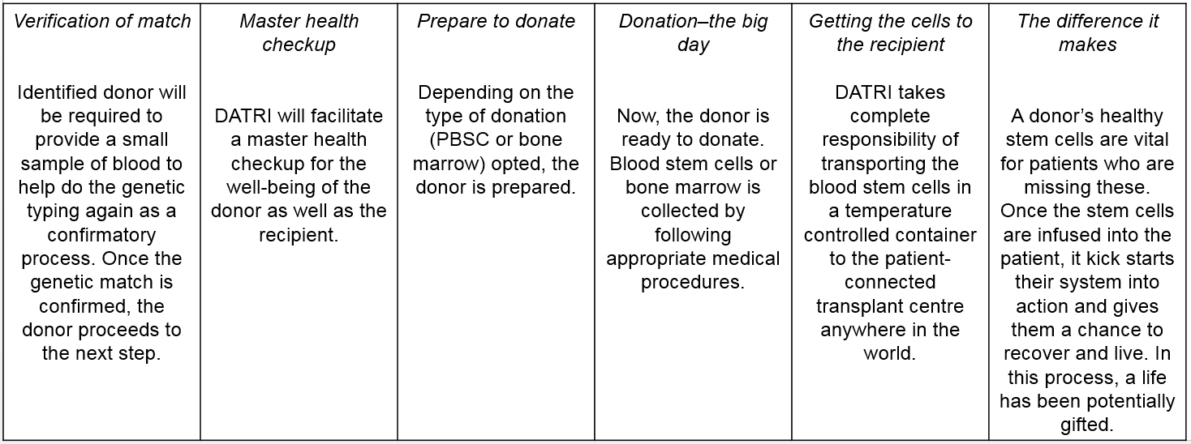

Note: PBSC = peripheral blood stem cells.

Source: Created by the case authors based on company interview.

Exhibit 6: Donors Backing Out of the Donation Process

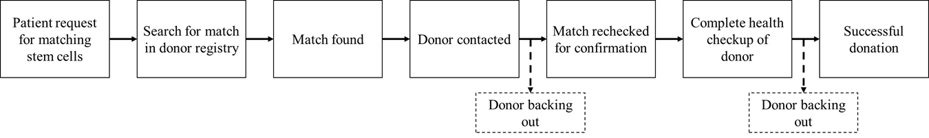

Source: Created by the case authors based on company interview.

1. ₹ = INR = Indian rupee; ₹1.00 = US$0.01551 as of April 9, 2017; all currency amounts are in ₹ unless otherwise specified.
2. “Stem Cells for Life,” Canadian Blood Services, accessed April 9, 2017, https://blood.ca/en/stem-cells.