

9B18M180

DECOMMISSIONING THE PICKERING Nuclear Generating station: 2024 or 2054?

Ken Mark wrote this case under the supervision of Professor Peter C. Bell solely to provide material for class discussion. The authors do not intend to illustrate either effective or ineffective handling of a managerial situation. The authors may have disguised certain names and other identifying information to protect confidentiality.

*This publication may not be transmitted, photocopied, digitized or otherwise reproduced in any form or by any means without the permission of the copyright holder. Reproduction of this material is not covered under authorization by any reproduction rights organization. To order copies or request permission to reproduce materials, contact Ivey Publishing, Ivey Business School, Western University, London, Ontario, Canada, N6G 0N1; (t) 519.661.3208; (e)* [*cases@ivey.ca*](mailto:cases@ivey.ca)*;* [*www.iveycases.com*](http://www.iveycases.com)*.*

Copyright © 2018, Ivey Business School Foundation Version: 2018-11-29

On May 5, 2017, Rick Jennings, then a strategic analyst at the Ontario Ministry of Energy, had been asked by the minister to look at the current situation facing the Ontario Power Generation’s (OPG) Pickering Nuclear Generating Station (Pickering). “Should we support the immediate decommissioning of . . . Pickering once extended operations are completed in 2024?” Jennings wondered. “Should we mothball it over the next 40 years before beginning decommissioning?” He continued, “There are pros and cons, and a lot depends on our financial assumptions.”

Nuclear power generation delivered two key benefits to OPG and the province: it had reasonable operating costs and, while operating, it generated no emissions that could contribute to global warming or acid rain. Even on a lifecycle basis, with mining, materials, and construction taken into account, nuclear power production had lower air emissions than renewable energy sources such as wind, hydro, and solar power. OPG had two nuclear power stations—Pickering and the Darlington Nuclear Generating Station (Darlington)—with a combined generating capacity of about 6,600 megawatts. In Ontario, nuclear power supplied over half of the province’s electricity needs.

The decommissioning of Pickering had been discussed for more than a decade, in anticipation of the end of its operating life. The station’s Canada deuterium uranium (CANDU) reactors were designed to operate for 25–30 years and then to undergo major refurbishment, including the replacement of critical components. Following a successful refurbishment, the plant could be expected to operate for a further 25–30 years. Both Pickering and Darlington were scheduled to be decommissioned in 2020. However, in early 2016, the Ontario government announced that it had approved OPG’s plan to commence refurbishment of the first of the four Darlington units in October 2016. OPG planned to spend $12.8 billion[1] overall to sequentially refurbish four reactors at Darlington, extending their useful lives to 2055. The work was scheduled to be completed by 2026. The Conference Board of Canada estimated that the Darlington refurbishment would generate $14.9 billion in economic benefits for the province and create up to 11,800 jobs annually during refurbishment. A subsequent Conference Board of Canada study found that the refurbishment and operation of Darlington to 2055 would have a combined economic effect of $90 billion on the Ontario economy.[2]

Several years earlier, OPG decided not to proceed with refurbishing the six operating Pickering units because their age and smaller size relative to the Darlington units (500 megawatts compared to 881 megawatts) made refurbishing Pickering less economically attractive. However, ongoing detailed monitoring and inspection by OPG had demonstrated that Pickering could continue to be operated safely and effectively for several years. To ensure that it could continue to generate cost-effective electricity, Ontario approved OPG’s plan to pursue continued operation of Pickering to 2024.

Anti-nuclear activists were incensed: the Ontario Clean Air Alliance started a petition to close Pickering by 2018. The group cited several reasons: Pickering was the fourth-oldest nuclear station in North America; it was also the station located closest to a large city. The Clean Air Alliance also suggested that shutting down Pickering would reduce Ontario’s electricity costs by $900 million per year and that there were design, performance, and safety issues.[3] While some of the Clean Air Alliance’s claims raised questions, the OPG and the Independent Electricity System Operator (IESO) both completed studies that found that continuing to operate Pickering would result in savings in the form of lower prices charged to Ontario consumers. OPG’s studies found up to $600 million in savings,[4] and IESO’s studies—reviewed by the Ontario Energy Board and relying on different assumptions, including a different discount rate—concluded that the savings from continuing to operate Pickering would be between $300 million and $500 million. Meanwhile, the Canadian Nuclear Safety Commission (CNSC), the federal nuclear safety regulator, gave Pickering the highest possible safety grade in 2016. Jennings nevertheless took note of the Clean Air Alliance’s claims as part of his research.

While he could understand the Clean Air Alliance’s concerns, Jennings was worried about the potential for cost overruns in general. “Immediate decommissioning after extended operations conclude in 2024 will drive up labour costs for all nuclear activities as labour shortages are likely,” noted Jennings. “This could add $30 million to the decommissioning bill in total. Our base case is to mothball the Pickering plant and begin decommissioning in 2054.”

There was an argument to be made for keeping Pickering open, and there were counterarguments against it. “Which variables should I consider, and what weight should I give them?” he wondered. He had three days before he had to present a draft outline of his thoughts to the minister.

**Pickering Nuclear Generating Station**

Located in the city of Pickering, Ontario, the Pickering station was built between 1966 and 1986 by Ontario Hydro, a provincial Crown corporation (see Exhibit 1). Pickering A, the first set of four units, came into service in the early 1970s, with the first unit starting up in 1971. Pickering B, the second four units, came into service in the mid-1980s. Pickering was one of the largest nuclear facilities in the world, with eight CANDU nuclear reactors when it was fully completed. The four oldest reactors were shut down in 1997 for upgrades, and two of the four were eventually restarted in 2003 and 2005. In 2017, with six reactors currently in operation, Pickering had an output of 3,100 megawatts of electricity. For perspective, Pickering alone generated 14 per cent of Ontario’s total electricity needs—enough to meet the annual electricity requirements of 2.0 million homes.

Waste from Pickering, including spent nuclear fuel and other waste that was deemed low and intermediate level waste, was initially stored on site and subsequently transferred to OPG’s Western Waste Management Facility near Kincardine, Ontario. While Pickering experienced some operational issues in its early years, it had never had any accidents, adding to OPG’s track record of safe operations. An OPG document provided more information on the safe record of nuclear power in Ontario:

The number one priority at OPG’s nuclear stations is to ensure that there are no public safety concerns as a result of our operations. Our nuclear stations are designed with multiple safety systems and are staffed by station personnel who are extremely well trained.

In the more than four decades that nuclear energy has served Canada’s energy needs, no member of the public has ever been harmed as a result of a radiation emission from a nuclear power plant or waste storage facility. An excellent measure demonstrating that the public is protected at all times from radiation emissions is provided by the continuous monitoring of radiation exposure at the perimeter of our stations.[5]

Nuclear-generated power was cost-effective, as OPG noted:

In 2014, the Independent Electricity System Operator Interties Report estimated the cost of large scale power purchased from Québec to replace nuclear generation, including transmission, would be 9 to 15 cents per kWh—a significant increase when compared to 7 cents per kWh from OPG nuclear. Additionally, the power from Quebec does not currently exist and would have to be licenced and constructed; a 20-year process.[6]

In addition, nuclear power was environmentally friendly, generating 5 grams of carbon dioxide equivalent per kilowatt hour (kWh), compared to 5 grams for wind, 97 grams for solar power, 912 grams for natural gas, 988 grams for fuel oil, and 1,003 grams for coal.[7]

In January 2016, the Ontario Ministry of Energy announced its approval for OPG to pursue continued operation of the Pickering station to 2024, with two of the six units shutting down in 2022. Any proposal to extend Pickering’s operations would require approval by the CNSC.

**Decommissioning Pickering: Process and Costs**

Pickering’s current operating license ran to August 31, 2018, so OPG had to invest additional funds in monitoring and inspection to provide confidence to extend its operations to 2024 (see Exhibit 2).

The CNSC had approved a decommissioning plan for OPG’s nuclear plants. Under this approved plan, the units would be dewatered and defueled and then laid up and mothballed for 30 years prior to being dismantled. Deferred decommissioning was consistent with international trends over the last 10 years, which showed consistently more plants selecting deferred decommissioning (48 per cent) over plants selecting prompt decommissioning (36 per cent).

The 30-year mothballing period greatly reduced the risk of radiation exposure for the workers who would be involved in dismantling the plant. Most of the radioactive components in the plant had a half-life that was shorter than 30 years—that is, much of the radiation would have dissipated during the mothballing period. Because limiting individual radiation doses would be critical, this meant that fewer workers would be required, and this meant the cost would be significantly lower and safety levels would be significantly higher, compared to immediate dismantling.

Under the CNSC-approved plan, dismantling of the Pickering units would begin in 2054, and dismantling of the Darlington and Bruce Nuclear Generating Station units would begin in the late 21st century. The current plan was to place Pickering in safe storage for 30 years. OPG would remove fuel and heavy water from the reactors and place the equipment in a safe caretaking state. Next, the facility would be monitored for 30 years as radiation levels declined. Concurrent with the monitoring activities, used fuel from Pickering’s wet storage bays would be removed and placed into dry storage containers to be stored temporarily. Monitoring the dry storage containers would be the task of both OPG and the International Atomic Energy Agency. After the 30-year period was over, skilled professionals would remove all radioactive material and begin the process of dismantling the physical structures. Once these were demolished and removed, the site would be repurposed.

In 2016, OPG estimated the cost of decommissioning Pickering at about $5.264 billion in present value (2016) terms. The estimated costs included $270 million to prepare six reactors for dormancy; $644 million to maintain Pickering during the dormancy period (from shutdown to 2050); $350 million to manage low-level radioactive waste generated during the dormancy period; $2.4 billion to dismantle the reactors, systems, and buildings in 2050; and $1.6 billion to manage, transport, and dispose of the radioactive waste.

Jennings noted that, while OPG had estimated the cost of decommissioning at about $630 million per reactor, another estimate in New Brunswick had put the cost of decommissioning a single CANDU reactor at over $900 million.[8] As New Brunswick had a single 600-megawatt reactor at its Point LePreau site, this higher cost estimate may have reflected the economies of scale per reactor based on decommissioning several reactors from the same site.

The cost of long-term storage and management of the spent fuel from Pickering was expected to reach an additional $4.3 billion in 2016 terms. The cost of dealing with the spent fuel would be independent of the option chosen for reactor decommissioning.

The CNSC had approved a nuclear decommissioning plan for Pickering and the other nuclear plants, and the cost of the plan would be funded through segregated funds contributed by OPG during the plants’ operation and investments that were jointly overseen by the Ontario Financing Authority (OFA) and OPG. OFA was a provincial government entity created to conduct borrowing, investment, and financial risk management for Ontario. In addition to managing the province’s debt and providing cash management services for Ontario, it worked with OPG to manage the funds set aside for nuclear station decommissioning under the Ontario Nuclear Funds Agreement (ONFA).

**The Ontario Nuclear Funds Agreement**

The ONFA between the Ontario Ministry of Finance (Finance) and OPG set up two funds: a decommissioning fund, which was principally for nuclear fixed-asset removal and low- and intermediate-level waste management; and a used fuel fund.

Future obligations were estimated as part of the ONFA Reference Plan developed by Finance and OPG. The most recent plan was approved in December 2016 for 2017–2021. OPG set aside and invested funds in segregated accounts to meet the future obligations estimated through the Reference Plan. This was a similar framework to the funding and management of a pension plan to meet actuarially identified future obligations. Similar to a pension fund, the ONFA funds were invested in a diversified portfolio of equities and fixed-income securities, based on a long-term investment horizon. Investment management was jointly overseen by OPG and Finance, through the ONFA.

As part of the ONFA, OPG was required to contribute two separate funds amounting to $2.75 billion for decommissioning Pickering and for used fuel management: the Decommissioning Segregated Fund and the Used Fuel Segregated Fund.

**The Decommissioning Fund**

As of December 31, 2016, the Decommissioning Fund was overfunded. The fair market value of the Decommissioning Fund ($8.3 billion) exceeded by $1.5 billion the present value of the decommissioning obligations set out in the recent ONFA Reference Plan ($6.8 billion). In developing the Reference Plan, it had been assumed that the fund would be managed so as to earn an average real return (i.e., above inflation) of 3.25 per cent. Under ONFA, any surplus ultimately belonged to the province. The agreement provided that, in the event that the Decommissioning Fund was more than 120 per cent funded, 50 per cent of the surplus could be applied to a shortfall in the Used Fuel Fund and the remainder could be transferred to the province.

The Reference Plan requirements were based on the assumption that the fund would be invested so as to increase in value in real terms by 3.25 per cent per year. That is, the $6.8 billion (in 2016 terms) invested in the fund would grow over time to an amount sufficient to cover the cost of decommissioning and dismantling the Pickering, Bruce, and Darlington nuclear stations under the current planned schedule.

Under the Reference Plan assumptions, the real value (in 2016 terms) of the fund would approximately double in 20 years. The present value of the costs of decommissioning would be significantly affected by the timing of the decommissioning.

**Decommissioning in 2024 or Mothballing until 2054**

Jennings looked at the alternative option: decommissioning in 2024. “Well, one of the most immediate impacts would be that the Decommissioning Fund would not have the opportunity to grow at the estimated investment return rates,” noted Jennings.

He also read that the economic costs and technical and safety challenges of dismantling a more radioactive plant would be significantly higher than for a nuclear plant that had been mothballed for 30 years, perhaps by 20 per cent. This was because workers would be trying to dismantle the plant during a phase when many components were highly radioactive.

He wondered if proponents of decommissioning in 2024 were using artificially inflated decommissioning employment numbers. High radiation fields at the time of shutdown meant that more workers would be required in order to limit radiation doses for individual workers. This greatly increased decommissioning costs and radiation safety risks. An OPG manager noted,

Prompt decommissioning would bring forward the requirements for a Low and Intermediate Level Waste Deep Geological Repository. The Ontario Nuclear Decommissioning Fund is fully funded to accomplish the regulator approved decommissioning plan. If instead it was decided to implement a higher cost plan such as prompt decommissioning for whatever reason, the proposed plan would have to go to the CNSC for review and the CNSC would have to approve the amended plan before it could be implemented. The CNSC would likely be concerned about the higher potential radiation exposure to workers that would arise from immediate dismantling.

The federal Nuclear Safety and Control Act requires OPG to have sufficient funds available to discharge the current nuclear decommissioning and waste management initiative. The Province has provided a Provincial Guarantee to the CNSC on behalf of OPG since 2003.

“Based on the figures, should we look to decommission Pickering in 2024 or 2054?” wondered Jennings.

**Exhibit 1: Ontario Power Generation—Pickering Nuclear station**

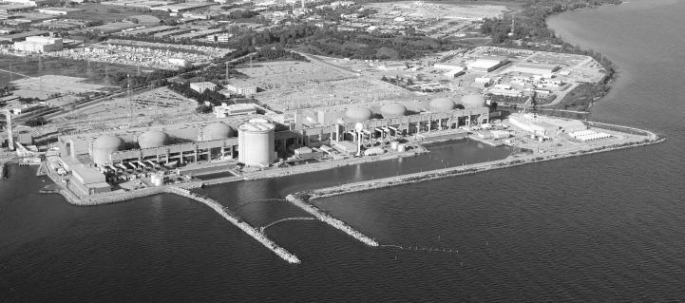

Source: Ontario Power Generation.

**Exhibit 2: Ontario Power Generation—Pickering Station Decommissioning Timeline**

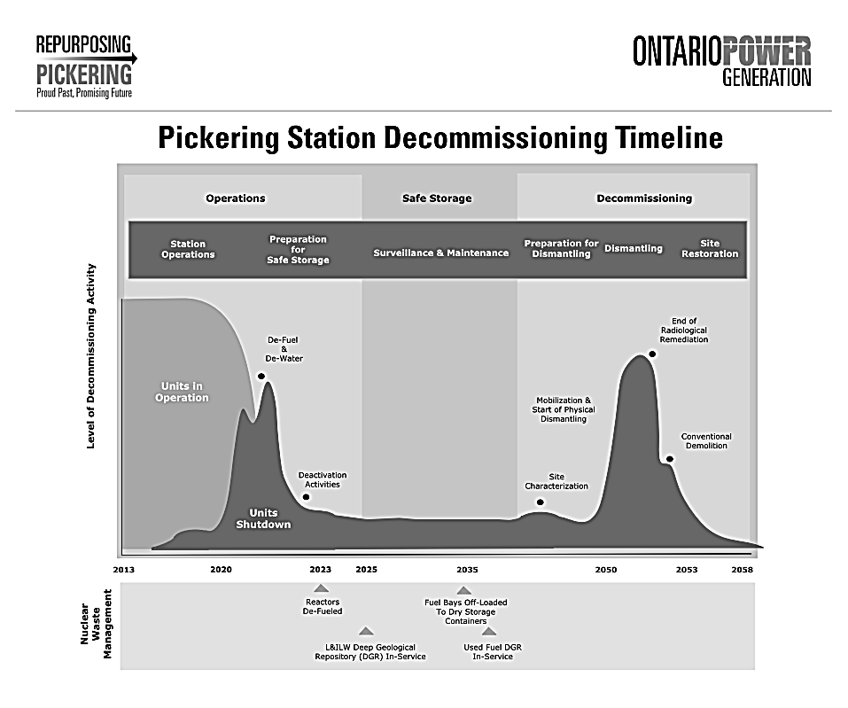



Note: The units shutdown dates are 2022–2024, and the dismantling date is schedule to be in the late 2050s.

Source: Ontario Power Generation.

1. All currency amounts are in CA$ unless otherwise specified.
2. “Refurbishment of Darlington Nuclear Generating Station Would Boost Economic Activity and Employment,” Conference Board of Canada, November 23, 2015, accessed March 2, 2017, www.conferenceboard.ca/press/newsrelease/15-11-23/Refurbishment_of_Darlington_Nuclear_Generating_Station_Would_Boost_Economic_Activity_And_Employment.aspx?AspxAutoDetectCookieSupport=1.
3. “Petition to Close the Pickering Nuclear Plant by 2018,” Ontario Clean Air Alliance, accessed May 22, 2018, www.cleanairalliance.org/close-pickering/.
4. Ontario Ministry of Energy, “Ontario Moving Forward with Nuclear Refurbishment at Darlington and Pursuing Continued Operations at Pickering to 2024,” news release, Independent Electricity System Operator, January 11, 2016, accessed May 22, 2018, www.ieso.ca/en/corporate-ieso/media/news-releases/2016/01/ont-moving-forward-with-nuclear-refurb-at-darl-and-pursuing-continued-ops-at-pickering-to-2024.
5. “Nuclear Power,” Ontario Power Generation, accessed May 22, 2018, www.opg.com/generating-power/nuclear/Pages/nuclear.aspx.
6. “Nuclear Facts”, Ontario Power Generation, accessed March 2, 2018, www.opg.com/generating-power/nuclear/stations/pickering-nuclear/Documents/PickeringNuclearFacts_Info.pdf.
7. Parliament of Australia, Standing Committee on Industry and Resources, “Chapter 4: Greenhouse Gas Emissions and Nuclear Power,” in *Inquiry into Developing Australia’s Non-Fossil Fuel Energy Industry*, 168, December 4, 2006, accessed May 22, 2018, www.aph.gov.au/Parliamentary_Business/Committees/House_of_Representatives_Committees?url=isr/uranium/report/chapter4.htm.
8. Ralph Torrie, *Direct Decommissioning of the Pickering Nuclear Generation Station: Economic and Other Benefits*, Ontario Clean Air Alliance Research, March 2016, accessed May 22, 2018, www.cleanairalliance.org/wp-content/uploads/2016/03/decomfinal.pdf.