

9B18M191

Yildiz Holding: global expansion strategy

Saul Estrin, Christine Côté, and Katherine Nunner wrote this case solely to provide material for class discussion. The authors do not intend to illustrate either effective or ineffective handling of a managerial situation. The authors may have disguised certain names and other identifying information to protect confidentiality.

*This publication may not be transmitted, photocopied, digitized, or otherwise reproduced in any form or by any means without the permission of the copyright holder. Reproduction of this material is not covered under authorization by any reproduction rights organization. To order copies or request permission to reproduce materials, contact Ivey Publishing, Ivey Business School, Western University, London, Ontario, Canada, N6G 0N1; (t) 519.661.3208; (e)* [*cases@ivey.ca*](mailto:cases@ivey.ca)*;* [*www.iveycases.com*](http://www.iveycases.com)*.*

Copyright © 2018, Ivey Business School Foundation Version: 2018-12-21

In November 2014, after completing the acquisition of UK-based biscuit and snacks company United Biscuits (UB), maker of McVitie’s digestive biscuits, Jaffa Cakes, and Jacob’s crackers, the senior management of Yildiz Holding (Yildiz) were feeling quite pleased. As a statement by the Turkish holding company made clear, “In the past six years, [after] adding premium chocolate maker Godiva [Godiva Chocolatier, Inc.] and established US candy maker DeMet’s [DeMet’s Candy Company] to its portfolio, Yildiz Holding has taken its largest step towards globalisation with acquiring United Biscuits.”[1]

The Turkish company had made headlines in 2008 by overcoming competition from such global giants as Starbucks Corporation; Mars, Incorporated (Mars); and Nestlé SA (Nestlé) to snap up the US-based luxury chocolate brand Godiva from the Campbell Soup Company for US$850 million.[2] The company was well on its way to achieving management’s goal of becoming the top-ranked global snacks business with worldwide operations and an expanding portfolio of internationally recognized household brands (see Exhibits 1 and 2).

As the company moved beyond its acquisition of UB in pursuit of its goal of global domination in the confectionary market for biscuits and snacks, in late 2014 senior management at Yildiz were questioning whether the business model that had brought the company success for so long would continue to be viable. How could Yildiz achieve its goal of becoming the leading global snack company? Should it pursue further acquisitions in the confectionary segment? More importantly, how should it integrate the recent high-profile acquisitions of Godiva and UB? Additionally, what were the implications of its global expansion for its diversified business model? Many of its early business choices had been born of necessity to operate and thrive in an emerging market such as Turkey’s, but as the Turkish economy had prospered and developed, the rationale for many of Yildiz’s non-core businesses was no longer relevant. Should Yildiz consider the divesture of its non-core activities?

The Company

History: From Ülker Bisküvi (Ülker) to Yildiz

Yildiz began its operations as a small bakery in Istanbul under the Ülker brand, with the first Pötibör biscuits being manufactured under the Ülker brand name in 1944. The company opened its first factory in 1948 and subsequently moved it in 1965 to Topkapı Davutpaşa, a modern location outside of Istanbul, where production, scale, and technology were improved to meet national demand. In the 1970s, a production facility was established outside of Istanbul, at the Anadolu Gıda company factory in Ankara.

Besides the company’s expanded production facilities, Ülker’s growth in the 1960s and 1970s was also fostered by successful marketing campaigns through both radio and television. For instance, the marketing campaign “It’s not teatime without Ülker” had contributed significantly to the brand’s growth in popularity. The jingle “Daddy, don’t forget to bring the Ülker home tonight” became a television advertising phenomenon.

Ülker undertook product diversification by investing in a chocolate manufacturing factory in 1972. Challenging the perception that chocolate was an expensive product, Ülker decided to sell its products at affordable prices. Its diversification efforts were facilitated by the establishment of its first research and development department in 1974. As a result, the company developed and marketed a wide variety of chocolate and biscuit products, such as Ülker Çikolata, Ülker Çikolatalı Gofret, and Ülker Çokonat.

By the beginning of the 1980s, 36 years after its creation, Ülker had become a household name in Turkey. That decade marked Ülker’s diversification into further products, and included investments in production and packaging, particularly the use of cellophane packaging technology. The business group Yildiz was established in 1989 to integrate its packaging business with the Ülker subsidiary. Other non-food activities had since been added to the holding, including private equity, real estate, retail, information technologies, and personal care products.

Yildiz in Turkey in 2014

Since its beginnings in 1944 under the operating name Ülker, Yildiz had grown to become a diversified and vertically integrated holding company in Turkey comprised of four main businesses—food and beverage, non-food business activities, retail, and its core business, confectionary (see Exhibit 3).

Food and Beverage, Non-Food Businesses, and Retail

The food and beverage business was focused on a diverse set of products including fats and oils, frozen food, packaged bread, beverages, dairy, cereals, tea, herbs and spices, and processed meat. The non-foodbusinessincluded packaging, information technology, private equity, and personal care products. The company also had substantial operations in retail,with its presence reflected chiefly in Bizim Toptan and Şok supermarkets*.*

Since launching in 2002, Bizim Toptan had grown 28 times over—expanding from six to over 170 retail points in Turkey. The products sold by the retailer represented over 7,000 wholesale items, with everything from beverages to treats to cleaning products, including leading Turkish and international brands. Key customers included many of Turkey’s workplaces, as the retail chain was known for its appealing prices, reflected in its slogan “Earn more with us.” Yildiz acquired the Şok chain of retail stores in 2011. This supermarket chain was also recognized for its low prices and quality brands, and had over 2,236 outlets throughout the country.

The Core Business—Confectionery

The confectionery business was Yildiz’s core business. It focused on the competitive snacks segment, with biscuits and cakes, chocolate, and gum and candy, and included a host of well-known brands such as Ülker, McVitie’s, Godiva, and Turtles. The Ülker brand was well established in Turkey as well as in the Middle East and Northern Africa, and until the recent acquisitions had been the umbrella brand for the confectionery business. Ülker had the largest production capacity in the domestic market, with facilities spread out to minimize dependency on a single location. It had nine factories in Turkey, located in Istanbul, Gebze, Ankara, and Karaman.

Since its creation, Ülker’s distribution network had been one of its competitive advantages when competing with established Turkish brands such as Luks and Ideal. Orders for products placed by retailers in Anatolia were shipped to them at factory prices, with no transport charges.

In 2011, Yildiz simplified its traditional distribution channel for all its companies, consolidating all sales under its new sales company Horizon. This resulted in fewer distributors (from 235 down to 103) but the same coverage in sales points. Production companies were merged under one roof, and sales companies were merged under two main companies—Horizon became the sales company for traditional trade; Pasifik Pazarlama became the sales company for organized trade.

Ülker had focused on marketing and promotion since its early days. When asked about the “secret” of the company’s success, founder Sabri Ülker mentioned the great importance he attached to advertising: “This is a factor that I would really like to emphasize . . . We placed significance on advertisement from the very first day, we still do and we will always continue to do this. . . . We have been advertising Ülker since 1950.”[3] Ülker had made creative use of different marketing channels to produce successful marketing campaigns, with its most recent campaign promoting Ülker’s so-called “Happy Moment.” Ülker was consistently recognized as one of the best brands in Turkey and had won many awards. Ülker had cultivated a youthful image with most of its social responsibility programs focused on children. Its initiatives included Ülker Children’s Cinema Festival; educating school children on eating a healthy and balanced diet; and projects geared towards children that focused on art and sport, such as the construction of infrastructure for football, and football training centres and villages.

Yildiz’s confectionary business, however, was vulnerable to fluctuations in the market prices of key ingredients such as cocoa, palm oil, wheat, and sugar. Any significant hike in these key raw material prices could deteriorate margins, but the company was hedged. At the same time, market share erosion risk limited the company’s ability to pass on the increases in input costs to consumers.

In 2014, Ülker’s market share in the Turkish biscuit segment was 46 per cent, down from 48 per cent four years earlier, while the market share of its main local competitor, ETI Gida Sanayi ve Ticaret A.S. (Eti), had grown from 40 per cent to 45 per cent over the same period. In the cake segment, Ülker’s market share had decreased from 39 per cent in 2011 to 32 per cent, while Eti’s had increased from 49 per cent to 55 per cent. Ülker remained the clear market leader in the chocolate segment, with its most direct competitor, Eti, owning only 12 per cent of the market share in 2014. However, Ülker recorded a 5-per-cent decline of its market share in this segment in 2014, when it fell to 47 per cent from 51 per cent in 2011 (see Exhibit 4). But Ülker had been consistently gaining market share against its main competitors including Eti since 2011, while remaining the market leader in the snacks categories.[4]

Yildiz Global Expansion Strategy, 2014

Yildiz had an impressive global presence, with 60,000 employees worldwide. It had over 300 brands in its portfolio, revenue of $12 billion, 80 factories producing in 15 countries, and distribution in over 100 countries through both foreign direct investment and exports. Its most recent acquisitions had been done with the aim of becoming a global player in the confectionary market and had included Godiva in 2008 and both DeMet’s and UB in 2014.

The company’s exports made up 19 per cent of total sales in 2014, and the holding company had pursued growth through acquisition as the main motivator for international expansion, focusing on a strong international expansion strategy in other emerging markets and becoming a strong regional player in the Middle East, North Africa, and Eastern Europe (see Exhibit 5). The company had a strong presence in Iraq, as well as in Germany, which had a significant Turkish immigrant population.

Yildiz had expanded into the Middle East and had operations in Saudi Arabia and Egypt, and it aimed to pursue its internationalization by focusing on underpenetrated markets. Manufacturing operations in both Saudi Arabia (launched in 2000) and Egypt (launched in 2007) had been established through joint ventures with a local partner, while sales in Egypt were established in 2010 via the creation of a wholly owned subsidiary of Yildiz. The two manufacturing companies recorded net sales of $91 million in Saudi Arabia (number one in biscuits) and $36 million in Egypt (number three in biscuits) in 2013.[5]

Strategic partnerships had also played a major role in Yildiz’s ambitions to target the Turkish market and neighbouring regions. Its successful partnerships around the world included those with Kellogg Company (Kellogg’s) and Cargill Inc. from the United States, Gumlink Confectionary Company from Denmark, Nissin Goods Holdings Co. Ltd. from Japan, and Svenska Cellulosa Aktieboaget SCA from Sweden.

Recent Acquisitions: Godiva 2008 and UB 2014

Godiva

In 2008, Yildiz acquired Godiva Chocolatier, Inc., the owner of the Godiva brand, the world’s leading brand of premium chocolate and chocolate-coated products, for $850 million from the Campbell Soup Company. It was the largest overseas acquisition by a Turkish company, marking a critical strategic moment for the firm, which was previously Turkey-centric and focused on low-price products. According to company management, “Though this [acquisition] was a totally new endeavour for Yildiz, it was able to establish Godiva on its path to become a truly global premium chocolate brand with the mission to democratize luxury.”[6]

In 2013, only 7.2 per cent of chocolate purchased in the United States was made in specialty stores.[7] Yildiz therefore set out to make Godiva a premium brand that was accessible for purchases on a more mass-market basis and more than just once a year, while retaining its high-end status. As a result, Godiva expanded into food, drug, and mass (FDM) stores, lowering the price point and making Godiva more competitive with brands such as Lindt and Ghirardelli. Yildiz was meticulous about differentiating the portfolio for FDM stores to avoid any brand dilution for its retail chain. The purchase of DeMet’s well-known FDM brands and competencies in established trade relations, further helped Godiva to expand in new product areas.

Since acquiring Godiva, Yildiz’s revenues had grown by 10 per cent each year and its factories had expanded into Belgium and the United States, helping to boost international sales, which represented 52 per cent of Godiva’s total sales (particularly in the United States and Japan). Building on its globalization strategy, Yildiz had also guided Godiva into new markets in Australia, China, Indonesia, Korea, Macau, Saudi Arabia, and Turkey.

UB

The third and largest acquisition by Yildiz was that of UB in 2014. At the time of the acquisition, UB was based mainly in the United Kingdom, with more than half of its employees at sites in Aintree, Carlisle, Halifax, Harlesden, Manchester, Tollcross, and Wigston.

Yildiz approached the acquisition as an opportunity to continue to build global brands and capitalize on its own global distribution network. At the time, Murat Ülker, the chairman of Yildiz, had said, “We want to grow United Biscuits to be a global player as part of Yildiz. This will include enhancing its position in the UK, where Yildiz currently has minimal presence, so we will continue to invest in the UK and Europe.”[8]

As with Godiva, the introduction of UB, a company with sales of £1.1 billion[9] in 2013, represented a new phase in Yildiz’s globalization strategy, putting the company on the map as the world’s third-largest biscuit company after Mondelēz International, Inc. (Mondelēz) and Kellogg’s (see Exhibit 6).

Competition in the global confectionary market

The market for global snacks had continued to grow in recent years. According to data from The Nielsen Company (US), LLC, global snack sales grew at an increase of 2 per cent year over year in 2014. Europe ($167 billion) and North America ($124 billion) represented the largest regional markets; however, sales in Europe had remained flat while the North American market had grown at a rate of 2 per cent. While data pointed to the remaining world regions as being significantly smaller, snack sales were growing in regions such as Asia Pacific ($46 billion), Latin America ($30 billion), and the Middle East/Africa ($7 billion).[10]

Each region also had its own preferences in the overall snack market segmentation. Sugary snacks were popular in Europe ($46.5 billion) and Middle East/Africa ($1.9 billion), while salty snacks topped the charts in North American markets ($27.7 billion). The Asia Pacific market ($13.7 billion) enjoyed refrigerated snacks and cookies, while snack cakes were preferred in Latin America ($8.6 billion).[11]

“The competitive landscape in the snacking industry is fierce,” said Susan Dunn, executive vice-president of Global Professional Services at The Nielsen Company (US), LLC in 2014. “Demand is driven primarily by taste and health considerations and consumers are not willing to compromise on either. The right balance is ultimately decided by the consumer at the point of purchase. Understanding the ‘why before the buy’ provides the foresight necessary to deliver the right product to the right consumer at the right time.” The US industry was highly concentrated: the top 50 companies accounted for 75 per cent of industry revenue.[12] The strength of Yildiz’s key competitors lay in their global power brands, which had established histories and name recognition within the categories. Mars, Mondelēz, and Nestlé produced 40 per cent of the chocolate consumed around the world; these companies also had diverse food and snack product lines.[13]

Mondelēz’s net revenues were approximately $30 billion in 2014, giving it the number one position globally in biscuits, chocolate, and candy, as well as the number two position in gum.[14] The company’s strategy had been to invest in its power brands such as Oreo, Chips Ahoy, and Cadbury, both domestically in the United States and internationally. The company’s power brands accounted for 68 per cent of net revenue.[15] At that time, Mondelēz generated about one-third of its revenue from its healthier line of snacks, and planned to increase this to one-half within the next five years (see Exhibit 7). Mars and Nestlé had also developed strategies in research and innovation to differentiate their products and promote healthier lifestyles.

Within the biscuits category, the purchase of UB had helped Yildiz to overtake Nestlé and PepsiCo Inc., and thus secure the position of third largest after Mondelēz and Kellogg’s (see Exhibit 6).[16] Yildiz’s challenge lay in establishing its own brands globally amidst competition from the power brands (e.g., Oreo and Ritz) of its main competitor, Mondelēz.

Referring to the changes occurring in the industry, a member of Yildiz’s management said,

In contrast to its name—fast moving consumer goods—the industry had historically changed quite slowly. In the past decade, there had been a transformation in the preferences of consumers. The perception of health had changed a lot, so it had been affecting the industry. Consumers were in constant search for convenience in snacks products, and in everything they consumed. The shopping and consumption habits of global consumers were also shaped by new, disruptive technologies and digitalization. Without addressing these changes companies cannot stay in the game, let alone differentiate.

While sugary snacks continued to hold the largest retail value, the healthy snack segment had been growing faster than traditional snack sales, with sales up 40 per cent since 2011 and a retail value of $140 billion.[17]

“People are not just thinking of snacking occasions as that time when we get extraneous calories anymore,” said Darren Seifer, food and beverage industry analyst for market research company The NPD Group. “People now think of snacking as a way to get extra ingredients into their bodies or as a way to eat more sensibly throughout the day.”[18]

Since 2007, Yildiz has launched a company-wide initiative to holistically address well-being, including portfolio and consumer communication. Big brands had to find ways to compete with the increased competition from smaller emerging brands, especially in the United States. For example, KIND LLC, a health food company founded in 2004 and based in New York City, had sales of close to $120 million in 2012, up from about $10 million in 2010.[19]

Another New York-based company, Chobani, which produced Greek yogurt, also posed a risk to the sugary snack industry. The products Chobani introduced into the yogurt aisle became more popular than traditional brands, eroding the market share of General Mills Inc., producer of Yoplait, at least 10 per cent since 2008.[20]

Challenges going forward

Yildiz had seen many changes in the years leading up to 2014. The company had made some high-profile acquisitions and moved from being the leading biscuit and snack company in Turkey to competing on the global stage against competitors such as Kellogg’s, Nestlé, and PepsiCo Inc. Its vision to become the leading global snack company continued to drive its international strategy; however, it faced some serious challenges. With the growing domestic and international competition in the snack business, the company had to consider how it could capture the synergies from its acquisitions without jeopardizing the strong global brands. It also had to consider how to organize itself going forward. How involved should it be in the management of these new businesses? How integrated should its sales, marketing, manufacturing, and distribution be across each brand within each geographical region?

Furthermore, the company had to consider how it would deal with the other non-core businesses in its portfolio. The rationale for much of the company’s early diversification was no longer relevant. It needed to consider whether it should pursue the divesture of these non-core activities.

Exhibit 1: Yildiz Vision and Mission, 2014

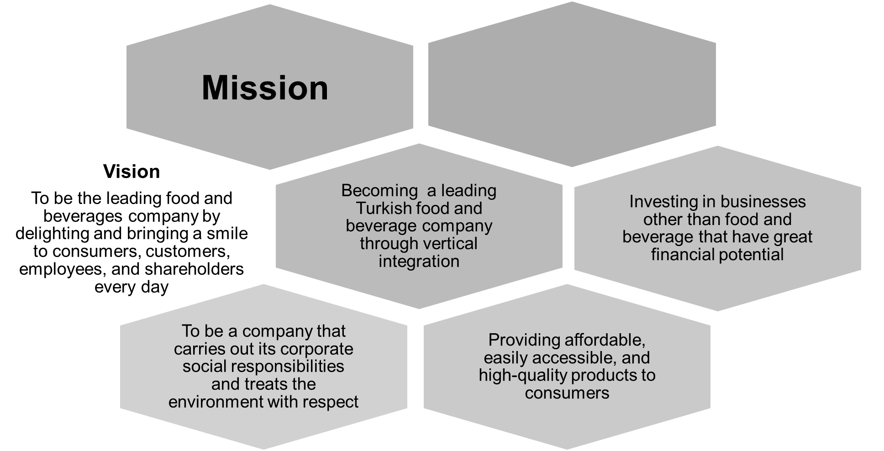

Showing consideration for the

health of our employees, the community, and consumers, while achieving sustainable growth

Source: Company documents.

Exhibit 2: Yildiz Holding Leading Market Brands

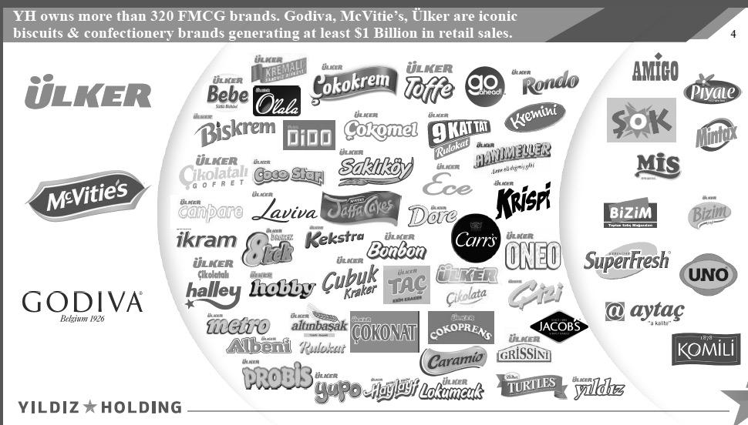

Note: YH = Yildiz Holding; FMCG = fast moving consumer goods; $ = US$.

Source: Company documents.

Exhibit 3: 2014 Yildiz Business Activities

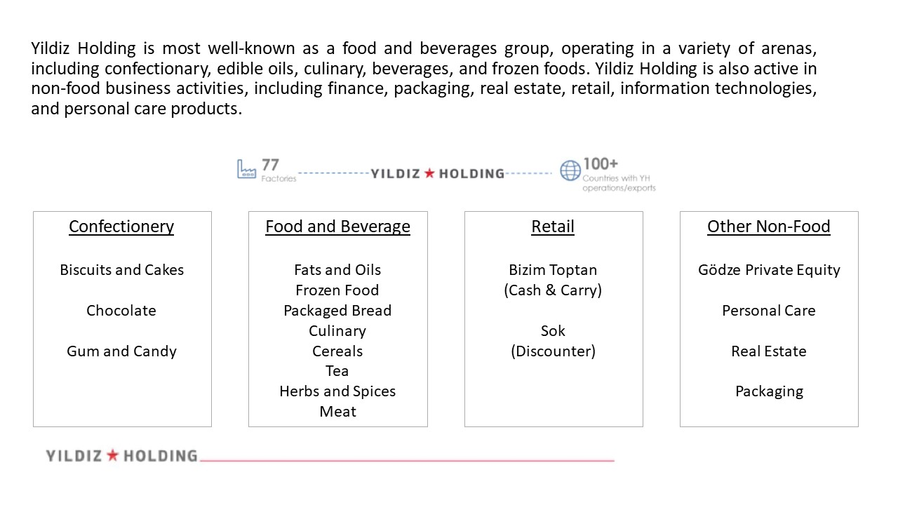

Source: Company documents.

Exhibit 4: Market Share Development, Volume-Based

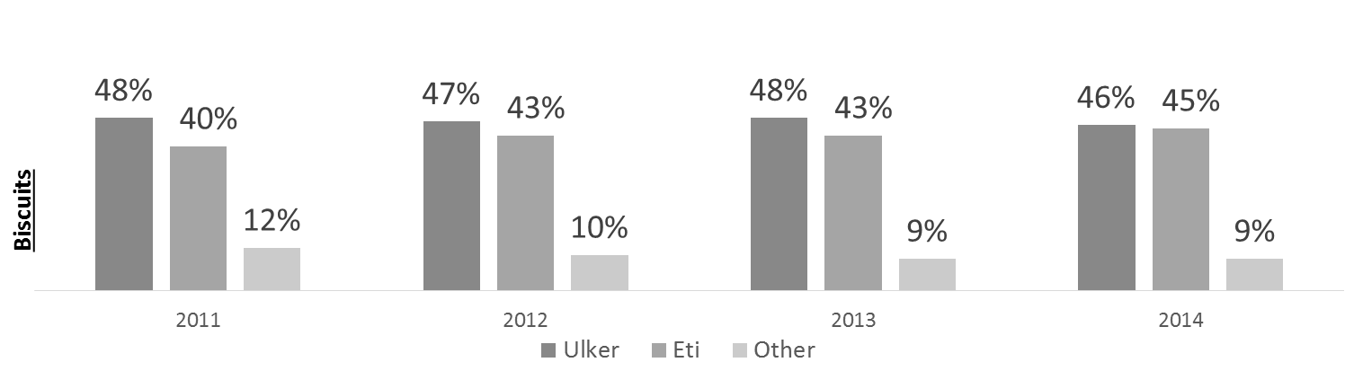



EXHIBIT 4 (CONTINUED)

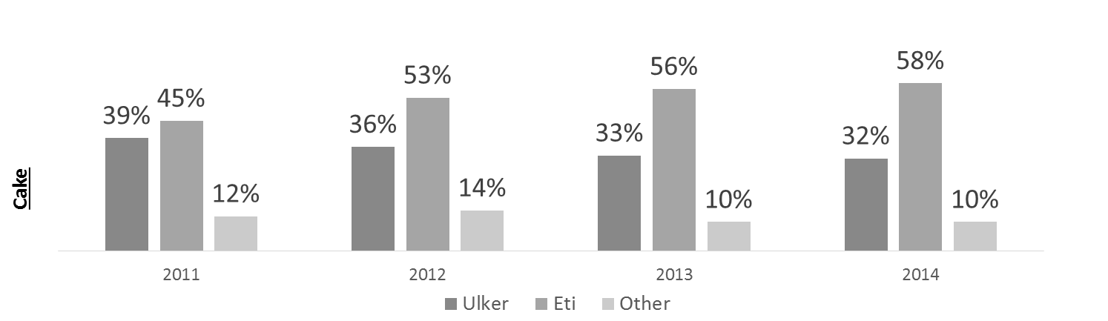

Note: Market shares may not add up to 100 per cent, due to rounding.

Source: Company documents.

Exhibit 5: Yildiz global presence

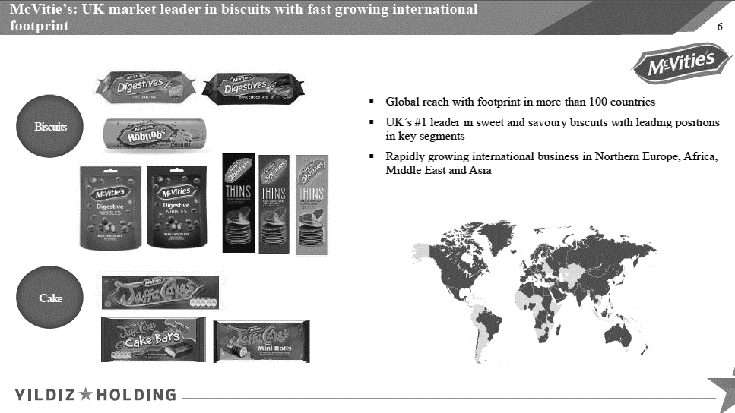

EXHIBIT 5 (CONTINUED)

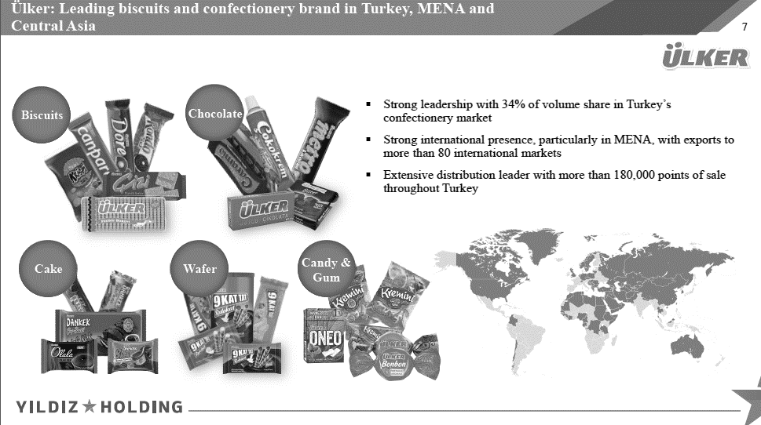

Note: MENA = Middle East and North Africa.

Source: Company documents.

Exhibit 6: largest biscuits companies in the world (2014)

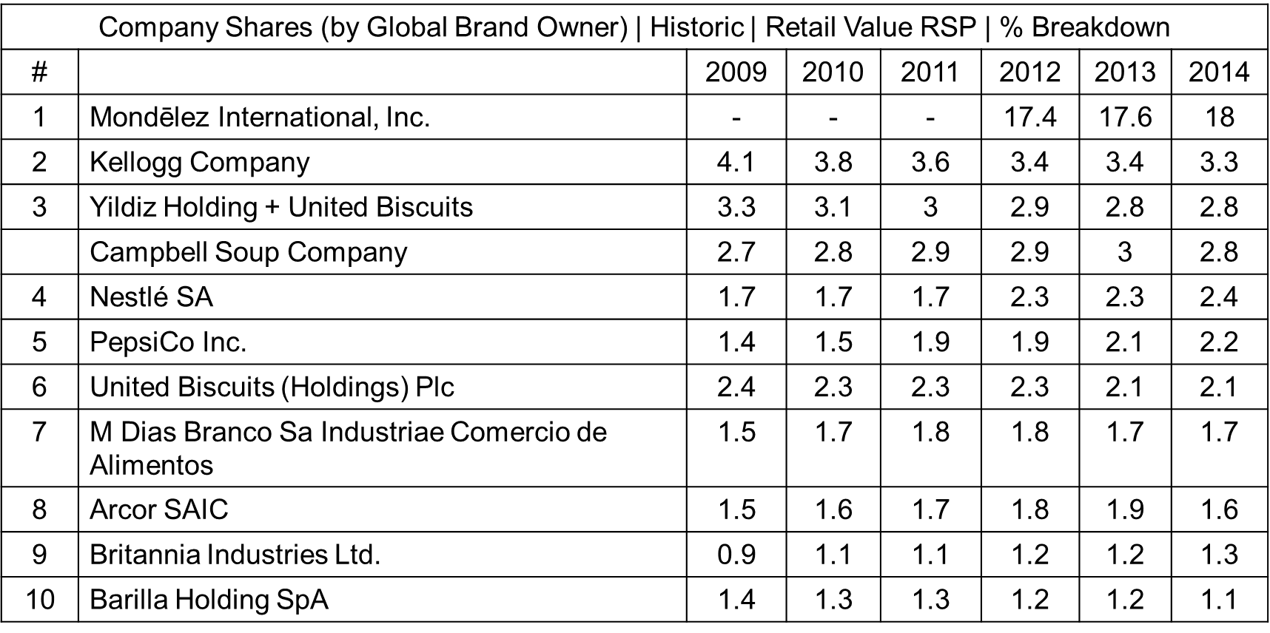

Note: RSP = retail sale price.

Source: Company documents.

Exhibit 7: Mondelēz International Sales by Category and Sales by Geography

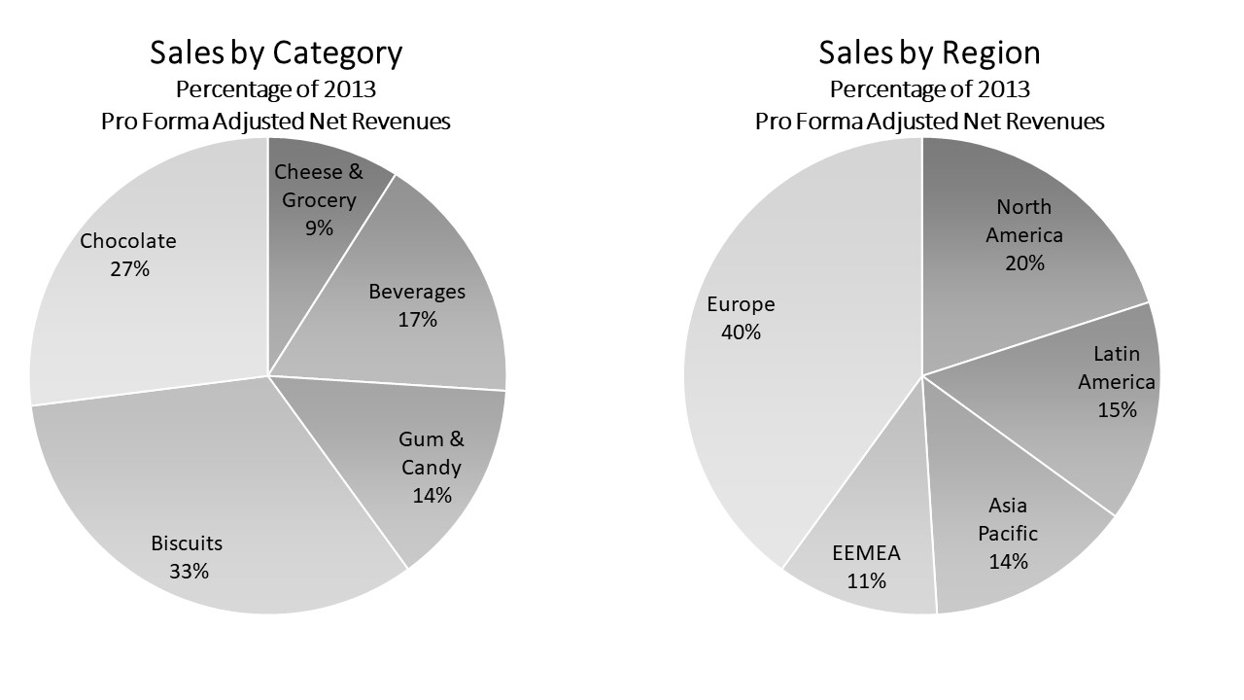

Note: EEMEA = Eastern Europe, Middle East, Africa.

Source:Mondelēz International, *Fact Sheet* *2014: Unleashing a Global Snacking Powerhouse*, accessed December 8, 2018, www.mondelezinternational.com/~/media/mondelezcorporate/za/Uploads/downloads/mondelez_intl_fact_sheet.pdf.

1. Asli Kandemier, “UPDATE 2—Turkey’s Yildiz Buys United Biscuits as Pursues Global Quest,” Reuters, November 3, 2014, accessed November 20, 2015, www.reuters.com/article/yildizholding-unitedbiscuits/update-2-turkeys-yildiz-buys-united-biscuits-as-pursues-global-quest-idUSL6N0ST3OI20141103.
2. Pelin Turgut, “Ülker: Ambitious Confectioner Snaps Up Belgium’s Godiva,” *Financial Times*, November 28, 2008, accessed November 20, 2015, www.ft.com/content/f071969e-bcdb-11dd-af5a-0000779fd18c; all currency amounts are in US dollars unless otherwise specified.
3. “Life Story,” Ülker, accessed November 2015, [www.ulker.com.tr/en/meet-ulker/message-from-honarary-president/life-story](http://www.ulker.com.tr/en/meet-ulker/message-from-honarary-president/life-story).
4. Ülker, *Ulker: Management Presentation*, June 2012, accessed November 20, 2015, [www.ulkerbiskuvi.com.tr/documents/Ulker/pdf/Ulker_Presentation_June_2012.pdf](http://www.ulkerbiskuvi.com.tr/documents/Ulker/pdf/Ulker_Presentation_June_2012.pdf).
5. Okutgen Irem, *Ulker Biskuvi Outperform*, *Garanti Securities*, June 18, 2015, accessed November 20, 2015, https://rapor.garantiyatirim.com.tr/arastirma/ULKER062015.pdf.
6. Mustafa Önder Kiyiklik interview with global head of Corporate Strategy at Yildiz Holding, October 12, 2017.
7. Rohit Deshpande and Esel Cekin, *Rebranding Godiva: The Yildiz Strategy* (Boston, MA: Harvard Business Publishing, 2015). Available from Ivey Publishing, product no. 515059.
8. “United Biscuits Sold to Turkey’s Yildiz for £2bn,” British Broadcasting Corporation (BBC), November 3, 2014, accessed November 20, 2015, [www.bbc.co.uk/news/business-29885332](http://www.bbc.co.uk/news/business-29885332).
9. £ = GBP = British pound; US$1 = £0.63957 on November 30, 2014.
10. The Nielsen Company (US), LLC, *Snack Attack: What Consumers Are Reaching for around the World*, September 2014, accessed January 30, 2016, www.nielsen.com/content/dam/nielsenglobal/kr/docs/globalreport/2014/Nielsen%20Global%20Snacking%20Report%20September%202014.pdf.
11. Ibid.
12. Laura Wood, “Research and Markets: The US Snack Foods Manufacturing Industry Is Concentrated: The Top 50 Companies Account for 75 Per Cent of Industry Revenue,” Business Wire, February 22, 2010, accessed November 20, 2015, www.businesswire.com/news/home/20100222006355/en/Research-Markets-Snack-Foods-Manufacturing-Industry-Concentrated.
13. Beth Hoffman, “Mars, Nestle Commit to Better Chocolate, for All,” *Forbes*, March 26, 2013, accessed November 30, 2015, [www.forbes.com/sites/bethhoffman/2013/03/26/mars-nestle-commit-to-better-chocolate-for-all/#10c13d1865f3](http://www.forbes.com/sites/bethhoffman/2013/03/26/mars-nestle-commit-to-better-chocolate-for-all/#10c13d1865f3).
14. Mondelēz International, *2014* *Annual Report*, accessed December 8, 2018, https://ir.mondelezinternational.com/static-files/8310aaa4-55a8-49c7-9358-88b1c34bb1c0?CIK=1103982&filingID=1193125-15-55355.
15. Ibid.
16. Annie Harrison-Dunn, “Yildiz Still Lacks ‘Power Brands’ after United Biscuits Buy: Analyst,” Confectionary News, November 5, 2014, accessed November 15, 2015, [www.confectionerynews.com/Manufacturers/Yildiz-still-lacks-power-brands-after-United-Biscuits-buy-Analyst](http://www.confectionerynews.com/Manufacturers/Yildiz-still-lacks-power-brands-after-United-Biscuits-buy-Analyst).
17. Scheherazade Daneshkhu, “Big Food Groups Take Healthy Approach in Battle of the Snacks,” *Financial Times*, February 22, 2017, accessed March 20, 2017, [www.ft.com/content/1dc7eaee-de48-11e6-86ac-f253db7791c6](https://www.ft.com/content/1dc7eaee-de48-11e6-86ac-f253db7791c6).
18. Food Business News, “Snacks—The Year in Review,” Food Business News, October 27, 2014, accessed March 2017, www.foodbusinessnews.net/articles/3367-snacks-the-year-in-review.
19. Caroline Fairchild, “Why Kind Bars Are Suddenly Everywhere,” *Fortune*, February 10, 2014, accessed March 2017, http://fortune.com/2014/02/10/why-kind-bars-are-suddenly-everywhere/.
20. Annie Gasparro, “General Mills Whips Yoplait into Shape,” *The Wall Street Journal*, December 14, 2017, accessed March 2017, www.wsj.com/articles/general-mills-whips-yoplait-into-shape-1418609154.