

9B18M192

background note on turkey

Saul Estrin, Christine Côté, and Katherine Nunner wrote this case solely to provide material for class discussion. The authors do not intend to illustrate either effective or ineffective handling of a managerial situation. The authors may have disguised certain names and other identifying information to protect confidentiality.

*This publication may not be transmitted, photocopied, digitized, or otherwise reproduced in any form or by any means without the permission of the copyright holder. Reproduction of this material is not covered under authorization by any reproduction rights organization. To order copies or request permission to reproduce materials, contact Ivey Publishing, Ivey Business School, Western University, London, Ontario, Canada, N6G 0N1; (t) 519.661.3208; (e)* [*cases@ivey.ca*](mailto:cases@ivey.ca)*;* [*www.iveycases.com*](http://www.iveycases.com)*.*

Copyright © 2018, Ivey Business School Foundation Version: 2018-12-21

economic and political environment

Turkey is a relatively large country at the crossroads of Europe and Asia. With a population of nearly 79 million people and gross domestic product (GDP) of almost US$800 billion[1] in 2015,[2] Turkey ranks with Brazil, China, Russia, and South Africa as an “upper middle income” economy.[3] Modern Turkey grew out of the Ottoman Empire, which until World War I dominated Southern Europe, the Middle East, and Egypt.

After the fall of the Ottoman Empire, Kemal Attatürk—Turkey’s founding father—created a secular state, though Islam remained the dominant religion. His reforms included introducing Western scripts and numbers, banning many traditional rules and norms including the fez (a traditional Turkish hat), and establishing women’s rights to vote and be elected. He also spearheaded a “Turkification” of the economy that saw the emergence of large business groups (BGs).[4] Economic liberalism and integration into the world economy has been a consistent policy since the 1980s, though there was significant political instability including coups and periods of military rule in the 1960s–1980s.[5] Since 2002, the secular tradition has been increasingly challenged by the political success of Recep Erdogan and his Islamicist AKP party. Erdogan was prime minister until 2014, when he became the country’s first directly elected president.[6]

Turkey’s GDP per capita was fairly static, in dollar terms, during the 1990s but grew rapidly from 2001 (see Exhibit 1), in line with the other major emerging markets (see Exhibit 2). However, domestic growth has slowed again since around 2010. Structural economic problems include a persistent balance of payments deficit, representing around 4–6 per cent GDP, between 2010 and 2015. The economy is also highly reliant on energy imports, which are only partially financed by foreign direct investment inflows (e.g., around $17 billion in 2015). Finally, the economy shows a tendency toward inflation, with bouts of very high inflation seen during the period before and after 2000, and somewhat lower, but still high levels around 8–10 per cent between 2010 and 2015.[7]

The country’s institutional voids

Turkey has been democratic since the 1990s, and the AKP has won every election since 2002; its leader, Erdogan, presides over an increasingly divisive political regime. A key fault line is between the secularist, economically liberal tradition of Atatürk, and the increasingly conservative and traditionally Islamic rhetoric and policies of the AKP. These sometimes find voice in violent street demonstrations in cosmopolitan Istanbul over issues such as women’s rights or the environment.[8]

Despite recent progress, the Turkish business environment still causes many problems for business. The country ranks 69th out of 190 in the World Bank 2018 Doing Business ranking, comparable with China at 78th and South Africa at 74th. The World Justice project[9] sees Turkey at or near the norm for development level in terms of corruption (which therefore remains quite a serious problem), and as especially poor in terms of fundamental rights and criminal justice; Turkey therefore suffers many of the problems—in terms of corruption, the rule of law, and human rights—typical of middle-income countries.[10]

emergence of and rationale for business groups in Turkey

Initially, the Turkish economy grew in the period 1920–1980 largely behind tariff walls and based on the benign support for domestic businesspeople by the nationalist regime.[11] This environment encouraged the widespread development of large BGs, which came to dominate much of the business landscape—and that remain the key players in the Turkish economy to this day. BGs are a set of legally independent firms linked by ownership and a variety of other formal and informal ties that act in a coordinated manner.[12] They exist in most economies but are especially common in emerging markets.[13] BGs are viewed as an efficient or functional response to institutional underdevelopment, filling voids in themarket-supporting infrastructure and enabling firms to acquire resources that would be otherwise unavailable in the business environment of emerging markets.[14] However, it is argued that BGs might begin to disappear with increasing economic development. This is because it becomes more profitable for individual firms to be unaffiliated with a BG when domestic markets are able to provide the resources and capabilities more efficiently and cheaply than from within the BG. Under this scenario, group affiliation should become progressively less prevalent following institutional and economic development.[15]

The rise of BGs in Turkey was associated with Attatürk’s nationalist revolution, and Yildiz Holding, together with other family companies of that generation, was part of the national secular elite protected in the early days. As we have seen, Turkey’s economic strategy from the 1930s was to develop local national champions supported by the state and growing behind a relatively protected tariff and regulatory wall hindering foreign competitors,. However, the Turkish economy began to integrate more closely with the rest of the world from the 1980s, and as part of this movement to engage with globalization, the protectionist barriers were gradually reduced. However, most business groups were by then sufficiently well positioned to survive that transition. The Muslim AKP party took office from 2001, and maintained the policy of global integration. However, it represented a somewhat different elite and the close relationship between the government and these business groups no longer exists. This is significant because in an environment with institutional voids, political ties can be very important, though perhaps more in creating a business than in maintaining one.

Exhibit 1: Turkey Gross Domestic Product Per Capita

Note: GDP = gross domestic product.

Source: The World Bank, *Turkey GDP per Capita: World Development Indicators*, accessed November 20, 2015, https://data.worldbank.org/indicator/NY.GDP.PCAP.CD.

Exhibit 2: Gross Domestic Product growth—select countries

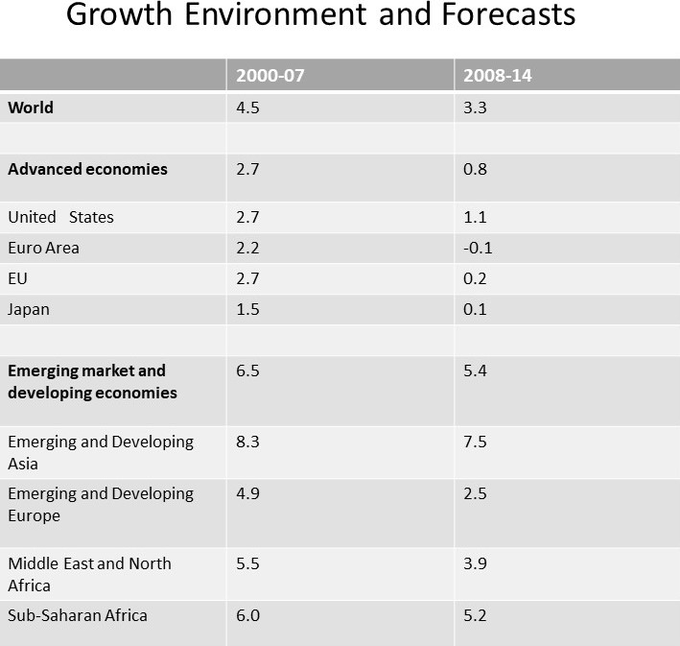

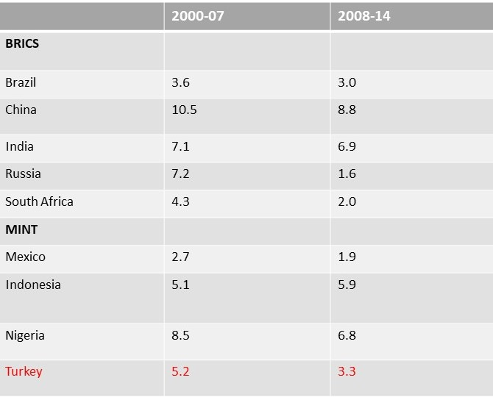

Note: BRICS = Brazil, China, India, Russia, and South Africa; MINT = Mexico, Indonesia, Nigeria, and Turkey

Source: International Monetary Fund (IMF), “Uneven Growth, Short and Long Term Factors 2015”, *World Economic Outlook (WEO) Update*,” January 2015, accessed November 20, 2015, www.imf.org/external/pubs/ft/weo/2015/01/.

1. All currency amounts are in US$ unless otherwise specified.
2. The World Bank, *World Development Report: Governance and the Law*, 2017, accessed March 2017, www.worldbank.org/en/publication/wdr2017.
3. Jim O’Neill, *The Growth Map (*London, UK: Penguin, 2011).
4. Erik J. Zurcher, *A History of Modern Turkey* (London, UK: I B Tauris, 2004).
5. Faruk Selcuk, Libby Rittenberg, and Aykut Kibritcioglu, *Inflation and Disinflation in Turkey (*London, UK: Routledge, 2002).
6. Sevket Pamuk, Globalization, Industrialization, and Changing Politics in Turkey (Cambridge, UK: Cambridge University Press, 2008).
7. Faruk Selcuk, Libby Rittenberg, and Aykut Kibritcioglu, *Inflation and Disinflation in Turkey (*London, UK: Routledge, 2002).
8. Human Rights Watch, “Turkey: Events of 2017,” *Reuters*, accessed March 2017, [www.hrw.org/world-report/2018/country-chapters/turkey](https://www.hrw.org/world-report/2018/country-chapters/turkey).
9. World Justice Project Reports, 2015, accessed March 2017, <https://worldjusticeproject.org/our-work/publications/world-justice-project-reports>.
10. The World Bank Group, *Doing Business 2018: Reforming to Create Jobs*, accessed 2018, www.doingbusiness.org/content/dam/doingBusiness/media/Annual-Reports/English/DB2018-Full-Report.pdf.
11. Erik J. Zurcher, op. cit.
12. Asli M.Coplan, “Turkish Business Groups,*”* in Asli M. Colpan, Takashi Hikino, and James R. Lincoln, *Handbook of Business Groups* (Oxford, UK: Oxford University Press, 2010).
13. Tarun Khanna and Krishna G Palepu, “The Future of Business Groups in Emerging Markets: Long-Run Evidence from Chile,” *Academy of Management Journal*, 43 (2000), 268–285.
14. Michael Carney, Marc van Essen, Saul Estrin, and Daniel Shapiro, “Business Groups Reconsidered: Beyond Paragons and Parasites,” *Academy of Management Perspectives* (forthcoming).
15. Ibid.