|  |  |
| --- | --- |
|  | **logo_greyscale** |

9B18M194

SWIGGY: OPTIMIZING CASH BURN

[Singfat Chu](https://iveypubs.my.salesforce.com/003A000001CqZDK) and [Venkata Praneeth Tammiraju](https://iveypubs.my.salesforce.com/0031J00001QrUbC) wrote this case solely to provide material for class discussion. The authors do not intend to illustrate either effective or ineffective handling of a managerial situation. The authors may have disguised certain names and other identifying information to protect confidentiality.

This publication may not be transmitted, photocopied, digitized, or otherwise reproduced in any form or by any means without the permission of the copyright holder. Reproduction of this material is not covered under authorization by any reproduction rights organization. To order copies or request permission to reproduce materials, contact Ivey Publishing, Ivey Business School, Western University, London, Ontario, Canada, N6G 0N1; (t) 519.661.3208; (e) cases@ivey.ca; www.iveycases.com. Our goal is to publish materials of the highest quality; submit any errata to publishcases@ivey.ca. i1v2e5y5pubs

Copyright © 2021, National University of Singapore and Ivey Business School Foundation Version: 2021-08-18

In August 2015, Sriharsha Majety, the chief executive officer (CEO) of Swiggy,[[1]](#footnote-1) walked out of the office of yet another venture capital (VC) firm with mixed emotions. While the discussions had not ruled out another round of funding, the VC managing partner was not inclined to invest further in Swiggy anytime soon. Majety remembered the managing partner’s parting words: “Food delivery is a tough business everywhere. We like what Swiggy has done so far, but we have reached the end of our investment cycle. Why don’t we meet in a few months when we will have raised fresh funds? Swiggy would have grown and would be more appetizing then.” These words more or less echoed the sentiments of the other VC firms Majety had visited, and there were no more VC firms left on his visiting list.

Majety now had to think about how to survive the impending funding “winter,” which he expected would last for about one year. He was confident Swiggy’s on-demand food delivery business would continue to grow exponentially. However, its cash reserves would not suffice to finance the cash burn needed to support its growing operations and market share. One option considered by his associates was to suspend operations in some localities. But this was quickly dismissed, as they had toiled hard to open up these localities. Also, a diminished Swiggy would not be attractive to future investors; it had to stay in all of its present localities and adjust its operations in order to survive and attract fresh VC funds.

OVERVIEW

Just over one year earlier, Majety and two of his friends[[2]](#footnote-2)—Nandan Reddy and Rahul Jaimani—plunged into the food delivery business after a bad experience ordering food in Bengaluru, India. Pizza was about the only food being delivered. Most restaurants did not deliver, or if they did, they mandated a large order value or made extremely delayed deliveries. Majety and his friends saw the opportunity for a modern delivery firm offering responsive on-demand services and food diversity—thus, Swiggy was born.

Given their previous work experience, Majety took on the role of CEO, while Reddy and Jaimani took charge of the business and information technology platform developments. Their common ambition was to develop Swiggy into the go-to, on-demand delivery service for hyperlocal food in Bengaluru—and then across India.

Swiggy would act as an intermediary between three parties—the consumer, the restaurant, and the delivery rider. Swiggy built applications (apps) for each of these parties and interconnected them into a marketplace. Swiggy’s consumer app listed restaurant partners within a three-to-five-kilometre vicinity of the consumer’s current or chosen delivery location to enable “lightning fast” deliveries, typically within 30 minutes. Consumers could order from the menu of each restaurant partner and either prepay online or upon delivery. As soon as an order was received on the consumer app, Swiggy would relay it to the restaurant and to a delivery rider in the vicinity.

Upon arrival at a restaurant, a rider would check all of the ordered items before placing them in insulated bags (provided by Swiggy) to ensure optimal delivery condition. Riders used their own motorcycles and were compensated for their gasoline expenses via a bonus for each delivery. Each delivery was decided using an algorithm that considered factors such as the distance of the rider from the restaurant, the familiarity of the rider with the delivery location, and the equitable distribution of orders among riders. Because Swiggy prioritized top-notch customer experience, over the past year it had meticulously ironed out many issues pertaining to the rider’s role as a Swiggy brand ambassador: greeting customers and accepting customer feedback, accepting or rejecting orders, and dealing with order pileup during peak times.

Swiggy’s key differentiators for its initial success in Bengaluru had been the eclectic selection of restaurant partners, the development of smart phone apps for easy ordering and real-time tracking by customers, no delivery fees (following the suspension of an initial delivery fee for orders below ₹200[[3]](#footnote-3)), and professional and fast deliveries due to the strategic decisions to employ full-time riders and enforce a limit of one order per delivery. These elements had been the foundation of its customer retention. Swiggy credits, which were offered for new referrals, had also proven to be a productive customer-acquisition strategy.

The demand for Swiggy’s services was not uniform across Bengaluru; the services were more popular in business districts and dense residential localities than in recently developed suburbs. Variation in demand and in the size of order bills across geographies had led Swiggy to classify areas or localities into three tiers: tier 1 (premium), tier 2 (mid-range), and tier 3 (low) (see Exhibit 1).

Swiggy paid its riders a weekly base salary and a bonus for each delivery. The payment terms differed across the tiers in view of the number of orders, the average order amount, and the productivity levels of the riders. Swiggy had no difficulty procuring riders that were often university graduates who were attracted by the pay, the opportunity to be their own boss, and the opportunity to meet interesting customers.[[4]](#footnote-4) Swiggy was charging its restaurant partners 15 per cent commission, on average. It was earning the most in tier 1 localities, which had both the highest number of orders and the highest average order bill size. Generally, the more productive riders operated in tier 1 and tier 2 localities, and they were paid more than those in tier 3 localities (see Exhibit 2). For example, CBD was classified as a tier 2 locality. There, riders earned a weekly base salary of ₹1,700, plus a bonus of ₹30 (after gasoline expenses incurred by the rider, this would be more like ₹26) for each order delivery. A typical order bill in the CBD locality was ₹292, on which Swiggy earned about 15 per cent, or ₹43.80. The CBD locality recorded 7,339 deliveries in week 52 at the end of the first year of operations. That business volume required about 90 riders who were each capable of making about 82 deliveries weekly (see Exhibit 1).

PROBLEM AT HAND

Seed capital from Swiggy’s founders and a series-A round of VC funding had helped Swiggy grow in its first year of operations. Swiggy started deliveries in August 2014; in its first week of operations across 15 localities within metropolitan Bengaluru, it had made almost 34,000 deliveries. By week 52, just prior to Majety seeing the final VC firm in the hope of fresh funds, the number of deliveries had more than tripled across the 15 localities. However, available data on payments to riders and commission earnings made it obvious that Swiggy was burning cash on each delivery (see Exhibit 2). For example, a typical rider in a tier 2 locality who made 82 deliveries per week was paid a fixed salary, plus bonuses, amounting to ₹4,160—but Swiggy was only earning about ₹3,592 in commissions. In short, the cash burn was about ₹7 per delivery. In the first 52 weeks of operations, Swiggy had a total cash burn of about ₹20 million in its delivery operations.

While Swiggy had shown credible growth, in August 2015 the Indian VC landscape looked grim, as many on-demand food delivery start-ups had failed and died. Majety resigned himself to the stark reality that Swiggy would have to survive the upcoming “winter” with its remnant funds. He believed that VC firms would be in a better mood to invest in about a year.

After accounting for marketing, technology, and administration expenses, Swiggy had about ₹28 million in cash reserves left to finance the delivery operations’ cash burn. Swiggy believed that as long as it maintained its marketing expenses, growth patterns would persist in all localities.

Exhibit 3 illustrates the historical number of deliveries in the past 52 weeks for KRM, JPN, and FRT, respectively classified as tier 1, 2, and 3 localities. An in-house data scientist had concluded that an exponential growth model provided the best fit with the weekly deliveries. Thus, for the first 52 weeks of operation in the KRM locality, the estimated model had a base level of about 5,250.6 weekly deliveries, while the week-on-week growth was about 2.25 per cent. Because the exponential growth model provided a good fit with the data (with an r-squared statistic of 0.9098), and the pattern was expected to persist, it was used to project the number of future deliveries; therefore, for the forthcoming week 53, about 5250.6e.0225x53, or 17,303, deliveries would be expected.[[5]](#footnote-5) Exhibit 3 displays similar projections up until week 104. The bottom half of Exhibit 1 reports the estimated exponential models and the forecasts for all 15 localities.

Because forecasting accuracy could be a concern due to the range in r-squared (0.74 to 0.95) across the 15 localities, the same methodology was applied to the total weekly deliveries across the three tier 1, five tier 2, and seven tier 3 localities (see Exhibit 4). The fitted models had r-squared statistics of 0.9655, 0.9694, and 0.9649, respectively. Interestingly, although the tier 2 localities started with a lower base, their total weekly orders were projected to surpass those of the three tier 1 localities from week 63 due to their higher exponential growth rate. This may have influenced Swiggy’s decision to stay in all localities.

Swiggy’s accountant had estimated that the projected deliveries across all 15 localities for the forthcoming weeks 53–104 would require a cash burn of about ₹70 million, or about 150 per cent above ₹28 million in available cash reserves. Without fresh funds, the expected ₹42-million shortfall would have to be covered through operational adjustments. To keep operations as smooth as possible, the accountant had advised Majety to implement the adjustments at the start of any of the forthcoming four quarters. Once implemented, they would stay in place until the end of the upcoming fourth quarter. As Swiggy would not budge from its fundamental principle of “zero delivery fee for any order,” Majety was now left with the delicate task of concocting one or several adjustments that would be minimally painful to its stakeholders (i.e., the delivery riders and/or restaurant partners). The accountant had already prepared a file containing the order forecasts and the accounting calculations for the next four quarters (see Exhibit 5); Majety simply had to tweak certain cells to configure the adjustments needed to stay afloat and possibly make a profit from the operations (see Exhibit 6).

To survive the upcoming funding “winter,” Majety reasoned that the adjustments would have to be few and as digestible as possible in order to be explained persuasively to and approved by the stakeholders. Their buy-in would constitute a success story of resilience, ingenuity, and team adaptability, which Swiggy could highlight in a future series-B VC funding round for further expansion in Bengaluru and beyond.

EXHIBIT 1: HISTORICAL (WEEKS 1–52) AND PROJECTED (WEEKS 53–104) ORDERS

|  |  |  |  |  |  |  |  |  |  |  |  |  |  |  |  |
| --- | --- | --- | --- | --- | --- | --- | --- | --- | --- | --- | --- | --- | --- | --- | --- |
| **Tier** | **1** | **1** | **1** | **2** | **2** | **2** | **2** | **2** | **3** | **3** | **3** | **3** | **3** | **3** | **3** |
| **Locality** | HSR | IND | KRM | CBD | JPN | JYN | MLS | MRT | ELC | FRT | HBL | RJJ | SNT | WLG | WTF |
| Week 1 | 3,410 | 7,470 | 5,821 | 1,449 | 2,294 | 2,484 | 2,224 | 1,798 | 646 | 1,103 | 669 | 1,322 | 1,331 | 743 | 957 |
| Week 2 | 3,156 | 6,405 | 4,871 | 1,596 | 2,298 | 2,616 | 2,293 | 1,576 | 647 | 1,134 | 581 | 1,356 | 1,188 | 755 | 771 |
| Week 51 | 9,498 | 21,869 | 15,636 | 7,026 | 11,039 | 8,601 | 7,389 | 7,989 | 1,745 | 1,779 | 2,553 | 2,343 | 3,569 | 1,596 | 3,842 |
| Week 52 | 10,262 | 22,691 | 17,057 | 7,339 | 12,450 | 9,865 | 8,407 | 7,350 | 2,041 | 1,928 | 2,463 | 2,838 | 3,375 | 1,522 | 4,035 |
| **R-sq** | **0.92** | **0.90** | **0.91** | **0.90** | **0.87** | **0.93** | **0.93** | **0.88** | **0.82** | **0.71** | **0.83** | **0.84** | **0.82** | **0.95** | **0.83** |
| *Week 53* | *9,725* | *19,293* | *17,303* | *6,998* | *11,149* | *7,762* | *8,412* | *7,942* | *1,684* | *1,906* | *2,745* | *2,819* | *3,080* | *1,711* | *3,811* |
| *Week 54* | *9,925* | *19,742* | *17,697* | *7,201* | *11,472* | *7,932* | *8,640* | *8,172* | *1,715* | *1,925* | *2,843* | *2,860* | *3,140* | *1,739* | *3,913* |
| *Week 103* | *26,834* | *60,930* | *53,295* | *29,239* | *46,585* | *22,857* | *31,965* | *33,021* | *4,224* | *3,126* | *15,872* | *5,706* | *8,204* | *3,827* | *14,195* |
| *Week 104* | *27,385* | *62,347* | *54,508* | *30,088* | *47,937* | *23,356* | *32,830* | *33,975* | *4,302* | *3,157* | *16,439* | *5,787* | *8,367* | *3,889* | *14,573* |

Notes: R-sq = the closeness of fit between the data and the model. For each locality, an exponential growth model was estimated based on the locality’s orders in the first 52 weeks. Projected orders in week 53–04 are extrapolations of the estimated models.

Source: Created by the authors using company information.

EXHIBIT 2: RIDER PAYMENTS & PRODUCTIVITY, COMMISSION EARNED BY SWIGGY

|  |  |  |  |  |  |
| --- | --- | --- | --- | --- | --- |
| **Tier** | **Weekly Base Salary (₹)** | **Bonus per Order Delivered (₹)** | **Average Orders Delivered by Rider per Week** | **Average Order Value (₹)** | **Average Commission (%)** |
| 1 | 2,000 | 35 | 90 | 340 | 15 |
| 2 | 1,700 | 30 | 82 | 292 |
| 3 | 1,500 | 25 | 75 | 260 |

Note: ₹ = INR = Indian rupee; all currency amounts are in ₹ unless otherwise specified; ₹1 = US$0.0156 on August 1, 2015.

Source: Created by the authors using company information.

EXHIBIT 3: ILLUSTRATIVE HISTORICAL (SOLID LINE) AND PROJECTED (DOTTED LINE) WEEKLY ORDERS of TIER 1, 2, and 3 localities

Exponential model fit for tier 1 (i.e., KRM) weekly orders ~ 5250.6e.0225 Week#, r-squared = 0.91

Exponential model fit for tier 2 (i.e., JPN) weekly orders ~ 2448.5e.0286 Week#, r-squared = 0.87

Exponential model fit for tier 3 (i.e., FRT) weekly orders ~ 1127.3e.0099 Week#, r-squared = 0.71

Source: Created by the authors using company information.

EXHIBIT 4: HISTORICAL (SOLID LINE) AND PROJECTED (DOTTED LINE) total weekly ORDERS ACROSS TIER 1, 2, and 3 LOCALITIES

Exponential model fit for tier 1 localities weekly total orders ~ 14314e.0222 Week#, r-squared = 0.97

Exponential model fit for tier 2 localities weekly total orders ~ 10345e.0266 Week#, r-square = 0.97

Exponential model fit for tier 3 localities weekly total orders ~ 6247.2e.0196 Week#, r-squared = 0.96

Source: Created by the authors using company information.

EXHIBIT 5: simulation template of PROJECTED CASH BURN AND POTENTIAL OPERATIONAL ADJUSTMENTS IN NEXT four QUARTERS

**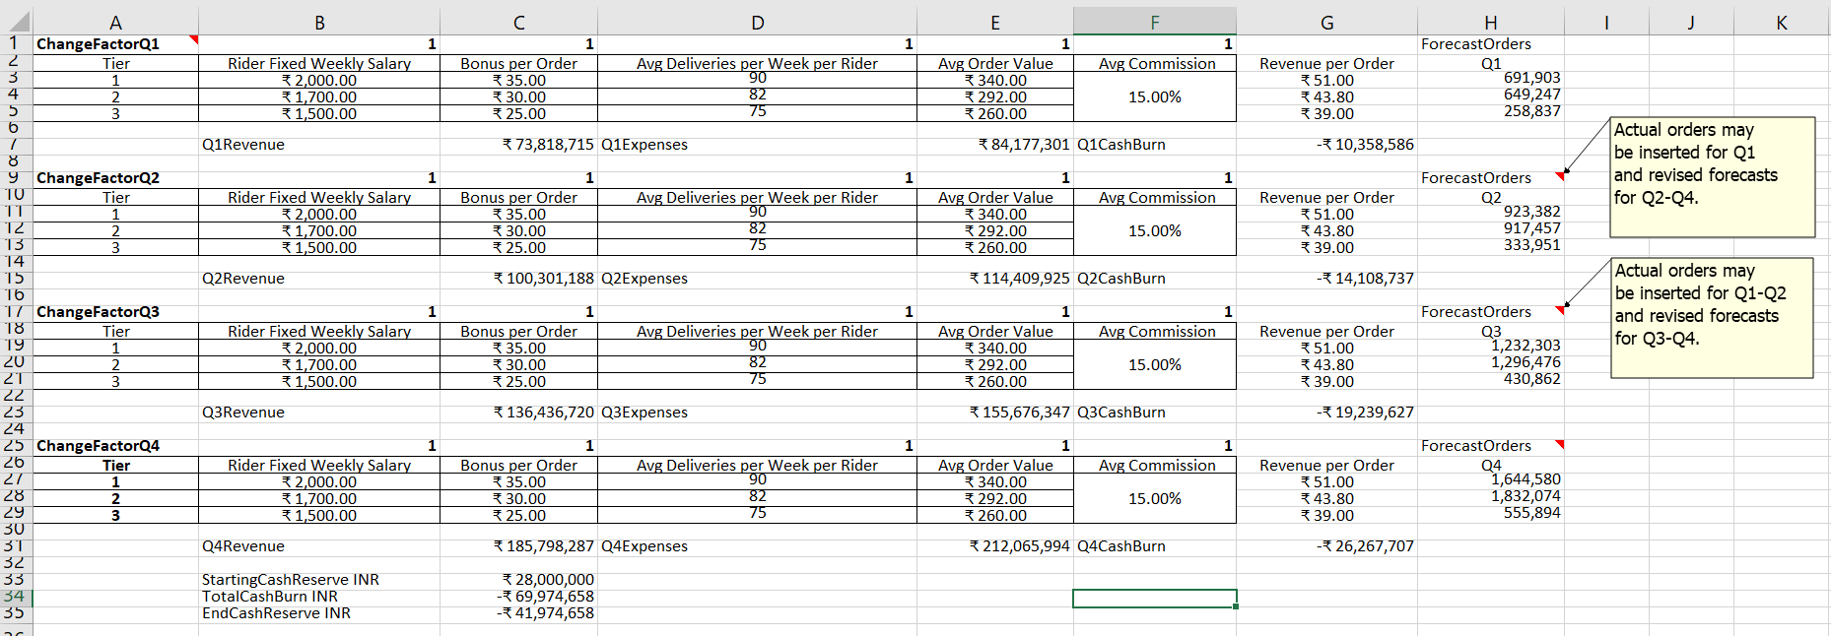**

Note: Any adjustment to the change factors at the beginning of a quarter will be automatically reflected in subsequent quarters. For example, changing B1 from 1 to 0.98 will cut the fixed weekly salary of riders in B3 to B6 (and automatically to B11–B13, B19–B21, and B26–B29) by 2 per cent. A combination of change factors may be used—for example, C9 (to adjust bonus per delivery from Q2) and F17 (to adjust commission rate from Q3). The template is also flexible with the use of actual (when available) and updated forecasted deliveries across each the three tiers of localities.

Source: Created by the authors using company information.

EXHIBIT 6: ILLUSTRATION OF OPERATIONAL ADJUSTMENTS

**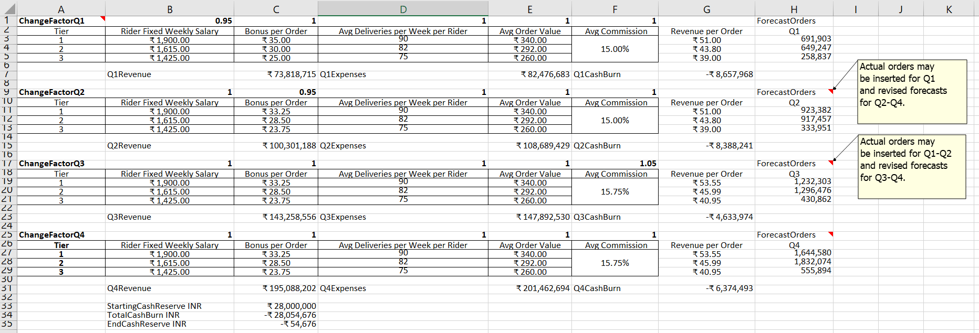**

Notes: This screenshot illustrates a combination of three operational adjustments: (1) a 5-per-cent reduction in the fixed weekly salary of all riders from Q1 (i.e., B1 = 0.95); (2) a 5-per-cent reduction in the bonus per delivery from Q2 (i.e., C9 = 0.95); and (3) a 5-per-cent increase in commission rate from Q3 (i.e., F17 = 1.05, which results in projected cash reserves of −₹54,676 at the end of the forthcoming four quarters.

Source: Created by the authors using company information.

1. Swiggy (website), accessed August 1, 2018, <https://www.swiggy.com/>. [↑](#footnote-ref-1)
2. Alok Soni, “Bengaluru-Based Swiggy Takes Food Ordering and Delivery Hyperlocal, Secures $2 Million Funding,” YourStory, April 5, 2015, <https://yourstory.com/2015/04/swiggy/>. [↑](#footnote-ref-2)
3. ₹ = INR = Indian rupee; all currency amounts are in ₹; ₹1 = US$0.0156 on August 1, 2015. [↑](#footnote-ref-3)
4. Apurva Venkat, *Bangalore Mirror* Bureau, “These Engineers Want to Be Delivery Boys,” *Times of India*, January 4, 2016, <https://timesofindia.indiatimes.com/city/bengaluru/Theseengineers-want-to-be-delivery-boys/articleshow/50434572.cms>. [↑](#footnote-ref-4)
5. 5250.6e.0225x53 was the formula for the exponential forecasting model. [↑](#footnote-ref-5)