

9B18M201

OHMYCAKE.IN: Scaling up by Scaling back

Nobin Thomas and Abhilash Nambudiri wrote this case solely to provide material for class discussion. The authors do not intend to illustrate either effective or ineffective handling of a managerial situation. The authors may have disguised certain names and other identifying information to protect confidentiality.

*This publication may not be transmitted, photocopied, digitized, or otherwise reproduced in any form or by any means without the permission of the copyright holder. Reproduction of this material is not covered under authorization by any reproduction rights organization. To order copies or request permission to reproduce materials, contact Ivey Publishing, Ivey Business School, Western University, London, Ontario, Canada, N6G 0N1; (t) 519.661.3208; (e)* [*cases@ivey.ca*](mailto:cases@ivey.ca)*;* [*www.iveycases.com*](http://www.iveycases.com)*.*

Copyright © 2018, Ivey Business School Foundation Version: 2018-12-21

On a Sunday morning in January 2017, Thomas Murickan absent-mindedly went over his company’s numbers again. The troubling sales figures brought back memories of a report from his friend Alex:

Last week, I ordered a simple chocolate cake from Ohmycake. It was delivered about two hours late, and when I opened it, I discovered that the icing was all over the place. Thomas, what happened? Your shop had the best cakes in the city, and now it seems like you need to get your company under control.

At the time, Murickan had been rendered speechless. He was ashamed. He knew that business was getting worse, but to hear it from a friend was painful.

Ohmycake.in (Ohmycake) was Murickan’s brainchild, and in just under two years, he had made the company’s name synonymous with cake in Kochi.[1] One day, the results had all been positive; the next, revenues were falling. While busy with expansion and branch openings, Murickan had failed to notice that the business was in trouble. Sales had halved and the quality that he had strived to maintain had degraded. It was getting out of control. He needed to hold a meeting with the chief operating officer (COO), John Rijin, immediately. If sales continued to dip, Murickan knew the game was over. Then, just as he was about to leave for the factory, Rijin called Murickan; Rijin needed direction in dealing with a demanding order for a 3-kilogram Angry Birds cake. How could Murickan gain control of his business and scale up when customers had such extraordinary requests?

MAIDEN VENTURE

Murickan held an MBA from a leading management college in South India. He gained experience in retail marketing by working as a manager at Spencer’s, a department store in Chennai. After a brief stint there, he felt an urge to leave his job to pursue his entrepreneurial ambitions. Thus, he came to Kochi and started scouting for opportunities.

In the early 2000s, Kochi was on the verge of major development. The city was populated with a growing number of young and affluent people who had more sophisticated taste than the market could provide. A lack of established actors in the restaurant sector caught Murickan’s attention. However, his friends and family were not encouraging, pointing out his inexperience in the food and beverage sector. Murickan took it as a challenge to prove his critics wrong.

Under a parent company called Flakes, Bakes, and Confectioneries, Murickan launched Flakes Restaurant, which served authentic Kerala cuisine.[2] Though his restaurant was not located strategically (it was on the outskirts of the city) and prices were a little higher than average, Murickan was under the impression that his target market would not mind travelling long distances to eat quality dishes.

The initial response to Flakes was positive. Early feedback and word-of-mouth goodwill were instrumental in getting more clients to the restaurant. However, the momentum did not last. Within two months, it became clear that the restaurant’s location was a serious constraint that could not be easily fixed. As business lagged, Murickan struggled to accept that his maiden venture, in which he had invested his entire savings, was failing. Finally, he had to disband the business because employees’ salaries could not be paid on time.

ENTRY TO THE BAKERY SECTOR

Even though Murickan’s restaurant had failed, he was determined to correct his mistakes and use his entrepreneurial skill within the food industry. This time, he decided to shift to baked goods and confectionery. His interest was piqued by an article Murickan had seen on Food and Beverage News.[3] The article noted growth in the bakery sector in India and identified probable reasons for the growth as being changes in consumption patterns and the willingness of youth to experiment with new products, their propensity to spend, and their preferences when choosing locations to socialize.

Through his first endeavour, Murickan had learned the critical importance of location, so he decided to conduct a more thorough study of location this time. As a test, he rented space from one of his acquaintances and set up two bakery outlets in the heart of Kochi. The bakeries were crowd-pleasers and Murickan was back in business. Upon discovering the business’s potential, he quickly expanded within the city. Within three months, he was overseeing seven successful outlets.

The steady, fast-paced growth of a novice like Murickan began to interest his competitors. Murickan knew that the only way to sustain his momentum was to make his product unique. He explained, “In baking, the primary ingredients remain the same and hence one cannot differentiate much in taste. The only way to stand apart is through branding and improving the look and feel of the product. My initial success made me realize that I was moving in the right direction.”

Murickan soon found that his business was selling more confectionary products, such as puff pastry and fried items, than all other goods. However, the profit margin on the confectionary products was the lowest and their shelf-life the shortest. Murickan noted, “Puff pastry and other fried items were hardly increasing profit. This brought my attention to other items that could bring me better returns, namely cakes and pastries.”

Murickan now envisioned cake as the future of his business. To realize its potential, he hired marketing students from a nearby business school to conduct a survey on cake consumption patterns in Kochi. The results were encouraging. They showed that people were willing to try different flavours of cake if they were of decent quality and available at affordable prices.

MOVING INTO THE CAKE BUSINESS

With hard data in his favour, Murickan decided to open a store that exclusively sold cakes and pastries. Having understood the decisive importance of location, Murickan chose Kakkanad, a fast-growing information technology (IT) hub within the city, for the first store (see Exhibit 1). Kakkanad was the administrative headquarters of the district of Ernakulam. Moreover, it was home to SmartCity Kochi, the largest industrial IT township in Kerala, and home to InfoPark, Kochi, the second largest industrial park in Kerala.

After the failure of his restaurant, Murickan did not have much working capital at his disposal, leaving him with little to invest in marketing. Yet, he managed to use his savings, generated by the initial bakery outlets, to advertise on several hoardings around the city. Although he was short of money, Murickan never ran short of ideas. Even the name of the shop, Ohmycake, contained a dose of creativity and was an instant hit in Kochi. A personalized mascot designed by Murickan (see Exhibit 2) also attracted customers, alongside the wide array of cakes.

Within a short period of time, Ohmycake became the talk of the city. As Murickan’s clientele grew, his turnover also started to rise. At one point, he found himself unable to fulfill orders on time. Still, throughout, he stayed true to his original vision for Ohmycake: to introduce new flavours and varieties every week. He acknowledged with pride, “It was the most lucrative period of my entire business life. Business just kept growing every day.”

FRANCHISING

With the success of his cake shop in Kakkanad, Murickan began exploring expansion possibilities. However, he was mindful not to commit his own hard-earned cash to new stores. One concept that he considered was a franchise model, and the manager at the first cake shop wanted to become the initial franchisee. Others followed, though Murickan did not employ set criteria when selecting them.

As franchises opened around the city, Ohmycake became a household name in Kochi. However, as the number of outlets increased, so did the challenges. In order to ensure that the franchises’ operations were standardized, Murickan met with each franchisee and explained his expectations to them. Yet, contrary to Murickan’s forecasts, the franchises did not make significant sales, even after a few months of operation. In contrast, his own cake shop was continuing to do good business.

Murickan was in flux. The franchisees had taken the risk of launching a cake shop because of their belief in Murickan and his product. But now, they were only managing to keep themselves afloat. Murickan set out to learn why the model was failing when his own shop was doing well. He discovered that in their hurry to break even, franchisees were cutting corners. At times, franchisees would stock pastries for a third day, even though this was past their estimated shelf life. Customer complaints started pouring in, and the trust that Murickan had built over time was eroding.

The time had come for Murickan to decide whether he should continue with the current model. It was a tough call: if he decided to end the franchise relationships, he knew there would be cost implications and, more importantly, he would lose a large proportion of his customer base. But his reputation for quality had been degraded by the franchise model, and Murickan did not want to cause any more damage. Therefore, he decided to bear the cost of the franchises’ fixtures and fittings, and offloaded the model completely.

MOVING ONLINE

The franchise model might have failed, but it left Murickan with some interesting ideas. He considered how to reach customers other than through brick and mortar stores. Online shopping was becoming popular and Murickan saw a huge opportunity in Kochi. However, a survey he conducted revealed that people preferred to buy cakes from bakeries and stand-alone cake shops like one of Ohmycake’s competitors, Pandhal Cake Shop, where customers could ensure they were satisfied with the physical product.

Despite the circumstances, Murickan considered launching an online portal to be a harmless risk. Within a month, he had started an online cake shop, Ohmycake.in, named after his initial store. He said, “I opened an online cake store when there were none of its kind in Kochi. I tried persuading my customers to shop online. I convinced them not to come to the store because everything they needed was just a click away from home.” However, some people were unable to acclimate to buying a cake without seeing it in a physical outlet. Murickan reported, “After placing an order online, one of my customers kept asking me where the cake would be delivered from—our outlet in Palarivattom or Kakkanad. I asked them, ‘Why does it matter?’”

The online shop helped draw back the old customer base and brought in new consumers who wanted to try Ohmycake’s delicacies. As the company’s popularity increased, Murickan hired more staff. By mid-2016, he had 10 delivery staff, two chefs, two kitchen workers, and two coordinators split between centres in Kakkanad and Irumbanam (10 kilometres apart). However, synergy between the locations and staff was lacking. It soon became apparent that while Murickan was aware of the difficulties that came with increasing orders, he had not anticipated the complexities of fulfilling them. This led to late deliveries, a lack of customer care, and mismatched orders, followed by a large number of complaints. Murickan understood that he could not manage the business alone. He needed help.

Murickan had encountered Rijin, an engineer-turned-entrepreneur who had left his job to start something big of his own, through a mutual acquaintance. A meeting over lunch was enough for Rijin to join the Ohmycake team as COO. Hearing about Murickan’s entrepreneurial adventures made Rijin all the more interested in working with him. Rijin was also impressed with the advances that Murickan had made in the online space.

Rijin spent the next week trying to understand the business to identify problem areas, tackle their root cause, and remodel the company (see Exhibit 3). He interacted with all the internal stakeholders, including chefs, kitchen assistants, and delivery staff. Rijin was surprised to learn that the couriers would travel as far as 70 to 80 kilometres to deliver cakes without levying an extra charge. The numbers did not make sense to him: for one cake worth ₹600,[4] the delivery could cost ₹700.

After a thorough inspection, Rijin understood the key challenge: an inability to optimize systems. In his words, “It was a clear case of over-promise and under-delivery.” To satisfy clientele, the customer care agents had been accepting orders that had no practical chance of being delivered on time with the resources available.

Rijin detailed such an incident:

A week ago, we received an order at about 4 p.m. It was a telephone order for a special cake (the shape of cricket bat and ball), which takes at least two hours to make. After the promised delivery time of 6:30 p.m., the customer called. The customer agent then realized that he had forgotten to log the entry with the kitchen. To save face, he apologized to the customer for the delay. He told the customer that it would be delivered in an hour due to heavy traffic in the city. He called the kitchen and asked them for an urgent delivery of the special cake. The kitchen staff protested, saying they already had a huge pile of orders to fulfill. Half-heartedly, the kitchen staff finally agreed. It took them around two and a half hours to get the cake ready. By that time, the customer had lost his patience and cancelled the order, while other orders kept piling up, waiting to be serviced. The aggrieved customers started calling and there was a long line of cancellations. We lost a lot of customers on that one day.

The issue was partly resolved the next day by implementing a time-slot delivery rather than a fixed-time delivery. An automatic log system was also introduced that transferred the order directly to the kitchen without any manual entry once an order was confirmed. The new system also ensured that customer agents called customers who had placed orders after a particular time (usually after 7 p.m.) to arrange a next-day delivery. They also started providing customers with the option of placing orders a day in advance for next-day deliveries.

The optimization of delivery services was another big issue. Rijin recalled another incident:

There was a customer from Punjab who would call us every year during the Diwali season. She would give us an order for a special cake that needed to be delivered to her best friend in the nearby district. The fact is that we have to deliver the order some 100 kilometres away from Kochi. Murickan did not want to displease the lady who was calling from the other end of the country, so he accepted the order every time. In the beginning, we couldn’t afford to miss even one order. That was okay in the initial days, but imagine if you had some 30 orders like this and only 10 delivery boys. What do we do then?

Rijin slowly took control of operations and understood that a hub and spoke model would work for Ohmycake. He adopted a mechanism whereby couriers could be spread across the city equally, so that any order could be delivered within an hour. The model worked when there were uniform orders. However, the couriers struggled when large numbers of orders arrived.

Looking at the long list of cakes offered (see Exhibit 4), Rijin noted, “I have a lot of scope for improvement here.” Rijin wondered how to streamline the variety of offered cakes and thought of categorizing them into different types, treating them separately in terms of production and sales. Also, while looking at the price list (see Exhibit 4), he realized that some cakes that sold in large volumes were not making enough of a margin; other cakes with higher margins were slow-moving items. He wondered if the customer agents were not being pushy enough with the high-margin items or if it was a case of consumer preference. Rijin was curious and examined the cost, production layout (see Exhibit 5), process (see Exhibit 6), past demand, and price for all cakes sold by Ohmycake. He also looked at the postal codes from where the most orders were placed (see Exhibit 7). Rijin believed that the solution to his problems was hidden in the charts and figures.

The competition was also catching up (see Exhibit 8). Initially, when Murickan started the company, the only competitor was Pandhal, which had a limited and elite clientele. Pandhal only had brick and mortar shops and its cakes were priced at a premium level. Now, in and around the city, there were 24 chain bakery outlets, representing brands such as Navya Bakers, Cake Hut, and Best Bakers. There was also a large number of small, stand-alone bakeries in Kochi. In total, the competition stood at more than 500 bakeries. One competitor, Cake Hut, had even been successful in taking some of Murickan’s business. Its cakes were priced approximately ₹50 lower than Ohmycake’s, and price-conscious customers in Kochi had no difficulty in shifting their loyalty if they got the same product for a little less. Murickan could not reduce the price of his cakes because it would send the wrong signal.

By launching an online model, Murickan initially gained a competitive advantage and the business soon became a high-visibility brand. But with the popularity of social media, many young entrepreneurs and start-ups were thinking of capitalizing on the online model of selling cakes. Murickan knew that the entry of new players would lead to intense competition and undercutting of prices. Amid these internal and external problems, Murickan needed a new plan to outpace his competition and sustain his company.

Murickan had a hunch that “gifting a cake” was an underexplored territory. Though he had not tested the idea, conversations with his peers left him convinced. He shared an interesting anecdote: “I have a customer in Mumbai who calls up once every three months and asks us to give a cake to one of her acquaintances in Kochi.” Murickan listed some of the potential customers of a cake gifting business: “There are a number of architects in the city who give their interior decorating or kitchen work to people who specialize in the field. These people always want to keep the architect happy and sending a cake along with good wishes on the architect’s birthday is a way of extending that relationship. Similarly, there are patients wanting to thank doctors, banks remembering high-net-worth individuals, insurance companies thanking customers. They all present opportunities in the gifting domain.” However, giving a cake as a gift had its own challenges. Murickan remarked, “There was one instance when the bill also went to the customer who was given the cake. Quite embarrassing!”

As Murickan reflected on the idea of cakes as gifts, the telephone rang. Rijin was calling …

EXHIBIT 1: Ohmycake.in’s KAKKANAD SHOP

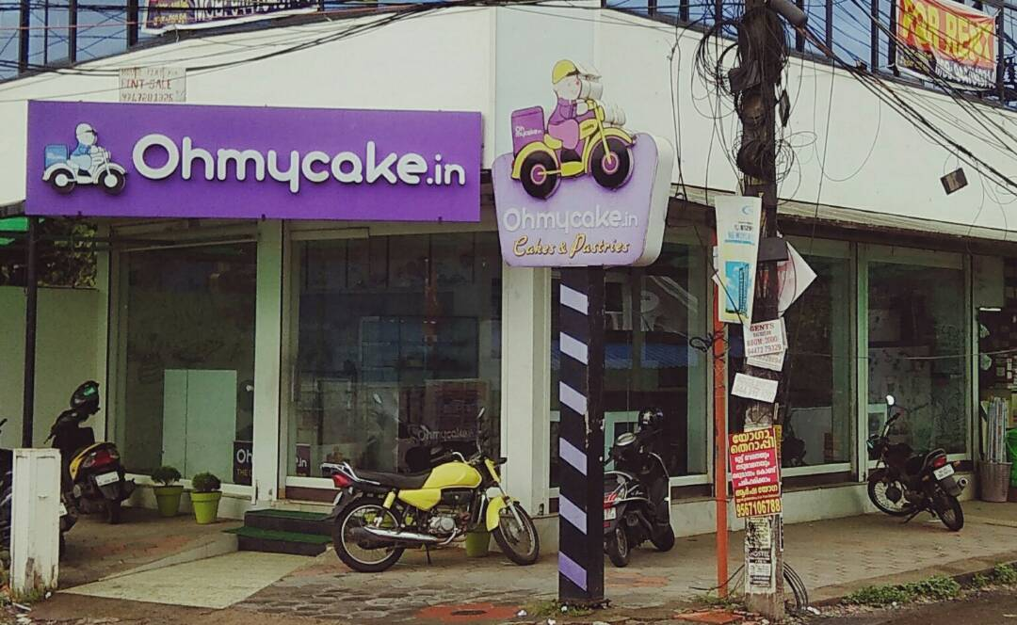

Source: Company documents.

EXHIBIT 1: THE OHMYCAKE.in MASCOT

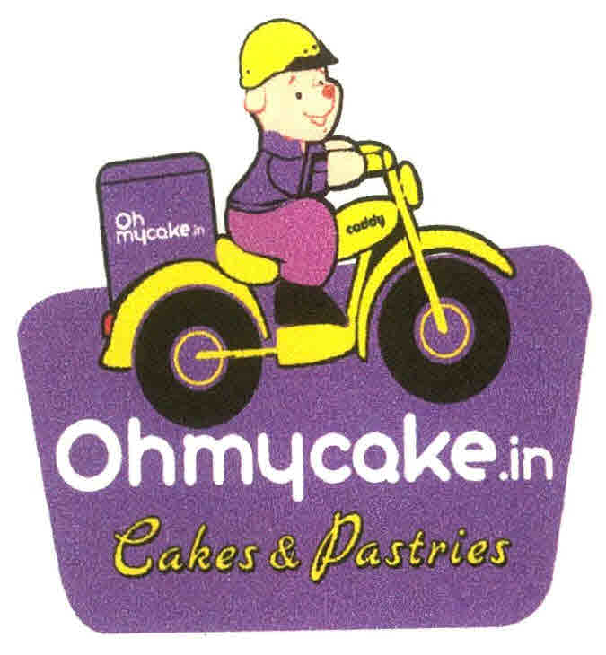

Source: Company documents.

EXHIBIT 3: Ohmycake.in’s Financial Statements (in ₹)

|  |  |
| --- | --- |
| Profit and Loss, Fiscal Year 2015–16 | |
| Sales | 15,505,154 |
| Purchases | 9,230,112 |
| **Direct Expenses** |  |
| Fuel charges | 163,750 |
| Wages | 2,608,635 |
| Freight | 14,747 |
| Total | 2,787,132 |
| **Operating Expenses** |  |
| Accounting charges | 24,000 |
| Advertisement charges | 50,502 |
| Audit fee | 29,997 |
| Cleaning charges | 10,100 |
| Diesel generator | 9,400 |
| Computer service charges | 14,610 |
| Donation | 3,000 |
| Electricity charges | 229,807 |
| Electrical maintenance | 15,640 |
| Generator rent | 48,600 |
| Interest and bank charges | 4,295 |
| Incentive | 28,991 |
| Insurance charges | 23,750 |
| Marketing expenses | 130,102 |
| Miscellaneous expenses | 108,456 |
| Professional charges | 2,000 |
| Parking fee | 2,306 |
| Registration fees | 1,800 |
| Rent | 425,400 |
| Repairs and maintenance | 58,076 |
| Salary and perks | 1,007,898 |
| Telephone charges | 73,978 |
| Transportation charges | 200,519 |
| Travelling charges | 248,923 |
| VAT (Value Added Tax) paid | 115 |
| Uniform | 39,135 |
| Water charges | 2,390 |
| Depreciation | 228,953 |
| Total | 3,022,742 |

EXHIBIT 3 (continued)

|  |  |
| --- | --- |
| Balance Sheet, as of March 31, 2016 | |
| **Assets** |  |
| Fixed assets (Schedule Ill) | 1,318,840 |
| Sundry debtors (Schedule IV) | 339,324 |
| Cash in hand | 264,458 |
| Bank accounts (Schedule V) | 100,622 |
| Tax deducted at source | 12,463 |
| Advance tax | 50,000 |
| Sales tax deposit | 15,000 |
| Closing stock | 117,550 |
| Total Assets | 2,218,256 |
|  |  |
| **Liabilities** |  |
| Murickan’s capital account (Schedule I) | 1,185,886 |
| Sundry creditors (Schedule II) | 1,009,010 |
| VAT payable | 7,970 |
| Audit fee payable | 15,390 |
| Total Liabilities | 2,218,256 |

Source: Company files.

EXHIBIT 4: CAKES OFFERED BY OHMYCAKE.in, 2016 (in ₹)

|  |  |  |
| --- | --- | --- |
| Name of Cake | Price | Unit Sales/Month |
| Chocolate Fantasy Cake | 600 | 197 |
| Photo Cake | 900 | 185 |
| Black Forest Cake | 650 | 120 |
| Swiss-Roll Cake | 750 | 67 |
| Irish Coffee Cake | 600 | 66 |
| Red Velvet Cake | 750 | 59 |
| Exotic Butterscotch Cake | 750 | 52 |
| Single Digit Number Shape Cake | 950 | 40 |
| Belgian Chocolate Cake | 800 | 40 |
| Passion Fruit Delight Cake | 750 | 39 |
| Vanilla Chocolate Cake | 700 | 29 |
| Alphonso Delight Cake | 800 | 29 |
| Dark Chocolate Overload Cake | 800 | 28 |
| Chocolate Truffle Cake | 650 | 28 |
| Coffee & Almond Cake | 700 | 24 |
| Cheese Cake | 750 | 17 |
| Custom Photo Cake | 800 | 14 |
| English Toffee Cake | 700 | 11 |
| Fig & Honey Cake | 750 | 10 |
| Beautiful Angel Theme Cake | 1,050 | 8 |
| Chocolate Fudge Cake | 650 | 5 |
| Praline Fudge Cake | 600 | 5 |
| White Chocolate Overload Cake | 750 | 4 |
| White Forest Cake | 650 | 3 |
| Heart Birthday Cake | 900 | 2 |
| Custom Shape Cake | 950 | 1 |
| Orange Chocolate Cake | 650 | 0 |
| Pineapple Delight Cake | 750 | 0 |
| Triple Chocolate Cake | 650 | 0 |
| Honey & Almond Cake | 650 | 0 |
| Excess Chocolate Cake | 750 | 0 |
| Lychee Butterscotch Cake | 600 | 0 |
| Tiramisu Cake | 750 | 0 |

Source: Company documents.

EXHIBIT 5: Ohmycake.in’s PRODUCTION LAYOUT, JANUARY 2017

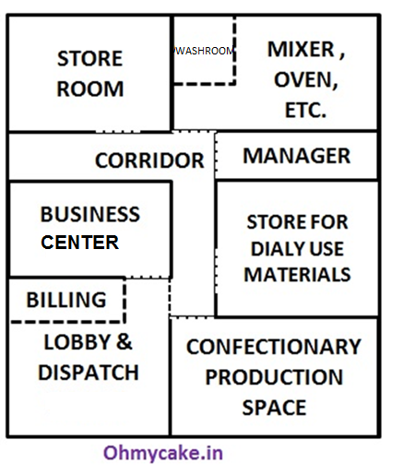

Source: Company documents.

EXHIBIT 6: Ohmycake.in’s PRODUCTION PROCESS, JANUARY 2017

Sponge inventory

Source: Company documents.

EXHIBIT 7: ORDERS BY Postal CODE, IN 2016

|  |  |  |  |  |  |  |  |  |  |
| --- | --- | --- | --- | --- | --- | --- | --- | --- | --- |
| Postal Code | 682030 | 682305 | 682301 | 682311 | 682005 | 682024 | 682037 | 683104 | 682312 |
| % orders | 29.50% | 15.75% | 6.39% | 3.56% | 2.90% | 2.83% | 2.70% | 2.70% | 2.37% |
| Postal Code | 682019 | 682021 | 682308 | 682017 | 682025 | 682304 | 682020 | 682016 | 682018 |
| % orders | 2.24% | 2.18% | 1.91% | 1.85% | 1.85% | 1.71% | 1.52% | 1.32% | 1.12% |
| Postal Code | 682306 | 682041 | 683562 | 682309 | 682013 | 682040 | 682035 | 682032 | 682028 |
| % orders | 1.12% | 1.05% | 1.05% | 0.99% | 0.92% | 0.92% | 0.86% | 0.79% | 0.73% |
| Postal Code | 682302 | 682313 | 682033 | 682039 | 682011 | 682026 | 682036 | 682303 | 682012 |
| % orders | 0.73% | 0.73% | 0.66% | 0.66% | 0.59% | 0.59% | 0.46% | 0.46% | 0.33% |
| Postal Code | 682038 | 683503 | 682034 | 683501 | 683565 | 682009 | 682299 | 682310 | 682314 |
| % orders | 0.33% | 0.33% | 0.26% | 0.26% | 0.13% | 0.07% | 0.07% | 0.07% | 0.07% |

Source: Company documents.

EXHIBIT 8: BENCHMARKING OHMYCAKE.in’s Cake Prices WITH COMPETITORS, JANUARY 2017 (in ₹)

|  |  |  |  |  |
| --- | --- | --- | --- | --- |
| Flavour | Pandhal  Cake Shop | Cake Hut | Amma’s Pastries | Ohmycake |
| Black Forest | 810 | 600 | 500 | 650 |
| White Forest | 810 | 600 | 500 | 650 |
| Red Velvet | — | 750 | 600 | 750 |
| Chocolate Truffle | 850 | 650 | 550 | 650 |
| Cheese Cake | 850 | 900 | 650 | 750 |
| Irish Coffee | 810 | 650 | — | 600 |

Source: Company documents.

1. Kochi was the commercial capital of Kerala, the southernmost state of the Indian subcontinent.
2. Kerala cuisine was distinct to the region. Although diverse, the cuisine was noted for generous use of coconut, chilli, and spices in foods with bright flavour profiles.
3. Nandita Vijay, “Bakery Industry in India: Riding High on Retail Chains Wave,” Food and Beverage News (FnB News), June 21, 2011, accessed September 24, 2018, www.fnbnews.com/Overview/Bakery-industry-in-India-Riding-high-on-retail-chains-wave-2.
4. ₹ = INR = Indian rupee; all currency amounts are in ₹ unless otherwise specified; ₹1 = US$0.0147 on January 1, 2017.