

9B18N022

UNDER ARMOUR UNDER PRESSURE: RATIO ANALYSIs[1]

Michael Saunders wrote this case under the supervision of Professor Zhichuan (Frank) Li solely to provide material for class discussion. The authors do not intend to illustrate either effective or ineffective handling of a managerial situation. The authors may have disguised certain names and other identifying information to protect confidentiality.

*This publication may not be transmitted, photocopied, digitized or otherwise reproduced in any form or by any means without the permission of the copyright holder. Reproduction of this material is not covered under authorization by any reproduction rights organization. To order copies or request permission to reproduce materials, contact Ivey Publishing, Ivey Business School, Western University, London, Ontario, Canada, N6G 0N1; (t) 519.661.3208; (e)* [*cases@ivey.ca*](mailto:cases@ivey.ca)*;* [*www.iveycases.com*](http://www.iveycases.com)*.*

Copyright © 2018, Ivey Business School Foundation Version: 2018-10-17

Under the Gun

On February 20, 2018, Thomas Richter, an analyst at Vaux Gibson Inc. (Vaux Gibson), was tasked with reviewing the firm’s holdings of Under Armour, Inc. (Under Armour). Vaux Gibson managed a large portfolio of North American equities with a focus on the diversified retail, heavy industrial, and technology sectors, and had a reputation for identifying key growth sectors and investing in undervalued companies. The fund had initially purchased Under Armour stock in early 2013, expecting a high return due to its great potential for growth in market share and revenues.

On October 31, 2017, Under Armour reported its third-quarter earnings, which had fallen well below analyst expectations. As a result, the stock dropped over 25 per cent on that trading day.[2] The stock had not seen much recovery since then, which had resulted in Richter’s new task. Vaux Gibson had boasted attractive returns on its investment in Under Armour until 2017, but noted that the stock was down over 43 per cent since the beginning of 2017. Under Armour was in a difficult financial situation and analysts were aware of this. In its 2017 annual report, the company stated that revenues had grown by only 3.1 per cent and that profit margins had taken a significant hit, citing a US$48-million loss.[3]

Richter’s task was to review Vaux Gibson’s investment in Under Armour and provide recommendations to the partners on the direction the fund should take with it. Under Armour’s stock had appreciated from early 2013 to early 2017 by over 150 per cent, yet selling the stock now would provide the fund with only a 20-per-cent return on investment. Richter wondered whether it was the right time to exit the investment, providing investors with an above-market return, or if there was still room for Under Armour to recover and grow.

Under Armour, Inc.

Under Armour was founded in 1996 under Chief Executive Officer (CEO) Kevin Plank. At the time, Plank was the Special Teams captain of the University of Maryland football team, and he hated having to change his sweat-soaked kit on longer practice days. To remedy this discomfort, Plank experimented with synthetic fabrics to create an athletic shirt that would keep athletes dry and cool in hot playing conditions. Under Armour described its products as a performance alternative to traditional products, for wear in nearly every climate.[4]

The company currently developed and sold athletic apparel, footwear, and accessories for men, women, and youth. Furthermore, the company made most of its sales on a wholesale basis, but also had direct-to-consumer sales, product licensing, and “connected fitness” channels. Under Armour sold products internationally, the majority of which were sourced from North America and a smaller portion from European, Middle Eastern, Asian, and Latin American countries.

An important part of Under Armour’s business model was its contracts with professional athletes and sports teams, which allowed the company exclusivity in the supply of its athletic gear. Notable examples of its “roster” included basketball player Stephen Curry, football quarterback Cam Newton, golfer Jordan Spieth, ice hockey goaltender Carey Price, and football quarterback Tom Brady.[5]

Under Armour had performed well for the past few years, citing revenues over $4.8 billion in fiscal 2016, having grown over 20 per cent since the prior year. Top-line revenue growth was matched by profit growth of 10 per cent year over year. Despite this momentum, the company had not lived up to analysts’ expectations for growth in 2017 and these yearly growth figures were stifled.[6]

Industry and Economic Conditions

From 2014 to 2016, North America saw real gross domestic product growth of over 2.5 per cent, which was estimated to continue at a rate of 2.19 per cent until 2019, indicating healthy growth.[7] Additionally, the United Nations had just published its second-quarter *World Economic Situation and Prospects 2017* briefing, which cited that, despite the global uncertainty in the international policy environment, global trade had continued to gain momentum, with world trade volume growth of 4.3 per cent and global industrial production growth of 3.7 per cent, a six-year high.[8] Growth in trade and industrial production was a positive sign for manufacturers and retailers like Under Armour who operated across multiple countries, as this growth lowered the cost of trade and production.

The purchasing managers’ index (PMI), a key indicator of economic health in the manufacturing sector, was hovering just above 56 per cent and had seen growth in the past few years. PMI values above 50 per cent were indicative of economic growth for manufacturers, as the values were driven by new orders, inventory levels, production, supplier deliveries, and the employment environment. The recent growth above 50 per cent in this index was a positive sign for the athletic retail space.[9]

From 2011 to 2016, U.S. sports apparel stores saw a 4.6-per-cent revenue compound annual growth rate (CAGR). Despite attractive historical figures, IBIS World projected this growth to slow significantly, citing an expected −0.2-per-cent revenue growth from 2016 to 2021. In contrast, comparable stores in Canada saw a 3.5-per-cent revenue CAGR from 2012 to 2017, and this was projected to grow at 2.1 per cent in the following five years. In both Canada and the United States, athletic apparel stores were considered mature industries with low revenue volatility, low capital expenditure maintenance, and low regulation levels. The industry was predominantly driven by per-capita disposable income, consumer confidence, and youth sports participation.[10]

Peer Group

Richter had identified Under Armour’s main competitors. In early 2018, Nike, Inc. (Nike), Adidas AG (Adidas), and lululemon athletica inc. (lululemon) were the three main companies competing with Under Armour for market share in the North American athletic apparel market.

Nike, Inc.

Nike was an American athletic manufacturer, designer, and retailer of athletic apparel that sold products globally. It divided its products into nine segments: Running, NIKE Basketball, the Jordan Brand, Football (soccer), Men’s Training, Women’s Training, Action Sports, Sportswear (sports-inspired lifestyle products), and Golf.[11] With 2017 revenues more than $34 billion, Nike was Under Armour’s largest competitor. Nike also owned several other successful brands including Air Jordan, Hurley, and Converse. Similar to Under Armour, Nike had deals with several high-calibre athletes and sports teams to maintain exclusivity of its athletic supply, including basketball player LeBron James, golfer Tiger Woods, tennis player Eugenie Bouchard, soccer player Neymar Jr., and tennis player Roger Federer.[12]

Adidas AG

Adidas was a German athletic manufacturer, designer, and retailer of athletic apparel that sold the majority of its products in Western Europe, North America, and Greater China. Adidas divided its products into four categories: shoes, clothing, accessories, and sport, where it sold products related to the same sports as both Nike and Under Armour. Adidas boasted 2017 revenues of €21.22 billion,[13] surpassing Under Armour.[14] Furthermore, Adidas had a comparably large roster of professional athletes that it sponsored, including soccer player Lionel Messi, basketball player James Harden, and basketball player Derrick Rose.[15] Due to its geographic presence, Adidas was the dominant supplier of soccer gear in Europe, with a significant portion of its sales coming from deals with clubs including Real Madrid C.F., Chelsea F.C., FC Bayern Munich, A.C. Milan, and Olympique de Marseille. Its main competitor for soccer-related revenues, Nike, had since taken second place to Adidas in this segment.[16]

lululemon athletica, inc.

lululemon was a Canadian designer, distributor, and retailer of healthy lifestyle-inspired athletic apparel. lululemon products were marketed under the lululemon and Ivivva brand names and included an assortment of items across various product lines including pants, shorts, tops, and jackets designed for healthy lifestyle and athletic activities such as yoga, running, training, and most other sweaty pursuits, as well as athletic wear for female youth.[17] Lululemon’s main selling geography was the United States, where it housed close to 70 per cent of its retail locations. The majority of the remainder of its retail locations were in Canada (close to 15 per cent) and Australia (close to 8 per cent). Though lululemon did sponsor some athletes, the company was not of the same pedigree as Under Armour, Nike, or Adidas, as it targeted strength/personal trainers, dancers, and yoga enthusiasts. Despite this, lululemon enjoyed revenues of $2.65 billion in 2017.[18]

Buy, Sell, or Hold?

Richter’s recommendation was due at Vaux Gibson’s weekly status meeting that following Monday. The fund manager and the CEO had scheduled two additional meetings with Richter to talk about Under Armour, as it was Vaux Gibson’s largest investment. Under pressure, Richter was perplexed over this project with all the financial information he had gathered on Under Armour and its peer group (see Exhibits 1–9). He needed to suggest an appropriate investment strategy that would convince management to buy more shares, sell their current position, or hold the shares. If Richter were to decide that liquidating the fund’s position in Under Armour was the best choice, it would leave the fund with a large cash balance. What would Richter suggest if his analysis determined that one of Under Armour’s competitors was a good stock to purchase?

**Exhibit 1: Balance Sheets**





Note: All financial information found in the exhibits has been taken from public sources and normalized by the case authors. € = EUR = euro; US$1 = €0.81997 on February 28, 2018.

Source: Under Armour, Inc., *2017 Annual Report*, 2017, accessed April 20, 2018, <http://investor.underarmour.com/annuals.cfm>; Nike, Inc., *Nike, Inc. 2017 Annual Report*, 2017, accessed April 20, 2018, <https://s1.q4cdn.com/806093406/files/doc_financials/2017/ar/index.html>; Adidas AG, *Adidas 2017 Annual Report*, 2017, accessed April 20, 2018, www.adidas-group.com/en/investors/financial-reports/; lululemon athletica, inc., *lululemon 2017 Annual Report*, 2017, accessed April 20, 2018, http://investor.lululemon.com/annuals-proxies.cfm.

Exhibit 2: Income Statements



Source: Under Armour, Inc., *2017 Annual Report, 2017*, accessed April 20, 2018, <http://investor.underarmour.com/annuals.cfm>; Nike, Inc., *Nike, Inc. 2017 Annual Report*, 2017, accessed April 20, 2018, <https://s1.q4cdn.com/806093406/files/doc_financials/2017/ar/index.html>; Adidas AG, *Adidas 2017 Annual Report*, 2017, accessed April 20, 2018, www.adidas-group.com/en/investors/financial-reports/; lululemon athletica, inc., *lululemon 2017 Annual Report*, 2017, accessed April 20, 2018, http://investor.lululemon.com/annuals-proxies.cfm.

Exhibit 3: Statement of Cash Flows



Exhibit 3 (continued)



Note: The Adidas AG cash flow statement will not show the corresponding ending cash balance due to assumed normalization techniques by the authors. Adidas AG reports under International Financial Reporting Standards, while all the other peers report under U.S. Generally Accepted Accounting Principles. PP&E = property, plant, and equipment; AFS = available for sale

Source: Under Armour, Inc., *2017 Annual Report, 2017*, accessed April 20, 2018, <http://investor.underarmour.com/annuals.cfm>; Nike, Inc., *Nike, Inc. 2017 Annual Report*, 2017, accessed April 20, 2018, <https://s1.q4cdn.com/806093406/files/doc_financials/2017/ar/index.html>; *Adidas AG, Adidas 2017 Annual Report*, 2017, accessed April 20, 2018, www.adidas-group.com/en/investors/financial-reports/; lululemon athletica, inc., *lululemon 2017 Annual Report*, 2017, accessed April 20, 2018, http://investor.lululemon.com/annuals-proxies.cfm.

Exhibit 4: Common Size Balance Sheets





Source: Under Armour, Inc., *2017 Annual Report, 2017*, accessed April 20, 2018, <http://investor.underarmour.com/annuals.cfm>; Nike, Inc., *Nike, Inc. 2017 Annual Report*, 2017, accessed April 20, 2018, <https://s1.q4cdn.com/806093406/files/doc_financials/2017/ar/index.html>; Adidas AG, *Adidas 2017 Annual Report*, 2017, accessed April 20, 2018, www.adidas-group.com/en/investors/financial-reports/; lululemon athletica, inc., *lululemon 2017 Annual Report, 2017*, accessed April 20, 2018, <http://investor.lululemon.com/annuals-proxies.cfm>.

Exhibit 5: Under Armour Ratios over Four Years

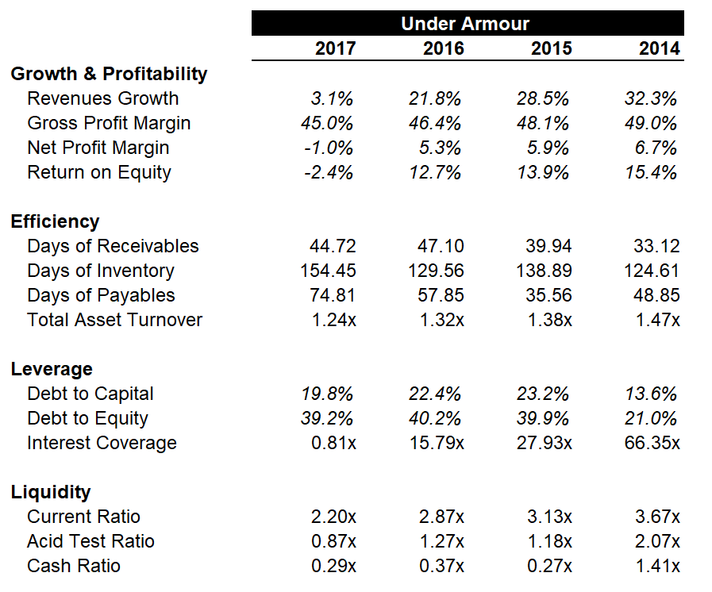

Source: Case writer calculations. Under Armour, Inc., 2017 Annual Report, 2017, accessed April 20, 2018, <http://investor.underarmour.com/annuals.cfm>.

Exhibit 6: Valuation Metrics and Economic Data for Under Armour and Competitors



Note: € = EUR = euro; US$1 = €0.81997 on February 28, 2018; GDP = gross domestic product; S&P = Standard & Poor’s; P/E = price-earnings

Source: “3 Month Treasury Bill Rate,” YCharts, accessed April 20, 2018, <https://ycharts.com/indicators/3_month_t_bill>; “S&P 500 PE Ratio by Year,” multipl.com, accessed April 20, 2018, [www.multpl.com/table](http://www.multpl.com/table).

Exhibit 7: Comparative Financial Ratios



Note: n/a = not available

Source: Case writer calculations. Under Armour, Inc., *2017 Annual Report, 2017*, accessed April 20, 2018, <http://investor.underarmour.com/annuals.cfm>; Nike, Inc., *Nike, Inc. 2017 Annual Report, 2017*, accessed April 20, 2018, <https://s1.q4cdn.com/806093406/files/doc_financials/2017/ar/index.html>; Adidas AG, *Adidas 2017 Annual Report*, 2017, accessed April 20, 2018, www.adidas-group.com/en/investors/financial-reports/; lululemon athletica, inc., *lululemon 2017 Annual Report*, 2017, accessed April 20, 2018, <http://investor.lululemon.com/annuals-proxies.cfm>.

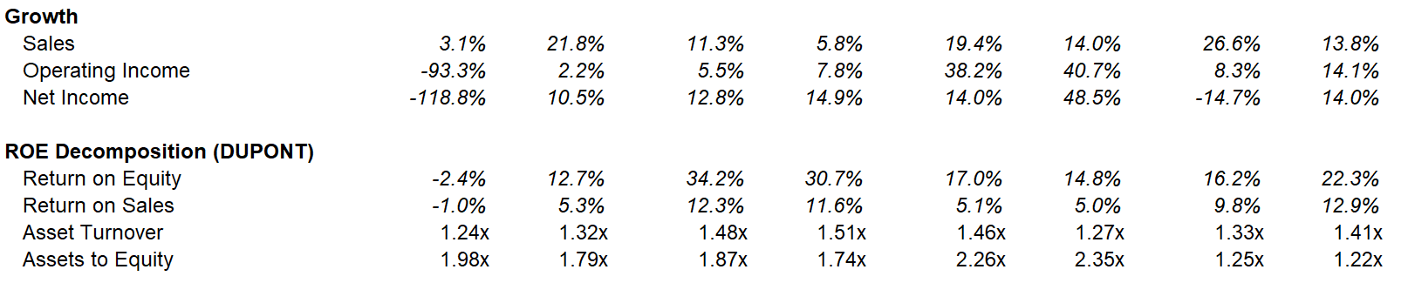

**Exhibit 8: Ratio Definitions**



Note: EBIT = earnings before interest and tax; ROE = return on equity

Source: Created by the case authors.

Exhibit 9: Historical Stock Performance (IN US$)

Source: Yahoo Finance, “Under Armour, Inc. (UA): Historical Data,” accessed April 20, 2018, <https://finance.yahoo.com/quote/UA/history?p=UA>; Yahoo Finance, “NIKE, Inc. (NKE): Historical Data,” accessed April 20, 2018, <https://finance.yahoo.com/quote/NKE/history?p=NKE>; “adidas AG (ADS.DE): Historical Data,” accessed April 20, 2018, <https://ca.finance.yahoo.com/quote/ADS.DE/history?p=ADS.DE>; Yahoo Finance, “lululemon athletica iInc. (LULU): Historical Data,” accessed April 20, 2018, <https://ca.finance.yahoo.com/quote/LULU/history?p=LULU>.

1. The case has been written based on published sources only. Consequently, the interpretation and perspectives presented in this case are not necessarily those of Under Armour, Inc., Vaux Gibson Inc., or any of its employees.
2. Source: Yahoo Finance, “Under Armour, Inc. (UA): Historical Data,” accessed April 20, 2018, <https://finance.yahoo.com/quote/UA/history?p=UA>.
3. All currency amounts are in US$ unless otherwise specified; Under Armour, Inc., 2017 Under Armour Annual Report, 2017, accessed April 20, 2018, <http://investor.underarmour.com/annuals.cfm>.
4. Under Armour Inc., “1996 – 1998: It All Started with an Idea,” Under Armour, accessed April 20, 2018, www.uabiz.com/company/history.cfm.
5. Under Armour, Inc., “UA Roster,” Under Armour, accessed April 20, 2018, www.underarmour.com/en-us/ua-roster.
6. Ibid.
7. World Bank, “Table 1: Real GDP Growth,” in Global Economic Prospects, January 2017, accessed April 20, 2018, http://pubdocs.worldbank.org/en/412901492626964674/GDP-forecast-table.pdf; Organisation for Economic Co-operation and Development, “Real GDP Forecast,” accessed April 20, 2018, https://data.oecd.org/gdp/real-gdp-forecast.htm.
8. United Nations, World Economic Situation and Prospects 2017, accessed April 20, 2018, www.un.org/development/desa/dpad/wp-content/uploads/sites/45/publication/2017wesp_full_en.pdf.
9. “ISM Purchasing Managers Index,” YCharts, accessed April 20, 2018, https://ycharts.com/indicators/purchasing_managers_index.
10. IBIS World, Fitness & Athletic Clothing Stores – US Market Research Report, accessed April 20, 2017, www.ibisworld.com/industry-trends/specialized-market-research-reports/consumer-goods-services/apparel-accessories-stores/fitness-athletic-clothing-stores.html.
11. Nike, Inc., Nike, Inc. 2017 Annual Report, 2017, accessed April 20, 2018, <https://s1.q4cdn.com/806093406/files/doc_financials/2017/ar/index.html>.
12. Nike, Inc., “Our Athletes,” Nike, accessed April 20, 2018, <https://news.nike.com/athletes>.
13. € = EUR = euro; US$1 = €0.81997 on February 28, 2018.
14. Adidas AG, Adidas 2017 Annual Report, 2017, accessed April 20, 2018, www.adidas-group.com/en/investors/financial-reports/.
15. Adidas AG, “Athletes & Ambassadors,” Adidas, accessed April 20, 2018, https://news.adidas.com/us/Athletes-And-Ambassadors.
16. Richard Weiss, “Adidas Beats Nike in European Soccer's Shirt-Sponsorship League,” May 2, 2017, Bloomberg, May 2, 2017, accessed May 4, 2017, www.bloomberg.com/news/articles/2017-05-12/adidas-beats-nike-in-european-soccer-s-shirt-sponsorship-league.
17. Lululemon Athletica, Inc., Lululemon 2017 Annual Report, 2017, accessed April 20, 2018, http://investor.lululemon.com/annuals-proxies.cfm.
18. Ibid.