

9B19A004

6 Ballygunge place: HAS The brand reacheD ITS destination?

[Soumya Sarkar](https://iveypubs.my.salesforce.com/003A000001QlQ7x) and [Madhupa Bakshi](https://iveypubs.my.salesforce.com/003A0000024jK2K) wrote this case solely to provide material for class discussion. The authors do not intend to illustrate either effective or ineffective handling of a managerial situation. The authors may have disguised certain names and other identifying information to protect confidentiality.

This publication may not be transmitted, photocopied, digitized, or otherwise reproduced in any form or by any means without the permission of the copyright holder. Reproduction of this material is not covered under authorization by any reproduction rights organization. To order copies or request permission to reproduce materials, contact Ivey Publishing, Ivey Business School, Western University, London, Ontario, Canada, N6G 0N1; (t) 519.661.3208; (e) cases@ivey.ca; www.iveycases.com. Our goal is to publish materials of the highest quality; submit any errata to publishcases@ivey.ca. i1v2e5y5pubs

Copyright © 2019, Ivey Business School Foundation Version: 2019-03-01

S. Ramani, the founder and director of Savourites Hospitality Private Limited (Savourites), and his associate Aninda Palit were in London on an autumn day in 2016 to discuss future plans for 6 Ballygunge Place (6BP), the company’s flagship Bengali restaurant in Kolkata. The pair had been in London six years earlier, when they attended Ananda Utsav, a fair for members of the Indian diaspora in London. Ramani and Palit had been enthusiastic about the assignment, which gave them an opportunity to showcase 6BP on a global platform, and their earnestness had paid off: 6BP became one of the market leaders of Bengali cuisine restaurants in Kolkata. Now, if 6BP was to move to the next level, Ramani and Palit faced some serious questions. To exploit the exposure they had gained, they wanted to go global, starting with London; but before that, they needed to figure out whether Bengali cuisine was amenable to foreign palates. Alternately, they could expand by giving up 6BP’s location-specific advantage as a regional cuisine restaurant and repackaging it to suit local tastes.

**THE 6BP STORY**

6BP was the first of its kind: a fine-dining restaurant (FDR) serving authentic Bengali cuisine. Other players had made sporadic forays into this space, but most of them had remained stand-alone outlets. The other major player was Aaheli, an in-house restaurant in the Peerless Inn, a four-star hotel in Kolkata run by the diversified Peerless Group. Aaheli had been operating since 1993,[1] but it had not grabbed the attention of tourists and locals to the desired extent. Oh! Calcutta was another Kolkata restaurant, which had actually started operations before Aaheli, in 1992. However, its focus was more on Kolkata food rather than Bengali food. Over the years, it had seen better brand growth than Aaheli, owing in large part to the financial and marketing might of Anjan Chatterjee, the restaurateur and owner of Speciality Restaurants Limited, which also owned successful brands like Mainland China, Only Fish, and Flame & Grill.[2]

Savourites, founded by Palit, Ramani, and Sushanta Sengupta, had started as a catering service provider to offices in Kolkata. After a fruitless venture called Raga, a new-age offering for South Indian vegetarian food, the Savourites team began planning 6BP. The Raga experiment had been a non-starter because, according to Kanchan Datta, chief executive officer (CEO) of Savourites’ advertising agency Inner Circle Advertising India Private Limited (Inner Circle), the restaurant had a bad location and was not serving food that customers wanted:

It was a fusion restaurant, with mini dosas, fried idlis, and stuff. It was on the second floor, and we all know restaurants don’t survive even on the first floor unless you are a Michelin star restaurant. On top of that, it was located at the rear of the building, without a parking area, in an unfriendly lobby. Somehow, I had a bad feeling for the restaurant . . . they then tried to change it into Chinese which obviously did not work.

After two years of trying with Raga, Savourites decided to close it down and start a new venture.

**The 6BP Team**

According to Dibyajyoti Chaudhuri, the head of Corporate Communications for 6BP, “the three pillars on which 6BP had been built were Palit, Ramani, and of course, Chef Sengupta.” Chef Sengupta, a master chef, was an expert in Southeast Asian cuisine. He had curated cookery shows abroad and had been the head of an Oriental restaurant at The Park in Kolkata called Zen when Savourites was being conceived. Chaudhuri described him as “the most passionate person about food and cooking that I have ever seen.” Sengupta was the driving force behind the cuisine of 6BP, and Palit was the person who brought in the management skills to run an FDR.

Palit had made a career in the food and beverage industry and had managed restaurants, including managing their infrastructure, ambience, and personnel. Trained in advanced food and beverage management in the Netherlands, Palit ensured that the 6BP machine ran smoothly. The catalyst for smooth operations was Ramani, the only one among the three who had also worked outside the food service and restaurant industry. A hotel management graduate, Ramani had almost nine years of experience in sales and marketing in the automotive sector. As a result, said Chaudhuri, he brought “street-smartness and convincing skills to the arsenal, which come in handy for dealing [with] external people and as the public face of 6BP.” Ramani was a visionary in bringing out new offerings, and he was well respected in the industry for his insights.

**Birth of 6BP**

The new venture Savourites was contemplating happened to be a Bengali restaurant. By the time 6BP was born, Savourites found success in catering Bengali food across Kolkata. Sengupta reminisced about this success:

[It] was not that 6BP happened to us in day one. Our business started in ’98, and there was a four-year lapse, and then we started off again. The entire idea of 6BP was [Palit’s]. I did not have that much confidence. Aninda was absolutely sure that a Bengali restaurant would do well and we believed him because he had an understanding of the market.

Although conventional wisdom in the food service industry in Kolkata suggested that one could not sell Bengali food to Bengalis, Ramani and his associates decided to go for it. One strong driver behind the outlet was not food: “That we had an old ancestral house right in the heart of South Kolkata, which amalgamated the idiosyncrasies of Indo-British architecture, was a revelation,” admitted Palit. The southern part of Kolkata was relatively modern and upmarket, hence stumbling upon a house with authentic old-world charm was “an act of providence,” according to Ramani. He insisted that the myths about the Bengalis of Kolkata being fussy eaters who were not comfortable having Bengali food outside their homes needed to be exploded. So the team went ahead with 6BP. Ramani and Sengupta wanted the place to be steeped in *Bangaliana* (“Bengaliness,” or everything Bengali culture and tradition stood for)—in terms of not only the food but also its décor, marketing collaterals, and overall character. The restaurant was named after its address, in part because a Bengali name might be difficult to pronounce.

The name would roll nicely off non-Bengali tongues, more so since Ramani intended to target the so far alienated yet highly affluent segment of the population. That the ploy worked was evident in one consumer’s remark: Mr. Bose, an entrepreneur who frequented 6BP, said, “My business guests visiting Kolkata often requested to be taken to 6BP because they had heard from their relatives or associates that 6BP stood for Bengali cuisine in a fine-dining atmosphere.”

**FINE DINING IN INDIA**

India was as diverse in its cuisine as it was in its geography and demography. The varied climate, topography, flora and fauna, culture, society, and religion were factors that had influenced the country’s diverse gastronomy. Food was an integral part of Indian life, but to gain an understanding of fine dining in India, one needed to go back a few hundred years. Until the early 1900s, Indians were not used to eating out because restaurants were few and far between. When the clubs of the British Raj started allowing Indians inside, they provided Indians with their first taste of dining out of home. The growth of restaurants all over India was fuelled by another decision of the British rulers: the Partition of India in 1947.[3] The uprooted and pauperized Punjabis from west of the border streamed into North India, including Delhi, during this time. In order to sustain themselves, many ventured into the food business. Two other migration streams also added to this trend. Chinese migrants fanned out from Kolkata (then Calcutta) to all over the country, and South Indians moved into Mumbai (then Bombay). These two communities started setting up traditional eating places, the former to earn a living and the latter to alleviate their longing for home food.

Consequently, when it came to dining out, Indians were conventional and generally veered towards their own cuisine. People—especially those who had relocated to other cities due to professional reasons—chose the food of their own provinces or the fare they had been brought up with; they craved the fare that they were missing. While this trend continued in most parts of the country, Punjabi and South Indian snacks and Chinese food remained universal favourites all over the country. With the liberalization of the Indian economy in 1991 followed by the spurt in the Indian information technology (IT) and IT-enabled services (ITES) industry, more Indians started travelling abroad. Along with this came social media food blogging, food channels on YouTube, and the popularity of television series such as *MasterChef*. The influx of foreign tourists also increased. These factors led to changes in the Indian food service industry: (1) consumers were introduced to cuisines from different parts of the world; (2) leading multinational quick-service restaurant brands like McDonalds, KFC, Pizza Hut, and Starbucks set up operations in India and expanded quickly; and (3) Indian entrepreneurs gradually joined the fray with newer concepts in food, cuisine, and dining. These trends combined to make Indians go out, be more adventurous, and try out new types of food more frequently.

In general, FDRs were “typically higher end and fancier restaurants. . . . [F]ine dining caters to an upscale clientele and provides the highest quality of food. A fine-dining restaurant has a formal atmosphere, is almost always a sit-down restaurant, and has a fancier menu than most restaurants.”[4] From the consumer’s perspective, there was a distinction between “eating” and “dining” that led consumers to have different desires and expectations from an FDR. The sensory pleasure that a consumer attained from dining in an FDR could not be gleaned from a routine eating encounter. This pleasure could be attributed to a host of restaurant-related factors, such as food, ambience, quality of service, and price, but there were other, more critical factors associated with consumer psychology. These included the goals of the consumer—having good food or having a good time—which in turn affected the core desire of the person—to have an experience that bordered on entertainment.[5] The food and beverages served in an FDR were seen as incidental to the overall experience.

The value of the food service market in India was estimated at ₹3,090 billion[6] (US$46.8 billion) for the year 2016. The FDR segment, including organized and unorganized players, represented just about 10 per cent of this. The value of this relatively newly organized sector was estimated at ₹722 billion (US$10.9 billion). This segment was growing at around 14 per cent per year. Casual dining restaurants and quick-service restaurants formed the major chunk of the Indian food industry with an almost 79-per-cent share of the market. Cafés had garnered another 10 per cent of the market (see Exhibits 1, 2, and 3). The FDR sector thus had a long way to go before it could make a significant mark in the Indian market. At the same time, it was acknowledged that the FDR segment had come a long way from the early 1990s, when it was largely dominated by unorganized players. Atul Singh, president and CEO of Coca-Cola (India and South West Asia) and president of the National Restaurant Association of India, explained:

The good news is that the fine dining industry in India is set to grow for many years to come, given the rising disposable incomes, a greater population of younger people, the growth of consumers in smaller towns and the widening exposure to new cultures and cuisines besides an increased propensity [for] eating outside the home.[7]

**Fine Dining in Kolkata**

The dining-out boom had also engulfed Kolkata, which to a lot of people was the food destination of the country.[8] Although Mumbai and Delhi-NCR were the major markets for food services in terms of business volume, the other metropolitan areas were catching up fast, with a diversity in offerings as wide as that of Mumbai and Delhi. These two mega-metros contributed a total of 22 per cent (11 per cent each) to the food services market. The biggest eight cities in India had been the centres of development, especially for organized food services, catering to 42 per cent of the nation-wide market, and the next categories (mini-metros and the rest of India) had a lot of catching up to do.

The residents of Kolkata had witnessed the establishment of restaurants offering varied fare long before food businesses took shape in other major cities. The people of Kolkata had patronized Chinese restaurants for a long time, and the demonstrated success of these restaurants led entrepreneurs to launch new food ideas in Kolkata. As the millennial generation joined the paying population, outlets offering experimental and exotic cuisine started cropping up all over the city. The Savourites top brass estimated that street food and unorganized eateries, which occupied 49 per cent of the market, were more popular among the Kolkata population, with quick-service restaurants next. FDRs, being niche outlets, took up 11 per cent of the market.

The people of Kolkata were open to all types of cuisine: from the basic, street-corner Chinese to the high-street Continental; from the snacks of South India (*dosa*,*[9] meduvada*,*[10]* and *idli[11]*) to the esoteric *biriyani[12]* of Oudh (today’s Lucknow). Even so, the affinity for local cuisine was striking, and Chinese food was the next most-favoured choice, followed by food of other Indian provinces and snacks. Almost all of the new restaurants appearing in the city emphasized ambience and décor along with their food, with some projecting specific themes.[13] Consumers in Kolkata were made to look beyond just food, and a fine-dining revolution took place in the city as consumers sought enriching eating-out experiences.[14]

As themed restaurants kept appearing, restaurateurs and entrepreneurs also started to think about Bengali-themed restaurants. The prevailing sentiment in Kolkata was that Bengalis were too choosy and condescending towards restaurants serving Bengali food. Being very fastidious about their own cuisine, as well as reluctant to pay high prices for food that they had at home, Bengali consumers were accepted as a challenging segment. Bengali dishes also varied in taste and style; each household had its own version of a dish. However, a few brave souls decided to set up shop peddling Bengali cuisine to the people of Kolkata. The evolution of fine-dining Bengali restaurants was the backdrop against which 6BP decided to make its appearance. Since then, more people had joined the Bengali cuisine bandwagon (e.g., Bohemian and Saptapadi), and they had managed to pull off the unthinkable: they persuaded Bengalis to “pay good money for food that they could just as easily make at home.”[15]

**BUILDING THE 6BP BRAND**

What set Savourites and 6BP apart from most other start-ups and FDRs was that both Ramani and Datta had taken brand building seriously from the very outset. Ramani was very clear about spreading the brand through the offering of the combined package of product and services itself and through all possible communication channels. He said, “We introduced certain distinguishing features that people loved to remember. Like our *kosha mangsho*. As Soumitra Bhattacharya of Saatchi and Saatchi had told me—create a benchmark of your product. Or even the use of different metals (utensils) for different dishes.”[16]

Similarly, Datta, as the agent handling the brand from its infancy, was trying to carve a niche for 6BP through his endeavours. Datta and his team at Inner Circle went full steam with the Bangaliana plank. As Datta reminisced, “The logo was very simple. We chose vermilion as the colour for the logo, which epitomizes Bangaliana by representing *sindoor* and *alta*.”[17] In respect of the shape, it was inspired by the Bengali woman’s sindoor *bindi*[18]—an oval one to merge with the *6* in the name (see Exhibit 4). For the menu, Datta added short poems, which took a fun view of the food, to different pages (see Exhibit 5).

**The Core Offering**

The initial attention towards the core product (the food) was never negotiable in the minds of the 6BP top brass. Chef Sengupta insisted from day one that all ingredients had to be fresh, just like in any Bengali household. Bengalis preferred to shop daily and were generally averse to having the previous day’s fare. 6BP began with that philosophy and had stuck to that practice. The team took care of all aspects of the overall offering, including maintaining the feel of British-era Kolkata in the décor, the way the guests were greeted by the doormen, the attentions of the waiting staff while taking orders and suggesting dishes, the presentation of the dishes, and the outfits of the hosts and the servers. As 6BP was being commended for its food by conventional Bengali consumers, the non-Bengali clientele also gradually warmed up to the restaurant, much to the satisfaction of Ramani. The staff who were in direct contact with the diners were well trained, not only with regard to overall demeanor and communication, but also regarding the combinations of dishes they could suggest to the patrons, especially those who were not very familiar with Bengali cuisine. The deference of the staff towards the patrons emanated out of the fundamental Indian philosophy of hospitality wherein each guest is believed to be God and served accordingly. In the initial months, like all strong brands, 6BP ensured the strength of its product offering through meticulous attention to the quality of the food. The brand took off smoothly. A sizeable proportion of the restaurant’s customers were non-resident Indians and Bengalis staying outside West Bengal. “The place evoked a sense of nostalgia among customers, as they got a slice of old Bengali recipes which are no longer prepared in Bengali households,” commented Sengupta. Among its loyal customers, 6BP counted Bollywood singers and actors, namely, Asha Bhosle and Rishi Kapoor, and others from among the who’s who of [Kolkata.[19]](http://www.business-standard.com/search?type=news&q=kolkata)

In the next stage, Inner Circle played a crucial role in providing substance to the core of the 6BP brand. Datta talked about the “sensory brand, which brought in a sense of drama in the whole package. The people of Kolkata had not seen anything as aristocratic before in the realm of FDRs. The respect for the brand started to transform into love, as the physical newness of the venue was not awe-inspiring but welcoming.” Datta brought celebrities from the Kolkata film, television, art, and business circuits to 6BP for informal *adda* (“chat sessions”). These sessions, being good photo opportunities, gave 6BP a great deal of free publicity and added to the aura of the brand. Gradually, other events were held at the restaurant, including book launches; poetry sessions; and music CD launches, including one for Bollywood singer Babul Supriyo’s CD of Tagore songs.[20] The 6BP logo was ubiquitous during these events and kept the brand invigorated. An in-house team headed by Chaudhuri maintained the brand conversation through consistent experiential programs at all the outlets.

**Role of the Agency**

According to Datta, the agency had played a bigger role in building the brand than Ramani and his team. The comment could be construed as boastful, but that was not what Datta intended, as 6BP had been nurtured from day one by Inner Circle, and Inner Circle was an integral part of 6BP. Datta stressed unequivocally, “They did not even give us the brief . . . they did not have money to pay us nor to advertise . . . we had, and still do have, all the liberty to do what we want.” As a result, the young creative boutique became a full-service agency for the young restaurant, taking care of public relations, advertising, out of home (OOH), and events. Inner Circle created cultural touchpoints, recognizing culture as a crucial force that drove most initiatives in Kolkata. The idea of getting celebrities for adda sessions had come out of this strategy. Datta said, “We regularly got our friends, who were cultural leaders, also great foodies. It made us happy to be a part of the 6BP dream and its subsequent journey.”

Inner Circle organized and hosted several events for 6BP. Some of these had participation from the city’s opinion leaders and the press—personal contacts of Datta and his team. Most of the celebrities did not charge appearance fees, as they were getting into a gastronomic event, where food remained the prime focus. Datta talked about a brand on three levels: physical, sensory, and emotional. He believed that the association of the brand with someone respectable and trustworthy had a positive effect on the brand, even without explicit endorsements from those people. People who were recognized as celebrities or stalwarts in the fields of language, culture, and heritage lent their personal brand equity to the fledgling brand. Their sheer presence created emotional connections, beyond the physical and the sensory, with the 6BP brand, and lent it permanence.

**EMERGENCE OF THE 6BP DESTINATION BRAND**

As 6BP continued its brand-building efforts among Kolkata’s fine-dining cognoscenti, it gradually became one of the most sought-after places to go in the city. The food was of course the main draw, but the experience created by 6BP was also attracting people steadily. Savourites had achieved ₹500 million (US$7.7 million) in revenue in 2016 (see Exhibit 6), and it was evident that the destination brand 6BP had strongly established itself, as it outperformed the average growth rate of around 13 per cent in the Kolkata food services industry.

Most destination brands suffered because of an absence of a clear point of differentiation, so it became interesting if an FDR transformed itself into a destination. Coming up with an original brand story in a crowded restaurant market was difficult at that time, so the branding strategies pursued had to be imaginative, single minded, and consistent. Chaudhuri said, “We are trying our best to create an interesting story for our very choosy patrons so that we can move beyond the realm of just Bengali food.” Ramani concurred, saying, “Creating a consistent story is about feeling the excitement of the Bengali foodie. It did not need a lot of money. We spent no more than 2 per cent of our turnover on creating and growing the brand.” In a bid to give a concrete shape to a destination brand, 6BP managed to trademark the South Kolkata address, which was a first in India. Intellectual property rights attorney Biswajit Sarkar, who successfully secured the registration, cited the restaurant as a case study in his class lectures.[21] As the patrons of an FDR became urbane, so did their expectations, and for a brand like 6BP, which was trying to challenge the conventions of the eating-out industry in Kolkata, delivering on all such expectations was crucial, as the quality of service, food, and ambience all combined to form a destination brand.[22]

A restaurant was elevated to destination status when it reached a point where it was consumed simultaneously at both symbolic and experiential levels. The 6BP address itself had an aura of being contemporary but with a legacy, as it was that particular part of the city that was inhabited by modern, elite, and liberal Bengalis. The building, a quaint one, bore the heritage of Indo-British architecture. It was a house with a past of its own: it had vaulted ceilings, doors opening into archways, and windows with wooden panes and wooden slatted shutters typical of a 19th-century Bengali house. Given the way 6BP positioned itself in a staid Bengali market, it showed the characteristics of a challenger brand. As Datta pointed out, “Challenger brands are built around an idea, rather than consumers.” However, 6BP was not detached from the consumers, and it constantly threw out fresh ideas to refresh its consumer relationships. It had started branding itself through the gastronomic aspects of numerous Indian, Bengali, and foreign festivals (see Exhibit 4). It also took marketing to a new level when domestic airline IndiGo started mentioning 6BP to its passengers arriving at Kolkata, just before the aircraft doors opened. This way, 6BP would anchor itself into the “potential consumer’s mental shopping list.”[23] Then Ananda Utsav took place. According to Ramani, this was when 6BP matured into a destination brand.

**EXTENDING THE BRAND**

With the 6BP brand established in the minds of Kolkata food lovers, Ramani and his team started thinking about growth. They contemplated growth along two avenues: new markets and new products.

**New Markets**

A business could think of untapped segments as new markets to capture. It could also move to completely new geographical locations. For 6BP, both options seemed feasible.

For newer segments, Savourites came up with the idea of the *thali* (“plate”), a word that in most Indian languages connoted a full meal consisting of various dishes and served on a plate. Ramani thought the team could offer authentic Bengali meals with a fixed menu in the form of a thali, at a price that would be lower than the regular 6BP fare. This would extend the 6BP brand and bring in customers from segments lying outside the core segment. The company launched two outlets in Kolkata in 2013 under the brand extension 6BP Thali (Thali). One of these outlets was in the city’s IT hub; here, working professionals could grab a relatively quick Bengali lunch, without foregoing authenticity, quality, or taste. In the meantime, another 6BP restaurant in the original FDR format had already opened in Salt Lake in 2008 to cater to consumers in the northern and eastern parts of the city. Overall, 6BP was moving into new markets it had not previously served.

The launch of the Bengal Lounge at the prestigious Bengal Chamber of Commerce (BCC) building in the heart of Kolkata’s business district indicated that 6BP had arrived. BCC was one of the oldest chambers of commerce in Kolkata, and it still carried a colonial legacy, with membership restricted to the who’s who of Kolkata. The BCC management wanted the building to be more lively and contemporary, so they allotted one of their lounges to 6BP. This meant that 6BP was competing directly with the other banquet and lounge rooms in the building. As the lounge housed a bar and faced the prospect of becoming merely a watering hole for office goers, 6BP took up the challenge with customary seriousness and created a campaign based on the traditional Bengali penchant for *tiffin*, the elaborate lunch in a carry box eaten by the Bengali *babus* (clerks who worked under the British Raj). The campaign created nostalgia, and a series of celebrity lunches at the venue made Bengal Lounge the talk of the town.

While 6BP grew, the holding company, Savourites, was also growing its catering division. Taking advantage of the 6BP brand, the catering business had over 100 bookings a month and did not require much marketing. Having 6BP provide the catering services at a wedding signified that the wedding was “quite elite,” as one customer pointed out, and therefore often ensured repeat business from a discerning set of customers.

In the meantime, 6BP had added floor space by taking over the entire building, adding the first floor to the original ground floor as well as a banquet area on the rooftop. The rooftop banquet area was used for both small parties of 50–60 guests and wedding ceremonies. The ethnic décor and the quintessential Bengali ambience made it an ideal venue for Bengali functions.

**New Products**

Keeping in mind the perennial favourite cuisine of local gastronomes, Ramani decided to further emphasize Chinese cooking under the leadership of Chef Sengupta. However, instead of adding yet another Chinese restaurant to the crowd, the company launched a pan-Asian restaurant where diners could get authentic, tastefully presented Japanese, Thai, and other meals. The Wallwas in an upmarket section of the city, making its presence felt in elite Bengali circles and among food connoisseurs. This attempt to diversify was made in 2007, and a decade later, The Wall was maintaining its niche in a city crazy about Chinese food in any variant. Just like 6BP*,* The Wall attracted consumers during all the major festivals. The essential elements of the 6BP brand had been successfully transferred to The Wall (see Exhibit 7).

With these actions for establishing paths of potential growth, Ramani and his team had moved into uncharted territory and had so far been successful. These actions had extended the 6BP brand into unserved and underserved segments, thus strengthening the brand’s equity. On the other hand, there was always the possibility that an outlet like The Wall might detract from the company’s core focus on providing the finest Bengali food, which in turn would affect customers’ delight. The concept of thali had the potential to dilute the brand’s personality. On the geographical front, taking 6BP to other parts of Kolkata had worked well. Patrons were flocking to the new fine-dining outlet in the newly developed part of the city, Rajarhat New Town. Another, in Guwahati, in the state of Assam, was also doing very well. However, in Kolkata, statistics suggested that the bulk of the consumers were not Bengalis. This segment was affluent and needed to be involved in the 6BP growth story. On the other hand, wooing Bengalis would require 6BP to be more authentic in Bangalore or in Boston, as going beyond Kolkata meant that the destination brand needed to offer more than the destination alone. As Ramani and Palit paced up and down the streets of London, they wondered how to create a global 6BP brand.

**EXHIBIT 1: INDIAN FOOD SERVICE MARKET SIZE**

**(in ₹ Billions)**

|  |  |  |  |  |
| --- | --- | --- | --- | --- |
|  | **2013** | **2014** | **2015** | **2016** |
| Unorganized | 1,730 | 1,835 | 1,950 | 2,076 |
| Organized | 550 | 605 | 660 | 722 |
| Chains | 128 | 150 | 175 | 204 |
| Restaurants in Hotels | 70 | 75 | 80 | 88 |
| **Total** | 2,478 | 2,665 | 2,865 | 3,090 |

Source: Adapted from Federation of Indian Chambers of Commerce and Industry, Technopak Advisors, *Indian Food Services Industry: Engine for Economic Growth & Employment—A Roadmap for Unlocking Growth Opportunities*, 10, 2017, accessed December 21, 2018, http://ficci.in/spdocument/20969/foodzania-2017-report.pdf.

**EXHIBIT 2: ORGANIZED STAND-ALONE RESTAURANT MARKET SIZE**

**(in ₹ Billions)**

|  |  |  |  |  |
| --- | --- | --- | --- | --- |
|  | **2013** | **2014** | **2015** | **2016** |
| Casual Dining | 330 | 365 | 400 | 435 |
| Quick Service Restaurants | 62 | 71 | 81 | 93 |
| Pubs, Bars, Cafés, and Lounges | 85 | 91 | 95 | 105 |
| Cafés | 44 | 47 | 50 | 54 |
| Fine Dining | 16 | 17 | 18 | 18 |
| Frozen Dessert/Ice Cream | 13 | 14 | 16 | 17 |
| **Total** | 550 | 605 | 660 | 722 |

Source: Adapted from Federation of Indian Chambers of Commerce and Industry, Technopak Advisors, *Indian Food Services Industry: Engine for Economic Growth & Employment—A Roadmap for Unlocking Growth Opportunities*, 11, 2017, accessed December 21, 2018, http://ficci.in/spdocument/20969/foodzania-2017-report.pdf.

**EXHIBIT 3: ORGANIzED STAND-ALONE MARKET SHARE**

|  |  |  |  |
| --- | --- | --- | --- |
|  | **Market Share** | | |
| **2013** | **2016** | **2022 (Projected)** |
| Casual Dining | 60.0% | 79.1% | 66.0% |
| Quick Service Restaurants | 11.3% | 16.9% | 13.0% |
| Pubs, Bars, Cafés, and Lounges | 15.5% | 19.1% | 12.0% |
| Cafés | 8.0% | 9.8% | 6.0% |
| Fine Dining | 2.9% | 3.3% | 1.5% |
| Frozen Dessert/Ice Cream | 2.4% | 3.1% | 1.5% |

Source: Adapted from Federation of Indian Chambers of Commerce and Industry, Technopak Advisors, *Indian Food Services Industry: Engine for Economic Growth & Employment—A Roadmap for Unlocking Growth Opportunities*, 11, 2017, accessed December 21, 2018, http://ficci.in/spdocument/20969/foodzania-2017-report.pdf.

**EXHIBIT 4: 6BP BRAND COMMUNICATION**

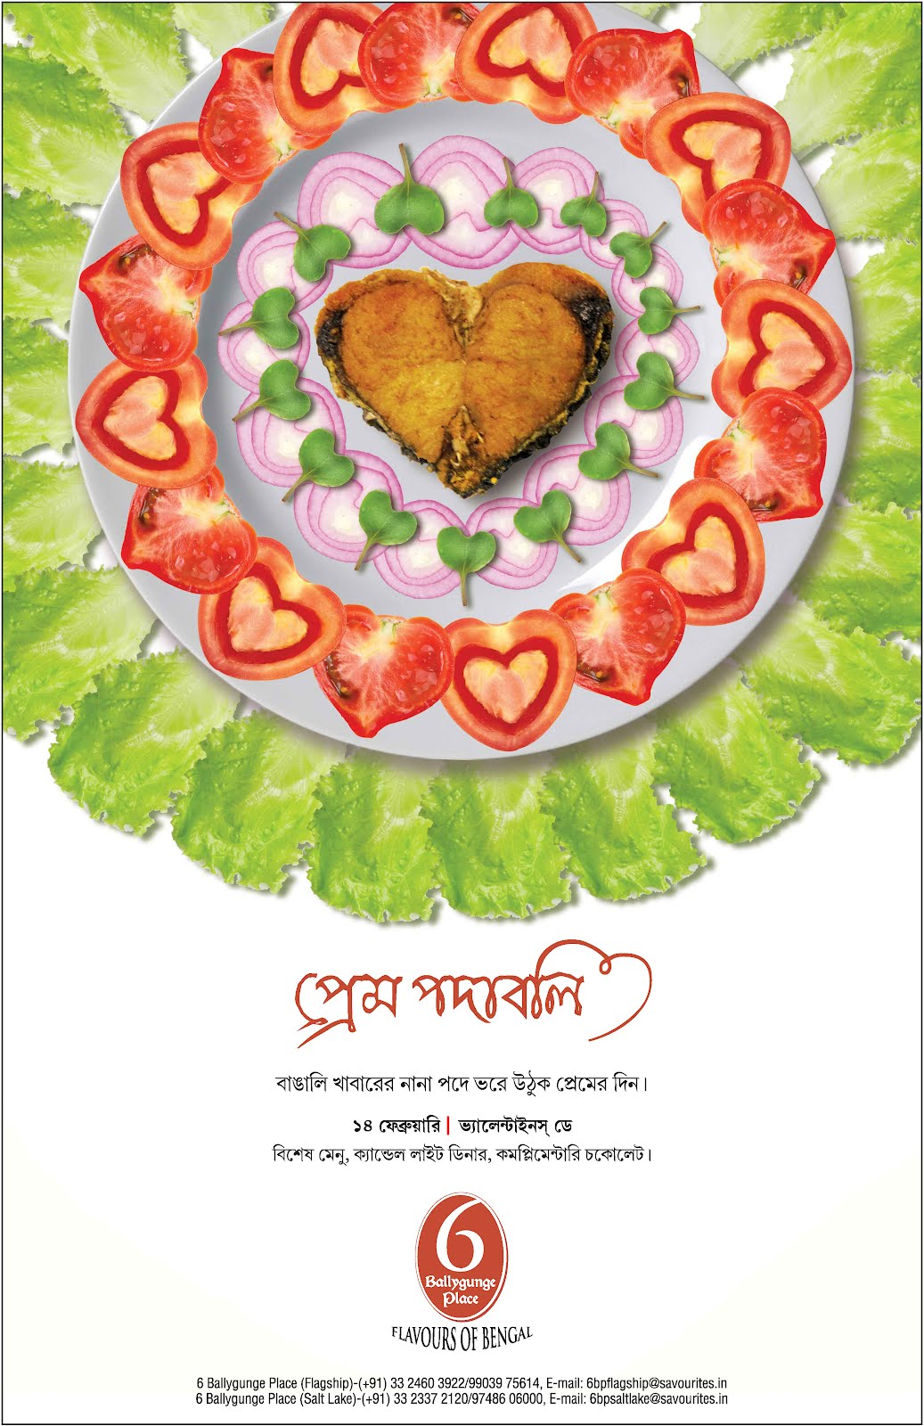

Note:A 6 Ballygunge Place poster for Valentine’s Day, with a cut piece of fish used as a heart-shaped motif

Source: Company documents.

**EXHIBIT 5: 6BP MENU**

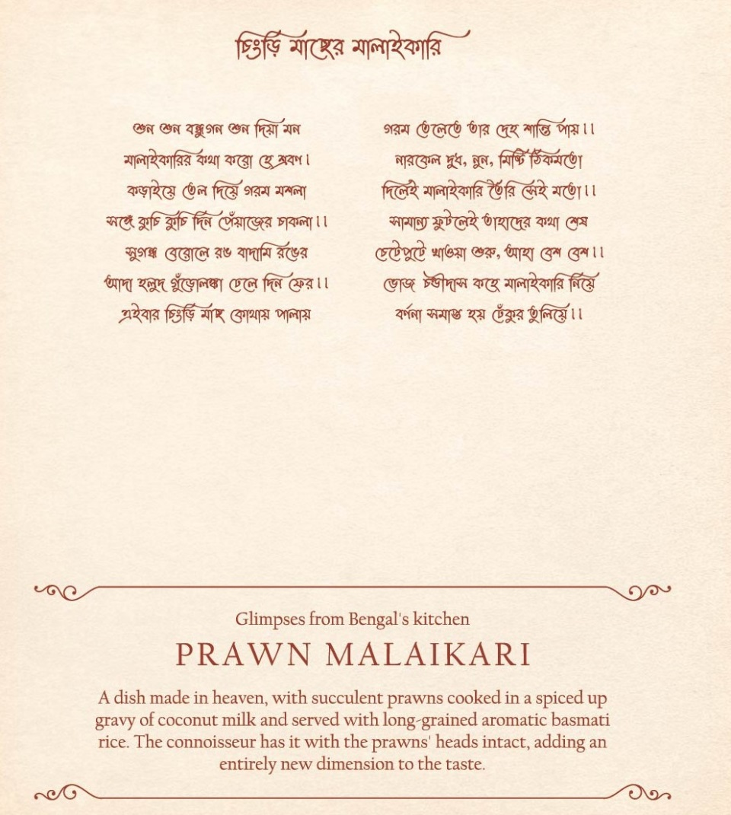

Note: A page from the 6BP menu: the top half of the page is a poem in the Bangla language describing, in a humorous way, the dish mentioned below.

Source: Savourites.

**EXHIBIT 6: savourites REVENUE, 2016**

|  |  |
| --- | --- |
| **Business** | **Revenue (₹ Millions)** |
| 6 Ballygunge Place | 154 |
| 6BP Thali | 19 |
| Kiosks | 22 |
| Catering | 306 |

Source: Company data and author estimates.

**EXHIBIT 7: SISTER BRAND, THE WALL—COLLATERALS**

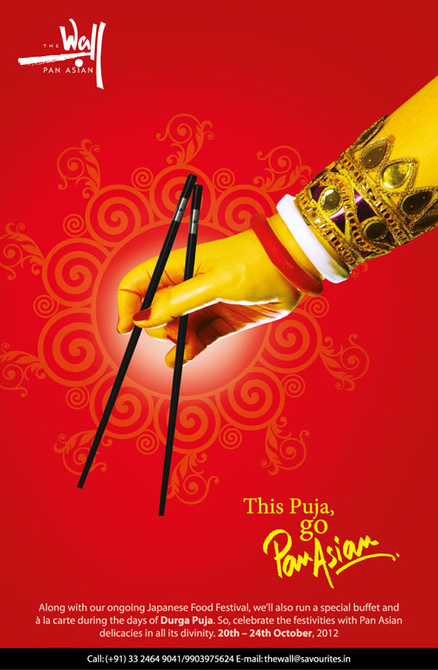

Note: An advertisement for The Wall, created specifically for the Durga Puja days: the creative supposedly shows one of the 10 hands of the goddess Durga.

Source: Inner Circle.

1. “Aaheli,” Peerless Hotels, accessed January 25, 2018, [www.peerlesshotels.co.in/f-n-b/index.html](https://www.peerlesshotels.co.in/f-n-b/index.html).
2. “Our Story,” Speciality Restaurants Ltd., accessed January 25, 2018, www.speciality.co.in/our_story.php.
3. Vir Sanghvi, “History on Our Plate: How India Started Enjoying Food,” *Hindustan Times*, October 2, 2014, accessed January 25, 2018, www.hindustantimes.com/india/history-on-our-plate-how-india-started-enjoying-food/story-wrphlSI5OnfD3COWOkaiZO.html.
4. Superpages, “What Is Fine Dining?,” Superpages, accessed January 28, 2018, [www.superpages.com/em/what-is-fine-dining/](https://www.superpages.com/em/what-is-fine-dining/).
5. Raj Arora and Joe Singer, “Cognitive and Affective Service Marketing Strategies for Fine Dining Restaurant Managers,” *Journal of Small Business Strategy* 17, no. 1 (2006): 51–61.
6. ₹ = INR = Indian rupee; ₹1 = US$0.02 on September 30, 2016.
7. Bindu D. Menon, “India’s Restaurant Revolution,” *Hindu Business Line*, May 17, 2013, accessed January 29, 2018, www.thehindubusinessline.com/news/variety/indias-restaurant-revolution/article23029875.ece.
8. Souvik Ray, “10 Epic Street Foods That Make Kolkata the Gastronomic Capital of India,” Indiatimes Lifestyle Network, May 10, 2017, accessed January 29, 2018, [www.indiatimes.com/culture/food/10-epic-street-foods-that-explain-why-kolkata-is-indias-gastronomic-capital-228037.html](https://www.indiatimes.com/culture/food/10-epic-street-foods-that-explain-why-kolkata-is-indias-gastronomic-capital-228037.html).
9. Dosa was a type of pancake made from a fermented batter of rice and black gram. It was somewhat similar to a crepe in appearance. Nash Patel and Leda Scheintaub, “Introduction,” in *Dosa Kitchen: Recipes for India’s Favorite Street Food* (New York, NY: Clarkson Potter, 2018).
10. Meduvada was a fritter made from black lentils. It was usually made in a doughnut shape, with a crispy exterior and soft interior. Richa Hingle, *Vegan Richa’s Indian Kitchen: Traditional and Creative Recipes for the Home Cook* (Woodstock, VA: Vegan Heritage Press, 2015).
11. Idli was a type of savoury rice cake, made by steaming a batter consisting of fermented, de-husked black lentils and rice. K.T. Achaya, *The Story of Our Food* (Hyderabad, India: Universities Press, 2003), 80.
12. Biryani was a South Asian mixed rice dish generally made with spices, rice, and meat (chicken, mutton, beef, prawn, or fish). Pratibha Karan, “Introduction,” in *Biryani* (Gurgaon, India: Random House India, 2012).
13. Abhilash Ponnam and M.S. Balaji, “Matching Visitation-Motives and Restaurant Attributes in Casual Dining Restaurants,” *International Journal of Hospitality Management* 37 (2014): 47–57.
14. Grant Thornton, *Indian Food & Beverage Sector: The New Wave,* August 27, 2014, accessed February 1, 2018, www.grantthornton.in/insights/articles/indian-food--beverage-sector-the-new-wave/.
15. Vir Sanghvi, “India’s Greatest Mutton Curry,” *Hindustan Times*, June 29, 2014, accessed February 1, 2018, www.hindustantimes.com/brunch/india-s-greatest-mutton-curry/story-0lTwf3KPmutN5j7sWgKBlO.html.
16. Kosha mangsho was a semi-dry mutton (or lamb) dish cooked using spices like red chilli powder. The stand-out feature of this item was that the mutton was slow-cooked and sautéed to maintain its juiciness and flavour. Mumbai Mirror, “Delectable Bengali Foods to Tuck into on Poila Boishakh,” *Times Food*, April 15, 2015, accessed January 29, 2018, <https://recipes.timesofindia.com/articles/features/delectable-bengali-foods-to-tuck-into-on-poila-boishakh/articleshow/46920244.cms>.
17. Sindoor was a traditional vermilion red-coloured cosmetic powder from India, usually worn by Hindu married women along the parting of their hair. The application of sindoor denoted the married status of the woman. Susie J. Tharu and Ke Lalita, eds., *Women Writing in India: The Twentieth Century*. *Vol. 2* (New York, NY: Feminist Press at CUNY, 1991), 317; Alta was a red dye, originally produced from lac, which women in India and Bangladesh applied to the outer rims of their hands and feet during marriages and festivals. Ganga Ram Garg, *Encyclopaedia of the Hindu World, Vol. 2* (New Delhi, India: Concept Publishing, 1992), 348.
18. Bindi (literally “point, drop, dot or small particle” in Hindi) was a red dot worn commonly by Hindu and Jain women on the centre of the forehead.
19. Debaleena Sengupta, “Taste of Bengal,” *Business Standard*, January 20, 2013, accessed January 30, 2018, www.business-standard.com/article/beyond-business/taste-of-bengal-111061900017_1.html.
20. Bennett Coleman & Co. Ltd., “Babul’s CD Launch,’” *Navbharat Times*, August 7, 2009, accessed February 15, 2018, <http://photogallery.navbharattimes.indiatimes.com/events/kolkata/babuls-cd-launch/articleshow/4867985.cms>.
21. ## Biswajit Sarkar, “World's First Trademark As An Address—6 Ballygunge Place,” Biswajit Sarkar, accessed February 15, 2018, www.biswajitsarkar.com/trademark-as-an-address.php.

   
22. S.R. Crockett and L.J. Wood, “Western Australia: Building a State Brand,” in *Destination Branding: Creating the Unique Destination Proposition,* ed. Nigel Morgan, Annette Pritchard, and Roger Pride (Oxford: Elsevier, 2004), 185–206.
23. Rachel Piggott, Nigel Morgan, and Annette Pritchard, “New Zealand and *The Lord of the Rings*: Leveraging Public and Media Relations,” in *Destination Branding: Creating the Unique Destination Proposition,* ed. Nigel Morgan, Annette Pritchard, and Roger Pride (Oxford: Elsevier, 2004), 208, 207–225.