

9B19A009

ZYDUS WELLNESS: Nutralite’s marketing twist

Falguni Vasavada, [Smita Pranav Kothari](https://iveypubs.my.salesforce.com/0031J00001S2fiW), and [Sudiksha Patil](https://iveypubs.my.salesforce.com/0031J00001S2fiX) wrote this case solely to provide material for class discussion. The authors do not intend to illustrate either effective or ineffective handling of a managerial situation. The authors may have disguised certain names and other identifying information to protect confidentiality.

This publication may not be transmitted, photocopied, digitized, or otherwise reproduced in any form or by any means without the permission of the copyright holder. Reproduction of this material is not covered under authorization by any reproduction rights organization. To order copies or request permission to reproduce materials, contact Ivey Publishing, Ivey Business School, Western University, London, Ontario, Canada, N6G 0N1; (t) 519.661.3208; (e) cases@ivey.ca; www.iveycases.com. Our goal is to publish materials of the highest quality; submit any errata to publishcases@ivey.ca. i1v2e5y5pubs

Copyright © 2019, Ivey Business School Foundation Version: 2019-03-07

At the end of the sales meeting for the second quarter of 2014, Sachin Dingankar, head of marketing at Zydus Wellness Ltd. (Zydus) and deputy general manager of marketing for the brand Nutralite, had a eureka moment when he noted, “If it’s just a transactional kind of relationship, then it’s not good for the brand in the future.” He felt that in the eight years of the brand’s existence, Nutralite had established itself as a healthy, functional butter substitute in the minds of consumers. Now, the brand needed to reach consumers’ hearts in order to fight the competition in the market.

Dingankar approached the company’s advertising agency, DDB Mudra Group (DDB Mudra), to figure out a way to grow Nutralite’s market. On May 17, 2016, DDB Mudra West launched a television commercial (TVC) for Nutralite that featured a man who was grumpy on account of being served an unappetizing, healthy breakfast. The idea was to connect emotionally to women who faced the challenge of cooking healthy yet tasty and varied breakfasts every morning. The TVC was part of the Khane Mein Twist campaign, through which the agency tried to reach Nutralite consumers’ hearts. The brand’s repositioning exercise was to compete with Amul butter, which brandished the tag line “The Taste of India.” By the end of 2017, the campaign had achieved encouraging outcomes, but Dingankar was already thinking about how he could take the brand to the next level.

**Zydus Wellness**

Zydus, a subsidiary of Cadila Healthcare, was a pharmaceutical company based in Ahmedabad, in Gujarat, India. Zydus was incorporated in January 2009 to develop, produce, and market products in the areas of cosmeceuticals, nutraceuticals, and health care. The company operated in the country’s consumer goods sector, offering products such as Sugar Free, Everyuth, and Nutralite (see Exhibit 1).

Sugar Free, a sugar substitute, was launched in 1988 and had captured a market share of 94.5 per cent by May 2017.[1] The brand was initially introduced as a sugar substitute for diabetic patients and was subsequently positioned as being useful to anyone who was health conscious. Sugar Free was offered in a number of different applications and forms under its flagship brand. According to the Sugar Free website, the brand offered three products: Sugar Free Gold, Sugar Free Natura, and Sugar Free Green.[2] All three products were alternatives to sugar, and all were made from different ingredients. Sugar Free Gold was made from aspartame, Sugar Free Natura was made from sucralose, and Sugar Free Green was made from stevia leaves. Sugar Free products were available as drops, pellets, sachets, and powder. The brand’s latest offering, Sugar Free Green, was a naturally sweet substitute that could be used by the entire family, including children.

Everyuth, launched in 1991, offered skin care products. In March 2016, Everyuth Naturals (the brand was re-launched under this name in 2013) held first position in the market in the peel-off mask segment, with a 90-per-cent market share, as well as the leading position in the scrub segment, with a market share of 30 per cent.[3] The brand ranked sixth in the facial-cleansing segment, with a market share of 6 per cent, and it ranked ninth in the face-wash segment, with a market share of about 1 per cent.[4]

**Nutralite**

Nutralite, classified by the Food Safety and Standards Authority of India (FSSAI) as a fat spread, was the flagship product of the brand. It was positioned as a healthier alternative to butter, as it was cholesterol-free. Under FSSAI regulations, a fat spread had to contain 40–80 per cent fat by mass. For butter, however, the milk fat had to be not be less than 80 per cent.

In 2006, the Zydus Cadila Group (Zydus Cadila) bought Nutralite from Carnation Nutra-Analogue Foods Ltd. (Carnation Foods). Carnation Foods, incorporated in 1994 in Gujarat, operated in the dairy market and manufactured products such as margarine.[5] When Zydus Cadila bought Nutralite, Carnation Foods was mainly an institutional business that catered to larger buyers such as hotels, hospitals, schools, and universities, which purchased goods and services for use in the production of their own goods or services.[6] The product did not have a retail presence. Within the first quarter after the acquisition, Zydus Cadila decided to also place the brand in the retail sector after reformulating the product and its packaging. In November 2006, Nutralite was launched as a premium consumer product. The company launched the product at a party that took the form of a food show—The Better Food Show—at which presenters prepared and served food made with Nutralite, which it claimed was healthier/better than butter.

By mid-2017, 70 per cent of Nutralite’s business was derived from institutional buyers, including hotels, restaurants, and cafés,but its marketing communication targeted retail consumers. “Nutralite as a brand doesn’t want to be associated with *maska bun wala*, sandwich *wala*, etc.,” said Sharat Kuttikat, senior creative director at DDB Mudra West, speaking of the vendors who sold sandwiches and maska buns (a street food consisting of butter applied generously over a specific kind of bread). The company had made a conscious decision in 2006 to focus on the retail sector in order to build the brand in the minds of consumers. Dingankar said that urban metropolitan areas constituted 70 per cent of the company’s retail business, and within that, Mumbai and Delhi contributed 40–45 per cent of the business.

Between 2006 and 2011, Nutralite was involved in an advertising war with its closest competitor, Amul butter. The Nutralite campaign promoted Nutralite using the tag line “Butter *se* better” (“Better than butter”), which led Amul to file a case against the company with the Advertising Standards Council of India (ASCI). “They are sending a wrong message to consumers that consumption of butter is unhealthy. Our product is natural and healthy. It is not synthetic, neither is it laced with chemicals,” said R.S. Sodhi, chief general manager of the Gujarat Cooperative Milk Marketing Federation, which owned the Amul brand.[7] Amul officials said Nutralite’s advertising was “‘denigrating and discrediting’ butter as a category and the ad council had asked Zydus to substantiate its claims in future advertising.”[8]

In 2012, Nutralite introduced an omega-3 variant to cater to health-conscious consumers. Omega-3 fatty acids were later included in the base version as well. Dingankar explained that the fortification was a way to differentiate between Nutralite and other low-priced fat spreads in the market (see Exhibit 2).

In 2014, as a response to a strong competitor’s low-priced fat spread, Nutralite launched Yummy, positioning the product as having “great taste at great value” (see Exhibit 2).

In 2016, Nutralite held a 40-per-cent share in the margarine sector[9] and a 1-per-cent share in the combined butter and margarine sector in India.[10]

Amul butter had been in the market since the middle of the 20th century. The dairy launched Amul Lite—a bread spread—in 1994, and the first Amul Lite TVC was aired in 1996.[11] The co-operative launched Amul Delicious in the margarine category in 2004.[12] In addition to Amul, Nutralite competed with Vimal Lite, a table spread produced by Vimal Oil and Foods Ltd. Vimal Lite’s first TVC aired in 2011.[13]

**Milestones in the Advertising Journey of Nuralite**

From the time Zydus Cadila acquired Nutralite in 2006 until 2017, the brand went through four major advertising phases, which were conceptualized by DDB Mudra West.

First Phase: Deewana hua Baadal

In the brand’s first TVC, “Deewana hua Baadal,”[14]created in November 2006, a husband was ecstatically singing the titular song because his wife was making *aloo paratha* (Indian bread stuffed with potatoes) for breakfast. But when the wife hesitated to use a generous amount of butter, the advertisement advocated using Nutralite, claiming it was better than butter on health grounds.

In 2007, Amul took objection to Nutralite’s campaign tag line, “Butter *se* better,” and filed a case against the brand with the ASCI.[15] The judgment was in Amul’s favour, so Nutralite had to change its campaign tag line to “Healthier than butter.”

Second Phase: Khaane Mein Kya Hai

Nutralite’s TVC for its second major marketing campaign, “Khaane Mein Kya Hai,”[16] aired in March 2008 and featured actors Satish Shah and Ratna Pathak as husband and wife. In the commercial, plump Shah asked his wife about a menu, and Pathak replied by naming mouth-watering dishes like club sandwiches. Shah waited for the food with great anticipation and enthusiasm, only to be served fruits and salads. Pathak made different excuses to her husband in the TVC—for example, the children had eaten the tasty food. Then a voice-over asked Pathak, “So many excuses for escaping butter?” and advocated using Nutralite, which was better than butter. The TVC ended with Pathak laying out a feast of her husband’s favourite foods, all cooked with Nutralite.

Third Phase: Cyrus Broacha

The next major TVC, in December 2012, cast popular comedian Cyrus Broacha[17] and introduced the omega-3 variant. The TVC showed Broacha being tempted by high-calorie fast food like *pav bhaji* (an Indian fast food dish)and being admonished by a doctor to abstain. Later, the doctor in the commercial explained the benefits of the omega-3 fortification in Nutralite.

Fourth Phase: Healthier Choice

In 2013, famous chef Sanjeev Kapoor was engaged to market Nutralite, and his picture was put on the institutional product packs. In the same year, Nutralite’s communication tag line was changed to “Healthier choice.” Starting that year, Nutralite also started investing in digital marketing efforts. The brand organized social media campaigns on occasions such as Teacher’s Day, Mother’s Day, and World Health Day. One such campaign, HealthGram, was conducted on World Health Day in 2016. For the campaign, women were asked to send health advice to their families through Nutralite; the premise was that their advice usually fell on deaf ears. The brand arranged a musical band, which performed the messages as songs. The video of the campaign had more than 13,000 views.[18]

Although Nutralite had been mainly involved with television as an advertising medium, the brand had done a few on-ground activations. DDB Mudra carried out an on-ground campaign during the Hindu festival of Ganesh Chaturthi in September 2015 called Health Cha Shree Ganesh.[19] The aim of the campaign was to promote health and fitness to the citizens of Mumbai who came to worship Lord Ganesha; the pot-bellied Ganesha would be transformed into a fit and slim avatar with a “six-pack” of defined abdominal muscles. Devotees were asked to do physical exercise and donate calories to Lord Ganesha to help him retain less calories. The calories lost were monitored through a real-time calorie count every day. *Pandits*[20] had to go through auditions, and those who were obese were rejected. The *prasad*[21] consisted of sprouts and healthy food.

**Brand Dilemma**

Nutralite had existed in the market for about a decade. The brand had fared well initially, but it hit saturation in terms of sales after 2009–2010. It competed in a product category that was dominated by Amul butter and thus had to face the strong loyalty that Amul had created in the market. (In 2017, Amul butter had a market share of 86 per cent in India.)[22] The Nutralite brand communicated that it was better than butter in terms of health because it was cholesterol-free, but there was a clear gap in consumer understanding. As was supported by Kuttikat’s experience, most people knew butter but were unable to comprehend what Nutralite was. Research also identified another problem: while the brand was known as a healthier alternative to butter, most people could not clearly understand how or why it was healthier.

In addition, the marketing environment for Nutralite was growing more and more competitive by the day, with market leader Amul delivering frequent campaigns.[23]

At the consumers’ end, there was an upward trend towards health and wellness in India, including a rising consciousness of the dangers of excessive sodium intake.[24] Butter was thought to be high in salt. However, owing to rising incomes and other factors, there was also an increase in demand for processed dairy items like butter.[25]

**Market Research and Findings**

Nutralite’s marketing team felt that although the brand’s market potential was immense, they needed to ensure stronger understanding among consumers to overcome the sales challenge. Hence, Zydus and DDB Mudra commissioned market research in four cities in the third quarter of 2014 to find out why people were not buying the product. “One of the biggest reasons was taste,” Dingankar said, explaining that there was a big taste difference between Nutralite and the salty butter that people were accustomed to. Under FSSAI regulations, a fat spread could not contain more than 2 per cent salt by weight in the aqueous phase.

The market study also revealed that 85 per cent of the market was aware of Nutralite but only one-third of the audience had tried the brand. Among consumers who had tried the brand, only one-third repurchased it and stayed loyal to the brand. It was also clear from the research that people were buying Nutralite for health reasons.

The research helped Shekhar Pandey, vice-president of strategic planning at DDB Mudra, to define Nutralite’s target group: modern women who were interested in food and inclined to experiment, and who read and wrote food blogs and watched cooking programs. Cooking was not drudgery for this group; they considered it to be education as well as entertainment. The research indicated that members of the Nutralite target group were more than 30 years of age and were married. The women also acted as gatekeepers for healthy eating for their husbands, who might have been at risk of suffering from heart ailments. Dingankar, however, aimed to make Nutralite a family consumption brand in the long run.

After conducting the research, Dingankar and his team and DDB Mudra West set about to reposition the brand while keeping the health promise constant. Based on the above research and brainstorming with the client, one of the concepts the agency defined in a brand workshop built on the pivot of versatility (see Exhibit 3). In refining the concept of versatility further, Pandey said three questions emerged:

First: How do you use this product in more ways than one? The answer to this application problem was to use Nutralite not just as a spread on bread but also for sautéing, grilling, baking, and so on. “Then you are not restricted to a top-up sort of application wherein the taste goes through a litmus test,”[26] Pandey explained. He added, however, that the marketing of Nutralite as a cooking ingredient was being done subtly so as not to compete with, for example, Saffola oil, an edible oil brand in India.

Next: How can you offer the same product in different forms? “Rather than improving the flavour of the base variant, if we give them [consumers] more flavour options, then the taste barrier can be tackled,” Dingankar reasoned. In January 2017, Nutralite launched two flavours: (1) garlic and oregano; and (2) mint leaves and coriander. These were showcased in the May 2017 TVC. (Amul also offered flavours such as garlic and herbs in its butter.)

Finally: How do you extend product and brand categories? This was the main reason Dingankar wanted to incorporate an emotional aspect into advertising for Nutralite. “From 2014, we were also thinking of getting into other categories where a pure functional (health) route may not have helped,” he said.

**Campaign with a Twist**

Chef Kapoor had been endorsing Sugar Free since 2007.[27] His picture had also been placed on packaging for non-premium Nutralite since 2013 to increase the product’s credibility with institutional buyers. However, Dingankar and Pandey later realized that Kapoor’s credentials were strong even in the consumer space, and that whatever Kapoor said would be followed blindly by the target group. Hence, not only was Kapoor’s image incorporated on the packaging of premium Nutralite, but he was also featured in the TVC beginning in May 2016. Kuttikat, who was involved in conceptualizing the TVC, said that he knew exactly what the last 10 seconds of the TVC would look like: “Sanjeev Kapoor, with his credibility, would assure the women—the gatekeepers—that taste needn’t be compromised while going for something healthy,” he said.

Getting a domain expert as a brand endorser helped the brand in terms of recall and credibility. The Amul girl, the face of the brand since 1967,[28] was a strong part of the Amul visuals. So it made market sense for Nutralite to move away from a mascot and instead have a brand ambassador. Having an ambassador who was a famous chef helped a great deal in adding credibility to the dishes cooked with Nutralite. So when the woman in the TVC delighted her husband with an open-faced toast and vegetable wrap made with Nutralite, the hope was that it would increase the brand equity of Nutralite. And indeed it did: overall, the sales of the product increased significantly.

In addition to the 30-second TVC, Nutralite was also marketed on an ongoing basis on Facebook using the hashtag #KhaneMeinTwist. “It’s difficult to build the versatility angle with one TVC,” Dingankar said, adding, “Digital gives me the flexibility of showing how we can use Nutralite in many different ways.” Kapoor was involved in the social media marketing of Nutralite as well. He invited people to share their recipes on Nutralite’s Facebook page, giving a “twist” to the recipes by using Nutralite, and to post videos demonstrating the altered recipes on the page tagging #KhaneMeinTwist. Tonic Media Digital Private Limited managed Nutralite’s digital marketing. Nutralite’s digital campaign reached 15.2 million people and had 5.8 million total views. The campaign’s engagement rate was 188 per cent.

**Challenge ahead**

As a brand, Nutralite had gone through a journey of positioning and repositioning by understanding category dynamics and consumer preferences. The brand had emphasized its versatility to position itself better in the minds of consumers in a way that made it possible for the brand to come up with variants and broaden its consumption. By doing so, it successfully went from being just the additional or applied ingredient to becoming an enabler of versatility in cooking. The challenges ahead for the brand were multi-fold. Dingankar considered the challenges and concerns the brand needed to address going forward: It needed to extend its versatility positioning beyond product variants. It also needed to build its marketing communication efforts using versatility as the theme. Engaging consumers on social media to further build up product usage experiences under the versatility theme was also a challenge. Finally, it needed to stay relevant with the growing trend of consumers moving towards healthier lifestyles and food patterns.

Exhibit 1: Relationship between Cadila healthcare and Zydus

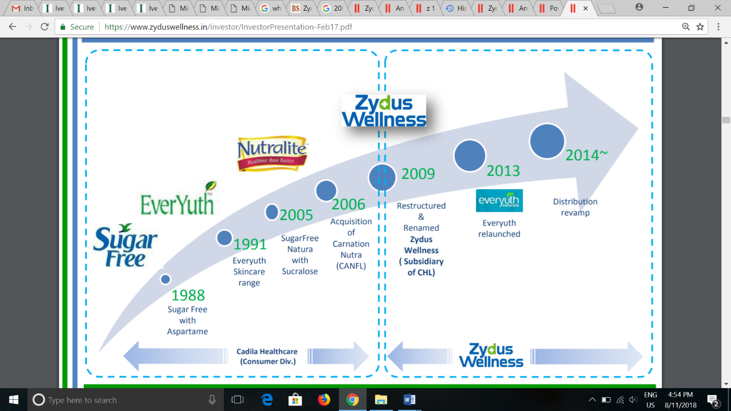

Source: Company files.

Exhibit 2: Nutralite versus the Competition

|  |  |  |  |
| --- | --- | --- | --- |
| **Product Name** | **Price per 100-gram Package (in ₹)** | **Price per 200-gram Tub (in ₹)** | **Price per 500-gram Package (in ₹)** |
| Nutralite (flavoured) | 42 | 85 |  |
| Nutralite Classic | 40 | 82 | (carton) 180  (tub) 185 |
| Nutralite Yummy (fat spread) | 15 | NA | (carton) 72 |
| Amul Delicious (fat spread) | 1 | NA | 68 |
| Amul Lite (mixed-fat spread) | 30 | NA | 145 |
| Vimal Lite (margarine) | NA | 55 | (brick) 95 |

Note: ₹ = INR = Indian rupee; ₹1 = US$0.02 as of December 1, 2017; NA = not available

Source: Created by the authors based on “Nutralite Table Spread Range,” Nutralite, accessed September 25, 2018, www.nutralite.com/table-spread-range/; “Amul,” Amul online, accessed September 25, 2018, [www.amulonline.com/search?q=amul+delicious](https://www.amulonline.com/search?q=amul+delicious); “Vimal,” Vimal Mart, accessed September 25, 2018, <http://vimalmart.com/vimal-lite>.

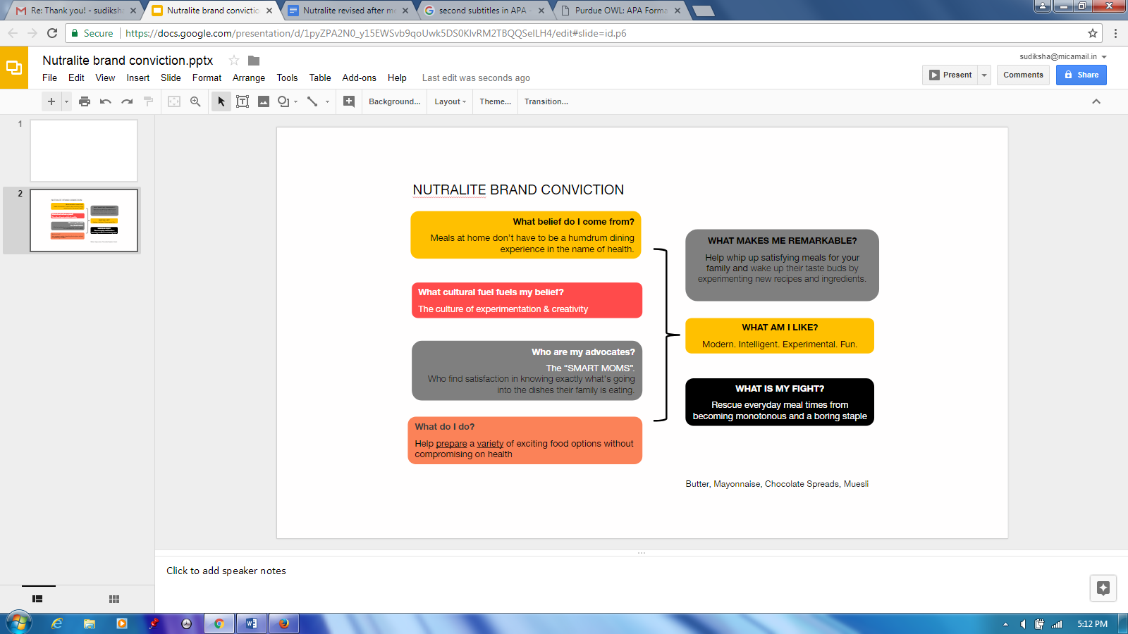EXHIBIT 3: NUTRALITE’S BRAND CONVICTION TOOL

Source: DDB Mudra Group.

ENDNOTES

1. Zydus Wellness, *Good For You: Zydus Wellness Ltd. Annual Report 2016–17*, 72, 2017, accessed September 25, 2018, [www.zyduswellness.in/investor/Annual%20Report%2016-17.pdf](https://www.zyduswellness.in/investor/Annual%20Report%2016-17.pdf).
2. Zydus Wellness, “Sweeteners,” accessed January 28, 2019, www.sugarfree-india.com/.
3. Zydus Wellness, *Zydus Wellness: A Snapshot*, 26, 2017, accessed August 6, 2018, [www.zyduswellness.in/investor/InvestorPresentation-Feb17.pdf](https://www.zyduswellness.in/investor/InvestorPresentation-Feb17.pdf).
4. Ibid.
5. Regional Bureau, “Cadila Buys Stake in Carnation Foods,” *Business Standard*, February 6, 2013, accessed August 6, 2018, [www.business-standard.com/article/companies/cadila-buys-stake-in-carnation-foods-106031801038_1.html](https://www.business-standard.com/article/companies/cadila-buys-stake-in-carnation-foods-106031801038_1.html).
6. “Institutional Market,” Business Dictionary, accessed September 25, 2018, www.businessdictionary.com/definition/institutional-market.html.
7. Ratna Bhushan, “Amul Spoofs Nutralite, Spreads Butter Ad War,” *Economic Times*, February 16, 2018, accessed April 24, 2018, https://economictimes.indiatimes.com/industry/services/advertising/amul-spoofs-nutralite-spreads-butter-ad-war/article show/5577829.cms.
8. Ibid.
9. Equentis Wealth Advisory Services Ltd., *Zydus Wellness Limited: Independent Equity Research*, 2, January 2016, accessed September 25, 2018, www.researchandranking.com/wp-content/uploads/2015/11/Zydus-Wellness-Note-Jan20-2016.pdf.
10. Nutralite, “Brand Share,” Euromonitor International, 2017, accessed September 25, 2018, www.portal.euromonitor.com/portal/resultslist/index.
11. Amul website, “Amul Lite,” accessed January 28, 2019, https://amul.com/products/amul-lite-info.php.
12. “Amul Forays into Margarine Segment,” Exchange4Media, September 30, 2004, accessed August 21, 2018, [www.exchange4media.com/marketing/amul-forays-into-margarine-segment_13601.html](https://www.exchange4media.com/marketing/amul-forays-into-margarine-segment_13601.html).
13. Vimal Lite TVC.wmv, YouTube video, 0.35, March 24, 2011, accessed January 28, 2019,www.youtube.com/watch?v=8du91lZImW4.
14. “Nutralite TVC,” YouTube video, 0:51, posted by “malukid,” December 4, 2006, accessed January 21, 2019, https://youtu.be/P2pHuwPT_WA.
15. Ratna Bhushan, op. cit.
16. “Nutralite Ad – Funny Indian TVC,” YouTube video, 0:51, posted by “Kapil Ojha,” January 6, 2009, accessed January 21, 2019, https://youtu.be/-WpA4p-Fjlo.
17. “Nutralite with Omega 3,” YouTube video, 0:46, posted by “man josh,” December 6, 2012, accessed January 21, 2019, https://youtu.be/OxXW4CsZ-Ek.
18. “Nutralite’s #Healthgram Takes a Musical Route to Create Engagement,” Social Samosa, April 19, 2016, accessed September 25, 2018, [www.socialsamosa.com/2016/04/nutralite-healthgram-musical-route-engagement/](https://www.socialsamosa.com/2016/04/nutralite-healthgram-musical-route-engagement/).
19. Aditi Srivastava, “Nutralite’s ‘Slimming Ganesha,’” Afaqs!, September 25, 2015, accessed April 24, 2018. www.afaqs.com/news/story/45750_Nutralites-Slimming-Ganesha.
20. A pandit was a Hindu scholar learned in Sanskrit and Hindu philosophy and religion. He was typically also a practicing priest.
21. A prasad was a devotional offering made to a god, typically consisting of food that was later shared among devotees.
22. Hitesh Bhasin, “Marketing Mix of Amul Butter,” Marketing91, December 26, 2017, accessed April 24, 2018, [www.marketing91.com/marketing-mix-of-amul-butter/](https://www.marketing91.com/marketing-mix-of-amul-butter/).
23. Shruti Kedia, “The Amul Campaigns Continue to Deliciously Capture the Pulse of India,” YourStory, December 18, 2017, accessed July 6, 2018, <https://yourstory.com/2017/12/amul-girl-india-rahul-dacunha/>.
24. Indo Asian News Service, “Indian Are Now Alert to Dangers of High Salt Intake and Are Modifying Their Diet,” *Hindustan Times*, May 1, 2017, accessed July 6, 2018, [www.hindustantimes.com/fitness/indian-are-now-alert-to-dangers-of-high-salt-intake-and-are-modifying-their-diet/story-yx2GUHAYogVVbWZH69M3KJ.html](https://www.hindustantimes.com/fitness/indian-are-now-alert-to-dangers-of-high-salt-intake-and-are-modifying-their-diet/story-yx2GUHAYogVVbWZH69M3KJ.html).
25. Vijay Intodia, “Dairy and Products Annual,” Global Agricultural Information Network, 5, 2016, accessed July 6, 2018, <https://gain.fas.usda.gov/Recent%20GAIN%20Publications/Dairy%20and%20Products%20Annual_New%20Delhi_India_9-29-2016.pdf>.
26. A litmus test was “a test in which a single factor (such as an attitude, event, or fact) [was] decisive.” “Litmus test,” Merriam-Webster online, accessed January 21, 2019, www.merriam-webster.com/dictionary/litmus%20test.
27. “#KhaneMeinTwist- Nutralite film by DDB Mudra West,” YouTube video, 0:37, posted by “DDB Mudra Group,” June 22, 2017, accessed January 21, 2019, https://youtu.be/by9nTDCA9wo; “Cadila Eyes FMCG Links for Sugar Free Growth,” *Financial Express*, February 4, 2007, accessed April 24, 2018, www.financialexpress.com/archive/cadila-eyes-fmcg-links-for-sugar-free-growth/189606/.
28. Harish Bhat, “Where Have the Brand Mascots Gone?,” *Hindu Business Line*, April 10, 2014, accessed April 24, 2018, [www.thehindubusinessline.com/catalyst/where-have-the-brand-mascots-gone/article23030487.ece](https://www.thehindubusinessline.com/catalyst/where-have-the-brand-mascots-gone/article23030487.ece).