

9B19A012

MIXTAPE SOCIAL: BUILDING BRANDS FOR ATHLETES AND COMPANIES

[Ken Mark](https://iveypubs.my.salesforce.com/003A000001CqbJR) wrote this case under the supervision of [Miranda Goode](https://iveypubs.my.salesforce.com/003A000001CqbJu) solely to provide material for class discussion. The authors do not intend to illustrate either effective or ineffective handling of a managerial situation. The authors may have disguised certain names and other identifying information to protect confidentiality.

This publication may not be transmitted, photocopied, digitized, or otherwise reproduced in any form or by any means without the permission of the copyright holder. Reproduction of this material is not covered under authorization by any reproduction rights organization. To order copies or request permission to reproduce materials, contact Ivey Publishing, Ivey Business School, Western University, London, Ontario, Canada, N6G 0N1; (t) 519.661.3208; (e) cases@ivey.ca; www.iveycases.com. Our goal is to publish materials of the highest quality; submit any errata to publishcases@ivey.ca. i1v2e5y5pubs

Copyright © 2019, Ivey Business School Foundation Version: 2019-03-22

We understand that athletes are now brands, media platforms in themselves with a direct line to fans.

Joe Myers, founder, Mixtape Social

“Should we focus on growing Mixtape Social or Side B?” wondered Joe Myers, founder and chief executive officer of Mixtape Social. It was February 23, 2018, and Myers had spent the past two years bootstrapping his two-pronged business, which offered services to help professional athletes build their personal brands (Mixtape Social) and creative advertising and social media campaigns for corporations and other entities (Side B). Myers had succeeded: he had a roster of professional athletes he worked with, including Mitch Marner, one of the top players for the Toronto Maple Leafs hockey team (see Exhibits 1 and 2).

A veteran of the Canadian advertising industry, Myers left his job to start Mixtape Social because he saw an opportunity to offer high-end social media branding services at a lower cost.

Myers looked at the first slide of his introductory pitch document, which read:

What makes us different? We offer Whole Foods Product at Walmart Pricing. We’re nimble, flexible and cost efficient. We challenge the old agency model and invest in what really matters—smart, creative people who can rise up to meet our clients’ goals. We’re passionate digital and social experts who enjoy what we do.

We’ve taken our decades of agency experience and focused on delivering what matters: strong results without the extra frills and red tape. From content plans to social playbooks, analytics dashboards and strategic planning tools, our proven process exceeds our clients’ social media expectations.

Having gained momentum in the last year, Myers thought about how he should map out the next two years: Where should he focus? What services should he offer? How should he position his value proposition?

The Advertising Industry

Advertising agencies coordinated creative material and output and provided coordination and marketing execution services to Canadian businesses. Advertising spending in Canada was expected to reach CAD $11.52 billion[1] in 2018, and about half of this figure ($5.61 billion) was spent on digital advertising.[2] At the end of 2017, there were 6,634 businesses in the advertising industry, employing a total of about 30,000 people.[3]

The largest advertising agencies—Leo Burnett, Cossette, BBDO, and the Grey Group, for example—worked with firms such as the Procter & Gamble Company and the Coca-Cola Company on multi-million-dollar budgets. A marketing campaign for a large brand could cost $5 million a year and include the entire range of traditional advertising—television, print, and radio—as well as digital advertising. The agencies developed creative material, worked with clients to shape and approve it, arranged for commercials or creative executions to be developed, and then booked media time to air the advertising.

There were also smaller advertising agencies that worked with smaller firms (see Exhibit 3). They generally worked on smaller projects of at least $10,000 and employed fewer people.

Influencer Marketing

The growth of social media tools allowed individuals—key influencers—to start building their personal brands. Advertisers, keen to market products and services to influencers’ followers, started to sponsor personalities and athletes, paying them to promote their wares on their behalf. In 2018, two-thirds of marketers surveyed by Bloglovin’, an advertising research agency, believed that “influencer marketing campaigns helped them reach a more targeted audience, thus leading to more impactful results.”[4]

The global Instagram influencer market—that is, monies paid to influencers by brands—was worth USD $1.07 billion in 2017. This market was forecast to more than double to USD $2.38 billion by 2019.[5]

The notion that celebrities or athletes could be paid to promote products was not new. After all, decades of traditional marketing—television, radio, and print—relied on images of popular people wearing, eating, or using branded products.

There were key differences, however, in influencer marketing: First, the influencer was expected to create a personalized message that seemed genuine and, at the same time, notify his or her audience that they were being paid for the message. Second, brands had little creative control over what the influencer had to say because the intent was to have the message seem as genuine as possible.

For many professional athletes focused on training and competition, the art of “fulfilment”—of creating and sending personalized content to meet their needs and the needs of their sponsors—was difficult because this was often not part of their core competency.

Mixtape Social—value proposition

Myers had the following pitch on what Mixtape Social had to offer:

We make social easy. Leave it to us—we take the work off our client’s hands and give them their time back. By developing data-driven creative content using our in-house designers, photographers, videographers and copywriters, we deliver engaging content that speaks in our client’s voice.

We understand that athletes are now brands, media platforms in themselves with a direct line to fans. We want to foster and grow a positive relationship between our clients and fans. We proudly act as co-owners of our clients’ social properties—we’re the connective tissue between pro athletes, brands, and fans. Social is the most under-utilized revenue stream for athletes and by not activating this option, they are leaving money on the table.

We provide creative [advertising materials], strategy, management and moderation in order to encourage the development of a strong fan base, generating revenue opportunities for our clients now and beyond their playing days.

Myers and his team began the business development process by getting to know prospective clients in order to understand their focus and motivation and get a sense of their tone and voice on social media. According to Meyers, Mixtape Social could help an athlete in the following way:

As an athlete, you feel that your day-to-day life isn’t all that glamorous. The training routine, the restrictive eating plans or the fact that you hang out at home to rest. But that doesn’t mean your life isn’t interesting. What may seem like just another day to you is actually, to your follower, an exciting peek into the life of a high-performance athlete. You’re on a life path many people can only dream about.

As Myers explained, having athletes as influencers could benefit brands:

They always have an engaging story. An athletic season is a real-life story with ups and downs, comebacks, setbacks, tests and triumphs. We give our fans a behind the scenes look into a unique world. People love the idea of getting a sneak peek behind the headlines into the world of high-performance athletes. Many people choose to follow athletes via social media because seeing someone putting in the hard work necessary to achieve their dreams is extremely motivating. Being part of something bigger. People love to feel that they belong to a larger community. Following an athlete as he/she prepares for the ﬁght gives your fans the sense of being connected. Last, we are able to offer health, ﬁtness and sport tips and tricks. Many athletes provide training tips or share products that work for them, which anyone who plays the sport or is involved in physical ﬁtness can appreciate.

The top influencers had big audiences and commanded high prices (see Exhibit 4).

Mixtape Social and Side B

Myers had 17 years of digital experience in Toronto and Chicago at top advertising agencies. He created, launched, and managed websites, social pages, videos, and advertising campaigns for top brands such as the Kellogg’s Company, McDonald’s, Nestlé, the Campbell Soup Company, IKEA, General Mills, Conagra Brands, and others. He recalled why he decided to start his own firm:

I was a sports fan, and I saw athletes making career-limiting mistakes. They are not marketers or content creators. Athletes were leaving money on the table because they didn’t know how to fulfill the terms of the contract. Or they’d take contracts and wouldn’t be able to deliver on them. I saw clients spending too much money. In an effort to develop creative [material], I saw others relying on poor design and “lazy” photography. By that I mean that the design work and photography . . . weren’t linked to the brand or the image the athlete was trying to convey. I saw an industry using 40-year-old pricing models, processes and structures in an effort to tackle fast-moving, high-response digital and social media challenges. The infrastructure and processes worked well for traditional advertising: preparing and delivering television or radio advertising. The same approach fell short when one has to deal with tweets or posts in real-time. The industry was full of people who could talk the talk, but who could not walk the walk.

In 2018, Mixtape Social offered the following packages to suit varying client budgets:

Full Retainer

This package included full management of social properties. The average full-service contract cost $6,000 per month.

Content Packages

Content packages could include video shoots, highlight reels, photo shoots, video editing, photo retouching, and social content development (stories, creating GIFs with Instagram’s Boomerang app). These packages ranged from $1,000 to $5,000 per month.

Design

Design packages could include websites, emails, print materials such as brochures or print advertisements, Facebook cover photos, profile pictures, visual identity, and promotional material. These packages ranged from $1,000 to $5,000 per month.

Technology (Tech) Strategy and Development

Tech packages could include website building, testing, and wireframing; consumer journey mapping; digital ecosystem analysis; analytics reviewing; establishing and developing an e-commerce set-up; and digital content creation and promotion. These packages ranged from $1,000 to $5,000 per instance.

The most prominent athlete using Mixtape Social’s services was Mitch Marner of the Toronto Maple Leafs. At the start of 2018, Myers was providing services to a range of athletes. He was also providing services to traditional corporations and other entities under his Side B agency. These digital and creative services—provided through Myers’s wholly owned Side B agency—generated about $5,000 a month per client. In 2017, Side B generated 85 per cent of Mixtape Social’s revenues and required 50 per cent of its time.

Mixtape Social employed the equivalent of nine employees other than Myers: three account representatives to manage client interactions and answer questions, four designers, and two copywriters. The Mixtape Social team worked out of a start-up incubator loft office on Bathurst Street in Toronto. Myers had been able to strike a deal to rent office space for about $200 a person a month.

Growing the business

“How should we grow our personal brand management (PBM) business?” Myers wondered. Outside of a core group of highly paid superstar athletes, professional athletes tended to rely on their friends and family or a close business acquaintance to manage their social media platforms. Myers estimated that in North America there were about 3,000 athletes per sport—baseball, hockey, basketball, and football being the big four—who could benefit from Mixtape Social’s athlete branding service. About 300 of these athletes were in Toronto, and about 5,000 were in Canada. Many people recognized professional athletes, and having professional athletes as customers of Mixtape Social could open doors to other traditional advertising business opportunities. Myers estimated that Mixtape Social could currently take on a total of 10 athletes in its PBM business. “To manage a total of 20 athletes, we’d have to hire another three or four people—a designer, one or two copywriters and an account executive—at about $50,000 to $65,000 each,” he estimated.

To sell his services to athletes, Myers had to educate them on the value of PBM services and how they could boost sponsorship and influence revenues. Young professional athletes tended to have gatekeepers—parents, usually—who helped them review sponsorship and influencer opportunities. Providing PBM services was a high-touch service offering. Athletes could face social media issues or events, many of which were out of their control: for example, personal emergencies—such as an incident that generated reactions on social media—could require a Mixtape Social account manager to step in on the athlete’s behalf, even in the early hours of the morning. If he were to focus on PBM, Myers wondered if he should focus on a single sport—hockey players in Toronto or across Canada, for example—or if he should look at acquiring clients from a range of sports.

On the Side B front, Myers had a few prospective clients he was pitching to (see Exhibit 5). The market for advertising services for small and medium-sized businesses was large. In Ontario in 2015, there were 407,175 businesses with 1–99 employees, 8,437 businesses with 100-499 employees, and 1,189 businesses with over 500 employees.[6] Myers had been able to find his Side B employees through referrals, and he was planning to tap into his network of contacts; however, he was concerned that it could take 20–50 hours over three months per client to develop a proposal and for meetings. He wondered how best to decrease this resource commitment or improve his close rate—or both.

Myers wanted to decide if he should hire his 11th employee: “I am the most senior person in the office at the moment,” he said. “If I hire a professional manager from the advertising world, he or she can take on a lot of the strategic work that I do at the moment. It would cost us $100,000 per year but it would free me up to meet more prospective clients.”

Myers currently spent 10 per cent of his time meeting with new clients and pitching for business. With the new hire, he could devote up to 80 per cent of his time to business development activities. He wondered how best to direct his company: “What should my marketing strategy look like for the next 12 months? And what about the next three years?”

Exhibit 1: Mitch Marner

Before

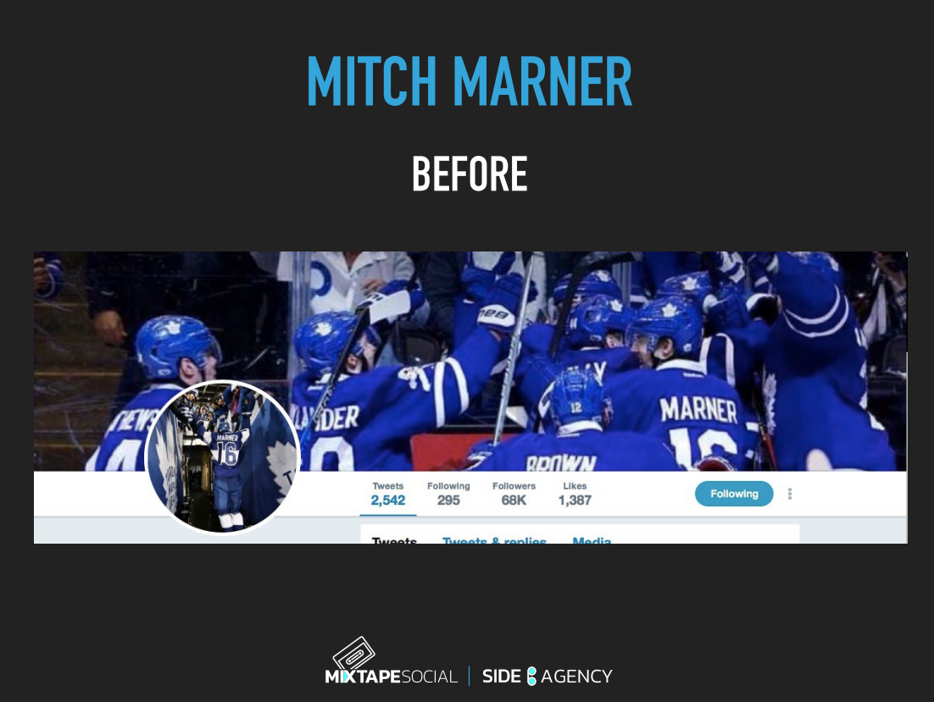

**After**

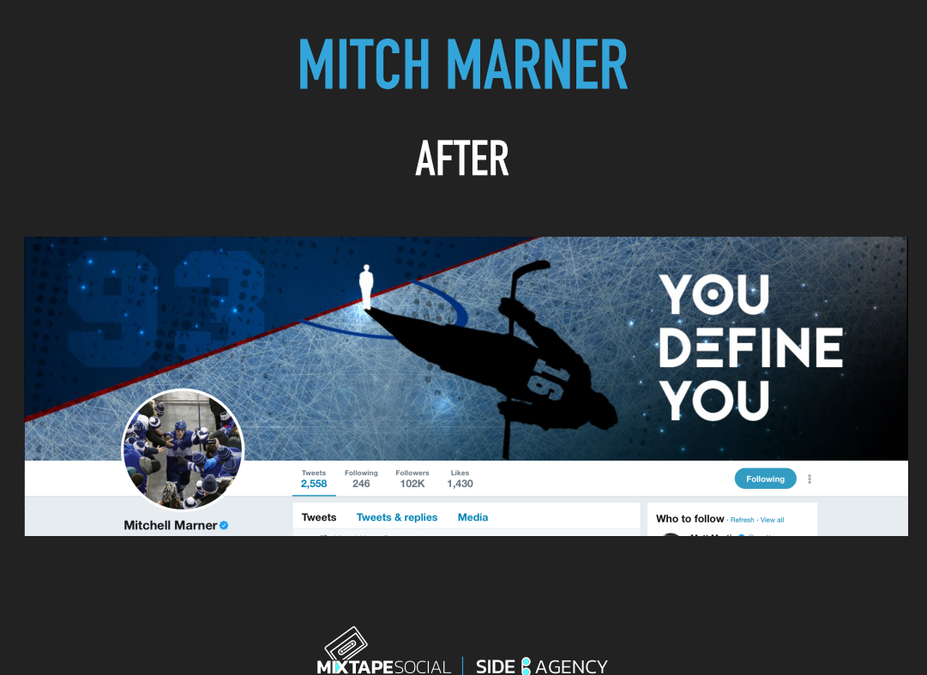

Source: Company documents.

Exhibit 2: Mitch Marner

**Before**

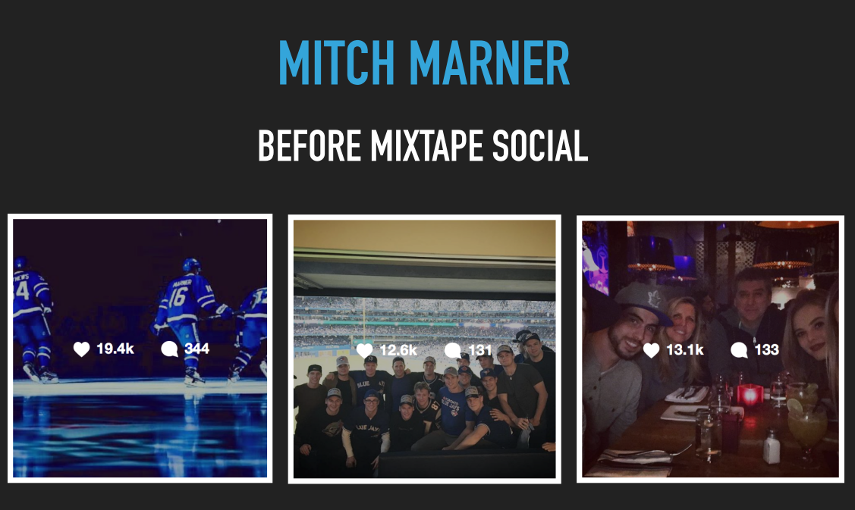

**After**

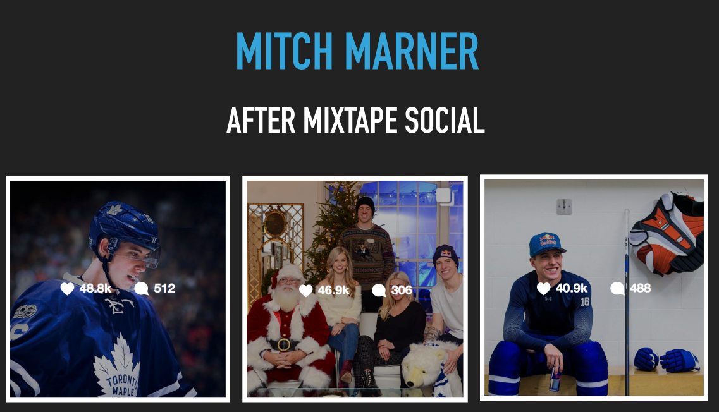

Source: Company documents.

Exhibit 3: Data on Other Advertising Agencies in Toronto

|  |  |  |  |  |  |
| --- | --- | --- | --- | --- | --- |
| **Name** | **Focus** | **Minimum Project Size (CAN)** | **Average Hourly Rate (CAN)** | **Number of Employees** | **Reviews/Past Work** |
| Media Launch | Web marketing | $10,000 | $100–$149 | 2–9 | “Media Launch backs up what they say and the customer service is excellent.” (Principal, real estate management company) |
| Bob’s Your Uncle | Food and beverage | $25,000 | $150–$199 | 10–49 | “You have access to the senior people at all times, and they’re very responsive.” (Senior marketing manager, Catelli Foods Corporation) |
| Giants & Gentlemen | Strategy and creative advertising | $5,000 | $100–$149 | 10–49 | “They can deliver something interesting that drives interest and engagement for that target.” (Marketing manager, Mac’s Convenience Stores) |
| Upperkut | Publicity, websites, and social networks | $10,000 | $150–$199 | 10–49 | Past work included Rue St. Denis, Business Development Bank of Canada, Les Grands Ballets, and WonderBra. |
| Gravity Partners | Brand strategy | $25,000 | $100–$149 | 50–249 | Gravity Partners’ clients include Sobeys Inc., Coca-Cola, Simply Orange, NESTEA, Synaptive Medical, and GSK. |
| Blast Radius | Global branding and digital marketing | $10,000 | $100–$149 | 50–249 | Past work included Nike, Sony, and Motorola. |

Source: “Top Canada Advertising & Marketing Agencies,” Clutch, last updated August 1, 2018, accessed February 28, 2019, <https://clutch.co/ca/agencies>.

exhibit 4: Pricing for a branded message

|  |  |  |  |  |
| --- | --- | --- | --- | --- |
| **Athlete** | **Price per Branded Message (USD)** | **Twitter Followers (Millions)** | **Facebook Followers**  **(Millions)** | **Instagram Followers (Millions)** |
| Cristiano Ronaldo | $525,038 | 68 | 122 | 118 |
| LeBron James | $140,019 | 40 | 23 | 35 |
| Rafael Nadal | $65,25 | 15 | 14 | 4 |

Source: Company documents.

exhibit 5: Revenue and Projections (CAD)

|  |  |  |  |  |  |  |  |  |  |  |  |  |  |
| --- | --- | --- | --- | --- | --- | --- | --- | --- | --- | --- | --- | --- | --- |
| **2018 Revenue Projections** | | | | | | | | | | | | | |
|  | **January** | **February** | **March** | **April** | **May** | **June** | **July** | **August** | **September** | **October** | **November** | **December** | **Total** |
| Existing Clients | | | | | | | | | | | | | |
| Brands | | | | | | | | | | | | | |
| Brant Hill Charitable Foundation | $4,000 | $4,000 | $4,000 | $4,000 | $4,000 | $6,000 | $6,000 | $6,000 | $6,000 | $6,000 | $6,000 | $6,000 | $62,000 |
| Peachland Farms Winery | $3,000 | $3,000 | $3,000 | $5,000 | $5,000 | $5,000 | $5,000 | $5,000 | $5,000 | $5,000 | $5,000 | $5,000 | $54,000 |
| Mary's Fine Foods |  | $2,000 | $2,000 | $2,000 | $2,000 | $8,000 | $8,000 | $8,000 | $8,000 | $8,000 | $8,000 | $8,000 | $64,000 |
| Gunther Group |  |  | $8,000 | $8,000 | $8,000 | $3,000 | $3,000 | $3,000 | $3,000 | $3,000 | $3,000 | $3,000 | $45,000 |
| Athletes | | | | | | | | | | | | | |
| Athlete 1 |  |  | $5,000 | $5,000 | $5,000 | $5,000 | $5,000 | $5,000 | $5,000 | $5,000 | $5,000 | $5,000 | $50,000 |
| Athlete 2 |  |  |  |  | $5,000 | $5,000 | $5,000 |  |  |  |  |  | $15,000 |
| Athlete 3 |  |  |  | $5,000 | $5,000 | $5,000 | $5,000 | $5,000 | $5,000 | $5,000 | $5,000 | $5,000 | $45,000 |
| Athlete 4 |  |  |  |  |  |  |  |  | $5,000 | $5,000 | $5,000 | $5,000 | $20,000 |
| Athlete 5 |  |  |  |  |  |  |  |  |  | $5,000 | $5,000 | $5,000 | $15,000 |
| Athlete 6 |  |  | $5,000 | $5,000 | $5,000 | $5,000 | $5,000 | $5,000 | $5,000 | $5,000 | $5,000 | $5,000 | $50,000 |
| Athlete 7 |  |  |  | $5,000 | $5,000 | $5,000 | $5,000 | $5,000 | $5,000 | $5,000 | $5,000 | $5,000 | $45,000 |
| Total Clients | $7,000 | $9,000 | $27,000 | $39,000 | $44,000 | $47,000 | $47,000 | $42,000 | $47,000 | $52,000 | $52,000 | $52,000 | $465,000 |
| Prospects | | | | | | | | | | | | | |
| Sports Participation Social Campaign |  |  | $7,000 | $5,000 | $4,000 |  |  |  |  |  |  |  | $16,000 |
| Entertainment and Hospitality Client |  |  | $6,500 | $6,500 | $6,500 | $6,500 | $6,500 | $6,500 | $6,500 | $6,500 | $6,500 | $6,500 | $65,000 |
| Content Production Business Unit |  |  |  | $6,500 | $6,500 | $6,500 | $6,500 | $6,500 | $6,500 | $6,500 | $6,500 | $6,500 | $58,500 |
| North American Food Conglomerate (small) | |  |  |  |  | $1,000 |  | $5,000 |  | $10,000 |  |  | $16,000 |
| North American Food Conglomerate (small) | |  |  |  |  | $5,000 | $5,000 | $5,000 |  |  |  |  | $15,000 |
| Consumer Packaged Goods firm (medium) | |  |  |  |  |  | $10,000 | $10,000 |  |  |  |  | $20,000 |

EXHIBIT 5 CONTINUED

|  |  |  |  |  |  |  |  |  |  |  |  |  |  |
| --- | --- | --- | --- | --- | --- | --- | --- | --- | --- | --- | --- | --- | --- |
| Consumer Packaged Goods firm (medium) | |  |  |  | $5,000 | $5,000 | $5,000 | $5,000 | $5,000 | $5,000 | $5,000 | $5,000 | $40,000 |
| Social Media Firm | |  |  | $1,000 |  | $1,000 |  | $1,000 |  | $1,000 |  | $1,000 | $5,000 |
| Social Media Firm | |  | $1,200 | $750 |  | $750 |  | $750 |  | $750 |  | $750 | $4,950 |
| Consumer Packaged Goods firm (medium) | |  |  |  | $2,500 | $2,500 | $2,500 | $2,500 | $2,500 | $2,500 | $2,500 | $2,500 | $20,000 |
| Healthcare Industry Client | |  |  |  |  | $3,000 | $3,000 | $3,000 | $3,000 | $3,000 | $3,000 | $3,000 | $21,000 |
| Athlete 8 |  |  |  |  | $2,700 | $2,700 | $2,700 | $2,700 | $2,700 | $2,700 | $2,700 | $2,700 | $21,600 |
| Athlete 9 |  |  |  |  | $2,500 | $2,500 | $5,000 | $5,000 | $5,000 | $5,000 | $5,000 | $5,000 | $35,000 |
| Athlete 10 |  |  |  |  |  |  |  |  | $5,000 | $5,000 | $5,000 | $5,000 | $20,000 |
| Athlete 11 |  |  |  |  |  |  | $2,000 | $2,000 | $5,000 | $5,000 | $5,000 | $5,000 | $24,000 |
| Athlete 12 |  |  |  |  |  |  |  | $2,000 | $5,000 | $5,000 | $5,000 | $5,000 | $22,000 |
| Athlete 13 |  |  |  |  |  |  |  |  |  | $2,500 | $2,500 | $2,500 | $7,500 |
| Athlete 14 |  |  |  |  |  | $2,000 | $5,000 | $5,000 | $5,000 | $5,000 | $5,000 | $5,000 | $32,000 |
| Athlete 15 |  |  |  |  |  | $2,000 | $5,000 | $5,000 | $5,000 | $5,000 | $5,000 | $5,000 | $32,000 |
| Athlete 16 |  |  |  |  |  | $2,000 | $5,000 | $5,000 | $5,000 | $5,000 | $5,000 | $5,000 | $32,000 |
| Athlete 17 |  |  |  |  |  |  |  |  | $5,000 | $5,000 | $5,000 | $5,000 | $20,000 |
| Athlete 18 |  |  |  |  |  |  |  |  | $5,000 | $5,000 | $5,000 | $5,000 | $20,000 |
| Total Prospects | |  |  |  |  |  |  |  |  |  |  |  | $547,550 |
| TOTAL | $14,000 | $18,000 | $68,700 | $97,750 | $117,700 | $136,450 | $157,200 | $155,950 | $160,200 | $184,450 | $172,700 | $174,450 | $1,012,550 |
| Strong Prospects | $187,050 |  |  |  |  |  |  |  |  |  |  |  |  |
| Warm Prospects | $305,500 |  |  |  |  |  |  |  |  |  |  |  |  |
| Athlete 12 |  |  |  |  |  |  |  |  |  | $2,500 | $2,500 | $2,500 | $7,500 |
| Athlete 13 |  |  |  |  |  | $2,000 | $5,000 | $5,000 | $5,000 | $5,000 | $5,000 | $5,000 | $32,000 |
| Athlete 14 |  |  |  |  |  | $2,000 | $5,000 | $5,000 | $5,000 | $5,000 | $5,000 | $5,000 | $32,000 |
| Athlete 15 |  |  |  |  |  | $2,000 | $5,000 | $5,000 | $5,000 | $5,000 | $5,000 | $5,000 | $32,000 |
| Athlete 16 |  |  |  |  |  |  |  |  | $5,000 | $5,000 | $5,000 | $5,000 | $20,000 |
| Athlete 17 |  |  |  |  |  |  |  |  | $5,000 | $5,000 | $5,000 | $5,000 | $20,000 |
| **Total Prospects** | |  |  |  |  |  |  |  |  |  |  |  | $547,550 |
| **TOTAL** | $14,000 | $18,000 | $68,700 | $97,750 | $117,700 | $136,450 | $157,200 | $155,950 | $160,200 | $184,450 | $172,700 | $174,450 | $1,012,550 |
| Strong Prospects | $187,050 |  |  |  |  |  |  |  |  |  |  |  |  |
| Warm Prospects | $305,500 |  |  |  |  |  |  |  |  |  |  |  |  |

Source: Company documents.

1. All dollar amounts are in Canadian dollars unless otherwise indicated.
2. Catherine Phillips, “Ad Spending in Canada to Reach $11.52 Billion in 2018: Report,” Media in Canada, May 8, 2018, accessed February 28, 2019, http://mediaincanada.com/2018/05/08/ad-spending-in-canada-to-reach-11-52-billion-in-2018-report/.
3. “Advertising Agencies—Canada Market Research Report,” IBIS World, December 2017, accessed February 28, 2019, www.ibisworld.ca/industry-trends/market-research-reports/professional-scientific-technical-services/advertising-agencies.html.
4. Giordano Contestabile, “Influencer Marketing in 2018: Becoming an Efficient Marketplace,” *AdWeek*, January 15, 2018, accessed February 28, 2019, www.adweek.com/digital/giordano-contestabile-activate-by-bloglovin-guest-post-influencer-marketing-in-2018/.
5. “Global Instagram Influencer Market Size from 2017 to 2019 (in Billion U.S. Dollars),” Statista, June 5, 2018, accessed February 28, 2019, www.statista.com/statistics/748630/global-instagram-influencer-market-value/.
6. “Key Small Business Statistics—June 2016,” Government of Canada, November 17, 2016, accessed February 28, 2019, www.ic.gc.ca/eic/site/061.nsf/eng/h_03018.html#point1-1.