

9B19A014

AN INFLUENCER STRATEGY FOR BUDWEISER IN CANADA

Ken Mark wrote this case under the supervision of Mary Weil solely to provide material for class discussion. The authors do not intend to illustrate either effective or ineffective handling of a managerial situation. The authors may have disguised certain names and other identifying information to protect confidentiality.

This publication may not be transmitted, photocopied, digitized, or otherwise reproduced in any form or by any means without the permission of the copyright holder. Reproduction of this material is not covered under authorization by any reproduction rights organization. To order copies or request permission to reproduce materials, contact Ivey Publishing, Ivey Business School, Western University, London, Ontario, Canada, N6G 0N1; (t) 519.661.3208; (e) cases@ivey.ca; www.iveycases.com. Our goal is to publish materials of the highest quality; submit any errata to publishcases@ivey.ca. i1v2e5y5pubs

Copyright © 2019, Ivey Business School Foundation Version: 2019-03-29

“What should our influencer strategy for Budweiser look like?” wondered a senior manager at Labatt Breweries of Canada (Labatt Breweries). “We want to engage with a particular consumer segment, people aged 19–24, and one of the ways we can do this is to connect with influencers.” It was January 2018, and the senior manager wanted to put together a plan for the marketing team to consider for the summer and fall.

Influencer marketing was becoming more prominent; the global Instagram influencer market was estimated to grow from US$1.07 billion in 2017 to US$2.38 billion in 2019.[1] Influencers were people who had gained prominence online — who had thousands or millions of followers. They could be social commentators, writing about a wide variety of topics, including sports and fashion trends. They could be actors or professional athletes or broadcast personalities. The common thread linking all influencers was that they had an impact on trends.

“The majority of our advertising dollars are channelled to protecting and growing our core consumer group,” the senior manager continued:

Yet we need to reach out to nurture and cultivate connections with our point-of-entry consumer. This consumer is mobile, takes in a large variety of media, and is keenly attuned to trends. We want to reach out to him or her. We want to ensure Budweiser as a brand is relevant and meaningful to this target market.

In crafting her influencer strategy, the senior manager had to consider the focused nature of this effort: it would represent a small but important part of Budweiser’s marketing budget. She would also have to contend with Budweiser’s U.S. advertising, both online and via traditional sources such as television and radio. She wanted to put together a proposal that would allow Budweiser Canada to continue conversations with the 19–24 target segment.

**The Canadian Beer Industry**

The total beer market in Canada was worth CA$9 billion[2] in 2015, with 27.8 million hectolitres (hl) of beer sold. Canadians consumed 63.34 litres, or 186 standard, 341-millilitre (ml) bottles of beer per capita per year.[3] The retail market for bottled or canned alcoholic beer was served by 16,730 government-owned and private stores across the country. Beer was sold for consumption on the premises at licensed establishments such as restaurants, sports facilities, hotels, and other venues.

In 2016, domestic-brewed beer sold in bottles accounted for 38 per cent of the total beer sold in Canada in terms of format by value; domestic beer in cans accounted for 35 per cent; and draught sales accounted for eight per cent. The remainder of the beer sold, about 20 per cent, was imported beer in bottles, cans, and draught kegs.

The two key competitors in the market, in terms of volume and value share, were Anheuser-Busch InBev (Anheuser-Busch) and Molson Coors Brewing Company (Molson). Anheuser-Busch had 43.6 per cent of the market by volume and 44.1 per cent by value, and Molson had 34.1 per cent by volume and 38 per cent by value. The remaining market comprised Canadian craft brews and imported beer. The three leading beer brands in Canada were Budweiser, Molson Canadian, and Coors.

Men consumed 50 per cent more beer than women. Beer consumers were further segmented into age groups with distinct characteristics: 19–30, 31–50, 51–70, and 71 and older (see Exhibit 1).

**The Budweiser Brand**

Introduced in the United States in 1876 by Adolphus Busch and Carl Conrad, Budweiser was a Bohemian-style lager based on the beer brewed in České Budějovice, the Czech Republic, for hundreds of years. As it was known in Europe as “the beer of kings,” Busch styled his new brew “the king of beers.” Budweiser was the most popular beer brand in the United States, and the brand supported this position with heavy media spending, sports sponsorships, and consistent use of iconic characters such as the Budweiser Clydesdale horses.

In Canada, Budweiser had been brewed under license by Labatt Breweries since the 1980s. In 2004, Budweiser became the top beer brand in Canada, taking the place of Labatt Blue, which had been competing with Molson Canadian for the number-one spot since the 1980s.

Budweiser, the best-selling beer brand in Canada, was known primarily as a sports-focused brand in English Canada and was traditionally targeted at older consumers. Budweiser’s marketing focused on its connection to sports such as hockey and baseball with unique merchandise such as the Budweiser Red Light, a stand-alone light that lit up and produced sound whenever a goal was scored during a particular hockey game. Budweiser’s image was shaped largely by the significant amount of U.S.-based advertising consumed by Canadians. For example, in May 2016, Budweiser temporarily renamed its beer “America” in the United States to “inspire drinkers to celebrate America and Budweiser’s shared values of freedom and authenticity.” While this promotion did not take place in Canada, many Canadians would have seen the advertising and would have known about the renaming.

In contrast, Molson Canadian, Budweiser’s closest rival, had linked its brand image with the image of its home country, and this was made easier, and perhaps more obvious, by its brand name. Its “I Am Canadian” advertising series included themes such as hockey success, the outdoors, and Canadian national pride.

**The Call to Action: Focus on the 19–24 Age Group**

The manager’s attention to Budweiser had begun a few years earlier. As she explained, “We are the number-one brand and have stable market share, but we can do better. We are not content and we cannot be complacent. We want to grow and disrupt ourselves before a competitor does.” Budweiser invested in advertising to highlight its products and allocated trade dollars to retailers — restaurants in particular — to promote Budweiser over its competitors.

With momentum building, the senior manager wanted to do more to grow the consumer base. “We want to be relevant with our point-of-entry consumer group, aged 19–24,” said the manager:

This group sees brands such as Apple or Google as influencers, and even Adidas has revived itself to become a popular brand. How do we know they’re popular? Because they’re being followed on Instagram and on other social-media sites. How can we get people following Budweiser? How can we establish our “cool” factor with this group? Our challenge is to use our global marketing tools in relevant ways for our Canadian target groups. Keep in mind that we have to be very cognizant of how we develop Canadian brand strategy. We have to be mindful of what our U.S. team does because our Canadian consumers have access to the brand and brand image coming from the U.S.

The brand needed to be relevant among six distinctive sub segments of the 19–24 age group:[4]

* **Dynamos**: This segment represented 17 per cent of the market; it was 90 per cent female and 10 per cent male. This segment was focused on high-achieving careers. Members were bold, adventure-seeking, and willing to take little risks. They would try new brands, new restaurants, and new products, but they did not tend to blindly follow trends. Their life was semi-structured: they set aside time for work and play and knew how to set boundaries between the two. They were not prone to “taking it easy” or underperforming in life or at play. They were likely university educated, and many were thinking of post-graduate degrees. Their friends might consider them very motivated and a little too competitive at times. They would define themselves as worldly, environmentally conscious, trend-aware, and cultured. They sought out local, organic foods and joined running or climbing gyms. They tended to consume a range of media, including newspapers, some television, and online media.
* **Connoisseurs**: This segment represented 16 per cent of the market; it was 75 per cent male and 25 per cent female. Connoisseurs liked to be aware of the latest fads, and their friends looked to them as trendsetters. They focused on unearthing new ideas, brands, and styles, and sought to put their own spin on them. They were technology-focused, preferring to write pithy blogs about their latest finds. They tended to be known as quiet, even shy, and socialized with those like them. They also tended to prefer sedentary pursuits and were usually found participating in online discussion groups and playing video games.
* **Eco-Socials**: This group represented 17 per cent of the market; it was 75 per cent female and 25 per cent male. This segment lived, studied, and worked in the core of the city, where everything was close by. Members of this group valued freedom and time with friends, and avoided the limelight and loud social events. They were socially and environmentally conscious and sought to give back to the community by volunteering and making “green” choices. Work and career success were not priorities to them at this point, and they were likely to be in solid but low-stress careers.
* **Adventurers**: This segment represented 14 per cent of the market; it was 90 per cent male and 10 per cent female. This segment was made up of athletic individuals who loved sports and parties. They were trend-conscious extroverts who were most likely seen at concerts, bars, and sports events. They participated in high-energy activities, including traditional sports and weekend warrior–type events such as adventure races. They were career-focused yet unconcerned by the fact that they typically lived at home with their parents. They were technology-savvy and tended to rely on technology to communicate with their friends.
* **Impromptus**: This segment made up 18 per cent of the market; it was 50 per cent female and 50 per cent male. This segment lived life in the moment: they were likely to switch plans at the last instant and tended not to have set routines. They participated in low-competition athletic pursuits such as yoga and hiking and were focused on living their lives, conscious of the fact that they “only lived once.” They had good careers but were not particularly interested in working harder to advance themselves at the moment.
* **Practicals**: This group made up 18 per cent of the market; it was 50 per cent female and 50 per cent male. These individuals were not risk takers, preferring security and practicality above all. They were not entrepreneurs but contributed by working in teams at large organizations. They did not follow trends: they were aware of them but selected sensible choices in every aspect of their lives. They liked to follow simple life-plans that included finishing school, getting a stable job, buying a home, and starting a family, in that order. They were not particularly interested in thrill-seeking activities and could be found enjoying a coffee at a local shop, meeting friends in their apartments for simple meals, and going to the mall.

To target the 19–24 age group, the team identified the group’s three “passion points”: music, food, and travel. “We have to home in on those passion points to be able to relate to this group. Millennials are focused on experiences,” the manager noted.

The Influencer Strategy

Influencers typically had several social-media platforms through which they cultivated a following. They wrote about products and trends, developing personal brands that appealed to their followers. These influencers were open to working for compensation but were usually wary of how they presented their products because they wanted their posts to appear genuine. Brands interested in attracting these influencers understood that the brand had to be a good fit with the influencer’s personal brand and the proposal had to be valuable to the influencer. On average, influencers could expect to receive $0.01 per follower per Instagram post for participating in a brand’s influencer campaign. For an influencer with more than 100,000 followers, a rate of about $1,000 per post was the norm.

The senior manager had allocated a budget of $250,000 for 12 months of focused influencer marketing in Canada. She looked at the online properties that Budweiser owned, operated, and sponsored. Budweiser had its own U.S. blog at Budweiser.com, which featured news on its brand and related elements, including the horses it used in its promotional activities. On December 1, 2017, the site had been ranked the 77,530th-most-popular site in the past 30 days. It had an average daily time on-site of one minute, 41 seconds; daily page views per visitor of 1.60; and a bounce rate of 69.2 per cent (see Exhibit 2). Budweiser also maintained Instagram, Facebook, and Twitter accounts.

Budweiser sponsored two other U.S. blogs, The Beer Necessities and October. The Beer Necessities[5] aimed to “celebrate beer” and “unify the industry.” It featured articles on drinking and dining and reviewed beers, food, and distilleries. Feature articles included “The Best Beer-Filled Desserts in America,” “10 Quintessential American College Town Breweries,” and “Fall’s Wildest and Craziest Beers.” The site was the 155,891st-most-popular site in the United States for the 30 days prior to December 1, 2017. It had an average daily time on-site of 7 minutes, 37 seconds; daily page views per visitor of 5.7; and a bounce rate of 37.2 per cent.

October,[6] which used the subtitle Falling For Beer, provided essays about beers, reviews, and opinion editorials. Feature articles included “Barleywine is Life: Serious Hashtag or Inside Joke,” “Day Beer to Take over LA’s Most Temporary Bars?” and “Founders Built a Portfolio, Then Found a Flagship.”

The Budweiser manager noted that her goal was “to drive conversations about Budweiser in Canada, targeting the 19–24 age group” with higher coverage and positive reviews. Increased sales to this target group was the objective. She continued:

Before we start looking for influencers with whom we can partner, what should our Canadian influencer strategy look like? Here are some thoughts. First, we want influencers who would want to work with us. They will have Instagram and Snapchat accounts, likely in beauty, fashion, and music. How can we encourage them to talk about our brand in a way that is authentic to their style and for them to still seem “cool” to their followers?

Everyone is on social media these days. We look at other examples — Nike, for instance — where the firm has a list of influencers that pose with their products. We need to recognize that posing with cans of beer is different from posing with the latest and rare sneakers, for example.

The senior manager wanted to consider whether Budweiser should pay influencers, or if the brand could offer them something else in return. She explained her thinking on this question:

Do we pay them? We are aware of the industry standard payment norms and we know that our competitors are paying them. We would sign a contract for them to deliver a set number of posts or tweets, and we would pay per instance. . . . Yet we believe we have properties — products and experiences — that are unique and can be valuable. For example, what price can be put on being allowed backstage access and, say, 10 minutes onstage at one of the music festivals we sponsor — we sponsor music at the Budweiser Stage in Toronto — or meet-and-greets with athletes or music acts at the Budweiser Gardens in London, Ontario?

The senior manager took a quick inventory of the other sponsorship opportunities her team could leverage, including those involving the Calgary Flames and the Vancouver Canucks hockey teams, the Calgary Stampede event, numerous cultural events in Quebec, the Blue Jays baseball team, and summer music festivals. “As sponsors, we have access and can provide access to these events and their stars,” she concluded. “How can we leverage these properties to our advantage?”

Another aspect to consider was how to approach and work with these influencers so that their posts were “on-brand” with what Budweiser was trying to achieve. The manager thought about whether or not to provide direction to these influencers and whether she should have a list of key performance indicators that would track the return on investment per influencer.

The senior manager sat down at her desk to collect her thoughts. In two days, she wanted to provide an outline of a plan to her marketing team.

Exhibit 1: Beer Consumer Segments

|  |  |  |  |
| --- | --- | --- | --- |
| **Age Group** | **Bottles per Week** | **Occasions** | **Brand Loyalty** |
| 19–30 | 2.0–2.5 | -With friends at restaurants/bars  -Some home-based consumption | -Willingness to try new brands  -Primarily domestic-brewed; some non-U.S. beers |
| 31–50 | 2.0–3.75 | -With friends after work, in restaurants and bars  -The bulk of retail alcoholic beverage sales are to this group. | -Loyalty preferences are largely set.  -Fewer occasions and lowered interest in sampling new beers |
| 51–70 | 2.0–2.5 | -Home-based consumption  -Fewer out-of-home consumption occasions | -Very brand loyal; limited interest in sampling new brands |
| 71+ | 1.0–2.0 | -Home-based consumption  -Fewer out-of-home consumption occasions | -Brand loyal; limited interest in sampling new brands |

Source: Company documents.

Exhibit 2: screen capture from The Budweiser Blog

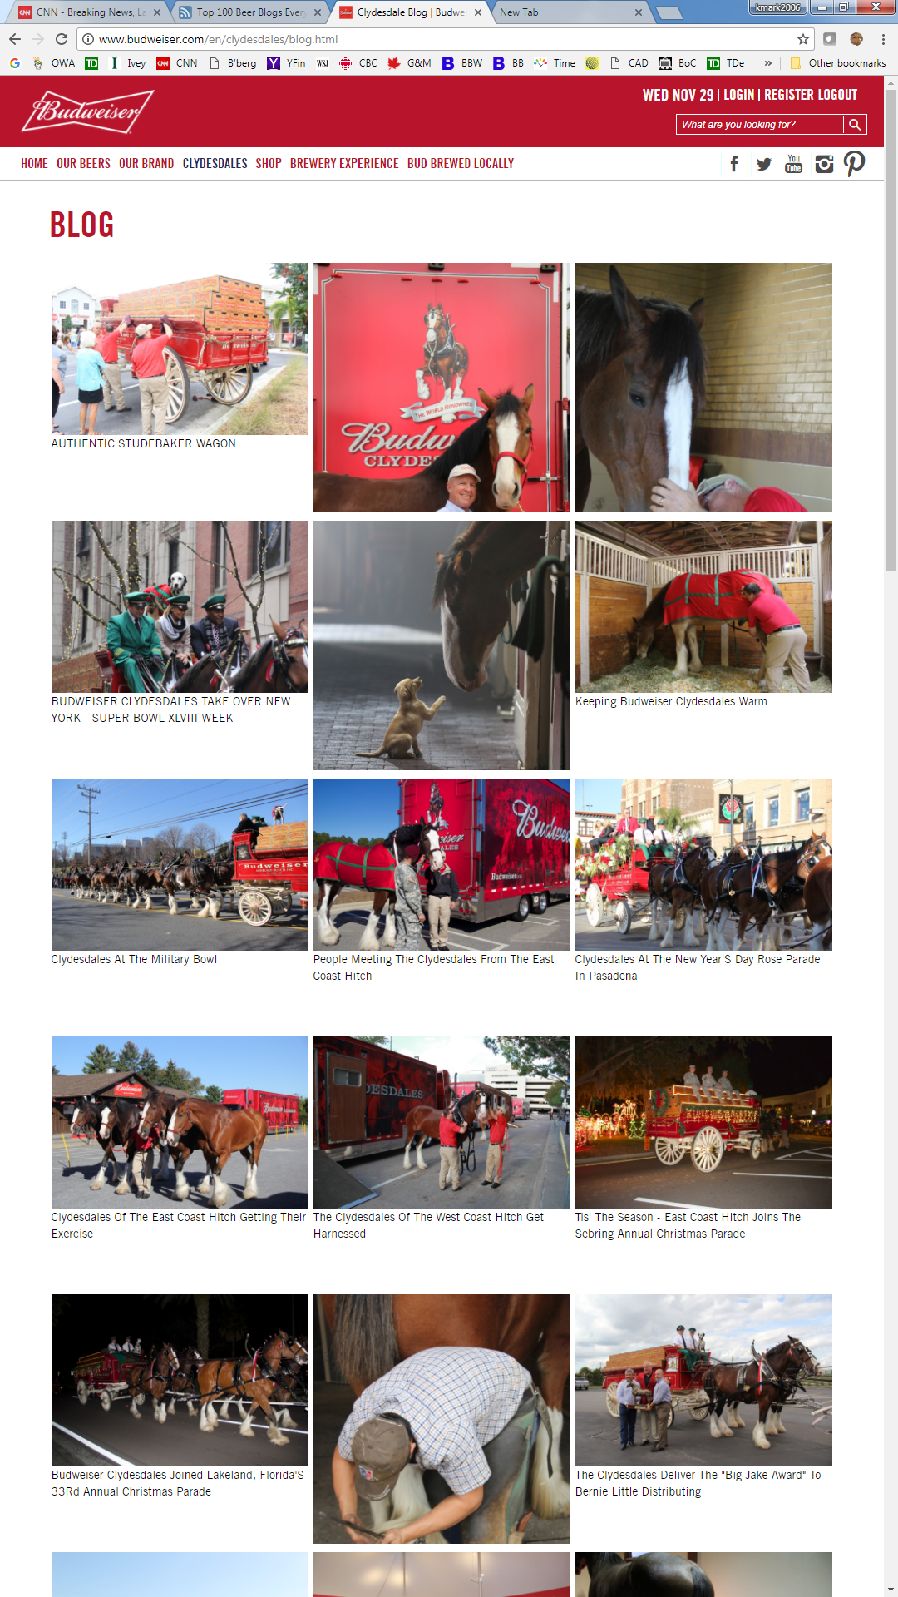

Source: Company documents.

1. “Global Instagram Influencer Market Size from 2017 to 2019 (in Billion U.S. Dollars),” Statista, January 2018, accessed March 23, 2018, www.statista.com/statistics/748630/global-instagram-influencer-market-value/.
2. All currency amounts are in CA$ unless otherwise specified.
3. “National Overview,” Beer Canada, 2016, accessed March 23, 2018, <https://industry.beercanada.com/national->overview.
4. Adapted from Johnathan Nadeau and David Coletto, *Canadian Millennials and Beverage Alcohol: A Survey of 1,012 Canadian Millennials (Aged 18 to 31)*, 5–7, Abacus Data Inc., January 30, 2013.
5. The Beer Necessities website, accessed February 6, 2019, https://thebeernecessities.com/.
6. October website, accessed February 6, 2019, https://oct.co/.