** **

9B19A016

OPENSKY.TV: a new BUSINESS MODEL—CONTENT CREATION, CURATION, CONSUMPTION, commercialization

Professors Howard Pong Yuen Lam, Andrew C. F. Chan, and Ms. Icy Fong Ling Ngai wrote this case solely to provide material for class discussion. The authors do not intend to illustrate either effective or ineffective handling of a managerial situation. The authors may have disguised certain names and other identifying information to protect confidentiality.

This publication may not be transmitted, photocopied, digitized, or otherwise reproduced in any form or by any means without the permission of the copyright holder. Reproduction of this material is not covered under authorization by any reproduction rights organization. To order copies or request permission to reproduce materials, contact Ivey Publishing, Ivey Business School, Western University, London, Ontario, Canada, N6G 0N1; (t) 519.661.3208; (e) cases@ivey.ca; www.iveycases.com. Our goal is to publish materials of the highest quality; submit any errata to publishcases@ivey.ca. i1v2e5y5pubs

Copyright © 2019, Ivey Business School Foundation Version: 2019-05-03

Wilson Yuen, the chief executive officer of OpenSky.tv (OpenSky) founded the company in 2016. In October 2017, he had to make an important decision. Should he help scale up his company’s business by continuing to offer free services in Hong Kong? How could he achieve his initial objective of creating a business-to-consumer (B2C) recommendation platform?

Yuen’s idea had come about two years earlier, when he shared his thoughts and plans with a colleague:

I discussed with a friend who had recently resigned from his management position at a television broadcasting company. My friend’s expertise was in the television industry, while my experience was in developing video-related technologies. So, the discussion triggered us to develop a B2C recommendation platform.

Yuen summed up what OpenSky was trying to achieve and his vision for the future of the television industry:

We wanted to bring people back to consuming video content on television with personalized content in their own channel, and OpenSky understood. All they needed was a single on/off button in the device for them to watch videos across various platforms, such as TV broadcasters, Facebook, or YouTube.

OpenSky combined AI (artificial intelligence) and user-experience design to offer a recommendation platform for a wide range of quality video content, including dining, art, architecture, tourism, and culture. The platform analyzed each user’s behaviour and curated a personalized experience for the viewer. OpenSky aimed to drive more television programming consumption and disrupt the industry with machine-learning intelligence and human curation, supported by video content creation and amplified by commercialization.

By October 2017, OpenSky had more than 3,000 hours of video programs from Hong Kong, Japan, South Korea, Taiwan, Singapore, Malaysia, the United Kingdom, France, Germany, Austria, Spain, Switzerland, the Netherlands, the United States, Canada, and Australia.

COMPANY BACKGROUND

Yuen had taught at various universities in Hong Kong from 1997 to 2013, including the City University of Hong Kong and The Hong Kong Polytechnic University. In 2010, noting the extreme popularity of online video, Yuen founded TFI Digital Media Limited (TFI). The “TFI” in the company name referred to its slogan: “Technology. Fun. Innovation.”[1] The company’s mission was to “bring content, culture and people together.” TFI leveraged its patented technology for video encoding to offer live streaming and over-the-top technology, which allowed businesses to deliver video content across the world. By November 2017, TFI had 30 full-time employees with branch offices in Hong Kong, Taiwan, China, and the United States, serving over 4 million devices in 25 countries. After Yuen founded OpenSky in 2016, it became a wholly owned subsidiary of TFI (see Exhibit 1).

OPPORTUNITY

Online video consumption became widespread with the increased bandwidth that fourth-generation (4G) technology provided on mobile and Wi-Fi networks. As well, cloud infrastructure continued to improve at a rapid pace, while content production costs continued to drop. High definition videos could be captured through smartphone cameras. A user could create video content and instantly broadcast the video to a global audience. Video production and sharing proliferated throughout the Internet and continued to grow, with experts forecasting that 74 per cent of all Internet traffic in 2017 could be in video format.[2]

Online video viewing across the globe was expected to increase by about 20 per cent in 2017, with people spending an average of 47.4 minutes per day viewing online video.[3] Spending on online video was projected to account for 31 per cent of total digital display advertising expenses by 2019. This figure was an increase from 28 per cent in 2017.[4] In Hong Kong, spending on online video content was the largest segment, at 22.9 per cent, with the highest growth being recorded in the period 2016–2021. In comparison, spending on online advertising was 10.2 per cent, and spending on video games was 6.6 per cent.[5]

Yuen summarized his reasons behind choosing to move from a business-to-business (B2B) technology provider to a B2C video content recommendation platform:

TV programs were becoming less costly to be replaced by short videos, driven by a few factors: (1) technological advancements, (2) reduced prices of production equipment, and (3) increase in video sharing platforms. We were entering a new era in which quality production could be achieved, while immense popularity could be gained through the viral effect of social media. We expected that more and more videos with differentiated contents would be created due to the social atmosphere, and thus we aimed to build a recommendation platform. The platform helped audiences navigate through the sea of video content, analyzing their interests and choosing and prioritizing the most suitable video content. The platform had to be localized for targeted geographical regions in order to align with local culture.

Yuen claimed that the decision to move from a B2B technology provider to a B2C video content recommendation platform would generate various key advantages for his venture:

We had technological strength and were experienced in working with content providers on both technical and business workflows in all cases. We understood how to minimize their workload and allowed them to focus on producing quality video content. In such cases, they had no need to worry about promotion, marketing, and other operational mechanics. The foreseeable trend on video sharing, in our case, derived the B2C business model of OpenSky. The goal of OpenSky was to achieve “automation.” Only three pieces of information were required when uploading videos to OpenSky: (1) authorization of access rights for certain countries, (2) age range of target audience, and (3) the category. And based on the latest trends and social issues, we, OpenSky, produced recommendations to users in a humanized approach, rather than a rigid engine with no comprehension of user desires. YouTube’s recommendation engine could achieve similar outcomes. However, premium content providers could gain little merit from this practice, having challenges in monetizing and building their own brand case.

CONSUMER PAIN POINT AND SOLUTION

Traditional television did not allow audiences to create their own channels, or to recommend personalized video content to fellow viewers. Yuen realized that viewers would find it difficult to locate their preferred video content among the millions of options available at any moment under any category, so he worked to address this issue:

OpenSky aimed to mitigate consumers’ pain point of knowing where to find content and what to watch. We helped viewers find the videos they were looking for and recommended the right video cases to viewers. TFI had the technology and experience in establishing OTT [over-the-top] platforms.

Yuen explained how OpenSky would address the viewer’s frustration and make the process more efficient:

It [OpenSky] helped users formulate their personal channel by human curation and AI. Users could also watch others’ personalized channels. Ultimately, each user had an individual list of video contents compiled by AI, combined with recommendations from friends and celebrities they follow.

BUSINESS MODEL: CREATION, CURATION, CONSUMPTION, COMMERCIALIZATION

OpenSky functioned as a video viewing guide and used AI and human curation to recommend videos aimed at people aged 25–40. Since its launch in December 2016, OpenSky had registered 43,000 video downloads by October 2017. Yuen developed OpenSky’s creation, curation, consumption, and commercialization (4C) model to create and distribute its content to the market.

How the 4C Model Worked

Creation

OpenSky would license videos from external content providers and individual producers through a revenue sharing model.

Curation

The company would then collaborate with television experts from the theatre and music industries to produce curated content. For example, popular television personality Stephen Chan, theatre star Olivia Yan, and music producer Terence Lam were considered as hosts for OpenSky content. Their influences would reach a wide range of target customers across different age ranges, from teenagers to mature adults.

Consumption

OpenSky’s viewership would be measured according to the number of content downloads from the platform, advertising volume, and membership subscriptions, among other indicators.

Commercialization

OpenSky expected to generate revenue from four different sources of income: advertising, subscriptions to its video recommendation service, subscriptions to its recommended videos (revenue shared with content providers), and the provision of its curation services (see Exhibit 2).

OpenSky enriched its video content by curation. The company would regularly create new themes and then actively provide related videos for that theme from three main sources: videos produced in-house, videos licensed from content providers, and videos created by contracted producers under a specific theme. According to Yuen, the various themes were set based on a particular strategy:

The frequency of changing the theme would be based on the resources and the latest trends; for instance, the theme of Andy Lau’s movie, when the Hong Kong Film Awards were approaching, or the theme of boxing, when Rex Tso won his [boxing match].

The 4C Model and Boxing

OpenSky live-streamed major events to great success. On October 7, 2017, it aired the Clash of Champions 3 boxing event, featuring Hong Kong superstar boxer Rex Tso.[6] In the process of airing the Rex Tso boxing match, OpenSky followed the 4C model to create and distribute the content to viewers.

Creation

The broadcasting service filmed the boxing match and asked several boxing trainers to upload videos featuring boxing training footage.

Curation

OpenSky hosted interviews with boxing athletes and coaches on the sport of boxing, which viewers could access through a search of relevant programs for that theme.

Consumption

Viewers downloaded the OpenSky mobile application (app) and were able to watch online live streaming of the boxing match as well as related videos available on the platform.

Commercialization

After watching the boxing match featuring superstar boxer Rex Tso, many viewers would have a renewed interest in joining boxing classes or purchasing merchandise from the boxing event to enrich their experience.

Yuen hoped to encourage Hong Kong viewers to watch more videos. He wanted to revolutionize the television industry and increase demand for video recommendations, which was the main business driver for OpenSky. To boost traffic, OpenSky looked for business partners from the traditional television industry. Broadcasters had a wealth of video, but they were unsure how to provide the content to an interested audience. OpenSky’s recommendation service was the perfect complement to meet the needs of traditional television broadcasters.

Yuen explained how OpenSky was changing the way video was delivered to viewers:

[Major] events like the Rex Tso boxing event were only broadcast on television or radio programs in the past. Consumers now had a choice with OpenSky. This was the value we provided to customers: premium, public, and local. Further, we could also introduce them to videos which were behind the scenes, other comparable boxing events/facilities/courses—anything that might interest audiences. This gave all around consumption and facilitated participation in boxing-related events and tasks. It perfectly fit into the 4C model of content creation, curation, consumption, and commercialization.

In addition to airing major events, OpenSky also used media outlets such as Facebook, radio programs, and newspapers to create awareness for its service, which was becoming more and more available to viewers. OpenSky struck a partnership with Samsung’s Smart TV to deliver a seamless experience to Smart TV subscribers. Audiences could bookmark and preview video content on their mobile phones and later enrich their experience at home by using the OpenSky app on their Smart TV. This partnership was intended as a marketing plan to boost the number of OpenSky app downloads (see Exhibit 3).

BUSINESS MODEL—REVENUE STREAMS

OpenSky adopted various methods to stimulate and generate revenue from different sources, including advertising, brand and product placement sponsorships, subscriptions, transactional video on demand, and subscription video on demand (SVOD). Each method was intended to reach a different occasion and viewer. To be viable, advertising required a large audience, in terms of online viewer traffic. Pay-per-view was suited to one-time content, such as movies. Subscription models needed content with appeal to a niche segment.

To accommodate the various different revenue models and consumer needs, OpenSky licensed content, created its own content, and brought together content from providers with viewers using various profit sharing models. OpenSky helped video content owners distribute and monetize their videos.

Content creation was becoming the company’s largest area of expenditure, accounting for approximately two-thirds of all aggregated costs. Therefore, OpenSky decided to partner with independent content creators to reduce fixed costs. However, building awareness about its service and generating demand could become the major source of expenses. For example, OpenSky’s expense breakdown for the period between July 1, 2017 and October 31, 2017 was as follows: platform development, 51 per cent; content, 30 per cent; marketing, 16 per cent; and miscellaneous, 3 per cent.

Among its revenue streams, Yuen saw two major sources of revenue as the key areas for OpenSky: its current business customers and new individual consumers. Yuen had some ideas on how to retain current customers:

Present customers of TFI had requested us to help develop over-the-top video platforms. However, here came a dilemma: as content providers, we were not motivated to commit upfront investments in developing online platform and promotion while technology companies charged for the services. With OpenSky, producers could upload their videos for free and monetize the content from viewers through a revenue sharing model.

Yuen also had some ideas on the recruitment and retention of new individual consumers:

Videos were divided into two categories: free and SVOD. Consumers cared less about the prices. They looked for a service provider who could provide what they wanted as soon as they had a need. OpenSky would not offer all the videos in the world, but we acted as the medium between quality video content and the public, in order to change Hong Kong people’s viewing habits. For instance, nowadays, the general public would search various keywords of the contents in Google, versus reaching the official website directly. We would like the public to search for videos through OpenSky. We could also help promote events and live stream the events. The important value of OpenSky for customers was to provide the widest range of a variety of videos they were interested in, in a timely manner.

Yuen also had some ideas on making the subscription model more effective:

At first, only subscribed and paid users could use our platform. What we wanted to achieve was how to facilitate users to only pay for the services they found worthy. Trailers with hooking punchlines were an option to attract users to pay for the claimed service.

I was confident that OpenSky was an innovative business model, because I really believed in my gut feeling, as I was sensitive to the trends and development potential in the digital world. My colleagues could provide more objective insights with evidence and cases from market research.

When asked if he had considered how much consumers would be willing to pay for the service, Yuen said, “We are still establishing the pricing level, the time to start our subscription model, and when to increase prices.”

As a platform that facilitated video consumption, Yuen did not see any direct competitors to OpenSky. In fact, he thought there was great potential for collaboration among other types of service and content providers (see Exhibit 4).

WHAT SHOULD THE BUSINESS MODEL BE?

One full year after OpenSky had been launched, Yuen reflected on the platform’s future:

We would like to focus on the Cantonese[7] market first and next the Mandarin and English audiences. We got some video content ready for the South East Asia markets, and we are actively working with a potential partner in the Guangdong province of China to enable OpenSky to expand its geographical footprint. . . . If we can capture the Cantonese market, we can do the same for any other market. I hope our kids will still watch television in 20 years’ time, apart from YouTube.

In terms of social contribution, Yuen planned to give back to the technology industry in Hong Kong, hoping to create an open and supportive environment for technology companies in Hong Kong.

We would like to build trust among consumers through OpenSky. We could extend live streaming to many other events, like Cantonese opera shows for the elderly, who are unable to go on site, for whatever reasons. We could contribute back to the public via our platform and technology.

Yuen had resolved many issues. However, how to make his pet project of creating a B2C recommendation platform grow into a major force in the industry was his most pressing concern at the moment.

Exhibit 1: Organizational Charts

Organizational Chart for TFI Digital Media

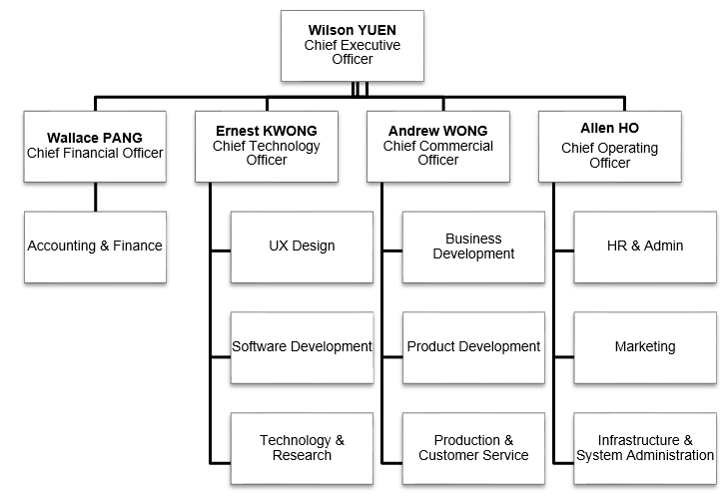

Organizational Chart for OpenSky.tv

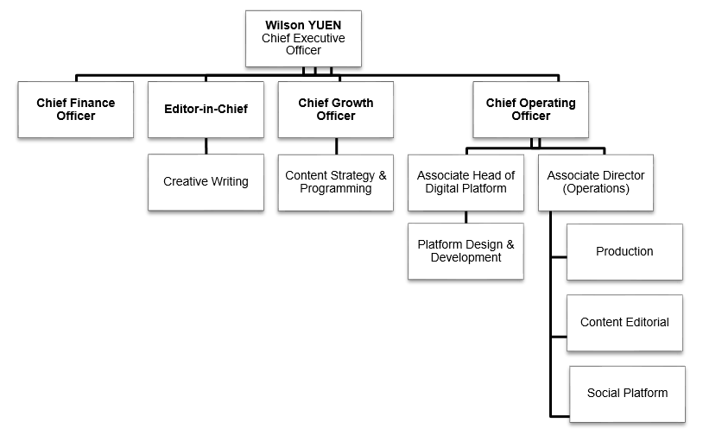

Note: UX = user experience; HR = human resources.

Source: Company documents.

Exhibit 2: OpenSky.tv Business Model using the Canvas Framework

|  |  |  |  |  |
| --- | --- | --- | --- | --- |
| **Key Partners** | **Key Activities** | **Value Propositions** | **Relationships** | **Customer Segments** |
| Outside key partners:  content providers or outsourced video production teams  In-house key partners:  TFI technical support | Video database, technology infrastructure build-up (reached)  Recruiting customers through marketing activities | Helping users formulate their personal and individualized channel, using human curation or artificial intelligence, with a simple power on-and-off button | Created awareness and attracted initial customer base through big events for those who enjoyed free services. Subsequently, tried to upgrade some of them from free to pay. | Viewers aged 25–40 with bachelor degrees or above, both single and married, looking for suitable video content for themselves and their family |
| **Key Resources** | **Channels** |
| OpenSky.tv app and platform  Technology infrastructure | Major events, large paid media outlets such as radio and Facebook  Partnerships with other media platforms |
| **Cost Structure** | | | **Revenue Streams** | |
| Platform build-up and content creation, including in-house program production and licensing of content; curation and marketing costs; all of them variable costs | | | Advertising, brand and product sponsorship in videos, subscriptions, transactional video on demand, and a wide range of free video content | |

Source: Alexander Osterwalder, “A Better Way to Think about Your Business Model,” Harvard Business Review, May 2013, accessed December 9, 2017, https://hbr.org/2013/05/a-better-way-to-think-about-yo.

Exhibit 3: OpenSky.tv Marketing activity Samples

OpenSky.tv launched its first marketing event by sponsoring Clash of Champions 3. The event was live streamed on both the OpenSky.tv Facebook fan page and the OpenSky.tv app. The event was also promoted in traditional media outlets including newspapers, radio, Apple Daily, online searches, banners, KOL event participation, and others.

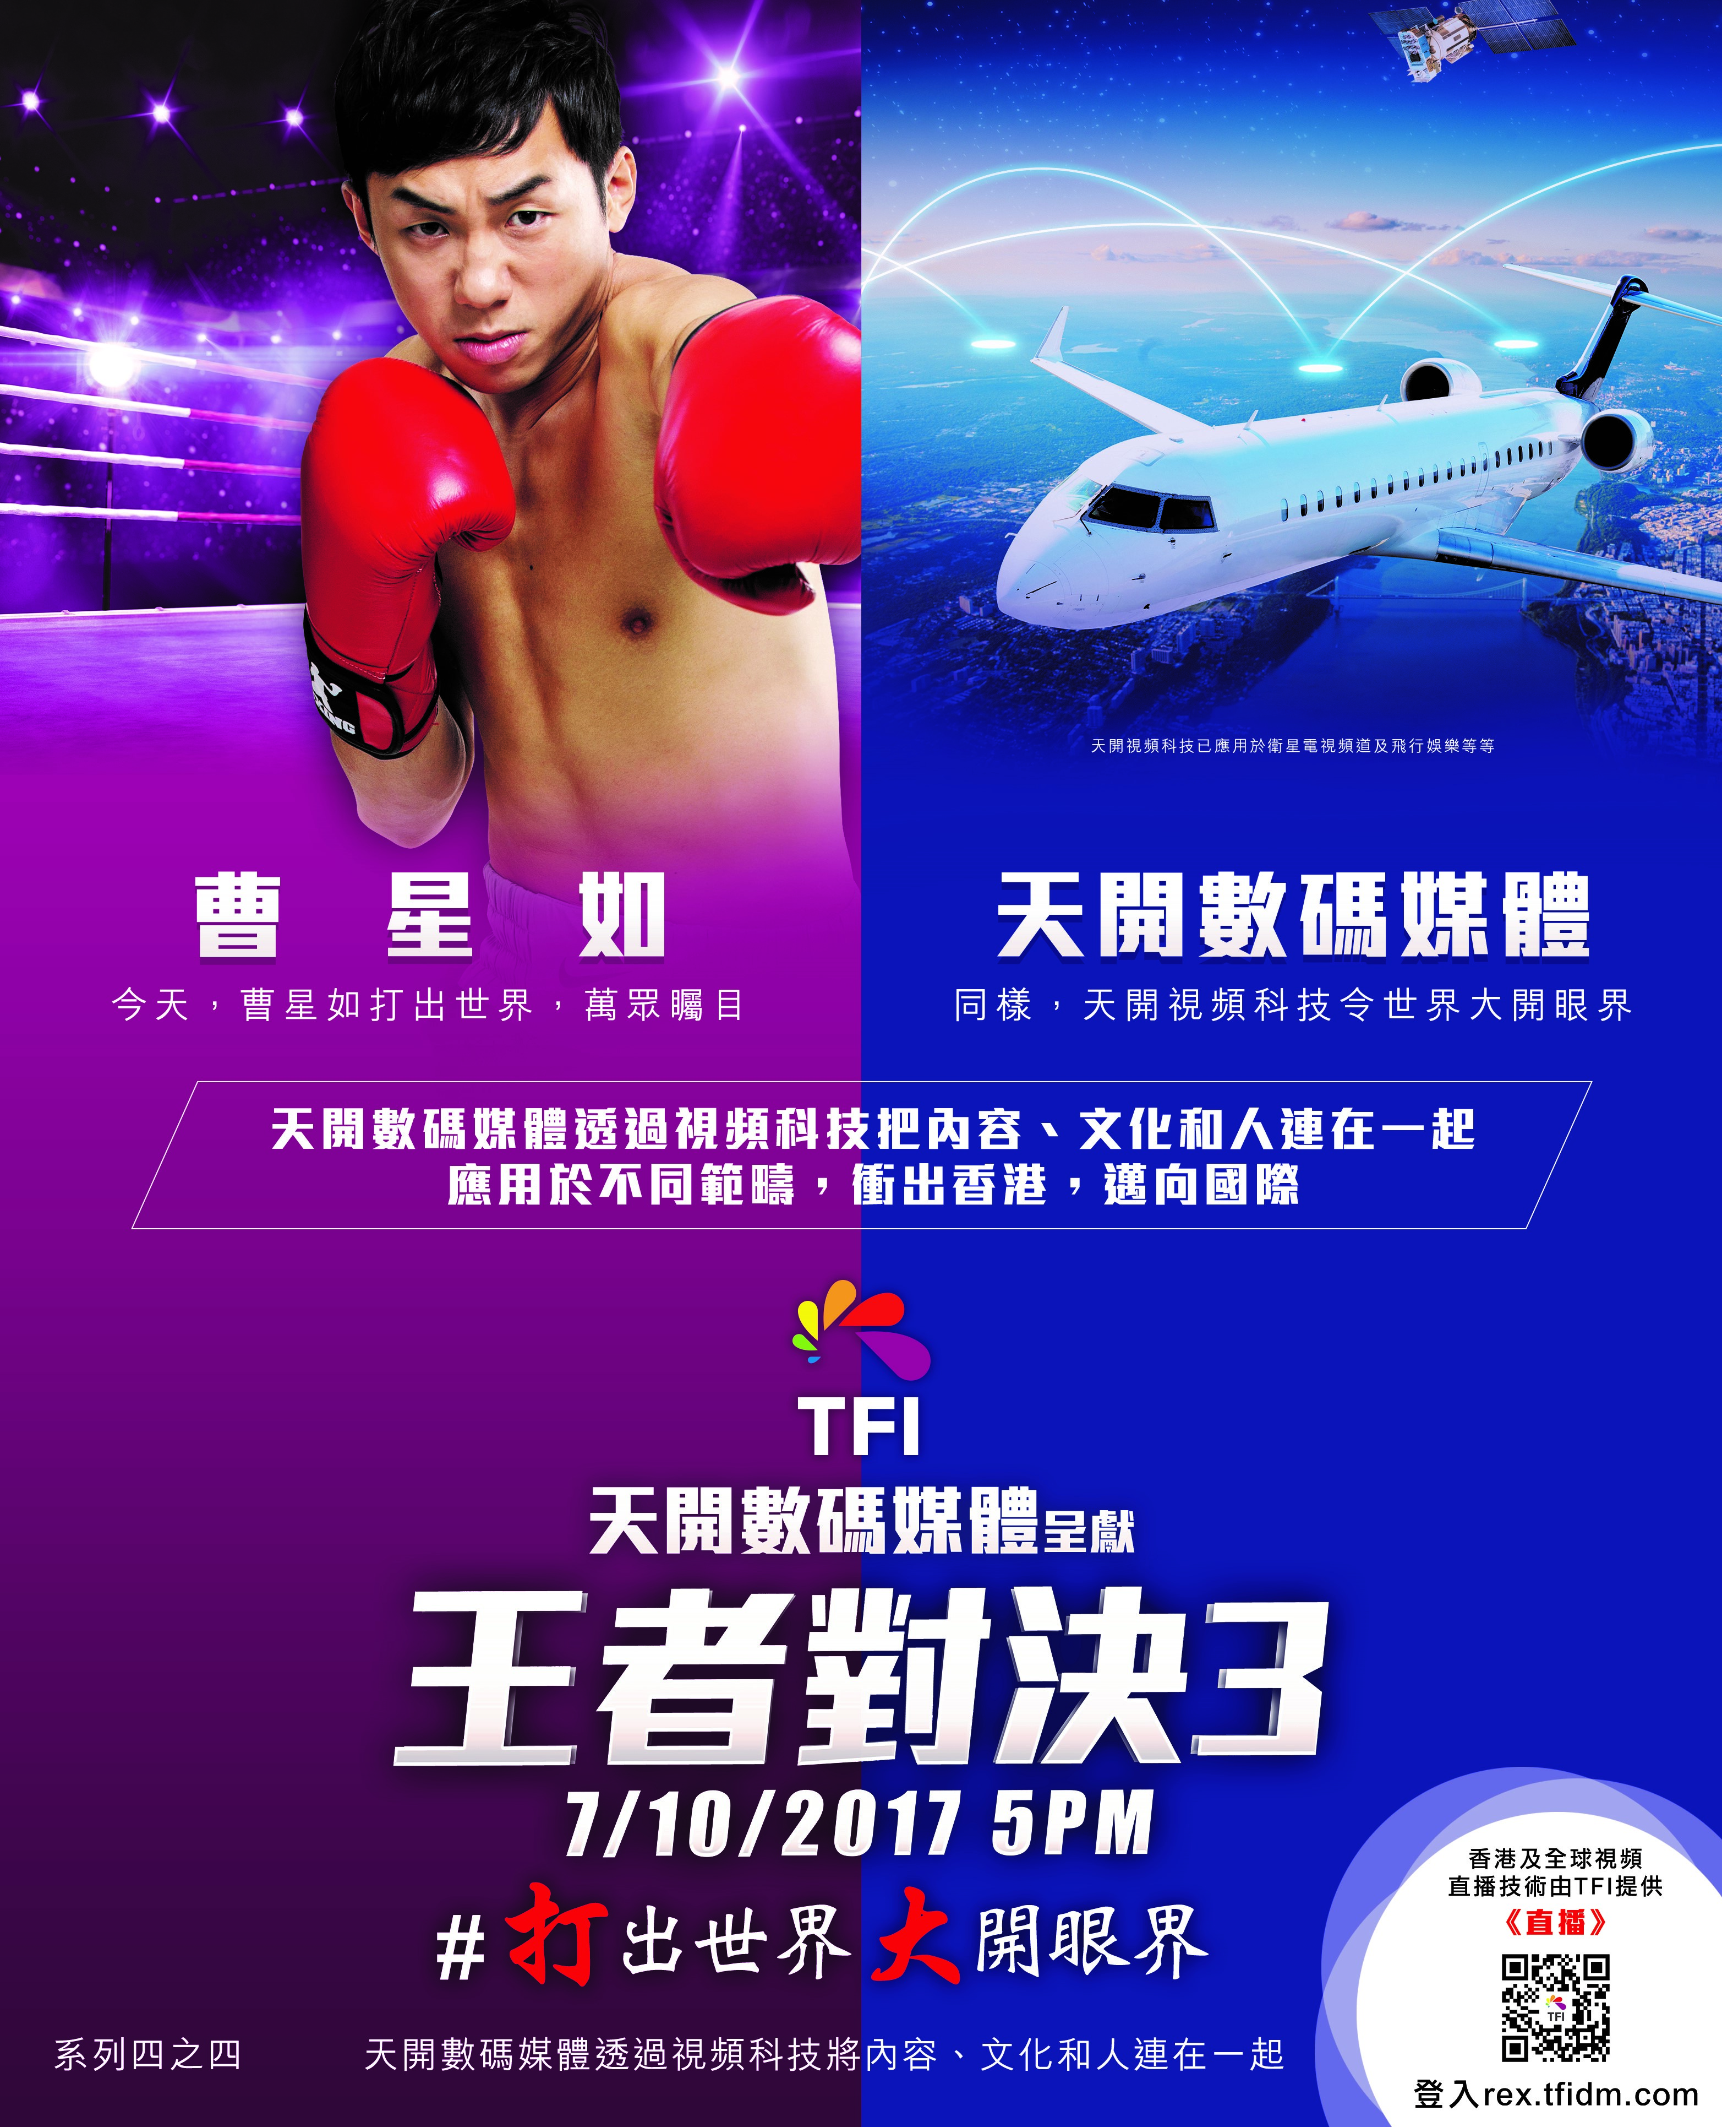

Fight for the world. Widen your horizon.

TFI Digital Media Presents

Clash of Champions 3

OpenSky.tv brings content, culture and people together through video technology. It applies in different areas, go beyond Hong Kong and worldwide

TFI Digital Media Limited

Rex Tso

Note: app = application; KOL = key opinion leaders.

Source: Company documents.

Exhibit 4: OpenSky.tv versus Google, Facebook, AND YouTube

|  |  |  |  |
| --- | --- | --- | --- |
|  | **Opensky.tv** | **Facebook** | **YouTube** |
| Established | November 2016 | February 2004 | February 2005 |
| Headquarters | Hong Kong | Menlo Park, California | San Bruno, California |
| Mission | Provides an individual, tailor-made channel | Gives people the power to build community and brings the world closer together; to stay connected with friends and family, to discover what is going on in the world, and to share and express what matters to them | Gives everyone a voice and shows them the world; believes that everyone deserves to have a voice, and that the world is a better place when we listen, share, and build community through our stories |
| Value Proposition | Helps users formulate their personal channel using human curation or artificial intelligence, with a simple power on and off button | Helps Internet users stay connected with their friends, families, and colleagues; facilitates exploring and learning about what is going on in the world; helps them express their views by sharing their opinions, ideas, photos, activities, and routines | Earns revenue through performance advertising and brand advertising, by delivering relevant ads at the right time and providing useful commercial information, regardless of the device used |
| Products/ Services | Wide range of premium, social, and local videos about diet, art, architecture, tourism, and culture in Singapore, Malaysia, Thailand, Philippines, Vietnam and Indonesia | Provides free products to users, including timeline, news feed, photos, videos, messaging (email, chat, text messaging), groups, lists, events, places, subscribe, ticker, notifications, and homepage from Facebook | Offers a wide variety of user-generated and corporate media video cases |
| Revenue Streams | Advertising and subscription | Advertising and payment from application developers | Advertising and subscription |

Source: “Tiankai TV Launch: Local Technology Internet TV New Experience,” (in Chinese), TechApple, December 9, 2016, accessed November 25, 2017, www.techapple.com/archives/4157; “Tiankai Digital Media 6th Anniversary World-Class Video Technology Show and Tiankai Network TV Long Restart,” (in Chinese), PCTech, accessed November 25, 2017, www.pctech.com.hk/index.php?option=com_content&view=article&id=7572:2016-12-09-08-22-36&catid=19:2009-03-10-02-42-32&Itemid=2; Sarah Philips, “A Brief History of Facebook,” *The Guardian*, July 25, 2007, accessed February 1, 2019, www.theguardian.com/technology/2007/jul/25/media.newmedia; Jeffrey Powers, “February 14, 2005: YouTube Is Founded,” Geekazine, February 14, 2018, accessed February 1, 2019, https://dayintechhistory.com/dith/february-14-2005-youtube-founded; “Facebook HQ,” accessed February 1, 2019, www.facebook.com/Facebook-HQ-166793820034304/; “FAQs,” Facebook Investor Relations, accessed February 1, 2019, https://investor.fb.com/resources/default.aspx; “YouTube: Our Mission Is to Give Everyone a Voice and Show Them the World,” YouTube, accessed February 1, 2019, www.youtube.com/yt/about; “Understanding Facebook Business Model,” Understanding Business Models: Design, Assessment, Innovation, Differentiation, and Transformation, accessed November 25, 2017, https://businessmodelinnovationmatters.wordpress.com/2012/04/10/understanding-facebook-business-model; Alphabet Inc., *Alphabet Annual Report 2017,* 2, accessed February 1, 2017, https://abc.xyz/investor/static/pdf/2017_google_annual_report.pdf?cache=5504fde.

1. “TFI Together: Technology. Fun. Innovation.” TFI, accessed November 1, 2017, www.tfidm.com/hk/en.
2. “Video Marketing Statistics & Trends 2015,” Syndacast, July 31, 2014, accessed Jan 30, 2019, http://syndacast.com/video-marketing-statistics-trends-2015/.
3. John McCarthy, “Global Online Video Consumption and Advertising to Increase by a Fifth in 2017,” The Drum, July 17, 2017, accessed November 1, 2017, www.thedrum.com/news/2017/07/17/global-online-video-consumption-and-advertising-increase-fifth-2017.
4. Ibid.
5. Staff Writer, “Digital Spending Continues to Surge in Hong Kong: PwC,” Marketing, September 6, 2017, accessed November 25, 2017, www.marketing-interactive.com/digital-spending-continues-to-surge-in-hong-kong-pwc.
6. “OpenSky.tv,” Facebook, accessed on November 1, 2017, www.facebook.com/OpenSkyTV.
7. Cantonese is the dialect of Chinese spoken by people from Guangdong, one of the provinces in China. Most people in Hong Kong also speak Cantonese as their mother tongue.