

9B19A019

ZENATIX: DISCOVERING MARKET FIT

Dr. Puran Singh and Dr. Harleen Kaur wrote this case solely to provide material for class discussion. The authors do not intend to illustrate either effective or ineffective handling of a managerial situation. The authors may have disguised certain names and other identifying information to protect confidentiality.

This publication may not be transmitted, photocopied, digitized, or otherwise reproduced in any form or by any means without the permission of the copyright holder. Reproduction of this material is not covered under authorization by any reproduction rights organization. To order copies or request permission to reproduce materials, contact Ivey Publishing, Ivey Business School, Western University, London, Ontario, Canada, N6G 0N1; (t) 519.661.3208; (e) cases@ivey.ca; www.iveycases.com. Our goal is to publish materials of the highest quality; submit any errata to publishcases@ivey.ca. i1v2e5y5pubs

Copyright © 2019, Ivey Business School Foundation Version: 2019-05-17

On the night of October 22, 2016, Amarjeet Singh was going over the slides of his pitch deck while his three-year-old son sat by his side curiously observing his father’s constant stare at the laptop screen. Singh, along with his co-founders Vishal Bansal and Rahul Bhalla, was scheduled to meet two venture capital firms the next morning to pitch for funding for Zenatix, an energy data analytics start-up that they had founded in 2013. There were no significant financials to show off, given that they had been in operation for only three years (see Exhibits 1 and 2). They had raised US$500,000[1] in 2015, which had kept them going for over a year; during that year, they tried to achieve a product–market fit but with limited success. Before they knew it, the funds that were expected to last three to four months had dried up. Singh, Bhalla, and Bansal had approached a number of investors in the past two months, also with no success. Singh said, “Lack of a proven model in this line of business, and particularly the hardware business, made it difficult for investors to believe our story. Hardware products move slowly and take time to stabilize. Investors don’t like that.”

For the meeting the next day, Singh was banking on the new control feature of Zenatix’s WattMan III technology, which had helped them get their first retail-chain client with a large number of outlets earlier in the month. WattMan III was a building energy-efficiency system based on Internet of things (IoT) technology, which monitored the usage and performance of electrical assets such as air conditioners, generators, and refrigerators. Insights into the usage patterns and performance of these electrical assets could help reduce wasteful energy consumption and so reduce the associated costs. Breakthroughs in remote and automated control features in the latest version of WattMan III had got them an order for over 100 site installations from their first retail-chain client. It was a strong indicator of market validation, and team Zenatix was relying on this to convince investors of the potential that WattMan III had for the retail-chain market.

After exploring the commercial building segment—shopping malls, office complexes, hospitals, and hotels—for over a year, Singh and his team had decided in February 2016 to drop that market and focus solely on retail-chain clients. It was the second time they had decided to change their target market. Two shifts in target market and technical challenges in product development and deployment presented enough uncertainty for investors to be cautious. This was a make-or-break situation for Zenatix as, in order to survive in the near future, they had to convince investors of their product–market fit.

GENESIS OF IDEA

In 2002, Singh, Bhalla, and Bansal were contemporaries during their bachelor of technology program at the Indian Institute of Technology Delhi (IITD), and they went on to do well in their respective careers in different fields (see Exhibit 3). In September 2013, Bhalla and Bansal approached Singh with the idea of starting a technology-based venture. Bhalla and Bansal had been deliberating starting something of their own for several years. Having worked in multinational corporations across several geographies, they knew that the future belonged to technology-based ventures. At this time, IoT and artificial intelligence (AI) were deemed to be important technologies of the future. E-commerce was also believed to be the next big thing in India, and it presented a growing need for data analytics solutions.

Singh, however, had always been passionate about creating social impact through technology. He suggested exploring ideas around analytics in the energy efficiency and healthcare domains. After initial deliberations, they initially chose “data analytics” as the theme for their new venture, but the target market and product were still to be narrowed down.

After further deliberations and market research, they ruled out the e-commerce and healthcare markets. They found that big e-commerce companies did their own analytics in-house rather than outsource it. In healthcare, doctors and hospitals were overburdened; collecting good-quality data from them was therefore going to be difficult. The energy sector was also tricky because the supply side—generation and distribution of energy—was largely government owned. The demand side, however, presented an opportunity since increasing prices and consumption of energy in India could force consumers to adopt energy-saving solutions. Government had also recognized the need for being energy efficient and had been taking measures in this direction for many years (see Exhibit 4).

Singh had done some research in the area of building energy-efficiency systems, for which he had raised a grant of about $1 million from corporate investors and the U.S. and Indian governments while he was at the Indraprastha Institute of Information Technology, Delhi (IIITD). In 2012–13, he had tested prototypes of an IoT-based monitoring system in some of the institute’s buildings to collect real-time data on energy usage and performance. The experiment had resulted in data-based insights that led to significant savings for the institution in terms of energy costs.

Keeping in mind the prior expertise of Singh, and coupled with market opportunities, the trio chose “energy data analytics” as the final theme for their start-up venture, which they named Zenatix. In December 2013, Zenatix was registered as a private limited company in India, a parallel of LLC in the United States. An existing tested prototype gave them a confident head start.

WATTMAN I: INITIAL TRACTION

In January 2014, Zenatix started building the product with one full-time employee, a former student of Singh’s, and a couple of interns. By March, WattMan I was ready for deployment. WattMan was a hardware product consisting of energy meters, sensors, and battery monitors connected to a zSmart Controller, a gateway device that collected usage and performance data from meters and sensors every 30 seconds (see Exhibit 5). The gateway published this data to a cloud stack—an open-source software platform that provided infrastructure to store, manage, and perform computing operations on data on a remote virtual server—where it could be analyzed to provide a breakdown of energy consumption for each electrical asset at different times of the day. Zenatix bought various sensors off the shelf, while the gateway device was built in-house by the tech team.

Zenatix targeted industrial clients that used heavy machinery and large manufacturing units because power consumption would be very high for such clients. Industrial units would be highly motivated to reduce these expenses. However, the only data they had access to was an electricity bill that gave no clue as to where they were consuming more or what they could do to consume less. There was lack of understanding as to which electrical assets were the major consumers of electricity and at what times of the day. WattMan I precisely answered these questions by providing insights on energy consumption by each individual electrical asset.

In March 2014, Zenatix was able to onboard an industrial client in Delhi. Over the next eight months, Zenatix improved the product and started developing business in the National Capital Region, which included Delhi, the national capital, and the two adjoining cities of Noida and Gurgaon. After onboarding a few industrial clients, Zenatix faced some issues with respect to product design and configuration. While interacting with industrial clients, they realized that plant heads and floor managers at each industrial set-up had unique inputs and different expectations on what would be useful for them to become more energy efficient.

Some clients were already collecting data from machines, but that data was limited to systems installed in-house that were not connected to the Internet. Zenatix evaluated the opportunity to integrate machine-level data with energy consumption data to generate richer insights. However, integration with archaic machines in industrial set-ups posed many challenges. Several machine-level systems were not designed to pull data in real time. Also, because of the lack of standardization of systems, interfacing across a variety of systems was not a repeatable process. Two industrial units producing the same product had differences in the type of machines in use, the skill level of the person operating the machine, and different environmental conditions. For each new industrial client, the product design and configuration had to be tweaked to fit the needs, the machines, and the local physical environment. A standardized product was clearly not going to work, and without a standard repeatable product, achieving scale was difficult. After many deliberations, Zenatix decided that industrial clients were not the right target.

Team Zenatix then explored other big consumers of electricity: commercial buildings such as hotels, hospitals, restaurants, and office complexes. In the initial market research and interaction with potential clients, the founders observed that there was an interesting energy consumption pattern in such buildings. Air conditioning constituted 40–60 per cent of total energy consumption; uninterruptible power supply (UPS) system loads such as computing devices and servers constituted 20–30 per cent; diesel generators constituted 10–20 per cent; and the balance was consumed by small devices and lighting. The usage pattern was similar for most commercial clients, and electrical assets were not strikingly different, so there was an opportunity to build a repeatable product and create a scalable business.

WATTMAN II: FIRST MARKET SHIFT

In September 2014, the tech team led by Singh changed product focus and started working on sophisticated analytical models for optimizing energy consumption in large commercial buildings. In order to optimize the usage of air conditioning, the largest power consumption centre, a temperature sensing feature was introduced into WattMan I. Temperature sensors needed to be spread out through a building, so Zenatix had to have a WiFi-based temperature sensing system that could communicate wirelessly to the zSmart Controller, the gateway device.

Zenatix had been buying various sensors off the shelf since they were affordable; however, wireless temperature sensors were very expensive and would increase the cost of the product. It was cheaper to develop the technology in-house, so Zenatix built a wireless sensor for their product.

Given the different dynamics and patterns of use in large commercial buildings, which typically operated on centralized air-conditioning systems, the analytics in WattMan II had to be more sophisticated than the previous product version. The systems needed to be switched on before the start of working hours so that comfortable temperature levels were reached before the employees and customers arrived. Typically, the facilities management team of a building switched on the air conditioning about two hours in advance. However, depending on weather conditions outside the building, the time taken by the air conditioner to cool the building varied. WattMan II was designed to factor in temperature data and weather conditions outside the building, and algorithms were developed to predict optimal start and stop times for the air-conditioning system, leading to savings in energy consumption.

WattMan II was also able to measure and report power consumption by the UPS system during night and non-operational hours. In addition, it was able to identify wasteful operations and diesel theft in the case of diesel generators. Overall, WattMan II was appropriately geared to optimize power consumption for commercial buildings (see Exhibit 6).

With these additional features, Zenatix was able to onboard a handful of clients from a range of sectors that included telecom, automobile, pharmaceutical, education, and consulting. The product was repeatable now, and it was merely a matter of making a sale. The market seemed to be promising; onboarding of commercial building clients signalled market validation and helped Zenatix raise $200,000 from a group of angel investors in March 2015, followed by $300,000 in a seed round in September the same year.

After taking on a few clients, the sales team, headed by Bhalla, realized that there was more than expected friction in making a sale. A client might have multiple buildings, each of which was an independent cost centre. Separate facility management teams were responsible for monitoring electrical assets in a building in addition to upkeep and maintenance of other facilities. These teams had to be convinced of the value that WattMan II could deliver. Because WattMan II indirectly questioned the efficiency of the facility management team, managers were usually on the defensive. They would argue that their building was better managed than other buildings and that no intervention was required. Each building was like a new customer that needed convincing and each had its own sales cycle. The sales team was overwhelmed by the effort that they had to put in to secure an order. Bhalla said, “Every sale started from zero and would take its own sweet time to materialize. We did not have manpower and time for this kind of on-the-ground sales effort. Honestly, we were running out of patience.”

Another challenge that Zenatix faced was in converting analytical insights and operational advice into actionable features. While the analytics were becoming more and more sophisticated, reducing energy consumption was entirely dependent on action taken by staff on the ground. Based on an advisory provided by Zenatix, building staff had to switch on or off one system or another at different points in time. If the staff ignored this advice, the potential energy savings were never actually realized.

One of the commercial building clients of Zenatix was a restaurant chain that had outlets distributed across geographies. The restaurant outlet was not very large, so there was no facilities management team in this case, and staff was not usually careful with their use of electrical assets. Typically, cleaning staff were the first ones to arrive, at 8:00 a.m., and they switched on the air conditioning. However, the first customers would arrive around 11:00 a.m., and at night, staff would forget to switch off electrical assets. It seemed that the owners had no knowledge or control over how the facilities were being used.

Zenatix realized that not only restaurants but all businesses that had small distributed sets of infrastructure or retail outlets across geographies also had no knowledge or control over how their electrical assets were being used. This constituted a major sub-segment in the commercial building market. Energy consumption patterns for this sub-segment were similar as well: air conditioning systems and diesel generators consumed most of the energy. Decisions pertaining to assets in retail outlets were taken by a central team. This meant that Zenatix needed to make one sale to the central operations head who could make decisions for hundreds of outlets at once. However, Zenatix had to eliminate the need to rely on ground staff to execute corrective actions based on an advisory generated by the data analytics team. If such a feature could be built into WattMan, Zenatix would have a solid value proposition for owners of retail chains.

In February 2016, after having worked with the commercial building clients for almost 18 months, the Zenatix team decided to narrow the focus to retail chains such as banks, fashion brands, and restaurants.

WATTMAN III: SECOND MARKET SHIFT

Over the next six months, Singh’s tech team had a single-point agenda: transform WattMan II for retail-chain outlets by developing a control feature that could bring centralized visibility into operations and so avoid misuse of the facilities’ energy.

The electrical load at retail outlets was much smaller compared to commercial buildings, where air conditioning was controlled centrally A retail outlet would have five to 10 split air conditioners of smaller capacities. The tech team found that developing an automated energy-monitoring system was possible in this case. For instance, detecting a person sitting in a large space in a big building and accordingly controlling air conditioning was much more difficult than controlling air conditioning in a retail outlet based on time of day and an approximate number of customers present.

There was a need to build a smarter gateway as well. Because connectivity at the cloud level could have been unreliable, the gateway had to have the ability to control air conditioners and other electrical assets locally. They also had to bring down the cost of the product to justify smaller costs and more savings at retail outlets. The tech team also planned to use the collected data to perform predictive maintenance of mission-critical assets such as refrigeration units. Predicting the failure of electrical assets and preventing and minimizing breakdowns would add significant value for retail-chain clients.

These abilities were possible only through an automated and remote-control feature, and the tech team was working on this. While the team struggled with product development and made gradual progress, the sales team managed to onboard a major retail chain in September 2016. Seemingly, onboarding a retail-chain client was not difficult, and they received an order for 100 site installations of a product that was still under development. Soon they were able to onboard more clients from the restaurant, telecom, fashion, insurance, and banking sectors. There were still challenges on the technology side, however, that would take more time to resolve and stabilize.

In October 2016, the tech team had a major breakthrough. WattMan II was upgraded to WattMan III, which included an automated control feature. This feature enabled a retail-chain client to centrally ensure that the outlet was at a prescribed temperature by 9:00 a.m.. Alternatively, if a section of a restaurant was not occupied, the air conditioners in that section could be switched off automatically to save energy and cost. Such outlets had electrical assets that included air conditioners, UPS machines, exhaust fans, modems, and outdoor signage. All this electrical equipment could be centrally controlled to optimize the usage and minimize the cost on energy bills. This was a game changer!

In WattMan III, Zenatix also added a feature that predicted breakdowns of electrical assets and indicated preventive maintenance that enhanced the value proposition further. Real-time energy usage and temperature monitoring data was used to develop algorithms to predict when an electrical asset could potentially break down. To top it all, WattMan III could now work in offline mode in case of power failure or disconnection from the central control team, and it was capable of supporting local decision making based on predefined programming (see Exhibit 7). Singh noted, “We were able to not just reduce costs by remotely controlling the usage, but also predict breakdowns based on performance data and hence contribute to clients’ topline by minimizing downtime.”

BUSINESS MODEL

The latest shift in target market presented promising prospects going forward. Zenatix did not need to reach out to large numbers of potential clients; it merely needed to capture a few clients that had a sizable number of outlets. Most clients initially wanted to sign up for paid pilot projects in a few outlets to experience first-hand the benefits of the system before committing to larger and longer contracts. In the pilot phase, Zenatix had to compromise on price in order to onboard the clients. However, Singh and team were confident that they could make this up with bigger and more profitable follow-up orders. Singh explained, “Once clients experience the value in the proposition, they would not mind paying higher prices. At that time, our older clients would start compensating the acquisition cost of new clients.”

Zenatix had to find customers that had hundreds of outlets so that pilots were followed by sizeable follow-on installation orders for WattMan III. Revenue was completely dependent upon clients seeing value in the product during the pilot. It was estimated that WattMan III could save a minimum of 8–10 per cent of energy cost, and Zenatix was hoping that clients would be willing to share a part of the savings as a cost of installation and maintenance. Zenatix came up with two subscription models. The Capex model required a client to pay up-front the cost of hardware and installation, followed by an annual subscription fee. In the Capex-free model, however, a client did not need to incur any up-front cost but had to pay a relatively higher annual subscription fee.

Most clients were inclined to go for the Capex-free annual subscription model to avoid the up-front costs in case the pilot failed. In order to ensure inflows in the longer term, Zenatix planned to offer five- to seven-year subscriptions. Some clients also had concerns around the honouring of long-term subscription contracts, especially given the weak legal enforcement mechanisms in India. Even if such a default in subscription payments were to come about, a start-up at the stage of Zenatix would not want to waste resources pursuing redemption.

Zenatix had contracted third-party vendors for on-site installations and maintenance. These vendors in turn hired front-line electricians or technicians who were trained to install the system. Vendors typically covered territories of 200–500 kilometres around their base locations. Zenatix would ship the required devices to the vendor after getting a sense of on-site requirement through a site survey. A front-line team, which typically included an electrician and a helper, would visit the location and install WattMan III. An analyst sitting at the Zenatix office would then connect remotely to the installation, configure it, and make it ready for deployment while the front-line team was still on site.

Front-line teams could carry out one or two installations per day, depending upon the size of the site. In some cases, where client sites were very large, it took two days to complete the installation. For two weeks after the on-site installations, usage and performance of electrical assets were monitored in order to establish a baseline, after which Zenatix brought in control interventions and demonstrated incremental benefit.

The Zenatix help-desk team took care of troubleshooting remotely. Every morning, the team would get a proactive preventive maintenance report. For any complaints from the client site, the help-desk team would evaluate and resolve the problem. In case remote monitoring could not be performed for any reason, all installations at site had light indicators that would make it easy for the client to identify and report the problem over the telephone. For problems that could not be addressed remotely, the front-line team would react within 24 hours.

THE ALL-IMPORTANT PITCH: CONCERNS, CHALLENGES, and OPPORTUNITIES

Having made three attempts at market discovery in last few months, Zenatix faced a tough ask in impressing investors. Singh and the team needed a convincing argument to showcase the potential and prospects of their latest target market.

In the past two months, all three founders had met various investors, but with no success. Given that growth in business-to-business (B2B) companies was slower when compared to business-to-customer (B2C) companies, not many investment funds were actively looking for B2B investment avenues. There was no precedent of Indian B2B companies that had grown by serving only Indian clients. As such, there was no benchmark for investors to compare against and gain confidence. In addition, the fact that hardware-based products took time to stabilize made investors even more wary. They had to think about stability before scalability. Add to that the technical challenges in product development and deployment, as they had just entered a fresh market. This made raising funds at this time even more difficult, and Zenatix was going to run out of money in two to three months. They were also forced to think of raising debt through a non-banking financial corporation—a financial institution with a partial banking license restricting it from taking deposits—to finance working capital needs in case investment did not come through soon.

Singh, however, was bullish on the new market discovery. Retail chains being a large market within in India and outside, Zenatix could potentially scale up fast as soon as the technology stabilized. It seemed to be the right product–market fit. The latest control feature in WattMan III made it a fully closed loop system: monitoring, analyzing, and automatic control. Savings in energy costs were estimated to be in the range of 8–30 per cent, depending on how inefficient previous operations had been. Real-time monitoring across a large number of geographically distributed outlets provided centralized visibility that could help plug lots of energy leakages that were previously unknown. Using data and artificial intelligence–based analytics, predicting and preventing breakdowns and eliminating the need for front-line maintenance teams could reduce downtime by 80–90 per cent. This meant more business and hence additional revenue for clients.

Singh was actually starting to believe that the application of their solution could be very wide and not just limited to energy saving. This could open up huge potential for Zenatix in the future. Singh said, “The broad theme was emerging to be an IoT solution that automated manual procedures, not just energy efficiency and monitoring of electrical assets. It could be expanded to include any range-of-use cases.”

The Zenatix team was hoping that their story would work for investors the next morning!

EXHIBIT 1: BALANCE SHEET OF ZENATIX (IN INR 000’s)

|  |  |  |  |
| --- | --- | --- | --- |
|  | **2014** | **2015** | **2016** |
| **Equities and Liabilities** | | | |
| Shareholders’ Funds | −294 | −233 | 22,554 |
| Non-Current Liabilities | - | - | 98 |
| Current Liabilities | 494 | 2,893 | 3,575 |
| **Total** | 199 | 2,660 | 26,227 |
| **Assets** | | | |
| Non-Current Assets | 100 | 117 | 874 |
| Current Assets | 99 | 2,543 | 25,354 |
| **Total** | 199 | 2,660 | 26,227 |

Note: INR 1 = USD 0.0153 (approximately) in 2016.

Source: Zenatix.

**EXHIBIT 2: INCOME STATEMENT OF ZENATIX (IN INR 000’s)**

|  |  |  |  |
| --- | --- | --- | --- |
|  | **2014** | **2015** | **2016** |
| **Revenues** | 0 | 4,050 | 6,322 |
| **Expenses** | | | |
| COGS | - | 1,271 | 3,031 |
| Employee Benefit Expenses | 233 | 1,375 | 10,910 |
| Other Expenses | 162 | 1,360 | 5,267 |
| **Total Expenses** | 395 | 4,006 | 19,208 |
| Profits/Loss Before Tax | −395 | 45 | −12,886 |
| Tax Expense | - | 17 | - |
| **Profit/Loss After Tax** | −395 | 61 | −12,886 |

Source: Zenatix.

EXHIBIT 3: BRIEF PROFILES OF ZENATIX FOUNDERS

Amarjeet Singh had masters and doctoral degrees in electrical engineering from the University of California, Los Angeles, in the United States. He joined the Indraprastha Institute of Information Technology, Delhi (IIITD) as assistant professor in the Department of Electrical Engineering and Computer Science (joint appointment) in 2009.

Vishal Bansal did a post-graduate diploma in business management at the Indian Institute of Management, Ahmadabad in 2007, and subsequently worked in the knowledge and asset-management industry in international positions until 2013.

Rahul Bhalla worked in the domains of strategy, solutions, business development, and delivery of intellectual property during 2002–2013.

Source: Zenatix.

EXHIBIT 4: THE ENERGY-EFFICIENCY MARKET IN INDIA

During 2002–2007, the Tenth Five Year Plan of the Indian planning commission, 877 megawatts (MW) of energy was saved in India. For 2007–2012, the Eleventh Five Year Plan, a target of 10,000 MW in savings was set. These targets were expected to increase in the coming five year plans, signifying the importance laid on energy saving by the government.

The Bureau of Energy Efficiency (BEE), Government of India (GoI), in its annual report for 2012–13, noted that there was a potential to save up to 40 per cent of energy usage in end uses such as lighting, cooling, ventilation, and refrigeration. The bureau was backing energy service companies (ESCOs) as a mechanism to deliver energy-efficiency services. ESCOs offered to industrial and commercial units a guaranteed savings model for energy savings that involved energy audits, recommendations, and implementation of solutions. The offerings included system design, retrofitting, implementation, financing, risk management, and saving guarantees.

As of 2013, over 100 ESCOs were empanelled by BEE. About 60 per cent of the market of ESCOs comprised of industrial clients, followed by governments and municipalities (24 per cent), commercial offices (9 per cent), and others.

According to a survey of ESCOs by World Resources Institute, revenues of ESCOs grew by a compounded annual growth rate of over 95 per cent during 2003–2007. ESCOs were able to save 20–25 per cent of energy for clients during this period. It was also estimated that energy demand in India would increase by 60 per cent between 2003 and 2016.

Source: Adapted from Bureau of Energy Efficiency, *Annual Report 2012–13*, Bureau of Energy Efficiency, India, 2013, accessed October 17, 2018, <https://beeindia.gov.in/sites/default/files/Annual%20Report%20%202012-2013%20%282%29.pdf>; and Ella Aglipay Delio, Saurabh Lal, and Chandan Singh, *Powering Up The Investment Potential of Energy Service Companies in India*, World Resources Institute, 2009, accessed October 17, 2018, http://pdf.wri.org/powering_up_full_report.pdf.

EXHIBIT 5: FUNCTIONING OF WATTMAN I

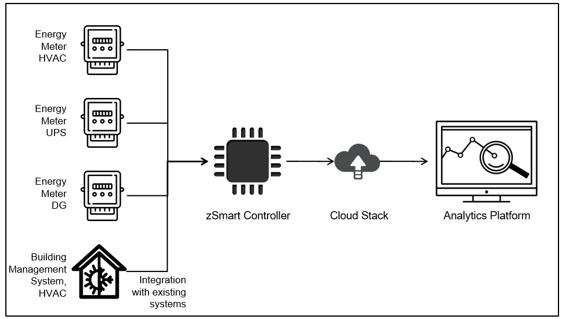

Notes: HVAC = heating, ventilation, and air conditioning; UPS = uninterruptible power supply; DG = diesel generation.

Source: Created by the case authors using inputs from Zenatix.

EXHIBIT 6: FUNCTIONING OF WATTMAN II

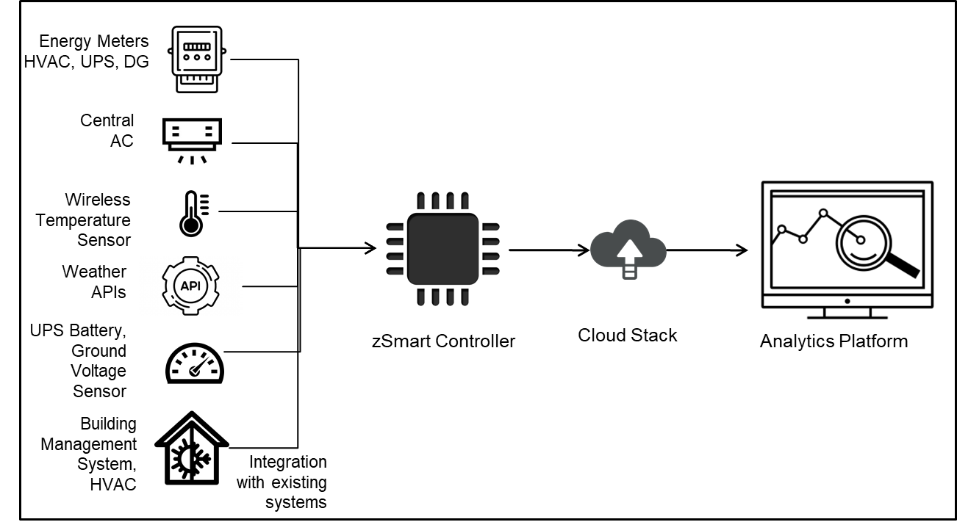

Notes: HVAC = heating, ventilation, and air conditioning; UPS = uninterruptible power supply; DG = diesel generation; AC = air conditioning; API = application programming interface.

Source: Created by the case authors using inputs from Zenatix.

EXHIBIT 7: FUNCTIONING OF WATTMAN III

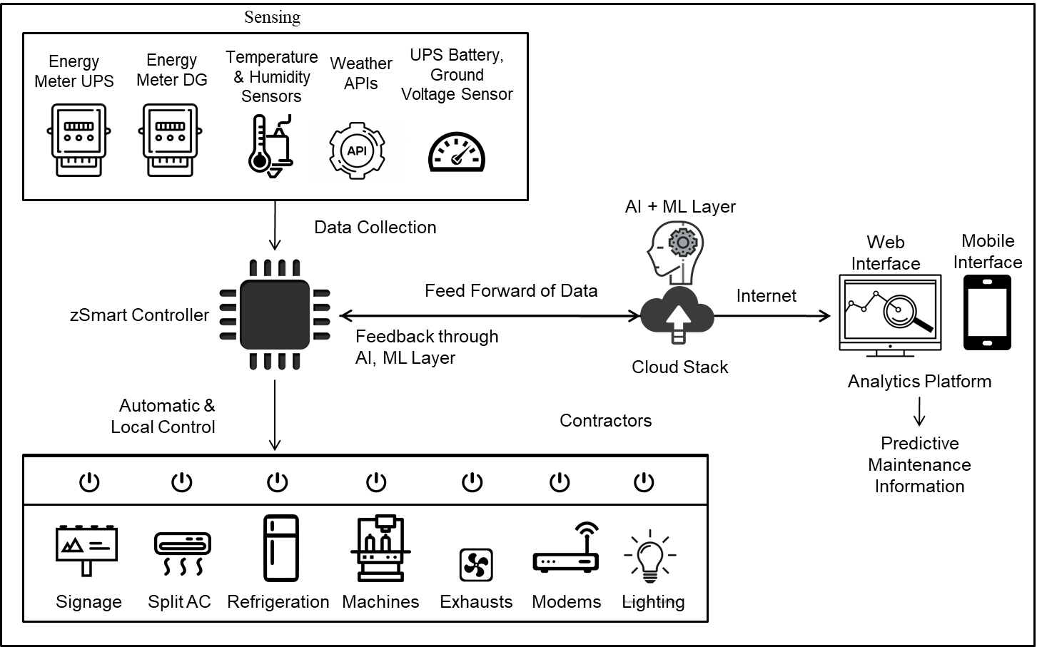

Notes: HVAC = heating, ventilation, and air conditioning; UPS = uninterruptible power supply; DG = diesel generation; AC = air conditioning; API = application programming interface; AI = artificial intelligence; ML = machine learning.

Source: Created by the case authors using inputs from Zenatix.

1. All dollar amounts are in USD unless otherwise specified.