

9B19A026

Speaker Labs: The Science of Talk

David A. Brooks wrote this case under the supervision of Julie Gosse solely to provide material for class discussion. The authors do not intend to illustrate either effective or ineffective handling of a managerial situation. The authors may have disguised certain names and other identifying information to protect confidentiality.

This publication may not be transmitted, photocopied, digitized, or otherwise reproduced in any form or by any means without the permission of the copyright holder. Reproduction of this material is not covered under authorization by any reproduction rights organization. To order copies or request permission to reproduce materials, contact Ivey Publishing, Ivey Business School, Western University, London, Ontario, Canada, N6G 0N1; (t) 519.661.3208; (e) cases@ivey.ca; www.iveycases.com. Our goal is to publish materials of the highest quality; submit any errata to publishcases@ivey.ca. i1v2e5y5pubs

Copyright © 2019, Ivey Business School Foundation Version: 2019-07-04

In late August 2018, Eric Silverberg and Eli Gladstone, the co-founders and operators of the Toronto public speaking, training, and consulting firm Speaker Labs, were thinking about their next steps to grow their business. The company had seen tremendous growth in the first two years of operations. For fiscal year 2019, Silverberg and Gladstone were targeting annual revenues of CA$1 million.[1] They were aware that their goal would require significantly more work than usual in the upcoming year, so they needed to act fast to begin executing their new strategy. They had until the end of the month to decide on a course of action and create a complete marketing plan.

TORONTO, ONTARIO

With a population of 6.4 million people, Toronto was the largest city in Canada and fourth largest in North America.[2] Known for its multiculturalism and diversity, Toronto was named one of the top 10 most liveable cities in the world.[3] It was a major business hub, with a highly respected financial services sector and one of the world’s fastest growing technology start-up centres. Nine post-secondary institutions (five universities and four colleges) were located within the city[4] and several other high-ranking universities were located near Toronto, which ensured a steady supply of talent to Toronto’s ever-growing business communities.

**ERIC SILVERBERG AND ELI GLADSTONE**

In 2010, after graduating from London, Ontario’s Ivey Business School’s Honours Business Administration program, Silverberg and Gladstone began their careers as lecturers in the school’s pre-business department. The experience sparked a professional relationship and cultivated a strong friendship between the two entrepreneurs. They also discovered their passion for teaching and presenting to audiences. Several years later, they moved to Toronto for work, primarily with technology companies and start-ups. While working in the industry, Silverberg and Gladstone discovered that public speaking—particularly, expressing ideas confidently and clearly—was a required skill in the business sector, spanning across job levels and industries. Although they enjoyed their work in the industry, they felt that they were not taking full advantage of the unique skill sets they had developed through their lecturing experience. Therefore, in August 2016, Silverberg and Gladstone chose entrepreneurship as their full-time career and founded Speaker Labs. In addition to managing the company, Silverberg and Gladstone were mentors for NEXT Canada, a non-profit organization focused on fostering innovation and entrepreneurship in Canada,[5] and for The DMZ, Ryerson University’s business incubator, where they helped grow new businesses by teaching communication and presentation skills to new entrepreneurs.[6]

**SPEAKER LABS**

Since its founding, Speaker Labs had experienced great success and was poised for even greater future growth. The company achieved sales of $100,000 in its first year of operations, which grew five times to $500,000 in 2017. Silverberg and Gladstone spent a large portion of their time facilitating workshops to help professionals develop their public speaking skills. However, as the only Speaker Labs employees, the two founders were also responsible for all other day-to-day business operations. Although it kept administrative costs low, the extra work kept them both extremely busy.

They enjoyed the wide variety of responsibilities required to operate their business. Rather than defining specific roles and responsibilities, Silverberg and Gladstone chose their work based on whatever was a priority that week. Because they worked extremely well together, they did not feel a need to change their workload plan.

**THE CONSUMER AND PRODUCT OFFERINGS**

Speaker Labs classified its clients under two categories: corporate and individual. Each client group had its own specific requirements, which differed from the other, and Speaker Labs developed offerings to address the needs of each group.

**Corporate Clients**

Speaker Labs catered predominantly to a corporate customer base of both large and small organizations across many industries, who saw value in developing their employees’ presentation skills. Some of the more prominent Speaker Labs clients included Royal Bank of Canada, Shopify Inc., and Maple Leaf Sports & Entertainment Ltd. Within the corporate client segment, Speaker Labs targeted technology companies, both well-established organizations and start-ups. Silverberg and Gladstone had prior experience within the technology industry and had developed connections with several companies, which helped them attract clients during the early stages of their business development.

They also found that the start-up culture of many technology companies in Toronto tended to prioritize investment in employee education and development, which coincided with Speaker Labs’ product offering. As a result, technology firms accounted for 70 per cent of Speaker Labs’ corporate clients. Most corporate client sales were gained through word-of-mouth referrals. The culture fit and connections to technology firms had proved lucrative, but the owners were actively looking to expand their reach into other industries. Potential sectors where Silverberg and Gladstone were planning to grow their sales included the financial sector and law firms.

Private Workshops

Speaker Labs’ core corporate offering was their signature two-day group workshops. Through these multi-day workshops, clients could develop into effective communicators. The two-day length of time was needed for Speaker Labs to cover all content and to coach the trainees through an in-person experience. Silverberg and Gladstone developed four labs to focus on content, delivery, visuals, and mindset. Each area of focus was covered in depth over the two days (see Exhibit 1). The workshops were presented together by Silverberg and Gladstone, providing clients with a dynamic and interactive experience. For corporate clients, Speaker Labs would present the workshops to employee groups within their Toronto office. Speaker Labs charged CA$1,495[7] per person for these sessions and a typical corporate workshop included between 15–20 participants. Developing the core curriculum was a massive time investment early on. However, after all content had been developed, the founders could focus purely on delivering the workshops. For each session Speaker Labs provided a book to each participant, which had a cost of $15, and provided them with other supplies that amounted to $5 per person. Silverberg and Gladstone estimated all other miscellaneous costs at $100 per two-day workshop. These workshops were the largest revenue generator for Speaker Labs, accounting for 65 per cent of all sales.

Despite the focus on the two-day workshops, Speaker Labs recognized that many of their corporate clients could not afford to budget the employee time or cost associated with these sessions. Therefore, the business offered shorter sessions, which they referred to as Lunch and Learn sessions because they were held over the lunch hour at the client’s site. Obviously, the entire two-day module content could not be covered during these brief sessions, so Silverberg and Gladstone customized them to the client’s needs and focused on specific areas of interest. They would either provide a surface level discussion of several different topics or concentrate on a particular area that was of interest to that client, such as one of Speaker Labs’ core topics. Lunch and Learn sessions were a small but growing element of Speaker Labs’ portfolio, accounting for five per cent of sales. These sessions varied by cost and topic but always included both founders as facilitators. The average attendance of a Lunch and Learn session was similar to the 15–20 participants of the two-day corporate workshops, but it lasted only 90 minutes. The client was charged a $3,000 flat rate for the session, with variable costs remaining consistent with the two-day corporate workshop expenses.

**Individual Clients**

Speaker Labs also offered services to individuals interested in developing their own presentation skills. This segment was growing, as the trend of investing in one’s professional development continued to rise. Like corporate clients, these consumers were influenced primarily by word-of-mouth referrals and signed up for Speaker Labs sessions on the company’s website. Many of these consumers were either seeking new employment or looking to further their skills to advance their careers. Individual customers came from a broad range of industries, but most participants were from technology firms, due to Speaker Labs’ presence and reputation in that community. To effectively grow this segment, Silverberg and Gladstone knew that they had to refine their consumer targeting process and use more effective marketing tactics. However, they still saw tremendous value in offering services to people from a variety of industries and experiences, and wanted to ensure that this continued.

There were two very different types of individual clients: those who attended public group workshops and those who used Speaker Labs’ private consultation services.

Public Group Workshops

For individuals, a two-day workshop similar to the one offered to corporate clients was available. Customers came from all over the Greater Toronto Area to attend these workshops, so they were held at a central location in downtown Toronto. The workshop space was located in a downtown Toronto computer coding school.[8] Holding the public workshops in that space allowed Speaker Labs to minimize office costs while maintaining its presence among Toronto’s business, start-up, and technology communities. Typically, individuals who attended the public two-day workshop were professionals between 25 and 35 years old. Pricing for these sessions was identical to corporate individual pricing. Public workshops were held less often, with a more intimate audience of approximately 13 participants, and accounted for 15 per cent of the company’s total revenue. Public sessions had the same costs as private workshops, but with additional costs of $950 for room rental and $250 daily catering costs.

Private Consultations

For a comparatively higher price, Speaker Labs offered private one-on-one consultation sessions that lasted about 60 hours. These clients were often higher-level executives looking to improve their communication skills. The average price for a private consultation was $20,000. However, Silverberg and Gladstone believed that an approximate amount of 10–15 additional hours of their time for each major one-on-one consultation was unbilled. Although no other major costs were associated with these sessions, they still reflected a much lower hourly revenue generator for Silverberg and Gladstone. They accounted for 15 per cent of sales, but were much less economical for Speaker Labs to run than the group workshops. Individual sessions also took up valuable time that Silverberg and Gladstone could be spending on facilitating workshops, developing new curriculum for their clients, or business development. As a result, they were not eager to promote this element of their business. They instead hoped to determine an optimal promotional strategy for the other offerings.

The two founders were generally happy with their pricing strategy for all programs, but they wondered if any changes were needed. They wanted to be sure that their prices were optimal for their chosen target market.

**BRAND STATUS**

Since starting operations, Speaker Labs’ primary form of brand exposure had been word-of-mouth referrals. Due to the nature of the product, consumers were hesitant to invest in development workshops if they were unsure of the quality of the service provided. As a result, referrals were paramount to generating sales within this industry. Silverberg and Gladstone believed that 90 per cent of their current sales came from highly satisfied customers referring friends, family, and colleagues. They knew that this was the nature of the industry, but still wondered what they could do better to meet their goals, given this reality.

To track client satisfaction, Speaker Labs clients were asked to complete a survey before each session regarding their expectations and current public speaking skills. A second survey would then be given after the service was provided to solicit feedback from the participants and determine customer satisfaction levels. Client satisfaction was critical for the company’s success, especially in poorer economic times. Speaker Labs had not yet had the experience of operating during a period of economic recession, but Silverberg and Gladstone were aware that their company provided a “luxury” service, and they also knew that only the strongest firms survived market downturns. Speaker Labs currently maintained an average score of 9.2 out of 10 on post-session surveys (see Exhibit 2). The two founders were thrilled to receive such strong satisfaction ratings from clients, but they believed Speaker Labs could improve its score to an average of 9.6, and they were eager to find a way. Currently, the company’s main advertising vehicle was Google Ads, which referred Speaker Labs as a provider when Toronto-area companies and individuals searched online using professional development and public speaking topics as their search terms.

COMPETITION

**Toastmasters International**

Toastmasters International was a non-profit organization founded in 1924 to help its members hone their public speaking, communication, and leadership skills. Since its inception, the organization had grown tremendously to a membership of over 352,000 people across 141 countries.[9] Toastmasters International used a club-based model with independent locations operating in different cities under the Toastmasters International banner. Each club ran meetings slightly differently but followed a general structure laid out by the international organization. These meetings involved members voluntarily delivering prepared or impromptu speeches,[10] and then receiving constructive feedback from peers. Fees for Toastmasters International ranged across clubs, but all members were charged a $60 fee to the international headquarters and an initial $20 fee to join the club. Most clubs also charged a membership or per-meeting fee that averaged $5–10 per meeting, which went toward club maintenance.[11]

Several Toastmasters International branded clubs existed within the Toronto area and followed the international model fairly closely. Toastmasters International was a considerably more affordable option than Speaker Labs as a means to simply gain experience and feedback when speaking in public. The Toastmasters International concept was purely amateur, allowing any member to present and any other member to provide feedback on public speaking and communication techniques, without requiring any proof of knowledge or expertise. Therefore, members could receive conflicting feedback and poor advice on their public speaking skills. Visuals and business presentation concepts were rarely explored in Toastmasters International meetings, which Silverberg and Gladstone felt was a failing for business communication. In addition, Toastmasters International did not have a strong presence in corporate training programs, focusing instead on individuals who were voluntarily looking for professional development.

**The Second City**

The Second City was a famous improvisational comedy theatre troupe operating in Chicago, Toronto, and Los Angeles.[12] Since its inception, it had served as a launching point for many successful comedians, providing their first experience in a performance and comedy environment. Notable Second City alumni included Tina Fey, Amy Poehler, Steve Carell, and Stephen Colbert. However, in addition to helping participants launch a career in theatre performance, The Second City offered training programs to people looking to develop their skills. Beyond typical classes such as script-writing and stand-up comedy, Toronto’s The Second City Training Centre offered speaking for individuals, and The Second City’s corporate arm, known as The Second City Works, offered corporate workshops promoting effective communication.[13]

The public communication classes were offered over two months and held in three-hour sessions once a week (24 class hours in total).[14] The classes were offered solely to individuals and were typically held on evenings and weekends, outside of standard work hours. The Second City classes offered a combined model of group classes and practice opportunities, as well as individual one-on-one feedback and strategy building. The Second City charged $320 for an individual to sign up for an eight-week session.[15] Corporate offerings were held at the client’s offices and ranged in durations from a few hours to multi-day workshops. The Second City’s corporate workshops were priced at a significant premium, with equivalent training programs often priced at over 25 per cent higher than Speaker Labs. Silverberg and Gladstone were aware that some of their customers had considered The Second City as an alternative when making a decision for public speaking training.

Silverberg and Gladstone believed that their focus and crafted offerings differentiated Speaker Labs significantly from The Second City, but they remained wary of the competitor’s established presence in this field. The Second City also benefitted from its novelty factor and from a very strong fan base, many of whom enjoyed the idea of taking a class with the esteemed theatre troupe, even if not interested in pursuing comedy.

**Dale Carnegie**

Named after the pioneer of the self-improvement industry and author of the bestseller *How to Win Friends and Influence People*, Dale Carnegie training courses were first developed by Carnegie himself in the early 20th century. Since then, the Dale Carnegie brand had expanded internationally, becoming one of the leading names around the world in personal development and self-improvement. Dale Carnegie had a clear business focus, with certain workshops dedicated to sales techniques and customer service strategies. In addition to the many different in-person workshops offered by an individual region or city’s office, Dale Carnegie offered many of its seminars in an online format that allowed individuals or groups who could not attend in person to train remotely. With offices across Canada, the Greater Toronto Area served as the company’s Canadian hub.[16]

Dale Carnegie offered seminars and workshops on several business-related topics, including presentation skills and public speaking. The courses offered included corporate training and public seminars for individuals.[17] Among all direct competitors, Silverberg and Gladstone felt that Dale Carnegie was the closest competitive offering to Speaker Labs. Its prices, however, were slightly higher than those of Speaker Labs, with the cost per person for a two-day presentation skills workshop priced at $1,995.[18] Dale Carnegie generally targeted more established companies and individuals, rather than the technology sector. From conversations with individuals who had attended Dale Carnegie’ workshops, Silverberg and Gladstone felt confident that the quality of the workshops offered by Speaker Labs was greater than that of Dale Carnegie classes.

**Public Speaking Digital Services**

There was growing competition from digital services and applications (apps) that provided similar services to Speaker Labs digitally. Virtual Speech[19] and Ummo[20] provided coaching to individuals and companies remotely though smart phone apps. These companies could not provide the physical presence that Speaker Labs did, but they were able to offer lower prices because of their substantially lower personal involvement in the coaching and tutorials. Silverberg and Gladstone wondered if these digital offerings could provide a comparable amount of the fun and entertaining classroom experience that Speaker Labs had become known for. However, due to their online nature, these virtual firms were able to cast a much wider net geographically than Speaker Labs could, and therefore had a much larger audience range for the tutorial elements of their workshops.

Silverberg and Gladstone maintained that their in-person presence and tailored content set their company apart. However, they couldn’t help but be impressed by some of the development these apps had made. Almost all of them used human coaches to provide feedback to clients who submitted videos of their presentations, but several products also used artificial intelligence to identify common public speaking errors, such as filler words and postures.[21] Additionally, the use of virtual reality software provided customers with a more convenient and immersive experience than in-person consultations or workshops. Silverberg and Gladstone wondered what the future of the industry would look like as these technology-based solutions became more sophisticated, effective, and popular. What could Speaker Labs do to maintain its place in the market?

**ALTERNATIVES—PROMOTION**

**Google Ads**

Google Ads was currently the only promotion vehicle used by Speaker Labs. Because Silverberg and Gladstone were too busy facilitating workshops and handling administrative duties for the company, promotion was one area that they could best outsource. The associate who managed promotion was paid $200 per month to maintain and optimize the company’s Google Ads profile. Speaker Labs used the Search Network service, and appeared in Google searches of interested parties[22] with an average ad position of 3.0[23] in the Toronto area. The company had no intention of deviating from this strategy, which resulted in an average cost per click of $2.53. Previously, Speaker Labs had spent $10 per day, five days per week, on Google Ads, but had decided to raise its budget to $12 per day after acknowledging the success this option provided.

Speaker Labs reached an overall rate of 1.84 per cent for conversion of potential clients. A conversion occurred when a potential client visited the Speaker Labs website and filled out the online form requesting further information or a quote. After optimizing its strategy, Speaker Labs managed to improve the conversion rate to four per cent. Speaker Labs realized that significant data analysis was needed for successful online promotion, and felt that the company’s poor initial conversion performance rate was a result of working with assumptions, without useful data available. Despite some success achieved using this technique, sales generated from Google Ads represented a small fraction of Speaker Labs’ total sales. Silverberg and Gladstone wondered if Google Ads was still an effective tool and what changes in techniques, spending, or strategy might improve results.

**Facebook Advertising**

Speaker Labs was also considering advertising on Facebook. As the world’s largest social network, with over 2 billion active accounts,[24] Facebook offered an opportunity for Speaker Labs to expose its brand to a new audience. Facebook allowed advertisers to target specific demographic groups using filters such as age, location, and interests. Facebook offered two advertising options: cost per click (CPC) and cost per impression (CPM).[25] Like Google Ads, CPC charged a fee to an advertiser whenever a user clicked on the displayed ad, whereas CPM charged advertisers a fee per 1,000 impressions that the advertisement received. The average Facebook CPC was $2.72[26] and the average CPM was $7.19.[27] Silverberg and Gladstone wondered how much research would be needed to ensure an effective campaign. They also considered the requirements of developing a Facebook page, which they did not yet have but would be required for Facebook advertising.

**LinkedIn Advertising**

Silverberg and Gladstone were examining advertising alternatives on LinkedIn. LinkedIn was the world’s largest professionally focused social network, boasting over 500 million users worldwide.[28] The founders saw LinkedIn as a good fit with Speaker Labs’ established brand due to the business focus that both companies shared. Speaker Labs had a company page on LinkedIn, but with very limited content and infrequent updates. Like Facebook, LinkedIn offered two advertising options for digital marketers: CPC and CPM.[29] The average CPC and CPM costs were $3.20 and $8.90,[30] respectively, with a $10 minimum daily spend.

**ALTERNATIVES—OPERATIONS ADJUSTMENTS**

**Online Courses**

With an increase of online resources for professional development, Silverberg and Gladstone wondered if Speaker Labs should consider an online system as a first step toward a more technology-centred offering. Elements such as instructional videos, quizzes, readings, tutorials, and individualized feedback were some of the elements that the owners envisioned as part of a Speaker Labs online package. Exactly how much content to offer online in general had yet to be determined, but the company thought it could provide an initial online course with eight hours of content. Online clients would undoubtedly want the same level of content that Speaker Labs was renowned for, but it was important that this offering would not become a replacement for in-person workshops. Silverberg and Gladstone were also concerned about the impact that any form of online course would have on the integrity of the Speaker Labs training program. The classroom experience and in-person coaching were an important element to the value that their workshops provided, which would be compromised with any kind of online delivery.

The Speaker Labs website did not currently have the infrastructure to handle the kind of traffic or content that this option would require to be effective. If this strategy was pursued, major development costs would have to be budgeted. A fee of $10,000 was estimated for initial website planning and development, plus an additional annual cost of $1,500 for website maintenance. In addition, a processing fee of three per cent per individual registered in the course was likely to be incurred. A price for the online course option was not yet estimated, nor was a plan for how it would fit in relation to the current offering by Speaker Labs.

**New Workshop Series**

Speaker Labs was also considering building on the success of its cornerstone two-day workshops by developing new products. Complementing the public speaking and presentation labs that the company offered, Silverberg and Gladstone considered creating new Sales Labs and Leadership Labs workshops. The founders had no intention of deviating from their current model of facilitating the workshops together, but they recognized that their own experience as lecturers was much less relevant to these two new topics. Developing the new workshops would not require a major financial investment, but Silverberg and Gladstone expected that development time could take two to three months, creating a significant opportunity cost of missed potential sessions for the company. The operating costs of running a new workshop were expected to be similar to the current two-day workshops costs, with a similar pricing structure per client. Silverberg and Gladstone thought that this offered a strong opportunity for growth, but they were not sure if this was the right time to introduce it.

**CONCLUSION**

Silverberg and Gladstone knew that in order to properly initiate whatever plan they chose, the decisions had to be made immediately. They wanted to achieve significant growth in the coming year, but they were adamant that this should not come with lower client satisfaction rates. Key factors for a new strategy for the company’s future included a clear focus, a strong target market, and appropriate marketing decisions. The founders knew that achieving their goal would not be easy, but a strong marketing strategy and an effective business plan would make their dream much more attainable.

EXHIBIT 1: SAMPLE COMPANY PROPOSAL

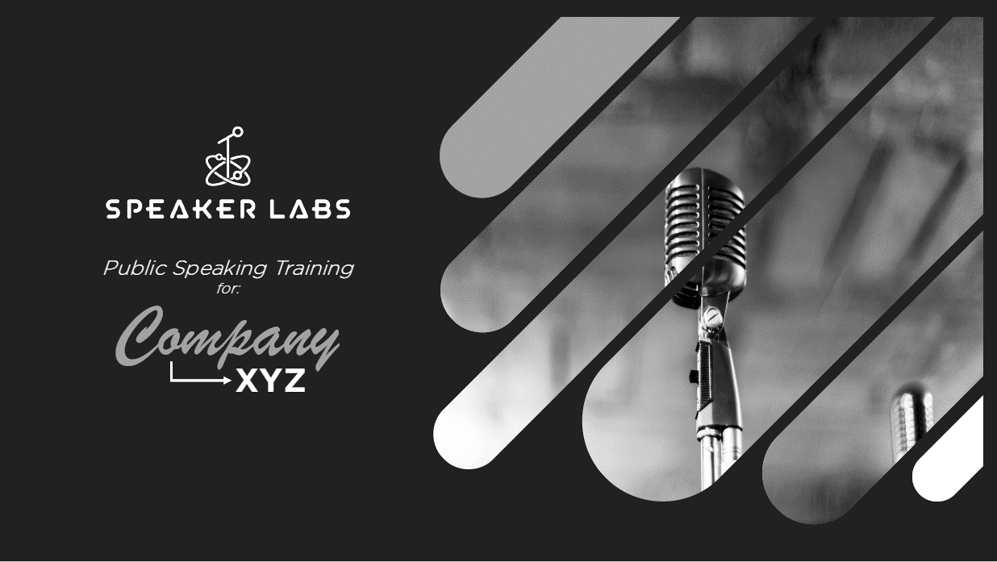

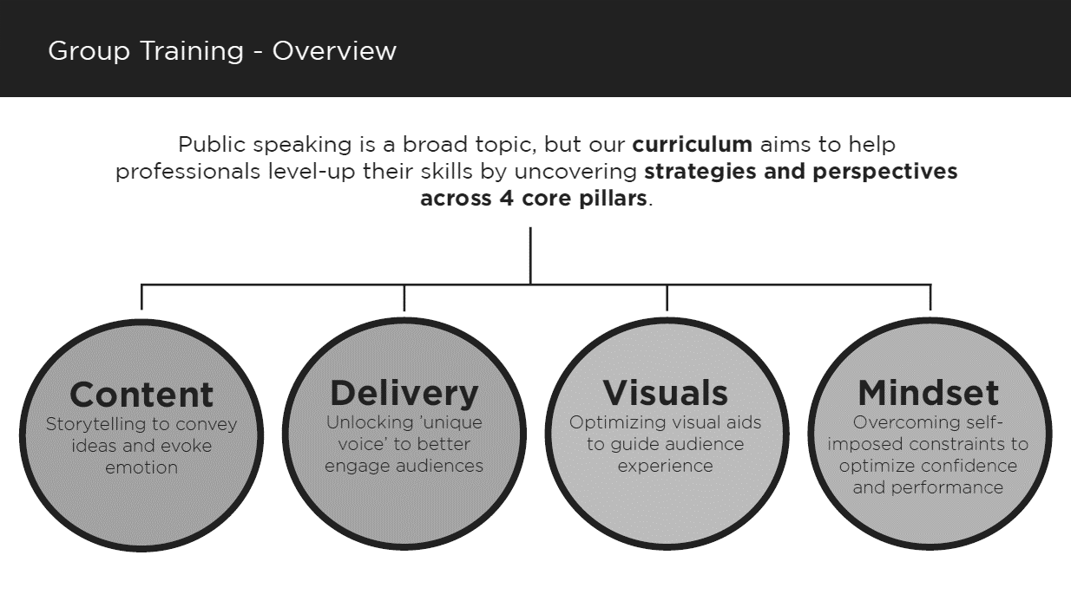

EXHIBIT 1 CONTINUED

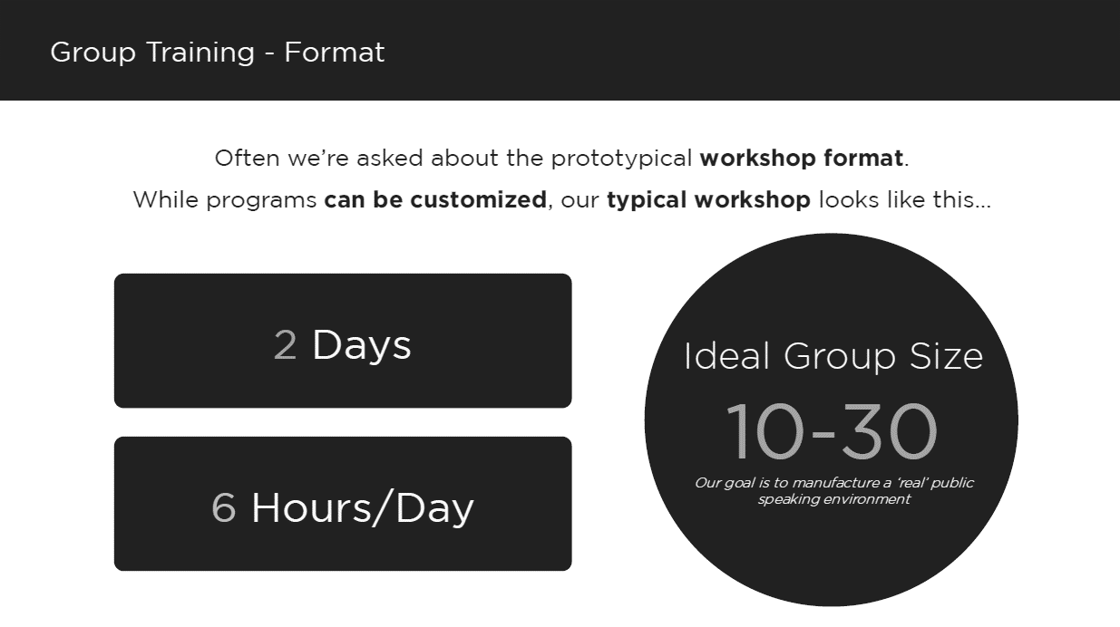

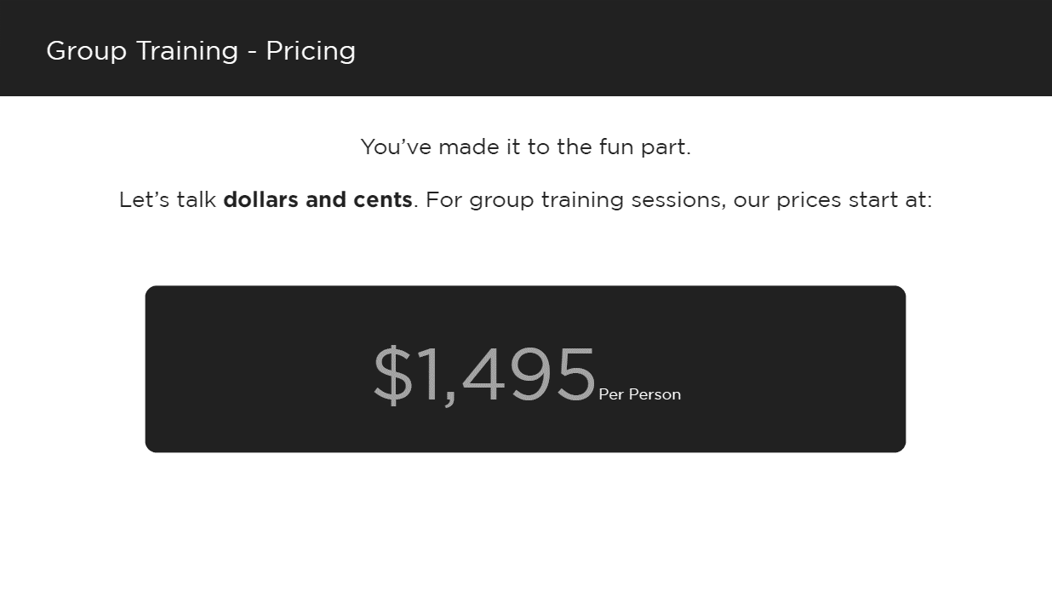

Source: Company files.

EXHIBIT 2: SPEAKER LABS REVIEWS

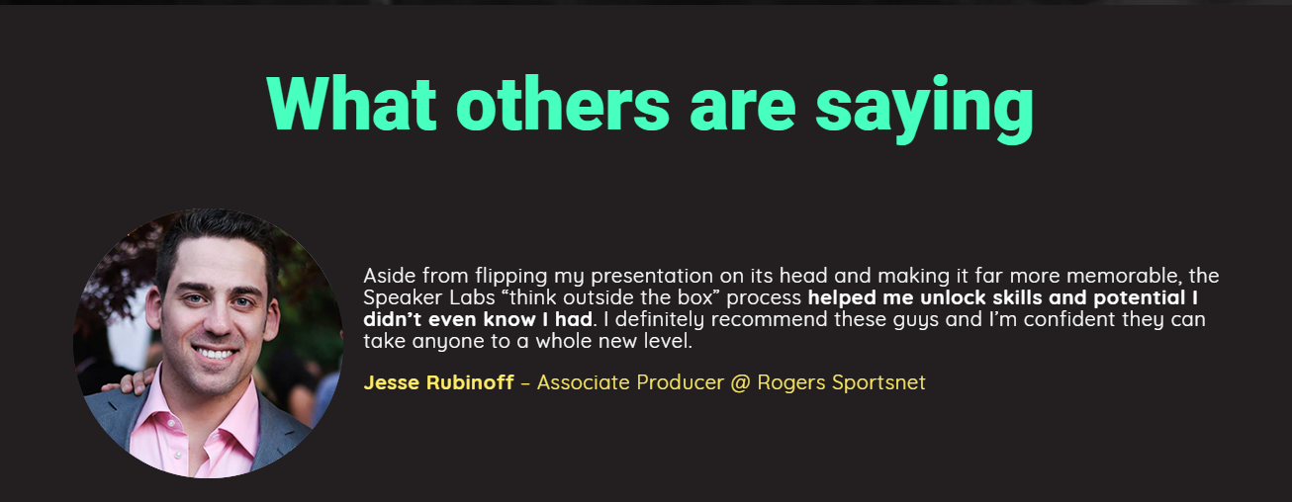

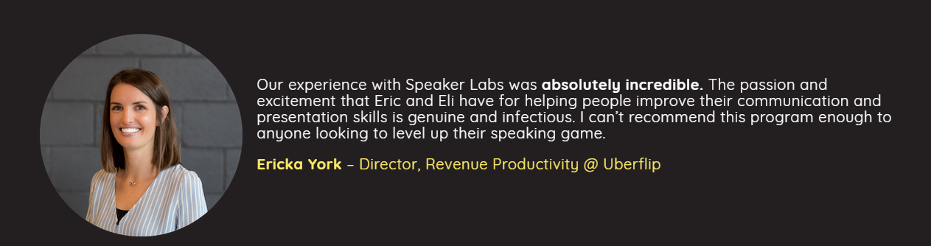

Source: Company files.

1. All currency amounts are in Canadian dollars unless otherwise specified.
2. “Toronto at a Glance,” City of Toronto, April 24, 2018, accessed July 5, 2018, www.toronto.ca/city-government/data-research-maps/toronto-at-a-glance.
3. “World Rankings for Toronto,” City of Toronto, June 30, 2018, accessed July 5, 2018, www.toronto.ca/city-government/data-research-maps/toronto-progress-portal/world-rankings-for-toronto.
4. “Education,” City of Toronto, May 14, 2018, accessed July 5, 2018, www.toronto.ca/business-economy/industry-sector-support/education.
5. “About NEXT Canada,” NEXT Canada, accessed July 11, 2018, https://nextcanada.com/about.
6. “About,” The DMZ, accessed July 10, 2018, https://dmz.ryerson.ca/about.
7. All currency amounts are in CA$ unless otherwise specified.
8. “About Us,” HackerYou, accessed July 7, 2018, http://hackeryou.com/about.
9. “History,” Toastmasters International, accessed July 15, 2018, www.toastmasters.org/about/history.
10. Impromptu speeches involve members giving a speech immediately after being provided a topic, promoting the concept of “thinking on one’s feet,” or public speaking without preparation.
11. “Facts for First Timers,” Toastmasters International, accessed July 16, 2018, www.toastmasters.org/membership/facts-for-first-timers.
12. “Second City History,” The Second City, accessed July 20, 2018, www.secondcity.com/history.
13. “Second City Alumni,” The Second City, accessed July 20, 2018, www.secondcity.com/people/alumni.
14. “Public Speaking,” The Second City, accessed July 20, 2018, https://trainingcentre.secondcity.com/s/sc-class-category/a2g1H000000EL5tQAG/public-speaking.
15. “Public Speaking,” The Second City, accessed July 20, 2018, https://trainingcentre.secondcity.com/s/sc-class-category/a2g1H000000EL5tQAG/public-speaking.
16. “Heritage,” Dale Carnegie, accessed July 30, 2018, www.dalecarnegie.com/en/approach/heritage.
17. “Courses,” Dale Carnegie, accessed July 30, 2018, www.dalecarnegie.ca/courses.
18. “High Impact Presentations,” Dale Carnegie, accessed July 30, 2018, www.dalecarnegie.ca/courses/high-impact-presentations.
19. “Business and Soft Skills Courses with VR,” VirtualSpeech,” accessed July 26, 2018, https://virtualspeech.com.
20. “About Ummo,” Ummo Application, accessed July 26, 2018, www.ummoapp.com.
21. Darren Menabney, “Can These AI-Powered Tools Help You Perfect Your Next Presentation?” Fast Company, October 28, 2016, accessed July 25, 2018, www.fastcompany.com/3064951/can-these-ai-powered-tools-help-you-perfect-your-next-presentation.
22. “About the Google Search Network,” Google, accessed July 22, 2018, https://support.google.com/google-ads/answer/1722047?co=ADWORDS.IsAWNCustomer.
23. An average ad position was a measurement of where the ad appeared in relation to other ads on the page. A position in the first four places was preferred.
24. “Number of Facebook Users Worldwide 2008–2018,” Statista, 2018, accessed July 24, 2018, www.statista.com/statistics/264810/number-of-monthly-active-facebook-users-worldwide.
25. “Facebook Ads,” Facebook, accessed July 22, 2018, www.facebook.com/business/products/ads.
26. Mark Irvine, “Facebook Ad Benchmarks for YOUR Industry,” WordStream, July 18, 2018, accessed July 31, 2018, www.wordstream.com/blog/ws/2017/02/28/facebook-advertising-benchmarks.
27. Chris Edwards, “How Much Does It Cost to Advertise on Facebook,” Data Driven Labs, July 19, 2018, accessed July 31, 2018, https://datadrivenlabs.io/blog/facebook-ads-cost.
28. Barb Darrow, “LinkedIn Says It Broke the 500 Million-User Mark,” Fortune, April 24, 2017, accessed July 21, 2018, http://fortune.com/2017/04/24/linkedin-users.
29. “LinkedIn Advertising Costs & Pricing,” LinkedIn Marketing Solutions, accessed July 25, 2018, https://business.linkedin.com/marketing-solutions/ads/pricing.
30. Abhishek Dey, “LinkedIn CPM Rates 2018,” Blognife, June 4, 2018, accessed July 28, 2018, https://blognife.com/2018/05/30/linkedin-cpm-rates-2018.