 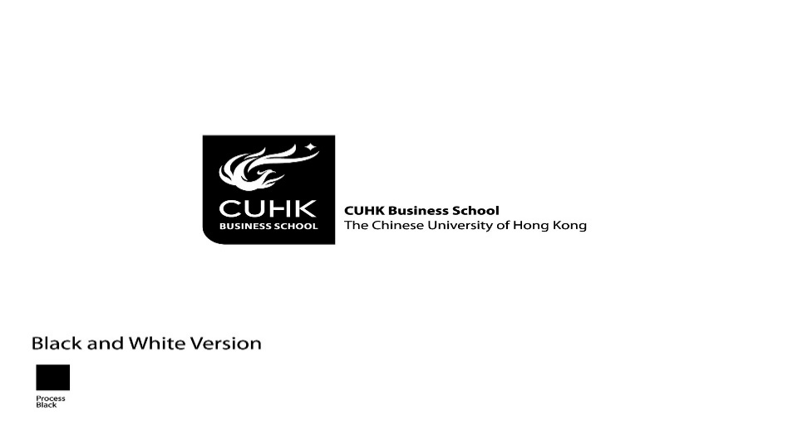

9B19A038

INCUBATION AND THE Hong kong science and technology parkS CORPORATION

Hugh Thomas, Andrew C. F. Chan, Howard Pong Yuen Lam, and Icy Fong Ling Ngai wrote this case solely to provide material for class discussion. The authors do not intend to illustrate either effective or ineffective handling of a managerial situation. The authors may have disguised certain names and other identifying information to protect confidentiality.

This publication may not be transmitted, photocopied, digitized, or otherwise reproduced in any form or by any means without the permission of the copyright holder. Reproduction of this material is not covered under authorization by any reproduction rights organization. To order copies or request permission to reproduce materials, contact Ivey Publishing, Ivey Business School, Western University, London, Ontario, Canada, N6G 0N1; (t) 519.661.3208; (e) cases@ivey.ca; www.iveycases.com. Our goal is to publish materials of the highest quality; submit any errata to publishcases@ivey.ca. i1v2e5y5pubs

Copyright © 2019, Ivey Business School Foundation Version: 2019-08-16

How should the incubation programmes of the Hong Kong Science and Technology Parks Corporation (HKSTP) be marketed to prospective incubatees? That was the problem facing HKSTP at the end of the fiscal year, March 31, 2018.

Albert Wong, chief executive officer of HKSTP, firmly believed that start-up companies, especially the technology start-ups in HKSTP’s incubation programmes, had to be passionate and self-reliant to survive and prosper. Yet HKSTP managed incubation programmes specifically to assist technology start-ups to survive the “valley of death,” where negative cash flow in its early stages might arbitrarily kill a highly innovative, potentially successful company (see Exhibit 1).

The Hong Kong government had given HKSTP unprecedented resources to support innovation and technology development in Hong Kong in its 2018-19 budget announced in March 2018. Over HK$50 billion would be spent for innovation including development of the infrastructure, research and development (R&D), nurturing start-ups, and promoting targeted industries. HK$10 billion of that HK$50 billion was for HKSTP. In addition to the HK$10 billion, the government had allocated HK$20 billion for construction of the Hong Kong-Shenzhen Innovation and Technology Park in Lok Ma Chau Loop, which would also be under the direction of the HKSTP’s wholly-owned subsidiary, Hong Kong-Shenzhen Innovation and Technology Park Limited, for the promotion of innovation and technology.[1]

Incubation was an important part of the HKSTP’s role in promoting technology development. Wong had to not only give HKSTP’s incubatees the resources to help them survive and prosper but also attract the best tech start-ups to join the programme.

incubation programmes

Business incubation programmes started in the late 1950s when a New York State real estate developer opted to sublet a large industrial facility to start-up companies, providing them with business services as well as space. In the 1970s, incubation was used by the United States National Science Foundation’s Innovation Centers Program to facilitate commercialization of new technologies.[2] Incubators marshalled resources—office space, clerical help, reception, accounting and legal support services, business knowledge, technology, access to customers and suppliers, a culture of entrepreneurship—for the benefit of newly established companies. By the second decade of the 21st century, numbers of U.S. incubators swelled to over 1,200[3] and European Union incubators to over 900.[4] In developing countries cities around the globe, striving to become the next Silicon Valley, followed suit, and China became the country with the largest number of incubators (see Exhibit 2). Hong Kong, an autonomous, globally open, special administrative region (SAR) of China, was among the first cities in China to use incubation to stimulate science, technology, and entrepreneurship, with its leading incubator located in HKSTP.

HONG KONG SCIENCE AND TECHNOLOGY PARKS CORPORATION

HKSTP was established on May 7, 2001 by the passage of the HKSTP Ordinance to

facilitate the research and development and application of technologies in manufacturing and service industries in Hong Kong, . . . to support the development, transfer and use of new or advanced technologies in Hong Kong [and] . . .to engage in such activities or to perform such functions as the Chief Executive in Council may . . . permit or assign to it.[5]

The Ordinance merged three former organizations—the Hong Kong Industrial Estates Corporation, Hong Kong Industrial Technology Centre Corporation, and the Provisional Hong Kong Science Park Company Limited[6]—to create a larger, more vibrant innovation and technology ecosystem to deliver social and economic benefits to Hong Kong and the region. It was founded to connect stakeholders, facilitate knowledge transfer, and nurture talents to accelerate technological innovation and commercialization.[7]

The establishment of HKSTP was an important part of the Hong Kong government’s plan. It was part of the Hong Kong government’s tentative shift away from what Hong Kong entrepreneurship researchers[8] referred to as the traditional, *laissez faire* approach that was based on free trade, open finance, low taxes, small government, budget surpluses, and a staunch positive non-internationalist deference to market forces.[9] Hong Kong had grown from an *entrepôt* into a manufacturing centre and then into a financial, logistics, and business services centre benefitting from its role as the gateway to modern China. By the turn of the century, however, the Hong Kong government increasingly provided not only an open, level platform but also promotion of new technologies, innovation, and entrepreneurship in specific clusters, drawing on local established industries and university research capabilities. HKSTP was formed at about the same time as Cyberport, a multi-building development on the western end of Hong Kong Island, to be an information and communications technologies (ICT) hub. HKSTP, in contrast, was substantially larger and strove to create five clusters: biomedical technology, electronics, green technology, ICT, and material and precision engineering. It also focused on three overarching application platforms: Healthy Ageing, Robotics, and Smart City.

As of March 31, 2018, HKSTP had over 13,000 people working in 675 companies (of which 263 were incubatees) lodged in its over 3.5 million square feet of lab and office space at Hong Kong Science Park. Seven divisions of HKSTP reported to Wong, including but not limited to the Corporate Development Division that included the Incubation & Acceleration Programmes, Technology Clusters and Platforms, and Investment/Corporate Venture Fund (see Exhibit 3).

THE hkstp incubation programMES

HKSTP provided workspace to technology start-up companies through three incubation programmes: the 18-month Incu-App Programme for web/mobile apps and games, the three-year Incu-Tech Programme for electronics, green technology, ICT as well as materials and precision engineering, and the four-year Incu-Bio Programme for therapeutics, personal care, Chinese and herbal medicine, regenerative medicines, medical devices, and diagnostics.[10] Incubatees paid HK$820 (US$105) per month for a desk in a co-working space that included access to conference rooms, telecoms and Wi-Fi, pantries, a gym, and recreational facilities. For similar commercially available facilities in Hong Kong, a tenant would have to pay well in excess of HK$2,000 (US$260)[11] per month. Incubatees also received mentorship, business partner matching, technical and professional consultation, marketing and promotion support, access to laboratory facilities, preparation for fund raising, and matching with potential investors.

Each applicant had to be a Hong Kong registered company not older than two years from the date of application submission, with at least one (Incu-App) or two (Incu-Tech and Incu-Bio) full time staff, at least 50 per cent of whom were technical personnel, working on R&D projects. Particularly for Incu-App and Incu-Tech, the technical person or team had to own individually or collectively, at least 10 per cent of the applicant’s equity.[12] In the fiscal year ending March 31, 2018, 234 companies applied and 97 were accepted into the incubation programs. Exhibit 4 summarizes the programme’s key statistics while Exhibit 5 gives information about other major incubators in Hong Kong and the mainland city of Shenzhen, located on the northern border of Hong Kong.

MEASURING IMPACT

While stating the goals of incubators was easy, measuring their success was more difficult. In the United States and China, respectively, about 80 per cent and 72 per cent of start-ups survived their first year of business while about half and about one quarter of companies survived for more than five years.[13] Exhibit 4’s data from HKSTP showed that as of the end of each recent year, the ratio of cumulative graduates still in business to cumulative total graduates was stable at around 75 per cent. HKSTP had carefully and competitively selected incubatees before they were admitted. Furthermore, during their residence, they enjoyed mentorship, access to professional advice, lower rents, and access to financing. In short, due to differences in samples and other factors, the above percentage of HKSTP’s incubatees that were still in business could not directly be compared with the one- and five-year survival rates from the United States and China.

The difficulty in measuring the impact of incubators was not unique to HKSTP. Academic studies of the effectiveness of incubation came to diverse conclusions (see Exhibit 6).

CHALLENGES FACING INCUBATEES

Incubatees viewed incubation programmes at HKSTP as a crucial support to enhance their prospects for survival and development. Incubatees’ plans were formalized as milestones, specific actions, or accomplishments to be completed by set dates. In fact, the vast majority of incubatees either successfully passed their milestones or appropriately re-set milestones with HKSTP’s agreement. During the fiscal year ending on March 31, 2018, only 8.4 per cent of incubatees withdrew from the programme.

The Head of Incubations Programmes, Peter Mok identified two main reasons for the withdrawals: team-related issues and business opportunities (both good and bad). Team related issues included family matters, health reasons, and irreconcilable arguments among founding team members over company direction. Business opportunities included, on the good side, a merger or an acquisition, leading to changes in ownership such that the founding team members held less than 50 per cent of the company. Or, the company could have changed its strategy so that fundamentally it no longer fit into the criteria for the programme. Finally, the business model could be proven unsustainable. Some companies simply developed products or services that failed to meet a market need.

Among the difficulties identified by incubatees, one was a lack of cash. Although Hong Kong was ranked as the third most powerful financial centre in the world, after New York and London but before Singapore (#4), Tokyo (#5), Shanghai (#6), Beijing (#10), and Shenzhen (#20),[14] local investors tended to be risk-averse and preoccupied with real estate, not technology. Incubatees complained that, in the absence of local high-tech entrepreneurial business models and heroes, angel investors, talented engineers, and managers were reluctant to bet their money and time.

The Hong Kong market had yet to build a critical mass to achieve economies of scale. Hong Kong was part of China, with national defence governed by Beijing; economically, Hong Kong was a special administrative region, having its own legal system, and negotiating commercial treaties directly with other countries of the world. While companies starting in Hong Kong had to be born global,[15] those starting in China or the United States could launch their globalization efforts after successfully establishing themselves domestically. Incubatees aimed to change customer habits with their new products and services, yet the change took time, especially when selling to conservative companies and government departments.

Shing Yuk Chow was the owner-manager of Lalamove, a logistics company specialized in on-demand short-haul deliveries in Asia using the sharing economy to match users and drivers in the same city; it had been in HKSTP incubation from June 2014, six months after its founding, until December 2015. Lalamove was affected by the pros and cons of its Hong Kong location, operating in Hong Kong, Bangkok, Manila, Singapore, Taipei, and more than 90 cities in mainland China.[16] One of HKSTP’s first unicorns (a privately funded, start-up technology company valued at over US$ 1 billion), Lalamove appreciated the convenience of Hong Kong, but as Chow commented, the size of the Hong Kong market was a disadvantage:

Imagine: if my business model worked in San Francisco, it would also work in New York. But my Hong Kong model is unlikely to work in New York and will not even work in Shenzhen. As a result, it narrows your target market. The biggest internet companies in the world come from the States and China, because their local market is large enough. But for Hong Kong, our local market is relatively small.

HKSTP strove to attract promising start-ups from around the world. Lumos Helmet was founded by Eu-wen Ding and Jeff Chen, who met at a weekend hackathon[17] in Boston, MA while they were both students at Harvard in 2015. Their idea, a sculpted, smart bike helmet that integrated headlights and brake lights and turn signals to improve bicycle safety and increase cyclists’ confidence[18] was tested in Kickstarter and successfully attracted over 6,000 backers who pledged over US$800,000 bringing the project to life.[19] Lumos joined the HKSTP incubation programme in November 2015. As of mid-2017, Lumos was producing one helmet size in five colours selling at US$199 per piece in the North American and European markets. Ding was from Singapore and chose Hong Kong because of the ease of conducting business in the city. The company made a physical product, a helmet, and he felt that there was nowhere else in the world better to manufacture it than Shenzhen. Ideally, he would have chosen to live in Shenzhen, except that Lumos’ marketing was all done online, using Google and Facebook, two services sporadically blocked in China. Hong Kong presented a natural middle ground for Lumos’ headquarters. Access to the internet was fast and reliable and travel to Shenzhen, where the Lumos engineering team was located, was convenient.

meeting the needs of start-ups

Wong knew that Hong Kong was an innovator’s paradox: according to the Global Innovation Index 2018, of 127 countries, Hong Kong’s overall ranking was a credible 14th, ahead of China (17th), but behind Singapore (5th), Korea (12th), and Japan (13th) in Asia. But this overall good ranking masked a dichotomy. While Hong Kong ranked eighth in the input sub-index, behind Singapore (1st) but above all other competitors in Asia, its innovation efficiency ratio was an unimpressive 64 per cent. In terms of overall entrepreneurial activity, Hong Kong ranked below its competitors (see Exhibit 7). To address these problems, Wong was determined to establish a new ecosystem at HKSTP. He wanted to do more than provide low rent to start-ups and help them with the administrative details of running a business. He wanted to help incubatees connect with the rest of the world.

Wong saw Hong Kong as a well-positioned platform for marketing high potential technology start-up goods and services to the world. He felt Hong Kong was an ideal location to test products and services because Hong Kong was small, and the regulatory requirements set by the Hong Kong government were stringent. He also considered Hong Kong’s location, next to the biggest market in the world, to be critical to any company with a strategy for China.

To help incubatees with their China strategies, HKSTP had developed partnerships so that incubatees in HKSTP could use facilities located in Beijing, Tianjin, Shanghai, and Shenzhen on a reciprocal basis.[20]

One of the strongest elements of HKSTP’s mainland China connection came from Hong Kong’s universities. University researchers—professors and their post-graduate students—formed a significant source of HKSTP incubatees. Most post-graduate research students of those universities came from the Mainland.

Wong noted that HKSTP could help incubatees navigate through regulations. Start-up companies promoting new technologies—whether autonomous self-driving or shared cars or stem cell research—often confronted regulatory constraints. HKSTP helped incubatees to understand and deal with regulations. The recently implemented Public Sector Trial Scheme for Incubatees and Graduate Tenants of HKSTP and Hong Kong Cyberport Management Company Limited provided funding for prototypes and trials in the public sector to help incubatees commercialize their R&D.[21] HKSTP could facilitate those applications.

HKSTP could also help with financing. Given the technology focus of the companies and the speed with which they were growing, Wong felt that, in the long run, HKSTP would become a place-to-go for Asian or even global technology investors. One of his goals was to increase deal-flow for companies at Hong Kong Science Park. Doing so, however, involved educating investors. Hong Kong investors, many of whom had made their fortunes in traditional labour-intensive manufacturing, trading, and real estate, tended to be averse to investing in new technologies. Part of this stemmed from their belief that Hong Kong had no competitive advantage in innovation and high technology, and part of it stemmed from a conservative strategy that set positive cash flow as a prerequisite for investment. Yet the global unicorns of new technologies typically had negative cash flows. To accomplish this education and matching of investors with investee companies, Wong created a new task force at HKSTP that he called the Investors’ Team. The team sought to create opportunities for investors, introducing them to many HKSTP companies in their areas of interest—artificial intelligence, biotech, electronics, green-tech, ICT, and new materials.

Eric Z.X. Chen, founder and chief commercial officer of Vitargent (International) Biotechnology Ltd., appreciated the help extended by HKSTP in the company’s start-up. He established Vitargent in 2010, and the company was in the incubation programme from 2011 to 2015. Vitargent applied its proprietary Transgenic Medaka and Zebrafish Fish Embryo Toxicity (FET) testing technology on food and skincare products. In 2013, Vitargent received the international standard ISO17025 Accreditation. As of 2017, it was the only test centre in Asia that could provide FET testing with results officially recognized in more than 100 countries. Vitargent planned to use its consumer product safety information platform, Test-it™, to become the global standard for consumer product safety. Chen felt that the key attraction of HKSTP incubation was its low rent, but HKSTP had also helped with fund-raising. As a university student, Chen had difficulty securing first-phase funding to launch his business. He secured initial funding from the government in 2010 and then reached out internationally for qualified employees. Chen commented that the HKSTP team was helpful in lining up additional funding and resources, as well as helping the new company with legal and accounting advice.

Unlike the CEO of a for-profit, private sector company, Wong did not restrict his mandate to HKSTP alone. He was responsible for promoting the Hong Kong technology start-up community. He believed that Hong Kong’s economic and business environment was the best in the world; however, it was a city with only seven million people. HKSTP could help its incubatees to expand beyond Hong Kong. As Wong expressed it:

If there are incubatees successful in Hong Kong and they move to Shenzhen, . . . if their business or their products or services are good for the big market of China, we will support them to scale up and go global . . . But . . . Hong Kong is their anchor and they should keep an R&D arm in Science Park.

Wong defined his role as serving the Hong Kong start-up and innovation community. He viewed other incubators in Hong Kong, and indeed the whole Hong Kong innovative ecosystem as complementing, rather than competing with HKSTP. Within that evolving ecosystem, Shenzhen, a city with approximately the same GDP as, and 50 per cent greater population than Hong Kong, just 15 kilometres north of HKSTP, was especially important. Moreover, the spirit of cooperation was being orchestrated not only by the Hong Kong government but also from the mainland China government through the promotion of the Greater Bay Area, a 70 million-population innovation megalopolis, encompassing not only Hong Kong and Macao but also Shenzhen, the Guangdong provincial capital of Guangzhou and seven other cities of the Pearl River Delta.[22]

In early 2017, the chief executive of the Hong Kong SAR announced that Hong Kong and Shenzhen would jointly construct the Hong Kong-Shenzhen Innovation and Technology Park at the 87-hectare formerly undeveloped loop of the river separating the two cities called the Lok Ma Chau Loop.[23] Physical infrastructure (i.e., roads, water, sewage, electricity, and telecommunications) were in the early planning stage. A budget of HK$20 billion (US$2.56 billion) was allocated for construction.[24]

MARKETING TO PROSPECTIVE INCUBATEES

Setting a marketing plan for prospective incubatees generally required following steps (see Exhibit 8).

Although incubation programmes were a part of Wong’s responsibilities at HKSTP, he saw them as critical to his mission to foster the development of the innovation, technology, and entrepreneurship ecosystem. Inspiring and attracting young techno-savvy entrepreneurs was key. He envisioned the re-industrialization of Hong Kong, not with labour-intensive traditional factories, but with high-end, R&D-intensive jobs.

HKSTP had been recognized by the international business innovation association as the leading incubator in the world in 2016.[25] Wong was delighted with the accomplishment, and HKSTP had also made continued efforts to enhance its reputation as well as promote its vibrant innovation and technology system (see Exhibit 9). Notwithstanding HKSTP’s accomplishments, however, Wong was aware that much work remained to be done. In that work, he saw marketing as a driving force. Why would a start-up choose to go to HKSTP? What did its brand convey? What services did it deliver to improve a start-up’s chances of success? How should HKSTP market itself and identify potential incubatees to enhance its position in the global market for incubator services?

EXHIBIT 1: THE VALLEY OF DEATH

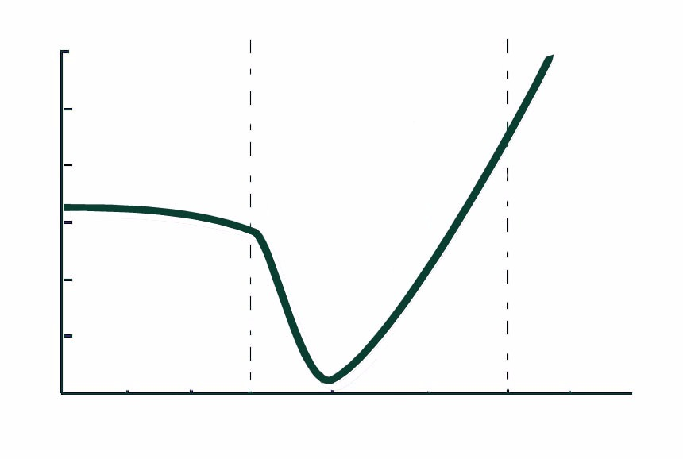

Availability of Capital

Basic Research

Development & Scale-up

Commercial Operation

Note: The introduction to Evans (2002) states “. . . the so-called ‘Valley of Death’ refers to the time period prior to the demonstration of technical and economic feasibility of a new technological concept, when the risks are very high due to uncertainty or complexity. It is believed that transcending the ‘valley’ in the shortest time is crucial for success in exploiting the new technology in the market place.” For recent measurement of the shape of the “valley” see WonKoo Park, KwangSook Lee, SeoYoung Doo, and Sung-SooYoon, “Investments for New Product Development: A Break-Even Time Analysis,” *Engineering Management Journal* 28, no. 3 (2016): 154-167.

Source: Case authors, adapted from D. L. Evans, *The Advanced Technology Program: Reform with a Purpose,* Office of the Secretary, U.S. Department of Commerce, February 2002.

**EXHIBIT 2: TECHNOLOGY INCUBATORS IN CHINA**

**A. Growth of Technology Incubators in China**

Note: The graph shows the number of technology incubators, the number of incubatees, and the number of incubatee employees as multiples of their numbers in 1995. In 1995, there were 73 incubators, 1,854 incubatees, and 26,000 employees of incubatees. In 2015, there were 2,536 incubators, 102,170 incubatees, and 1.662 million employees of incubatees. The figures include national-, provincial-, municipal-, and district-sponsored technology incubators.

Source: Table 3-1 “全国科技企业孵化其主要经济指标Main Economic Indicators of Technology Based Incubators,” The Torch Yearbook[《中国火炬统计年鉴》](http://www.yearbookchina.com/navibooklist-n2016010127-1.html) 全国科技企业孵化器主要经济指标, accessed from The Statistics Yearbook Platform 统计念经分享平台 accessed August 13, 2019 <http://www.yearbookchina.com/navipage-n2016010127000041.html>.

**B. Average Characteristics of Nationally Sponsored Technology Incubators in China**

|  |  |  |
| --- | --- | --- |
| **Item** | **Average Amount** | **Note** |
| Resident incubatees | 130 | number |
| Age of incubator | 12 | years |
| Management staff of incubator | 22 | number |
| Floor space of incubator | 53,741 | square meters |
| Proportion of incubatee workers with tertiary education | 78 | percent |
| Business service fees paid by incubatees to incubator | 0.822 | USD million per year |
| Trademarks and patents registered | 77.5 | number per year |
| Incubatees graduating | 12.4 | number per year |
| Venture capital funding | 17.3 | million USD per year |
| GDP per capita of host city | 9,894 | USD per year |
| Inward FDI of the host city | 4.0 | billion USD per year |

Note: The above data are averages of 120 technology incubators from a 2012 survey of the National Productivity Promotion Center of China.

Source: Jin Hong and Jinfeng Lu, “Assessing the Effectiveness of Business Incubators in Fostering SMEs: Evidence from China,” *International Journal of Entrepreneurship and Innovation Management* 20, no. 1–2 (2016) page 55, accessed June 20, 2017.

EXHIBIT 3: HKSTP ORGANIZATIONal CHart

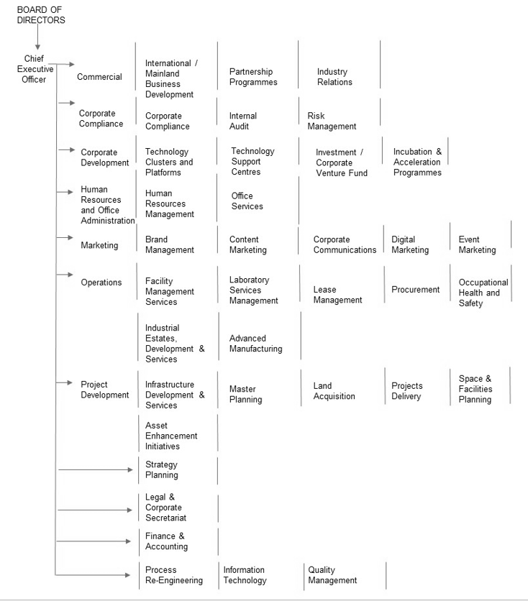

Source: HKSTP, *Hong Kong Science and Technology Parks Corporation: 2017–2018 Annual Report*, 22, 2018, accessed August 13, 2019, [www.hkstp.org/media/4405/e_hkstp-ar18.pdf](http://www.hkstp.org/media/4405/e_hkstp-ar18.pdf).

EXHIBIT 4: HKSTP INCUBATEES AND their accomplishments





Exhibit 4 (continued)



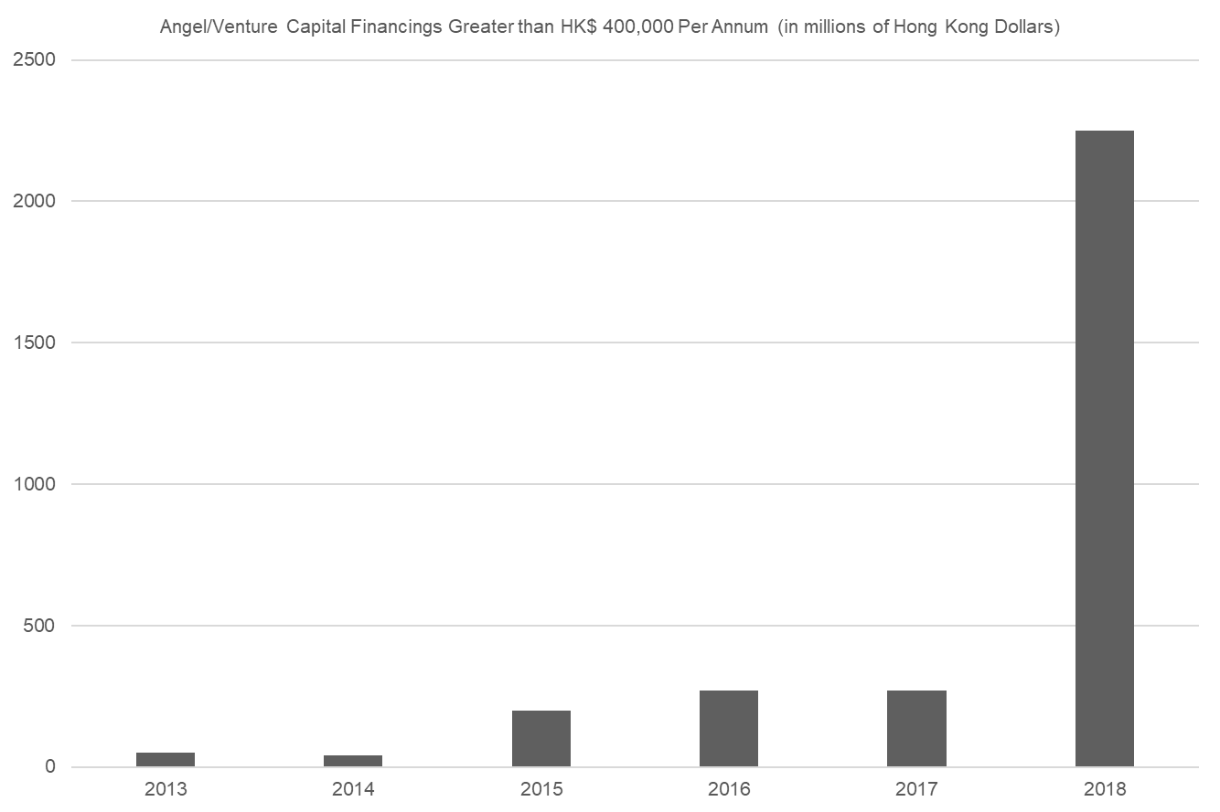

Source: HKSTP’s company files.

EXHIBIT 5: MAJOR INCUBATORS IN THE HONG KONG AND SHENZHEN REGION

|  |  |  |  |  |  |
| --- | --- | --- | --- | --- | --- |
|  | **HKSTP** | **Cyberport** | **CoCoon Hong Kong** | **Shenzhen E-Hub** | **Shenzhen Bay Inno Park** |
| Date Established | May 2001 | April 2002; Incubation program opens October 2005. | May 2012 | Dec. 2014 | June 2015 |
| Funding by | Public Funding | Hong Kong government | Private | Shenzhen government | Shenzhen government |
| Total Facilities Size | 22-hectare with R&D offices (330,000 m2) | 92,000-square-metre office complex with a 28,000-square-metre shopping mall and a 173-room hotel. | 836 square meters situated in a commercial office building. | 27,000 square meters in the planned area of about 40,000 square meters. | 500,000 square meters, 400 meters long street along with 18 buildings as the community. |
| Number of Incubatees | 267 as of March 2017 | 289 of which 51 were on-site and 238 off-site as of March 2017. | Approximately 70* based on 9-month residency over 5-year period. | Up to 200 | 45 professional incubators and start-up services companies and 200+ start-up companies as of Oct 2016. |
| Vision | Create a vibrant innovation and technology ecosystem to deliver social and economic benefits to Hong Kong and the region. | Establish Cyberport as a leading ICT hub in Asia-Pacific region. | Reignite the entrepreneurial spirit in Hong Kong and be a world class entrepreneurship hub at the cutting edge internationally in community building, entrepreneurship, education, and early stage investments. | Create an entrepreneur hub for innovative youth start-ups from around the world. | Implement the Shenzhen government’s innovation-driven development strategy and develop an international entrepreneurial venture capital centre. |
| Area(s) of Focus | Biomedical technology, green technology, electronics, materials & precision engineering and ICT. | FinTech, eCommerce, IoT/Wearables and Big Data/AI. | Community building, entrepreneurship, education, and early stage investments. | Modern logistics, financial services, information services, technology, cultural and creative industries, and related professional services. | Professional incubation, start-up/venture investment, and seed fund trading market. |

Exhibit 5 (continued)

|  |  |  |  |  |  |
| --- | --- | --- | --- | --- | --- |
| Pro-grammes & Services | Incu-App, Incu-Tech and Incu-Bio programmes: subsidised office space and shared facilities, matching potential investors, financial aid package, business matching, legal consultation, market promotion and development assistance, strategic partners building, business plan consultation, technical and management support and laboratory.  Leading Enterprises Acceleration Programme (LEAP) provides in-depth services to nurture high potential candidates into regional/global companies. | Subsidized office space, networking opportunities, business development and financing consulting, financial assistance up to HK$330,000 (US$42,300);  access to accelerator programmes. | Subsidized office space, lightning fast Wi-Fi, a 3D printer, and access to a community of partners and investors. | Subsidized office space, seed money, training, consulting, networking; access to angel investors and venture capital and tax incentives. | Entre-preneurship training, entre-preneurship show, public acceleration, creative apartment, business media, business exchange. |

Note:* Based on 450 incubatees cumulative since start-up in May 2012 with each resident staying approximately 9 months.

Source: See Advisory Committee on Innovation and Technology, *Report of the Advisory Committee on Innovation and Technology,*40–41, March 2017, accessed June 20, 2017, [www.itc.gov.hk/en/doc/ACIT_Report_Eng.pdf](http://www.itc.gov.hk/en/doc/ACIT_Report_Eng.pdf); “HKSTP’s Ongoing Efforts to Nurture I&T Talent and Start-ups Show Great Progress with Record Number of Incubation Graduates,” HKSTP: Corporate News, March 21, 2019, accessed June 20, 2017, [www.hkstp.org/en/about-us/press-room/hkstp-s-ongoing-efforts-to-nurture-it-talent-and-start-ups-show-great-progress-with-record-number-of-incubation-graduates/](https://www.hkstp.org/en/about-us/press-room/hkstp-s-ongoing-efforts-to-nurture-it-talent-and-start-ups-show-great-progress-with-record-number-of-incubation-graduates/); “Cyberport Incubation Programme,” Cyberport, accessed June 20, 2017, [www.cyberport.hk/en/about_cyberport/cyberport_entrepreneurs/cyberport_incubation_programme](http://www.cyberport.hk/en/about_cyberport/cyberport_entrepreneurs/cyberport_incubation_programme); “Hope Through Transformation,” Cocoon: Born to Fly, accessed June 20, 2017, [www.hkcocoon.com/](http://www.hkcocoon.com/); “Mr. Theodore MA Heng,” HKSTP, accessed June 20 2017, [www.hkstp.org/en/about-us/the-board/investment-committee/member/mr-theodore-ma-heng/](http://www.hkstp.org/en/about-us/the-board/investment-committee/member/mr-theodore-ma-heng/); “We Believe in Entrepreneurs,” Cocoon: Born to Fly, accessed June 20, 2017, [www.hkcocoon.org/mission.html](http://www.hkcocoon.org/mission.html); “About Us,” E-hub: Qianhai Shenzhen-Hong Kong Youth Innovation and Entrepreneur Hub, accessed 20 June 2017, <http://ehub.hkfyg.org.hk/aboutus.php>; “Shenzhen Bay Innovation and Technology Centre,” RMJM, accessed June 20, 2017, [www.rmjm.com/portfolio/shenzhen-bay-centre/](http://www.rmjm.com/portfolio/shenzhen-bay-centre/); [“Innovative operation to polish the "Shenzhen Bay" brand” (in Chinese](http://news.sznews.com/content/2016-10/09/content_13964589.htm%20(Chinese) 创新运营擦亮“深圳湾”品牌) *Shenzhen News* October 17, 2016， accessed August 13, 2019， <http://sztqb.sznews.com/html/2016-10/17/content_3637943.htm>; “Venture Plaza [in Chinese],” Shenzhen Bay Technology Development Co. Ltd., accessed June 20, 2017, www.szbay.com/gc_91.html#.

eXHIBIT 6: ACADEMIC STUDIES OF INCUBATORS

|  |  |  |  |  |  |  |  |  |  |  |
| --- | --- | --- | --- | --- | --- | --- | --- | --- | --- | --- |
| **Authors** | **Title** | **Publication venue** | **Publication / release date** | **Country** | **Dates of sample** | **Number of incubators** | **Types of incubator** | **Number of incubatees / companies** | **Study design** | **Conclusions** |
| Jin Hong and Jinfeng Lu* | Assessing the Effectiveness of Business Incubators  in Fostering SMEs: Evidence from China | International Journal of Entrepreneurship and Innovation Management | 2016 | China | 2008-2012 | 120 | State level technology incubators | 600 | Regression of incubatee performance as a function of incubator characteristics | Infrastructure support does not contribute to intellectual property generation or venture capital acquisition. Business assistance helps access to venture capital. Technical assistance increases growth. Larger and older incubators perform better than younger smaller incubators. |
| Alejandro S. Amezcua | Boon or Boondoggle? Business Incubation as Entrepreneurship Policy | Working Paper Whitman School of  Management, Syracuse University | 2010 | United States | 1990-2008 | 994 | All types | 35,000 | Incubatee and non-incubatee similar company matched-paired businesses performance evaluation | Incubation reduces the lifespan of new ventures. Incubation increases the rates of growth of employment and sales. |
| Centre for Strategy and Evaluation Services | Benchmarking of Business Incubators | European Commission Enterprise General | 2002 | European Union | prior to 2002 publication date | 78 | All types, but 75 % technology oriented | 71 | Questionnaires to incubators and incubatees followed by sub-sample interviews | Incubators make a significant contribution to job and wealth creation and substantially increase chances of incubatee survival. The cost per job creation is low and they are effective in promoting knowledge intensive, new technology-based activities. |

Source: Jin Hong and Jinfeng Lu, “Assessing the Effectiveness of Business Incubators in Fostering SMEs: Evidence from China,” *International Journal of Entrepreneurship and Innovation Management* 20, no. 1–2 (2016) pp 45-60, accessed June 20, 2017; Alejandro S. Amezcua, “Boon or Boondoggle? Business Incubation as Entrepreneurship Policy," Dissertation, Whitman School of Management, Syracuse University, August 2010, accessed April 30, 2019 <https://search.proquest.com/openview/48c3c0f7864b7e8000660d54527efcd7/1?pq-origsite=gscholar&cbl=18750&diss=y>; European Commission Enterprise Directorate-General, “Final Report: Benchmarking of Business Incubators,” Centre for Strategy and Evaluation Services, February 2002 accessed April 30, 2019, [http%3A%2F%2Fec.europa.eu%2FDocsRoom%2Fdocuments%2F2769%2Fattachments%2F1%2Ftranslations%2Fen%2Frenditions%2Fpdf&usg=AOvVaw1qVwpWnC2_yj6FXD8XTP2U](http://www.google.com/url?sa=t&rct=j&q=&esrc=s&source=web&cd=1&ved=2ahUKEwj3u7ngo_LhAhWS7WEKHWINAcIQFjAAegQIARAC&url=http%3A%2F%2Fec.europa.eu%2FDocsRoom%2Fdocuments%2F2769%2Fattachments%2F1%2Ftranslations%2Fen%2Frenditions%2Fpdf&usg=AOvVaw1qVwpWnC2_yj6FXD8XTP2U).

EXHIBIT 7: INNOVATIVE AND ENTREPRENEURIAL ENVIRONMENT OF HONG KONG AND COMPETITORS

1. **Global Innovation Index 2018 (Top 20)**



Note: The Global Innovation Index (GII) score is the simple average of the Input and Output Sub-Index scores. The Innovation Efficiency Ratio is the ratio of the Output Sub-Index score over the Input Sub-Index score. It shows how much innovation output a given country is getting for its inputs. The Innovation Input Sub-Index is comprised of five input pillars that capture elements of the national economy that enable innovative activities: (1) institutions, (2) human capital and research, (3) infrastructure, (4) market sophistication, and (5) business sophistication.

The Innovation Output Sub-Index provides information about outputs that are the results of innovative activities within the economy. There are two output pillars: (1) knowledge and technology outputs and (2) creative outputs. The Global Innovation Index does not separately calculate indices for mainland China cities.

Source: “The Global Innovation Index (GII) 2019: Creating Healthy Lives—The Future of Medical Innovation,” accessed September 3, 2018, [www.globalinnovationindex.org/](http://www.globalinnovationindex.org/).

1. **Global Entrepreneurship Monitor**

|  |  |  |  |  |  |  |
| --- | --- | --- | --- | --- | --- | --- |
|  | **Entrepreneurial Activity (Percentage of Adult Population)** | | | | | |
|  | **Nascent** | **New** | **Total Early Activity (TEA)** | **Established** | **Overall** | **GDP per Capita (in US$)** |
| **Hong Kong (China)** | 4.99 | 4.66 | 9.44 | 6.12 | 15.30 | 56,719 |
| **Shenzhen (China)** | 6.26 | 9.98 | 16.04 | 7.82 | 23.38 | 25,038 |
| **China** | 4.45 | 6.09 | 10.29 | 7.49 | 17.51 | 14,239 |
| **United States** | 8.88 | 4.00 | 12.63 | 9.22 | 20.99 | 55,837 |

Note: This table shows the percent of the population from 18 to 64 years of age engaged in entrepreneurial activities Nascent = those who have taken steps to start a new business, but have not yet paid for more than 3 months salaries or wages; New = those running new businesses that have been in operation for between 3 months and 42 months; TEA = New and Nascent; Established = those running a mature business in operation for more than 42 months; New + Nascent > TEA and TEA + Established > Overall because some entrepreneurs have multiple businesses.

Source: Marta Dowejko and Kevin Au, *Global Entrepreneurship Monitor: Hong Kong and Shenzhen Report 2016* (Hong Kong: SUP Publishing Logistics Limited, 2017).

**EXHIBIT 8: STEPS IN DEVELOPING A SERVICE MARKETING STRATEGY**

1.     **Define the Team:**

* What people/divisions in the organization will implement the strategy?
* What external strategic partners will help implementation?

2.    **Describe the target market:**

* List characteristics of customers (location, size, demographics, and psychographics).
* Specify task(s) that the organization helps the customers do.
* List the alternatives to the organization’s service and the process by which customers decide among those alternatives.

3.    **Specify current and potential contact points and communication channels with customers:**

* Describe contact and communications now used.
* List the owned, earned, and paid media available.

4.    **Set the SMART goals of marketing strategy. Each goal is:**

* *Specific* enough for the team to understand it exactly.
* *Measurable* and quantified so the team understands when the goal is reached.
* *Achievable* so the team and planners agree that, in theory, the goals can be met.
* *Realistic*, taking into consideration the macro-economy, resources, competitors, budget, and the ability and commitment of the team.
* *Timely* and subject to specific deadlines.

5.   **Set the message(s) to be at the heart of communications with the target customer:**

* Give each goal a single message (e.g., care, quality, price, convenience, and impact). Different goals can share the same message.
* Each message should differentiate the service of the organization from the competition in helping the customer accomplish the task.

6.     **Decide on the brand. This can involve maintaining or re-setting the brand:**

* The brand elicits the emotion that the organization wishes the target market to associate with its service.
* The brand should be consistent with the organization’s history, target customer perceptions, and the message(s) to be conveyed.

7.    **Set the marketing channels for delivering the message(s), promoting the brand, and maintaining contact with the target market during and following the communication:**

* The channels should effectively and efficiently reach the target market.

8.    **Summarize the strategy in a plan with a budget.**

Note: These steps should be followed iteratively. For example, a new goal may necessitate redefining the team, or an excessive budget may require redefining realistic goals.

Source: Case authors.

EXHIBIT 9: RECENT EXAMPLES OF HKSTP’S MARKETING INITIATIVES

1. **HKSTP Corporate Advertisement (2018)**

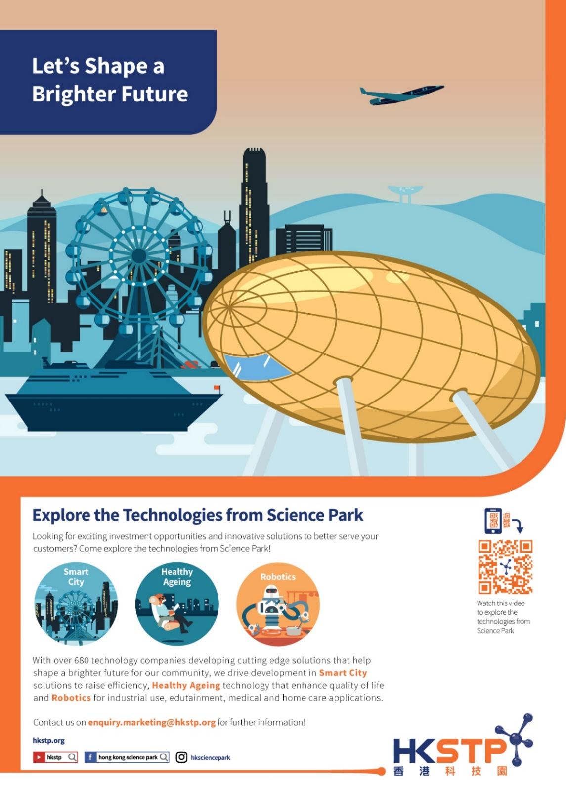

Source: HKSTP’s company files.

**exhibit 9 (continued)**

1. **HKSTP’s Community Engagement Campaign (2018)—Makeithongkong**

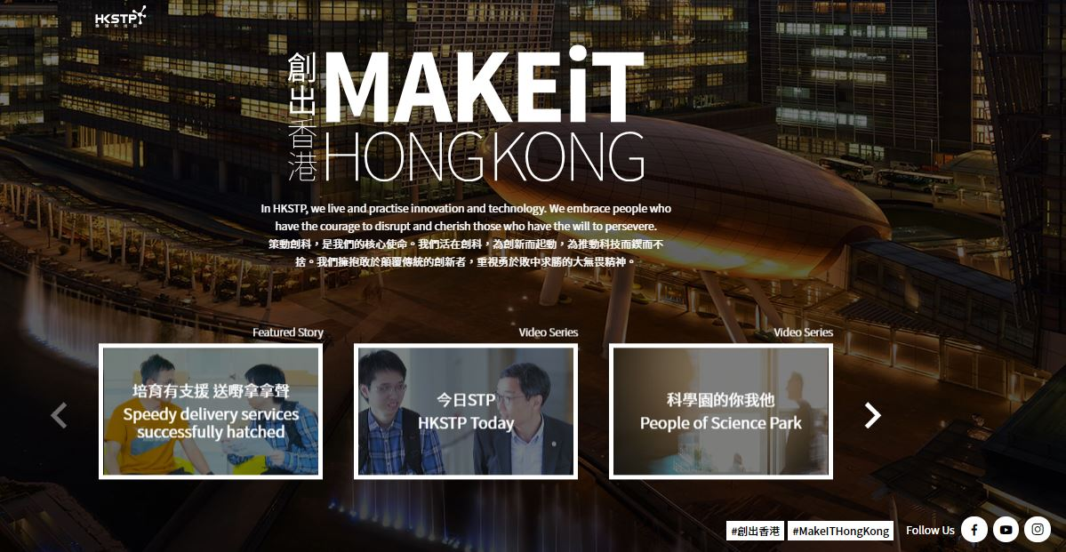

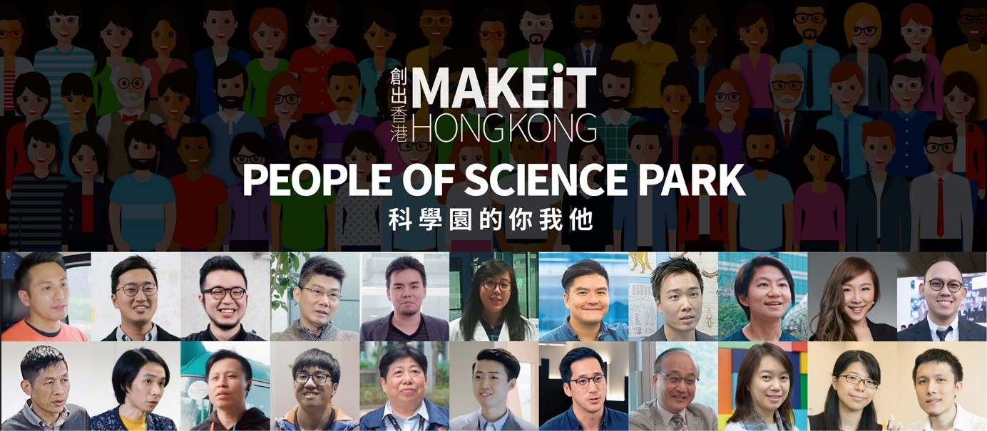

Source: HKSTP’s company files.

**exhibit 9 (continued)**

**C. HKSTP’s Education Programme (2018)—Robo Workshop@Science Park**

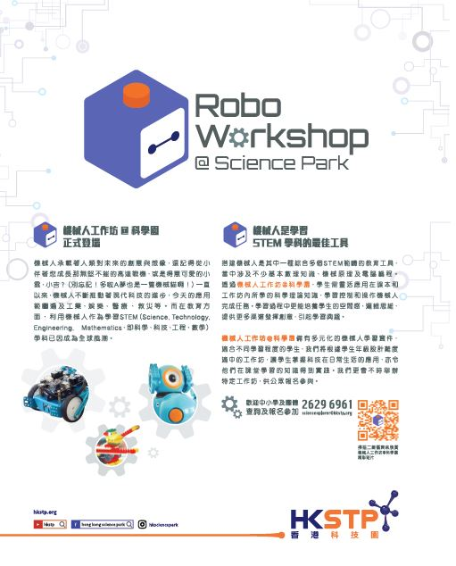

Brief translation of the Chinese content in the above poster:

Robo Workshop @SciencePark

Robots carry human’s creativity and imagination of the future. Remember the Gundam invincible fighters that grew up with you, or the cute Xiaoyun 小雲 （Arale Norimaki)，Xiaoji小吉 (Gatchan). (Don't forget! Doraemon is also a robotic cat!) Robots have been pushing the advancement of modern technology. Today's applications cover industrial, entertainment, medical, and disaster relief. In education, the use of robots for learning subjects of STEM (science, technology, engineering, mathematics) has become a global trend.

Robo Workshops are the best tool for learning about STEM subjects. Building a robot is an educational tool that integrates multiple STEM areas. It involves considerable basic knowledge, mechanical principles, and computer coursework. Through the Robo Workshop @Science Park, students can flexibly apply scientific theoretical knowledge learned in textbooks and workshops to control and operate robots to complete tasks. In the process of learning, students can develop a sense of space, logical thinking, and creativity, and also nurture their interest in STEM learning.

Robo Workshop @Science Park has a diverse range of learning kits on robotics which are suitable for students of various ages. Our workshops are designed with different levels of difficulty for both teachers and students of different age groups. Students can master the application of technology in daily life, and put their knowledge into practice. We also host specific workshops from time to time for the general public.

Source: HKSTP’s company files.

1. "2018–19 Budget Further Speeds up Hong Kong's I&T Development," Innovation and Technology Commission, March 2018, accessed August 21, 2018, [www.itc.gov.hk/enewsletter/180301/en/2018_19_budget_further_speeds_up_hk_it_development.html](http://www.itc.gov.hk/enewsletter/180301/en/2018_19_budget_further_speeds_up_hk_it_development.html).
2. Sean M. Hackett and David M. Dilts, “A Systematic Review of Business Incubation Research,” *Journal of Technology Transfer* 29, no. 1 (January 2004): 55–82, accessed August 13, 2019.
3. Ginger Lange in her PhD dissertation refers to 1,400 business incubators and accelerators in the United States of which approximately 1,200 are incubators. See Ginger S. Lange, “The Value of Business Incubators and Accelerators

   from the Entrepreneurs Perspective,” dissertation, Robinson College of Business, Georgia State University, May 6, 2018, https://scholarworks.gsu.edu/cgi/viewcontent.cgi?article=1099&context=bus_admin_diss.
4. Centre for Strategy & Evaluation Services, *Final Report: Benchmarking of Business Incubators*, European Commission Enterprise Directorate-General, February 2002, accessed June 28, 2019, http://ec.europa.eu/DocsRoom/documents/2769/at tachments/1/translations/en/renditions/pdf.
5. “Cap. 565 Hong Kong Science and Technology Parks Corporation Ordinance,” Hong Kong e-Legislation, April 19, 2019, accessed May 22, 2019 www.elegislation.gov.hk/hk/cap565.
6. “Work of the Hong Kong Science and Technology Parks Corporation,” Panel on Commerce and Industry Meeting, December 19, 2006, accessed August 25, 2018, [www.legco.gov.hk/yr06-07/english/panels/ci/papers/ci1219cb1-486-3-e.pdf](http://www.legco.gov.hk/yr06-07/english/panels/ci/papers/ci1219cb1-486-3-e.pdf).
7. “Our Commitment: Vision and Mission,” HKSTP, accessed August 7, 2018, [www.hkstp.org/en/about-us/our-commitment](http://www.hkstp.org/en/about-us/our-commitment).
8. Chua Bee-Leng, “Innovation Policy and High Growth Start-ups,” Center for Entrepreneurship, 7–12, 2006, accessed July 10, 2019, https://entrepreneurship.bschool.cuhk.edu.hk/sites/default/files/project/hong-kong-entrepreneurship-and-government-policy/innovationpolicyandhighgrowthstartups.pdf.
9. Haddon-Cave, Philip (1982), Public Policy and Economic Success, The Hong Kong Manager, 18 15-19, (1982), page 17.
10. “Incubation,” HKSTP, accessed August 3, 2018, [www.hkstp.org/en/how-we-serve/incubation-programmes](http://www.hkstp.org/en/how-we-serve/incubation-programmes).
11. “Press Coverage: Join Us Today,” Cocoon: Born to Fly, accessed June 26, 2017, [www.hkcocoon.com/press.html](http://www.hkcocoon.com/press.html).
12. For the admission criteria for the HKSTP Incubation Programmes, see “How We Serve,” HKSTP, accessed August 7, 2018, [www.hkstp.org/en/how-we-serve/](http://www.hkstp.org/en/how-we-serve/).
13. For U.S. estimates see “Table 7. Survival of Private Sector Establishments by Opening Year,” United States Department of Labor: Bureau of Labor Statistics, 2017, accessed July 23, 2017, [www.bls.gov/bdm/us_age_naics_00_table7.txt](http://www.bls.gov/bdm/us_age_naics_00_table7.txt); for Chinese data see David Audretsch, Xiaodan Guo, Adrian Hepfer, Hugo Menendez, and Xingzhi Xiao, “Ownership, Productivity and Firm Survival in China,” *Economia e Politica Industriale* 43, no. 1 (March 2016): 67-83.
14. Ben Moshinsky,“The 20 Most Powerful Financial Centres in the World,” *Business Insider*, September 12, 2017, accessed June 19, 2018, <http://uk.businessinsider.com/most-powerful-financial-centres-gfci-index-for-2017-2017-9/#20-shenzhen-the-chinese-city-climbed-two-places-to-reach-the-top-20-scoring-highly-in-the-infrastructure-category-1>.
15. Gary A Knight and S. Tamar Cavusgil, “Innovation, Organizational Capabilities, and the Born-Global Firm,” *Journal of International Business Studies* 35, no. 2(March 2004): 124–141.
16. “Delivery Made Easy,” Lalamove, accessed June 18, 2017 www.lalamove.com/hongkong/en/home.
17. A hackathon is an event in which teams compete to design specific software over a short period ranging from several hours to several days.
18. “Meet the New Lumos Helmet,” Lumos, accessed June 18, 2017 https://lumoshelmet.co/.
19. “Lumos—The Next Generation Bike Helmet,” accessed June 18, 2017, www.kickstarter.com/projects/819484536/lumos-a-next-generation-bicycle-helmet.
20. For HKSTP’s Co-working Space Programme, see “Co-Working Space Program,” HKSTP, accessed August 7, 2018, [www.hkstp.org/en/how-we-serve/market-and-industry-adoption/mainland-collaboration/co-working-space-program/](https://www.hkstp.org/en/how-we-serve/market-and-industry-adoption/mainland-collaboration/co-working-space-program/).
21. The Innovation and Technology Fund (ITF) was administered by the Innovation and Technology Commission of the Hong Kong government “to increase the added value, productivity and competitiveness of economic activities in Hong Kong.” See “About the Innovation and Technology Fund,” Innovation and Technology Commission: The Government of the Hong Kong Special Administrative Region, updated August 1, 2019, accessed August 11, 2017, www.itf.gov.hk/l-eng/about.asp.
22. National Development and Reform Commission People’s Government of Guangdong Province Government of the Hong Kong Special Administrative Region Government of the Macao Special Administrative Region.

    Framework Agreement on Deepening Guangdong-Hong Kong-Macao Cooperation in the Development of the Greater Bay Area, July 1, 2017 accessed May 22, 2019, www.bayarea.gov.hk/filemanager/en/share/pdf/Framework_Agreement.pdf
23. “Hong Kong and Shenzhen Sign Memorandum of Understanding on Jointly Developing the Lok Ma Chau Loop,” press release, The Government of the Hong Kong Special Administrative Region, January 3, 2017, accessed August 5, 2017, [www.info.gov.hk/gia/general/201701/03/P2017010300609.htm](http://www.info.gov.hk/gia/general/201701/03/P2017010300609.htm).
24. "2018–19 Budget Further Speeds up Hong Kong’s I&T Development,” Innovation and Technology Commission, March 2018, March 1, 2018, accessed August 21, 2018, [www.itc.gov.hk/enewsletter/180301/en/2018_19_budget_further_speeds_up_hk_it_development.html](http://www.itc.gov.hk/enewsletter/180301/en/2018_19_budget_further_speeds_up_hk_it_development.html).
25. “HKSTP Wins Technology/IT Incubator of the Year at International Business Innovation Association Awards,” CISION PR Newswire, March 30, 2016, accessed July 2017, [www.prnewswire.com/news-releases/hkstp-wins-technologyit-incubator-of-the-year-at-international-business-innovation-association-awards-300243315.html](http://www.prnewswire.com/news-releases/hkstp-wins-technologyit-incubator-of-the-year-at-international-business-innovation-association-awards-300243315.html).