

**9B19A039**

OPERA PHILADELPHIA: SEGMENTATION STRATEGIES FOR CHANGING MARKETS

Professors Dennis Paris, Jean Wilcox, Amy Lavin, Sheri Lambert wrote this case solely to provide material for class discussion. The authors do not intend to illustrate either effective or ineffective handling of a managerial situation. The authors may have disguised certain names and other identifying information to protect confidentiality.

*This publication may not be transmitted, photocopied, digitized, or otherwise reproduced in any form or by any means without the permission of the copyright holder. Reproduction of this material is not covered under authorization by any reproduction rights organization. To order copies or request permission to reproduce materials, contact Ivey Publishing, Ivey Business School, Western University, London, Ontario, Canada, N6G 0N1; (t) 519.661.3208; (e) cases@ivey.ca; www.iveycases.com. Our goal is to publish materials of the highest quality; submit any errata to publishcases@ivey.ca. i1v2e5y5pubs*

Copyright © 2019, Ivey Business School Foundation Version: 2020-09-28

In his new position as general director of Opera Philadelphia, David Devan decided that a serious assessment of market preferences and behaviours was necessary to overhaul the Opera’s go-to-market strategy. Between 2010 and 2014, the Opera had experienced a steep decline in household (HH) subscriber and single-ticket buyers coupled with severe revenue fluctuations. A further decline was on the horizon for the start of the 2015–2016 season with both HH cohorts.

Devan turned to his marketing team, led by Ryan Lewis, to manage this crucial research- and strategy- development initiative. Devan was convinced that an innovative strategy was required to first stabilize the subscriber base while attracting new single-ticket buyer markets. He also felt that a slight misstep in repositioning the Opera could easily result in further loss of its remaining subscribers—many of whom were also loyal donors.

By August 2014, Devan had to assure the research was finalized, decide on, and present to the board a new segmentation with a targeting and positioning strategy that would increase the following season’s revenues. With only a few months remaining, research results were still coming in. Time was not Lewis’s friend.

OPERA PHILADELPHIA

Founded in 1975, Opera Philadelphia had survived as a performing arts organization that offered traditional opera performances to traditionally minded audiences. The Opera listed itself as an American opera company and the only company in Philadelphia that produced grand opera. It also positioned itself as committed to embracing innovation and developing opera for the 21st century. The primary venue for Opera Philadelphia was the Academy of Music, which was considered one of the most treasured and legendary theatres in the world, over 150 years old, stunning, and opulent.

Opera Philadelphia’s successful productions depended on its upstream relationships with grant providers and set designers as well as numerous downstream partners, including venues such as the Academy of Music and the Perelman Theater, part of the Kimmel Center for the Performing Arts. The Opera not only ran regular season performances but also had developed a practice of creating new operatic works, many through partnerships such as that with Art Sanctuary of Philadelphia. Together, the Opera’s work with Philadelphia students helped inspire the creation of *We Shall Not Be Moved*, “combining a classical music style with hip-hop to create a compelling new operatic experience.”

Additional past partners included the Philadelphia Orchestra as well as the Barnes Foundation and the Philadelphia Museum of Art, who collaborated to incorporate Impressionist masterpieces into a production of *La bohème* and broadcast the performance for free onto high-definition screens.

In 2010, Opera Philadelphia’s mission was to “deliver outstanding productions of traditional repertoire often presenting these operas in innovative and technologically creative ways, and to underwrite and produce new and exciting operatic works that appealed to a socially and culturally diverse audience.” The Opera’s mission also included identifying rising young talent and developing educational programs that were geared toward introducing the rich heritage of opera to the multicultural Philadelphia region.

Despite Opera Philadelphia’s mission, total revenues fluctuated dramatically over the course of several seasons (see Exhibit 1). With these fluctuations in revenue, Devan and Lewis set out to understand changing market behaviours and value perceptions of Opera Philadelphia. The critical objective was to develop a fresh strategy specifically targeting evolving tastes for opera performance in Philadelphia and its surrounding geographical area.

Opera Philadelphia had to determine whether it needed to revise its segmentation and positioning strategy as well as make adjustments to its product (e.g., its seasonal model, opera compositions, talent, production aesthetic and set design, and other experiential elements for the audience). This new strategy also had to protect and prevent further loss of the Opera’s existing subscription audience.

GENERAL DIRECTOR and MARKETING MANAGEMENT TEAM

**General Director and President:** David B. Devan joined Opera Philadelphia in January 2006 and was appointed general director of the company in 2011. Since his arrival, Devan had guided the company through a transformative period of innovation that led *Opera News* to describe the Opera as “one of the leading instigators of new work in the country.”

Under his leadership and artistic vision, Opera Philadelphia had grown to become a company of international stature and a favourite co-producing partner with companies all over the globe, developing fresh productions of classic works as well as premieres written by today’s leading composers.

Devan had 29 years of experience with the Canadian Opera Company, Pacific Opera Victoria, and Opera Philadelphia.

**Vice-President of Marketing:** Ryan Lewis joined Opera Philadelphia in October 2012 with over 15 years of professional experience in the opera industry. He was responsible for planning and executing multi-channel advertising and sales campaigns as well as leading consumer research and guest experience initiatives. He previously served in marketing leadership positions at the John F. Kennedy Center for the Performing Arts and the Washington National Opera. Lewis had a degree in vocal performance from the University of Maryland-College Park.

**Marketing Manager:** Karina Kacala joined Opera Philadelphia in 2014 and was responsible for creating single-ticket promotions and sales efforts to increase revenue, attendance, and audience engagement. Kacala managed a variety of marketing functions as well as launching and overseeing VIVACE, Opera Philadelphia's community for young professionals. Prior to joining Opera Philadelphia, she directed marketing and communications on a full-time and consulting basis for a diverse array of Philadelphia organizations, including First Person Arts and Shakespeare in Clark Park.

INDUSTRY

Opera was defined by a prevailing notion as “a drama set to music and made up of vocal pieces with orchestral accompaniment and orchestral overtures.”[1] Opera had been considered an art form since the late 1500s and had evolved and changed as new composers joined the field. During the first half of the 20th century, opera was dominated by works from the previous 300 years. In the second half of the 20th century, the opera industry, through new composers, began to transition to more contemporary works. Changes included more innovative scores, dramas that connected more intimately with audiences, and a reduction in orchestra size.[2]

Opera companies and theatres were finding many challenges in marketing to audiences. According to an interview commentary with the Washington National Opera, some people considered the opera society to be elitist and closed as well as alienating due to its performances in foreign languages.[3] Potential attendees were also uncomfortable with an art form perceived as being for the wealthy.[4] The opera industry had also experienced significant reductions in U.S. attendance. There were 8.8 million opera attendees in 2008 versus 13.3 million in 2002. Additional research revealed that opera had the smallest participation rate for any performing art form attended live.[5]

Many factors contributed to the market’s waning preference for opera music and the continuing attrition in opera attendance: a desire for other types of performances, expensive tickets, audiences struggling with language, performance length, and the traditional perception of other audience members being too “upper crust.”[6] Also, from Opera Philadelphia’s perspective, while subscribers were vital and shrinking as a base, the traditional subscriber model had lost its appeal with new and younger audiences; for them, the routine of attending a performance on the same day of the week and sitting in the same seats was no longer as desirable.

The opera industry also found itself faced with change that was influenced by contemporary cultures that were sensitive to inclusion; for example, the Minnesota Opera did not close its casting until there was gender and colour diversity in the pool.[7] New technology such as the Internet and e-commerce along with shifting preferences also began to make waves in the industry of live events and performing arts.[8] These changing dynamics had an impact on the patterns and ways through which audiences consumed live content ranging from plays and concerts to sporting events. These changes could be described more broadly as geographical, technological, and preferential. All three areas were important when considering long-term strategic planning for live event venues in major metropolitan areas.

Another factor was the supplier power in the industry, where a demand for more innovative and contemporary performances in opera may have elevated the value and cost of composers, directors, and performers who had a reputation for understanding the evolving markets.

And finally, because many prominent opera companies were located in or near major U.S. metropolitan areas, the dynamic nature of the suburban job market had driven more people toward cities. Especially in the north-eastern United States, the country had experienced a recent wave of young people—mainly college graduates—moving into major cities in search of lucrative work or graduate education not found in their home town. This change had caused an increase in the number of persons with disposable income in these areas. Logic dictated that live event venues could capitalize on this influx by marketing more carefully toward these young adults.

COMPETITIVE ANALYSIS

Philadelphia, Pennsylvania, was a cultural hub and had a high concentration of performing arts substitutes in a relatively small radius, each serving various niches and segments. The city of Philadelphia alone had at least four performing and teaching institutions that positioned themselves as opera companies: Opera Philadelphia, Center City Opera, the Academy of Vocal Arts, and the Curtis Opera Theatre.

Opera Philadelphia’s unique geographical location was considered a benefit as well as a challenge given New York City, just roughly 97 miles to the north, was a performing arts mecca and home to several prominent opera companies such as the Metropolitan Opera, the Center for Contemporary Opera, the New York City Opera, and several others. New York City was also a major destination for shopping and dining. Baltimore, roughly 105 miles to the south, was home to the Baltimore Concert Opera.

Opera Philadelphia also had to consider the market effect of smaller opera companies regionally producing edgy and less expensive performances. And, while not exact substitutes, other local Philadelphia performing arts and concert venues (e.g., the Mann Center for Performing Arts, the Electric Factory, and Union Transfer) were also competing for the market’s free time. Kacala noted, “These venues may have appealed highly to a younger segment also targeted by the Opera through VIVACE, an age 21–45 professional community and program that offered access to a curated suite of exclusive events.”

OPERA PHILADELPHIA and ITS MARKET CHALLENGES

Between the 2010–2011 and 2015–2016 seasons, Opera Philadelphia lost a significant volume of its subscriber HHs and felt that the trend would only continue to worsen (see Exhibits 2A and 2B). Lewis said, “For each subscriber HH that we lost, the Opera would have to replace them with at least three new single-ticket buyer HHs. And the retention rate of single-ticket buyer HHs was only 9–10 per cent after the first year.”

What Devan set out to accomplish by hiring Lewis was to recognize marketing as a critical partner in market analysis and strategy development. Determining who Opera Philadelphia’s customers were, how they behaved, and what they truly valued were the most critical research objectives. The outcome of Lewis’s research would enable Devan and the remainder of Opera Philadelphia’s leadership to develop a fresh approach to strategy segmentation, targeting, and positioning along with a new seasonal performance model that offered a variety of educational and social events considered valuable by its target markets.

The market research and strategy agencies of Cicero Group and MoStrategy LLC were hired to assist with research planning, implementation, analysis, and determining strategic implications. The research had considerable depth and uncovered who Opera Philadelphia’s customers currently were, how they felt about the opera, and what influenced their behaviour. The research also identified new potential target markets and segments in which Opera Philadelphia should not invest.

In a patron or customer retention study conducted in 2013 by Opera Philadelphia, two groups were identified as single ticket buyers and subscribers. These groups were further segmented between active and lapsed (those that have not purchased or renewed in more than two years). Differences were found between gender and life stages, and clues were revealed about lapsed subscription holders (see Exhibits 3 and 4).

Using a MaxDiff analysis, Cicero Group tested 17 potential attributes that could apply to any entertainment form to determine preferences that were most important to Opera Philadelphia patrons when selecting their entertainment (see Exhibit 5). Behavioural differences that were researched between lapsed and active ticket buyers and subscribers revealed a potential segment opportunity that was interested in trying opera (see Exhibit 6).

While research also indicated that dissatisfaction was not a primary driver of attrition, data did reveal perceptions about why Opera Philadelphia had become better and worse. Reasons for patrons leaving Opera Philadelphia were revealing to Devan and his team (see Exhibits 7 and 8).

This round of research also tested a hypothetical concept of holding an opera festival that might attract new markets who were interested in trying out the opera experience. The objective would be to later convert festival goers to active multi-ticket buyers and subscribers (see Exhibit 9).

Given the importance of time, one option from this research was to quickly move forward with a marketing campaign that targeted active versus lapsed ticket buyers. Was it possible that creative messaging alone to lapsed ticket buyers reminding them of the upcoming performance season would do the trick?

IMPORTANCE OF SEGMENTATION TO OPERA PHILADELPHIA

The clock was running and clearly weighed heavily on Devan and Lewis’s decision to act; however, they were tempted to pursue an even more precise definition of who their existing and potential customers were, how they thought, how they felt about themselves, what they valued, and what they looked like. Essentially, they wanted to know what turned them on not only about opera, but about life itself.

The question was whether Devan allow the additional time to gather more details about ticket buyer and subscriber profiles. The added research could do little more than allow more time to pass while contribution and program revenue declined. With a second round of research, management could get to a level of understanding that would allow the Opera to more finely tune its seasonal approach to performances, programming, and marketing—and with much greater confidence, management thought.

Devan decided to dive deeper, and again, with the help of Cicero Group and MoStrategy, they could learn exactly who the Opera’s customer segments were and could be. One of Opera Philadelphia’s objectives was to position its brand so that it resonated with its target segments.

Roughly 2,000 research subjects were surveyed in 2014 over an area that spanned the northeast corridor from Washington, D.C., to Boston. By analyzing relationships between various segmentation variables among even richer data, it was discovered that eight uniquely defined segments existed (see Opera Philadelphia Survey Data: “Segmentation Strategies for Changing Markets,” Ivey product number 7B19A039).

More concise profiles were developed and each was personified. With this level of detail, Opera Philadelphia believed it could adjust its seasonal model to appeal to opera enthusiasts and attract more casual attenders. Considerations for the Opera included whether it could possibly add more affordable seating to attract those seeking a discount or adjust marketing communications and event tactics with appeal across all eight segments. There was also the question of whether a slightly different communication to each segment would be more effective.

TARGETING and POSITIONING—NOW EVEN MORE IMPORTANT TO OPERA PHILADeLPHIA

Questions needed to be answered with confidence. Who were Opera Philadelphia’s potential patron base and who had the Opera not yet reached? How could it best construct a seasonal model during the fall, winter, and spring? How would it most effectively market the various performances and events to each target segment, and what communication channels and messaging would be most effective? Which segments were most likely to become donors to Opera Philadelphia?

“Analysis paralysis” was a term frequently used with the pressures of time and business performance. When was it the right time to move on? What other strategic insights were necessary given what the Opera already knew? Devan and Lewis studied the data and recommendations made by Cicero Group and MoStrategy. Did they really need to go through the ranking of the eight segments? Was this “nice-to-know” information or would it greatly influence the final strategy and planning decisions?

Was there a way to determine which of the eight segments were viable targets for an opera festival if this were a decision? Would knowing how each segment felt about “opera engagement” versus the level of “festival interest” influence the Opera’s strategy decisions? Would mapping each segment against these two dimensions reveal who Opera Philadelphia should target?

Devan’s decision to spend time and money on analyzing which of the segments to target and how best to position Opera Philadelphia’s brand to each must also yield direction as to who the primary target was. He believed that there was enough evidence in the data to consider several strategy options such as repositioning the Opera’s brand and changing its performance and seasonal programming while maintaining the loyalty of its core patron base.

A final analysis of Opera Philadelphia’s targeting and positioning had to be completed. They needed to understand the following:

* To which segment did Opera Philadelphia’s brand speak the strongest? What was the profile and persona of this segment? Where should Opera Philadelphia have looked to reach this segment?
* How should the remaining target segments be profiled and personified? What type of programming, quality levels, events, and marketing pitches might have been considered for these segments?
* Which segments were most sensitive to price and the perception of elitism?
* Were there any segments that Opera Philadelphia should not make efforts to target?
* Finally, should Opera Philadelphia run a festival? When and what other seasonal and product or performance and event options should it have considered?

CONSIDERATIONS

Devan contemplated his options including recommendations by Lewis on the basis of Cicero Group and MoStrategy’s research outcomes.

Option #1: A modified strategy might be to get the job done at minimal cost. This option would cast a wide net across all segments, economizing on a simple adjustment to seasonal performance selections at the Academy of Music while executing a standardized approach to marketing and communications. Although the opera enthusiasts would likely appreciate more “A” title performances, the repertoire would be somewhat limited.

Option #2: Another strategy might be to adjust programming, venues, events, and pricing in a way that aligned with each target segment. In this scenario, while maintaining VIVACE, marketing would include treatments that considered each target uniquely and considered whether touring productions and musicals could be added to the season along with broadcast productions. While other venues ran musicals, many of these tactics would be expensive, and an exclusivity agreement with the Metropolitan Opera prevented other opera companies from broadcasting in movie theatres.

Option #3: A final strategy could be to add an opera festival as part of a new seasonal model; this option would be complex and could possibly risk distracting Opera Philadelphia’s management team from the work that went into planning and implementing a traditional season. Would including a festival either at the beginning of fall or in the following spring generate trial-and-lead attenders to consider regular season performances? Would this option attract a broader audience, including prospects from outside the Philadelphia market?

THE DECISION

Opera Philadelphia had endured a roller coaster ride of revenue fluctuations, and Devan needed to present a strategy to the board without further delay.

Now that segments were well-defined and targets identified by his marketing team, Devan had several options to consider. Should the Opera select a less complex strategy that enabled a quick implementation at minimal cost or was a more complex solution necessary?

Opera Philadelphia’s leadership realized that the answer was in the data that led to the latest round of segmentation, targeting, and positioning. The decision would lead to the creation and ratification of a new business plan along with provisional budgets for fiscal years 2016–19.

The authors would like to thank graduate research assistants Cara Blouin and Alexandra Safir for their assistance in preparing this case.

The authors would also like to acknowledge Opera Philadelphia’s steadfast support that enabled writing this business case, which is rich with research outcomes and data from which students can learn. Opera Philadelphia truly embraced the author’s objective to educate college students on the importance of segmentation and understanding changing markets.

Exhibit 1: OPERA PHILADELPHIA REVENUE ANALYSIS (in USD)

|  |  |  |  |  |  |
| --- | --- | --- | --- | --- | --- |
| **Annual Forms 990\*** | **2009–2010** | **2010–2011** | **2011–2012** | **2012–2013** | **2013–2014** |
| **Revenue** |  |  |  |  |  |
| **Contributions** | $4,184,712 | $9,766,866 | $9,645,480 | $7,596,066 | $7,424,834 |
| **Program Services** | $2,384,843 | $2,470,918 | $2,330,530 | $2,585,162 | $2,243,808 |
| **Total Revenue** | $6,569,555 | $12,237,784 | $11,976,010 | $10,181,228 | $9,668,642 |
| **Total Revenue Variance** |  | 86% | −2% | −15% | −5% |

Note: = Tax-exempt organizations and nonexempt charitable trusts organizations file Form 990 to provide required financial information to the IRS. “About Form 990, Return of Organization Exempt from Income Tax,” IRS, accessed August 14, 2019,

https://www.irs.gov/forms-pubs/about-form-990.

EXHIBITs 2A and 2B: SUBSCRIBER AND SINGLE-TICKET BUYER HOUSEHOLDS (HH)

1. Churn: HH Subscriber by Cohort

Exhibit 2: Continued

1. Churn: HH Single Ticket Buyer by Cohort

Note: Chart (A) shows the loyal subscriber base (long-time aggregate subscriptions pre-2010 represented by the solid line) that also makes up a significant portion of Opera Philadelphia’s contributed revenue base (from individual gifts). Each remaining style line reflects a starting point that represents the initial and subsequent years of HH subscribers. Similarly, in Chart (B), the line furthest left shows the long-time aggregate of single ticket buyers. Each remaining line reflects the initial and subsequent years of single ticket buyers.

Source: Company files.

EXHIBIT 3: Demographics Results—Gender, number in Household, Age

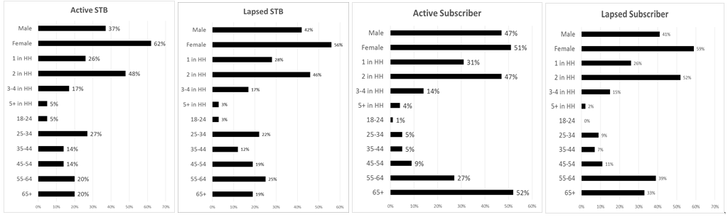

Source: Company files.

EXHIBIT 4: Demographics Results—Education, Income

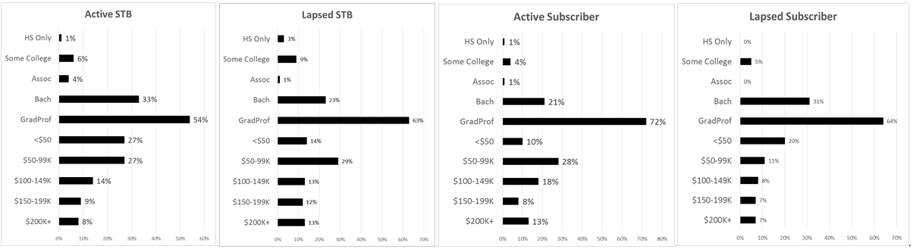

Source: Company files.

EXHIBIT 5: Most Preferred Attributes of Entertainment

(Share of Preference, n=854)

|  |  |  |  |  |  |  |
| --- | --- | --- | --- | --- | --- | --- |
| **ATTRIBUTES** | | **ALL** | **ASTB** | **LSTB** | **AS** | **LS** |
| **Artistry** | | **43%** | **39%** | **42%** | **48%** | **47%** |
| 1 | Features exceptional talent/production quality | 41% | 38% | 40% | 46% | 45% |
| 2 | Features well-known talent | 2% | 1% | 2% | 2% | 3% |
| **Status** | | **17%** | **15%** | **18%** | **20%** | **24%** |
| 3 | Provides a premium experience | 13% | 10% | 13% | 16% | 22% |
| 4 | Makes me feel cultured | 3% | 3% | 4% | 2% | 0% |
| 5 | Is something I'm proud to tell my friends/colleagues about | 2% | 2% | 1% | 1% | 1% |
| 6 | Provides an opportunity to "see and be seen" | 0% | 0% | 0% | 0% | 0% |
| **Price** | | **15%** | **19%** | **14%** | **10%** | **12%** |
| 7 | Overall good value for the money | 14% | 17% | 13% | 10% | 11% |
| 8 | Lowest price | 1% | 2% | 1% | 1% | 1% |
| **Conservative** | | **11%** | **11%** | **12%** | **11%** | **7%** |
| 9 | Preserves our cultural and/or artistic heritage | 10% | 10% | 11% | 10% | 7% |
| 10 | Is family-friendly | 1% | 1% | 1% | 1% | 0% |
| **Edgy** | | **7%** | **8%** | **7%** | **5%** | **4%** |
| 11 | Is "edgy" or pushes boundaries | 4% | 5% | 5% | 3% | 1% |
| 12 | Title or content I am familiar with | 2% | 3% | 1% | 2% | 3% |
| **Community** | | **7%** | **5%** | **5%** | **3%** | **3%** |
| 13 | Supports up-and-coming talent | 3% | 3% | 3% | 2% | 3% |
| 14 | Makes me feel like part of a community | 2% | 2% | 2% | 1% | 0% |
| **Physical Experience** | | **2%** | **1%** | **2%** | **2%** | **2%** |
| 15 | Is a physically comfortable experience | 1% | 1% | 1% | 1% | 2% |
| 16 | Offers luxurious amenities/creature comforts | 0% | 0% | 0% | 0% | 0% |
| **Service Experience** | | **1%** | **1%** | **1%** | **1%** | **1%** |
| 17 | Offers excellent hosting/customer service | 1% | 1% | 1% | 1% | 1% |

Note: ASTB = active single ticket buyers; LSTB = lapsed single ticket buyers; AS = active subscribers; LS = lapsed subscribers.

Source: Company files.

EXHIBIT 6: Opera Philadelphia Experience—Customer Value and Behaviour

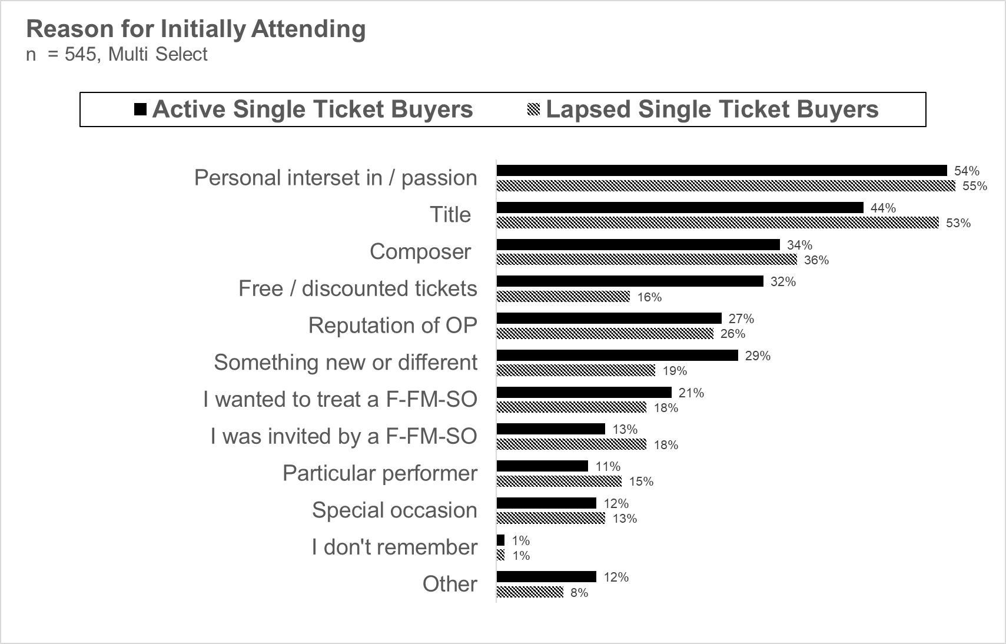



Note: F-FM-SO = friend, family member, or significant other; OP = Opera Philadelphia.

Source: Company files.

EXHIBIT 7: Perception of Opera Philadelphia

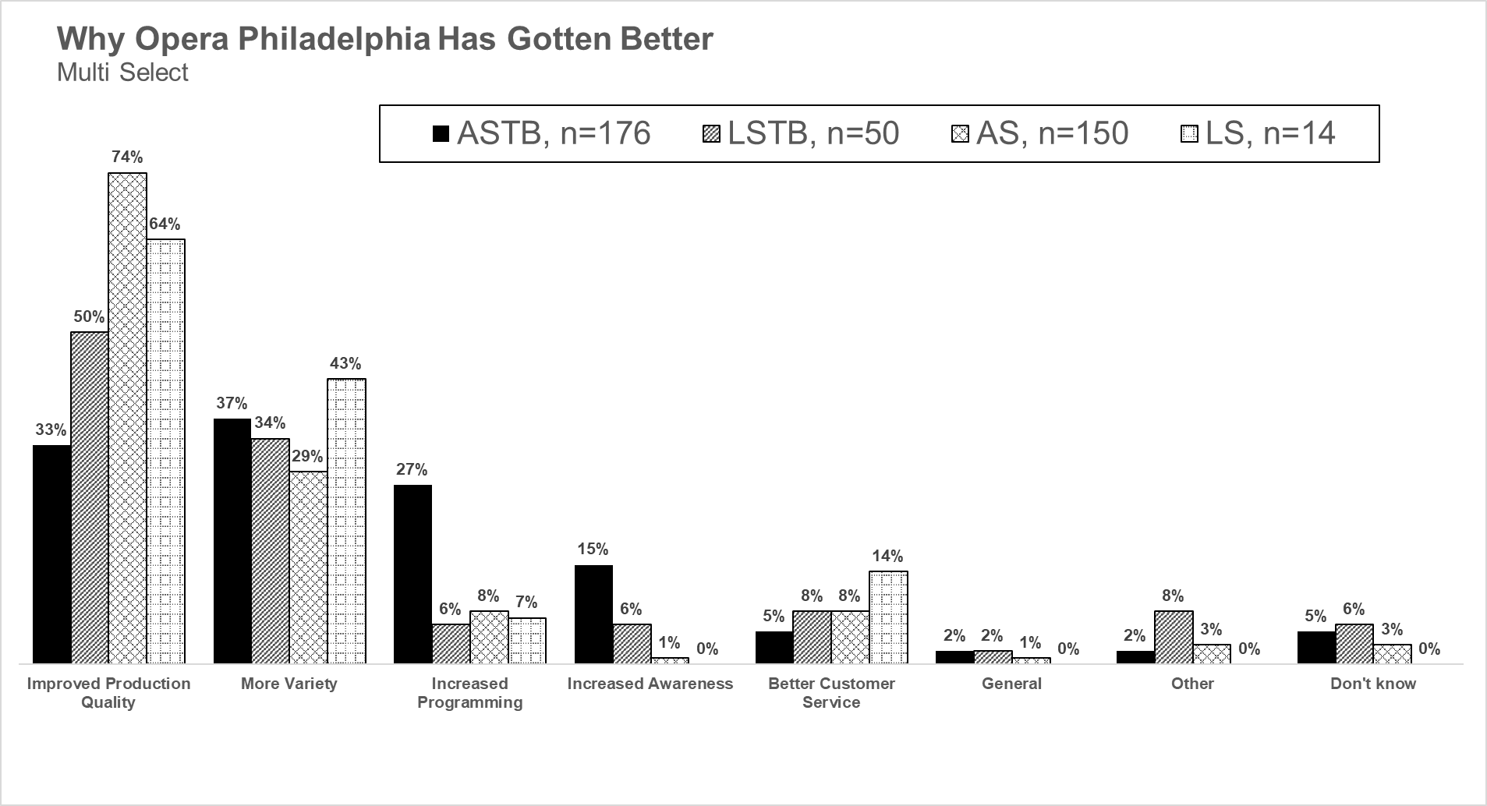

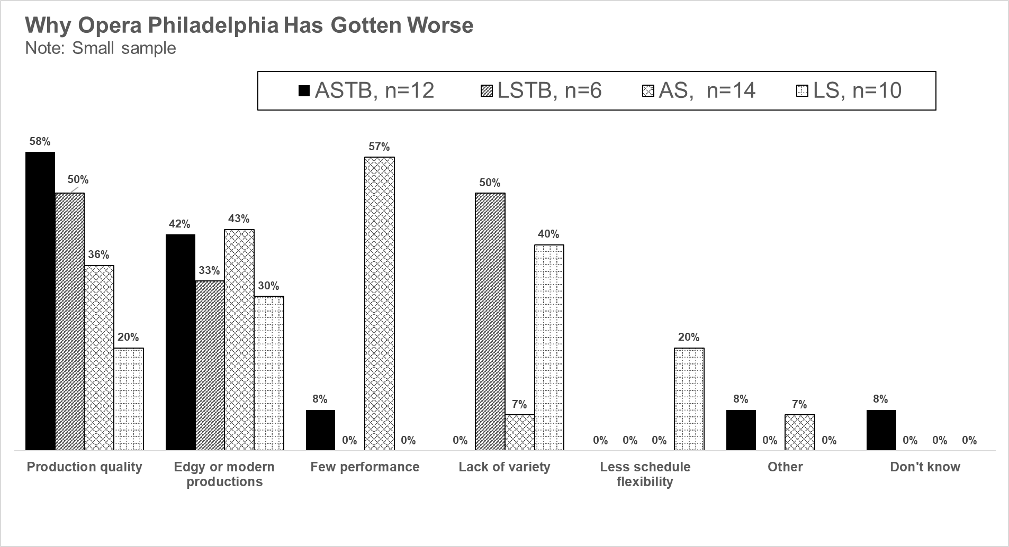

Note: ASTB = active single ticket buyers; LSTB = lapsed single ticket buyers; AS = active subscribers; LS = lapsed subscribers.

Source: Company files.

EXHIBIT 8: Leaving the Opera

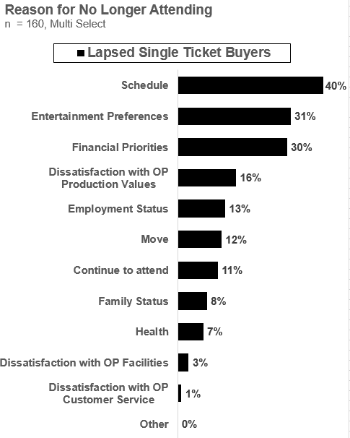 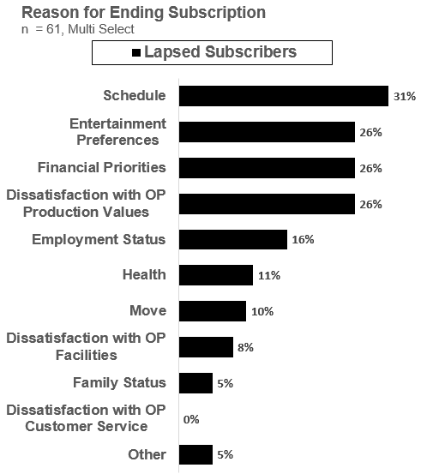

Note: OP = Opera Philadelphia.

Source: Company files.

EXHIBIT 9: Opera Festival Interest—Critical Decision Option

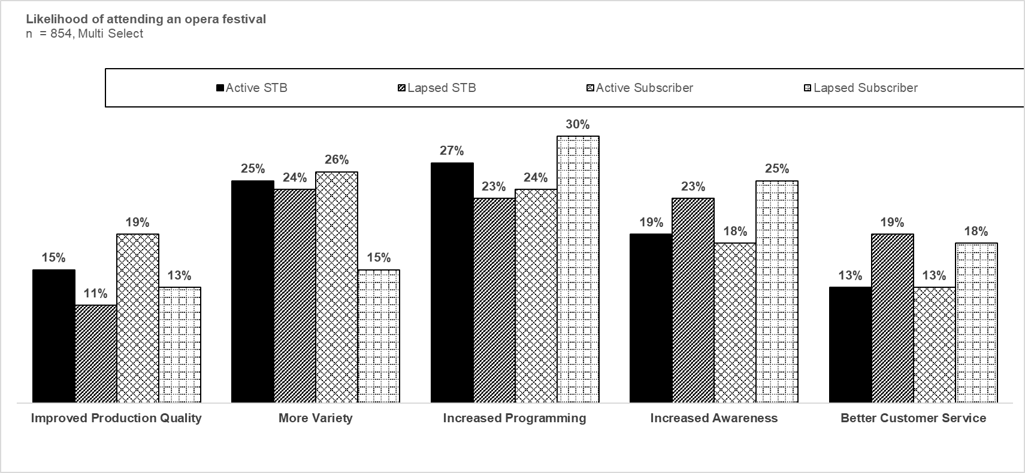

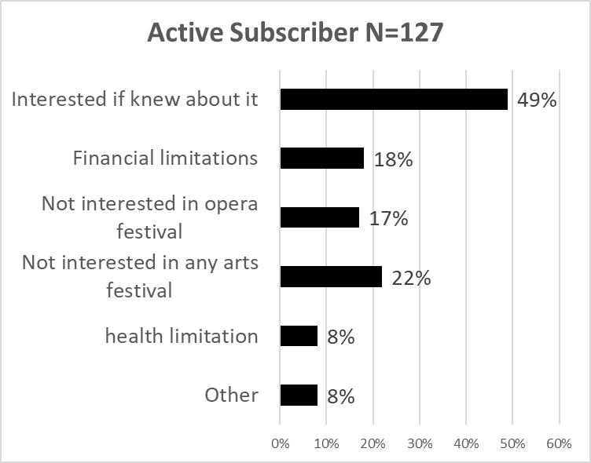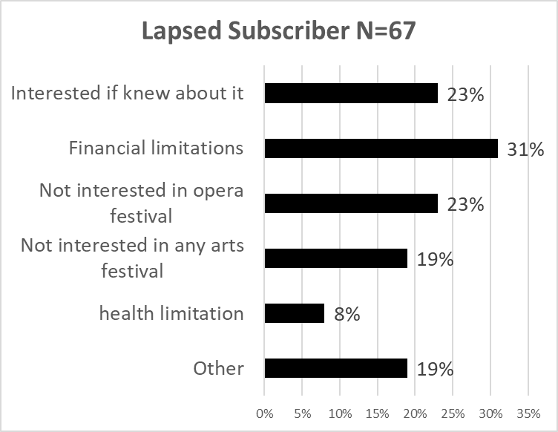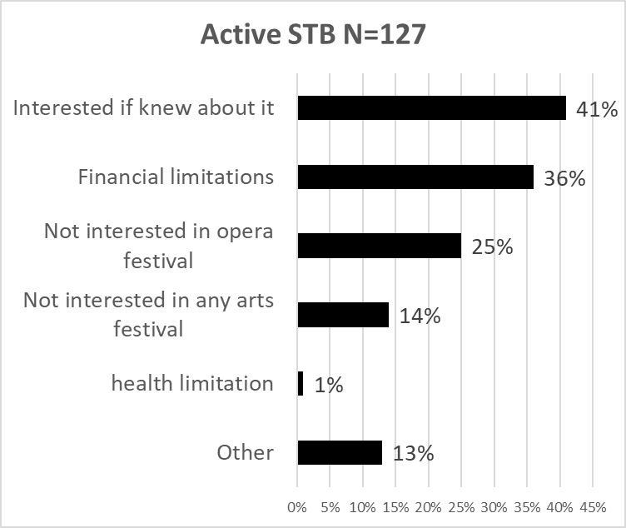 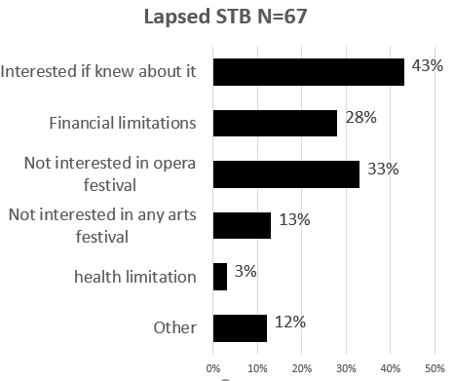

Note: STB = single ticket buyer.

Source: Company files.

1. Merriam-Webster Dictionary, s.v. “opera,” accessed October 2, 2018, www.merriam-webster.com/dictionary/opera.
2. “Opera’s History: From Baroque to the Present,” The Opera 101, accessed October 2, 2018, www.theopera101.com/operaabc/history.
3. Jessye Richmond, “Opera Marketing: Rebranding the Genre” (master’s dissertation: American University, Washington, D.C., 2018), accessed October 2, 2018, https://pqdtopen.proquest.com/doc/2039471758.html?FMT=ABS&pubnum=10786455.
4. Opera America, *Increasing Opera Attendance: The 2002 American Express National Audience Research Project* (Washington, D.C.: Opera America, 2002).
5. “A Decade of Arts Engagement: Findings from the Survey of Public Participation in the Arts, 2002–2012,” National Endowment for the Arts, Research Report #58, January 2015, accessed October 2, 2018, www.arts.gov/sites/default/files/2012-sppa-jan2015-rev.pdf.
6. Opera America, op. cit.
7. “Equity, Diversity, and Inclusion,” MN Opera, accessed October 10, 2018, https://mnopera.org/edi.
8. “The Performing Arts: Trends and Their Implications,” RAND Corporation, 2001, accessed October 9, 2018, www.rand.org/pubs/research_briefs/RB2504/index1.html.