

9B19B010

manitoba telecom services inc.: dividend sustainability[1]

Professor Darroch (Rick) Robertson wrote this case solely to provide material for class discussion. The author does not intend to illustrate either effective or ineffective handling of a managerial situation. The author may have disguised certain names and other identifying information to protect confidentiality.

This publication may not be transmitted, photocopied, digitized, or otherwise reproduced in any form or by any means without the permission of the copyright holder. Reproduction of this material is not covered under authorization by any reproduction rights organization. To order copies or request permission to reproduce materials, contact Ivey Publishing, Ivey Business School, Western University, London, Ontario, Canada, N6G 0N1; (t) 519.661.3208; (e) cases@ivey.ca; www.iveycases.com. Our goal is to publish materials of the highest quality; submit any errata to publishcases@ivey.ca. i1v2e5y5pubs

Copyright © 2019, Ivey Business School Foundation Version: 2019-10-30

Introduction

In mid-April 2015, Hugh Martin sat down to read a CIBC research report dealing with Manitoba Telecom Services Inc. (MTS). As a MTS shareholder and a dividend oriented investor, the opening paragraph of the report caught his attention.

“MTS shares remain under pressure from a relentless pension issue given the decline in rates. While other telcos have benefited from the demand for yield, MTS shares have come off meaningfully, as dividend safety has become an overriding concern. Given the pension shortfall has to be funded with cash, the company is faced with few real options.”[2]

Hugh quickly turned to his copy of MTS’s 2014 annual report and found in the Management Discussion and Analysis (MD&A) section on pensions that the company’s solvency deficit had grown from $206 million on January 1, 2014 to an estimated $395 million on January 1, 2015. Eager to determine the financial impact of this large obligation, he quickly turned to the 2014 annual financial statements. In particular, Hugh wondered how MTS’s unfunded pension obligations would affect the firm’s cash flow and its ability to continue to pay dividends.

Manitoba Telecom Services Inc. (MTS)

MTS, Canada’s fourth largest communications firm after Bell Canada, Rogers and TELUS, was incorporated in 1933 and was based in Winnipeg, Manitoba. MTS offered telecommunications services in the local, data, long distance, wireless and directory markets. At the end of December 2014, it employed approximately 5,000 people. MTS operated through two reportable segments, MTS and Allstream. MTS was the only full-service provider for residential and business customers in Manitoba. Services included wireless networks, high-speed internet, wireline voice and home security systems. Allstream competed nationally in the business and wholesale markets providing tailored telecommunication solutions for medium and large businesses and government organizations.

Previously known as AT&T Canada, Allstream was acquired by MTS in June 2004, for $1.7 billion in cash and shares. At the time of purchase of Allstream, MTS acquired approximately $2.7 billion of tax loss carryforwards. At December 31, 2014, MTS had $828 million of non-capital tax loss carryforwards remaining, which could be applied to reduce MTS’s future income taxes owing. These non-capital losses would begin to expire in 2025. The tax loss carryforwards and temporary tax differences were reflected as assets on MTS’s financial statements at $459.1 million as indicated in Exhibit 1. The MD&A section of the 2014 annual report indicated that these assets were expected to eliminate cash income taxes until 2020 at the earliest.

In 2014, MTS had diluted earnings per share of $1.70 and paid a $0.425 per share quarterly dividend. As a result of the company’s dividend reinvestment plan, 1,301,895 additional shares were issued resulting in a $37.5 million credit to share capital. MTS shares closed at $27.09 at the end of 2014. At the end of 2014, MTS had 78.1 million shares outstanding, total capitalization of $1,892 million and debt to capitalization of 44.4 per cent. MTS’s current debt ratings are outlined in Exhibit 2.

MTS’s strategy was outlined as follows:

* “The ongoing expansion of our broadband and wireless services coverage across the province
* Servicing and engaging our customers through our high-quality products and services along with our cost-effective bundling options
* Valuing, promoting and protecting our reputation, which guides how we work with our customers, shareholders and within our communities.”[3]

Allstream’s strategy was as follows:

* “Continue to leverage our national IP fibre network, facilitating high-margin IP growth
* Improve our profitability and margins by exiting low-margin legacy business and shifting to high-margin businesses, such as IP-based products that are delivered on our network
* Continue to improve the customer experience by the use of our service guarantees, increased training of sales staff and strong customer support and
* Improve operational efficiencies through simplification.”[4]

Exhibits 2, 3 and 4 show MTS’s 2014 financial statements. In its fourth quarter earnings conference call, Wayne Demkey, MTS’s chief financial officer (CFO), discussed the firm’s cash flow for 2014:

I want to point out how the accounting for the on-time SR&ED[5] IT tax investment tax credits impacted our earnings per share, CapEx and free cash flow results in 2014. The favourable audit adjustment of $23.6 million decreased our CapEx and increased our free cash flow by that amount. Otherwise our CapEx would have been $311.9 million and our free cash flow would have been $130.9 million.

The downward adjustments in CapEx had the impact of subsequently lowering our depreciation expense. The favourable impact on earnings per share was about $0.26 a share. In other words our EPS would have been lower at $1.44.[6]

the Canadian Telecommuncations Industry

The Canadian telecommunications industry had three national competitors, Bell Canada, TELUS Corporation and Rogers, and much smaller local competitors such as MTS and SaskTel. The Canadian Radio-television and Telecommunications Commission (CRTC), was an administrative tribunal responsible for regulating Canada’s broadcasting and telecommunications industries in the public interest. It reported to Parliament through the Minister of Canadian Heritage and Official Languages. In the 1990s, the CRTC, in an effort to increase competition in the industry, began deregulating long distance and data services. In 1992, incumbents were permitted to compete against each other in the long-distance resale market. By 1994, incumbent carriers were required to modify their networks to allow customers to make long-distance calls without having to dial extra digits, permitting equal ease of access by customers to different long-distance service providers. In 1997, incumbents were required to allow customers to switch service providers for local voice services without having to change their telephone numbers. Competition in the international long-distance service market was permitted in 1998. The increased competition in long-distance services resulted in falling revenues and market share for incumbents. In 2006, the government directed the CRTC to rely on market forces as much as possible where adequate competition exists.

Despite the desire to use market forces, the federal government had expressed concern about the lack of competitive forces in the industry and Prime Minister Harper had called for “at least four players in all markets across the country.”[7] As a result, the federal government had structure auctions of spectrum auctions to encourage a fourth entrant but had had limited success. Over 90 per cent of wireless subscribers were serviced by the three major providers of Bell, Rogers and Telus. The remaining subscribers were service by regional players such as MTS that service only 1.7 per cent of Canadian subscribers, almost exclusively in Manitoba (see Exhibit 6).

Although the long-distance market was looking less attractive to incumbents, the wireless segment was growing due to new product offerings, applications and marketing approaches. Over the period 2010 to 2014, revenue for the telecommunications industry had grown at an average compound rate of 2.5 per cent. The 5.1 per cent growth rate of wireless was offset by only a 0.3 per cent compound growth rate for wireline. In 2015 Consumers were continuing to increase the acquisition and use of smart phones. By 2014, 55 per cent of Canadians owned smartphones and growth was continuing. Looking into the future, there was concern that the industry growth rate may be reduced as the impact of declining oil prices impacted economic growth.

In short, the telecommunications industry was characterized by rapid changes in technology, the opening up of the market to new competitors and viable substitutes to traditional voice services. For industry players, constant updating of infrastructure and equipment was essential to remain competitive.

Pension Plans in Canada

In Canada, each province developed its own pension legislation. There was also federal pension legislation covering the territories and federally regulated businesses. Federal and provincial pension laws were harmonized through the Canadian Association of Pension Supervisory Authorities (CAPSA). In general, CAPSA could propose changes to existing pension legislation and regulations; however, any change was subject to provincial approval. In Canada, the provinces regulated pension plans and set regulatory standards such as minimum vesting periods, level of disclosure and minimum funding requirements. The federal government limited the maximum amount of funding into defined benefit pension plans through federal income tax rules on the type and level of benefits that such plans could provide. In addition, the income tax rules limited the amount of surplus that a pension plan could accumulate. Customary funding practices were established by the actuarial profession.[8]

Pension Valuation Tests

Pension plan solvency rules were developed in the 1980s, during a period of high interest rates, when some high-profile pension plans, which had inadequate assets to pay the promised benefits, were terminated, leaving behind unfunded pension obligations. There were two tests to ascertain whether pension plans had adequate assets to pay promised benefits: the solvency valuation and the going concern valuation. Valuations were required to be performed every three years; however, if there were solvency issues, annual valuations were generally required.

The solvency valuation was designed to reduce the risk of a loss of benefits if a pension plan was terminated or the plan sponsor failed financially. It had a short-term focus. In simple terms, the solvency test attempted to determine the financial status of the pension plan if the plan was wound up on the valuation date. With a solvency valuation, the pension plan’s assets were taken at market value, although in some cases, a smoothing method was allowed to take place over a five-year period if a smoothing method was also used over the same time period for the initial interest assumption in the valuation of the liabilities.

When determining the liability for the pension plan, the actuary was required to use the accrued benefit cost method and a current market interest rate to discount the pension liabilities, based on the assumption that the plan was wound up and annuities were purchased to cover its pension promise. Interest rates used to price annuities tended to be low as it was assumed that the principal was invested in high-quality, long-term bonds. As a result of this assumption, the pension obligation computed under the solvency test was subject to significant swings as interest rates changed. For a look at bond yields and interest rates from 2006 to 2014 (see Exhibit 7). Accrued liabilities[9] were valued using the accrued liability (current unit credit) method. Any shortfall (assets less than accrued liabilities) had to be eliminated within five years.[10]

Pension plan supervisors (who were members of CAPSA) required actuaries to make assumptions concerning the proportion of plan members who would elect a commuted value[11] (and transfer from the plan) and the remainder who would leave their deferred or immediate pension benefits in the plan and ultimately receive an annuity. In turn, the commuted value typically had to assume the most advantageous early retirement date provided by the plan.[12] For older or long-service employees, some supervisors required the commuted value to be determined assuming the active plan member would remain active and would retire at the most advantageous early retirement date. In some cases, employees could retire early if they qualified for either the 85 Factor (age + service = 85), or the 60/20 Rule (60 years of age + 20 years of pensionable service).

The going concern valuation referred to a valuation of the pension’s assets and liabilities using actuarial assumptions and methods that were in accordance with accepted actuarial practice for the valuation of a plan, assuming that the plan would continue to operate. The assumptions and methods were selected by the actuary and historically had been conservative with margins for adverse deviations built into the actuarial assumptions. Similar to the solvency test, assets were valued using current market value or market value could be smoothed over a period not exceeding five years.

The determination of pension liability was significantly different for a going concern valuation. Because this valuation took a long-term view, the discount rate for the pension obligation was generally set close to the expected return on the pension plan assets. As a result, it included a mix of both long-term bond and equity returns. Because the discount rate and the assumptions of turnover, future salary increases and similar variables tended to be stable over the short and medium term, the pension obligation tended to be more stable under the going concern valuation. In addition, because the discount rate was determined by the actuary rather than by the market, there could be pressure to increase the rate in order to reduce the size of the obligation. Most government supervisors allowed the funding of any deficiency or other unfunded liability (for example, retroactive plan improvements) over a period not exceeding 15 years.[13]

MTS’s Pension Plan

At the time MTS went public in 1997, a new pension plan was created. At that time the predecessor plan had a surplus of $43.3 million which was transferred to the new plan. Under a legal challenge initiated by workers and retirees it was determined that the surplus belonged to the current and former employees. In 2014, the Supreme Court of Canada upheld the decision of a lower court that the company did not have a right to the surplus. Assuming a rate of return equal to the actual return on the pension plan, the $43.3 million surplus would have grown to $140 million by July 1, 2014 and this amount was awarded to the pensioners. It was agreed that $30 million of this amount would be paid by the company in 2014 or early 2015 and $110 million would be funded by MTS’s pension plan over time in accordance with statutory funding rules.

MTS had both defined benefit pension plans and defined contribution pension plans,[14] which provided retirement benefits to employees. These plans were funded as determined through periodic actuarial valuations. In 2014 MTS used a discount rate of 4.1 per cent to calculate the defined benefit obligation down from 4.9 per cent used in 2013 (see Exhibit 8). Demkey, MTS’s CFO, responding to a question from a stock analyst about the amount of annual funding requirement for the company’s solvency deficit indicated that it would be about $60 million in 2015.

The way that it is calculated is based on a three year average solvency deficit. So in 2016 we would take the solvency deficit as of January 1st of that year add it to the two previous years and then divided that by 5 and that would be your funding requirement for 2016. So it will depend on what interest rates are at the end of this year then averaged over that period.[15]

Demkey went on to explain that the $60 million was in addition to the $25 million of normal funding for the pension plan. He also pointed out that it was a net number after considering letters of credit.

So the $60 million is a net number. So that’s the cash requirement that we expect and in terms of letters of credit our, I guess strategy in terms of funding has been and continues to be for the time being to utilize letters of credit to the maximum allowable, which is 15 per cent of our asset and the reason for that is really that at some point interest rates are expected to rise and so the letters of credit really become a cushion to help you to protect against trapping capital within the plan and so you can take those letters of credit down as interest rates grow overtime and your deficit reduces.

CONCLUSION

Hugh started to take a look at MTS’s financial statements. He wanted to examine the figures for himself, since MTS was a prominent dividend-paying stock in his holdings. He was concerned about the company’s ability to maintain its dividend payments in the future.

Exhibit 1: Composition of Deferred Income Tax Assets

2014 2013

Non-capital tax loss carryforwards $222.9 $294.6

Property, plant and equipment 130.1 115.1

Employee benefits 93.3 66.1

Other 12.8 (5.6)

Total $459.1 $470.2

Source: MTS Consolidated Financial Statements 2014.

Exhibit 2: MTS’s Debt Ratings, 2014

|  |  |  |
| --- | --- | --- |
| **Rating Agency** | **Rating** | **Trend** |
| Dominion Bond Rating Service (DBRS) | Senior debentures —- BBB  Commercial paper — R-2 (high) | Stable |
| Standard & Poor’s (S&P) | Senior debentures — BBB  Commercial paper — A-2 | Stable |

Source: MTS Annual Information Form 2014.

Exhibit 2: MTS Balance Sheets

December 31

**2014**

**2013**

(in millions)

**Assets**

Current assets

Cash and cash equivalents

33.4

87.8

Accounts receivable

158.3

147.1

Prepaid expenses

29.1

27.0

Inventories

20.3

17.5

241.1

279.4

Property, plant and equipment

1,526.7

1,486.6

Intangible assets

377.4

371.8

Other assets

82.8

73.4

Deferred tax assets

460.0

471.2

2,688.0

2,682.4

**Liabilities and shareholders' equity**

Current liabilities

Accounts payable and accrued liabilities

307.9

293.3

Advance billings and payments

58.3

57.3

Current provisions

19.6

41.4

Current portion of long-term debt

--

275.0

385.8

667.0

Long-term debt

873.1

648.1

Long-term provisions

4.0

2.9

Employee benefits

329.4

227.8

Other long-term liabilities

42.5

42.9

Deferred tax liabilities

0.9

1.0

1,635.7

1,589.7

Shareholders' equity

Share capital

1,646.2

1,608.7

Contributed surplus

21.1

21.4

Retained earnings

(615.0)

(537.4)

1,052.3

1,092.7

2,688.0

2,682.4

Source: Company files.

Exhibit 3: MTS Income Statements

Years ended December 31

2014

2013

(in millions, except earnings per share)

Operating revenues

1,612.0

1,633.7

Operating expenses

Operations

1,046.1

1,047.2

Transaction costs and restructuring

--

35.2

Depreciation and amortization

317.1

309.1

1,363.2

1,391.5

Operating income

248.8

242.2

Other expense

(2.5)

(0.8)

Impairment loss

--

(130.4)

Past service costs

--

(142.1)

Finance costs

(65.9)

(81.1)

Income before income taxes

180.4

(112.2)

Income tax expense (recovery)

48.7

(27.8)

Net income for the year

131.7

(84.4)

Basic and diluted earnings (loss) per share

1.70

(1.24)

Source: Company files.

Exhibit 4: MTS Statements of Cash Flows

Years ended December 31

**2014**

**2013**

(in millions)

**Cash flows from operating activities**

Net income

131.7

(84.4)

Add (deduct) items not affecting cash

Depreciation and amortization

317.1

309.1

Deferred income tax expense (recovery)

39.5

(27.3)

Loss on disposal of assets

6.0

3.1

Impairment loss

-

130.4

Past service costs

-

142.1

Deferred wireless costs

(71.1)

(72.2)

Pre-funded pension solvency payments

--

(125.0)

Pension funding and net pension expense

11.8

16.9

Pension plan lawsuit payment

(15.0)

--

Other, net

(1.2)

(0,7)

Changes in non-cash working capital

(21.9)

14.7

Cash flows from operating activities

396.9

306.7

**Cash flows from investing activities**

Capital expenditures

(288.3)

(296.0)

Acquisition of spectrum

(8.9)

--

Acquisition

-

(7.8)

Other, net

(7.9)

(2.3)

Cash flows used in from investing activities

(305.1)

(306.1)

**Cash flows from financing activities**

Dividends paid

(93.9)

(84.2)

Repayment of notes payable, net

-

(54.5)

Issuance of long-term debt

225.0

--

Repayment of long-term debt

(275.0)

--

Issuance of share capital

--

238.5

Other, net

(2.3)

--

Cash flows used in financing activities

(146.2)

99.8

Change in cash and cash equivalents

(54.4)

100.4

Cash and cash equivalents (bank indebtedness), beginning of year

87.8

(12.6)

Cash and cash equivalents, end of year

33.4

87.8

Source: Company files.

Exhibit 6: Number of Wireless subscribers December 2014

BCE 8,118,628

Rogers 9,450,000

Telus 8,100,000

MTS 481,127

SaskTel 618,083

Wind Mobile 800,000

Videotron 632,800

Public Mobile 212,000

Total 28,412,638

Source: Canadian Wireless Telecommunications Association, www.cwta.ca/wp-content/uploads/2011/08/SubscribersStats_en_2014_Q4-.pdf.

Exhibit 7: Bond returns and interest rates, January 2006 to December 2014

Source: Bank of Canada.

Exhibit 8: MTS’s Pension Plan

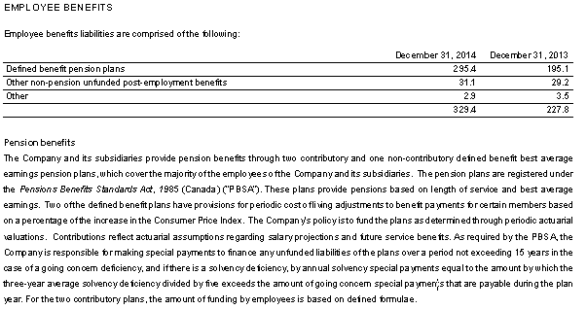

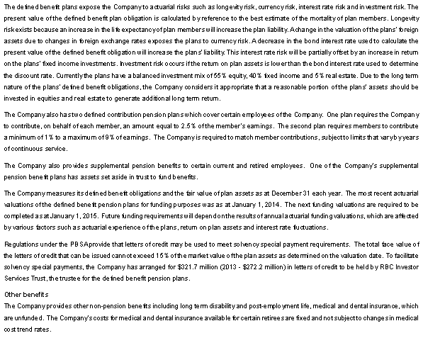

Exhibit 8 (continued)

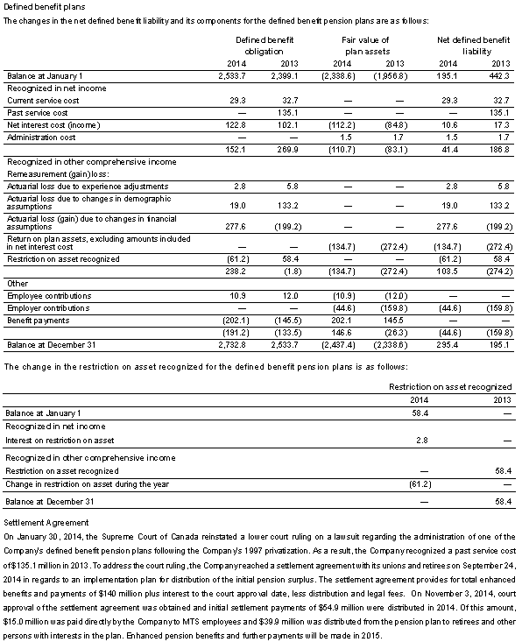

Exhibit 8 (continued)

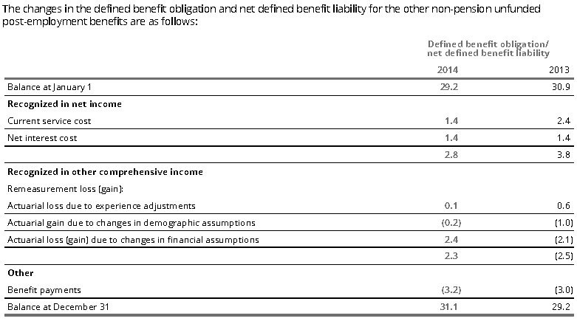

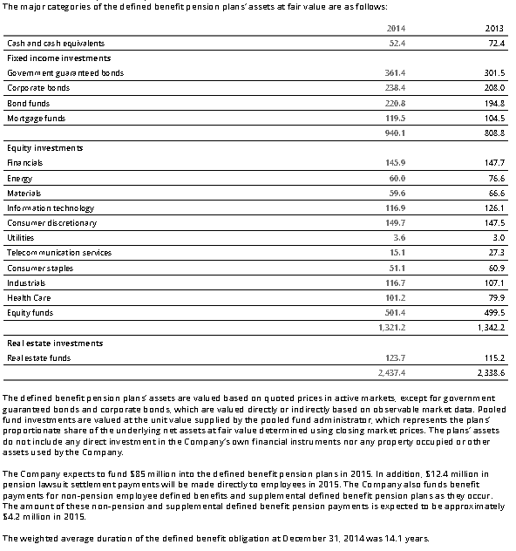

Exhibit 8 (continued)

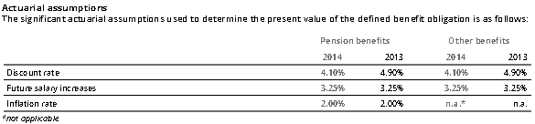

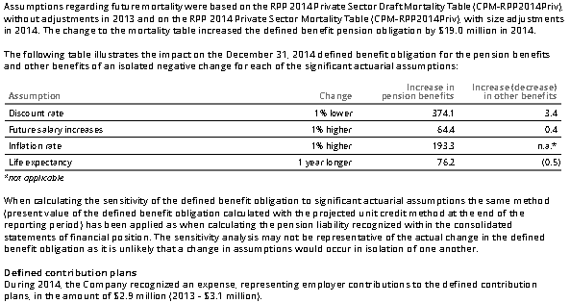

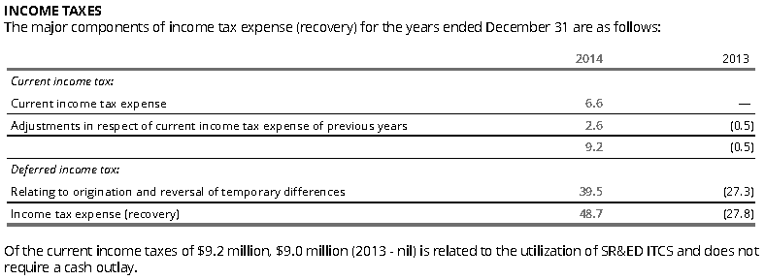

Exhibit 8 (continued)

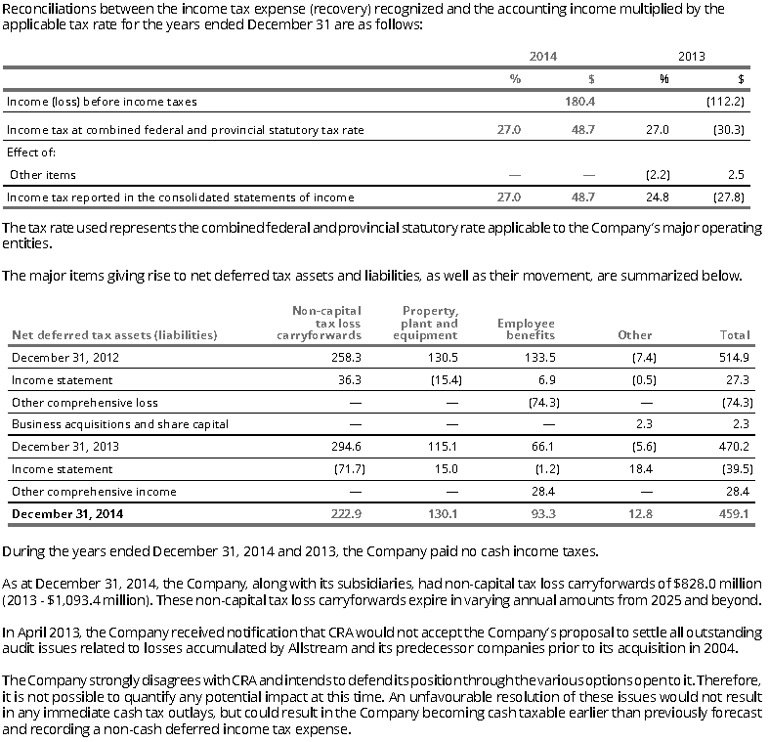

Source: MTS 2014 Audited Financial Statements.

1. This case has been written on the basis of published sources only. Consequently, the interpretation and perspectives presented in this case are not necessarily those of Manitoba Telecom Services Inc. or any of its employees.
2. Manitoba telecom Services Inc., CIBC Institutional Equity Research, April 14, 2015
3. Manitoba Telecom Services, Inc., MD&A for year ending December 31, 2014.
4. Manitoba Telecom Services, Inc., MD&A for year ending December 31, 2014.
5. The Scientific Research and Experiment Development (SR&ED) program is a Canadian Federal Government program that is designed to encourage companies to do research and development in Canada. The amount of the credit can be as large as 35% of the expenditure and generally comes in the form of a credit against taxes owing. In the case of a Canadian Controlled Private Company in a loss position, a cash rebate may arise.
6. Manitoba Telecom Services, Inc., Q4 2014 Earnings Conference Call, February 4, 2015.
7. Stephen Harper, February 20, 2014
8. Colin Pugh, “Report on Funding Rules and Actuarial Methods,” OECD, available at www.oecd.org/dataoecd/17/56/34023366.pdf, accessed March 15, 2006.
9. An accrued liability is a developing but not yet enforceable claim by another person, which is accumulating with the passage of time.
10. Colin Pugh, “Report on Funding Rules and Actuarial Methods,” OECD, available at www.oecd.org/dataoecd/17/56/34023366.pd, March 15, 2006.
11. The commuted value is the lump-sum amount that is required today to pay out a plan member’s accrued pension in the future. The commuted value is an actuarial calculation based on variable factors, including the plan member’s age, years of pensionable service and accrued pension, actuarial mortality rates and current interest rates. Ancillary benefits that the plan member is entitled to under pension plan provisions, such as survivor benefits and guaranteed indexing, are also considered in the calculation.
12. www.osfi-bsif.gc.ca/eng/pp-rr/ppa-rra/af-ac/pages/instr_2014-02-27.aspx#Toc-3.7.3 www.ipebla.org/.../W2%20Funding%

    20Issues%20For%20Private%20Pe.
13. Colin Pugh, “Report on Funding Rules and Actuarial Methods,” OECD, available at www.oecd.org/dataoecd/17/56/34023366.pdf, accessed March 15, 2006.
14. Manitoba Telecom Services, Inc., Q4 2005 Earnings Conference Call, January 31, 2006.
15. Manitoba Telecom Services, Inc. Q4 2014 Earnings Conference Call, February 4, 2015, accessed at seekingalpha.com.