

9B19B017

CRÈME COUTURE BRIDAL INC.: revenue segmentation

Edward Gray wrote this case under the supervision of Ian Dunn solely to provide material for class discussion. The authors do not intend to illustrate either effective or ineffective handling of a managerial situation. The authors may have disguised certain names and other identifying information to protect confidentiality.

This publication may not be transmitted, photocopied, digitized, or otherwise reproduced in any form or by any means without the permission of the copyright holder. Reproduction of this material is not covered under authorization by any reproduction rights organization. To order copies or request permission to reproduce materials, contact Ivey Publishing, Ivey Business School, Western University, London, Ontario, Canada, N6G 0N1; (t) 519.661.3208; (e) cases@ivey.ca; www.iveycases.com. Our goal is to publish materials of the highest quality; submit any errata to publishcases@ivey.ca. i1v2e5y5pubs

Copyright © 2020, Ivey Business School Foundation Version: 2020-01-10

On August 10, 2018, Michéle Sandra, president of Crème Couture Bridal Incorporated (Crème Couture) lay awake relishing the successes of her first profitable fiscal year (FY). Crème Couture, a private corporation located in Guelph, Ontario, was founded in 2013 and operated as a retail outlet for memorable lifestyle events. Crème Couture primarily sold wedding dresses but also retailed bridalwear,[1] formalwear, and various clothing accessories to women of all ages. External pressures from an increasingly saturated industry were forcing Sandra to contemplate the future of her business. She wanted to develop an expansion strategy that would best position Crème Couture for long-term success. Specifically, Sandra wanted to assess the profitability of each revenue segment to determine which segments should be further enhanced or eliminated. She had work to do to put a successful strategy in place.

Industry Analysis

The Wedding Services Industry

The average cost of a wedding had reached an all-time high of approximately US$32,000, with industry revenues growing at an annualized rate of 3 per cent over the prior five years.[2] Wedding industry success positively correlated with economic performance. In times of economic prosperity when consumer disposable income was highest, the average wedding spend would increase, whereas periods of high unemployment and economic suffering would restrict spending.[3] Data from the 2008 financial crisis revealed that couples would lower spending on their weddings by reducing secondary costs such as DJ music, photography, or venue fees.[4]

Since the 1900s, individuals had become increasingly less willing to commit to marriage at a younger age and prioritized work and cohabitation.[5] The median age of marriage had risen since 1960, from ages 20 to 27 for women, and 23 to 29 for men.[6] Additionally, the crude marriage rate (the number of marriages per 1,000 people every year) had decreased from 6.2 in 1991 to approximately 4.8 in 2018 and was expected to further decline by an annualized two per cent over the next five years.[7] Exhibit 1 provides a further overview of marriage statistics in Ontario.

The Bridalwear Industry

The bridalwear industry was one of the many sub-industries that comprised the wedding services market. Bridal salon operators retailed a variety of clothing lines and wedding-based accessories, catering to the needs of the entire wedding party: brides, bridesmaids, mothers-of-the-bride, grooms, groomsmen,[8] and flower girls.

The success of bridal salons could be attributed to a variety of factors: customer service, the depth and quality of merchandise, fashion selections, pricing, reputation, and location. Bridal appointments were typically scheduled several weeks in advance; few salons accepted walk-in appointments. Other apparel was sold on a walk-in basis similar to that of a normal clothing store. During the bridal appointment, a bridal consultant would assist the bride and her respective party[9] with the apparel selection process by providing fashion and sizing advice, carrying dresses to and from the podium, and creating an enjoyable atmosphere. Once purchased, it was often the case that wedding apparel would undergo alterations to better fit the consumer. Many bridalwear operators outsourced this process to third parties, while some offered the service in-house.

Due to the high capital requirements for in-house dress manufacturing, it was standard for bridalwear operators to source their dresses from designers all over the world. This required industry players to stay up-to-date with relevant fashion trends, and increased the average bridal gown price to CA$2,000.[10] The high price tag had led many brides to seek out cost-effective alternatives such as secondhand bridal gowns at consignment stores[11] or gowns that could be rented for the duration of the wedding. Some consumers purchased counterfeit brands from overseas manufacturers.

Finally, the bridal industry was unique as the majority of consumer purchases were one-time in nature. In comparison to other apparel industries, establishing customer loyalty was therefore difficult.

Guelph, Ontario

Guelph, located in Southwestern Ontario, had experienced strong economic growth since emerging from the 2008 recession. Guelph’s gross domestic product (GDP)[12] had out-paced all other metropolitan cities within Ontario, increasing at an annual average of 3.1 per cent compared with 2.4 per cent province-wide.[13] This growth was attributed to the success of Guelph’s manufacturing industry, which attracted a constant influx of new families and residents. Similarly, Guelph’s population had increased by 19.7 per cent since 2006, the largest growth rate in Ontario and third largest nation-wide.[14] Many attributed this increase to the rising real estate prices and high cost of living in the nearby city of Toronto, Ontario—many Toronto residents were moving to Guelph and commuting to work. Guelph’s population was expected to increase to more than 166,000 by the year 2021.[15] Exhibit 2 provides a summary of Guelph’s past and future economic indicators.

COmpetition

The bridal industry was highly fragmented, as technological introductions and shifting social norms had decreased barriers to entry. With the exception of David’s Bridal, which held a dominant 27 per cent market-share, there were no major industry players.[16] Niche independent retailers fought for the remaining revenues by differentiating themselves on four main pillars: product offering, price, quality, and customer service.

David’s Bridal

Founded in 1950, David’s Bridal operated as the world’s largest bridal gown retailer, managing an e-commerce platform and 300 brick-and-mortar stores throughout North America and the United Kingdom. David’s Bridal primarily sold bridal gowns but also retailed a variety of other products including bridesmaid dresses, prom dresses, jewellery, and accessories. David’s Bridal realized its successes by retaining control of its operational supply chain and manufacturing many of its dresses overseas. As a result, the company passed all labour and overhead cost savings to the consumer. The average David’s Bridal wedding gown retailed for approximately $650.[17] To mitigate developing a low-quality image, David’s Bridal also sold premium third-party bridal lines such as Vera Wang and Jenny Packham. These luxury gowns were often more expensive than the average wedding dress. The nearest David’s Bridal was located approximately 20 kilometres from Crème Couture.

Brick-and-Mortar Retailers

There were seven different brick-and-mortar bridalwear operators located within Guelph and over 30 different bridalwear operators within Southwestern Ontario alone. The highly fragmented nature of the industry forced each operator to differentiate or risk obsolescence. As a result, each company leveraged a variety of unique strategies, including but not limited to:

* Obtaining the exclusive rights to sell certain fashion lines.
* Competing on premium or discount price points.
* Catering to the needs of the entire wedding party.
* Diversifying product offerings to include other special occasion apparel, such as eveningwear.
* Custom-designing, altering, and manufacturing bridal apparel in-house.
* Retailing consignment dresses and second-hand bridal gowns.
* Using online sales platforms.

Bridalwear operators often pursued only a few of these strategies in order to carve out their own niche, develop a competitive advantage, and establish a unique brand image.

E-Commerce Retailers

The high overhead costs of operating a brick-and-mortar store had given rise to various e-commerce retailers. Overseas manufacturers sold their bridal gowns online directly to consumers at a fraction of the cost. This consequently had a negative impact on brick-and-mortar stores, which were forced to discount their products in order to compete.[18]

Customers

Customers of the bridal industry expected premium customer service. This meant that consumers prioritized certain factors when selecting a bridalwear operator, including the operator’s designer fashion selections, style, price, and diversity of product offerings. Customer preferences varied drastically from person to person; for example, those who preferred luxury apparel valued brand name and product style, whereas price-conscious consumers often did not. Brides would drive more than 100 kilometres in search of the perfect wedding dress.[19]

Due to the diverse composition of the consumer-base—women and men of a widespread range of ages, incomes, and fashion preferences— servicing the entire market was difficult for a bridalwear operator. Individuals aged 18 to 34 comprised 57 per cent of consumers, those who were aged 35 to 64 represented 40 per cent, and individuals 65 and older made up the remaining three per cent.[20]

Bridal stores primarily catered to the female members of the bridal party: the bride, the mother-of-the-bride, the bridesmaids, and flower-girls. Male consumers were considered a secondary market given that most men rented their apparel from men’s formalwear retailers, a more specialized alternative. Due to many longstanding North American cultural traditions, each member of the wedding party played a unique role in the purchasing process. The bride held the majority of the purchasing power, selecting not only her own dress but also those of the bridesmaids and flower-girls. The bride was responsible for the cost of her own dress, whereas the bridesmaids and families of the flower-girls traditionally paid for theirs. The mother-of-the-bride independently selected and purchased the outfit of her choosing, and finally, the groom and groomsmen rented tuxedos for the duration of the wedding. It was common for a wedding party to purchase almost all their apparel from one bridalwear operator if the bride had had a positive wedding dress purchasing experience.

Additional operational constraints also made consumer segmentation increasingly difficult. For instance, each bridal operator had a limited amount of inventory storage space and similarly could offer only a select range of designer styles and prices. As a result, most operators serviced a subsection of the total consumer market. Sandra wanted to reevaluate her target market to better identify the consumer segment that she should focus on.

Créme Couture Bridal Inc.

Crème Couture was located inside the Old Quebec Street Mall, in the heart of Guelph, Ontario (see Exhibit 3). Positioned as an upscale bridal operator, Crème Couture provided alteration services[21] as well as a diverse portfolio of wedding-related products including bridal gowns, bridesmaid dresses, social occasion apparel, prom dresses, and accessories (see Exhibit 4). Sandra was selective as to where she sourced her inventory, independently selecting and curating fashion designers from all over the world. To remain up-to-date with fashion trends, she attended annual fashion conventions throughout Europe and North America. Sandra made it a priority to meet with each designer in order to maintain a positive working relationship as well as to secure regional exclusivity rights for the apparel. The average Crème Couture wedding dress sold for approximately $1,500. Any inventory that could not be sold after several years was passed along to a consignment store.[22] Due to the logistical complexities associated with retailing online, Crème Couture sold inventory in-store only.

One of Crème Couture’s longstanding goals was to be renowned for its customer service. Sandra strongly believed that although the product was important to the consumer, the purchasing experience was what really drove sales. Many brides had noted that there was a societal standard to achieve “the perfect wedding,” creating unnecessary pressures during the wedding planning process.[23] With this in mind, Sandra invested a large amount of capital in establishing an elegant, comfortable, and relaxing atmosphere. Among other amenities, Crème Couture offered private one-on-one bridal consultations, conducted all apparel appointments on a first-name basis, provided sparkling water during appointments, and celebrated all purchases with complementary bridal gift bags. Crème Couture also made it a priority to give back to the community by participating in local charity fashion shows and frequently donating wedding dresses to those in need.

In addition to the community outreach, Crème Couture utilized a variety of advertising media. Radio, Facebook, and Instagram were used to promote in-store products, while popular wedding magazines featured many of Crème Couture’s current fashion lines. Sandra also coordinated an annual fashion show within the Old Quebec Street Mall to highlight new prom dress inventory. Expenditures for the FY 2018 prom fashion show totalled $6,045. Finally, Sandra advertised her wedding dresses at 14 bridal conventions throughout the year. Each bridal convention spanned over two days and allowed brides-to-be to browse the many different bridal retailers and fashion lines.[24]All other advertising expenditures would be allocated as a proportion of total applicable revenues.

Nevertheless, many operational issues plagued the business. Clothing racks were cluttered with an excessive amount of inventory and as a result, staff struggled to locate dresses. Additionally, the bridal boutique was not as efficient as Sandra had hoped, operating at a 15 per cent utilization rate and servicing approximately 500 brides per year.[25] Sandra knew that something had to be done in order to free up space, increase the bridal utilization rate, and ultimately achieve her long-term growth goals.

Financial Analysis

Sandra wanted to evaluate the performance of each revenue segment before creating her expansion strategy. She needed to determine which expenditures were direct and which were indirect to identify expenditures that should be allocated to the consignment sales segment. To do so, she gathered information pertaining to the company’s financial performance (see Exhibits 5 and 6). Sandra concluded that any expense that could not be easily traced to a specific revenue stream would be spread evenly among all applicable segments.

The travel expense included Sandra’s purchasing excursions, as well as the cost to transport equipment to and from the bridal conventions. Transportation to and from the bridal conventions cost a total of $6,478. Sandra also travelled to Atlanta, Georgia once a year to browse new prom fashion lines and designers, which cost a total of $1,500. The remaining purchasing excursion costs could not be allocated to a specific segment and thus were divided among all product segments, except prom dresses, in proportion to the cost of goods sold for each product segment.

In addition to Sandra, Crème Couture employed two bridal sales consultants and two general sales employees. Sandra oversaw and indirectly worked on all components of the business. The bridal sales consultants worked on an as-needed basis and focused exclusively on fitting and altering all bridal and bridesmaid dresses, whereas the general sales employees oversaw the remaining in-store apparel segments. In fiscal 2018, the bridal sales consultants earned a total of $40,534, $6,982, and $9,406 for the bridal gowns, bridesmaid dresses, and alterations segments, respectively. Similarly, the general sales employees were paid a total of $19,394 for the social occasion dress segment, $8,436 for the prom dress segment, and $9,891 for the accessories segment. All salaries and wages were allocated as a proportion of total applicable revenues.

The insurance policy pertained to all inventory and equipment that Crème Couture owned. Sandra estimated that 50 per cent of the total insurance policy would be allocated to the bridal gown segment, whereas the remainder would be split evenly among the remaining product segments. Rent and utilities were allocated based upon square footage. The bridal boutique occupied 950 of the total 1,900 square feet, whereas bridesmaid, prom, and social occasion apparel each occupied 200 square feet. The rest of the rent expenditure was split evenly between the remaining in-store revenue segments.

Sandra did not believe that office supplies, telephone, and Internet expenditures should be allocated to consignment sales and therefore spread them evenly among all in-store revenue segments. Finally, Sandra had taken out a bank loan to purchase Crème Couture in 2013, and the interest and bank expenses could be spread evenly among all segments.

Future Expansion

As she examined the company’s current state, Sandra began to establish a detailed expansion strategy that would best position Crème Couture for future growth. Specifically, she wanted to understand which revenue segments were most and least profitable, and as a result, which warranted further investment. She wanted her expansion strategy to align with her goals of freeing up inventory space, attracting more clientele, providing exceptional customer service, and increasing net profit.

EXHIBIT 1: ONTARIO MARITAL STATUS SUMMARY

|  |  |  |  |  |  |
| --- | --- | --- | --- | --- | --- |
| Marital status (persons) | 2013 | 2014 | 2015 | 2016 | 2017 |
| Legal marital status, single | 5,969,176 | 5,981,970 | 5,989,081 | 6,049,921 | 6,132,543 |
| Legal marital status, married | 5,588,112 | 5,663,956 | 5,732,541 | 5,821,423 | 5,917,071 |
| Legal marital status, divorced | 1,318,670 | 1,333,604 | 1,346,592 | 1,362,629 | 1,379,456 |
| Legal marital status, widowed | 679,796 | 700,895 | 721,383 | 742,347 | 764,314 |
| Total legal marital status | **13,555,754** | **13,680,425** | **13,789,597** | **13,976,320** | **14,193,384** |

Source: Created by the case authors using data from Statistics Canada.

**EXHIBIT 2: GUELPH ECONOMIC INDICATORS**

|  |  |  |  |  |  |  |  |  |
| --- | --- | --- | --- | --- | --- | --- | --- | --- |
|  | 2015 | 2016 | 2017 | 2018 | 2019 | 2020 | 2021 | 2022 |
| Real GDP (000s) | 8,070 | 8,340 | 8,639 | 8,829 | 9,011 | 9,198 | 9,329 | 9,595 |
| Total employment (000s) | 90 | 91 | 91 | 92 | 93 | 94 | 95 | 97 |
| Unemployment rate (%) | 4.0% | 4.8% | 5.4% | 5.1% | 5.0% | 5.0% | 4.9% | 4.9% |
| Household income per capita ($) | 47,445 | 46,692 | 48,682 | 50,082 | 50,939 | 52,442 | 53,917 | 55,478 |
| Population (000s) | 154 | 156 | 158 | 160 | 162 | 164 | 166 | 168 |

Source: Created by the case authors using data from Conference Board of Canada, “Metropolitan Outlook 2: Guelph,” March 20, 2019. Data used with permission.

EXHIBIT 3: CRÈME COUTURE BRIDAL

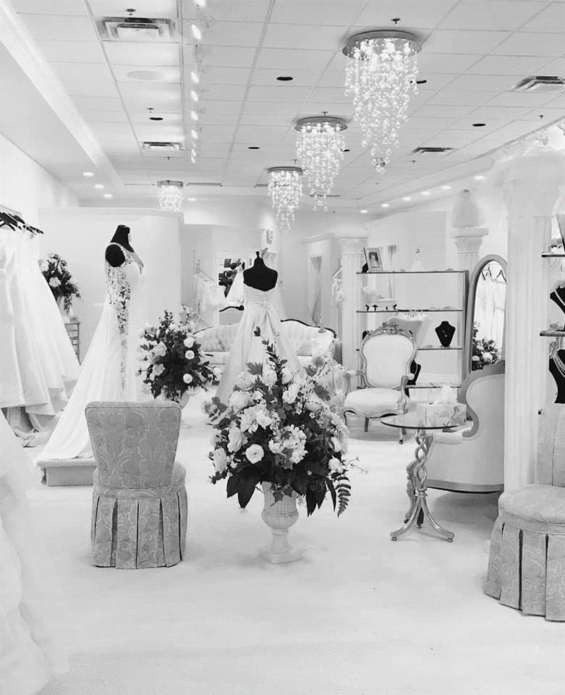

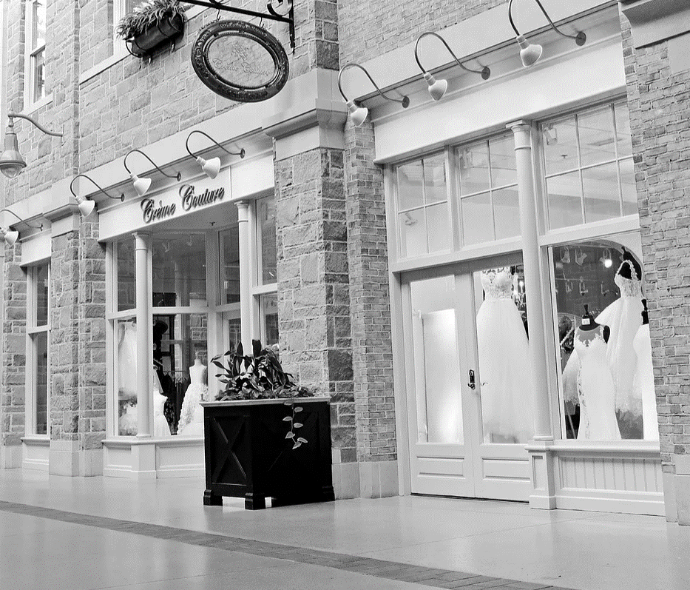

Source: Company files.

EXHIBIT 4: PRODUCT AND SERVICE REVENUE SEGMENTATION

Notes: Accessories included outfit-related items as veils, jewellery, purses, headpieces, belts, and shoes.

Source: Company files.

**EXHIBIT 5: STATEMENT OF EARNINGS FOR THE YEARS ENDING JULY 31 (CA$)**

|  |  |  |  |  |  |  |
| --- | --- | --- | --- | --- | --- | --- |
|  |  | **2018** | |  | **2017** | |
| **Revenues** |  |  | 765,781 |  |  | 651,500 |
|  |  |  |  |  |  |  |
| Cost of goods sold |  |  | 410,539 |  |  | 387,295 |
|  |  |  |  |  |  |  |
| Gross profit |  |  | 355,242 |  |  | 264,205 |
|  |  |  |  |  |  |  |
| **Operating expenses** |  |  |  |  |  |  |
| Advertising |  | 28,135 |  |  | 20,379 |  |
| Depreciation |  | 8,256 |  |  | 9,283 |  |
| Insurance |  | 2,390 |  |  | 1,307 |  |
| Interest and bank charges |  | 22,848 |  |  | 19,803 |  |
| Office supplies |  | 10,824 |  |  | 14,605 |  |
| Accounting fees |  | 9,324 |  |  | 10,154 |  |
| Rent |  | 58,531 |  |  | 61,642 |  |
| Repairs and maintenance |  | 5,772 |  |  | 4,235 |  |
| Telephone and Internet |  | 7,284 |  |  | 6,848 |  |
| Travel |  | 15,938 |  |  | 16,676 |  |
| Wages and benefits |  | 159,643 |  |  | 144,194 |  |
| Total operating expenses |  |  | 328,945 |  |  | 309,126 |
|  |  |  |  |  |  |  |
| Net income before tax |  |  | 26,297 |  |  | (44,921) |
| Income tax |  |  | – |  |  | – |
| **Net income (loss)** |  |  | 26,297 |  |  | (44,921) |
|  |  |  |  |  |  |  |

Notes: All financial data has been modified to maintain business confidentiality. Income tax: No income tax was incurred due to loss carryforwards from prior years.

Source: Company files.

**EXHIBIT 6: FISCAL YEAR 2018—COST OF GOODS SOLD AS A PERCENTAGE OF SEGMENT REVENUES**

|  |  |
| --- | --- |
| **Segment** | **Cost of Goods** |
| Bridal gowns | 43.4% |
| Bridesmaid dresses | 55.9% |
| Social occasion dresses | 56.9% |
| Prom dresses | 55.2% |
| Accessories | 48.1% |
| Alterations | 59.8% |
| Consignment sales | 189.8% |

Notes: Social occasion apparel included mother-of-the-bride dresses and formal eveningwear.

Source: Company files.

1. Bridalwear included wedding, bridesmaid, mother-of-the-bride, and flower-girl dresses.
2. Sarah Schmidt, “The Wedding Industry in 2017 and Beyond,” Market Research.com (Blog), May 16, 2017, accessed May 18, 2019, https://blog.marketresearch.com/the-wedding-industry-in-2017-and-beyond; “Wedding Services Industry in the US – Market Research Report,” IBISWorld, May 2019, accessed May 4, 2019, https://clients1.ibisworld.com/reports/us/industry/currentperformance.aspx?entid=2008.
3. Katie Steiner, “Bakersfield Brides Still Spending on Weddings Despite Recession,” Bakersfield.com, June 26, 2009, accessed May 18, 2019, www.bakersfield.com/news/bakersfield-brides-still-spending-on-weddings-despite-recession/article_8242ffce-8dec-57a4-8b61-c823ee9fa4b8.html.
4. “Bridal Industry Resilient despite Tough Economic Times,” Women’s Health Weekly, March 5, 2009, accessed December 30, 2018, http://link.galegroup.com/apps/doc/A194792331/AONE?u=lond95336&sid=AONE&xid=e7b-20d3b.
5. “Wedding Services Industry in the US – Market Research Report,” IBISWorld, op. cit.
6. Schmidt, op. cit.
7. Hilary Milnes, “How David's Bridal is Revamping the Online Experience to Drive People into Stores,” Digiday, October 17, 2018, accessed May 18, 2019, https://digiday.com/retail/davids-bridal-revamping-online-experience-drive-people-stores/; “Table 1: Marriages and Crude Marriage Rates, Canada, Provinces and Territories, 1981 to 2008,” Statistics Canada, November 30, 2015, accessed May 18, 2019, www150.statcan.gc.ca/n1/pub/91-209-x/2013001/article/11788/tbl/tbl1-eng.htm.
8. Bridesmaids and groomsmen were the respective members of a bride’s and groom’s wedding party.
9. The bride would often be accompanied by her family and friends.
10. All currency amounts are CA$ unless otherwise specified; “This Is the Average Cost of a Wedding Dress,” The Knot, April 15, 2019, accessed May 18, 2019, www.theknot.com/content/average-cost-of-wedding-dress.
11. Consignment goods are sold by a consignee on behalf of the original owner (consignor). In a consignment agreement, title of ownership remains with the consignor.
12. GDP is a standardized measurement of the value of goods and services produced by a region and is often an accurate indicator of economic performance.
13. Alan Arcand, Constantinos Bougas, and Robin Wiebe, “Metropolitan Outlook 2: Guelph – Winter 2018,” The Conference Board of Canada, March 13, 2018, accessed May 4, 2019, www.conferenceboard.ca/e-library/abstract.aspx?did=9522.
14. “Canada at a Glance 2017: Population,” Statistics Canada, March 31, 2017, accessed May 18, 2019, www150.statcan.gc.ca/n1/pub/12-581-x/2017000/pop-eng.htm.
15. Arcand et al., op. cit.
16. Tanvi, Kumar, "Wedding Services: Industry Performance." IBISWorld. May 20, 2019. Accessed May 04, 2019. https://clients1.ibisworld.com/reports/us/industry/currentperformance.aspx?entid=2008.
17. Ibid.
18. “Wedding Services Industry in the US – Market Research Report,” IBISWorld, op. cit.
19. Interview with company representative.
20. “Wedding Services Industry in the US – Market Research Report,” IBISWorld, op. cit.
21. Crème Couture outsourced all alteration services to a local tailor.
22. The consignment store retailed the dresses on behalf of Crème Couture and distributed a portion of the revenues back to Sandra.
23. Jacqueline Tynes, “7 Wedding Dress Shopping Mistakes All Brides Make,” WeddingWire, April 4, 2018, accessed May 18, 2019, www.weddingwire.com/wedding-ideas/wedding-dress-shopping-mistakes.
24. The bridal conventions represented approximately five months’ worth of FY 2018’s total advertising expenditure.
25. Crème Couture had a 40 per cent conversion rate on all bridal dress appointments.