

9B19C012

SÄBU HOLZBAU GMBH: From a LEADERSHIP CRISIS to qualitative growth (B)

[Dietmar Sternad](https://iveypubs.my.salesforce.com/003A000001QlQA2) wrote this case solely to provide material for class discussion. The author does not intend to illustrate either effective or ineffective handling of a managerial situation. The author may have disguised certain names and other identifying information to protect confidentiality.

This publication may not be transmitted, photocopied, digitized, or otherwise reproduced in any form or by any means without the permission of the copyright holder. Reproduction of this material is not covered under authorization by any reproduction rights organization. To order copies or request permission to reproduce materials, contact Ivey Publishing, Ivey Business School, Western University, London, Ontario, Canada, N6G 0N1; (t) 519.661.3208; (e) cases@ivey.ca; www.iveycases.com. Our goal is to publish materials of the highest quality; submit any errata to publishcases@ivey.ca. i1v2e5y5pubs

Copyright © 2019, Ivey Business School Foundation Version: 2019-04-26

Leadership means setting an example, being clear, placing trust in people, and providing them with space for development.

Christine Machacek, Managing Director, SÄBU Holzbau GmbH

The people and the organizational structure in which they work are the main determinants of quality.

Friedrich Nagel, Authorized Officer, SÄBU Holzbau GmbH

THE RELAUNCH

Christine Machacek, managing director of SÄBU Holzbau GmbH (SÄBU), clearly understood that her company faced a leadership crisis. In a time of adversity within the company, Machacek overcame her skepticism about management consultants and hired a team to help her make fundamental changes in how the company was being managed. Machacek noted, “I was incredibly lucky to find consultants who were different—who thought holistically and considered the human factor.”

The team of consultants that Machacek chose at the end of 2013 were—according to their own definition—specialized in “sensitive change.”[1] They first focused on the company’s management team. Above all, they tried to clarify the distribution of roles and the communication processes between Machacek and SÄBU’s authorized officer, Friedrich Nagel.

Machacek noted that “a fish rots from the head downward. If we do not have a values-oriented understanding of leadership, we will not be successful—regardless of what we do with our products.” She realized that although she had an important decision-making function as a shareholder, Machacek needed to play this role only three or four times a year. In the meantime, she could fully focus on her other roles as human resources director, head of marketing, commercial director, and head of support functions, while Nagel would take the operative lead of the company and manage both sales and research and development (R&D). “As shareholder, [Machacek] does, of course, have the highest role,” said Nagel, “but in-between—in another role—the relationship can also be turned upside down.”

In a further step, the consulting team helped to establish clear organizational structures and communication processes for an extended management team of seven people. Responsibilities and authorities were clearly defined in an organization chart. Most importantly, responsibility and authority were also transferred from the top management to other people in the organization. “This led to a huge leap forward,” said Christian Satzger, SÄBU’s production manager. “Everyone could move about more freely within a certain scope—with a credit of trust, combined with a reassuring ‘You can do that.’”

This shift was valid for managers and for all employees in the company. “They did not only have the opportunity but also the clear task to design their own workplaces to a great extent,” explained Satzger. For example, every employee was allowed to arrange his or her own workstation in a newly built production hall, which resulted in a much higher degree of efficiency.

With the transfer of responsibility, people in the company also began to show more willingness to be accountable. For example, when a wall element was finished in the plant, the responsible employee confirmed with his or her signature, “I have produced this wall and everything is in order.” As a consequence, production faults could be reduced to an absolute minimum.

COMMON VALUES

All employees of SÄBU were invited to a further workshop with the management consultants. The purpose of this workshop was to develop a set of company values that everyone could identify with. The consultants started with a catalogue of a few dozen values, but the workshop participants were also allowed to forward their own suggestions.

In the next step, all employees could allocate a certain number of points to those values that they most strongly identified with. By a process of eliminating those values with the lowest scores, everyone agreed on twelve values, one for each month. These values described how people wanted to interact with each other within the company and how they wanted the company to interact with its partners, customers, and subcontractors (see Exhibit 1). The in-house joinery team spontaneously offered to produce a wooden values tree that presented the values in an intuitively accessible way (see Exhibit 2).

The management team also recognized that autonomous and self-responsible work would only be possible if everyone—managers and employees alike—met each other on an equal footing. After 15 years of addressing each other very formally with the German pronoun *Sie,* Machacek and Nagel tried to change to the informal pronoun *du.* They also extended the offer to all other SÄBU employees during the following Christmas party to be on a first name basis in order to reduce the hierarchical distance between the management team and the rest of the employees. “Everyone was completely surprised because we originally came from a very stiff corner,” remembered Nagel. “Today, however, it is completely normal that every apprentice is using the informal form of addressing the owner.” Machacek was convinced that this move contributed to a considerable increase of trust within the whole company.

LEADERSHIP QUALITY

The changes in the leadership and organizational culture were soon bearing fruit. Machacek and Nagel both emphasized their excellent co-operation with each other. The management team continued to hold workshops that were organized by the consultants twice per year. SÄBU production manager Satzger highlighted “the very fruitful interplay between a highly gifted engineer and an extremely empathetic and attentive managing director.”He also compared the SÄBU team to a big family.

The whole new organization was characterized by a strong team orientation. For example, every Friday, the production team held a meeting in which all important developments and problems were discussed, always focused on the question “What can we do to improve together?” One item was also regularly on the agenda of these meetings: every week, one team member would make a statement that was linked to one of SÄBU’s core values. For example, to remind the whole team of the value of gratitude, one team member would say “thank you” to a colleague for a particular thing that the colleague had done.

The management team also considered a positive feedback culture as critical for the company. “It is all about praise and encouragement rather than yelling at others,” explained one member of the senior management team. “Whenever there is any issue, it is openly discussed. Openness and respect are important values for us, and we also bring these values to life.” Employees were also openly informed about the organization’s goals, as Machacek pointed out: “Friedrich Nagel and I noticed that when we are transparent as leaders, when we tell them what is on our mind and explain what we want to achieve, we get commitment in return.”[2]

FOCUS ON QUALITATIVE GROWTH

In addition to changing the leadership culture, SÄBU’s top management team came to an agreement on the strategic direction that they wanted the company to follow. “For me, growth was always quantitative growth,” said Machacek. “And this is where I—as someone who shuns risks—was always quite cautious, very much unlike Friedrich Nagel. But at one point in time, we both began to understand that we could also grow qualitatively. And it was really interesting to see that qualitative growth automatically triggered quantitative growth.”

The high-quality standards that the company and its management set for themselves were also added as a tag line to the new company logo: “SÄBU—Construction systems in perfection.”That did not only mean that SÄBU was trying to offer solutions for the customers’ construction tasks at the highest possible level of quality; it also meant that SÄBU would adhere to schedules and agreed budgets. SÄBU’s management team was also strongly focused on developing and maintaining trusting and fair relationships with customers, suppliers, subcontractors, and employees.

“We offer premium construction services in an interplay of construction management, engineering, and craftsmanship,” said Nagel. “We do not want to become the largest player—there are others who can do this—but we always want to secure the best projects in a certain market segment.” Machacek added, “We never make any promises that we cannot hold.” In the rare case that something went wrong, SÄBU’s management would make sure that the problem was immediately resolved to the entire satisfaction of the customer.

The management team also saw well-functioning communication structures as a major precondition for reaching its high-quality standards. For example, every fortnight, project teams conducted meetings in which the current project status was discussed. The team members distributed tasks among themselves, considered possible risks, analyzed the quality of co-operation with subcontractors, and tried to find potential for improvement. The plan for the following two weeks was also agreed upon in these meetings. The division of work—for example, who would be responsible for which assembling tasks—was autonomously decided by the team, without any need to include senior managers in the decision-making process (as had been the norm before the organizational changes).

QUALITY OF WORK

The level of perfection that SÄBU was striving for could only be reached with an exceptionally high quality of work from the employees. SÄBU’s management team was convinced that high-quality work began in the recruitment and selection process. Employees were not selected solely based on their qualifications. It was at least of equal importance that their values matched the company values. Unlike before, job interviews were no longer conducted only by members of the top management team. Before anyone received a binding job offer at SÄBU, the candidate was also interviewed by the members of the team that the new recruit would later be part of. The team’s recommendation would then be considered in the final decision-making process.

“To do outstanding work, you also need the right tools of the trade—and enough time,” Machacek said. “That means that you cannot put too much pressure on people to do everything in a minimum amount of time.” She was convinced that “when people have more time, they will also deliver higher quality.” Machacek also tried to reduce overtime to an absolute minimum and did not want her employees to work 45 or 50 hours instead of the normal working time of 40 hours per week.

There were approximately 15 different working hour schedules at SÄBU. Each schedule was tailored to the needs of the individual employee. Even some members of the management team worked part-time. From 2015 on, the company organized yearly employee surveys. The results of these surveys were analyzed in workshops (together with the team of consultants who also accompanied the organizational changes) with the aim of deriving improvement activities. The company also started to offer a new bonus scheme in which all team members would get a bonus based on the performance of the company as a whole (i.e., on the joint performance of the whole team).

Every Friday, the company offered free pretzels for all employees, and when Machacek spent some time in South Tyrol, she brought apples for everyone. During summer, the company organized a barbecue for the employees, and in fall, a Bavarian beer festival. In a jointly organized fundraising campaign, SÄBU employees helped the victims of a flood disaster. Whenever the employees needed support with anything (for example, additional training), they also knew that they could always directly approach the top management team.

RESULTS OF THE ORGANIZATIONAL CHANGE AND THE FOCUS ON QUALITATIVE GROWTH

The organizational changes and the clear focus on qualitative growth soon led to tangible results. The company’s turnover doubled within three years from €7.5 million[3] in 2013 to €14.9 million in 2016. At the same time, there was a fivefold increase in return of sales, while the number of employees remained at the same level of around 40 people. At the same time, the company was able to operate completely without debt financing.

The effective coordination and co-operation between the different departments and employees enabled SÄBU to offer almost unrivalled short construction times. For example, SÄBU was able to complete a new turnkey seminar building for a Bavarian university in a record construction time of only 10 weeks. SÄBU had become well known as a reliable partner that always adhered to schedules, which also contributed to the company’s ability to prevail against much larger competitors. The organizational changes also enabled the company to enter new markets. Prior to 2013, most projects had a size of between €0.5 and €1 million. Four years later, SÄBU worked on several projects in the range of €3 to €4 million.

The company continued to innovate and develop new product offers. Because the public sector remained SÄBU’s only customer segment, the company tried to enhance its offerings with new types of construction systems. SÄBU also entered the mobile hybrid construction segment with what it called a new “chessboard modular construction system.” This new system facilitated the construction and later removal of temporary buildings. The company filed a patent in connection with that system.

SÄBU’s quality development was also externally recognized. In 2018, the company received an award as one of the best employers of Bavaria. In 2017, it was selected as a finalist for the “Grand Prix of the Mittelstand,” one of the most renowned business awards in Germany. The new organizational structure with clearly assigned responsibilities and the changed organizational culture even convinced some of the employees who had quit their jobs in the period of crisis in 2012 and 2013 to return to SÄBU.

Finally, Machacek was convinced that she was taking the right path:

For a long time, I used to feel very lonely as a manager. Today, I actually have a lot of colleagues. I learned that I can delegate responsibility—and that others are also willing to take the responsibility if I really share it. And that definitely also enhances the quality that we are able to offer to our customers.

Exhibit 1: THE CORE VALUES OF SÄBU, AS STATED ON THE SÄBU VALUE TREE

|  |  |
| --- | --- |
| **Trust** | “Trust us; we place trust in you.” |
| **Respect** | “I respect you just the way you are.” |
| **Truth** | “Advocating the truth.” |
| **Recognition** | “Praise by word and deed.” |
| **Teamwork** | “Trustfully working on achieving a goal together.” |
| **Reliability** | “Do what you promise to do.” |
| **Health** | “Take care of yourself.” |
| **Openness** | “Sincerely voicing a thought; appreciating each other.” |
| **Variety** | “Room for change.” |
| **Tidiness** | “Makes work more relaxed.” |
| **Fun** | “What you make out of it yourself.” |
| **Gratitude** | “Consciously experiencing the positive things.” |

Source: SÄBU Holzbau GmbH, translated by the case author.

Exhibit 2: THE SÄBU VALUE TREE

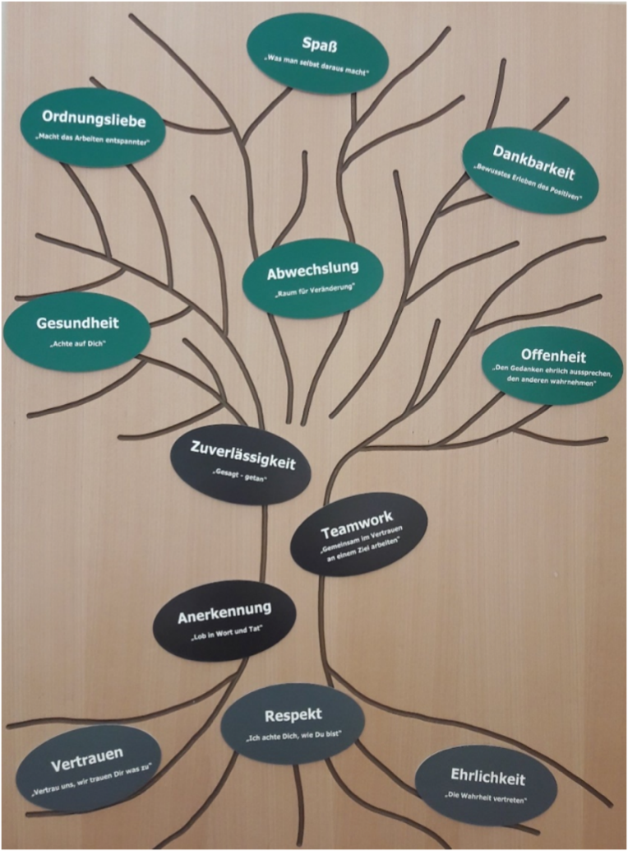

Source: SÄBU Holzbau GmbH.

1. Die UnternehmensBeatmer, “Veränderungsprozesse sind komplex …,” Die UnternehmensBeatmer, accessed May 25, 2018, https://die-unternehmensbeatmer.de/einfuhlsam-wandeln/.
2. Die UnternehmensBeatmer , “Aufatmen-Geschichten,” p.4, accessed March 25, 2019, e-book downloaded from https://die-unternehmensbeatmer.de/erfolge-feiern/.
3. € = EUR = euro; €1 = US$1.12 on September 30, 2016.