

9B19C016

Hella India Lighting Limited: Transforming Human Resources

[Akhil Pratap Singh](https://iveypubs.my.salesforce.com/0031J00001RX1wE) and [Raghav Garg](https://iveypubs.my.salesforce.com/0031J00001QtDJ1) wrote this case solely to provide material for class discussion. The authors do not intend to illustrate either effective or ineffective handling of a managerial situation. The authors may have disguised certain names and other identifying information to protect confidentiality.

This publication may not be transmitted, photocopied, digitized, or otherwise reproduced in any form or by any means without the permission of the copyright holder. Reproduction of this material is not covered under authorization by any reproduction rights organization. To order copies or request permission to reproduce materials, contact Ivey Publishing, Ivey Business School, Western University, London, Ontario, Canada, N6G 0N1; (t) 519.661.3208; (e) cases@ivey.ca; www.iveycases.com. Our goal is to publish materials of the highest quality; submit any errata to publishcases@ivey.ca. i1v2e5y5pubs

Copyright © 2019, Ivey Business School Foundation Version: 2019-05-22

We are extremely happy and proud to receive “Great Place to Work” certification. When passion meets purpose, supported by an open and collaborative organizational culture, then hunger to innovate solutions for our customers comes naturally.

Rama Shankar, manager director, Hella India Lighting Limited

The above statements, reflecting the commitment and aspirations of the employees of Hella India Lighting Limited (HIL), became a reality when, in 2018, HIL ranked 20th in India’s Great Place to Work (GPTW) Great Mid-Size Workplaces category[1] and as one of the best in their Manufacturing category.[2] HIL’s revenue was close to ₹2 billion,[3] and the employee satisfaction rating matched the highest scores of the GPTW survey at the national level. The GPTW survey had five parameters of evaluation: credibility, respect, fairness, pride, and camaraderie (see Exhibit 1).

Claudia Bachmann, chief auditor of Hella’s global corporate management system, congratulated Rahul Kumar, head of HIL’s human resources (HR), on this great achievement. Kumar was the person in charge of reaching this milestone when he was appointed way back in 2016—“The HR team at HIL made a remarkably positive impression when presenting evidence of their improvements to various processes in the organization.”

In October 2018, Kumar addressed his team in the monthly review meeting:

The work started in 2011, and the target was finalized as the top 50 position in Great Place to Work, but initially the organization could not even succeed in qualifying. But now we have accomplished the milestone and we are in the top 20. Management has appreciated our efforts and acknowledged our belief that values nurtured by the organisational culture create value of the organization [see Exhibit 2]. Therefore our target has been revised. They think our team has the calibre to do better than this. Our new target is the top 10 position in Great Place to Work by 2020. I hope you all will be feeling that it’s a bigger challenge for us now. I want your opinion on how we shall proceed from here. We need to brainstorm. Shall we sustain our strategy or find new ways?

Background

Hella was known for setting global standards for quality and customer orientation. It had created a niche for itself in both international and domestic markets as a supplier to leading vehicle manufacturers. Hella was a family-owned company with more than 125 locations in 35 countries. It was one of the top 40 automotive suppliers in the world and one of the 100 largest German industrial companies.

Hella had a presence in the Indian market for over 59 years, having entered into a joint venture (JV) with JMA Industries in 1959.

Hella’s presence extended to major automobile hubs in India with five locations: two manufacturing locations in Dhankot (near Gurugram) and Dera Bassi (near Chandigarh), one global electronics development centre in Pune, one engineering centre in Chennai, and one independent aftermarket location in Gurugram. In 2018, Hella had an employee strength of over 1,600 people in India. Hella offered a comprehensive range of quality automotive parts and accessories, both for original equipment manufacturers (OEMs) and the independent aftermarket.

Hella India Automotive Pvt. Ltd. (earlier known as Hella India Electronics Pvt. Ltd.) was established as a 100 per cent subsidiary of Hella GmbH & Co. KGaA of Germany in 2005 by ending the JV with Padmini Engineering Pvt. Ltd.

Contemporaneously, Hella India Lighting Limited (HIL) was established as an 81 per cent subsidiary of Hella GmbH & Co. KGaA by ending the JV with JMA Industries. HIL’s core focus was automotive lighting and supplying electrical and electronics equipment for a special OEM target group.

HIL had its manufacturing plant in Dera Bassi since 1981, and it was headquartered in Gurugram with a total employee strength of 600.

In 2008, HIL was ready with a new world-class facility in Faridabad, but the global market slowdown in the same year came as a shock. HIL suffered huge losses, and the German management had no option but to shut down and sell either the plant in Dera Bassi or in Faridabad. Management opted for selling the Faridabad plant, before any manufacturing had ever begun there.

At that time, Rama Shankar, an alumnus of the National Institute of Technology, Calicut and the Indian Institute of Management, Bangalore, was appointed managing director (MD) of HIL. He had previously been managing the Aftersales division. Shankar had been closely associated with HIL for a long time and therefore knew all of the issues prevailing in the organization at Indian locations. He was tasked with rejuvenating HIL. After analyzing the circumstances, Shankar realized that the financial health of HIL could be improved, and hence proposed a two-year plan to the German management, who agreed to it on condition that there would be no further investment in India and that HIL had to work as an independent unit.

Fortunately, the efforts of the Indian management produced results, and the company was on track for recovery, which gave the German management confidence. Shankar came up with Mission 2020, which was approved by the Germans (see Exhibit 3).

Mission 2020

Mission 2020 had three components, with the goal to achieve them by 2020:

* Achieve a revenue turnover of €50 million[4] (₹3.03 billion).
* Achieve earnings before interest and taxes of 10 per cent.
* Secure a place in the GPTW’s top 50 firms in India.

The management knew that in such a fast-growing, price-sensitive market as India, where global automotive giants were trying hard to penetrate and capture the market, HIL had to come up with a blue ocean strategy, and so they opted for light emitting diode (LED) lighting for India, with the objective to provide the present population with tomorrow’s technology (see Exhibit 4).

Millions of Indians drove, and close to 400 died, every day in road accidents. HIL wanted to reduce this number, and they knew that lighting played a major role in the number of accidents. Especially at night, the importance of well-functioning lights to avoid accidents was crucial, because the first task was to recognize the threat (see Exhibit 5). India had the world’s highest number of road accident deaths (one accident every four minutes, according to the National Crime Records Bureau), which resulted in a 3 per cent loss of India’s gross domestic product per year. By 2020, Hella India wanted to reduce road accidents by 10 per cent.

Human Resource Management at Hella India Lighting Limited

Like every other organization, HIL, too, had documented policies, norms, guidelines, and frameworks in position. Mission 2020 had already set a mammoth target for the HR department. Being in “recovery mode,” there were constraints on the availability of funds and the recruitment of HR personnel. Under the direction of the HR head, a small HR team of six people was working hard to succeed. The results were improving every year, but the team still failed to even qualify. Everyone knew that something was missing, but no one had the answer! As a Japanese proverb stated, “Vision without action is a daydream; action without vision is a nightmare.”

In March 2016, Kumar, the newly appointed head of HR (with 11 years’ experience in automotive companies like Robert Bosch GmbH and Continental AG), found the root cause of past failures:

Being aware of the German style of working through my previous employers, I was sure that Hella [HIL] too would have structured and well defined work processes. And I was right, hence I decided to do the gap analysis. I tuned myself to listening mode and interacted with blue collar employees at the shop floor as much as possible, listening to their problems, understanding their needs and expectations from us. In just a matter of a few months, I knew every single employee by his/her name irrespective of the position held.

Kumar elaborated:

I was given freedom by the management to change my team [see Exhibit 6], but I decided to stick with them. We sat together and discussed every aspect of the department. I also conducted frequent meetings with HODs [Head of Department] and managers of all the departments and garnered their suggestions and feedbacks. Slowly but steadily the dots were getting connected and the big picture emerged!

Finding the missing pieces

At first glance, there were two noticeable observations regarding the prevalent culture of the pre-2016 era. The environment was positive, and people were happy, but the initiatives of the HR department were not as effective as hoped, as HIL failed not only to be in GPTW’s top 50 companies of India by 2016 but also in sustaining top scores in the Hella employee opinion survey. There were certain redundant processes in the HR department’s workflow that were leading to resource wastage; therefore, it became crucial to address them.

There was a need felt for the culture audit to analyze existing gaps as well as the workflow being followed at that time. Benchmarking the best practices of other firms was also planned.

Based on the above plans, the HR team strategically developed Theme 2017, which included identifying priority areas by analyzing the employee opinion survey and the 2016 GPTW report by involving a task force from all departments. The task force was responsible for action planning and implementation. Actions would be based on the variety, originality, all-inclusiveness, human touch, and integration (VOAHI) principle.[5]

All policies, processes, and culture were judged and reframed on the basis of this principle by including all employees. Three key practice areas—inspiring, rewarding, and developing—were identified, and cross-functional teams, which included line managers and supervisors, along with members of the HR team, were created to carry out time-bound activities with measurable parameters for checking their effectiveness (see Exhibit 7).

Many loopholes were identified in the culture audit. It was found that the employee grievance redressal system was actually very theoretical and time consuming. It was handled through complaint forms and had no fixed time for the resolution of problems. It was more of a traditional system with very little appeal, and its usage rarely reflected the actual state of employee satisfaction or lack thereof. That system was replaced with a new system, the HR hotline, which was based on direct communication and a time-bound approach to resolving complaints within two days of receipt. This focused on the H (human touch) and the I (integration) of the VOAHI principle.

There was a missing spark in rewarding and recognizing employees. Awards were distributed in a conventional awards ceremony, where the MD and other top officials presented the awards. To improve the competitive spirit, the HR team decided to add V (variety), A (all-inclusiveness), and H (human touch) to this process, and the team started a new tradition of inviting family members of the awardees and letting family members present the awards at a glittering awards ceremony. Children of employees were appreciated and awarded for their outstanding achievements under the Little Star of Hella recognition campaign for employees’ children.

A structured annual calendar of activities planned around employee engagement and collective efforts toward the organizational mission of road safety was made to improve inclusivity.

Before, it had been the HR department that was primarily responsible for, and focused on, the development of GPTW culture. Later, the organization decided that each manager and supervisor would contribute to this target by becoming “people managers,” acting as HR managers and essentially becoming the first HR representatives of their own departments. This new culture development was a collective responsibility of everyone working in the organization.

Then came that historic moment when the same small—but now more effective—HR team of HIL made a major difference. A company that had been struggling until 2016 to even qualify for the GPTW survey suddenly entered GPTW’s Hall of Fame in 2018. Once stuck at the bottom, HIL also became number one in *Hella Universe* (the internal ranking system was based on an evaluation of work culture of all Hella locations across the world).

Narendra Nainwal, a senior manager in Finance, expressed the emotional connection of employees with this achievement: “When will we taste the victory, if not now? That moment has arrived when our dreams will be fulfilled now!”

The process of metamorphosis

Change began with a paradigm shift in the HR department’s approach, which moved from being a change follower to becoming a change agent.

Aditi Sharma, deputy manager of the HR department (who joined HIL in 2013), explained:

We have more autonomy now. Everyone has more clarity about their roles, freedom to make decisions makes the work swift and easy. Earlier all the information used to reside with the boss and it was mandatory to keep him in the loop for every single decision. Things used to get stuck if he was out of the office. This had a negative impact on the image of the department as well. Now the style is more of a decentralized nature. We just have to inform our HR head about the decisions we have taken and the best thing is that we all trust and support each other.

Shankar had a visionary approach back in 2010 when he realized that the key role of strategic HR management was to improve business performance and develop organizational culture that fosters innovation and flexibility to gain a competitive advantage. This became a necessity when the average duration of an employee at HIL was approximately 10 years. Kumar said:

It is rare to see so much loyalty from the workers of a loss making organization. I have seen people leaving the organization when the bad times arrive. But we have so many of them working here for more than 30–35 years. I have heard the stories of their faith in *Peer Badshah dargah* [the shrine of a Muslim saint] in front of our plant whom they all consider as a saviour of the Derrabassi plant in 2008, it is said that each one of them prayed there to save the plant from shutdown. Since then it has become a custom that on every Thursday, *Prasad* [a devotional offering made to a god, typically consisting of food that is later shared among devotees] from *dargah*, is distributed in the plant. People are empathetic here and never make unjustified demands from management and thus it becomes our responsibility that now as we are making profit, we provide them with everything that they deserve.

The 80–100 per cent rule stated thatyou were better off with a strategy that was 80 per cent right and 100 per cent implemented than one that was 100 per cent right but did not drive consistent action throughout the company. By adhering to this rule, along with the mindset of “employee = customer,” focus centred on employee welfare via creating more awareness, executing HR policies, and coming up with more initiatives to increase employee engagement. Strict guidelines had been set up for responsible HR managers to prevent any sluggishness and ensure the timely execution of activities planned in the revised rewards and recognition calendar(see Exhibit 8). Employees were encouraged to participate more in corporate social responsibility activities promoting road safety in India. The response had been overwhelming, and change in the culture was visible.

Various innovative HR initiatives became popular as shown below.

Hella Jogger’s park and diet lunch

With improvements in the existing facilities came an increase in demand for more. One of the most sought-after improvements was to have a gym in the plant. Kumar explained:

There were many constraints in setting up a gym in the plant. There were not enough funds available for that. Moreover, there is a natural tendency which has been observed that most people stop going to gym/clubs after a few months, even if they pay fees from their own pocket, so there was a big question mark on the effective utilization of the investment. But we were committed to [improving] the fitness level of employees.

Finally, after a lot of brainstorming, the concept “Jogger’s Park” came up. Initially, the HR team members tested its feasibility on their own. The concept was based on the free Runtastic fitness tracker and running application, which they all used in a competitive spirit to track how much they were walking daily. The trial was successful, as the competition enabled everyone to pursue it habitually, and the idea became official. Everybody working in the organization was allowed to participate. To further motivate, every month the Best Walker Award was presented along with a gift prize for a fitness product worth ₹2,000. Employees were so passionate about this initiative that within a few months after its launch, more than 105 employees were competing against each other, and every month new records were being reached. There was a drastic improvement in the employee fitness level. Furthermore, the dining hall at HIL offered a “diet lunch,” which was based on a weekly fitness diet chart, to all the fitness-conscious employees, at no additional charge.

Employees’ Welfare Fund

This fund consisted of the voluntary monthly contributions of individual employees, based on their own capacity to help and support each other financially in a crisis.

One example was of Raman Sharma, who was deputy manager in the Quality department. He belonged to a middle-class family and was the only breadwinner among his family members. He met with a severe accident in August 2018 and was admitted into the intensive care unit for many days. Hefty hospital bills exhausted Sharma’s insurance money and personal savings within a week. When Sharma was struggling between life and death, the HIL family came to his aid. Funds from the Employees’ Welfare Fund were used to pay Sharma’s hospital bills. His family was assured that they would keep receiving Sharma’s monthly salary every month, even though he was unavailable to work. Regular visits from staff were made to look after family members and ensure their needs were being met.

There were several such examples where this relief fund breathed new life into hard times.

*Mann ki baat* (Speak One's Mind) with human resources

At first glance, this initiative may not have seemed as something new. It had a tagline copied from one of the initiatives of the Indian government. However, digging deeper into the details, it proved to be a master stroke at a time when most manufacturing companies were facing lockouts and strikes due to poor industrial relations between management and labourers. Not long before, one of the most successful car manufacturers in India, Maruti Suzuki India Limited, had faced the dark side of this issue when an HR manager suffered a horrible accident in which he was burned to death.

When asked about the initiative, Kumar explained:

It’s very common these days to see labour unions in every major manufacturing firm. Sometimes they are formed out of political intentions[,] but in other cases, labourers are forced to form one such to get their basic demands fulfilled. But what if we reach them and ask for their needs and get the work done within a time frame? Why do we need unions if HR has the scope of becoming [an] “employee champion”? This is what we are doing in Mann ki Baat with HR.

In Mann ki Baat with HR, an HR manager was appointed to visit the shop floor on a regular basis to address worker grievances. Within two days, all issues had to be resolved. To verify the progress, surprise visits were made by the MD and HR head, whom employees were free to share their problems with.

Mini Townhall meet

Annually, all Hella employees, along with their family members (i.e., spouses and children), spent the whole day together and cherished moments with each other. The meet celebrated the success of the company with employee participation in cultural activities and a gala dinner. At the event, the company’s top performers—loyal employees who had served the organization for a long time—were honoured and awarded.

Present Day—October 2018

“This is not just a plant, it’s a second family to me. Everybody lives here with a feeling of brotherhood,” said Kailash Kher, who had been working in the production department since 1981. Kavita Sharma, who was selected to work at HIL five months earlier through a campus placement, said,

I have many of my friends working in other companies. They keep telling me about the problems which female employees face in their day-to-day work. Frankly speaking I have never seen those things happening here. I feel secure. Seniors are polite and supportive. I am looking forward to working here for a longer period of time just like everyone else.

Top management’s vision—blended with the HR department’s ground-level strategy execution—had successfully crafted the HIL family culture, based on Hella values that were deeply embedded in the roots of the organization (see Exhibit 9). Although Kumar was happy with the ranking that HIL had achieved, he was aware of the challenges ahead. Already there were expectations for HIL to secure a place among the top 10 organizations in the GPTW Survey and sustain its dominance in the Hella universe. The HR team prepared a report for Kumar’s review, including a list of best practices that were followed across the top workplaces recognized by the GPTW survey in 2018. Some of the policies highlighted in the report were the Wellness Quotient, the Trial Run, Help-to-Hire, Total Inclusion, and Leave, Balance.

*The Wellness Quotient:* This program consisted of a two-week education phase, followed by an implementation phase for encouraging employees to adopt a healthy lifestyle. The focus had been to educate employees on topics such as mindfulness strategies, stress management, and foods that impair and promote sleep. With the help of an online Sleep Transformation Community and a sleep journal to record progress, employees were motivated to take proactive steps toward improving their mental and physical well-being.

*The Trial Run:* This policy was centred on new employees. It aimed to provide a realistic picture of the job and what it actually felt like to be working in the organization. After an aptitude test and interview, the shortlisted candidates were sent to their respective department for three days to understand the exact job requirements and for the company to gauge the individual’s on-the-job fit. During the extension interview, the candidate stayed with the manager to understand the job and challenges involved. This format not only helped to ensure the right fit for the right job, but also provided the candidate with an opportunity to make a wise career choice.

*Help-to-Hire:* This policy was an initiative for preparing jobs for the employees’ children and for enhancing the employability of certain employees’ children who had not found suitable jobs, despite having a recognized educational background. The initiative included a two-year paid internship program with a combination of on-the-job and personality development training.

*Total Inclusion:* This initiative extended its care and support toward blue-collar employees and involved their family in various developmental activities. They were provided with good quality vocational training and skill-building opportunities for better integration and collaboration to achieve common goals. Employees were supported through various mediums such as coaching classes for children, discounted products, and personal accident insurance. Adding to the “human touch,” plant leadership also visited the employee’s home and interacted with the family members on a regular basis. Great workplaces focused on building personal relationships for employees to feel appreciated.

*Leave, Balance?:* This initiative was based on a very flexible leave policy. Some people often worked late nights and weekends, which were not tracked, so why should the organization track the leaves employees took? Therefore, as long as the employees ensured their responsibilities were being fulfilled, they were free to take leaves that would not be tracked. There also was no formal process for a leave application. In case of emergencies or crises, employees could simply inform their reporting managers and teams.

After reading the HR team’s report, Kumar was wondering: Should the company just sustain the momentum or should HIL benchmark the policies and practices of current top 10 firms and match, if not surpass, their achievements? Or, should the company come up with more engagement strategies because people tend to get inured with old schemes, no matter how well designed they might be? Or, should the company become engaged in some design thinking and come up with innovations that furrow an altogether different path?

Exhibit 1: Great Place To Work survey results

|  |  |  |  |  |  |  |  |
| --- | --- | --- | --- | --- | --- | --- | --- |
| **Great Place to Work Scores, 2011 to 2017** | | | | | | | |
|  | HIL 2011 | HIL 2012 | HIL 2013 | HIL 2014 | HIL 2016 | HIL 2017 | India Top 50 |
| Credibility | 66 | 73 | 79 | 83 | 89 | 85 | 83 |
| Respect | 64 | 72 | 76 | 82 | 88 | 86 | 83 |
| Fairness | 59 | 66 | 73 | 78 | 86 | 82 | 79 |
| Pride | 72 | 80 | 85 | 86 | 92 | 90 | 86 |
| Camaraderie | 68 | 74 | 81 | 84 | 90 | 88 | 86 |
| Great place to work | 65 | 73 | 85 | 83 | 89 | 86 | 83 |

Note: HIL = Hella India Lighting Limited

Source: Company files.

Exhibit 2: Profit earned by Hella India Lighting Limited over the years

Source: Company files.

Exhibit 3: Hella India Lighting Limited Mission 2020

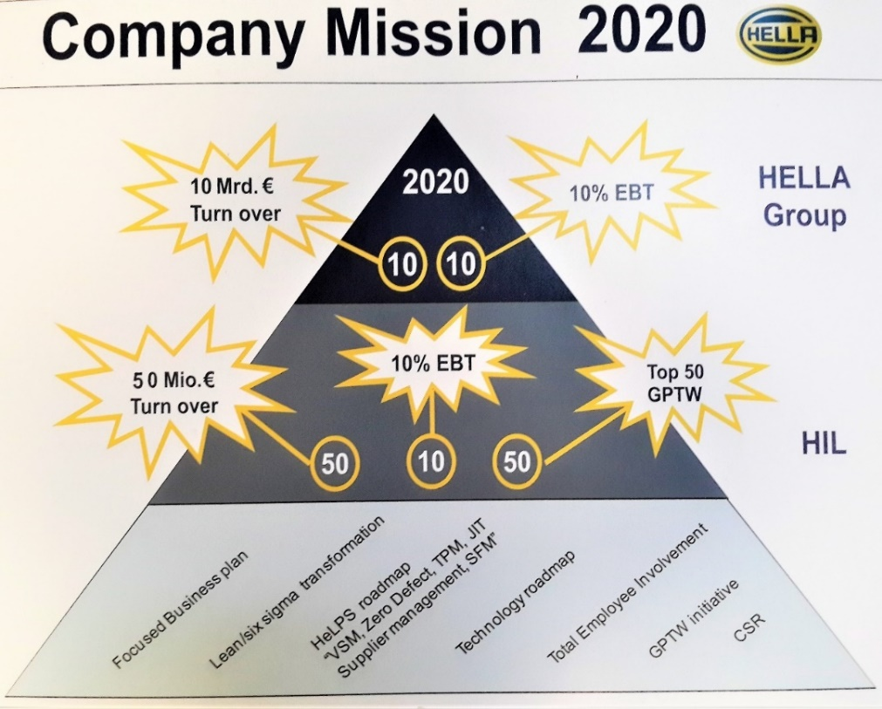

Source: Company files.

Exhibit 4: blue ocean strategy of Hella India Lighting Limited

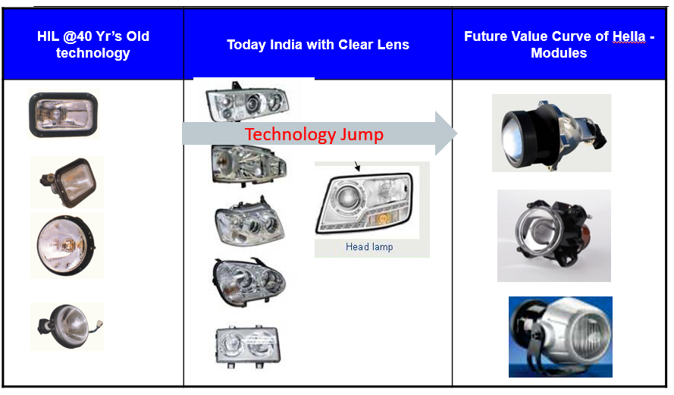

Note: HIL = Hella India Lighting Limited.

Source: Company files.

Exhibit 5: The Safety Circle

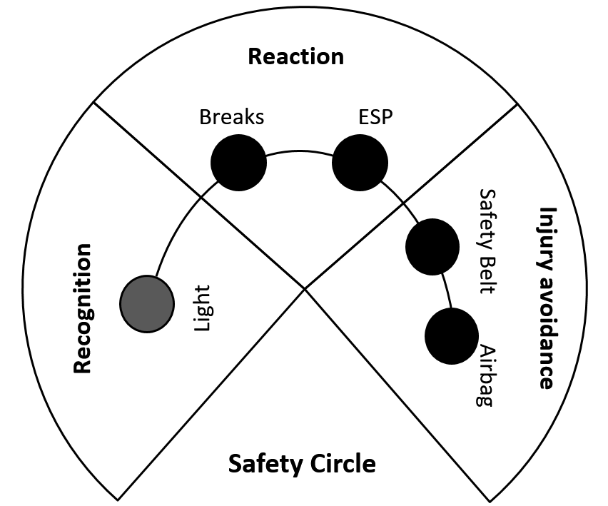

Note: ESP = Electronic Stability Program.

Source: Company files.

Exhibit 6: Human resources Department at Hella India Lighting Limited

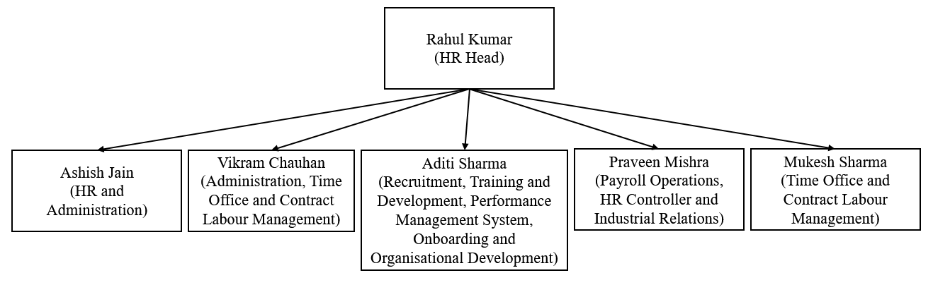

Note: HR = Human Resources.

Source: Company files.

Exhibit 7: Cross-functional teamwork in culture audit

|  |  |  |  |  |  |
| --- | --- | --- | --- | --- | --- |
| Action Planning | | | | | |
| Practice Area: Rewarding | | | | | |
| Action Idea: To implement a structured and human-touch reward system for all-inclusive employees and to implement more effective PMS activities. | | | | | |
| Project Team: Rahul Kumar, Selvam Rajagopal, Pallavi Sinha, Amit Rawat, Pravan Kumar Mishra | | | | | |
| S. No. | Activities | By When | Responsibility | Support | Measure of Effectiveness |
| 1 | Rollout of R&R calendar | 31-Jul-17 | Pravan Kumar Mishra | Operations team and line managers | Adherence to R&R calendar |
| 2 | Starting the “Little Star of Hella” awards for employees’ kids. Thank you card – “Shukriya” for Hella employees | 31-Jul-17 | Selvam Rajagopal | Project team and HR | Number of thank you cards issued in a month and number of awards given to kids of employees |
| 3 | Hellavien, Long Service Award | 30-Nov-17 | Rahul Kumar | Management team | Employee retention |
| 4 | Introduction of standard PMS, online process to be implemented | 31-Aug-17 | Rahul Kumar | Management team and central HR team | Feedback survey report after performance appraisal |
| 5 | Mid-year review to be given with current PMS | 31-Dec-17 | Rahul Kumar | Management team and central HR team | Feedback survey report after performance appraisal |
| Enablers: Line managers, management team, HR team, brainstorming sessions | | | | Barriers: Proper rollout and tracking, support of line managers | |
| Review mechanism: In MRM and fortnightly review with project team | | | | | |

Note: S. No. = serial number; PMS = Performance Management System; R&R = Rewards and Recognition; MRM = Monthly Review Meeting.

Source: Company files.

Exhibit 8: revised List of activities in Reward and Recognition Calendar (2018)

|  |  |
| --- | --- |
| Rewards and Recognition | |
| * Best Ground Zero Connect | |
| * Best Hoshin Kanri Performance | |
| * Best Performing Line | |
| * Best Secondary Reporting | |
| * Best Zonal Performance | |
| * Golden Boot Award—Hella Jogger’s Park | |
| * Hawk Eye Award | |
| * Hellavien—Long Service Recognition | |
| * Highest Sales Growth in Year | |
| * Kaizen Award | |
| * Line Champion | |
| * Little Star of Hella—Recognition of Employees’ Kids | |
| * Pat on the Back | |
| * Performer of the Month | |
| * Pride of Hella—Power of Zero Tolerance | |
| * Rising Star of the Month |
| * Shining Team—A 6S Culture | |
| * Shukriya—Thank You Culture | |
| * Spectacular Turnaround in a Year | |
| * Team of the Year | |

Note: 6S = sort, set in order, shine, sustain, standardize, and safety.

Source: Company files.

Exhibit 9: Hella Values

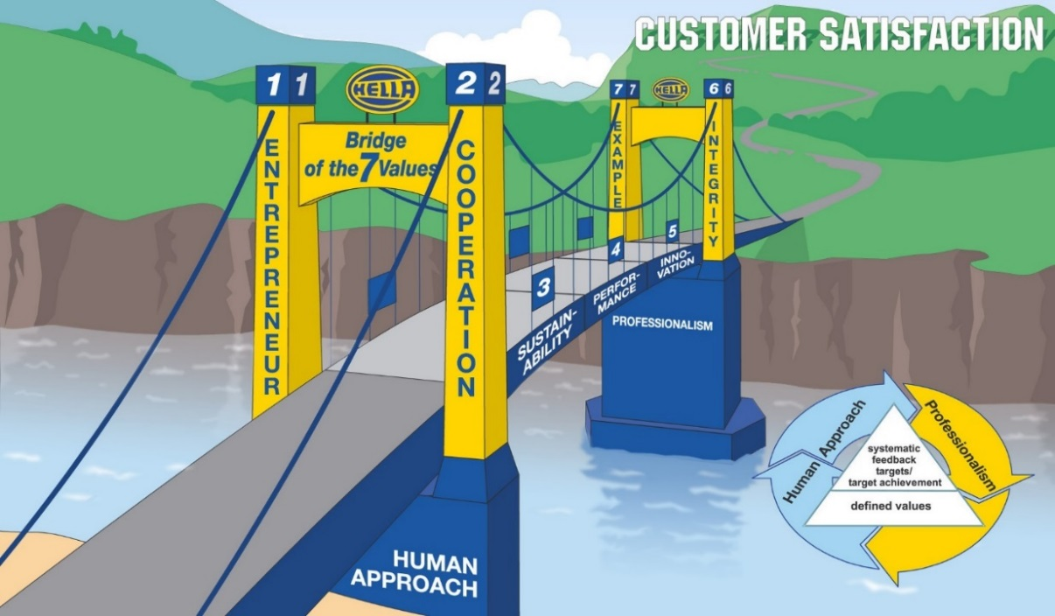

Source: Company files.

1. “India’s Great Mid-Size Workplaces—2018,” Great Place to Work, accessed April 1, 2019, www.greatplacetowork.in/best-work-places/midsize-18/.
2. “India’s Best Workplaces in Manufacturing—2019,” Great Place to Work, accessed April 1, 2019, www.greatplacetowork.in/best-work-places/best-manufacturing-2019/.
3. ₹ = INR = Indian rupee; all currency amounts are in ₹ unless otherwise specified; US$1 = ₹63.83 on January 1, 2018.
4. € = EUR = European euro; the average currency exchange rate in 2010 was €1 = ₹60.59.
5. Great Place to Work Institute Inc., *Culture Audit Deep Dive,* 2017, accessed May 7, 2019, www.greatplacetowork.com/images/support/Culture-Audit-FAQ-FINAL.pdf.