|  |  |
| --- | --- |
|  | ISB_Logo_BW2 |

9B19c017

iimjobs.com: INTEGRATED ANALYTICS FOR TALENT MANAGEMENT?

Debolina Dutta and Bishakha Majumdar wrote this case solely to provide material for class discussion. The authors do not intend to illustrate either effective or ineffective handling of a managerial situation. The authors may have disguised certain names and other identifying information to protect confidentiality.

*This publication may not be transmitted, photocopied, digitized, or otherwise reproduced in any form or by any means without the permission of the copyright holder. Reproduction of this material is not covered under authorization by any reproduction rights organization. To order copies or request permission to reproduce materials, contact Ivey Publishing, Ivey Business School, Western University, London, Ontario, Canada, N6G 0N1; (t) 519.661.3208; (e)* [*cases@ivey.ca*](mailto:cases@ivey.ca)*;* [*www.iveycases.com*](http://www.iveycases.com)*.*

Copyright © 2019, Ivey School of Business Foundation Version: 2019-06-17

In February 2018, Tarun Matta, founder and chief executive officer of Highorbit Careers Pvt. Ltd. (Highorbit), returned from a customer visit and called for an urgent meeting with his product development team:

I have the vision of iimjobs.com as being the last word on talent management. Our credibility is well-established through the job portal and serving the talent acquisition functions of organizations as well as meeting the career aspirations of high-calibre individuals. Our new product offering, Calculus, is expected to meet the talent analytics requirement of the HR [human resources] function. Information about talent and skill availability, associated costs, sliced by demographic and diversity should enable HR functions see us as the “one-stop shop” for all their talent and information needs. However, our top clients have posed a few troubling questions, and I will need all your ideas and support to equip our platform to deliver at the new expectation levels.

With over 1 million registered users as job seekers and over 70,000 recruiters using the platform to interact and find suitable candidates to fill jobs, iimjobs had become a leader in the recruitment industry. iimjobs had high-quality candidates who had graduated from premier business schools of India, such as the Indian Institute of Management (IIM), registered on its site. The company also found itself in possession of a large quantity of job-seeker related data that Matta thought to be of potential value to recruiters. This could provide organizations with critical insights that would help them understand the talent landscape in their specific industries. iimjobs created Calculus to share this data.

A team of iimjobs’s top employees was set up to collate all customer feedback from the company’s talent management platform. This task was to be completed within one month. Matta expected the team to present the gaps in their current platform and come up with solutions that could bridge these gaps to complete the holistic offering he envisioned. As planned, the team provided Matta with its observations in February 2018.

The team’s findings, however, raised critical questions about the uniqueness of the value proposition of Calculus. Customers’ expectations for the platform ranged widely—from information on talent availability across all skills, to the ability to replace market benchmarking as a practice, to speed of parsing the available applicants, to finding high-quality talent. All these services needed analytics from a wide spectrum of available talent, and this information was not available within the niche and premium business school talent that iimjobs.com had so far focused on attracting. This lack of information left Matta with the uncomfortable realization that the “premium” focus of iimjobs may have limited the validity of insights that were provided by Calculus.

Matta knew he needed to make decisions on two important issues. First, should Calculus be presented as a valuable offering for talent management, or should new features be explored and added to it to benefit the target market? Second, should iimjobs expand Calculus with a more comprehensive database, giving up its niche premium positioning and diversify to cater to all kinds of jobs and job-seekers?

THE INDIAN CONTEXT AND SCOPE FOR TALENT ANALYTICS

The Indian labour force, second only to China in the world, stood at 517 million in 2018,[[1]](#endnote-2) and was projected to grow by another 170 million by 2020.[[2]](#endnote-3) Around 1 million people entered the workforce every month.[[3]](#endnote-4) Salaried workers formed around 21.06 per cent of the total workforce in India.[[4]](#endnote-5) This segment witnessed an average annual voluntary attrition rate of 13.4 per cent, with the figure going as high as 20.4 per cent in the e-commerce sectors.[[5]](#endnote-6) By 2017, about 60 per cent of companies were planning to increase their headcount, with 45 per cent of the new hires being in the middle-management segment.[[6]](#endnote-7)

Understanding the talent landscape continued to present a challenge for HR professionals, who struggled to win the “war for talent.”[[7]](#endnote-8) At the rudimentary level, recruiters could informally call some of their peers in the industry to discover trends in their respective business segments. Companies that needed more exact data usually obtained it from job market analyses conducted by large consulting firms or from small recruitment agencies. This intelligence was used both for talent management decisions and for compensation benchmarking regarding the competitiveness of organizations’ pay policies with respect to the job market.

A common practice for checking internal pay equity with similar jobs in the market was accomplished through the exercise of compensation benchmarking.[[8]](#endnote-9) The compensation data for specific job families and grades were available from consulting firms that collated and provided this information for a considerable fee. Many organizations purchased these reports, which were customized for a defined market segment—comprising target skills, target companies, and specific roles—for approximately ₹2–₹4 million per year.[[9]](#endnote-10) Obtaining accurate data was contingent on mapping the entire industry and most industries associated with it, so that the relevant target talent group’s information was available. In many cases, to avoid high costs, this purchased data was “aged” using average merit-increase trends according to the industry, but this practice had the associated risk of referencing outdated data. Additionally, changing talent trends and availability were not visible in these reports because the benchmarking was performed against currently existing jobs and roles and not future planned roles.

Similarly, an organization’s internal context became the baseline point for HR business partners to reference while planning the current or future state of talent requirements. If an organization needed to hire for future needs, it needed information about talent availability and the associated cost trends. In many cases, hiring from the external job market required offering higher salaries than comparable internal hires.[[10]](#endnote-11) Defining a changed market group to accommodate future skills could impact the pay positioning with respect to the market. In many cases, the business looked to the HR function to provide data-driven decisions around costs of hiring, re-locating, and improving the skills of talent, as well as predicting attrition trends and costs for future talent needs. In the absence of clear and dynamic data, most HR departments tended to provide qualitative inputs, which affected the reliability of build–buy decisions around talent.

THE IIMJOBS.COM STORY

An engineer from the Indian Institute of Technology – Banaras Hindu University and an MBA from the Indian Institute of Management Indore, Matta typified the best of the burgeoning information technology (IT) talent emerging in India during the early years of the 2000s. Matta worked across a range of firms such as Nokia Bell Labs (Bell Labs), Lucent Technologies Inc., Computer Sciences Corporation, Neilsoft Ltd., and ITC Infotech. He was employed with RockeTalk, Inc. when he began to see a common complaint from his peers: it was difficult to match high-quality talent to top jobs. His peer group comprised equally qualified IT professionals who struggled to get visibility and access to recruiters. Recruiters, however, were swamped with the high volumes of applicants for jobs, and they faced challenges in sifting through these applicants.

Matta often received job links for premium managerial jobs within the IT industry along with requests to forward those to any suitable candidates he might know. Matta started to post such job links in his personal blog to view from June 2007 to mid-2008. Gradually, job seekers started visiting his blog to view these job links. Recruiters too started sharing their job postings with him so that they could reach the right audience. Matta realized that the job market in India was heavily crowded—in terms of both job seekers and recruiters. Often, this left people overwhelmed with listings or résumés that were not remotely relevant to his or her requirements. Hence, a key differentiator would be a focused approach that catered to a specific segment with specific kinds of jobs, thereby considerably reducing search times. Thus, there existed an opportunity for a platform linking the recruiters looking for premium qualifications with the job seekers looking for high-paying mid- to senior-level positions.

Matta started Highorbit in February 2008[[11]](#endnote-12) as a web platform, and it was incorporated as Highorbit Careers Private Limited in 2010. The website allowed interested job seekers to register and post their résumés, and recruiters to post jobs; these services were free. Recruiters could also pay a premium to get their listing prioritized on the first page of search results for about one month. As such, non-priority listings would move down as newer jobs were posted. In addition, relevant postings were collected directly from recruiters and posted on the site. In the early days, the website catered exclusively to IIM graduates. Unlike its popular competitors of the day, Naukri.Com[[12]](#endnote-13) and Monster.Com,[[13]](#endnote-14) iimjobs initially did not have a revenue model. The goal was to improve the website substantially based on user feedback, before launching it as a paid product to the market. In 2012, iimjobs secured angel funding that gave the firm the ability to build infrastructure and strengthen the value offering. In 2013, iimjobs.com evolved into a “freemium” model, which made its services available, in addition to the basic offerings, for a price. The company invested very little in conventional marketing channels, while allowing its superior service and value delivery to stakeholders to emerge as the differentiator from other job portals. Matta strongly believed that the value delivered by the platform would speak to both the targeted consumers:

Our objective is to help jobseekers connect with recruiters. Hence, we would concentrate on building a more effective platform that would help a larger number of job seekers. We have never spent any money on any form of advertising or customer acquisition. It’s all been organic growth with word-of-mouth referrals by satisfied job seekers.

Early Signs for Diversification

As he interacted with recruiters, Matta found that, while the premier educational pedigree mattered a lot for the entry level jobs for many major recruiters, the requirement seemed to become irrelevant when it came to the mid-manager level jobs, where experience became the key differentiator. This led Matta to divide the iimjobs.com offerings into two segments—one dealing with the job listings exclusive to graduates from premier business schools, and one for high-paying mid-manager level postings, for which a degree from a premier business school was not required.

In 2014, the large traffic of software specialization jobs and résumés on the portal, made Highorbit Careers Private Limited create an offshoot of iimjobs—hirist.com (Hirist), devoted exclusively to software engineers and technical non-managerial jobs. With the diversification of the market, there emerged the need for the company to dissociate itself from the original perception of catering only to IIM graduates. In an interview with Entrepreneur India in early 2017, Matta stated,

Although the name might suggest that ours is a platform purely for IIM graduates, over a period of time we have grown beyond this name, and we have begun to see a large number of mid-level and senior-level candidates registering and applying through the site. We are excited, by the way, that hirist.com, an exclusive platform for techies, has scaled up in last 6–12 months. Based on the traction, we have witnessed the need in the market, and we will be launching five more verticals in the next 18 months targeting other segments and industries.[[14]](#endnote-15)

By the end of 2017, iimjobs had acquired a prestigious clientele of 700 large companies (Fortune 500 firms, firms above 500,000 employees) including Accenture PLC, Hindustan Unilever Ltd., Flipkart Pvt. Ltd., Zomato Media Pvt. Ltd., ICICI Bank, Credit Suisse Group AG, and Amazon.com, Inc., and the iimjobs site received nearly 5.7 million page views per month. They also had around 65,000–70,000 registered recruiters and over 1 million job seekers registered on the iimjobs site, which had grown steadily from 2008 to 2017 (see Exhibit 1). iimjobs established its corporate office in New Delhi and two more satellite sales and support offices—in south (Bangalore) catering to Bangalore, Chennai, and Hyderabad, and in west India (Mumbai) catering to Mumbai and Pune. From a workforce of four people in 2013, iimjobs.com had expanded to over 140 employees, working in five different departments by December 2017.

OFFERINGS AT IIMJOBS.COM

Job Listings

The core offering of iimjobs.com for job seekers was job listings posted by registered recruiters. With the 2013 introduction of paid options on the site, listings under premium jobs were highlighted, and mailers were sent to relevant persons registered on the database. Recruiters were able to scan candidate profiles using various filters, such as current job role, sector, organization, location, education, salary, demographic details, notice period, team experience, and willingness to relocate. To support the recruiter in sifting through the large volume of applicants, the platform offered the option of Magic Sort (see Exhibit 2), which matched the applicant’s résumé with the requirements for a particular job. Job seekers received notifications on change of status of their application. For premium applicants (i.e., paid members who subscribed at ₹2,000 for a period of six months), notifications indicated the exact status of their candidature, as either rejected or shortlisted. Each job posted on the website got its own job page, where all details regarding the job were provided, such as title of the job, firm name, and required qualifications, as well as recruiter’s name, last login date, number of people viewing and applying for the job so far, and other information. All jobs, free or paid, were moderated to ensure functional salience and relevance. Job postings were filtered to ensure that only genuine recruiters posted, only managerial level jobs were posted, and the jobs met a minimum salary bar. The platform gave users the provision of reporting a profile or a job posting if it looked suspicious.

Assess Yourself

Assess Yourself (see Exhibit 3) was an assessment tool, available for every job posted on the portal. It consisted of a multiple-choice test for the applicant for a particular job, which measured and told both the recruiter and the candidate whether a candidate was a fit with the skills needed for the posted job. The assessment tool was auto-generated and free of cost. The 2017 release version of Assess Yourself mostly dealt with technical skills such as Java or PHP. Future upgrades of this feature were planned to include measures of values and personality.

Employer Branding

Launched in October 2016, the employer-branding offering evolved out of the iimjobs management’s conversations with its corporate clients, who expressed a need for avenues to talk about their brand positions and culture, and create awareness about the job demands and benefits—in short, to create a realistic job preview for potential employees. When a listed job was clicked, it would take the job seeker to a devoted page showing the dimensions of the organization, along with videos and narratives about the company, its culture, and its values, leading to both awareness and engagement. Employer branding was a paid feature that could be subscribed to by registered recruiters based on their needs. Employer branding received a warm reception from the existing clientele of iimjobs.com as soon as it was launched. By December 2017, more than 90 companies had registered for this product offering and it had contributed nearly 9 per cent of the organizations’ total revenues.

MAJOR COMPETITORS

The vast scale of hiring and job switching in the Indian white-collar labour market created an active need for forums that facilitated job posting and seeking. India had seen a significant rise in the number of job portals in the last two decades (see Exhibit 4 for some examples). Segmentation of the talent demand–supply solution providers could be seen as: pure intermediaries (Naukri.com,[[15]](#endnote-16) Monster.com,[[16]](#endnote-17) Timesjob.com,[[17]](#endnote-18) Shine.com[[18]](#endnote-19)); job aggregators (Indeed.com,[[19]](#endnote-20) Glassdoor.com[[20]](#endnote-21)); focused on managerial talent (Headhonchos.com[[21]](#endnote-22)); focused on niche skills and industries (AngelList,[[22]](#endnote-23) Techgig.com,[[23]](#endnote-24) Hasjob.co[[24]](#endnote-25)); and social networking (LinkedIn,[[25]](#endnote-26) GitHub,[[26]](#endnote-27) and Stackoverflow[[27]](#endnote-28)).

For a subscription fee, the pure job portals allowed recruiters to post jobs and access their résumé database to search for candidates, and let job seekers apply for jobs and post their résumés for other potential recruiters. Established in 1997, Naukri.com was the largest online job portal in India in terms of its résumé database and organization subscriptions, with a revenue of ₹5.9 billion in 2017[[28]](#endnote-29) across multiple domains and industries.[[29]](#endnote-30) Another leading job portal in India, Monster.com, had over 44 million registered users, and was known for Monster Education, which offered certifications and professional courses.[[30]](#endnote-31)

The job aggregators were job search engines that provided the seeker with access to the jobs posted in all the job portals, and offered a single-point access to all such content across different sites. Many of these sites used artificial intelligence bots that would scan a résumé and then search for digital job posting across the popular job portals to suggest a good fit. To filter out the clutter, sites like Headhonchos.com charged both organizations and individuals to access and post their résumés respectively on the site. Headhonchos.com also offered coaching and résumé building services to prospective mid- to senior-level talent. In order to ensure relevance and focus for the clients, the niche category sites dealt with jobs and résumés catering to only one vocational specialization. AngelList focused on start-up jobs, whereas Techgig and Hasjob catered to the IT industry.

The social networking sites, although intended primarily for networking and information sharing, had incorporated job searching and posting facilities as important components of their offerings. Chief among them was LinkedIn. Being primarily a social networking site, LinkedIn had the advantage of having a collection of profiles of active as well as passive job seekers, and it boasted one of the most comprehensive databases of the employable population around the world. GitHub and Stackoverflow were sites for crowdsourcing coding solutions, and they became attractive domains for recruiters to hunt and identify high-calibre entry-level talent from the IT industry.

THE MAKING OF CALCULUS

As the iimjobs.com customer base increased, the company received feedback from its customers about both the quality of the database and the features that could provide additional value and information on job market trends. In addition to an applicants’ demographic and salary data, the website also indicated tenure between jobs, educational background, and capability differences between individuals and between roles, as skills evolved as careers progressed. This enabled the system to build data intelligence on emerging trends related to skills that were valued by the industry.

So far, iimjobs had been successful in attracting passive talent[[31]](#endnote-32), people who were already working and generally content with their position, but had posted their résumés to be receptive to potential offers from other recruiters. The confidentiality provided by the iimjobs.com platform when an applicant expressed interest in a target company’s job posting helped build a database of high-calibre, but passive, job-seekers. These applicants were of interest to recruiters of other organizations, who felt this database of passive high-calibre talent could also be of interest for similar roles in their organizations. Paradoxically, maintaining the confidentiality of applicant information and preventing a wider broadcasting of their job-seeking behaviour reinforced the quality of the candidate pool that was available on the platform and for which the recruiters wanted access, albeit at a subscription cost.

With skill requirements constantly changing, organizations rapidly needed to retrain internal talent or acquire talent having these new skills with greater frequency. The Calculus platform had emerged as a repository of talent trends and a source of dynamic skill availability[[32]](#endnote-33). The user interface was simple and akin to other skill-search platforms (see Exhibit 5). Queries were available on talent availability, position looked for, short versus long term employment (Boolean operator), company name (e.g., Nestlé, International Business Machines (IBM), Accenture plc., or Royal Dutch Shell plc.), and industry. Other search parameters such as college (e.g., Tier I, II, III), type of course (e.g., full-time, part-time), batch (e.g., 2012–2014), and notice period (e.g., two months) were quickly and easily presented. The platform parsed the data so that only résumés active within a six-month period were used to present data trends. Based on the search query, the automation tool generated a sample set, while all outliers (e.g., salary, experience, etc.) were removed.

The Calculus platform let a recruiter study five dimensions related to hiring (see Exhibits 6 a, b, c, and d):

1. *Compensation*: This dimension included current and expected salary trends; range; mean and median salary; gender and age, and distributions of salary based on experience.
2. *Geographical location*: This dimension showed the talent density and salary ranges in a particular location, enabling the manager to decide where to open a new branch or to facilitate compensation management based on geographical zone.
3. *Gender diversity*: This dimension reflected the gender-related distribution of talent and its interaction with other factors such as experience, salary, location, and notice period.
4. *Average tenure*: This information about skills, functions, and age groups helped talent management teams calibrate talent expectations in terms of expected stability and future attrition.
5. *Availability* *index*: Based on information provided by the applicant, the expected notice period across different roles, seniorities, and functions was also indicated.

In the words of Matta,

Recruiters and hiring managers are often pushed to fill vacancies, that too with unrealistic specifications and targets. So this tool enables them to know and talk about expectations of talent availability in a more meaningful manner. They can now say that by relaxing a few parameters we can increase our supply side. It helps them to understand the industry trends and calibrate expectations accordingly.

The database for Calculus was limited to the database of registered applicants on iimjobs.com. Using the résumé database had the dual advantage of having a substantially large sample of over 1 million records, and having a sample that was highly select in terms of qualifications and skillsets. The Calculus offering was currently being made available to clients on a trial basis. When it came to the pricing of Calculus, to make the offering attractive, Matta and team adopted a penetration pricing strategy. In September 2017, the price was set at ₹300,000 for one year of the service. By this time, iimjobs.com had started doing road shows and reaching out to clients with Calculus.

FEEDBACK FROM THE CLIENTS

The crack team of Ramit Grover (sales manager), Amandeep Singh (marketing head), and Harshita Gakkhar (manager, strategic initiatives) met with Matta in December 2017 to discuss the findings from customer feedback.

Gakkhar was elated with the reception that Calculus had received:

The feedback, in general, is highly positive for our offerings. HR heads have been telling me that Calculus simplifies their HR decision making a lot and also aids in realistic planning. However, we also need to keep in mind that different segments have different requirements. Job seekers from the premium schools need a platform where they can easily find premium job opportunities. But the definition of what makes a premium institution itself is flexible—with new institutions entering the top-ten ranks every year. From an organization’s point of view and as a business head, I might prefer recruiting the gold medallist from a tier II institute over the student in the bottom percentile of a celebrated business school. So gatekeeping at the job seeker’s end might end up constricting our talent pool sub-optimally. We also need to cater to the requirements of recruiters, who preferred a select database to search from. But it was important to recognize that our job seekers also formed the fodder for our market analysis, and the more we constrict their entry, the less robust would be the insights from Calculus.

Singh was optimistic about the product’s potential, but he emphasized the need to enhance the product offering based on the inputs received from other HR professionals. The industry was seeking real-time data through demand-and-supply curves on function and skills. Accurate information on talent availability using big data, machine learning, or analytics could shape the “build versus buy” decisions in talent management. The practice in industry was to obtain this information from certain consulting firms that provided data collected from multiple sources and sample sets to build their reports (e.g., CEB-Gartner[[33]](#endnote-34) provided broad- based insights that were not role-specific). The use of predictive analytics could be a differentiator here.

Interactions with corporate customers had also revealed that about 70 per cent of the recruiter’s work was operational—drafting and sending offer letters, or scheduling and rescheduling interview meetings—while only 30 per cent of time was devoted to finding a fit of the candidate with the requirements of the organization. The product team at iimjobs.com had already initiated investments in artificial intelligence and machine learning to automate scheduling and replies in order to drastically cut down the time taken by the recruitment process and to support recruiter productivity and efficiency, but this offering was missing from Calculus in January 2018.

An additional request from talent acquisition functions was intelligence on the past performance of potential applicants. The team was asked to use machine learning and artificial intelligence to calibrate the talent and comparative growth trajectories in the applicant’s organization, and to benchmark the applicant’s growth to estimate performance ratings. Industry was also asking for information about how many times the applicant’s résumé had been shortlisted for similar jobs. Singh had reservations about enabling this offering:

What is talent and who is to say a particular applicant is talented or not? There are already so many biases at play in the recruitment process. Would it be ethical to share how many times a particular résumé has been shortlisted by other organizations? Even our assessment of a fast-track performer in a previous organization built painstakingly using artificial intelligence need not necessarily guarantee performance in the new organization.[[34]](#endnote-35) That could influence the credibility of our brand.

The product roadmap from the iimjobs.com team included a new offering called Careergraph, which allowed job applicants get information on salary distribution, preferred skills, and experience for a given profile. This offering was expected to help applicants calibrate their salary expectations. The corporate clientele of iimjobs.com was demanding low-volume but niche and high-quality talent. On the other hand, Calculus clients were seeking more granular information that would mitigate the need for their reward functions to conduct annual salary benchmarking surveys. The paradoxical demands were polarizing the founding team on the value proposition that the platform wanted to offer going forward.

After the team had left with new product development plans, Matta wondered whether he should feel satisfied with the direction that iimjobs.com was taking. The firm had truly grown exponentially in the last few years but with growth came the issue of diversification, which had both its merits and demerits. He wondered whether iimjobs.com should diversify for broad talent and job pools, and if so, how the firm’s “premium” talent positioning could be diluted without impacting the perceived quality of applicants that recruiters preferred about this job board. Also, would Calculus be able to replace traditional HR management practices—such as the manual compensation benchmarking exercise periodically undertaken by HR firms—and help HR practitioners make informed decisions of build-versus-buy on specific skills, based on availability and cost trends? His eyes fell on the prints of one of his old interviews, in which he had said,

I think a lot of people confuse innovation with building a new product. Innovation is also present when you bottle an existing product in a new way with the aim of delighting consumers, and I think iimjobs.com falls under the latter category. The picture might not be very clear in the beginning but if your idea is sound, then over a period of time, you’ll figure out the innovation that the market is seeking.

Exhibit 1: Growth story of iimjobs.com (in Thousands)

|  |  |  |  |  |  |  |  |  |  |  |
| --- | --- | --- | --- | --- | --- | --- | --- | --- | --- | --- |
|  | **2008** | **2009** | **2010** | **2011** | **2012** | **2013** | **2014\*** | **2015\*** | **2016\*** | **2017\*** |
| **Number of recruiters** | 0.5 | 1.5 | 2.5 | 4 | 7 | 10 | 20 | 30 | 50 | 70 |
| **Number of candidates** | 10 | 25 | 60 | 90 | 140 | 200 | 350 | 500 | 750 | 1000+ |
| **Number of job postings** | 1 | 2.5 | 4 | 8 | 30 | 60 | 100 | 150 | 200 | 250 |

Note: \*Data includes affiliated job boards of iimjobs.com such as Hirist.com, Updazz.com, Engineeristic.com, and Biojoby.com.

Source: Company data.

Exhibit 2: Magic Sort (Ranking most relevant skill-fit to Job Description)

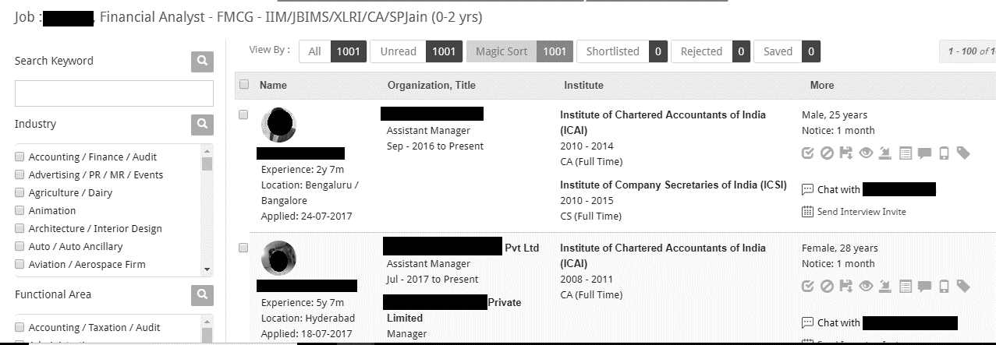

Source: Company data.

Exhibit 3: Self-assessment at iimjobs.com

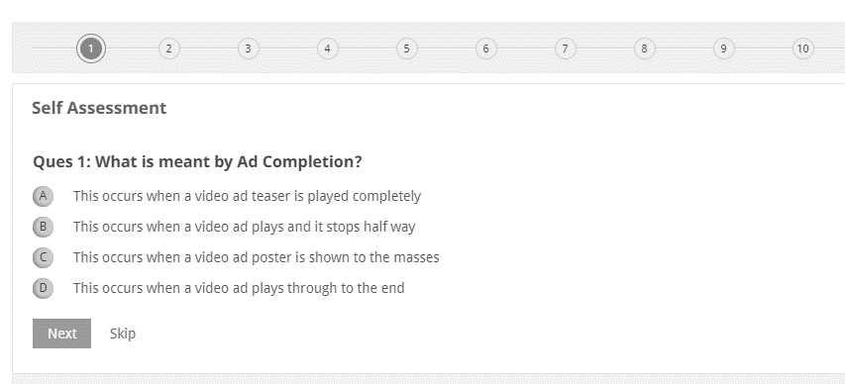

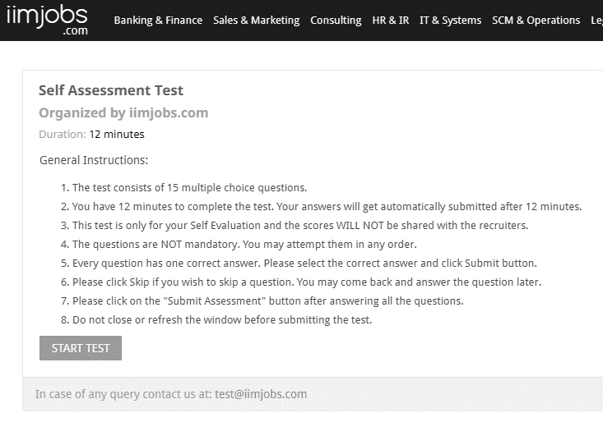

Source: Company data.

Exhibit 4: The competition landscape in India AS OF April 2018

|  |  |  |  |  |  |  |  |  |  |  |
| --- | --- | --- | --- | --- | --- | --- | --- | --- | --- | --- |
| **Competitors** | **Business Model** | **Target Talent Pool** | **Product Offerings** | | | | **Service Offerings** | | **Database Size** | **Cost Per Posting** |
|  |  |  | Posting | Database | Employer branding solutions | Talent mapping | Résumé maker | Résumé blast |  |  |
| Naukri | Job board | All types | ✓ | ✓ | ✓ | X | ✓ | ✓ | 50.0 Million | ₹1,650 |
| Monster India | Job board | All types | ✓ | ✓ | ✓ | X | ✓ | ✓ | 44.0 Million | ₹900–₹1,800 |
| Timesjobs | Job board | All types | ✓ | ✓ | ✓ | X | ✓ | INA | 22.5 Million | ₹1,200 |
| Shine.com | Job board | All types | ✓ | ✓ | ✓ | X | ✓ | INA | 20.0 Million | ₹800 |
| Olx jobs | Job board | Blue-collar jobs | ✓ | ✓ | X | X | X | INA | - | INA |
| Head honchos | Job board | Mid/Senior-level | ✓ | ✓ | ✓ | X | ✓ | INA | 1.8 Million | ₹3,000 |
| iimjobs | Job board | Tier 1 and Mid/senior-level | ✓ | ✓ | ✓ | ✓ | X | X | 1.0 Million | ₹5,000 |
| LinkedIn | Social networking | All types | ✓ | X | ✓ | X | X | X | 500.0 Million | Pay per click (no standard price) |
| Indeed | Job aggregator/ Job board | All types | ✓ | ✓ | X | X | ✓ |  | 25.0 Million | Free (pay per click for sponsored search) |
| Belong | Outbound | All types | X | X | X | X | X | X | INA | INA |
| Glassdoor for jobs/employers | Job board and reviews | All types | ✓ | X | ✓ | X | X | X | 50.0 million | Free (paid for job and display advertising) |
| AngelList | Job board | Start-up jobs and top jobs in start-ups (A-list) | ✓ | ✓ | X | X | X | ✓ (for A-List candidates) | 1.6 million | Free |
| Techgig.com | Social networking | IT Jobs | ✓ | X | ✓ | X | X | X | 2.0 Million | INA |
| Hasjob.co | Job board | IT Jobs (start-ups) | ✓ | X | X | X | X | X | INA | Free |

Note: ₹ = INR = Indian rupee: ₹1 = US$0.014 on December 31, 2018; IT = information technology; INA = information not available

Source: Information compiled by case authors.

Exhibit 5: Talent Information on Calculus

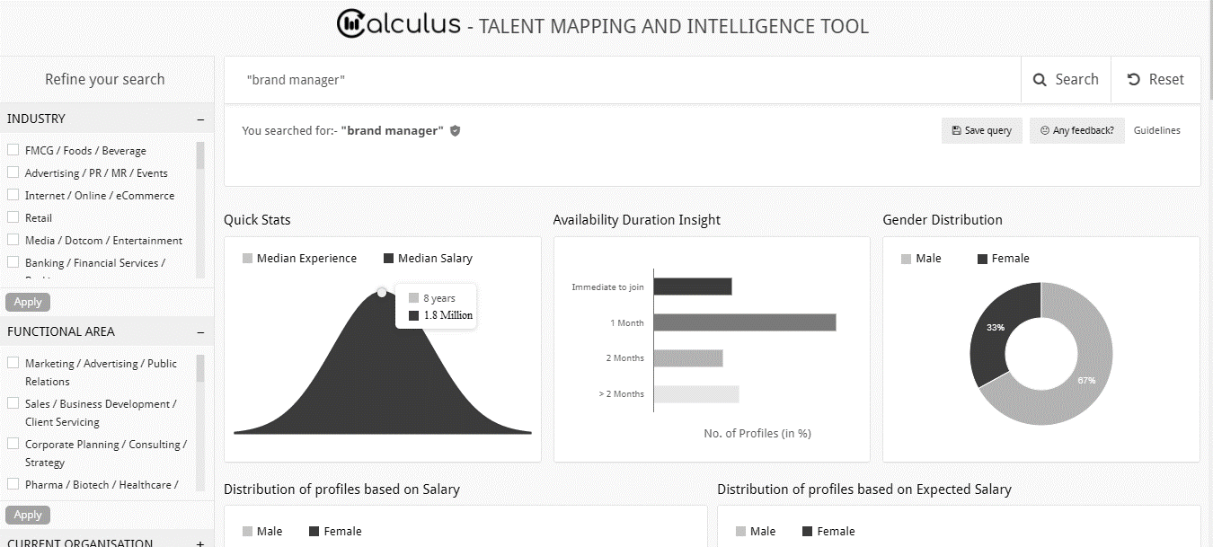

Source: Company data.

Exhibit 6a: GENDER DIVERSITY Information on Calculus

**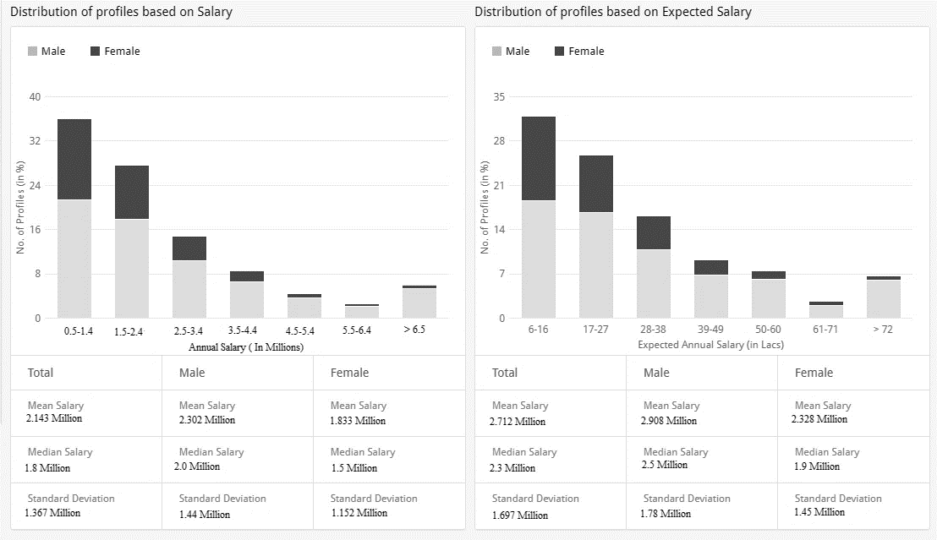**

Source: Company data.

Exhibit 6b: Talent AVAILABILITY FROM VARIOUS ORGANIZATIONS on Calculus

|  |  |  |  |  |  |  |
| --- | --- | --- | --- | --- | --- | --- |
| **Popular Companies** | **Asian Paints** | **Hindustan Unilever Ltd.** | **ITC Ltd.** | **Vodafone India** | **Emami Ltd.** | **Reckitt Benckiser (India) Ltd.** |
| Number of Profiles (in %) | 24 | 18 | 18 | 14 | 14 | 8.5 |

Source: Company data.

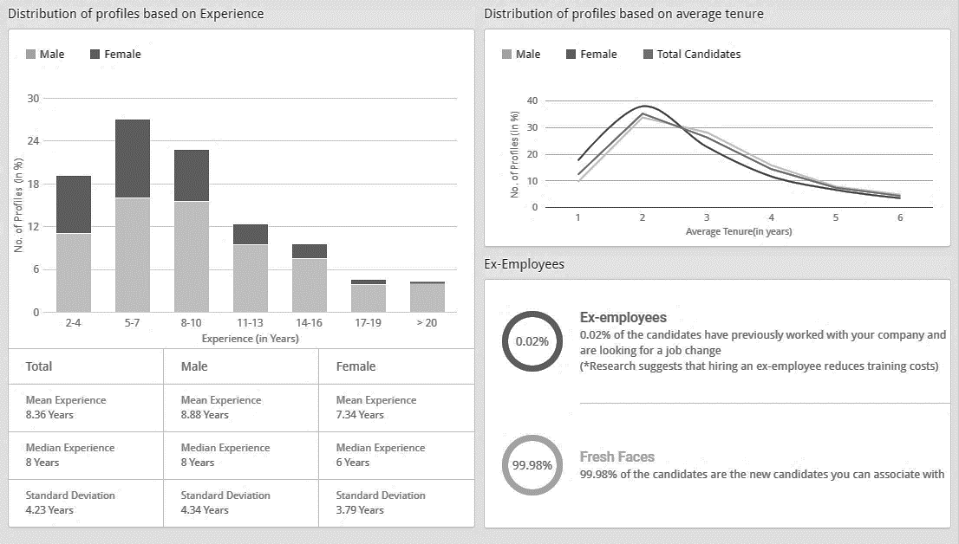Exhibit 6c: Talent EXPERIENCE & DIVERSITY Information on Calculus

Exhibit 6d: GEOGRAPHICAL AVAILABILITY OF Talent AS INDICATED BY Calculus

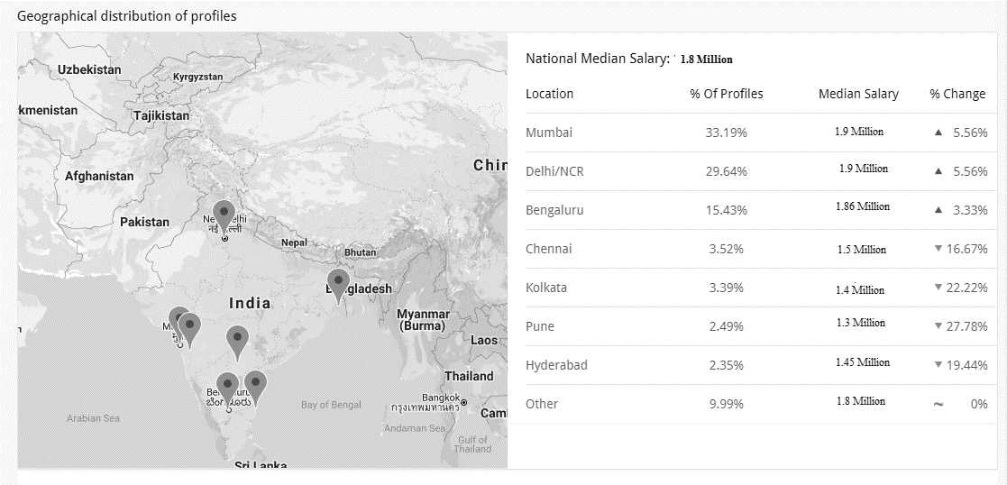

Source: Company data.

ENDNOTES

1. World Bank Group, “Labor Force, Total,” The World Bank, accessed April 13, 2018, https://data.worldbank.org/indicator/

   sl.tlf.totl.in. [↑](#endnote-ref-2)
2. Jaideep Shenoy, “India's Labour Force Will Expand to 170 Million by 2020: Assocham,” *The Times of India*, January 19, 2017, accessed March 9, 2018, https://timesofindia.indiatimes.com/business/india-business/indias-labour-force-will-expand-to-170-million-by-2020-assocham/articleshow/56666148.cms. [↑](#endnote-ref-3)
3. Asit Ranjan Mishra, “India to See Severe Shortage of Jobs in the Next 35 Years,” Livemint, April 28, 2016, accessed March 9, 2018, www.livemint.com/Politics/Tpqlr4H1ILsusuBRJlizHI/India-to-see-severe-shortage-of-jobs-in-the-next-35-years.html. [↑](#endnote-ref-4)
4. International Labour Organization, “Wage and Salaried Workers, Total (% of total employment) (Modeled ILO Estimate),” ILOSTAT Database, accessed March 20, 2019. [↑](#endnote-ref-5)
5. KPMG, *KPMG Annual Compensation Trends Survey 2017-2018*, 20, March 2017, accessed March 9, 2018, https://assets.kpmg.com/content/dam/kpmg/in/pdf/2017/03/KPMG-Annual-Compensation-Trends-Survey-2017.pdf. [↑](#endnote-ref-6)
6. Michael Page, *2017 India Salary and Employment Outlook*, 41, 2017, accessed March 9, 2018, www.michaelpage.co.in/content/salary-employment-outlook-2017-report/. [↑](#endnote-ref-7)
7. Many HR practitioners plan their talent management and compensation strategies. Examples of such reports can be found at www.mercer.com/content/dam/mercer/attachments/global/Career/gl-2018-talent-trends-2018-infographic-india-mercer.pdf, or https://apac.aonhewitt.com/home/insights-at-work/top-people-trends-india are available to HR professionals. Most of the reports with specific details on skills/wage costs are available as paid studies. [↑](#endnote-ref-8)
8. WorldatWork, *The WorldatWork Handbook of Compensation, Benefits and Total Rewards: A Comprehensive Guide for HR Professionals* (Hoboken, NJ: John Wiley & Sons, 2015). [↑](#endnote-ref-9)
9. ₹ = INR = Indian rupee; ₹1 = US$0.014 on December 31, 2018; all currency amounts are in INR unless otherwise specified. [↑](#endnote-ref-10)
10. The Wharton School at the University of Pennsylvania, “Why External Hires Get Paid More, and Perform Worse, than Internal Staff,” Knowledge@Wharton, March 28, 2012, accessed June 15, 2019, <https://knowledge.wharton.upenn.edu/article/why-external-hires-get-paid-more-and-perform-worse-than-internal-staff/>. [↑](#endnote-ref-11)
11. Startup Pitches, “New Delhi Based iimjobs Has Quickly Grown Itself into a Player in HR by Focusing on MBAs Seeking Employment in India,” Startup Beat, January 24, 2013, accessed March 9, 2018, https://startupbeat.com/2013/01/featured-startup-pitch-new-delhi-based-iimjobs-has-quickly-grown-itself-into-a-player-in-hr-by-focusing-on-mbas-seeki. [↑](#endnote-ref-12)
12. “All Jobs,” Naukri.com, accessed October 24 2017, www.naukri.com/. [↑](#endnote-ref-13)
13. “100,000+ Jobs. Find Better. Faster,” MonsterIndia.com, accessed October 24 2017, www.monsterindia.com/. [↑](#endnote-ref-14)
14. Samiksha Jain, “How iimjobs.com Found Its Niche in Already Crowded Recruitment Industry,” Entrepreneur, September 21, 2015, accessed March 9, 2018, www.entrepreneur.com/article/250876. [↑](#endnote-ref-15)
15. “All Jobs,” op. cit. [↑](#endnote-ref-16)
16. “About Us,” Monster India, accessed March 17, 2019, www.monsterindia.com/about-us.html. [↑](#endnote-ref-17)
17. “Timesjob,” Timesjob.com, accessed March 17, 2019, accessed March 17, 2019, www.timesjobs.com/. [↑](#endnote-ref-18)
18. “About Us,” Shine.com, accessed March 17, 2019, www.shine.com/aboutus/. [↑](#endnote-ref-19)
19. “Indeed.com,” Indeed.com, accessed March 17, 2019, www.indeed.co.in/?r=us. [↑](#endnote-ref-20)
20. “About Us,” Glassdoor, accessed March 17, 2019, www.glassdoor.co.in/index.htm?countryRedirect=true. [↑](#endnote-ref-21)
21. “Headhonchos,” Headhonchos, accessed March 17, 2019, https://headhonchos.quezx.com/. [↑](#endnote-ref-22)
22. “AngelList,” Angel.co, accessed March 17, 2019, https://angel.co/. [↑](#endnote-ref-23)
23. “About Us,” TechGig, accessed March 17, 2019, www.techgig.com/knowus/about-us. [↑](#endnote-ref-24)
24. “Hasjob,” Hasjob, accessed March 17, 2019, https://hasjob.co/. [↑](#endnote-ref-25)
25. “About Linkedin,” Linkedin.com, accessed March 17, 2019, https://about.linkedin.com/. [↑](#endnote-ref-26)
26. “About Us,” GitHub, accessed March 17, 2019, https://github.com/about. [↑](#endnote-ref-27)
27. “Stack Overflow - Where Developers Learn, Share, & Build Careers,” accessed June 6, 2019, https://stackoverflow.com/company. [↑](#endnote-ref-28)
28. Infoedge, *Infoedge Annual Report 2016-2017*, 224, 2017, accessed March 9, 2018, www.infoedge.in/pdfs/Annual-Report-2016-17.pdf. [↑](#endnote-ref-29)
29. David Rice, “Eight Best Job Portals You Must Check Out [India],” Hellbound Bloggers, January 5, 2019, accessed March 20, 2019, https://hellboundbloggers.com/job-websites-for-indians/46429/. [↑](#endnote-ref-30)
30. Monster India, “Buy online - Job Postings, Resume Access, SMS Solution, Adverting Jobs, Job Posting services, Packages and Offers,” accessed March 20, 2019, http://recruiter.monsterindia.com/v2/ecom/. [↑](#endnote-ref-31)
31. Ionannis Nikolaou. “Social Networking Web Sites in Job Search and Employee Recruitment.” *International Journal of Selection and Assessment*, 22, No. 2 (2014): 179-189. [↑](#endnote-ref-32)
32. For a detailed examination of emerging skill trends, please refer to: www.mercer.com/content/dam/mercer/attachments/

    global/Career/gl-2018-talent-trends-2018-infographic-india-mercer.pdf. [↑](#endnote-ref-33)
33. Gartner, “Talent Analytics: Transform HR’s Business Impact with HR Metrics and Analytics,” accessed March 20, 2019, www.gartner.com/en/human-resources/insights/talent-analytics. [↑](#endnote-ref-34)
34. Boris Groysberg, Ashish Nanda, and Nitin Nohria, “The Risky Business of Hiring Stars,” *Harvard Business Review*, May 2004. Available from Ivey Publishing, product no. R0405F. [↑](#endnote-ref-35)