 

9B19C023

JD.com (B): CULTURE consolidaTION AND TALENT REVIEW

Jean Lee, Jian Han, Ziqian Zhao, Leah Tan, and Rain Long wrote this case solely to provide material for class discussion. The authors do not intend to illustrate either effective or ineffective handling of a managerial situation. The authors may have disguised certain names and other identifying information to protect confidentiality.

This publication may not be transmitted, photocopied, digitized, or otherwise reproduced in any form or by any means without the permission of the copyright holder. Reproduction of this material is not covered under authorization by any reproduction rights organization. To order copies or request permission to reproduce materials, contact Ivey Publishing, Ivey Business School, Western University, London, Ontario, Canada, N6G 0N1; (t) 519.661.3208; (e) cases@ivey.ca; www.iveycases.com. Our goal is to publish materials of the highest quality; submit any errata to publishcases@ivey.ca. i1v2e5y5pubs

Copyright © 2019, CEIBS (China Europe International Business School) Version: 2019-07-26

After joining JD.com as chief human resources officer (CHO) and general counsel in August 2012, Yu Long observed the company’s operations for the first few months. She identified several human resources (HR) problems that were largely due to the company’s rapid multi-dimensional growth in the last decade, such as the dilution of corporate culture; a lack of talent in management positions; inadequate internal management and organizational capabilities, such as co-creation skills; and the lack of a fair job-ranking system as well as benefits packages designed to match the needs of different types of employees. At the strategic meeting held at the end of 2012, JD.com’s senior executives agreed that it was time for the company to improve internal management and to prepare for the next decade of growth. At the 2013 annual staff meeting, JD.com’s founder and chief executive officer (CEO), Qiangdong Liu, announced the theme of the year as “Xiu Yang Sheng Xi,” a Chinese idiom that meant “taking a rest to improve in order to revitalize.” He explained that the top management team would reflect upon the past and make necessary adjustments for the future.

While Long was adapting to the company’s culture and was establishing herself within the top management team, she obtained Liu’s approval to start with two HR initiatives in 2013—culture consolidation and talent review. In the fall of 2013, as she reviewed the HR department’s achievements so far, Long thought about how to tackle the remaining problems.

making observations in the first few months

Long noticed that HR managers often sat at the corner of the conference table in cross-department meetings and did not have much say in decision-making. She invited several HR managers to her office to talk about themselves and their jobs. To Long—a senior executive with a legal background—most of them seemed to lack a clear vision and logical arguments. She sometimes asked an HR team member who was presenting a proposal to leave within five or ten minutes. Long explained,

If team members come to my office and fail to tell me within five minutes which management problems the proposal addresses or what benefits the proposal can bring to the company, I will show them the door. If they make their goals clear to me in the first five minutes, but do not give me an impression within the next five minutes that their solutions are logical, I will also show them the door.

Long believed that if she could not understand the proposal right away, other busy executives would likewise not understand. Long found that because the HR specialists looked at problems from only the HR perspective (instead of the corporate perspective), they could not obtain support from the top management team and other departments, and this led to difficulties in launching or implementing their solutions.

Long was aware that she might be criticized for lacking expertise in HR, but she did not think that it was an obstacle. Based on her executive experience as an internal customer of HR departments, she knew very well what kind of HR team a company needed and what role a strong HR team should play. Long explained, “As the CHO, I need to set the direction for the HR team of over 300 members, and lead the team to support the company’s strategies, identify managerial problems, and work out solutions. We aim at chalking up wins one after another.” With the HR team leaders, Long developed the department’s new vision, mission, and five-year strategic plan (see Exhibit 1).

Long grouped all the HR problems under four interrelated areas—culture, talent, organization, and staff care. Long knew that building a sound HR management system would be complex and time-consuming. Because the top management team, with some recently joined chief officers (COs), had not yet developed a common managerial language, Long assumed that they might not appreciate HR reforms right away. She also believed that it was only when an organization was adequately staffed with qualified personnel that it could be properly organized. Otherwise, if she took radical actions to change the organization at the very beginning, some employees might quit. Only when a large pool of talent was available could she say, “OK, if you quit, we have someone else to fill your position.” She also thought that tailor-making benefits to employees in different job ranks or categories was necessary but that it could wait. Long therefore decided to start with culture consolidation and talent review.

Convincing the CEO

In the last 10 years, JD.com had come up with culture slogans, some of which, such as “never waste resources,” might not be appropriately interpreted by new or junior employees. Consequently, culture might be diluted when the company grew further. Long went to see Liu and suggested to him that the improvement of HR management should start with corporate culture. Unexpectedly, Liu replied without hesitation: “JD.com is a company with a strong culture. I will never change its culture!” Long realized that Liu might have misunderstood her real intention and reasoning. She believed that internal miscommunication existed because employees came from increasingly different backgrounds and that common corporate culture and values could solve such problems. Knowing that she needed another approach to persuade Liu, Long responded, “If you’re unhappy with my idea, I will put it aside. Culture should be diffused from the top. Without your support, there is no way to start this initiative.” Sensing that the tension was eased, Long then asked, “Do you want JD.com to be a domestic or international company?” Liu answered, “International, of course!” Long continued, “When we have employees all over the world in the future, they will speak different languages, but should share the same corporate values. How would you explain our Chinese-style culture to them?” Liu was silent. Long went on, “I have never suggested drastically changing our culture. What we need to do is to strengthen our culture by identifying and articulating our existing values, and train the staff to acknowledge and act upon them.” A week later, Liu told Long, “Let’s do it. I think you’re right.”

Consolidating Culture

Current State

Vision and Mission

JD.com’s vision had been “to become a leading e-commerce company in China and one of the top five in the world.” Its mission had been “making shopping simple and happy.”

Culture and Values

JD.com’s culture was largely shaped by founder and CEO Liu, who was very diligent and detail-oriented. The company did not resort to bribery when purchasing land for building warehouses. He laid down three “no” principles—no tax evasion, no counterfeit goods, and no [political] backers.

The core values he imposed within the company were golden rules of discipline: integrity (candid, honest, and trustworthy); putting customers first (going an extra mile for customers); passion (enthusiastic, proactive, diligent, ambitious, innovative, and competitive); learning (humble, eager-to-learn, progressive, and intellectual); teamwork (collaborative and synchronized); and never wasting resources (economizing and taking care of company properties).

Employee Selection Based on Corporate Values

Liu classified job candidates into five types: (1) “gold,” those who were highly capable and shared the corporate values; (1) “steel,” those who were capable and shared the corporate values: they would be the foundation of the company; (3) “iron,” those who shared the corporate values but were barely capable; (4) “scrap iron,” those who failed to meet the company’s requirements for capabilities and values; and (5) “iron rust,” those who did not share the corporate values but had outstanding capabilities.

The company would hire and keep only the first three types (i.e., those who shared the corporate values). For the “iron” candidates, after they failed to meet the requirements of an entry position, they would still be given an opportunity to try another position and receive additional training. They would be dismissed only if they failed again. JD.com once launched a massive campaign to “scrape off iron rust” to avoid those employees’ possible negative influence on others. As a result, JD.com’s merchandise often received better word of mouth than those sold on other e-commerce platforms, and its delivery services were perceived as excellent.

Improvement Project

Long formed a project team to launch the culture consolidation project in December 2012. The project team consisted of experts from a consulting firm and members of the HR department. Long hoped that the project team could lead the entire staff to sort out the cultural elements that had been supporting the company’s growth, present them in a logical manner, and develop a set of behavioural guidelines. Long said,

In lots of companies, the division in charge of building culture brainstorms on its own, and then presents the outcome to the boss. When it is approved, it will be rolled out to the staff. But things are different at JD.com. The project needs the full participation of all employees.

Refining Vision and Mission

The project team first analyzed JD.com’s business evolution for reviewing its vision and mission. In 2013, the company had already introduced JD Finance, which was related to, but independent of, JD Mall, the company’s core business. Thus, the original mission of “making shopping simple and happy” was no longer applicable. In addition, the original vision of “number one in China and the top five worldwide” lacked imagination. The company therefore restated the vision as “developing into a globally trusted company.” The mission was revised to “making *life* simple and happy,” foreseeing that the company’s services would cover various aspects of customers’ lives.

Soliciting Inputs from the Staff

Liu personally asked over 30 executives to participate in a retreat in the relaxing suburbs. The project team invited a management professor to give a lecture on corporate culture and guide participants to brainstorm suggestions for culture consolidation. Although they did make concrete conclusions at that early stage, they also took advantage of this opportunity out of their busy schedules to interact with each other.

The project team then distributed an anonymous survey to over 30,000 employees. The questionnaire featured multiple-choice questions and asked employees whether they agreed or disagreed with statements about values as well as how they ranked certain values based on importance. The project team received 3,400 valid questionnaires. They conducted interviews with 192 employees at all levels and from different business divisions. Finally, they gathered and analyzed the inputs as a preparation for the next step.

Forming a Value Framework

The project team organized a second meeting for executives to shape the value framework. Liu wanted to participate, but Long requested that he take a seat at the back of the room and suggested that he keep silent. She explained to him, “Anything you say is an order. Then, no one dares to say no!” Liu agreed.

At the meeting, the project team asked participants to vote for five core values among a list of values sorted out from the research survey. It was easily agreed that the value framework should have “Putting customers first” as its nucleus, with four other core values. Participants reached the consensus that “integrity,” “teamwork,” and “innovation” were core values. However, votes for “efficiency” and “passion” were close. At this moment, Liu could not restrain himself from stating, “Without passion, JD.com would not have gone this far. ‘Passion’ must be one of our core values. Efficiency is just a management practice.”

Participants went on to go through the research results to condense, from more than 500 phrases, some keywords to define each of the five values chosen (see Exhibit 2). Long explained, “These values derive from thorough reviews of our previous achievements, accumulated strengths, and usual problems. Many executives can confidently explain the logic behind their votes.”

For example, “integrity” was defined by “promises,” which required employees to keep promises both internally and externally. If an employee wrote in an email that they would provide certain information, then they had to do so. For “Putting customers first,” different departments had different codes of conduct. The customer service centre, for example, required its employees to make their smiles “heard” by customers over the phone. Each employee had a small mirror on their desk, reminding them to wear a smile when speaking with customers. The HR department also required its own employees to serve internal customers well. For example, when a colleague came to an HR representative to ask about social insurance, but the representative did not know the answer, the representative should not just respond with “I don’t know”; rather, they should take the colleague to the person in charge to get the information. Long added, “We should always focus on the corporate vision. Although the company has been growing rapidly and our people are results-oriented, no one should be self-centred.”

Translating the Framework into Behaviours

The project team held staff meetings in six regions and at the customer service centre. Without much disturbance to employees’ daily work, the meetings aimed to publicize the new value framework and gather opinions on specific behaviours that reflected the values. At least one-third of participants were front-line employees. Participants brainstormed the behaviours and grouped the ideas into lists of 20 behaviours for different value components. Then they voted for those that demonstrated the values most important for compiling into a handbook (see Exhibit 3).

By the end of March 2013, the project team had finished identifying and articulating the corporate culture and values. Long found herself being impressed by the company. She expressed,

As an executive, you have an expectation of the project outcome. I will be satisfied if I can reach 40 per cent or 50 per cent of the expectation. In a foreign MNC [multinational company], the project team might still argue internally without reaching a consensus a year after the project launch. But in JD.com, the project outcome is often beyond what you expected. This sense of satisfaction is awesome.

Training the Trainers and Promoting Top Behaviours

Long requested Liu to give the first culture training to directors and executives. She explained, “Culture consolidation must be top-down. When Liu interprets and explains the values in his own words and sets out his requirements for the senior-management team, he shows his stance.” After that, every director had to give at least one culture training to his or her subordinates. The project team also trained and qualified 60 managers, selected from different departments, as culture trainers, who were then responsible for training the rest of the staff. The team gave them a three-day workshop and individual tutorials and then monitored and commented on their first few training sessions. The culture trainers also asked colleagues from their departments to vote on a list of behaviours in order to come up with their department’s top five behaviours, which were then printed on posters to be mounted on the wall (see Exhibit 4).

By the end of August 2013, a total of 1,500 culture training sessions had been given to the company’s 32,000 employees nationwide. All employees signed to confirm that they had received the culture training and that they promised to hold on to these values. Long said excitedly, “Completing so many rounds of training [within eight months] is a mission impossible at foreign MNCs. I am deeply impressed by this company’s strong execution power.”

Recognizing Success Stories

To ensure that the staff would put these values into effect and that the top behaviours would not become empty slogans on the wall, the project team launched a value scorecard program. Each manager or director had three value scorecards to give out each quarter. The front cover of the card offered Liu’s remarks: “Your commitment to our values helps JD.com become a great company.” The card allowed the manager or director to recognize a subordinate’s demonstration of the company’s culture and values through their behaviours (i.e., a situation, action, and result). The recipients could convert the scorecards into rewards, including badges, trophies, and shopping cards. Following some employees’ suggestions, the team issued cards of higher scores to let COs recognize employees whose behaviours most closely matched the company’s values. When employees achieved sufficient scores, they could compete for the titles of “Culture Star of the Quarter” and “Value Star of the Year,”—the recipients of which were recognized onstage at the annual staff meeting. To show its commitment to these behaviours, the company also published success stories in its staff newsletters.

reviewing Talent

Advising Outsider Executives

When joining the company, Long thought that taking a new role as CHO would be her major challenge. However, she later discovered that the impact of cultural shock—arising from moving from a foreign MNC to a local market leader—was much bigger. While Long felt thrilled, she knew that most outsider executives had difficulties in adjusting themselves to “survive” in the company. There was tension between long-serving executives and outsider executives. For example, long-serving executives felt that the company neglected them but gave opportunities to outsiders, making their own careers head to a dead end. Furthermore, when the company granted authority to outsider executives to run the business in new ways, long-serving executives felt that they were being passed over and assumed that the company would soon abandon them. They were even more frustrated when they saw that outsider executives blindly applied foreign MNCs’ practices to the company.

Liu was upset by such tensions, and he turned to Long for opinions about whether to let an executive go. As an outsider herself, Long thought that it was necessary for those outsider executives to take time to adapt to the company. The company should therefore spend sufficient time getting to know their capabilities and assessing whether they cared about their personal interests over the corporate ones. Long believed that work pressure came from the fast-growing industry rather than the company. If executives did not “love” the company, they might be able to take such pressure for a few months or so—but not longer than a couple of years. Long gave advice to every new outsider executive coming from foreign MNCs:

You are not a saviour. Do not think that you can use your past experiences to drastically change JD.com, which has been so successful over the last decade. Your past experiences may work for your previous employers but not necessarily for JD.com. You must “love” the company to be able to fit in.

Long was planning to put together a “90-day transformation program” for new executives, especially those who came from foreign MNCs, to help them integrate into the senior management team.

Improving the Job Ranking System

Although the consulting firm had attempted to design a job ranking system, because of the rapid growth of the workforce, they were unable to finalize a scheme at the end of the two-year contract in 2012. Long commented, “When there is a fair job ranking system, the talent identification and promotion can be more effective. Then, we can define a clear path for talent development.” It was very difficult to lower someone from an over-ranked position. However, Long insisted that this must be done.

The HR department first sorted all the jobs into four groups—managerial, professional, technical, and operational—and ranked the jobs in each group. Long explained, “Every employee now knows which positions they head to and the salary range of each rank.”

Identifying High-Potential Talent

As a consequence of massive recruitment programs in the past, reversed supervisor–subordinate pay levels in the management team became a problem. Long believed that the key to solving this was to assess the management team and identify high-potential talent according to performance and potential, rather than by seniority or years of service. The talent review would also, on the one hand, help relieve the tension between outsider newcomers and long-serving executives and, on the other hand, give hope to new generations of managers who wanted to grow with the company.

To build a talent development system, Long assigned a few team members to form a talent development unit at the company headquarters. The unit first reached a company-wide consensus on the core purpose of developing “true JD people” and their attitudes—JD Style (JD.com looked for talent sharing its corporate values), JD Stage (JD.com provided employees with sufficient and equal opportunities), JD Speed (JD.com’s talent development system empowered employees), and JD Success (JD.com supported employees to create value in life). Then, within three to four months from March 2013, the unit organized over 50 talent review meetings to assess over 700 managers and directors. In the past, senior executives within the HR department conducted talent reviews, but the scale was smaller, and the results were not disclosed. They assigned reviewees into a three-by-three matrix, according to a pre-set scheme (see Exhibit 5). This time, the process was transparent and conducted by the respective business departments. Every department would assign managers or directors to review those of a lower rank and at the same level. The reviewers used the same performance-potential matrix and discussed to which box a reviewee should be assigned. The high-potential talent from each department—those in boxes seven, eight, and nine—would join the company-wide talent pool.

The talent reviews were performed across all departments. For primary business departments, members of the talent-development unit were involved in their reviews. For secondary departments, the human resources business partners who were sent to support these departments were involved in their reviews. The talent-development unit would report the final results to the staff. The talent review in 2013 identified a talent pool of 168 high-potential managers and 30 high-potential directors. The company also required every manager or director to select one to three subordinates as his or her successors and to be in charge of developing them. Long explained,

Though being selected as a high-potential talent does not have an immediate impact on his or her salary, it gives them priority for training and development. For instance, they are now entitled to take programs at business schools, without waiting in the seniority line as in the past.

The COs were responsible for reviewing the 28 vice-presidents (VPs) across the company. Each CO would first consider to which of the nine cells the VPs under his or her supervision should be assigned. Then, all COs would agree on a unified assessment standard for the VP rank and determine, through discussions and consensus, which VPs were truly qualified to be high-potential talent.

The company needed to wait and see whether the high-potential talent could achieve outstanding performance, as expected. Long also needed to design the follow-up procedures. But she was positive that the identification of high-potential talent would facilitate other HR practices, such as future promotion and salary increases, as well as training and development programs. The company was planning to carry out these talent reviews on a yearly basis.

improving futher

In the fall of 2013, Long noticed that Liu increased his trust in the HR department and that he often considered her opinions about major decisions. She felt fortunate because she knew that it was only when she had the support from the founder and CEO that was she able to improve the internal management. Long also believed that her willingness to help others could lower the defences of her male executive colleagues; some of them even called her “elder sister.” Their trust in her allowed her to act as an “adhesive” in the top management team to make a difference in the company. Long expressed, “The organization offers me a platform with many opportunities. It is like a huge machine that needs me to add oil, replace components, etc.” Culture consolidation and talent reviews laid a foundation for further improvements of HR management. Reviewing her HR five-year strategic plan drafted a year ago, Long thought about how to proceed in the coming few years.

EXHIBIT 1: NEW DIRECTION OF THE JD.com HR DEPARTMENT (AS AT END of 2012)

**Vision**

* Establish a sound HR management system within three years and become an efficient and reliable partner to other departments.
* Evolve into a leader of organizational transformation in five years.
* Become one of the most efficient, respectable and professional HR teams within the business community in China by 2020.

**Mission**

To create a simple, happy, and passionate working environment so that the satisfaction of employees supports the sustainable development of the company.

**Five-Year Strategic Plan**

|  |  |  |
| --- | --- | --- |
| **Order of implementation** | **Objective** | **Actions** |
| 1 | Foster an outstanding corporate culture. | Consolidate corporate culture and bring it into effect. |
| 2 | Build a sound talent management system to maintain a sufficient supply of talent. | Review talent and establish a pipeline of successors and a pool of high-potential talent.  Specify the principles of talent management. |
| 3 | Set up JD University. | Chart out the blueprint for JD University’s hardware and software development.  Design the curriculum. |
| 4 | Continuously improve the performance evaluation system to support company growth. | Introduce the concept of a performance contract. |
| 5 | Build an efficient HR information system. | Have e-HR project going live. |
| 6 | Establish and promote the employer brand. | Conduct an employee engagement survey. |

Note: HR = human resources.

Source: Company information.

**Exhibit 2: the New value framework (Released March 2013)**

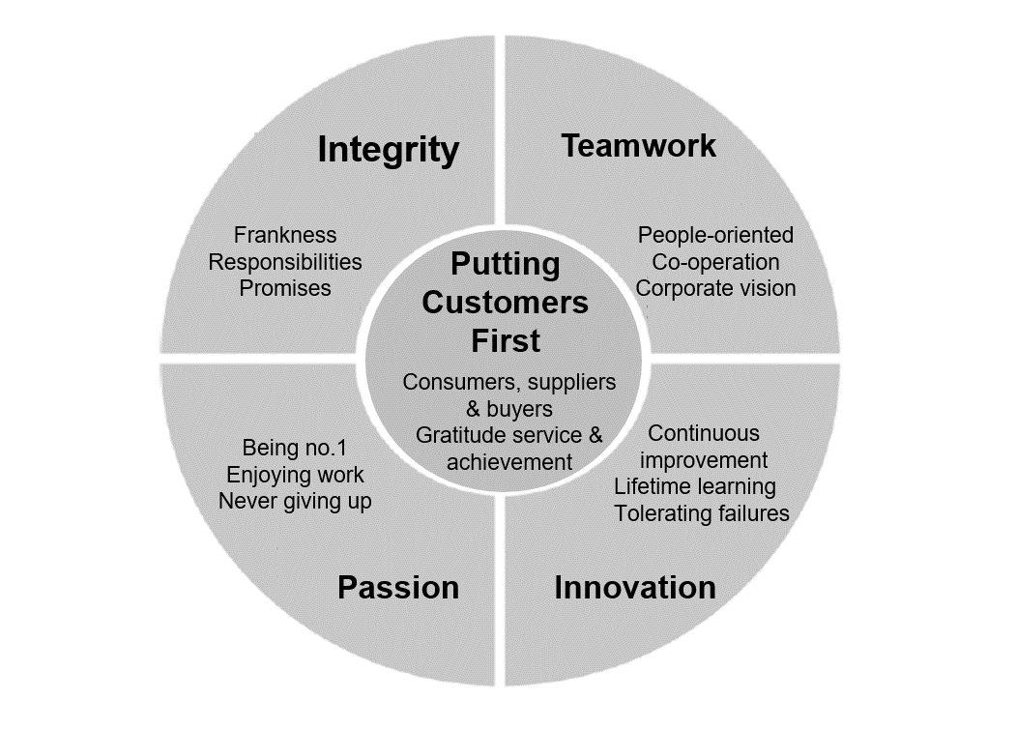

Source: Company information.

**Exhibit 3: Handbook for JD.com’s Core Values (Excerpt)**

**Value “Integrity” and its component “Responsibilities”:**

Behaviours we advocate (in terms of “Responsibilities”)

For managers,

* Take the initiative to shoulder responsibilities: lead the team to undertake challenging tasks and targets;
* Deliver high-quality results within deadlines;
* Delegate reasonably to subordinates to encourage them to assume more responsibilities;
* Be accountable for outcomes: when achieving the company’s strategic goals, can complete the assigned tasks even under huge pressure or suffering the loss of personal interests.

For employees,

* Respect company rules: never jeopardize company interests;
* Fulfill job duties: be punctual; be able to overcome difficulties; and take responsibilities for customers, the company, shareholders, and society.

Behaviours we object (in terms of “Integrity”),

* Break the state laws, regulations, and social morals; violate company rules, such as providing false information during recruitment; take leaves with fraudulent excuses; and work at other companies when being employed by JD;
* Take advantage of the position to obtain personal gains; personally receive gifts, cash, banquet invitations, and merchandise samples, as well as other improper benefits from customers, suppliers, or business associates;
* Commit an act of deception, concealment of truth, or evasion of responsibilities;
* Discuss the company’s financial secrets or other sensitive topics on inappropriate occasions;
* Disclose salary information;
* Hold double standards at work;
* Use improving customer experience as an excuse to seek benefits for the department or self.

Source: Company information.

**Exhibit 4: voting for the TOP Five behaviours**

The staff was asked to vote for their department on the following behaviours:

|  |  |  |  |
| --- | --- | --- | --- |
| **Category:**  **Putting Customers**  **First** | **No.** | **Behaviours** | **Number of Votes** |
| **Employees** | 1 | Help customers achieve the greatest success and create value for them. | 24 |
| 2 | Proactively put forward reasonable suggestions. | 14 |
| 3 | Take the initiative to solve problems for customers. | 14 |
| 4 | Keep in close contact with customers and pay attention to details. | 12 |
| 5 | Follow up their requests instantly and put yourself into their shoes. | 9 |
| **Managers** | 6 | Set a good example by serving internal staff well and thinking from their standpoint. | 20 |
| 7 | Hold regular exchange meetings with customers. | 14 |
| 8 | Understand why customers complain. | 13 |
| 9 | Welcome customers’ advice and feedback. | 12 |
| 10 | Communicate more with customers to understand their needs. | 12 |
| **Not to Do** | 11 | Fail to respond to customers’ feedback. | 23 |
| 12 | Evade responsibilities. | 16 |
| 13 | Blame customers and adopt a bad attitude towards them. | 11 |
| 14 | Fail to communicate with customers; be self-centred. | 11 |
| 15 | Ignore the building of team-service awareness. | 7 |
| **Category:**  **Integrity** | **No.** | **Behaviours** | **Number of Votes** |
| **Employees** | 1 | Take the initiative to shoulder team responsibilities. | 27 |
| 2 | Post data online in a timely manner and keep promises to deliver business results. | 25 |
| 3 | Submit accurate reports that truly reflect the situation. | 23 |
| 4 | Announce and explain the inability to complete tasks. | 13 |
| 5 | Properly assess workload and finish work according to schedule. | 12 |
| **Managers** | 6 | Maintain fairness and justice within the team. | 26 |
| 7 | Give accurate reports on teamwork and project progress in a timely manner. | 26 |
| 8 | Define clearly project goals and assist in solving problems. | 22 |
| 9 | Praise employees for their merits. | 14 |
| 10 | Properly manage the work plan. | 12 |
| **Not to Do** | 11 | Exaggerate achievements and evade responsibilities. | 26 |
| 12 | Avoid additional workload by not disclosing potential bugs when adding new features. | 17 |
| 13 | Cover up problems to evade responsibilities. | 16 |
| 14 | Not delegate enough but interfere too much during project implementation; fail to monitor project progress. | 15 |

Exhibit 4 continued

|  |  |  |  |
| --- | --- | --- | --- |
| **Category:**  **Teamwork** | **No.** | **Behaviours** | **Number of Votes** |
| **Employees** | 1 | Organize various interest groups to enhance understanding among team members. | 36 |
| 2 | Share knowledge among team members. | 34 |
| 3 | Trust each other; work together closely to solve problems. | 25 |
| 4 |  |  |
| 5 |  |  |
| **Managers** | 6 | Coordinate the team effectively to allow everyone to contribute. | 33 |
| 7 | Allocate team resources well to enhance efficiency. | 32 |
| 8 | Create a harmonious working atmosphere and establish common goals. | 25 |
| 9 | Get to know each team member and relieve any tension among them immediately. | 16 |
| 10 | Communicate often with employees, especially when they resent the team | 13 |
| **Not to Do** | 11 | Complain or spread negative emotions. | 20 |
| 12 | Use overtime as a key performance indicator. | 14 |
| 13 | Fail to follow the work plan. | 12 |
| 14 | Practice personal heroism. | 12 |
| 15 | Coordinate personnel according to personal preference or favouritism. | 10 |
| **Employees** | 1 | Be prepared to learn; be courageous to act; confront failures by drawing lessons from the experience; avoid being arrogant or impatient. | 20 |
| 2 | Stay positive and keep improving oneself; be confident; enjoy sharing. | 17 |
| 3 | Set learning goals and work out learning plans. | 13 |
| 4 | Do not hesitate to ask questions and exchange ideas. | 12 |
| 5 | Be prepared to tackle difficulties with determination and perseverance. | 12 |
| **Managers** | 6 | Become stronger after obstacles; be inclusive; make reasonable plans. | 17 |
| 7 | Help team members learn and create a supportive environment for learning. | 15 |
| 8 | Give team members advice on career planning and point out their areas for improvements. | 15 |
| 9 | Create an open and free working environment to encourage team members to give feedback. | 12 |
| 10 | Pay close attention to the development of the industry and the new ideas of rivals. | 11 |
| **Not to Do** | 11 | Easily get frustrated by minor difficulties and lose interest in learning. | 19 |
| 12 | Fear changes and failures; pessimistic. | 15 |
| 13 | Reject new knowledge, new things, and new ideas. | 15 |
| 14 | Do not care about team members’ learning, resulting in their pessimism. | 12 |
| 15 | Fail to trust colleagues and share responsibilities with them; complain about work. | 10 |

Exhibit 4 continued

|  |  |  |  |
| --- | --- | --- | --- |
| **Category:**  **Passion** | **No.** | **Behaviours** | **Number of Votes** |
| **Employees** | 1 | Regularly check dispatch status via internal system; handle dispatch errors immediately. | 11 |
| 2 | Complete daily work on time, especially crucial and urgent tasks. | 11 |
| 3 | Work professionally. | 10 |
| 4 | Dare to do new things, with the passion to overcome any unknown difficulties. | 10 |
| 5 | Engage in the department; encourage technical exchanges; share valuable technical achievements; and increase enthusiasm for work. | 10 |
| **Managers** | 6 | Provide guidance on and insights into work and projects. | 68 |
| 7 | Ensure fair division of labour. | 11 |
| 8 | Promote communication within the team and organize team-building activities. | 11 |
| 9 | Set clear vision for the department; develop smooth workflows; show respect for employees. | 11 |
| 10 | Vitalize team spirit and broaden technical horizon for team members. | 7 |
| **Not to Do** | 11 | Be over-emotional; give up easily. | 15 |
| 12 | Lack common team goals; abandon the team. | 12 |
| 13 | Object to simple, boring tasks of platform development. | 10 |
| 14 | Stay idle; assume that there is little or no room for improving the project. | 10 |
| 15 | Lack long-term planning for task assignment among team members. | 5 |

Results: The Top Five Behaviours That Obtained the Highest Number of Votes:

|  |  |
| --- | --- |
| **Top Five Behaviours** | **Number of Votes** |
| * + - 1. Provide guidance on and insights into work and projects. | 68 |
| * + - 1. Organize various interest groups to enhance understanding among team members. | 36 |
| * + - 1. Share knowledge among team members. | 34 |
| * + - 1. Coordinate the team effectively to allow everyone to contribute. | 33 |
| * + - 1. Allocate team resources well to enhance efficiency. | 32 |

Source: Company information.

**Exhibit 5: talent review matrix**

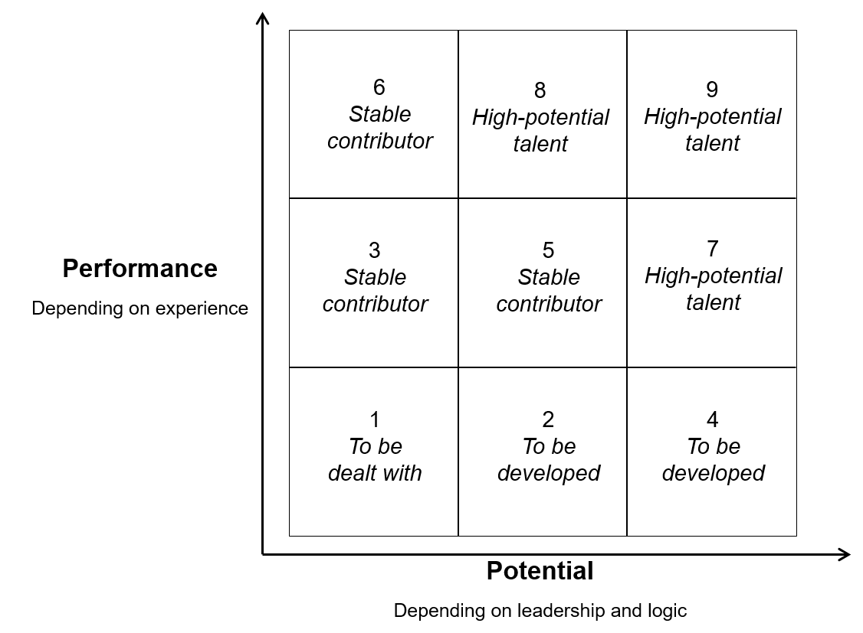

Source: Company information.