 

9B19C024

JD.com: HR Management challenges arising from Rapid growth and Transformation

Jean Lee, Leah Tan and Rain Long wrote this case solely to provide material for class discussion. The authors do not intend to illustrate either effective or ineffective handling of a managerial situation. The authors may have disguised certain names and other identifying information to protect confidentiality.

This publication may not be transmitted, photocopied, digitized, or otherwise reproduced in any form or by any means without the permission of the copyright holder. Reproduction of this material is not covered under authorization by any reproduction rights organization. To order copies or request permission to reproduce materials, contact Ivey Publishing, Ivey Business School, Western University, London, Ontario, Canada, N6G 0N1; (t) 519.661.3208; (e) cases@ivey.ca; www.iveycases.com. Our goal is to publish materials of the highest quality; submit any errata to publishcases@ivey.ca. i1v2e5y5pubs

Copyright © 2019, CEIBS (China Europe International Business School) Version: 2019-07-26

Between 1998 and 2018, JD.com Inc. (JD.com) transformed from a compact disc (CD)-burner shop into a technology-driven group of service companies and China’s largest retailer by revenue (US$55.7 billion). Headquartered in Beijing and listed on NASDAQ, JD.com was a Fortune Global 500 company and the third-largest Internet company in the world by revenue.[1] It had also been diversifying: for instance, in 2017, it turned its core competency—smart supply-chain management and logistics—into a profit-making business, JD Logistics, serving various industries. JD.com’s global research hub in Silicon Valley, with about 12,000 engineers and researchers, drove research and development (R&D) on machine learning, cloud computing, big data, and artificial intelligence (AI) to enhance both the online and offline shopping experience.

In 2011 and 2012, the company’s founder, chairman, and chief executive officer (CEO), Qiangdong Liu, recruited several chief officers (COs) to strengthen JD.com’s internal management in order to prepare for rapid growth to start in 2014. Yu Long was one of the new recruits. She joined in August 2012 as chief human resources officer (CHO) and general counsel. The staff increased from nearly 30,000 employees in 2012 to nearly 180,000 employees in 2018. Over these six years, Long launched various initiatives to strengthen the human resources (HR) team and improve its practices, including the annual talent review and several talent-development programs. She reorganized the HR team and was involved in designing management mechanisms to match the rapid growth and restructuring of JD.com. In 2018, JD.com aimed at developing proprietary technologies to transform into an “intelligent” conglomerate. The company aspired to revolutionize retail in China and other countries and to diversify into other sectors. To prepare for this, JD.com had already conceptualized and tested several new organization models that demanded a new mindset of its management and staff. Long thought about what her team could do more, or differently, in developing talent to support JD.com’s next phase of technology-driven growth.

Rapid Growth (up to 2017)

After Liu founded JD.com and closed all his brick-and-mortar stores in 2004, he focused on online retailing. Starting in 2007, with the aim of enhancing customer experience by offering speedy, reliable, and pleasant delivery services, Liu obtained a series of private equity investments to build the company’s own logistics centres and to employ its own warehouse and delivery staff. Between 2010 and 2012, JD.com’s headcount quickly grew from several thousand to nearly 30,000, 66 per cent of which were warehouse and delivery staff. In 2012, the company was already China’s biggest online retailer, with various brand partners. Liu set the theme for 2013 as “Xiu Yang Sheng Xi,” a Chinese idiom that meant “taking a rest to improve in order to revitalize.” In October 2013, the recently acquired finance business became an independent business group (BG), JD Finance. Being specialized, JD Finance took strategic guidelines from JD.com but remained autonomous in operations. In March 2014, JD.com formed a strategic alliance with Tencent Holdings Limited[2] to gain access to the latter’s WeChat social groups. In April 2014, the e-commerce business became the business group JD Mall, held by JD.com (the Group) (see Exhibit 1).

The COs stayed with JD.com at the JD Group level. In May 2014, JD.com Inc. was listed on NASDAQ to obtain funding for further growth. In 2015, JD Mall was reorganized into four business units (BUs), according to the major product categories: 3C (computers, telecommunications, and consumer electronics); Home Appliances; FMCG (fast-moving consumer goods); and Apparel & Home Furnishings. It launched the New Path BU to provide consulting services to small retailers, and a Silicon Valley R&D centre was established to redefine customer experience through cutting-edge technologies. In 2016, it added a Fresh Food BU, and in 2017, it branched out the Fashion BU from Apparel & Home Furnishings. In 2017, the logistics cost centre became a separate business group, JD Logistics, which had undertaken research on smart fulfillment capabilities, such as drone and autonomous-vehicle delivery, as well as automated warehouse technologies. JD Logistics had built the technologically advanced infrastructure of “Asia No. 1” smart fulfillment centres, including a nationwide network of about 500 warehouses with a total of 11.6 million square metres, as well as temperature-controlled supply chain facilities for temperature-sensitive merchandise. Its delivery service covered 99 per cent of the population in China. JD Logistics was able to deliver orders from within six hours to the next day, depending on the location in China, and this set the industry benchmark.

In 2017, JD.com’s net revenues reached ¥362.3 billion,[3] a 40 per cent increase over 2016 (compared to ¥41.4 billion in 2012), and its non-GAAP[4] net income increased 140 per cent over the previous year. Its core business, JD Mall, achieved a gross merchandise volume (GMV)—total sales value for merchandise—of ¥1,300 billion (compared to ¥86.9 billion in 2012), which was a multiple of 130,000 of the GMV in the year of foundation in 2004, thereby achieving a compound annual growth rate of about 150 per cent. The company served 292.5 million active customers in China in 2017 (compared to 29.3 million in 2012).

management challenges (UP TO 2017)

Liu brought in new COs from local industry leaders or foreign multinational companies (MNCs) in 2011 and 2012. Long, having work experience in foreign MNCs, discovered that the company’s HR problems were interrelated. In her first year (fall 2012 to fall 2013), she completed culture consolidation and talent review projects while integrating into the top management team. In mid-2013, Liu travelled to the United States to take a half-year “study break.” Just before he left, the talent review initiated by Long was completed, resulting in a pool of identified high-potential talent and successor pipelines. Liu said to the top management team, “The talent review gave me confidence to leave the business in your hands.”

When Liu returned, executives could feel the change of his mindset and leadership style. He became more open-minded and tolerant and showed respect to hierarchy and decision-making processes. In 2014, Liu no longer attended the entire management meeting or gave instructions on the e-commerce operations every morning. He attended the daily group-level top management meeting to listen to executives’ reports for 20 minutes only, then left the CEO of JD Mall to run the rest of the operational meeting. To speed up decision-making, JD.com implemented the ABC approval process. An employee, C, needed to obtain approval from only two levels up—from the employee’s supervisor, B, and that supervisor’s supervisor, A. Senior vice-president (VP) Yan Xiaobing commented, “[Liu] used to micro-manage us. Restraining himself from interfering with us needed courage.”

After the 2013 year of “rest to improve in order to revitalize,” Liu believed that JD.com needed to innovate and to mitigate the risk of the top management team operating further and further away from customers as JD.com grew. Liu set the theme of 2015 as “let the front line make decisions.” At the strategic meeting held at the end of 2015, Liu said to the executives, “From now on, I want you to take charge. My primary role is to nurture leaders.” Liu set the theme of 2016 as “find the boundary through delegation, empowerment, and activation.” He also realized that different businesses had different goals, growth paces, and resource requirements. Such variance demanded different employee capabilities and incentives. All of these management issues called for the support of the HR team.

Sophistication of HR management (2012–2017)

Long grouped the interrelated HR problems under the solution of culture, talent, and organization. She believed that culture would sustain the business, talent would execute strategies, and organization would win in the future. After completing the culture consolidation and talent review in 2013, she started on other improvement projects, in accordance with her five-year strategic plan set in late 2012. Long remarked,

To promote strategic HR management, the first step is to get involved in strategic business planning. I take the lead to participate in those strategy meetings. From the HR perspective, we need to understand the CEO’s management concepts and to diffuse them into the organization.

Being one of the few female COs, Long saw herself as using her communication skills to act as either a “lubricant” or an “adhesive” within the top management team.

Talent Development

Regarding talent development, Liu expressed,

Our successes are attributable to our team, a very strong team. That’s why I scout around for the best people. We emphasize potential. An important element of potential is the sharing of our corporate values.

As JD.com diversified, its complexity demanded versatile talent who could manage various product categories or even business groups.

Anticipative Talent Reserve

JD.com started a management trainee program in 2007, taking in only a few people in each of the first two years. It then gradually increased the number of annual intakes. In the beginning, Liu personally mentored trainees and regularly had lunch with them to discuss their lives and careers. In 2012, when the annual intake number was close to 100, the respective department heads took over the coaching role. Still, Liu wrote encouraging emails to the trainees. The HR team also ran special training programs for the trainees and set aside a budget for their activities. Each trainee went through a three-year program, which included military training, initial job rotations, and one-year job assignments. With their supervisor’s approval, trainees could attend morning management meetings to observe how the executives operated. By 2017, JD.com had admitted a total of 510 trainees. Among them, 118 people became JD.com managers by about the age of 30—for example, Rui Yu, who joined the program in its second year, with Liu as his mentor, became a regional director within five years of completing the program and later became JD.com’s youngest internally groomed VP.

To support the internationalization strategy, Long launched an international management trainee program in October 2013, recruiting MBA graduates from top schools in the United States who also had three to five years of prior working experience. In the first year, Long took her HR team members to six schools and recruited six candidates to go through a one-year job rotation program. Liu maintained regular idea exchanges with these international management trainees. As a result, the trainee team from the first year (2015) took only 102 days to launch the JD Worldwide cross-border e-commerce platform, which gave Chinese consumers access to imported goods.

Long also launched an internship program, recruiting high school students worldwide. These interns spent the first week learning JD.com’s operations and then had nine weeks of practice. The HR team monitored their progress and selected the best students to participate in interviews for the respective management trainee programs.

Internal Talent Pool

In the first half of 2013, among 700 managers and directors assessed during the talent review, 198 high-potential individuals were identified using the three-by-three matrix (see Exhibit 2). Such identification did not immediately lead to salary increases or promotions, but the HR team and the newly established JD University designed a series of leadership programs specifically for them. In that year, based on performance, 30 per cent of those identified as high-potential talent received a job promotion (compared to 25 per cent of the rest of the staff). Liu declared, “By 2018, at least 80 per cent of the directors and executives must be from internal promotion.” JD.com identified high-potential talent every year, and the HR team monitored their development. For instance, in 2014, among 1,650 managers and directors assessed, about 400 were identified as high-potential. Long added,

Not only did the talent review help us develop a common managerial language, but it also let the management team agree on the talent selection criteria and formed the talent development consciousness.

JD University also started building a systematic educational system to support managerial and professional staff in progressing in their careers within JD.com.

Reorganization of the HR Team

The HR team members adapted to JD.com’s growth and restructuring by reorganizing themselves. Before JD.com became a group of companies, there were already HR business partners (BPs) allocated to the businesses, and they performed all HR duties. In 2015, after JD Mall branched out, the HR team was split into Group HR and JD Mall HR. The HR VP of JD Mall directly reported to the CEO of JD Mall and indirectly reported to Group CHO Long. In 2016, the Shared Service Centre (SSC) was established at the Group headquarters. The SSC and the e-HR information system established in 2013 formed the back office to support all the BGs. In 2017, to enhance efficiency and competency, the Group HR and JD Mall HR shared the Centre of Excellence/Expertise (COE), which emerged to take over the role of setting HR policies and practices from the HR BPs. Since its corporation in 2013, JD Finance had its own HR head, which led to a dedicated team of HR BPs, and continued to have its own COE.

The specific purpose of each of the three layers of the HR team became clear (see Exhibit 3). JD.com formed a management committee for making strategic HR decisions, headed by Group CHO Long (see Exhibit 4). The HR VP of JD Mall and the HR head of JD Finance indirectly reported to Long. After the branching out of JD Logistics, its HR VP, who directly reported to its CEO and indirectly reported to Long, also joined the committee. Head of Organizational Development, Qian Mao, commented,

On the one hand, the changes of the HR teams followed the changes of JD.com. On the other hand, the reorganization of the HR team stemmed from the foresight and planning of how to better manage HR professionals. We need to consider the member composition and team dynamics, and to reposition the team as often as needed.

Management Mechanism

To make the theme of the year 2016 “find the boundary through delegation, empowerment, and activation” come alive, JD.com created and implemented a new management mechanism (see Exhibit 5).

Delegation

Long knew that clarifying authority between the Group parent company and the BGs or BUs and making decision-making processes transparent and simple would be essential (see Exhibit 6). When the Group level passed the decision-making power to the BGs and BUs, there were three management aspects: finance, people, and business. In terms of finance, the Group parent company controlled the overall budget, while each BG or BU set its own profitability target and had the autonomy to use the approved budget. In terms of people, the Group parent company handled HR decisions regarding executives, while each BG or BU made decisions regarding directors and below. For instance, each BU could decide the salary range of a job rank. In terms of business, the Group parent company set the overall strategy, mitigated risks, and allocated cross-BG resources, while each BG or BU set its own business strategy, allocated its own resources, and managed daily operations. Mao, reflected,

At the beginning, people were testing the boundary. When we did a review in end-2016, we found out that some people grasped the real meaning of delegation, while others were still not good at [resource] allocation. In 2017, we adjusted the degree of delegation by tracking data to monitor how they used resources. For BG/BUs that showed good use of resources, we gave them more autonomy.

In August 2017, to help the managers find the performance boundary, JD.com offered 14 management principles of organizational efficiency to do the following (see Exhibit 2):

* Affirm the use of corporate values as the most important performance evaluation criterion—the principle of “Corporate values first, capabilities second.”
* Build an internal promotion path—the principles of “Backup” and “70 per cent, 80 per cent.”
* Refine performance evaluation—the principles of “Three-by-three matrix elimination” and “Ironman triathlon assessment.”
* Minimize hierarchical levels—the principles of “ABC” and “8150.”
* Improve management quality—the principles of “One taking two,” “No, no, no,” “24 hours,” and “Meeting 333.”
* Strengthen cross-department communication—the principles of “Two subordinate support, two job rotations,” “Internal communication four,” and “Open five.”

Empowerment

There were four ways to enhance the management capability of the BGs and BUs and to strengthen the expertise of HR BPs: mechanisms, organization, practice, and professionalism.

JD.com had developed various mechanisms to support its increasingly complex operations. For instance, the “internal transfer” mechanism stated clearly the value of internal resources to facilitate transactions among departments. The “internal communication” mechanism required vice presidents and above to attend a weekend business meeting once a month. The “alert-and-improve” mechanism showed the people in charge their business results and reminded them to improve accordingly.

Organization-wise, JD.com dedicated experts in functions such as HR, finance, and R&D to support the BGs and BUs.

Practice referred to the support given by the headquarters and BGs to new BUs. When the scale of a new business, such as Fresh Food, was small, the Group and the BGs acted as coaches to help it make important decisions or launch big initiatives. Once the business matured, the BU became autonomous.

The key of professionalism was the sharing of information through the availability of information systems and analytical tools, as well as through regular formal and informal communications across departments.

Activation

Activation was intended to motivate and energize employees in an effective managerial environment that had been created through delegation and empowerment.

the Future (2018 onwards)

In 2017, Liu announced that JD.com would transform into an “intelligent” conglomerate during the next 12 years by making use of the capabilities it had accumulated in the previous 12 years. Its global research hub and innovation labs would continue to develop and apply technologies in the areas of smart supply-chain management and logistics, machine learning, cloud computing, big data, and AI. Not only would JD.com diversify to other sectors such as intelligent insurance, but it would also aspire to revolutionize retail operations in China and other countries. In 2018, Google LLC (Google) agreed to invest US$550 million in JD.com to explore joint development of retail solutions for expansion into Southeast Asian, North American, and European markets. In return, Google acquired a stake of JD.com. Meanwhile, after the successful launch of the first JD X-Mart unmanned store in Beijing, JD.com continued to open more unmanned stores across China and launched its first international unmanned store in Indonesia. In August 2018, it launched a new blockchain open platform for enterprises, building on multiple underlying technologies.

Liu knew that the reasons for JD.com’s rapid growth in the past might not be its competitive advantages in the future. Rather, updating business models, developing proprietary technologies, establishing sound and relevant management systems, and enhancing organizational efficiencies would be crucial. To achieve this, JD.com would need to use innovative ways to reorganize its people. JD.com would not only need talent with relevant competencies but also talent with the right mindset to match Liu’s new vision.

New Organization Models

Facing this huge transformation, Liu believed that the organization should be more flexible and agile; he thought of “building blocks,” with the idea that the organization should transform into many modules that could be assembled differently to satisfy external or internal customers. JD.com came up with the following three business models in the spirit of “flexibility and agility.”

Customer-Oriented “Net”

This model consisted of three parts—terrace structure, task marketplace, and net relation (see Exhibit 7). The keys of terrace structure were customer orientation and new division of labour. The idea was to rearrange employees into three layers of role—front line, middle ground, and back office. The front line aimed at quickly responding to customers and satisfying customers’ individual needs. The middle ground aimed at developing expertise and excellence to satisfy customers’ common needs. The back office aimed at building an infrastructure to offer shared services. In the second half of 2017, JD.com finished the pilot of the terrace structure at JD Mall’s R&D department. Its front-line employees then focused on interacting with internal customers. Its middle-ground employees focused on renewing technologies to support the front line in offering customers more open technological solutions. The back-office employees focused on maintaining the platform infrastructure.

The “task marketplace” aimed to solve problems of internal resource allocation. Front-line staff would specify each customer request as a job, then the job would be translated into a set of tasks that called for the formation of cross-department task teams. Each team’s performance would be evaluated.

Because of the task teams, employees no longer reported to their supervisors only but also to their team leaders. This would form net relations and lead to net appraisals. The net relations would have two levels: within the organization and with external parties such as customers, brand partners, and suppliers. To enable net appraisal, JD.com would use the e-HR information system to allow each party in the nets to give feedback to every employee. In the beginning of 2018, JD.com finished the pilot of the net model at JD Mall’s R&D department and other functional departments. JD.com planned to roll out this model to the rest of the organization.

“Diamond”

At the end of 2012, when Long had devised her five-year HR strategic plan, she thought about introducing the concept of a “performance contract.” In 2017, Long refined this thought and proposed the “diamond” model to use corporate values and a psychological contract as the “glue” to strongly hold people together (see Exhibit 8). The model aimed to use a psychological contract, rather than just a legal contract, as before, to regulate employees. It was also designed to use corporate values, rather than individual values, to guide employees’ judgments and behaviours. The diamond had two elements:

* Three cultural pillars—corporate culture, leadership culture, and team culture.
* Two Ts: the first T was what an employee could offer—breadth and depth of capabilities; the inverse T was what JD.com could offer—platform value and developmental space.

The diamond model showed that JD.com aimed to develop its workforce to share the same characteristics of a diamond—pure, transparent, tenacious, and long-lasting.

Interdependent “Bamboo Grove”

This model was designed to connect the organization’s management and staff with its customers, brand partners, and suppliers in order to integrate internal and external resources and empower external parties, as in a bamboo grove ecosystem (see Exhibit 9). Such an ecosystem—which would be built by openness, co-creation, and empowerment—symbolized the interdependence of all parties. To demonstrate this concept, the HR team launched TELink (Talent Eco Link) in 2017 to extend talent development beyond JD.com. It established a cross-organization job-rotation mechanism to allow staff to work in other organizations within the ecosystem.

New Talent War

Because of Liu’s new vision, JD.com needed more talent who were savvy regarding the relevant breakthrough technologies and who could also work internationally. By the end of 2017, the HR team had already given training to 86 per cent of its managerial staff and 60 per cent of its professional and technical staff. But such internal training would not be enough for the new competencies required. For example, in 2010, Amazon started developing and adopting intelligence technologies to enhance shopping experiences and to improve big-data-driven analytics, consumer targeting, and inventory management. In October 2017, it opened a new research centre, the fourth in Germany, to focus on AI.[5] Amazon had not only developed new talents in this emerging field but had also preluded a war for these talents. JD.com’s head of Talent Development, Dongni Ji, remarked,

We are very concerned about anticipating and preparing for our talent requirements. With our internationalization, we have stringent requirements for management skills, business knowledge, and cross-culture interpersonal skills. With our new technology-driven vision, we have to intensively develop new core competencies. We face the challenge of how to identify and recruit this new breed of talents [in China and other countries]. We also need to create an echelon for them.

The new corporate vision and organization models would also impact existing management and staff. They would need to have a new mindset—to be more flexible and agile. What options would Long have regarding talent management to meet these new organizational needs?

**Exhibit 1: business divisions**

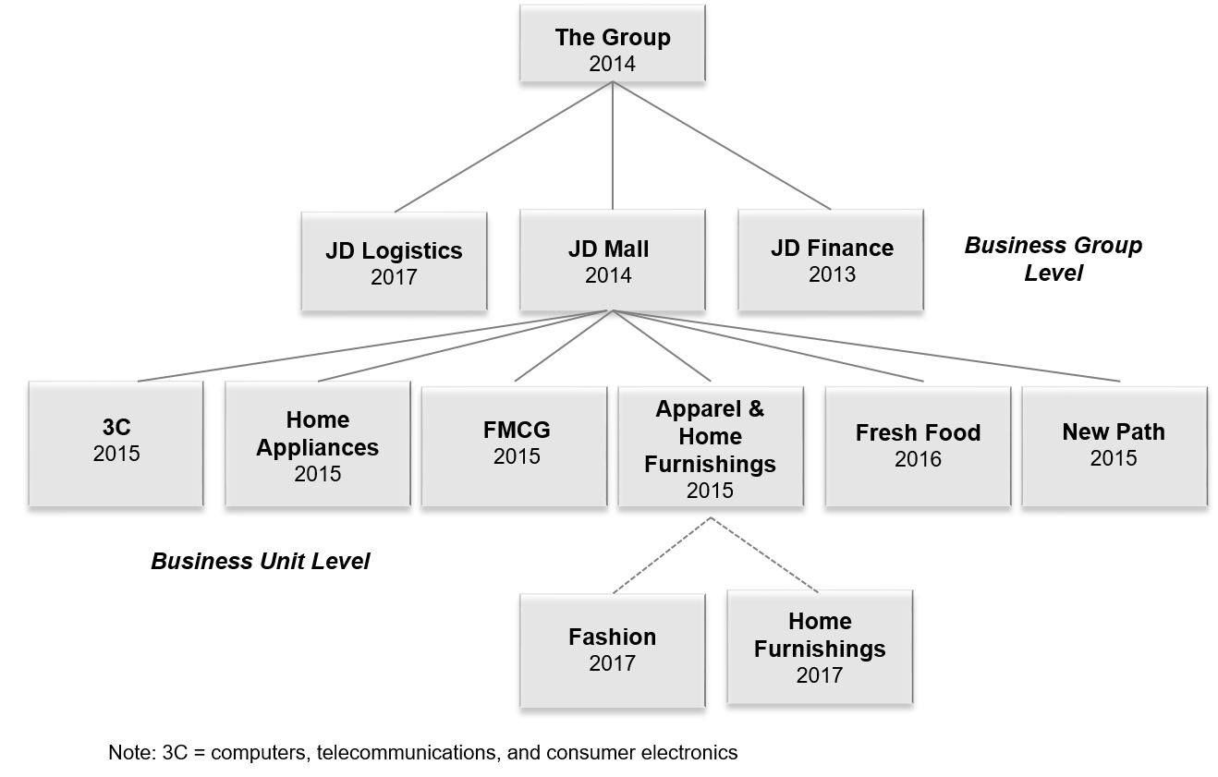

Note: 3C = computers, telecommunications, and consumer electronics; FMCG = fast-moving consumer goods.

Source: Compiled by the case authors based on company information.

**Exhibit 2: 14 management prinicples of organizational efficiency**

**Principle 1: Corporate values first, capabilities second**

JD.com continued to classify employees and job candidates into five types:

(1) “Gold”–-those who were highly capable and shared the corporate values.

(2) “Steel”–-those who were capable and shared the corporate values.

(3) “Iron”–-those who shared the corporate values but were barely capable.

(4) “Scrap iron”–-those who failed to meet the company’s requirements for capabilities and values.

(5) “Iron rust”–-those who did not share the corporate values but had outstanding capabilities.

JD.com strove to have 80 per cent of the staff as “steel” and the remaining as “gold.”

**Principle 2: ABC**

Only supervisors A and B (one level and two levels up) of C were needed to jointly make HR decisions on C. This simplified the approval process.

**Principle 3: One taking two**

With the respective chief officer’s approval, an incoming manager (or above) could take a maximum of two subordinates from the previous internal department or external company into his or her department in order to minimize the risks of forming political parties within JD.com (except as required by organizational restructuring.

**Principle 4: Backup**

One year after joining, every new director (or above) had to identify a potential successor who could take over his or her position within three years. Otherwise, the director would not receive any rewards such as salary increases and promotions. Two years after joining, if the director was still unwilling to identify a potential successor, he or she had to leave JD.com.

**Principle 5: No, no, no**

Without facts or data to prove that the request was incorrect, one could not say no.

If the request would enhance customer experience or support JD.com’s growth, one could not easily say no.

**Principle 6: 70 per cent, 80 per cent**

If an employee, especially a young one, shared the corporate values and reached 70 per cent of the position’s requirements, his or her AB supervisors (one level and two levels up) should pay attention to their development.

For an available position of manager (or above) in an established business, the business unit should give priorities to internal staff. JD.com strove to have 80 per cent of the total position fulfillment each year come from internal promotions.

EXHIBIT 2 (CONTINUED)

**Principle 7: Three-by-three matrix elimination**

In the annual talent review, the high-potential talents identified (cells 7–9 in the matrix below) would enter JD.com’s talent pool and be given additional development opportunities. Staff in cells 2 and 4 could stay and would be given improvement opportunities to try a different position and receive coaching. Problematic staff in cell 1 would be asked to leave JD.com.

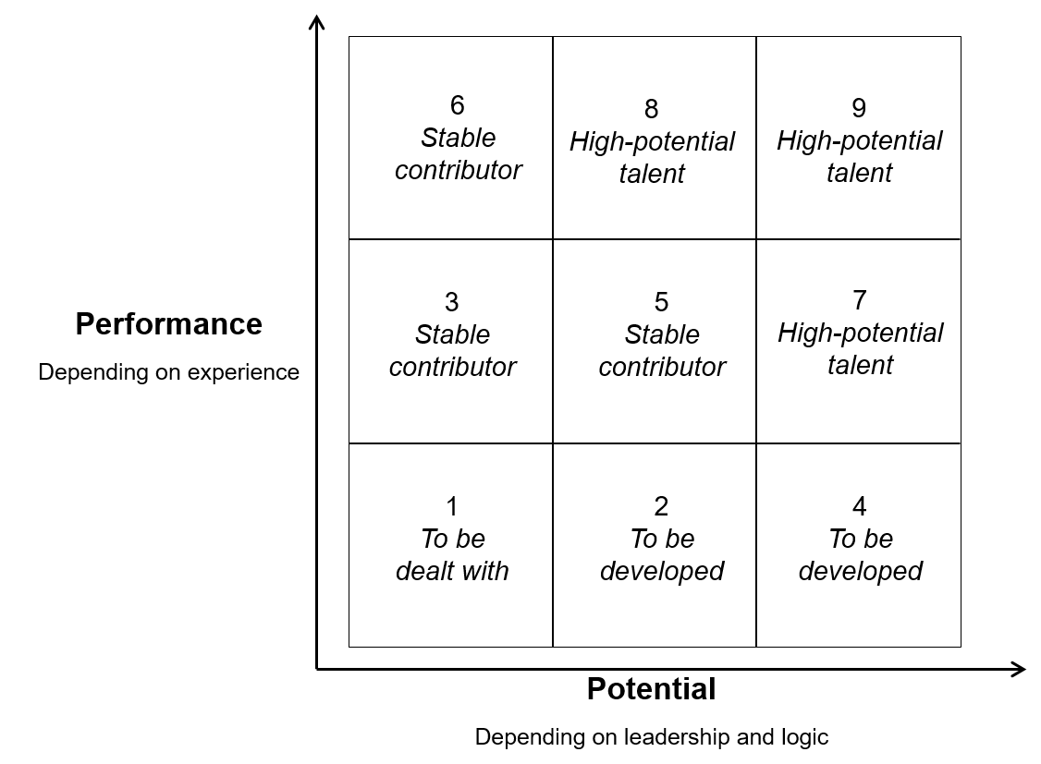

**Principle 8: Two subordinate support, two job rotations**

Managers (or above) had to give support to their subordinates (one level below) two times a year.

Every manager (or above) had to go to other departments for at least one day of job rotation two times a year. At least one of the two job rotations had to be in a collaborating department.

**Principle 9: 8150**

To avoid having too many layers, every manager (or above) should have at least eight direct reports. Only when there were more than 15 subordinates should a new manager be added at the same level to share these subordinates.

**Principle 10: 24 hours**

Every manager (or above) should respond to subordinates’ requests, inquiries, and reports—by phone, email, SMS (short messaging service), WeChat, etc.—within 24 hours.

**Principle 11: Meeting 333**

A PowerPoint presentation should not be more than three slides.

Each meeting should not be more than 30 minutes.

Meetings for the same decision should not occur more than three times.

Exhibit 2 (continued)

**Principle 12: Ironman triathlon assessment**

Each staff member or manager should focus on only three key performance indicators.

**Principle 13: Internal communication four**

* Time allocation 721: Each manager should spend their time as follows: 70 per cent communicating with subordinates, 20 per cent with peers, and 10 per cent with supervisors.
* Report line ABC: Each employee should report to a maximum of two immediate upper levels and should not bypass them.
* Open communication: One could equally communicate with any ranks or departments.
* Project leader accountability: Each project leader would have the authority and resources for fulfilling his or her responsibilities set by the project.

**Principle 14: Open five**

* Open weekly report: In addition to his or her supervisors, both one level and two levels up, each manager should also send the weekly report to any other relevant colleagues.
* Open regular meeting: Managers should reserve one-third of the total seats at a regular meeting for directors (or above) of other departments who wish to attend the meeting.
* Open data: Each department should share relevant data (except highly sensitive) with collaborating departments.
* Open strategies: Each manager (or above) should explain strategies of the Group parent company and BGs and BUs to the staff.
* Open talent: Managers should not reject an employee’s application to move to another position if the employee has been in the existing position for a year. Managers should initiate discussions with an employee who has been in an existing position for three years to plan his or her career development and to explore possibilities to move to another position. Managers must move an employee who has been in an existing position for five years to another position.

Note: BGs = business groups; BUs = business units.

Source: Compiled by the case authors based on company information.

**Exhibit 3: structure of the HR TEAM**

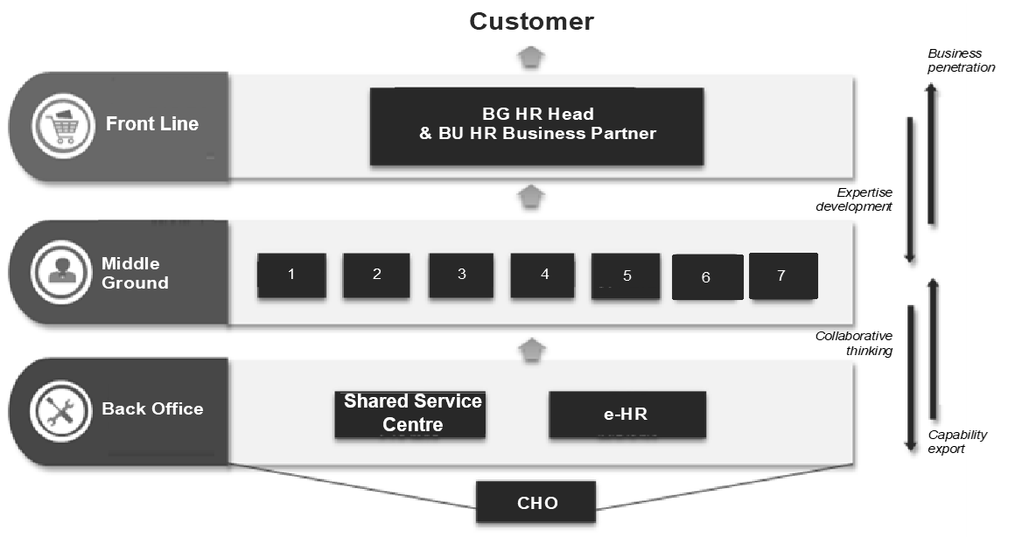

The HR team had three layers:

* Business Partners, allocated to BGs or BUs at the Front Line:
  + Existed a long time ago to penetrate into business.
  + Aims: To promote the business, allocate resources, and come up with solutions.
* Centre of Excellence/Expertise to support BGs in the Middle Ground:
  + Its role blurred with BP before, but became distinct under this model: setting HR policies and practices in organizational design, talent management, recruitment, training and development, performance appraisal, salary and benefits, and corporate culture (cells 1–7 in the diagram).
  + Aims: To promote expertise, integrate resources, and export capability.
* The Shared Service Centre and the e-HR information system assemble and analyze HR digital data at the Back Office:
  + Established in 2016 at the headquarters; started to build Shared Service Centres in other regions.
  + Aims: To promote efficiency, establish systems, and oversee and improve processes.

Note: HR = human resources; BGs = business group; BUs = business units; CHO = chief human resources officer.

Source: Company information.

**Exhibit 4: HR management committee**



Note: HR = human resources; CHO = chief human resources officer; VP = vice-president; COE = Centre of Excellence/Expertise.

Source: Compiled by the case authors based on company information.

**Exhibit 5: management mechanisms**

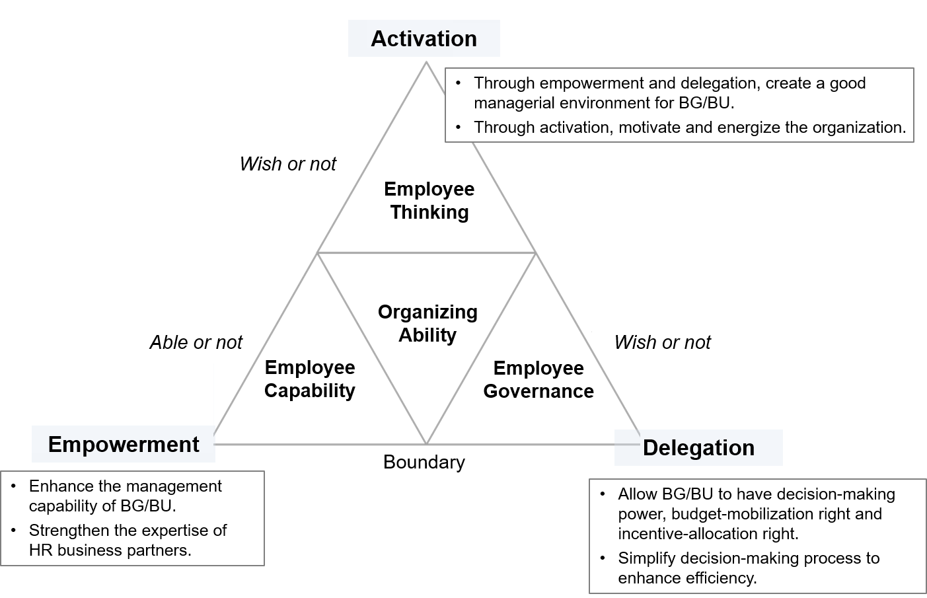

Note: BG = business group; BU = business unit; HR = human resources.

Source: Company information.

**Exhibit 6: delegation mechanism**

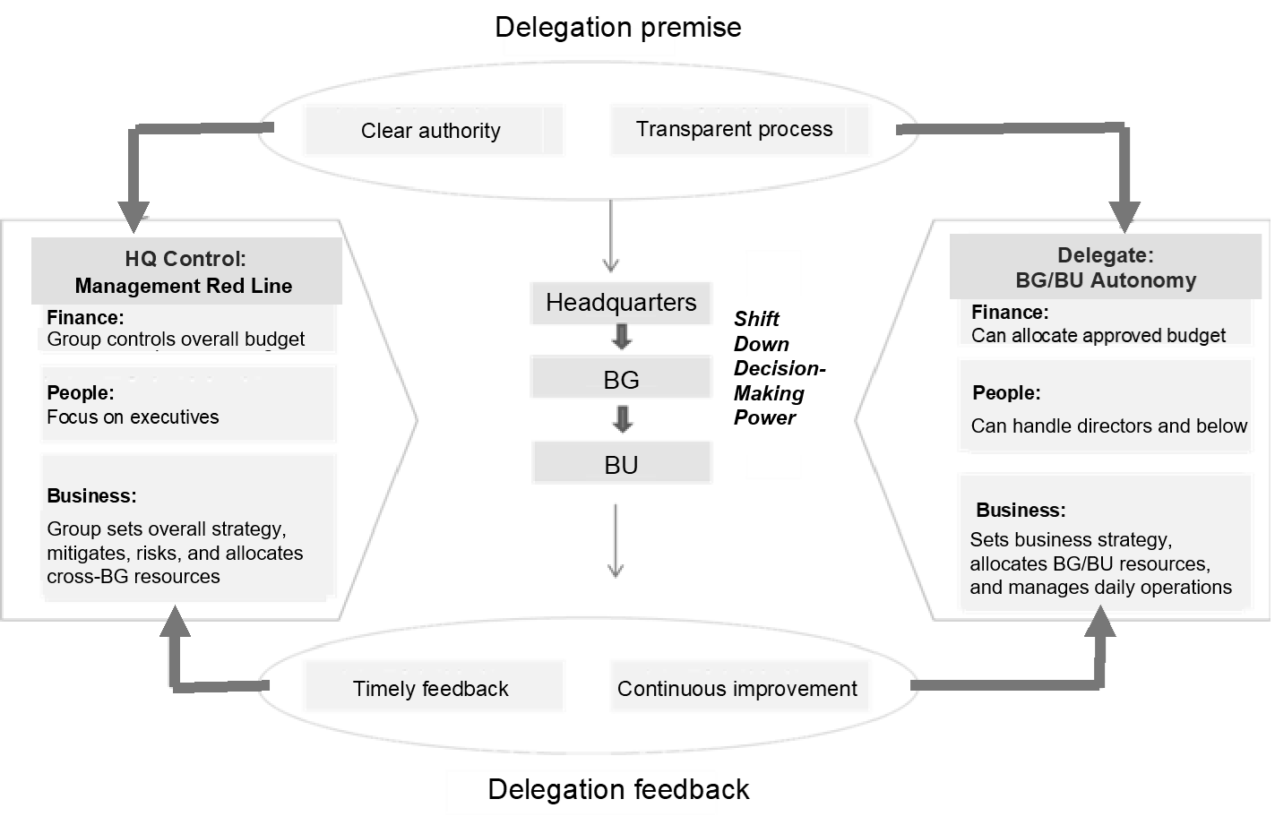

Note: HQ = headquarters; BG = business group; BU = business unit.

Source: Company information.

**Exhibit 7: customer-oriented “NET” organization model**

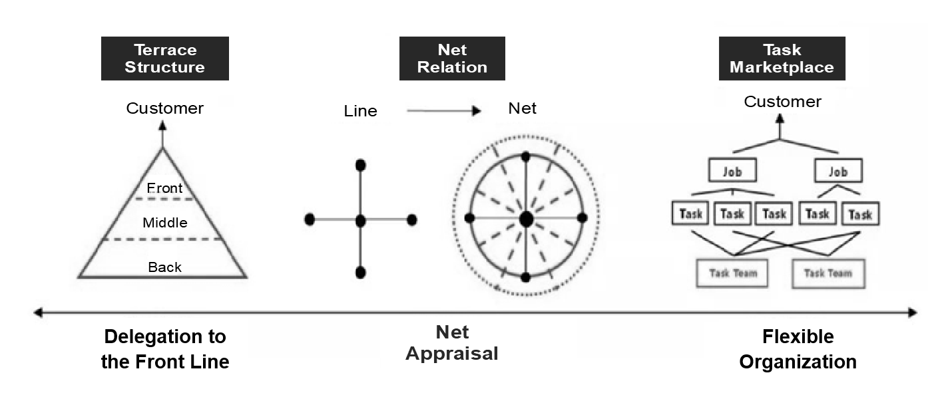

Source: Company information.

**Exhibit 8: “diamond” organization model**

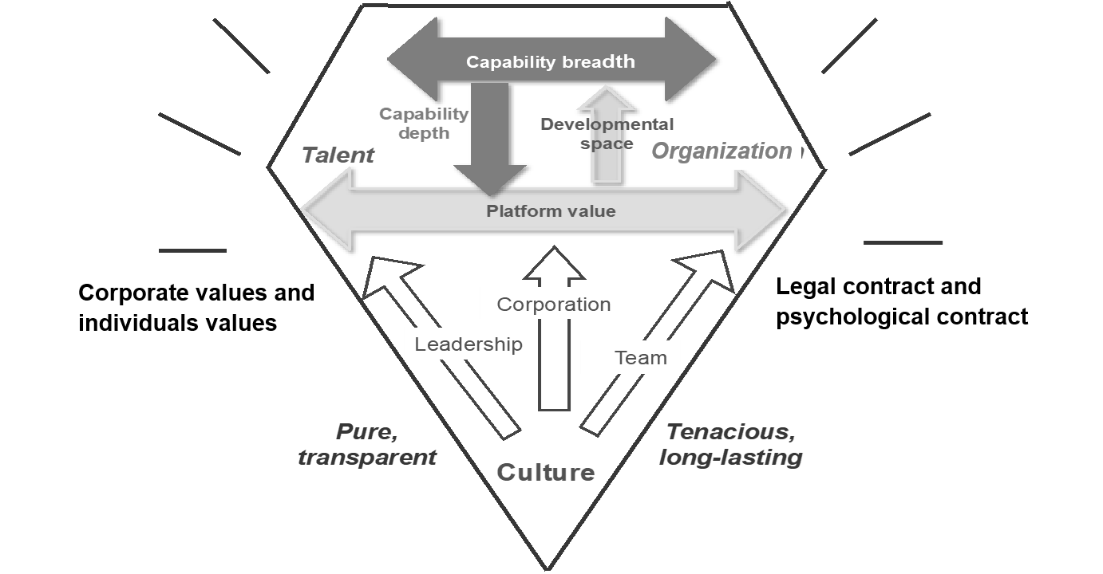

Source: Company information.

**Exhibit 9: interdependent “bamboo grove” organization model**



Source: Company information.

1. “Corporate Factsheet,” JD.com, accessed October 31, 2018, <https://jdcorporateblog.com/factsheet/jd-com-factsheet>. After Amazon (US$177.9 billion) and Alphabet (US$110.8 billion).
2. Tencent Holdings, accessed June 10, 2019, www.tencent.com/en-us/index.html.
3. ¥ = CNY = Chinese yuan renminbi; US$1 = ¥ 6.5059 on December 31, 2017.
4. “GAAP” stood for “generally accepted accounting principles.” Non-GAAP earnings was an alternative accounting method, and was reported as the supplement for GAAP earnings.
5. Natasha Lomas, “Amazon to Open Visually Focused AI Research Hub in Germany,” TechCrunch, October 23, 2017, accessed October 31, 2018, <https://techcrunch.com/2017/10/23/amazon-to-open-visually-focused-ai-research-hub-in-germany>. For another source in Chinese, see “Amazon to Open Visually Focused AI Research Hub in Germany,” TechWeb, October 23, 2017, accessed October 31, 2018, www.techweb.com.cn/world/2017-10-24/2596876.shtml.