

9B19C029

Street Child Europe: Growing a Charity

Joerg Dietz and Anna Zampa wrote this case solely to provide material for class discussion. The authors do not intend to illustrate either effective or ineffective handling of a managerial situation. The authors may have disguised certain names and other identifying information to protect confidentiality.

This publication may not be transmitted, photocopied, digitized, or otherwise reproduced in any form or by any means without the permission of the copyright holder. Reproduction of this material is not covered under authorization by any reproduction rights organization. To order copies or request permission to reproduce materials, contact Ivey Publishing, Ivey Business School, Western University, London, Ontario, Canada, N6G 0N1; (t) 519.661.3208; (e) cases@ivey.ca; www.iveycases.com. Our goal is to publish materials of the highest quality; submit any errata to publishcases@ivey.ca. i1v2e5y5pubs

Copyright © 2019, Ivey Business School Foundation Version: 2019-11-22

At the end of March 2018, Florian Weimert, the director of the Barcelona office of Street Child, knew that Street Child Europe would have to continue growing in terms of funding and volunteers recruitment. Street Child was a charity organization with headquarters in the United Kingdom (UK). The Barcelona office was a sub-unit of the UK office. In addition to running Street Child Spain, this office was responsible for growing Street Child in continental Europe, and so it was internally referred to as Street Child Europe.

Since January 2018, the Barcelona office had added a paid employee, Anne Beuken, who was also the director of Street Child Netherlands. The office could now employ up to eight interns, twice as many as before. Weimert was relieved to have Beuken on board. However, he was concerned about five key tasks that Street Child Europe had to accomplish to achieve its objectives. First, Street Child Europe had to address its governance structure to determine its exact role in relation to the continental European country branches. Second, it had to clarify its brand positioning in the crowded market of children’s charities. Third, it had to consolidate its fundraising strategy, and fourth, it had to find a way to increase the appeal of the international volunteering program (IVP), which was an important source of funds and volunteers. Lastly, Street Child Europe needed an organizational design that used its network effectively, while avoiding the loss of knowledge loss associated with the constant turnover of interns and volunteers.

Street Child Overview

Street Child raised funds, mostly in Western countries, to finance its field activities in African and Asian countries. The UK headquarters in London coordinated the efforts of Street Child globally and determined where the charity would be active in the field. The European and US branches of Street Child served primarily as fundraising offices. The African and Asian branches were in charge of field operations.

Although the legal registration of charities varied by country, the basic model was that charities operated like trustees that managed assets, such as facilities or equipment, in the interest of intended beneficiaries. Each charity also had to spend its funds in the interest of beneficiaries. If a charity dissolved, its assets went to the beneficiaries or to another charity. At the UK headquarters of Street Child, a six-member board controlled the use of assets and funds, relying on an external auditor’s reports. This board of trustees, the beneficiaries, and the external auditor were the main stakeholders. Other stakeholders included funders, such as foundations, and the charity’s staff, which consisted of paid employees and volunteers.

History

Tom Dannatt founded Street Child in 2008 in London as a charity for the children of Sierra Leone, West Africa. After a decade of civil war in Sierra Leone, many children suffered from the loss of their families, poverty, and a lack of education. Street Child’s philosophy envisioned “a world where the rights of every child are realised, in particular, the right to education” (see Exhibit 1). It’s core areas of work were education, child protection, and livelihood. In 2013, Street Child expanded to Monrovia, the capital of Sierra Leone’s neighbour Liberia.

The main projects in Sierra Leone and Liberia were related to education. Street Child built or renovated schools. It also took on partial management of schools, typically within consortia including local partners, other charities, and governmental organizations. Activities included teacher training, provision of teaching materials, and renovation of school facilities. The focus was on elementary-level education to prepare children for enrollment in advanced schooling systems. Some programs targeted specific groups, such as children affected by the Ebola outbreak or children in a specific region. A 20-week family business scheme helped recipients learn to generate their own income and eventually pay for schooling their families.

The growth of Street Child’s projects in Africa coincided with its emergence in continental Europe. In 2012, Street Child launched its signature funding activity: the annual Sierra Leone Marathon, which brought supporters and funders of Street Child to visit the charity’s field operations in Sierra Leone. The marathon led to an exponential growth in the number of people committed to the charity. In the years after 2012, Street Child opened branches in Spain, Italy, the Netherlands, Germany, France, Switzerland, Sweden, Denmark, and the United States. Initially, these branches were just small groups of supporters without offices. Their initial key task was the legal registration of branches in their countries.

In 2014, the Ebola epidemic orphaned thousands of children in Sierra Leone. Street Child led the Ebola orphan response, helping over 12,000 children. Street Child soon expanded its Ebola-related efforts to Liberia. In April 2015, after the Nepal earthquake, the United Nations Children’s Fund (UNICEF) asked Street Child to help rebuild schools for more than one million children. In 2017, Street Child started working in Nigeria, where three million children could not go to school due to the activities of the terrorist organization Boko Haram. In Borno State, three out of five schools had closed, and over 19,000 teachers had been displaced. Street Child provided emergency support in camps, facilitated access to education, and offered psychological support in collaboration with local partners.[1]

At the end of 2017, the UK headquarters of Street Child had 12 full-time employees and about 100 interns and active volunteers (see Exhibit 2). Street Child Nepal and Street Child Nigeria were subsidiaries of the UK office with their own boards and staff. Street Child Spain also was a sub-unit of Street Child UK because the registration of Street Child Spain as a Spanish charity was still ongoing. The full Street Child network also included the Sierra Leone and Liberia offices, the nationally registered European branches, and the US office—which were all registered as legally independent entities, separate from Street Child UK and its subsidiaries. In 2017, the entire Street Child organization employed 34 employees, 13 more than in 2016. Street Child’s 2016–17 annual report explained the organization’s structure:

Street Child UK continually supports its partner entities with a combination of management and financial supervision, and technical and strategic advice. This allows Street Child entities to receive direct local funding and maintain local ownership, whilst retaining a minimum level of oversight by Street Child UK.

Key Fundraising Activities

For the fiscal year 2016–17, the total income of the UK office was £3,854,314,[2] up from £2,058,783 in the preceding period. Most of the increase came from the launch of Street Child Nepal. Street Child’s total income for the same two periods was approximately £6.0 million and £3.8 million, respectively. The subsidiaries in Sierra Leone and Liberia had obtained greater funding through school building programs.

Street Child had four main sources of funding. First, the UK government often matched the donations of its citizens. Over the years, the UK Department for International Development had been a consistent source of funding for the entire Street Child organization. In 2017, it contributed 34 per cent of the Street Child network’s total income (due to large amounts granted to Street Child UK and Street Child Sierra Leone). Second, by partnering with the United Nations and private companies, the Street Child network received 26 per cent of its income from the United Nations and other partnerships.

The Street Child network also obtained grants from foundations and trusts. These institutions were private or public entities that supported individual projects. Foundations were accountable to their sponsors, whether they were companies or private people, and typically required the submission of project proposals, including detailed action plans, expected outcomes, and budgets. Street Child received 16 per cent of its income from foundations and trusts in 2017. Fourth, private citizens, mostly from the United Kingdom, donated to Street Child directly or through participation in Street Child events, such as the marathons in Sierra Leone (since 2012) and Nepal (since 2016). Donors also raised funds to become eligible for the IVP. Of Street Child organization’s total income, 24 per cent came from public fundraising.

The financial income contributed through the marathon events was relatively small, yet these events were important activities for promoting the Street Child brand. Annually, the Sierra Leone marathon attracted over 200 runners from Europe to compete in the event and learn about the supported communities. Street Child organized the marathon, including travel, accommodation, and accompanying events. The participants paid for their participation, typically drawing on their networks to raise the necessary funds.

Most grants from foundations and trusts had to be spent on specific projects, under strict monitoring and reporting requirements, and these grants usually did not cover administrative expenses. In contrast, money received from personal fundraising including the IVP was unrestricted funding, so Street Child had more flexibility and could cover salaries, administrative costs, emergency expenses, and unforeseen field costs.

People at Street Child

People contributed to Street Child mainly as employees or volunteers. Employees included contracted staff members and interns. Contracted staff members received salaries, but interns were typically unpaid. Nonetheless, interns were *de facto* employees. They were mainly students or recent graduates, who worked typically four to five months in Street Child offices under the supervision of contracted employees.

Street Child had local and international volunteers. Local volunteers helped organize events, joined activities, and supported local efforts of Street Child. In continental Europe, with the exception of Spain, each country typically had no more than 10 volunteers. Their commitment varied depending on availability and skills. Some volunteers supported the Street Child communication program by updating and maintaining local websites or by translating materials. Others represented the charity by joining events or presenting Street Child activities in schools, companies, and communities. In some cases, some board members of country branches merely lent their names for legal registration of the charity in their country. Some former interns later become local volunteers. International volunteers joined Street Child through the IVP. These volunteers were selected through a recruitment process, which included interviews and background checks. International volunteers had to raise €1,200[3] before being assigned a field term of 2–16 weeks. Some international volunteers later became local volunteers.

The International Volunteering Program

Street Child’s IVP offered students, professionals, and teachers the opportunity to work in countries where Street Child was active. Volunteers worked with Street Child offices to execute field projects, thereby gaining hands-on experience in international development, human rights, and working with children. International volunteers often became ambassadors by raising funds before their assignments and by promoting Street Child’s activities after completion of their field assignments.

Running the IVP program at Street Child was a challenge due to competition against more established organizations, such as International Cultural Youth Exchange, which had sub-organizations in 34 countries and partnerships with both the United Nations and the United Nations Educational, Scientific and Cultural Organization (UNESCO). Other competitors included WE Charity, All People All Places, and Projects Abroad Inc. In 2015, about 50,000 volunteers were recruited abroad by approximately 85 UK organizations, which were mostly for-profit travel agencies.[4] Street Child also had to contend with critiques. Critics claimed that these programs served the volunteers more than the supposed beneficiaries or that volunteer programs were simply vehicles to make money, rather than to do good.[5]

Florian Weimert

Weimert, a German citizen, completed his studies in marketing, sports, and new media in 2002. After initially working as an online marketing manager at a German company, in 2005 he moved on to Vistaprint, a multinational retailer with headquarters in the United States that offered Internet-based mass-customized solutions to businesses. Weimert worked in sales and marketing in Germany, Spain, and the United States. Concurrent with his corporate career, he worked with charities and non-profit projects, including co-founding the non-profit organization Surf and Help, which operated surf camps in combination with projects that supported social and environmental causes.

In 2012, while working for Vistaprint in Barcelona, Weimert spoke with a client who was purchasing products for Street Child’s UK office. Weimert became enamoured with Street Child, and soon after, a team of Vistaprint employees, including Weimert and Beuken, went to Street Child’s Sierra Leone Marathon. In 2013, Weimert, Beuken, and some other employees founded an informal Street Child Spain branch. Weimert and Beuken took their engagement further. They stopped working for Vistaprint and became employees of Street Child UK. In January 2014, Weimert started working for Street Child in Sierra Leone, and Beuken became program support officer in Sierra Leone.

Founding of the Street Child Europe Office in Barcelona

After the founding of the Street Child Spain branch, other supporters wanted to see Street Child branches in their countries. Weimert, although continuing to reside in Barcelona, also became the president of the German branch, and Beuken supported the foundation of the Dutch branch. Branches in Italy, Switzerland, France, Sweden, and Denmark followed. These branches were often initially informal associations without a legal status, and they did not have physical offices. Founding the branches entailed registering them as legal entities that could collect donations. This process varied by country in terms of requirements regarding the degree of local representation, the number of individual members, and fees. In some countries, a charity had to exist for three years before it could legally accept donations. Until European branches could legally accept donations, potential donors to these branches had to be guided to the donation website for Street Child UK.

In 2015, the UK headquarters of Street Child authorized the opening of a physical office in Barcelona. Street Child members informally used the term “Street Child Europe” in reference to the Barcelona office. Weimert, as the sole paid employee in the Barcelona office, was responsible for developing the office to promote the charity in continental Europe and for raising funds for it. The office employed unpaid interns from European countries that had Street Child branches. These interns were typically international students, who normally worked for about four to five months. Their tasks included submitting grant applications and developing marketing plans for their assigned national Street Child branch (see Exhibit 3). In 2016, the Street Child office in Barcelona finally found office space (see Exhibit 4).

Fundraising in 2016 and 2017

In 2016, Street Child Europe raised a total of €71,446, far below the target of €220,601 set by Dannatt, Street Child’s founder. For 2017, the target was €254,550, and Street Child Europe raised €188,298 (see Exhibit 5). Contributions varied across countries. The Street Child Spain branch, like those in France, Denmark, and Switzerland, did not receive any funds from foundations. In Spain, legal registration was still ongoing; therefore, incoming Spanish donations were officially donations to the UK headquarters of Street Child.

Street Child UK considered Street Child Europe to be a risky venture and restricted its funding to the Barcelona office. The UK headquarters insisted that Street Child Europe had to meet its fundraising targets and develop a clear fundraising strategy.

A Year of Changes: 2017 at Street Child Europe

January 2017

In January 2017, all interns who had joined for the autumn 2016 term were preparing to leave. The new interns would not join for several weeks or had not yet been recruited. In early January, Anna Zampa joined the office as a new intern in charge of Street Child Switzerland. She also took on interim responsibility for coordinating the European communications platform and for managing daily tasks at Street Child Europe and at the branches of France and the Netherlands. She received only limited tutoring, as few senior interns were available.

At the end of January 2017, Zampa brought several issues to Weimert’s attention. The authority and responsibilities between Street Child UK and Street Child Europe were not clear to her and other interns. The use of Google Drive as an information management system was unorganized. Each new intern had to request access to each file. Some documents were lost while multiple copies of other documents were made.

Interns had to take on too many tasks with varying requirements, for which they often lacked skills and did not receive training. These tasks included uncovering funding opportunities and writing grant applications. Numerous interns saw the internship merely as a requirement for their bachelor’s programs, rather than as an opportunity to contribute to a charity. These interns did not feel accountable, in part due to the unpaid and temporary status of their employment. Zampa also saw a connection of these internal issues to external challenges. Becoming a respected charity in Europe was difficult for Street Child due to tough competition and barriers to building a reputation outside the United Kingdom.

February and March 2017

Weimert noted that the Street Child Europe activities of the Barcelona office needed additional support. He reduced Zampa’s commitment to Street Child Switzerland and assigned her to tasks mainly related to the external relations of Street Child Europe, including handling corporate relations and delivering local events.

Weimert also decided to invest more resources to recruit interns. Initially, Street Child Europe had no choice but to accept most internship candidates. Now, Weimert screened applications for indicators of competencies and signals of motivation to contribute to Street Child over the long term. The motivation of interns emerged as a key element for developing Street Child Europe. Motivated interns had been crucial in identifying the office space for Street Child Europe and in finding new corporate partners. Candidates who passed the screening process were interviewed up to three times. Finally, after consulting with other members of the office, Weimert made selection decisions. Zampa started organizing the onboarding process to integrate new interns in a more consistent way and to limit the difficulties of entering a working environment, which was itself a work in progress. In spring 2017, a structured training on core activities proved effective with three new interns.

April to December 2017

With a full team of interns, the Street Child Europe office organized several promotional events in Barcelona to raise awareness for its sport events and to gain more visibility in Spain. The branch formed partnerships with business schools and became a regular presence at networking events, which allowed the office to build relationships with entrepreneurs, among others.

In May 2017, Weimert extended Zampa’s internship for an additional period of two and a half months. She took on the responsibility of trusts and foundations coordinator for the European branches and visited the UK Street Child headquarters. The visits helped her learn from the UK office’s expertise and to improve co-operation between the two offices on communications and promotional efforts*.* By the end of 2017, Weimert noticed improvement in the quality of the work delivered by interns. Improved recruiting, new socialization processes, and social activities seemed to improve the abilities and motivation of the interns.

Challenges: Organizational Design and Managing People

Organizational Design

Street Child Europe relied greatly on the expertise of Street Child UK for writing grant applications or relaying information about sport challenges. However, Street Child Europe encountered challenges when applying UK expertise. Using UK fundraising tools in Europe (e.g., personal fundraising for sport events) would ensure coherence in a core activity of the charity, but the success rate varied greatly among different countries.

Managing the differences across countries, while fulfilling Street Child’s vision and mission, was also difficult because most European branches lacked a consistent presence in their countries. Ex-interns who returned to their home countries only occasionally continued to support Street Child’s efforts. As a result, interns in the Barcelona office often struggled to keep up with country developments. In Barcelona, Street Child could count on broader support mainly due to the network Weimert had developed. By linking his efforts at Street Child to his previous experience with the Surf and Help program, he helped the Barcelona office gain a well-defined reputation and co-operate with business schools, start-ups, and entrepreneurs. Street Child Spain was also able to rely on its board members and volunteers, who supported Street Child both financially and with their skills and knowledge.

Street Child Europe’s efforts to raise funds in each country in Europe uncovered another challenge. The office language was English. However, applying for grants in European countries required filing legal and financial documents as well as marketing materials in the national language of each country. Weimert could only verify documents in German, English, and Spanish. In February 2017, the new Dutch intern noted the poor quality of the documents written in Dutch. To ensure high-quality materials, the office standardized all documents and folders and set specific parameters for documents stored on Google Drive, which had to have at least a summary in English. Interns received country-specific email addresses with mapped access to the Google drive to ensure transparency in everyday operations.

Managing People

Weimert also wanted to improve team spirit and make interns feel at home by creating an atmosphere that welcomed questions and constructive criticism. Welcome brunches for new interns and weekly lunches gave opportunities for dialogue between Weimert and the interns and for building a social network. In addition, the social brunches and lunches helped the interns learn office jargon and helped with institutionalizing office routines. Interns often joined the most active volunteers and board members on external events to represent Street Child. Generally, office members became more aware of their ambassador roles.

The Current Situation

At the end of March 2018, Weimert pondered how Street Child Europe could continue growing in terms of fundraising and supported projects. After Beuken joined the office as development and marketing manager, Weimert became director of Street Child Europe (see Exhibit 6). Because fundraising by European branches did not yield sufficient unrestricted funds, Weimert and Beuken were still officially employees of the UK office. Dannatt, as chief executive officer of Street Child, was Weimert’s boss and had the final word in setting fundraising goals for European branches and in deciding which European countries should have branches, but Weimert had autonomy in running the everyday operations of Street Child Europe. Dannatt and Weimert had a very good relationship, although Dannatt was rarely available.

After consulting with Beuken, Weimert decided to create a new intern position with a focus on business and marketing development. A new dedicated marketing research position held great promise for Street Child Europe and could point the charity into new directions for fund acquisition. In addition to the new position, Weimert identified five objectives that Street Child Europe had to accomplish: governance, brand positioning, fundraising, IVP, and internal organization.

*Governance*: Street Child Europe could be European in scope but had to grow locally. To what extent should the Barcelona office support and control the efforts of country branches, considering that numerous country-level differences existed, including cultural and legal matters? How should Street Child Europe co-ordinate with and benefit from the UK office’s expertise? What should the roles of Street Child Europe and the UK office be in terms of managing the European branches?

*Brand Positioning:* As a young charity, how could Street Child Europe raise its presence and visibility in European countries? Awareness about Street Child was a precondition for donations and volunteering. Which marketing strategy and brand positioning, in particular, was best suited to raise awareness with both donors and volunteers?

*Fundraising*: Which fundraising strategies should Street Child Europe apply in European countries to secure funding over the long term? For 2018, Dannett had set a goal of €300,000.

*Volunteers*: Street Child Europe needed to contribute directly to field projects targeting the charity’s mission. A key tool of Street Child UK was the IVP. Weimert wondered what strategies Street Child Europe could use to recruit more volunteers to this program.[6]

*Internal Organization*: Street Child Europe needed to build a network of staff and volunteers who were motivated and skilled in resolving these challenges. With two paid employees (Weimert and Beuken), eight interns in the Barcelona office, and about 80 volunteers in the European branches, how should Street Child Europe design its processes and its culture to assure the continuity of management and to avoid loss of knowledge?

To address these five issues, Weimert needed concrete and executable answers, rather than philosophical discussions, so that Street Child Europe could have targets to aim for and an implementation plan that specified who did what, how, by when, and where.

Exhibit 1: STREET CHILD’S PHILOSOPHY

|  |
| --- |
| **OUR VISION**  Street Child’s vision is a world where the rights of every child are realised, in particular, the right to education.  121 million school-aged children are currently out of education worldwide, mainly in the world’s poorest, most fragile and disaster-hit countries. Millions more children are in school but failing to learn.  These children are denied their right to education and life opportunities. Street Child believes that achieving universal basic education is the single greatest step that can be taken towards the elimination of global poverty.  **OUR APPROACH**  Street Child works where the need is the greatest, with the most marginalised children and communities. We are quick to respond, and willing to go where others won’t – including remote, hard-to-reach areas and fragile, disaster-affected states.  We help children to realise their rights, in particular to a good basic education, by running projects focused on a combination of education, child protection and livelihoods support.  Wherever we work, we partner with local organisations, with the aim of building relationships built on trust and mutual respect, supporting the growth of local partners over time to take a leading role in their national development.  Street Child takes an outcome-led approach, and we use evidence to drive learning and the constant refinement and scale-up of programmes that create maximum impact for the most children at the lowest cost. |

Source: Street Child, *Annual Report for the Period Ended 31st March 2017*, accessed April 26, 2019, https://static1.squarespace.com/static/531748e4e4b035ad0334788c/t/5a5cd9fef9619a9a192112d5/1516034612228/Street+Child+Annual+Report+1617.pdf.

Exhibit 2: Organizational Chart for Street Child UK

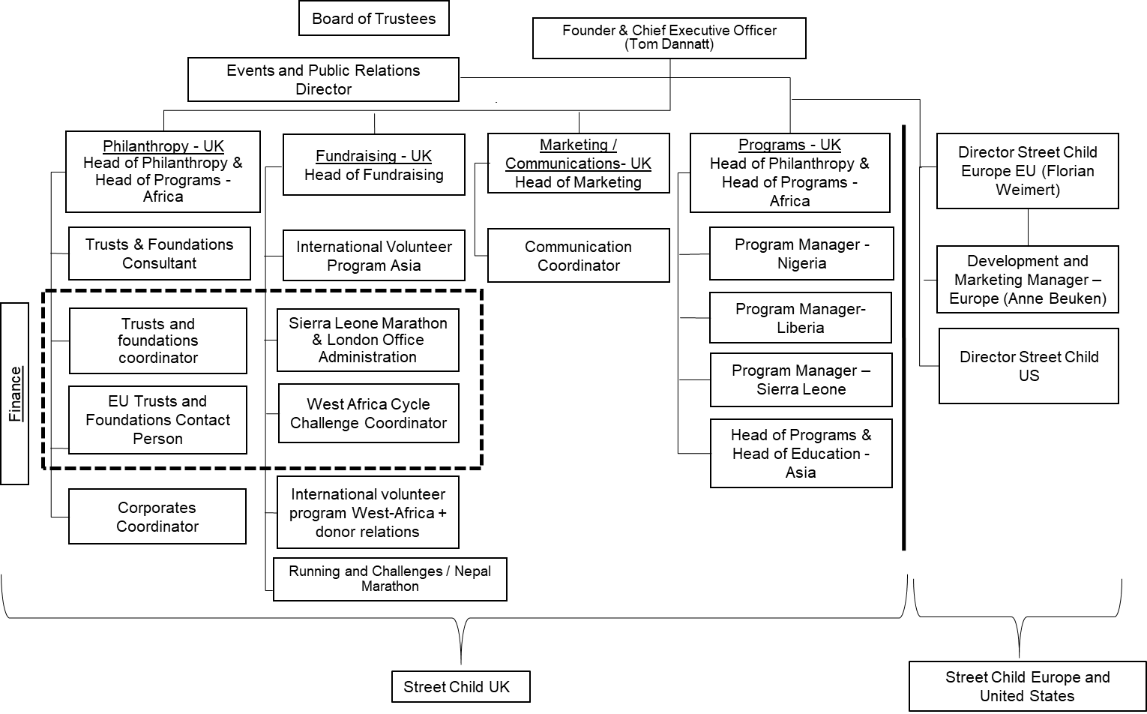

Note: This organizational chart featured roles by function and included all roles performed in the different offices; Some employees were in charge of several roles; EU =European Union; US = United States.

Source: Company documents.

Exhibit 3: Street Child Europe—Tasks for Interns and Scheduling

April to December 2016

|  |  |  |  |  |  |  |  |  |  |
| --- | --- | --- | --- | --- | --- | --- | --- | --- | --- |
|  | **April** | **May** | **June** | **July** | **August** | **September** | **October** | **November** | **December** |
| ES | 0.00 | 0.00 | 0.00 | 0.00 | 0.00 | 0.00 | 0.00 | 0.00 | 0.00 |
| FR | 0.50 | 1.00 | 2.00 | 2.00 | 3.00 | 1.00 | 1.00 | 1.00 | 1.00 |
| NL | 0.00 | 0.00 | 0.00 | 0.00 | 0.00 | 2.00 | 2.00 | 2.00 | 2.00 |
| DE | 0.00 | 0.00 | 0.00 | 1.00 | 1.00 | 1.00 | 0.00 | 1.00 | 1.00 |
| IT | 0.00 | 0.00 | 0.25 | 1.00 | 1.00 | 1.00 | 1.00 | 1.00 | 1.00 |
| Nordic | 0.00 | 0.00 | 0.00 | 0.00 | 0.00 | 0.00 | 0.00 | 0.00 | 0.00 |
| CH | 1.00 | 1.00 | 1.00 | 1.00 | 0.25 | 0.00 | 0.00 | 0.00 | 0.00 |
| EVP | 0.00 | 0.00 | 0.00 | 0.00 | 0.00 | 0.00 | 0.00 | 0.00 | 0.00 |
| Other | 0.00 | 0.00 | 0.50 | 1.50 | 1.25 | 0.50 | 0.00 | 0.00 | 0.00 |

January to December 2017

|  |  |  |  |  |  |  |  |  |  |  |  |  |
| --- | --- | --- | --- | --- | --- | --- | --- | --- | --- | --- | --- | --- |
|  | **January** | **February** | **March** | **April** | **May** | **June** | **July** | **August** | **September** | **October** | **November** | **December** |
| ES T&F-BCN | 0.00 | 0.00 | 0.00 | 0.00 | 0.00 | 0.00 | 0.00 | 0.00 | 0.00 | 0.25 | 1.00 | 1.00 |
| FR T&F-BCN | 0.25 | 0.25 | 1.00 | 1.00 | 1.00 | 0.75 | 0.00 | 1.00 | 1.00 | 1.00 | 1.00 | 0.75 |
| NL T&F-BCN | 0.50 | 1.00 | 1.00 | 1.00 | 1.00 | 1.00 | 0.00 | 0.00 | 1.00 | 1.00 | 1.00 | 1.00 |
| DE T&F-BCN | 1.00 | 1.00 | 2.00 | 1.00 | 1.00 | 1.00 | 1.00 | 2.00 | 2.00 | 1.00 | 1.00 | 1.00 |
| EU Sales and BizDev-BCN | 0.00 | 0.00 | 0.00 | 0.00 | 0.00 | 0.00 | 0.00 | 0.00 | 0.00 | 0.00 | 0.00 | 0.00 |
| IT T&F- LON | 1.00 | 1.00 | 0.00 | 0.00 | 0.00 | 0.00 | 0.00 | 0.00 | 0.00 | 1.00 | 1.00 | 1.00 |
| IT/EU Comms-LON | 0.00 | 0.00 | 0.00 | 0.00 | 0.00 | 0.50 | 1.00 | 1.00 | 1.00 | 0.00 | 1.00 | 1.00 |
| Nordic T&F-LON | 0.00 | 0.00 | 0.00 | 0.00 | 0.00 | 0.00 | 0.00 | 0.00 | 0.00 | 0.00 | 0.00 | 0.00 |
| CH T&F | 1.00 | 1.00 | 1.00 | 1.00 | 1.00 | 1.00 | 1.00 | 0.00 | 0.00 | 0.00 | 0.00 | 0.00 |
| EVP | 0.00 | 0.00 | 0.00 | 0.00 | 0.00 | 0.00 | 0.00 | 0.50 | 1.00 | 0.00 | 0.00 | 0.00 |
| Other |  |  |  |  |  | 0.50 | 1.00 | 1.00 | 1.00 | 1.00 | 1.00 | 1.00 |

Note: ES = Spain; FR = France; NL = The Netherlands; DE = Germany; IT = Italy; CH = Switzerland; EVP = European volunteer program; T&F = trusts and foundations; BCN = Barcelona; EU = European Union; BizDev = business development; Comms = Commission; LON = London; 1.00 = entire month; 0.75 = three weeks; 0.50 = half month; 0.25 = at least one week.

Source: Company documents.

Exhibit 4: Pictures of the Barcelona Office (Florian Weimert and Interns at Work)

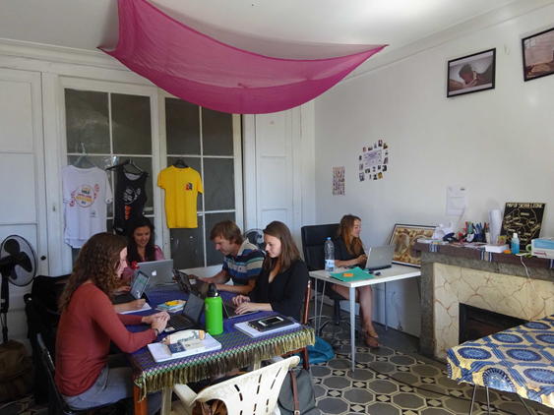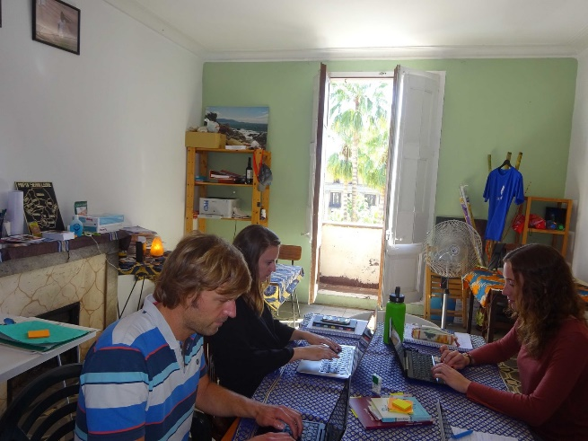

Source: Anna Zampa, with permission from Street Child Europe.

Exhibit 5: European Fundraising Plan 2017

|  |  |  |
| --- | --- | --- |
| **European Union** | **Plan** | **Actual** |
| Events | €16,520 | €6,388 |
| International Volunteer Program | €14,000 | €5,983 |
| Running and Challenges | €61,000 | €39,930 |
| Trusts and Foundations | €125,000 | €99,733 |
| Corporate Fundraising | €23,300 | €14,910 |
| Direct Donations | €14,730 | €11,355 |
| **Total** | **€254,550** | **€178,298** |
| **Trusts and Foundations Applications** | **144** | **75** |
| **Sierra Leone and Nepal Marathons** | **53** | **26** |
| **International and European Volunteer Programs** | **8** | **14** |
|  |  |  |
| **Spain** |  |  |
| Events | €7,600 | €5,238 |
| International Volunteers | €2,400 | €1,243 |
| Running and Challenges | €26,200 | €13,456 |
| Trusts and Foundations | €2,500 | €0 |
| Corporate Fundraising | €15,500 | €13,998 |
| Direct Donations | €1,560 | €649 |
| **Total** | **€55,760** | **€34,584** |
| **Trusts and Foundations Applications** | **12** | **3** |
| **Sierra Leone and Nepal Marathons** | **25** | **9** |
| **International and European Volunteer Programs** | **2** | **8** |
|  |  |  |
| **The Netherlands** |  |  |
| Events | €1,400 | €0 |
| International Volunteers | €1,300 | €415 |
| Running and Challenges | €7,200 | €2,022 |
| Trusts and Foundations | €25,000 | €33,045 |
| Corporate Fundraising | €1,900 | €0 |
| Direct Donations | €4,890 | €2,010 |
| **Total** | **€41,690** | **€37,492** |

Exhibit 5 (continued)

|  |  |  |
| --- | --- | --- |
|  | **Plan** | **Actual** |
| **Trusts and Foundations Applications** | **24** | **14.5** |
| **Sierra Leone and Nepal Marathons** | **6** | **2** |
| **International and European Volunteer Programs** | **1** | **1** |
|  |  |  |
| **Germany** | **Plan** | **Actual** |
| Events | €2,400 | €0 |
| International Volunteers | €1,300 | €0 |
| Running and Challenges | €14,200 | €23,957 |
| Trusts and Foundations | €17,500 | €3,588 |
| Corporate Fundraising | €1,400 | €412 |
| Direct Donations | €5,000 | €5,990 |
| **Total** | **€41,800** | **€33,947** |
| **Trusts and Foundations Applications** | **24** | **20** |
| **Sierra Leone and Nepal Marathons** | **13** | **15** |
| **International and European Volunteer Programs** | **1** | **1** |
|  |  |  |
| **Italy** |  |  |
| Events | €2,620 | €1,150 |
| International Volunteers | €1,300 | €0 |
| Running and Challenges | €4,200 | €495 |
| Trusts and Foundations | €51,000 | €63,100 |
| Corporate Fundraising | €2,400 | €500 |
| Direct Donations | €1,300 | €1,452 |
| **Total** | **€62,820** | **€66,697** |
| **Trusts and Foundations Applications** | **24** | **17** |
| **Sierra Leone and Nepal Marathons** | **1** | **0** |
| **International and European Volunteer Programs** | **1** | **2** |
|  |  |  |
| **France** |  |  |
| Events | €800 | €0 |
| International Volunteers | €1,300 | €1,583 |
| Running and Challenges | €3,000 | €0 |
| Trusts and Foundations | €11,000 | €0 |
| Corporate Fundraising | €800 | €0 |
| Direct Donations | €640 | €626 |
| **Total** | **€17,540** | **€2,209** |
| **Trusts and Foundations Applications** | **24.0** | **15.5** |
| **Sierra Leone and Nepal Marathons** | **1** | **0** |
| **International and European Volunteer Programs** | **1** | **2** |
|  |  |  |
| **Switzerland** |  |  |
| Events | €1,300 | €0 |
| International Volunteers | €1,300 | €0 |
| Running and Challenges | €4,000 | €0 |
| Trusts and Foundations | €15,000 | €0 |
| Corporate Fundraising | €1,000 | €0 |
| Direct Donations | €900 | €323 |
| **Total** | **€23,500** | **€323** |
| **Trusts and Foundations Applications** | **18** | **3** |
| **Sierra Leone and Nepal Marathons** | **0** | **0** |
| **International and European Volunteer Programs** | **1** | **0** |

Exhibit 5: (Continued)

|  |  |  |
| --- | --- | --- |
|  | **Plan** | **Actual** |
| **Nordics** |  |  |
| Events | €400 | €0 |
| International Volunteers | €1,300 | €0 |
| Running and Challenges | €2,200 | €0 |
| Trusts and Foundations | €3,000 | €0 |
| Corporate Fundraising | €300 | €0 |
| Direct Donations | €440 | €304 |
| **Total** | **€7,640** | **€304** |
| **Trusts and Foundations Applications** | **18** | **1** |
| **Sierra Leone and Nepal Marathons** | **1** | **0** |
| **International and European Volunteer Programs** | **1** | **0** |

Source: Company documents.

Exhibit 6: Organizational Chart for Street Child Europe

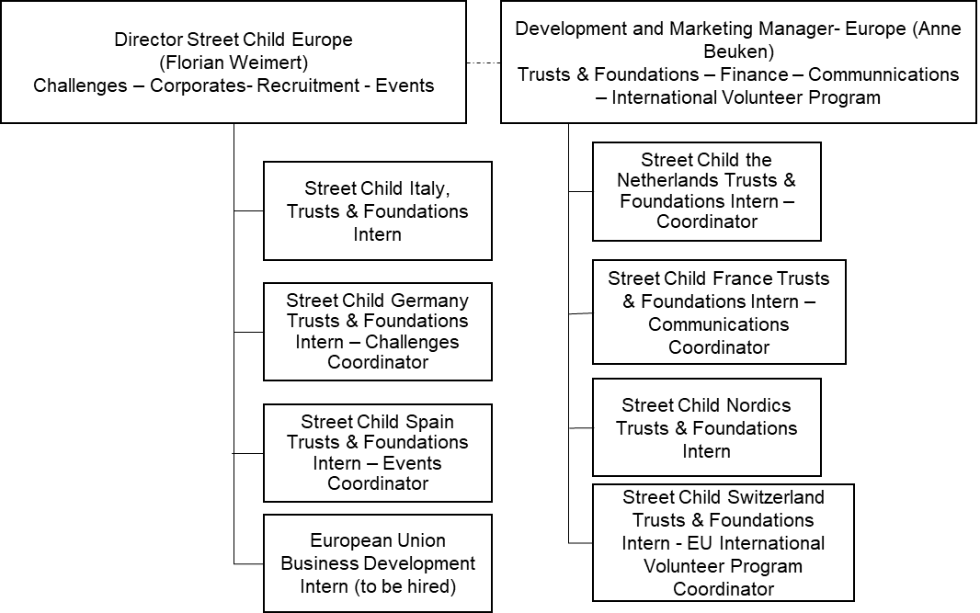

Source: Company documents.

1. “In Nigeria Newly Accessible Areas Reveal Scale of Crisis”, UNICEF, accessed August 15, 2019, www.unicef.org/nutrition/nigeria_94204.html.
2. £ = British pound sterling; £0.714 = US$1 on March 31, 2018; all currency amounts are in £ unless otherwise specified.
3. € = European euro; US$1 = €0.811 on March 31, 2018.
4. Katherine Purvis and Lindsey Kennedy, “Volunteer Travel: Experts Raise Concerns over Unregulated Industry,” *Guardian*, January 13, 2016, accessed April 26, 2019, www.theguardian.com/global-development-professionals-network/2016/jan/13/concerns-unregulated-volunteer-tourism-industry; Claire Crawford and Jonathan Cribb, *Gap Year Takers: Uptake, Trends and Long Term Outcomes* (London, UK: Institute for Fiscal Studies through the Centre for Analysis of Youth Transitions, November 2012), accessed April 26, 2019, https://assets.publishing.service.gov.uk/ government/ uploads/ system/ uploads/attachment_data/file/219637/DFE-RR252.pdf.
5. Natalie Jesionka, “The Reality of Voluntourism and the Conversations We’re Not Having”, *Muse*, accessed April 26, 2019, www.themuse.com/advice/the-reality-of-voluntourism-and-the-conversations-were-not-having; Matthew Jenkin, “Does Voluntourism Do More Harm than Good?” *Guardian*, May 21, 2015, accessed April 26, 2019, www.theguardian.com/voluntary-sector-network/2015/may/21/western-volunteers-more-harm-than-good.
6. Examples of Street Child Europe’s international volunteer programs: “International Volunteering: A Unique Humanitarian Experience [in French],” Street Child France, accessed April 26, 2019, www.street-child.fr/volontariat-international; “International Volunteer: A Unique Experience,” Street Child Suisse, accessed April 26, 2019, www.street-child.ch/international-volunteering; “The International Volunteer Program: An Experience that Has a Lasting Effect [in German],” Street Child Deutschland, accessed April 26, 2019, www.streetchild.de/international-volunteer-program.