

9B19C031

A note on using social network analyses to explore and enhance team effectiveness

Professor Lucas Monzani wrote this note solely to provide material for class discussion. The author does not intend to provide legal, tax, accounting, or other professional advice. Such advice should be obtained from a qualified professional.

This publication may not be transmitted, photocopied, digitized, or otherwise reproduced in any form or by any means without the permission of the copyright holder. Reproduction of this material is not covered under authorization by any reproduction rights organization. To order copies or request permission to reproduce materials, contact Ivey Publishing, Ivey Business School, Western University, London, Ontario, Canada, N6G 0N1; (t) 519.661.3208; (e) cases@ivey.ca; www.iveycases.com. Our goal is to publish materials of the highest quality; submit any errata to publishcases@ivey.ca. i1v2e5y5pubs

Copyright © 2020, Ivey Business School Foundation Version: 2020-01-27

OVERVIEW

Social network analysis (SNA) is a useful technique that enables users to capture and illustrate the relationships among social actors.[1] More precisely, SNA enables team leaders and project managers to take specific and informed action to enhance their team’s *outcomes* and thus overall team effectiveness.[2] For example, a project manager can use SNA to identify which team members are co-operating well with each other, who is isolated in a team, or where potential sources of intra-group conflict reside. Therefore, SNA has the potential to inform managers’ practices when leading project teams.

According to existing empirical studies, team and project leaders’ decisions can rely on SNA graphs to make decision on how to manage *team-level processes* in the teams they lead (e.g., conflict management) and thus shape positive *emerging states* in such teams (e.g., psychological safety[3] and swift trust[4]).[5] For example, unlike inter-personal conflict, task-oriented conflict can be positive for teams as it usually leads to collective innovation and acts as protective factor against groupthink[6]. In contrast, purely personality-related conflict usually leads to dysfunctional team behaviours. In many teams, the root causes of personality-related conflict derive from divergences in team members’ personal situations and motives, also known as *individual-level inputs*. Thus, team leaders need a way to make sense of such individual-level inputs, and how they affect the collective functioning of their teams. SNA provides such an instrument for such sense-making efforts.

This note provides a step-by-step approach to guide students and practitioners in the construction of an SNA graph. The note also covers the use of qualitative information for determining node attributes, populating an adjacency matrix, and utilizing the resulting graph structure to identify dysfunctional social exchanges across team members.

Building AN SNA network

Given that SNA draws heavily from graph theory, an area of applied mathematics, some definitions are necessary. First, when conducting a large scale SNA, each social actor of a collective is referred to as a “node.” Similarly, within a smaller collective, such as a workgroup or a team, each team member is referred to as a “node,” and the relationship between two nodes (e.g., friendship or animosity) is referred to as a “tie.” In SNA, a “tie” expresses a form of social relationship that has a direction, valence, and strength.

First, a tie’s *direction* can be bidirectional (e.g., both Faizan and Pedro see each other as friends), unidirectional (Faizan considers Pedro a friend, but Pedro does not reciprocate such friendship), or express no relationship at all (we have no information on the status of Pedro and Faizan’s association).

Second, the *valence* of a tie refers to the nature of the relationship. For example, Faizan and Pedro can be friends (a positive valence, usually expressed with “+”) or adversaries (a negative valence, usually expressed with “-”).

Third, ties might differ in *strength* (e.g., if Faizan sent 25 emails to Pedro, but only two emails to Vera, the tie connecting Faizan and Pedro is said to be “stronger” than the tie connecting Faizan and Vera). However, it is beyond the scope of this introductory note to elaborate on the properties of tie strengths.

Finally, the third critical element of an SNA is a “community,” which occurs when several actors have a common characteristic that “binds them together”[7] (e.g., students in the same class).

1. Map the individual characteristics and circumstances of social actors as node attributes.

The first step in using SNA to explore intra-group relationships is to outline the four types of unique features of the social actors: (1) What are the unique strengths of each team member? (2) What are the unique weaknesses of each team member? (3) What are each team member’s motivations? (4) Are there any personal situations the team leader should be aware of?

A practical way to map such individual inputs is to construct a table with one column allocated for each individual input (see Table 1). As Table 1 shows, for the team to be effective, team leaders must use their judgment to adjust the leadership style that is applied.[8]

Table 1: Example of Mapping Node Attributes for SNA

|  |  |  |  |  |
| --- | --- | --- | --- | --- |
| *Social Actor* | *Strengths* | *Weaknesses* | *Personal Motives* | *Personal Situation* |
| Faizan | Critical thinker | Overthinks things | Monetary incentives | ? |
| Pedro | Good with people | Usually unfocused | Increased social status | ? |
| Rahina | Numbers expert | Not a public speaker | Monetary incentives | Mortgage loan |
| Vera | Sees “the big picture” | Poor attention to detail | Wants to leave a legacy | Retiring soon |

For example, when considering the personal situations of each team member, team leaders need to rely on not only their leader character dimension of humanity, but also their drive and transcendence, to communicate the team goals and their associated rewards in a way that satisfies the personal motives of the team members. All these node attributes can be collected in an auxiliary table, as shown in Table 1.

2. Use an adjacency matrix to map social relationships between social actors.

The second step to conduct an SNA is to construct an adjacency matrix. In short, an adjacency matrix consists of a collection of social actors that are distributed in rows and columns so that each social actor has the same row and column number (e.g., in Table 2, John occupies row 1 and column 1, and Paul occupies row 2 and column 2). Information regarding the social relationship between two social actors (e.g., John and Paul) will comprise the content of the respective cell (e.g., the cell of column 1 and row 2).

Constructing an adjacency matrix gives users the advantage of easily spotting information gaps in the social relationships within teams. In our example, the team leader has limited information regarding Mary’s attitudes toward other members, which is expressed with the “– ? –” operator. Once the adjacency matrix is constructed, an “empty” graph can be constructed. In this context, an “empty” graph represents the main actors or nodes and their properties: Strengths, Weaknesses, Personal Motives, and Personal Situations (see Exhibit 1).

In SNA, the content of the adjacency matrix can derive from qualitative or quantitative information. Qualitative information usually reflects an external assessment of social relationships (e.g., a consultant’s perception of the relationship between John and Paul), whereas an adjacency matrix based on quantitative information usually includes objective data (e.g., the number of emails between John and Paul, and the number of emails between John and Mary). Given that social relationships might or might not be reciprocated, it is essential to express the direction of the relationship between two social actors. A bidirectional relationship can be expressed using the “< – >” operator, whereas a unidirectional relationship can be expressed either using the “ – >” or “ < –” operator, depending on its valence (see Table 2).

Table 2: Example of an Adjacency Matrix Populated with Qualitative Data

|  |  |  |  |  |
| --- | --- | --- | --- | --- |
|  | John | Paul | Jane | Mary |
| Faizan | – | **Pedro–** **>** **Faizan** | *Rahina < – > Faizan* | Vera– ? – Faizan |
| Pedro | **Faizan** **–>** **Pedro** | – | Rahina – ? – Pedro | Vera – ? – Pedro |
| Rahina | *Faizan < – > Rahina* | **Pedro** **–** **>** **Rahina** | – | Vera – ? – Rahina |
| Vera | Faizan – ? – Vera | *Pedro –> Vera* | *Rahina–> Vera* | – |

Exhibit 2 shows Faizan and Rahina have a positive (denoted in *italics*), bidirectional relationship (e.g., they are friends, and they went to same school), but Pedro and Rahina have a negative (denoted in **bold**), unidirectional relationship (e.g., Pedro is jealous of Rahina’s intelligence; there is no information of Rahina’s attitudes toward Pedro).

The lower and upper diagonals of the adjacency matrix should express the relationship between two social actors (e.g., between Faizan and Pedro). More precisely, the lower diagonal should capture the first social actor’s perspective (e.g., Faizan: “Pedro rushes to conclusions”), whereas the upper diagonal should capture the relationship from the second social actor’s perspective (Pedro: “Pedro thinks Faizan takes forever to answer simple questions”). When the relationship is bidirectional, both upper and lower diagonals will show the same information (e.g., “Rahina < – > Faizan”; “Both went to the same school”).

3. Use SNA graphs to manage social relationships within teams.

Constructing a graph is a practical and intuitive way to make sense of node attributes. For “large-world” networks—that is, social networks involving dozens, hundreds, or even millions of actors—relying on statistical software packages and visualization algorithms is a must. As the number of nodes increases, and thus the size of the adjacency matrix expands, the need to rely on graphs to make sense of the data becomes stronger. For “small-world” networks, which display relationships among four to 10 social actors, graphs can be constructed manually, but several attempts might be needed to display the information with clarity.

The first step is to situate each node in a space, alongside a description of its unique characteristics. Also, different node colours or shapes can be used to map the communities that the social actor belongs to (e.g., the actor’s department, hierarchical position, and gender assigned at birth). The second step is to draw the ties depicted in the adjacency matrix, distinguishing their direction and valence. When ties do not overlap (or cross over), the resulting graphs are clearer and more informative than graphs with ties that cross over each other. Finally, the third step is to identify “structural holes” in the graph, which refers to the social actors that serve as “brokers” by connecting different communities.

Team leaders can use the information resulting from Exhibit 2 to enhance their team’s effectiveness. They can decide how to leverage their team’s individual-level inputs to the collective advantage of the team. For example, when team leaders are trying to gain their team members’ commitment toward a collective goal, the language they use might vary, depending on the team members’ personal situations and motives.

In the example depicted in Exhibit 2, the team leader might want to highlight different aspects of the potential outcomes of the project to Vera, to Pedro and Rahina, and to Faizan. More precisely, the team leader could signal to Vera that this project is a unique opportunity to identify a potential mentee (Vera’s personal motive is to build a legacy), given that she will retire soon (Vera’s personal situation). Similarly, when communicating the collective goal to Rahina and Faizan, the team leader might want to emphasize the monetary rewards associated with completing the project successfully (Faizan and Rahina share the personal motive of monetary incentives), and address Rahina’s concerns regarding her job security (her personal situation is that she has a mortgage loan). Instead, the team leader might want to emphasize to Pedro how important the project is, and the recognition that achieving such a goal might bring to the team (Pedro’s personal motive is increased social status).

Regarding group processes and emerging states, Exhibit 2 suggests that individual-level inputs might influence group process and emerging states. More precisely, the incongruence in team members’ personal motives will drive (latent) personality-related conflicts. In our example, both Rahina and Faizan seem to disagree with Pedro in that they value tangible rewards more strongly (Rahina and Faizan share the personal motive of monetary incentives) than intangible rewards (Pedro’s personal motive is increased social status). Such lack of coherence in personal motives will likely affect the team’s ability to work as a cohesive unit, and thus negatively impact their collective effectiveness. In our example, based on the information in Exhibit 2, the team leader could then rely on Vera to overcome the potential personal conflict between, on the one hand, Pedro, and on the other hand, Faizan and Rahina. Because Vera is a social actor who is respected by both Pedro and Rahina (in positive unidirectional relationships), she has direct influence on Rahina and Pedro, and indirect influence over Faizan (through Rahina). Hence, the team leader could rely on both Vera and Rahina to extend influence over Faizan, and thus increase the likelihood of modifying Faizan’s attitudes and behaviours.

Finally, it is important to understand that the cyclical nature of team dynamics will affect the relationship between team leaders and team members. More precisely, as a team gains experience and develops, team outcomes will influence both individual-level and team-level inputs, and thus the number of ties might increase (or decrease). Therefore, as their team evolves, team leaders should update their SNA graph accordingly. Contrasting and comparing different SNA snapshots can provide team leaders with additional insights regarding whether group process and emerging states have consolidated, or whether further action is needed to sustain their team effectiveness.

This note introduces SNA as a useful tool to enhance managers’ ability to enhance their team’s effectiveness. Readers interested in more in-depth discussion about network-based analyses (e.g., topological properties) should explore the supporting references cited earlier in this note. In particular, Kolaczyk and Csárdi’s book provides detailed descriptions and R scripts for conducting statistical analyses of network-based data.

Exhibit 1: Using Social Network Analysis to explore a team’s Individual-level Inputs as Node Attributes

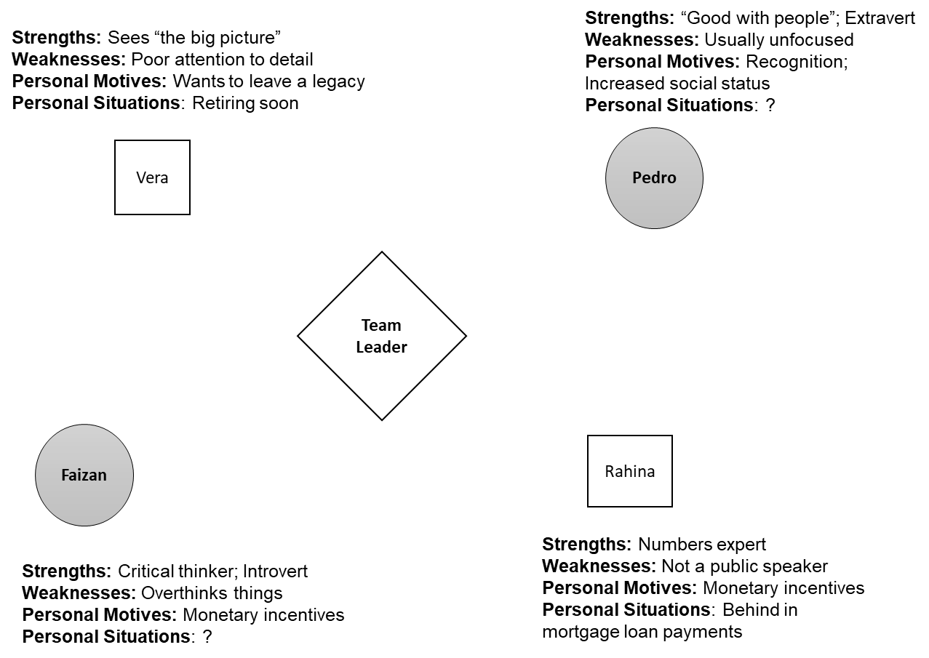

Source: Created by the case author.

Exhibit 2: Illustration of a small-work network using a qualitative adjacency matrix

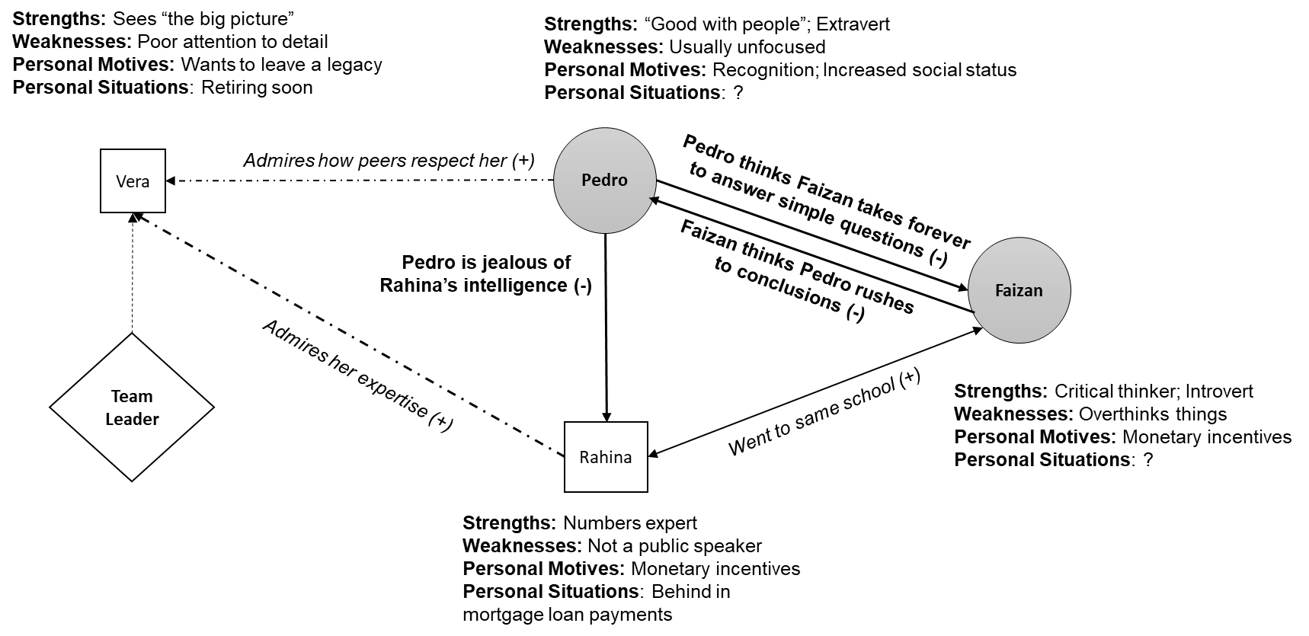

Source: Created by the case author.

1. Eric D. Kolaczyk and Gábor Csárdi, *Statistical Analysis of Network Data with R*, vol. 65 (New York, NY: Springer, 2014). https://doi.org/10.1007/978-1-4939-0983-4.
2. John E. Mathieu, M. Travis Maynard, Tammy Rapp, and Lucy Gilson, “Team Effectiveness 1997–2007: A Review of Recent Advancements and a Glimpse into the Future,” *Journal of Management* 34, no. 3 (2008): 410–476.
3. Amy Edmondson, “Psychological Safety and Learning Behavior in Work Teams,” *Administrative Science Quarterly* 44, no. 2 (1999): 350–383.
4. Sirkka L. Jarvenpaa and Dorothy E. Leidner, “Communication and Trust in Global Virtual Teams,” *Journal of Computer-Mediated Communication* 3, no. 4 (1998): 1–26.
5. Prasad Balkundi and David A. Harrison, “Ties, Leaders, and Time in Teams: Strong Inference about Network Structure’s Effects on Team Viability and Performance,” *Academy of Management Journal* 49, no. 1 (2006): 49–68.
6. Irving L. Janis, *Victims of Groupthink: A Psychological Study of Foreign Policy Decisions and Fiascos* (Boston, MA: Houghton Mifflin, 1982).
7. Miller McPherson, Lynn Smith-Lovin, and James M. Cook, “Birds of a Feather: Homophily in Social Networks,” *Annual Review of Sociology* 27 (2001): 415–444.
8. Mary M. Crossan, Alyson Byrne, Gerard H. Seijts, Mark Reno, Lucas Monzani, and Jeffrey Gandz, “Toward a Framework of Leader Character in Organizations,” *Journal of Management Studies* 54, no. 7 (2017): 986–1,018.